SENUKE AI DEVELOPMENT MASTER

DEV-052 — Adaptive Business Discovery
& Simplified Intake
  - Short developer guide for users with a business, an idea, or only skills and knowledge
Document field | Value
Status | Authoritative simplified V1 intake guide
Version | 1.0
Date | August 13, 2026
Primary owner | Project Creation / Business Discovery
Connected systems | Business Brain, Opportunity Finder and Workflow Controller
Developer goal | Produce a useful AI result after no more than five initial answers
Applies to | New projects in Personal, Business and Agency workflows

FINAL V1 DECISION
Build this Replace the long universal questionnaire with three adaptive starting paths. Ask only for facts needed to create the next useful result. A domain, business address, city, service area, postal code, phone number and Google Business Profile are not required unless the selected business direction needs them.
This guide narrows DEV-003 Project Creation, extends DEV-006 Opportunity Finder and follows DEV-011D AI-Assisted Project & Client Information. If an older document makes location or target markets universally required at the first step, use the conditional rules in this guide.

1. What Developers Need to Change
Build one adaptive intake router inside Project Creation / Business Discovery. Do not create another top-level product. The first screen asks one question: “How would you like to start?”
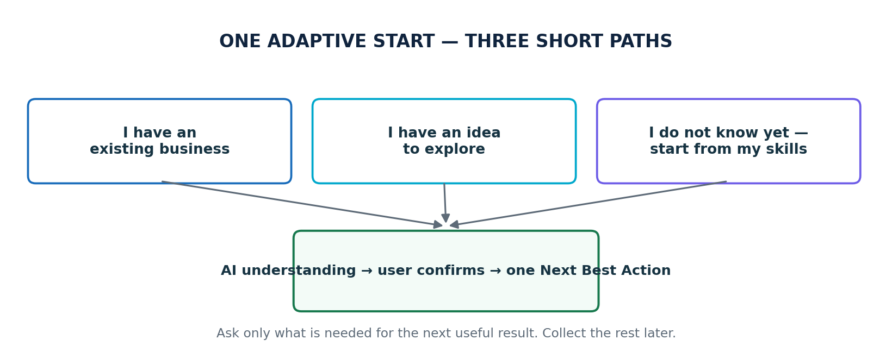
Figure 1 — Three short starting paths
Starting choice | Use when | First useful result
I have an existing business | The user already sells, serves customers or owns a business asset. | A short Business Brain summary and the best next diagnostic or strategy action.
I have an idea to explore | The user knows the topic, product, service or business model but has not built it yet. | A refined direction, audience and recommended validation step.
I do not know what to start | The user has skills, knowledge, interests or experience but no business idea. | Three to five realistic opportunity cards to compare.

Five-answer rule Before showing a useful AI output, request no more than five user answers. One large free-text answer may fill several facts. After the output, ask only one blocking follow-up at a time.

2. Rules for Every Path
- Read the workspace, client, project, Business Brain and connected asset data before asking a question.
- Never ask for a fact that is already user-confirmed and still current.
- Use conditional questions. A field is shown only when it is applicable and required for the next action.
- Let the user answer in plain language. Extract multiple facts from one response.
- Show AI-suggested values for review. The user can Accept, Edit, Regenerate or Ignore.
- Offer “Help me decide” and “Skip for now” for every non-blocking question.
- Do not save AI inference as confirmed fact. Save it as AI-suggested until the user accepts it.
- Generate a provisional project name from the description. The user may edit it later.
- Show one clear Next Best Action after every confirmation.
- Explain why a later question is needed when it first appears.

Required, optional and deferred
State | Meaning | UI behavior
REQUIRED_NOW | Without this fact, the system cannot produce the next promised result. | Ask one concise question and explain why.
OPTIONAL | The fact could improve the result but is not blocking. | Show Skip for now and continue.
DEFERRED | The fact may be needed at a later workflow stage. | Do not show it yet.
NOT_APPLICABLE | The selected direction does not use the fact. | Never ask or show an error.
AI_SUGGESTED | The AI inferred a value from the user’s answer or an asset. | Show it for Accept/Edit; do not treat it as confirmed.
CONFIRMED | The user accepted or directly provided the fact. | Reuse it downstream; ask again only if a conflict appears.

3. Path A — Existing Business
The user may describe the business or provide an existing website, store, marketplace listing, social profile or Google Business Profile. The asset is optional.

Ask now
- “Tell us about the business, or paste a website/store/profile link.”
- “What is the main result you want right now?” Examples: more leads, sales, traffic, visibility or a new website.
- Ask whether the business is local, online or hybrid only if the answer and asset do not make it clear.

AI does next
- Analyze any supplied asset using the approved limited-analysis rules.
- Suggest the business description, model, products/services, audience, primary goal and known digital assets.
- Show “Here is what I understand” with Accept, Edit and Start over.
- After confirmation, save the confirmed Business Brain facts and choose the relevant diagnostic or strategy Next Best Action.

Ask later only when relevant
Fact | Ask when
Domain / website URL | The user wants site analysis, website management or a new website/domain step. It remains optional at project start.
Location / postal code | The model is local or hybrid and Local SEO, a service area, local competitors or local regulations are relevant.
Google Business Profile | The confirmed business serves local customers and the user enters Local SEO.
Analytics / CMS | The user approves a diagnostic, measurement or website execution action that needs the connection.
Detailed brand fields | Content, design or publishing reaches the stage that needs them.

4. Path B — Idea to Explore
This path is for a user who knows what they may want to build but has no domain, website or complete business plan.

Ask now
- “Describe the idea in your own words.”
- “Who do you think it may help?” Include “Help me decide.”
- “How might it make money?” Include affiliate, service, coaching/consulting, digital products, ecommerce, advertising and “Help me decide.”
- Optionally ask time and budget only if needed to rank practical directions.

AI does next
- Classify the likely model: local service, online service, content/affiliate, ecommerce, coaching/consulting, digital product/course, marketplace seller or unclear.
- Refine the topic, audience, revenue model and primary problem being solved.
- Show the AI understanding for confirmation before saving it as the active direction.
- Run Opportunity Finder only when the direction is unclear or the user asks for alternatives.
Affiliate example Input: “I want an affiliate site about camping gear.” Classify it as online content/affiliate. Ask about the intended audience or offer Help me decide. Recommend a focused angle and validation step. Do not ask for an address, city, postal code, service area, phone, business hours or Google Business Profile. Ask about a domain only when the user reaches website planning.

5. Path C — No Idea Yet; Start from Skills
This is a discovery session, not a full project questionnaire. The user should receive useful business directions before being asked to invent business details they do not have.

Ask no more than five prompts
Prompt | Input style
What are you good at, knowledgeable about or experienced in? | One open text box; examples are optional.
What do people already ask you for help with? | Open text; Skip for now allowed.
What topics or work do you enjoy or want to avoid? | Open text or simple preference chips.
How much time and startup budget can you realistically use? | Simple ranges; Skip for now allowed.
Would you prefer online, local, either or Help me decide? | Single choice.

Opportunity Finder output
Return three to five opportunity cards. Rank them by fit, evidence, effort and confidence. Do not promise demand, income or success.
Every opportunity card shows | User actions
Opportunity and simple description | Explore this
Why it fits the user’s skills and constraints | Compare
Likely audience and problem solved | Show more ideas
Likely revenue model | Tell AI what I like or dislike
Available demand evidence and evidence date/source | Save for later
Startup difficulty, approximate time/cost band and major risk | Select as my direction
Confidence and first three validation steps | Start over

When a project is created
Keep the session as a Discovery Draft until the user selects a direction. After selection, create or update the project, store confirmed Business Brain facts and send the user to the next validation or strategy action. Do not require a domain or location before selection.
Important distinction “Target audience” is not the same as “physical business location.” An online opportunity may need an audience or selling geography later without ever needing a business address, city or postal code.

6. Applicability Rules
Detected direction | Ask during quick start | Do not ask during quick start
Local service | Service type, main goal; location only when needed to evaluate the local market. | Domain, GBP, hours, phone and full address unless immediately needed.
Online service | Service, audience, result and delivery preference. | Physical location, postal code, service area and GBP.
Content / affiliate | Topic, audience, revenue preference and constraints. | Physical location, phone, hours, GBP and domain.
Ecommerce | Product/category, buyer, sales model and constraints. | Physical address unless pickup/local operations matter; domain until store planning.
Coaching / consulting | Expertise, audience, outcome and online/local/either. | Location until the user selects local or hybrid delivery.
Digital product / course | Knowledge, learner, promised outcome and format preference. | Location, GBP, phone, hours and domain.
Marketplace seller | Product, buyer, marketplace or Help me decide. | Independent domain and local fields unless the model later needs them.
Unclear | Skills, interests, constraints and preferences. | All operational business fields.

7. Screen and Workflow Behavior
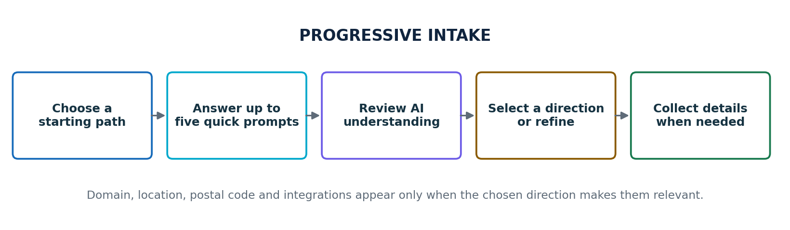
Figure 2 — Progressive collection instead of one large questionnaire

Screen 1 — Start choice
- Show the three starting choices as plain-language cards.
- Agency workflow: select or create the client first, then reuse known client data. Do not ask it again.
- Let the user change paths without losing reusable answers.

Screen 2 — Short conversation
- Use one question per step or one compact screen with no more than five prompts.
- Show progress as “Quick start,” not as a long onboarding checklist.
- Allow back, skip, Help me decide and save/continue later.

Screen 3 — Here is what I understand
- Show business/project direction, audience, revenue model, primary goal and constraints that are actually known.
- Label every inferred value “AI suggested.”
- Offer Accept and continue, Edit, Regenerate and Start over.
- Do not force empty irrelevant fields into the summary.

Screen 4 — Next Best Action
- Clear direction: proceed to the relevant validation, diagnostic or strategy action.
- Unclear direction: show Opportunity Finder recommendations.
- Selected opportunity: create/update the project and Business Brain, then show one validation or strategy action.
- Never send a user back to a universal required-fields form.

8. Minimal Implementation Contract

Store these values
Field | Purpose
start_path | EXISTING_BUSINESS, IDEA_TO_EXPLORE or SKILLS_FIRST.
discovery_status | DRAFT, AI_SUMMARY_READY, USER_CONFIRMED, DIRECTION_SELECTED or HANDED_OFF.
business_model | Normalized model plus confidence; may remain UNKNOWN.
facts[] | Fact key, value, source, state, timestamp and user who confirmed it.
question_history[] | Question ID, reason, answer, skipped state and time; prevents repeats.
selected_direction | The confirmed existing direction or selected opportunity.
next_best_action | One actionable next step with expected outcome.

Question decision rule
Ask only when all are true The fact is applicable to the current direction; the fact is not already confirmed; the next promised action truly requires it; and the system cannot safely infer a suggestion for user confirmation. Otherwise reuse, suggest, defer or mark not applicable.

Source priority
Use this order: current user confirmation → existing confirmed Business Brain/client fact → verified connected asset → AI suggestion → unknown. A lower-priority source never silently overwrites a confirmed value.

Events
- discovery.started, discovery.answer_saved, discovery.summary_generated
- discovery.summary_confirmed, opportunity.generated, opportunity.selected
- project.direction_confirmed, next_best_action.updated

9. Edge Cases and Recovery
Situation | Required behavior
User gives a detailed first answer | Extract all usable facts and skip covered questions.
User gives only one skill | Generate broad options or ask one helpful refinement; do not demand business fields.
User chooses Help me decide repeatedly | Make a recommendation with assumptions, label confidence and let the user refine it.
User switches starting path | Preserve compatible answers, clear incompatible assumptions and regenerate the summary.
Location becomes relevant later | Ask for the minimum geography needed at that moment and explain the reason.
Connected asset conflicts with the user | Show the conflict and ask the user which value is current.
No reliable demand evidence is available | Say evidence is limited; lower confidence and recommend a validation task.
AI cannot classify the model | Keep UNKNOWN and use Opportunity Finder. Do not guess operational requirements.
User leaves and returns | Restore the Discovery Draft at the last completed step.
Integration or analysis fails | Preserve answers and offer retry, manual description or continue without the asset.

10. Do Not Build
- One large questionnaire containing every possible business, website and Local SEO field.
- Mandatory domain, website, address, city, location, postal code, phone, hours or Google Business Profile at project start.
- A separate top-level menu item for this intake; it belongs inside Project Creation / Business Discovery.
- Repeated questions when the workspace, client, project or Business Brain already has the answer.
- A requirement to create a complete project before a skills-first user can view opportunities.
- Automatic saving of AI suggestions as confirmed business facts.
- Guaranteed revenue, demand, ranking or success claims in opportunity recommendations.
- A requirement to connect analytics, CMS, social accounts or Google before the first useful result.

11. Build Order and Acceptance Tests

Recommended build order
Step | Deliverable
1 | Three-choice router and Discovery Draft state.
2 | Question applicability rules, five-answer limit and fact reuse.
3 | AI understanding screen with suggestion confirmation.
4 | Existing business and idea paths.
5 | Skills-first prompts and Opportunity Finder cards.
6 | Business Brain/project handoff and one Next Best Action.
7 | Instrumentation, accessibility, edge cases and QA.

Acceptance checklist
- A user can reach a useful AI summary or opportunity list with five or fewer answers.
- An affiliate-site user can continue without location, address, postal code, phone, hours, GBP or domain.
- A skills-first user receives three to five comparable opportunities before project details are required.
- Existing confirmed client/project/Business Brain facts are reused and not asked again.
- Location appears only after local relevance is confirmed and the next action requires it.
- Domain remains optional until site analysis, domain selection or website execution needs it.
- AI suggestions are visibly labeled and require user confirmation before becoming confirmed facts.
- The user can skip non-blocking questions, return later and change starting paths.
- Each confirmed direction produces one Next Best Action with an expected outcome.
- Agency client data stays isolated and known client information is not duplicated.
- Mobile, keyboard, screen-reader, empty, loading, error and resume states pass QA.
- No screen reintroduces DEV-003’s universal first-step location requirement.
Definition of Done The feature is complete when users with an existing business, a starting idea or only skills/knowledge can receive a useful, confirmable direction through a short adaptive flow; irrelevant questions are suppressed; confirmed information is reused; and the selected direction enters the existing Opportunity, Strategy and Next Best Action workflow.

