PRODUCT WORKFLOW & IMPLEMENTATION SPECIFICATION

SEO Plan to SEO Content Plan

AI-Guided End-to-End Workflow with DEV-022 Local Grid Integration
SEnuke AI Developer Implementation Manual

Document field | Value
Document ID | SEO-WF-001 with DEV-022 integration
Version | 1.1
Priority | P1
Applies to | Business, Agency and Ecommerce Workspaces
Dependencies | Keyword Intelligence, Site Analysis, Rank Tracking, Content Planning, Notifications and Reporting
Prepared date | July 20, 2026
Primary purpose | Convert SEO strategy and evidence into approved, AI-guided and continuously optimized execution work across content, technical, local and authority teams.

Core design principle
The SEO Plan is the master strategy. The SEO Content Plan is a linked execution plan created only when a recommendation requires content. AI assists with intent analysis, gap analysis, briefing, drafting and Next Best Action recommendations, while humans retain control of editing, approval and publishing. Technical, GBP, citation, review and authority recommendations remain in their correct workstreams.

CONFIDENTIAL - INTERNAL PRODUCT SPECIFICATION

Contents
1. Executive Summary
2. Product Goals and Scope
3. SEO Plan vs SEO Content Plan
4. End-to-End Workflow
5. Workflow Decision and Routing Rules
6. Roles, Permissions and Approvals
7. Status Models and Activity History
8. Master SEO Plan Specification
9. SEO Content Plan Specification
10. Approval Inbox and Notification Specification
11. Reporting, Next Best Action and Continuous Optimization
12. Example: Custom Software Development Cluster
13. DEV-022 Local SEO Grid & Heatmap Tracking
14. Functional Requirements
15. Non-Functional Requirements
16. Definition of Done and Acceptance Checklist
Reading guide
Sections 4-7 define the operational workflow. Sections 8-10 define the product screens and records. Section 13 integrates DEV-022 into that same workflow.

1. Executive Summary
SEnuke AI should manage SEO as a connected, AI-guided planning and execution system rather than as a list of unrelated recommendations. The platform must begin with business goals and evidence, analyze intent and gaps before writing, create a master SEO Plan, route each approved recommendation into the correct workstream, keep humans responsible for review and approval, and use measured outcomes to generate the Next Best Action.
- The SEO Plan defines objectives, priorities, workstreams, owners, dependencies, target dates and business KPIs.
- The SEO Content Plan contains only content-related execution: page updates, new landing pages, supporting articles, case studies, FAQs, internal links and refreshes.
- DEV-022 contributes geographic ranking evidence. Its recommendations may create content actions, but they may also create GBP, citation, review, technical or authority tasks.
- Every record must remain traceable from finding -> recommendation -> approved plan action -> intent and URL decision -> execution item -> approved version -> publication/deployment -> indexing/discovery check -> measured outcome -> Next Best Action.
- Company admins and approvers must have a single Approval Inbox, supported by in-app, email and optional collaboration-channel notifications.
Expected outcome
A company can see why each SEO action exists, who owns it, what must be approved, when it was executed and whether rankings, visibility and conversions improved.

2. Product Goals and Scope

2.1 Goals
- Create one source of truth for SEO strategy and execution.
- Prevent keyword cannibalization through keyword clustering and target-URL mapping.
- Route findings to the correct delivery team instead of treating all SEO recommendations as content.
- Provide structured approvals with version history and required comments for change requests.
- Connect content, technical and local work to rankings, traffic, leads and conversions.
- Support single-company execution and multi-client Agency workflows.
- Use AI to recommend actions while keeping humans responsible for approval and publishing.
- Treat publishing as the beginning of an optimization cycle rather than the end of the content workflow.

2.2 In Scope
Workstream | Examples
Strategy | Business goals, markets, service priorities, competitors, KPI targets and quarterly roadmap.
Technical SEO | Crawling, indexing, canonicals, redirects, structured data, performance and rendering.
On-page SEO | Search intent, metadata, headings, proof, FAQs, internal links and conversion actions.
Content | Page updates, new pages, supporting content, case studies and content refreshes.
Local SEO | GBP, location pages, citations, reviews, geographic rank grids and local reports.
Authority | Digital PR, link acquisition, partnerships, mentions and topical authority.
Approvals | Review, comments, changes requested, approved versions and publishing permission.
Measurement | Rankings, grid visibility, traffic, leads, conversion rate and content decay.

2.3 Out of Scope for Version 1.1
- Automatic publication without a configured approval policy.
- Guaranteed ranking outcomes.
- Automated manipulation of reviews, citations or backlinks.
- Replacing platform-specific access controls for Google Business Profile or analytics providers.

3. SEO Plan vs SEO Content Plan
Dimension | SEO Plan | SEO Content Plan
Purpose | Defines the complete organic-growth strategy. | Defines content work required to execute approved strategy.
Scope | Technical, on-page, content, local, authority, conversion and measurement. | Page updates, new pages, articles, case studies, FAQs, internal links and refreshes.
Created from | Business goals, audits, keyword intelligence, ranking data, competitors and DEV-022 findings. | Approved SEO Plan actions classified as Content Required.
Primary owner | SEO Manager or Strategist. | Content Strategist or SEO Manager.
Typical cadence | Quarterly plan with monthly updates. | Weekly or monthly production calendar.
Approval | Company-level strategy and budget approval. | Item-level brief, draft and publication approval.
Success measures | Organic leads, conversions, market visibility, technical health and authority. | Published work, rankings, traffic, engagement, assisted leads and refresh performance.

Mandatory relationship
Every content item must link to a parent SEO Plan action, except manually created editorial items. Every parent action must show whether it created zero, one or multiple execution records.

4. End-to-End Workflow
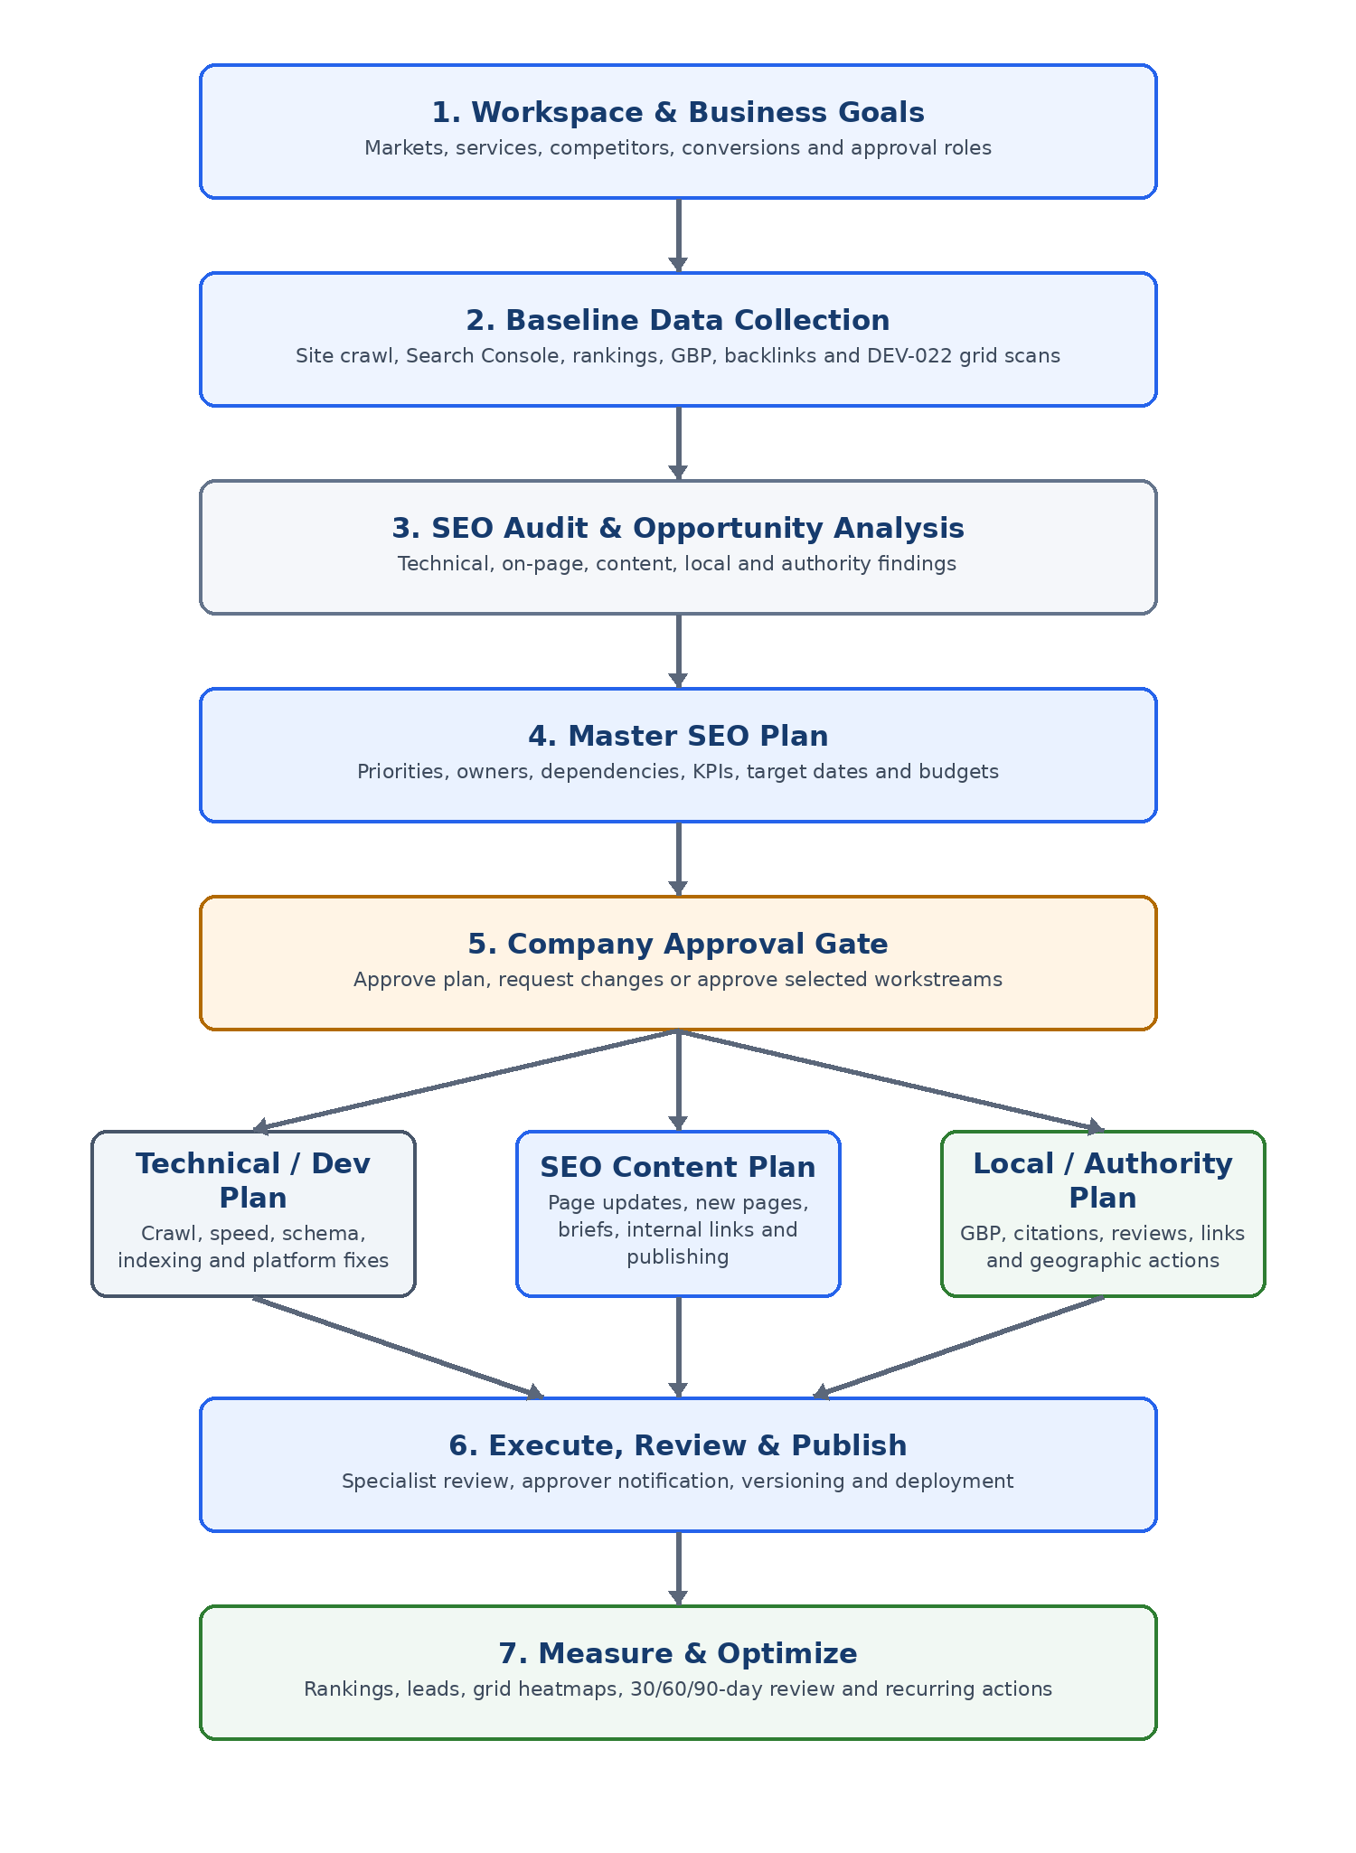
Figure 1. Master SEO planning and execution workflow.

4.1 Workspace and Goal Configuration
Capture the business model, locations, products or services, target markets, buyer groups, priority conversions, competitors, available resources, approval policy and reporting cadence.

4.2 Baseline Data Collection
Collect site crawl data, indexing information, keyword and competitor rankings, analytics, conversion events, backlink data, GBP data and DEV-022 geographic rank scans when local tracking is enabled.

4.3 Audit and Opportunity Analysis
Transform raw evidence into findings. Each finding must include evidence, affected URLs or locations, impact, confidence, recommended action type and suggested priority.

4.4 Master SEO Plan Creation
Group related findings into objectives and workstreams. Assign owners, dependencies, target dates, effort, expected outcome, KPI and approval requirement.

4.5 Company Approval Gate
Submit the complete plan or selected workstreams to the Company Admin or Approver. Approval creates the execution backlog. A change request returns the plan to Draft with mandatory comments.

4.6 Workstream Routing
Route approved actions to Technical/Development, SEO Content, Local/GBP, Citation/Review or Authority plans according to the decision rules in Section 5.

4.7 AI-Guided SEO Content Workflow
Content creation must not begin immediately after a keyword is identified. The platform first confirms search intent, the correct target URL and the content gap. AI then accelerates briefing and drafting, while human specialists control expertise, accuracy, optimization and approval. The complete workflow is shown below.
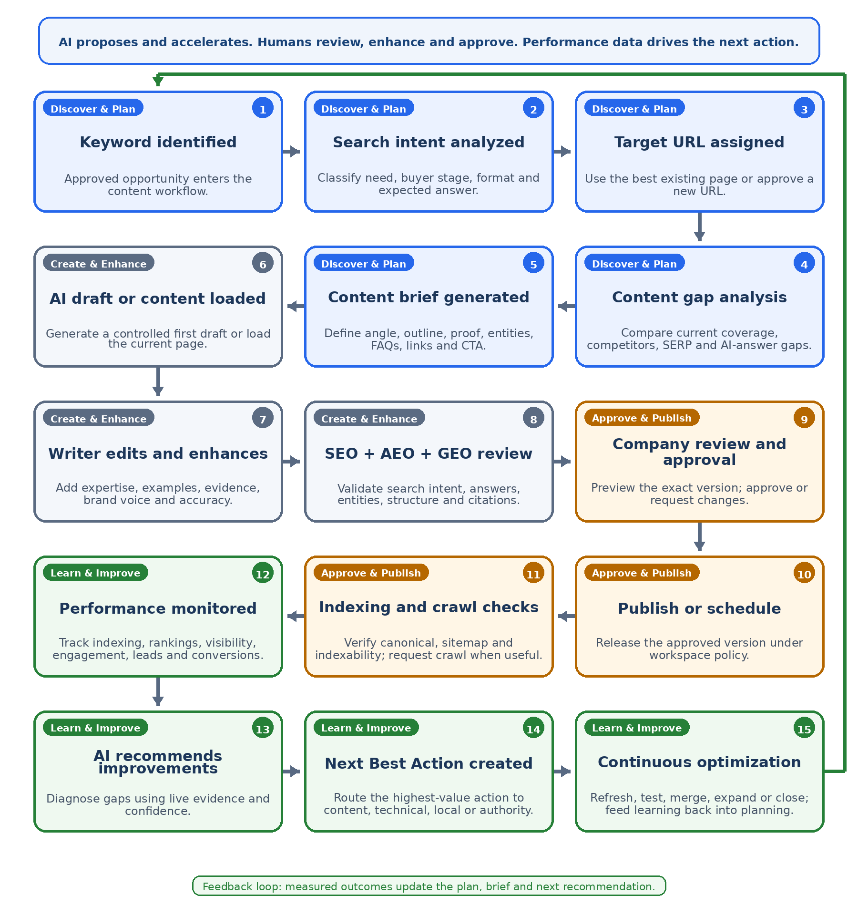
Figure 2. AI-guided SEO content workflow with Next Best Action and continuous optimization.
Phase | Required output | Human control
Discover & Plan | Intent classification, target URL decision, gap analysis and approved brief. | SEO Manager confirms evidence, route and page strategy.
Create & Enhance | AI-assisted draft or loaded content, followed by expert editing and SEO/AEO/GEO review. | Writer owns accuracy and brand voice; reviewer owns optimization quality.
Approve & Publish | Version-specific approval, scheduling/publication and discovery checks. | Company Approver controls the public version and release permission.
Learn & Improve | Performance evidence, AI diagnosis, Next Best Action and linked optimization work. | SEO Manager accepts, edits, dismisses or reroutes the recommendation.

4.8 Human Editing and AI-Assisted Specialist Review
AI may create a controlled first draft or load the current page for improvement, but the writer remains responsible for expertise, examples, evidence, factual accuracy and brand voice. The specialist then reviews the exact edited version for SEO, Answer Engine Optimization (AEO) and Generative Engine Optimization (GEO) requirements before it can move to company approval.

4.9 Company Approval, Publishing and Discovery
For approval-controlled workspaces, the approver previews the exact immutable version, approves it or requests changes. Approved content can be scheduled or published. After publication, the system verifies the live URL, canonical destination, indexability and sitemap presence, and may create a crawl or indexing request where the connected platform supports it and the action is appropriate.

4.10 Monitoring, Next Best Action and Continuous Optimization
Publishing starts the learning cycle. The system monitors indexing, rankings, AI-answer visibility where measurable, traffic, engagement, leads and conversions. AI diagnoses changes, proposes an evidence-based Next Best Action, and routes approved follow-up work into content, technical, local or authority execution. Content remains active until it is closed, merged, redirected or scheduled for future review.

4.11 Workflow Gates
Gate | Question | Allowed outcomes
G1 - Evidence | Is the finding supported by data and linked evidence? | Accept finding; request more data; dismiss with reason.
G2 - Strategy | Does the recommendation support an approved business objective? | Add to plan; backlog; reject; merge with another action.
G3 - Routing | What type of execution is actually required? | Technical, Content, Local/GBP, Citation/Review, Authority or Mixed.
G4 - SEO/AEO/GEO Review | Does the edited version meet the approved brief, factual, search, answer and generative-readiness requirements? | Submit for company approval; request specialist changes; return to brief.
G5 - Company Approval | Is the company willing to publish or deploy this exact version? | Approve; request changes; reject; approve with scheduled date.
G6 - Discovery | Is the published URL live, canonical, indexable and discoverable? | Confirm; request crawl/indexing; fix technical issue; rollback.
G7 - Outcome / Next Best Action | Did the action produce the expected result, and what is the highest-value next step? | Close; continue monitoring; optimize; merge/redirect; create routed follow-up action.

5. Workflow Decision and Routing Rules
The routing engine decides where a recommendation belongs. AI may propose a route, but a permitted user can change it before approval.
Finding or recommendation | Primary route | Create content-plan item? | Example
Missing or weak service page | SEO Content Plan | Yes | Create or update a commercial landing page.
Keyword cannibalization | SEO Content Plan + Technical | Usually | Merge content and add redirects/canonical changes.
Slow Core Web Vitals | Technical / Dev Plan | No | Optimize images, scripts and server performance.
Missing schema | Technical or On-page | Sometimes | Implement Organization, Service, LocalBusiness or Article schema.
Weak local grid caused by poor location relevance | SEO Content Plan | Yes | Create or improve a local service page with genuine local proof.
Weak local grid caused by incomplete GBP | Local / GBP Plan | No | Improve categories, services, attributes, photos and posts.
Weak local grid caused by inconsistent listings | Citation Plan | No | Correct NAP and improve citation coverage.
Weak local grid caused by low review prominence | Review Plan | No | Launch compliant review acquisition and response workflow.
Competitor authority gap | Authority Plan | Maybe | Digital PR, partnerships, linkable assets or case studies.
Content decay | SEO Content Plan | Yes | Refresh facts, sections, examples, links and conversion copy.
Mixed recommendation | Linked child actions | Only for content child | Create multiple execution items under one parent action.

Routing rule
Do not create a new page simply because a keyword exists. First cluster keywords by search intent and map each cluster to the best existing or planned URL.

6. Roles, Permissions and Approvals
Role | Primary responsibilities | Typical permissions
Platform Super Admin | Configure product defaults, templates, integrations and support access. | All workspaces; no client publishing unless explicitly granted.
Agency Admin | Manage clients, teams, report templates and workspace-level policies. | Create plans, assign work, submit and view approvals across assigned clients.
Company Admin / Approver | Approve strategy, content and deployment; manage company users. | Approve, request changes, reject, schedule and view all activity.
SEO Manager | Own strategy, audit, routing, priorities and SEO quality review. | Create/edit plans, assign, submit, comment and close work.
Content Strategist / Writer | Create briefs and drafts; respond to review comments. | Edit assigned content; submit for SEO review.
Developer | Implement technical SEO actions and attach deployment evidence. | Edit assigned technical tasks; submit for review.
Local SEO Specialist | Configure DEV-022, manage GBP/citations/reviews and local reports. | Run scans, create recommendations and complete local actions.
Viewer / Client Stakeholder | Review progress and reports without changing records. | Read-only access; optional comments.

6.1 Approval Policy Options
- No approval: authorized SEO users may publish or deploy after specialist review.
- Company approval required: every public content or production deployment requires company approval.
- Risk-based approval: minor metadata/internal-link changes can bypass company approval; new pages, major rewrites and production changes require approval.
- Agency plus company approval: agency lead approves first, then company approver approves the final version.

6.2 Approval Rules
- Approval applies to a specific immutable version. Any substantive edit after approval creates a new version and may require reapproval.
- Request Changes requires a comment and returns the item to the appropriate editing status.
- Rejection requires a reason and closes or returns the action based on permission.
- Approvers can delegate while out of office, but delegated approvals must be recorded in the audit history.
- Users cannot approve their own work when separation-of-duties policy is enabled.

7. Status Models and Activity History

7.1 SEO Plan Status
Draft -> Internal Review -> Pending Approval -> Approved -> In Progress -> Monitoring -> Completed

7.2 SEO Content Item Status
Planning: Identified -> Intent Analysis -> URL Mapping -> Gap Analysis -> Briefing
Production and learning: AI Draft / Content Loaded -> Human Editing -> SEO + AEO + GEO Review -> Company Approval -> Approved -> Scheduled / Published -> Discovery Check -> Monitoring -> Optimization Recommended -> Refresh Due

7.3 Technical or Local Task Status
Backlog -> Planned -> Assigned -> In Progress -> Review -> Approval -> Deployed -> Verified -> Done

7.4 Activity History
Every important action must create an immutable activity record containing timestamp, actor, workspace, entity, previous value, new value, related version, comment and source channel.
Event category | Examples
Planning | Plan created, objective changed, priority changed, target date changed.
AI Guidance | Intent analyzed, gap analysis generated, brief generated, AI draft created, recommendation accepted or edited.
Routing | Recommendation classified, child action created, route manually overridden.
Content | Brief created, draft updated, link added, metadata changed, version submitted.
Discovery | Live URL verified, canonical checked, sitemap detected, crawl requested, indexing confirmed or blocked.
Approval | Submitted, viewed, approved, changes requested, rejected or delegated.
Publication | Scheduled, published, deployment completed, URL changed or rollback performed.
DEV-022 | Scan configured, scan run, grid generated, competitor changed, report exported.
Measurement | Checkpoint generated, KPI updated, decline detected, AI diagnosis created, Next Best Action accepted, follow-up action created.

8. Master SEO Plan Specification

8.1 SEO Plan Header
Field | Description
Plan name | Human-readable name, normally including period or objective.
Workspace / Client | Business, Agency client or Ecommerce workspace.
Planning period | Start and end dates; quarterly is recommended.
Business goals | Organic leads, revenue, bookings, store visits, visibility or another measurable result.
Target markets | Countries, regions, cities, languages and service areas.
Approval policy | No approval, company approval, risk-based or agency plus company.
Plan owner | SEO Manager responsible for completion and reporting.
Plan status | Workflow status from Section 7.1.

8.2 SEO Plan Objectives
Objective field | Example
Objective | Increase qualified leads for custom software development services.
Baseline | Current clicks, rankings, leads, conversion rate and local visibility score.
Target | Target metric and target date.
Workstreams | Technical, content, local, authority and conversion optimization.
Dependencies | Analytics access, development capacity, GBP access, legal review or design.
Risk | Cannibalization, thin location pages, deployment delay or insufficient proof.
Success KPI | Non-branded clicks, form submissions, booked calls and target-market visibility.

8.3 SEO Plan Action Record
- Action ID
- Parent objective
- Source finding IDs
- Action title
- Action type
- Affected URLs/locations
- Evidence
- Priority
- Impact
- Confidence
- Effort
- Owner
- Dependencies
- Target date
- Approval requirement
- Expected outcome
- Primary KPI
- Status
- Child execution items
- Activity history

9. SEO Content Plan Specification

9.1 Content Plan Views
View | Purpose
Content Board | Kanban by workflow status.
Content Calendar | Planned, due, approved, scheduled and published dates.
Keyword Cluster View | Pillar page, secondary keywords and supporting content.
Target URL Map | One primary cluster per URL, with cannibalization warnings.
Approval Queue | Items awaiting SEO or company approval.
Performance View | 30/60/90-day outcomes, decay alerts and refresh recommendations.
Next Best Action View | Rank evidence-based improvement recommendations by expected impact, confidence, effort, urgency and route.

9.2 Required Content Item Fields
Field group | Required fields
Identity | Content ID, title, content type, workspace and parent SEO Plan action.
Targeting | Primary keyword, secondary keywords, cluster, search intent and buyer stage.
URL | Existing/new, target URL, parent/pillar page and canonical destination.
Brief | User question, recommended angle, outline, entities/topics, proof, FAQs and CTA.
Links | Required internal links, anchor guidance, source pages and destination pages.
Production | Owner, reviewer, approver, priority, due date and planned publish date.
Versioning | Current version, submitted version, approved version and comparison notes.
Performance | Baseline, publish date, checkpoints, ranking, traffic, engagement and conversion outcomes.
Intelligence | SERP snapshot, search intent, buyer stage, expected format, competitor coverage and content-gap evidence.
AI Guidance | AI action type, instruction/template version, generated draft or loaded source, confidence, warnings and user edits.
Optimization Review | SEO, AEO and GEO checklist results, reviewer notes, factual checks, evidence/provenance and approval readiness.
Discovery | Live URL, canonical, robots/noindex status, sitemap status, crawl/indexing request status and first confirmed discovery date.
Next Best Action | Trigger, evidence, diagnosis, recommended action, expected impact, confidence, effort, route, owner and decision status.

9.3 Content Quality Checks
- Search intent matches the target query and buyer stage.
- The target URL does not conflict with another page in the same keyword cluster.
- The content includes relevant experience, proof, examples or case-study evidence.
- Metadata, H1, headings and page copy are aligned without keyword stuffing.
- Internal links use descriptive anchors and support the cluster structure.
- FAQs are useful to users and are not included only for schema.
- The CTA matches the conversion goal.
- Local pages contain genuine location-specific value and are not city-name swaps.
- Claims, testimonials and regulated statements have the required company approval.
- Intent and page format are supported by current search-result and competitor evidence, not only by keyword wording.
- The draft answers important questions directly, uses clear headings and provides concise, extractable summaries where useful for AEO.
- Entities, products, services, locations and relationships are unambiguous, factually consistent and supported by verifiable proof for GEO.
- AI-generated statements, statistics, examples and claims are reviewed by a human and corrected or removed when they cannot be verified.
- The reviewer checks whether an existing page should be improved, merged or redirected before approving creation of a new URL.

9.4 AI-Guided Operating Principles
- Evidence before generation: intent, URL mapping and gap analysis must be completed before AI drafting begins.
- Reuse before creation: load and improve an existing page when it already owns the intent; do not generate a competing page by default.
- AI accelerates; humans own the outcome: writers and reviewers remain accountable for expertise, accuracy, tone, compliance and approval.
- Every AI recommendation must show evidence, confidence, expected impact and the proposed execution route.
- AI-generated drafts cannot bypass SEO/AEO/GEO review or the configured company approval policy.
- Publishing begins the optimization cycle; measured outcomes must be eligible to generate a new Next Best Action.

10. Approval Inbox and Notification Specification

10.1 Approval Inbox
The Approval Inbox is the source of truth for all records requiring action. It must be available from the main navigation and show an unread/pending badge.
Column or control | Requirement
Item | Title, type, workspace/client and parent plan objective.
Submitted by | User and role.
Submitted version | Exact version being approved.
Evidence | Finding, keyword, scan, screenshot/report or affected URL.
Due date | Approval SLA and overdue indicator.
Preview | Rendered page/draft preview and before/after comparison where available.
Actions | Approve, Request Changes, Reject, Comment and Open Full Item.
Filters | Client, type, priority, owner, due date, status and unread.
History | Previous comments, versions and decisions.

10.2 Notification Triggers
Trigger | Recipient | Default message/action
Plan submitted | Company approver | SEO Plan is ready for approval. Open the plan summary and evidence.
Content submitted | SEO reviewer or company approver | Content item is ready for review or publication approval.
Changes requested | Owner and plan manager | Changes were requested. Open comments and create a new version.
Approval completed | Owner, plan manager and scheduler | Approved version is ready to schedule, publish or deploy.
Approval due soon | Current approver | Approval is due within the configured reminder window.
Approval overdue | Approver and escalation recipient | Approval is overdue and blocking execution.
Significant rank movement | SEO manager and configured stakeholders | Ranking improved or declined beyond the configured threshold.
DEV-022 weak-area change | Local SEO specialist and SEO manager | Geographic visibility changed and recommendations are available.
Publish or deployment complete | Stakeholders | Action is live; measurement checkpoints have been scheduled.
Refresh due | Content owner and SEO manager | Performance or age threshold requires a content review.
AI brief ready | Content owner and SEO manager | Intent, URL decision, gap analysis and draft brief are ready for human review.
Discovery issue detected | SEO manager and technical owner | Published content is not reachable, canonical, indexable or discoverable as expected.
Next Best Action ready | SEO manager and configured approver | A performance-based recommendation is ready to accept, edit, dismiss or route.

10.3 Notification Channels
- In-app notification bell with unread count and deep link.
- Approval Inbox badge and dashboard widget.
- Email for submission, overdue, major movement and final approval events.
- Optional Slack or Microsoft Teams integration for configured workspaces.
- Digest mode for low-priority reminders; immediate mode for blockers and significant declines.

11. Reporting, Next Best Action and Continuous Optimization
Checkpoint | Review focus | Possible result
Post-publish: 0-7 days | Verify live rendering, canonical, indexability, sitemap/discovery status and analytics tracking. | Confirm discovery; request crawl/indexing where applicable; create technical fix or rollback.
Pre-publish / Pre-deploy | Capture baseline ranking, traffic, conversions, grid visibility and technical state. | Baseline stored.
30 days | Indexing, early ranking movement, answer visibility where measurable, grid changes, engagement and obvious issues. | Continue, fix discovery, improve internal links, adjust metadata or create a targeted Next Best Action.
60 days | Trend stability, query coverage, competitor movement and lead quality. | Optimize sections, add proof, strengthen AEO/GEO structure, improve authority or expand supporting content.
90 days | Business impact and strategic outcome. | Close successful action, accept a new Next Best Action, merge/redirect, refresh or change strategy.
Recurring | Content decay, technical regression, competitor change and local visibility shifts. | Create refresh, technical, local or authority follow-up.

11.1 Dashboard Metrics
Category | Metrics
Plan delivery | Actions planned, in progress, blocked, overdue and completed.
Content delivery | Intent analyses, URL decisions, gap analyses, briefs, AI drafts, human edits, reviews, approvals, published items and refresh due.
Approval | Pending, average approval time, changes requested and overdue.
SEO outcomes | Indexing/discovery, rankings, non-branded clicks, answer visibility where measurable, organic leads, conversion rate and target-page performance.
Local outcomes | Average grid rank, share of top-3/top-10 points, competitor visibility and weak-area count.
Quality | Cannibalization warnings, thin pages, unresolved technical issues and content decay.
Optimization intelligence | Next Best Actions created, accepted, edited, dismissed, completed and outcome lift by recommendation type.

11.2 Next Best Action Model
The Next Best Action engine converts measured evidence into one prioritized recommendation rather than presenting an unranked list of suggestions. The recommendation is advisory until an authorized user accepts, edits, dismisses or reroutes it.
Observed evidence | Possible diagnosis | Example Next Best Action | Route
Published but not discovered | Indexability, canonical, sitemap or rendering issue. | Run discovery checks and create the highest-confidence technical fix. | Technical / Dev
High impressions, low click-through rate | Search snippet or intent mismatch. | Test title and description while preserving page intent. | SEO Content
Ranking positions 4-10 with weak proof | Page is relevant but lacks authority, evidence or internal support. | Add original proof, stronger internal links or a supporting case study. | Content + Authority
Traffic grows but conversions remain weak | CTA, offer or buyer-stage mismatch. | Improve conversion path and align the page action with user intent. | Content / CRO
AI-answer visibility is weak | Answers, entities, structure or provenance are unclear. | Add direct answers, clear entity context, verified facts and extractable summaries. | SEO Content
DEV-022 weak geographic areas | Local relevance, GBP, citation, review or proximity gap. | Create the highest-confidence local action and route it correctly. | Local / Mixed
Next Best Action rule: the recommendation must reference the source evidence, expected impact, confidence, estimated effort, owner and route. It must never publish or deploy automatically unless the workspace policy explicitly permits that action.

12. Example: Custom Software Development Cluster
The following example converts the user-provided keyword list into a non-cannibalizing content cluster and workflow.
Page / asset | Primary target | Secondary targets | Action
/custom-software-development/ | Custom software development | Custom software solutions; custom software development company; best custom software development | Optimize existing or best-matched main service page.
/custom-software-development-toronto/ | Custom software development Toronto | Toronto custom software company; software developers Toronto | Create or improve a genuinely Toronto-specific local service page.
Cost guide | Custom software development cost | Software development pricing Canada | Create supporting commercial-investigation article.
Comparison guide | Custom software vs off-the-shelf | Build vs buy software | Create supporting article linked to main service page.
Selection guide | How to choose a custom software company | Best custom software development company | Create buyer guide; avoid separate thin best-keyword landing page.
Case study | Custom software development case study | Relevant industry/problem query | Create proof asset and link to commercial pages.

12.1 Example Workflow
- Keyword Intelligence clusters the five phrases by search intent and identifies the commercial and Toronto-local groups.
- Search intent analysis confirms the buyer stage, expected page type, key questions and conversion action for each cluster.
- The Target URL Map assigns the commercial cluster to the main service page and the local cluster to the Toronto page.
- The system compares each target URL with current results, competitors and existing content to produce a gap analysis.
- The SEO Manager creates one parent objective and separate approved page actions.
- AI generates structured briefs containing angle, outline, proof requirements, entities, FAQs, internal links and CTA.
- For an existing page, the current content is loaded; for an approved new page, AI may create a controlled first draft.
- The writer edits and enhances the content with company expertise, examples, case-study evidence, accuracy and brand voice.
- The SEO reviewer completes the SEO, AEO and GEO review, including intent, cannibalization, direct answers, entities, proof, links and CTA.
- The Company Approver receives a deep-linked notification and reviews the exact immutable version.
- After approval, the content is scheduled or published under the configured workspace policy.
- The system verifies the live URL, canonical, indexability, sitemap presence and tracking, and requests discovery where applicable.
- Performance is measured at the post-publish, 30-day, 60-day, 90-day and recurring checkpoints.
- AI diagnoses performance and creates one evidence-based Next Best Action with impact, confidence, effort and route.
- An authorized user accepts, edits, dismisses or reroutes the recommendation, creating the next optimization cycle only where evidence supports it.

13. DEV-022 - Local SEO Grid & Heatmap Tracking
Specification field | Value
Document | Local SEO Grid & Heatmap Tracking Specification
Product | SEnuke AI Developer Implementation Manual
Version | 1.0
Priority | P1
Dependencies | Keyword Intelligence, Site Analysis and Rank Tracking
Applies to | Business, Agency and Ecommerce Workspaces

13.1 Purpose
Show how a business ranks across different geographic locations instead of presenting only one ranking. Help users identify strong and weak service areas, compare competitors and create traceable improvement actions.

13.2 Features
- Local ranking grid.
- Map heatmap.
- Competitor comparison.
- Historical trends.
- Location-based reports.
- AI recommendations linked to SEO Plan actions.
- Significant-movement notifications.
- Full activity and configuration history.

13.3 Inputs
Input | Requirement
Business Location | Address or verified center point; may be imported from connected GBP.
Target Markets | Service area polygon, radius, city/region selection or approved set of coordinates.
Google Business Profile | Optional connection used for business identity and optimization context.
Approved Keywords | Only tracked keywords approved for the workspace and selected market.
Competitors | Named local competitors or businesses selected from observed results.
Grid Settings | Grid size, distance/radius, device, language, search engine and schedule.

13.4 Grid Behaviour
- User selects a keyword and service area.
- SEnuke AI creates or loads the configured set of geographic scan points.
- The system checks local rankings from each point and stores rank, timestamp, coordinates, observed business and competitors.
- The UI displays results as a color-coded grid with a clear legend and accessible numeric labels.
- Users can change keyword, date, competitor and scan configuration without losing historical records.
- Failed scan points are marked as unavailable and can be retried; they must not be silently treated as weak rankings.

13.5 Heatmap
Display strong, average and weak ranking areas using configurable thresholds. Colors must always be paired with rank numbers, labels or patterns so that the result remains understandable without color alone.
Default classification | Example threshold | Meaning
Strong | Positions 1-3 | High local visibility.
Competitive | Positions 4-10 | Visible but improvement opportunity exists.
Weak | Positions 11-20 | Low first-page visibility.
Not visible | Beyond tracking depth | Business not found within configured depth.
Unavailable | Scan failed or no reliable result | Retry or investigate data collection.

13.6 AI Behaviour and Action Routing
DEV-022 recommendations must use the same Next Best Action model as the wider platform. The system diagnoses the geographic pattern, shows supporting grid and competitor evidence, estimates confidence and impact, and recommends the single highest-value route. The recommendation remains advisory until accepted or changed by a permitted user.
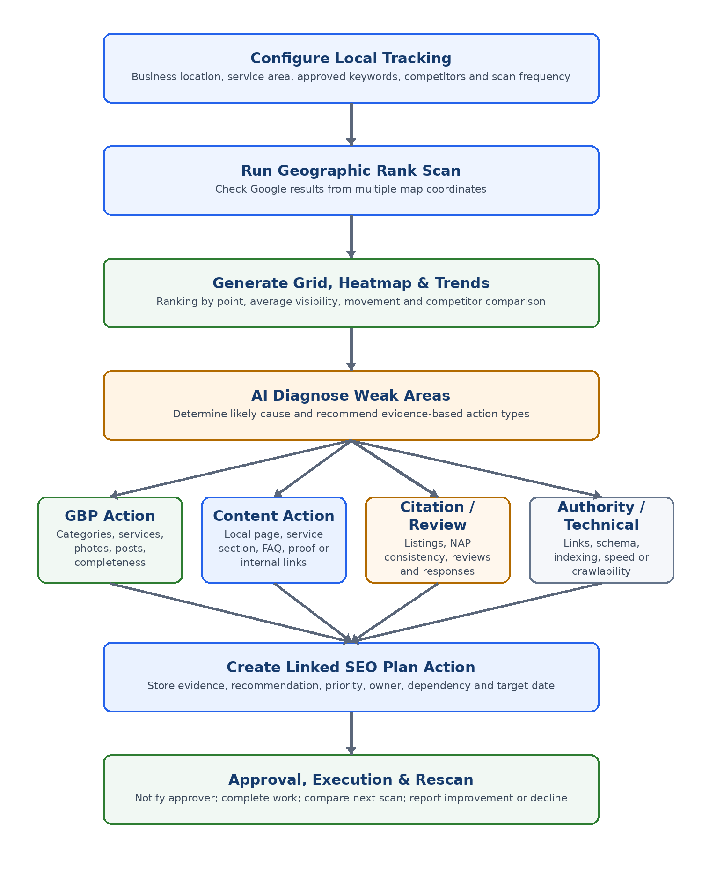
Figure 3. DEV-022 evidence-to-action workflow.
Detected pattern | Likely recommendation | Execution route
Weak near business location | Improve GBP completeness, categories and services; validate listing consistency. | Local / GBP or Citation Plan.
Strong near location but weak at service-area edges | Improve geographic relevance with useful local sections/pages and local proof. | SEO Content Plan.
Competitor consistently outranks across grid | Compare GBP, reviews, citations, page relevance, authority and proximity limitations. | Mixed child actions.
Sudden broad decline | Check GBP status, site changes, indexing, competitors and ranking volatility. | Investigation action; do not auto-publish.
Weak points align with crawl/index issues | Fix technical accessibility or target-page indexability. | Technical / Dev Plan.
Improvement after completed action | Attribute carefully, record correlation and continue scheduled scans. | Monitoring and reporting.

13.7 Reports
- Export heatmaps as image or PDF-ready report component.
- Include keyword, date, service area, grid settings, legend, average rank, top-3 share, top-10 share and competitor comparison.
- Support Agency client report templates and white-label branding where licensed.
- Report data coverage and failed points; do not imply complete data when scans are missing.
- Allow current-period and historical comparison views.

13.8 Notifications
- Notify configured users when average grid rank or top-3/top-10 point share changes beyond threshold.
- Notify when a significant number of points move from visible to not visible or vice versa.
- Notify when a configured scan repeatedly fails.
- Deep-link notifications to the exact keyword, scan date and comparison view.
- Allow immediate, daily digest or weekly digest delivery.

13.9 Activity History
- Scan created, started, completed, partially completed, failed or retried.
- Keyword, competitor, service area, grid size or schedule changed.
- Heatmap/report generated or exported.
- AI recommendation created, edited, dismissed, accepted or routed.
- SEO Plan action and child execution item created from recommendation.

13.10 DEV-022 Data Objects
Object | Minimum fields
Local Tracking Project | workspace_id, business_location, target_market, settings, status, created_by.
Grid Configuration | grid_size, spacing/radius, center, coordinates, device, language, engine, depth.
Tracked Keyword | keyword_id, approval_status, market, active dates and schedule.
Local Scan | scan_id, configuration_version, started_at, completed_at, status and coverage.
Scan Point Result | coordinate, rank, business result, competitor results, URL, confidence and error state.
Heatmap Summary | average rank, median rank, top-3 share, top-10 share, not-visible share and weak-area clusters.
AI Recommendation | evidence, diagnosis, confidence, action type, priority and linked plan action.
Movement Alert | metric, previous value, current value, threshold, recipients and delivery status.

13.11 DEV-022 Definition of Done
- Users can configure a keyword and service area and successfully run a multi-point local ranking scan.
- Users can view numeric grid results, a readable heatmap, competitors and historical comparison.
- The platform distinguishes weak, not-visible and unavailable points.
- AI recommendations include evidence and route to the correct SEO Plan workstream.
- Content recommendations can create prefilled SEO Content Plan items linked to the parent action.
- Users can export heatmaps and include them in Agency reports.
- Significant improvements and declines create configurable notifications.
- Scans, exports, settings and action creation appear in activity history.
- Completed actions can be compared against later scans to evaluate outcome.

14. Functional Requirements
Requirement ID | Requirement | Priority
SEO-FR-001 | Create, edit, version and approve a master SEO Plan. | P1
SEO-FR-002 | Create objectives and workstream actions linked to evidence and KPIs. | P1
SEO-FR-003 | Route approved actions into technical, content, local, citation/review or authority workstreams. | P1
SEO-FR-004 | Create linked child actions when a recommendation requires multiple workstreams. | P1
SEO-FR-005 | Maintain keyword clusters and target-URL mappings with cannibalization warnings. | P1
SEO-FR-006 | Manage content from intent analysis and URL assignment through AI-assisted drafting, human editing, review, publication, discovery and monitoring. | P1
SEO-FR-007 | Provide version-specific SEO and company approvals. | P1
SEO-FR-008 | Provide Approval Inbox, notification bell, dashboard counts and deep links. | P1
SEO-FR-009 | Record complete activity history for plans, content, approvals and publishing. | P1
SEO-FR-010 | Create post-publish, 30/60/90-day and recurring measurement checkpoints with evidence-based Next Best Actions. | P1
SEO-FR-013 | Analyze and store search intent, buyer stage and expected content format before drafting. | P1
SEO-FR-014 | Assign an existing or approved new target URL and warn about cannibalization before content generation. | P1
SEO-FR-015 | Generate a traceable content-gap analysis and structured brief from approved evidence. | P1
SEO-FR-016 | Create an editable AI draft or load existing content while preserving source and version history. | P1
SEO-FR-017 | Provide structured SEO, AEO and GEO review checklists with human reviewer decisions. | P1
SEO-FR-018 | Verify live publication, canonical, indexability, sitemap and discovery status. | P1
SEO-FR-019 | Generate evidence-based Next Best Actions with impact, confidence, effort, route and decision status. | P1
SEO-FR-020 | Create linked follow-up actions from accepted Next Best Actions and preserve the optimization loop. | P1
SEO-FR-011 | Support Business, Agency and Ecommerce workspace permissions. | P1
SEO-FR-012 | Export plan, content calendar, approval history and outcome reports. | P2
DEV-022-FR-001 | Configure and run geographic rank-grid scans. | P1
DEV-022-FR-002 | Render numeric grid, heatmap, competitors and history. | P1
DEV-022-FR-003 | Generate evidence-based AI diagnoses and routed actions. | P1
DEV-022-FR-004 | Export heatmaps and add them to Agency reports. | P1
DEV-022-FR-005 | Notify significant local visibility improvements, declines and scan failures. | P1

15. Non-Functional Requirements
Area | Requirement
Security | Enforce workspace isolation, least privilege, approval permissions and secure integration credentials.
Auditability | Preserve version history, actor, timestamp, source and before/after values for material events.
Reliability | Use retryable scan jobs; distinguish failed data collection from poor ranking.
Performance | Load normal plan, board and approval views within acceptable interactive latency; paginate large histories.
Accessibility | Support keyboard operation, visible focus, text labels and non-color-only heatmap interpretation.
Data quality | Display scan coverage, timestamp, configuration version and confidence where applicable.
Explainability | AI briefs, drafts, diagnoses and Next Best Actions must show source evidence, reasoning summary, confidence, warnings, proposed route and human decision history.
Configurability | Thresholds, approval policies, notification channels, scan schedules and report branding are workspace-configurable.
Privacy | Store only required location and integration data; respect provider access controls and retention settings.
Extensibility | Use linked entities and events so future AI search visibility, social, reputation or additional rank engines can reuse the workflow.

16. Definition of Done and Acceptance Checklist
- ☐ A new workspace can configure goals, markets, roles and approval policy.
- ☐ The system can collect or import baseline evidence and create findings.
- ☐ An SEO Manager can create a master SEO Plan with objectives and prioritized actions.
- ☐ A Company Approver can approve, request changes or reject a specific plan version.
- ☐ Approved actions route correctly and create linked execution items.
- ☐ Content items include keyword cluster, target URL, brief, owner, dates, review and approval data.
- ☐ Technical, GBP, citation/review and authority tasks remain outside the Content Plan unless they include a content child action.
- ☐ Approval Inbox, bell notifications and dashboard summaries show pending and overdue work.
- ☐ All material actions appear in activity history.
- ☐ Publishing or deployment captures baseline and schedules measurement checkpoints.
- ☐ 30/60/90-day reviews can close, optimize or create follow-up work.
- ☐ DEV-022 scans produce geographic results, heatmaps, competitor comparison, reports, alerts and routed recommendations.
- ☐ Agency users can manage multiple clients without cross-client data exposure.
- ☐ Exports and reports accurately disclose dates, configuration and data coverage.
- ☐ Acceptance testing validates permissions, status transitions, notifications, version-specific approval and rollback paths.
- ☐ Content cannot enter drafting until intent, target URL and content-gap records are complete or explicitly waived with reason.
- ☐ AI drafts remain editable, versioned and subject to human SEO/AEO/GEO review and configured company approval.
- ☐ Publication creates discovery checks and does not mark the item complete merely because a URL is live.
- ☐ Performance evidence can generate a ranked Next Best Action that users can accept, edit, dismiss or reroute.
- ☐ Accepted Next Best Actions create linked follow-up work and preserve traceability to the original plan, content and outcome.
Final acceptance principle
The implementation is complete only when a user can move from evidence to approved plan, correct workstream execution, AI-assisted but human-controlled production, publication/deployment, discovery verification, measurable outcome and an evidence-based Next Best Action without losing the relationship between records.

Appendix A - Recommended Product Navigation
Navigation item | Primary content
Dashboard | Goals, plan health, pending approvals, discovery issues, Next Best Actions, alerts, delivery and outcome KPIs.
SEO Plan | Objectives, workstreams, roadmap, actions, dependencies and approvals.
Content Plan | Intent analysis, URL map, gap analysis, AI-assisted briefs/drafts, board, calendar, SEO/AEO/GEO review, approvals, performance and Next Best Actions.
Technical SEO | Site issues, technical actions, deployments and verification.
Local SEO | GBP, DEV-022 grids/heatmaps, citations, reviews and local reports.
Authority | Backlinks, mentions, campaigns and linkable assets.
Approvals | All records requiring review or company decision.
Reports | Plan, execution, local heatmap, content and outcome reports.
Activity | Workspace-wide immutable history.
Settings | Integrations, roles, policies, thresholds, notifications and branding.

Appendix B - Suggested Dashboard Approval Widget
Metric | Example display
Pending approvals | 7
Overdue approvals | 2
High-priority blockers | 1
Approved this month | 12
Average approval time | 1.8 days
DEV-022 significant declines | 3 keywords

Appendix C - Implementation Event Examples
Event name | When emitted
seo_plan.submitted | Plan version enters Pending Approval.
seo_plan.approved | Approver approves plan version.
seo_action.routed | Action route or mixed child routes are confirmed.
content_item.submitted | Human-edited draft enters SEO/AEO/GEO Review or Company Approval.
content_item.approved | Exact content version is approved.
content_item.published | URL becomes live or publication is confirmed.
local_scan.completed | DEV-022 scan completes with coverage summary.
local_visibility.changed | Movement exceeds configured threshold.
recommendation.action_created | AI recommendation creates linked plan action.
measurement.checkpoint_due | Post-publish, 30/60/90-day or recurring review becomes due.
content_intent.analyzed | Search intent and expected format are saved for a content item.
content_gap.completed | Gap analysis is completed and linked evidence is stored.
content_brief.generated | AI-assisted brief is created or regenerated.
content_draft.ai_created | AI draft is created or current content is loaded for enhancement.
content_review.completed | SEO/AEO/GEO review is completed for a specific version.
content_discovery.checked | Live URL, canonical, indexability, sitemap and discovery status are recorded.
next_best_action.created | Performance evidence produces a ranked AI recommendation.
next_best_action.decided | Authorized user accepts, edits, dismisses or reroutes the recommendation.

