**BÁO CÁO BÀI TẬP LÝ THUYẾT**

1. **Thông tin chung**
2. *Họ tên: Đỗ Thế Nhuận Mã sinh viên: 2021600381*
3. *Lớp:20231IT6029002 Khóa: 16*
4. *Học phần: Phát triển ứng dụng trên thiết bị di dộng*
5. *Bài học: Thực hành xử lý sự kiện trên giao diện ứng dụng*

***Bài 4.2:***

***MainActivity***

package com.example.bai24b_49_dothenhuan;  
  
import androidx.appcompat.app.AppCompatActivity;  
  
import android.os.Bundle;  
import android.view.View;  
import android.widget.Button;  
import android.widget.EditText;  
import android.widget.TextView;  
  
public class MainActivity extends AppCompatActivity {  
 Button convert;  
 EditText inputYear;  
 TextView result;  
  
 String can[] = {"Canh", "Tân", "Nhân", "Qúy", "Gíap", "Ất", "Bính", "Đinh", "Mậu", "Kỷ"};  
 String chi[] = {"Thân", "Dậu", "Tuất", "Hợi", "Tý", "Sử", "Dần", "Mão", "Thì", "Tỵ", "Ngọ", "Mùi"};  
  
 @Override  
 protected void onCreate(Bundle savedInstanceState) {  
 super.onCreate(savedInstanceState);  
 setContentView(R.layout.*activity_main*);  
  
 convert = (Button) findViewById(R.id.*convert*);  
 inputYear = (EditText) findViewById(R.id.*inputYear*);  
 result = (TextView) findViewById(R.id.*outputResult*);  
 convert.setOnClickListener(new DoSomeThing());  
 }  
  
  
 protected class DoSomeThing implements View.OnClickListener {  
  
 @Override  
 public void onClick(View view) {  
 if (view.getId() == R.id.*convert*) {  
 int year = Integer.*parseInt*(inputYear.getText() + "");  
 result.setText("" + can[year % 10] +" "+ chi[year % 12]);  
 }  
 }  
 }  
  
}

***XML:***<?xml version="1.0" encoding="utf-8"?>  
<LinearLayout xmlns:android="http://schemas.android.com/apk/res/android"  
 xmlns:app="http://schemas.android.com/apk/res-auto"  
 xmlns:tools="http://schemas.android.com/tools"  
 android:layout_width="match_parent"  
 android:layout_height="match_parent"  
 android:orientation="vertical"  
 tools:context=".MainActivity">  
  
 <TextView  
 android:id="@+id/heading"  
 android:layout_width="match_parent"  
 android:layout_height="wrap_content"  
 android:background="#009688"  
 android:gravity="center"  
 android:text="Chuyển đổi năm dương lịch"  
 android:textColor="@color/white"  
 android:textSize="20sp" />  
  
 <LinearLayout  
 android:layout_width="match_parent"  
 android:layout_height="wrap_content"  
 android:orientation="horizontal"  
 android:weightSum="3">  
  
 <TextView  
 android:id="@+id/year"  
 android:layout_width="0dp"  
 android:layout_height="wrap_content"  
 android:layout_weight="1"  
 android:text="Năm dương lịch:" />  
  
 <EditText  
 android:id="@+id/inputYear"  
 android:layout_width="0dp"  
 android:layout_height="wrap_content"  
 android:layout_weight="2"  
 android:ems="10"  
 android:inputType="text"  
 android:hint="Year" />  
 </LinearLayout>  
  
 <LinearLayout  
 android:layout_width="match_parent"  
 android:layout_height="wrap_content"  
 android:orientation="horizontal"  
 android:weightSum="3"  
 android:gravity="right">  
  
 <Button  
 android:id="@+id/convert"  
 android:layout_width="0dp"  
 android:layout_height="wrap_content"  
 android:layout_weight="2"  
 android:text="Chuyển đổi" />  
 </LinearLayout>  
  
 <LinearLayout  
 android:layout_width="match_parent"  
 android:layout_height="wrap_content"  
 android:orientation="horizontal"  
 android:weightSum="3">  
  
 <TextView  
 android:id="@+id/result"  
 android:layout_width="0dp"  
 android:layout_height="wrap_content"  
 android:text="Năm âm lịch:"  
 android:layout_weight="1"/>  
  
 <TextView  
 android:id="@+id/outputResult"  
 android:layout_width="0dp"  
 android:layout_height="wrap_content"  
 android:layout_weight="2"  
 android:background="#FFEB3B"  
 android:text="Result"  
 android:padding="8dp"/>  
 </LinearLayout>  
</LinearLayout>

***Kết quả:***

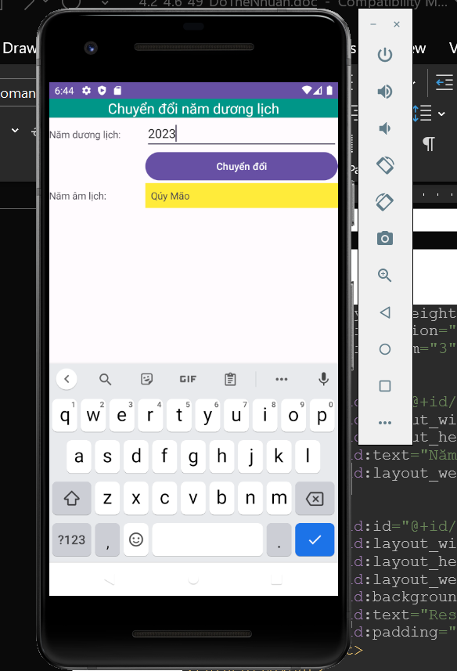

***Bài 4.3:***

package com.example.bai24c_49_dothenhuan;  
  
import androidx.appcompat.app.AppCompatActivity;  
  
import android.os.Bundle;  
import android.view.View;  
import android.widget.Button;  
import android.widget.EditText;  
  
public class MainActivity extends AppCompatActivity {  
 Button button;  
 EditText inputHeigh, inputWeigh, result, diagnostic;  
  
 View.OnClickListener listener = new View.OnClickListener() {  
 @Override  
 public void onClick(View view) {  
 if (view == button) {  
 double res = (Integer.*parseInt*(inputWeigh.getText() + "")) / (Math.*pow*((Double.*parseDouble*(inputHeigh.getText() + "")), 2));  
 res = Math.*round*(res * 10.0) / 10.0;  
 result.setText(res + "");  
 diagnostic.setText(check(res));  
 }  
 }  
  
 public String check(Double res) {  
 if (res < 18) return "Người gầy";  
 if (res < 24.9 && res > 18) return "Người bình thường";  
 if (res > 25 && res < 29.9) return "Người béo phì độ 1";  
 if (res > 30 && res < 34.9) return "Người béo phì độ 2";  
 return "Người béo phì độ 3";  
 }  
  
 ;  
  
  
 };  
  
 @Override  
 protected void onCreate(Bundle savedInstanceState) {  
 super.onCreate(savedInstanceState);  
 setContentView(R.layout.*activity_main*);  
 getWidget();  
 button.setOnClickListener(listener);  
 }  
  
 private void getWidget() {  
 button = (Button) findViewById(R.id.*button*);  
 inputHeigh = (EditText) findViewById(R.id.*inputHeigh*);  
 inputWeigh = (EditText) findViewById(R.id.*inputWeight*);  
 result = (EditText) findViewById(R.id.*outputResult*);  
 diagnostic = (EditText) findViewById(R.id.*outputDiagnostic*);  
 }  
}

***XML:***<?xml version="1.0" encoding="utf-8"?>  
<LinearLayout xmlns:android="http://schemas.android.com/apk/res/android"  
 xmlns:app="http://schemas.android.com/apk/res-auto"  
 xmlns:tools="http://schemas.android.com/tools"  
 android:layout_width="match_parent"  
 android:layout_height="match_parent"  
 android:orientation="vertical"  
 tools:context=".MainActivity">  
  
 <TextView  
 android:id="@+id/heading"  
 android:layout_width="match_parent"  
 android:layout_height="wrap_content"  
 android:background="#009688"  
 android:gravity="center"  
 android:text="Chương trình tính chỉ số IBM"  
 android:textColor="@color/white"  
 android:textSize="20sp" />  
  
 <LinearLayout  
 android:layout_width="match_parent"  
 android:layout_height="wrap_content"  
 android:orientation="horizontal"  
 android:weightSum="3">  
  
 <TextView  
 android:id="@+id/username"  
 android:layout_width="0dp"  
 android:layout_height="wrap_content"  
 android:layout_weight="1"  
 android:text="Nhập tên:" />  
  
 <EditText  
 android:id="@+id/inputUsername"  
 android:layout_width="0dp"  
 android:layout_height="wrap_content"  
 android:layout_weight="2"  
 android:ems="10"  
 android:inputType="text"  
 android:hint="Name" />  
 </LinearLayout>  
  
 <LinearLayout  
 android:layout_width="match_parent"  
 android:layout_height="wrap_content"  
 android:orientation="horizontal"  
 android:weightSum="3">  
  
 <TextView  
 android:id="@+id/heigh"  
 android:layout_width="0dp"  
 android:layout_height="wrap_content"  
 android:layout_weight="1"  
 android:text="Chiều cao:" />  
  
 <EditText  
 android:id="@+id/inputHeigh"  
 android:layout_width="0dp"  
 android:layout_height="wrap_content"  
 android:layout_weight="2"  
 android:ems="10"  
 android:inputType="text"  
 android:hint="Heigh" />  
 </LinearLayout>  
  
 <LinearLayout  
 android:layout_width="match_parent"  
 android:layout_height="wrap_content"  
 android:orientation="horizontal"  
 android:weightSum="3">  
  
 <TextView  
 android:id="@+id/weight"  
 android:layout_width="0dp"  
 android:layout_height="wrap_content"  
 android:layout_weight="1"  
 android:text="Cân nặng:" />  
  
 <EditText  
 android:id="@+id/inputWeight"  
 android:layout_width="0dp"  
 android:layout_height="wrap_content"  
 android:layout_weight="2"  
 android:ems="10"  
 android:inputType="text"  
 android:hint="Weight" />  
 </LinearLayout>  
  
 <Button  
 android:id="@+id/button"  
 android:layout_width="match_parent"  
 android:layout_height="wrap_content"  
 android:text="Tính IBM" />  
  
 <LinearLayout  
 android:layout_width="match_parent"  
 android:layout_height="wrap_content"  
 android:orientation="horizontal"  
 android:weightSum="3">  
  
 <TextView  
 android:id="@+id/result"  
 android:layout_width="0dp"  
 android:layout_height="wrap_content"  
 android:layout_weight="1"  
 android:text="BMI=" />  
  
 <EditText  
 android:id="@+id/outputResult"  
 android:layout_width="0dp"  
 android:layout_height="wrap_content"  
 android:layout_weight="2"  
 android:ems="10"  
 android:hint="result"  
 android:inputType="text" />  
 </LinearLayout>  
  
 <LinearLayout  
 android:layout_width="match_parent"  
 android:layout_height="wrap_content"  
 android:orientation="horizontal"  
 android:weightSum="3">  
  
 <TextView  
 android:id="@+id/diagnostic"  
 android:layout_width="0dp"  
 android:layout_height="wrap_content"  
 android:layout_weight="1"  
 android:text="Chuẩn đoán:" />  
  
 <EditText  
 android:id="@+id/outputDiagnostic"  
 android:layout_width="0dp"  
 android:layout_height="wrap_content"  
 android:layout_weight="2"  
 android:ems="10"  
 android:hint="Diagnostic"  
 android:inputType="text" />  
 </LinearLayout>  
</LinearLayout>

***Chạy chương trình:***

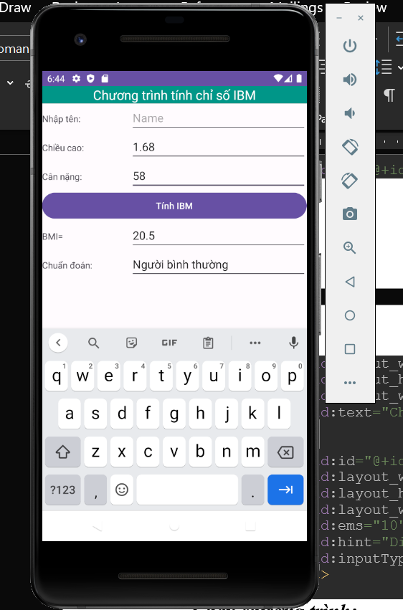

***Bài 4.4***

***mainActivity:***

package com.example.bai24d_49_dothenhuan;  
  
import androidx.appcompat.app.AlertDialog;  
import androidx.appcompat.app.AppCompatActivity;  
  
import android.content.DialogInterface;  
import android.os.Bundle;  
import android.view.View;  
import android.widget.Button;  
import android.widget.CheckBox;  
import android.widget.EditText;  
import android.widget.RadioButton;  
import android.widget.RadioGroup;  
import android.widget.Toast;  
  
public class MainActivity extends AppCompatActivity {  
 EditText inputName, inputCMND, inputSubInfo;  
 Button button;  
  
 CheckBox interest_1, interest_2, interest_3;  
  
  
 @Override  
 protected void onCreate(Bundle savedInstanceState) {  
 super.onCreate(savedInstanceState);  
 setContentView(R.layout.*activity_main*);  
 inputName = findViewById(R.id.*inputName*);  
 inputCMND = findViewById(R.id.*inputCMND*);  
 inputSubInfo = findViewById(R.id.*inputSubInfo*);  
 interest_1 = findViewById(R.id.*interest_1*);  
 interest_2 = findViewById(R.id.*interest_2*);  
 interest_3 = findViewById(R.id.*interest_3*);  
  
 button = findViewById(R.id.*button*);  
  
 button.setOnClickListener(new View.OnClickListener() {  
 @Override  
 public void onClick(View view) {  
 doShowInformation();  
 }  
 });  
  
 }  
  
 public void doShowInformation() {  
 String name = inputName.getText() + "";  
 name = name.trim();  
 if (name.length() < 3) {  
 inputName.requestFocus();  
 inputName.selectAll();  
 Toast.*makeText*(this, "Tên phải lớn hơn 3 ký tự", Toast.*LENGTH_LONG*).show();  
 return;  
 }  
  
 String level = "";  
 RadioGroup group = (RadioGroup) findViewById(R.id.*levelGroup*);  
 int id = group.getCheckedRadioButtonId();  
 if (id == -1) {  
 Toast.*makeText*(this, "Phải chọn bằng cấp", Toast.*LENGTH_LONG*).show();  
 return;  
 }  
  
 RadioButton rad = (RadioButton) findViewById(id);  
 level = rad.getText() + "";  
  
 String likely = "";  
  
 if (interest_1.isChecked()) {  
 likely += interest_1.getText() + "\n";  
 }  
 if (interest_2.isChecked()) {  
 likely += interest_2.getText() + "\n";  
 }  
 if (interest_3.isChecked()) {  
 likely += interest_3.getText() + "\n";  
 }  
  
 String subInfo = inputSubInfo.getText()+"\n";  
 AlertDialog.Builder builder = new AlertDialog.Builder(this);  
  
 builder.setTitle("Thông tin cá nhân");  
 builder.setPositiveButton("Dong", new DialogInterface.OnClickListener() {  
 @Override  
 public void onClick(DialogInterface dialogInterface, int i) {  
 dialogInterface.cancel();  
 }  
 });  
  
 String msg = name+"\n";  
 msg+= inputCMND.getText()+"\n";  
 msg+=level+"\n";  
 msg+=likely+"\n";  
 msg+="-------------------------\n";  
 msg+="Thong tin bo sung\n";  
 msg+=subInfo+"\n";  
 msg+="-------------------------\n";  
 builder.setMessage(msg);  
 builder.create().show();  
  
  
 }  
  
}

***XML:***

<?xml version="1.0" encoding="utf-8"?>  
<LinearLayout xmlns:android="http://schemas.android.com/apk/res/android"  
 xmlns:app="http://schemas.android.com/apk/res-auto"  
 xmlns:tools="http://schemas.android.com/tools"  
 android:layout_width="match_parent"  
 android:layout_height="match_parent"  
 android:orientation="vertical"  
 tools:context=".MainActivity">  
  
 <LinearLayout  
 android:layout_width="match_parent"  
 android:layout_height="wrap_content"  
 android:gravity="right"  
 android:orientation="horizontal"  
 android:padding="8dp"  
 android:weightSum="3">  
  
 <TextView  
 android:id="@+id/heading"  
 android:layout_width="wrap_content"  
 android:layout_height="wrap_content"  
 android:layout_weight="2"  
 android:gravity="center"  
 android:text="Thông tin cá nhân" />  
 </LinearLayout>  
  
 <LinearLayout  
 android:layout_width="match_parent"  
 android:layout_height="wrap_content"  
 android:orientation="horizontal"  
 android:weightSum="3">  
  
 <TextView  
 android:id="@+id/name"  
 android:layout_width="0dp"  
 android:layout_height="wrap_content"  
 android:layout_weight="1"  
 android:text="Họ Tên" />  
  
 <EditText  
 android:id="@+id/inputName"  
 android:layout_width="0dp"  
 android:layout_height="wrap_content"  
 android:layout_weight="2"  
 android:ems="10"  
 android:hint="Name"  
 android:inputType="text" />  
 </LinearLayout>  
  
 <LinearLayout  
 android:layout_width="match_parent"  
 android:layout_height="wrap_content"  
 android:orientation="horizontal"  
 android:weightSum="3">  
  
 <TextView  
 android:id="@+id/cmnd"  
 android:layout_width="0dp"  
 android:layout_height="wrap_content"  
 android:layout_weight="1"  
 android:text="CMND" />  
  
 <EditText  
 android:id="@+id/inputCMND"  
 android:layout_width="0dp"  
 android:layout_height="wrap_content"  
 android:layout_weight="2"  
 android:ems="10"  
 android:hint="CMND"  
 android:inputType="text" />  
 </LinearLayout>  
  
 <LinearLayout  
 android:layout_width="match_parent"  
 android:layout_height="wrap_content"  
 android:orientation="vertical">  
  
 <TextView  
 android:id="@+id/level"  
 android:layout_width="match_parent"  
 android:layout_height="wrap_content"  
 android:text="Bằng Cấp" />  
  
 <RadioGroup  
 android:id="@+id/levelGroup"  
 android:layout_width="match_parent"  
 android:layout_height="match_parent"  
 android:orientation="horizontal"  
 android:weightSum="3">  
  
 <RadioButton  
 android:id="@+id/level_1"  
 android:layout_width="wrap_content"  
 android:layout_height="wrap_content"  
 android:layout_weight="1"  
 android:text="Trung cấp" />  
  
 <RadioButton  
 android:id="@+id/level_2"  
 android:layout_width="wrap_content"  
 android:layout_height="wrap_content"  
 android:layout_weight="1"  
 android:text="Cao đẳng" />  
  
 <RadioButton  
 android:id="@+id/level_3"  
 android:layout_width="wrap_content"  
 android:layout_height="wrap_content"  
 android:layout_weight="1"  
 android:text="Đại học" />  
 </RadioGroup>  
  
 </LinearLayout>  
  
 <LinearLayout  
 android:layout_width="match_parent"  
 android:layout_height="wrap_content"  
 android:orientation="vertical">  
  
 <TextView  
 android:id="@+id/interest"  
 android:layout_width="match_parent"  
 android:layout_height="wrap_content"  
 android:text="Sở Thích" />  
  
 <LinearLayout  
 android:layout_width="match_parent"  
 android:layout_height="match_parent"  
 android:orientation="horizontal">  
  
 <CheckBox  
 android:id="@+id/interest_1"  
 android:layout_width="wrap_content"  
 android:layout_height="wrap_content"  
 android:layout_weight="1"  
 android:text="Đọc Sách" />  
  
 <CheckBox  
 android:id="@+id/interest_2"  
 android:layout_width="wrap_content"  
 android:layout_height="wrap_content"  
 android:layout_weight="1"  
 android:text="Đọc Báo" />  
  
 <CheckBox  
 android:id="@+id/interest_3"  
 android:layout_width="wrap_content"  
 android:layout_height="wrap_content"  
 android:layout_weight="1"  
 android:text="Đọc Code" />  
 </LinearLayout>  
  
 </LinearLayout>  
  
 <LinearLayout  
 android:layout_width="match_parent"  
 android:layout_height="wrap_content"  
 android:orientation="vertical">  
  
 <TextView  
 android:id="@+id/subInfo"  
 android:layout_width="match_parent"  
 android:layout_height="wrap_content"  
 android:text="Thông tin BSung" />  
  
 <EditText  
 android:id="@+id/inputSubInfo"  
 android:layout_width="match_parent"  
 android:layout_height="wrap_content"  
 android:ems="10"  
 android:hint="Info"  
 android:inputType="text" />  
  
  
 </LinearLayout>  
  
 <LinearLayout  
 android:layout_width="match_parent"  
 android:layout_height="wrap_content"  
 android:orientation="horizontal"  
 android:weightSum="3"  
 android:gravity="right">  
  
  
 <Button  
 android:id="@+id/button"  
 android:layout_width="wrap_content"  
 android:layout_height="wrap_content"  
 android:layout_weight="1"  
 android:layout_margin="20dp"  
 android:text="GỬI THÔNG TIN" />  
 </LinearLayout>  
  
  
</LinearLayout>

***Chạy chương trình:***

***Bài 4.5:***

package com.example.bai45_49_dothenhuan;  
  
import androidx.appcompat.app.AppCompatActivity;  
  
import android.os.Bundle;  
import android.view.View;  
import android.widget.AdapterView;  
import android.widget.ArrayAdapter;  
import android.widget.ListView;  
import android.widget.TextView;  
  
import java.util.ArrayList;  
  
public class MainActivity extends AppCompatActivity {  
 TextView result;  
 ListView lv;  
 ArrayList<String> location = null;  
 ArrayAdapter<String> adapter = null;  
  
 @Override  
 protected void onCreate(Bundle savedInstanceState) {  
 super.onCreate(savedInstanceState);  
 setContentView(R.layout.*activity_main*);  
 getWidget();  
 location = new ArrayList<String>();  
 location.add("Hue");  
 location.add("Sai Gon");  
 location.add("Ha Noi");  
 location.add("Hai Phong");  
  
 adapter = new ArrayAdapter<String>(this, android.R.layout.*simple_list_item_1*, location);  
  
 lv.setAdapter(adapter);  
  
 lv.setOnItemClickListener(new AdapterView.OnItemClickListener() {  
 @Override  
 public void onItemClick(AdapterView<?> adapterView, View view, int i, long l) {  
  
 result.setText("Vi tri: "+i+"; gia tri: "+location.get(i));  
  
 }  
 });  
  
  
 }  
  
 public void getWidget() {  
 result = (TextView)findViewById(R.id.*result*);  
 lv = (ListView)findViewById(R.id.*lvLocation*);  
 }  
  
  
  
  
}

***XML:***

<?xml version="1.0" encoding="utf-8"?>  
<LinearLayout xmlns:android="http://schemas.android.com/apk/res/android"  
 xmlns:app="http://schemas.android.com/apk/res-auto"  
 xmlns:tools="http://schemas.android.com/tools"  
 android:layout_width="match_parent"  
 android:layout_height="match_parent"  
 android:orientation="vertical"  
 tools:context=".MainActivity">  
  
 <TextView  
 android:id="@+id/result"  
 android:layout_width="match_parent"  
 android:layout_height="wrap_content"  
 android:background="#009688"  
 android:padding="10dp"  
 android:text="TextView"  
 android:textColor="@color/white"  
 android:textSize="16sp" />  
  
 <ListView  
 android:id="@+id/lvLocation"  
 android:layout_width="match_parent"  
 android:layout_height="wrap_content" />  
</LinearLayout>

***Chạy chương trình:***

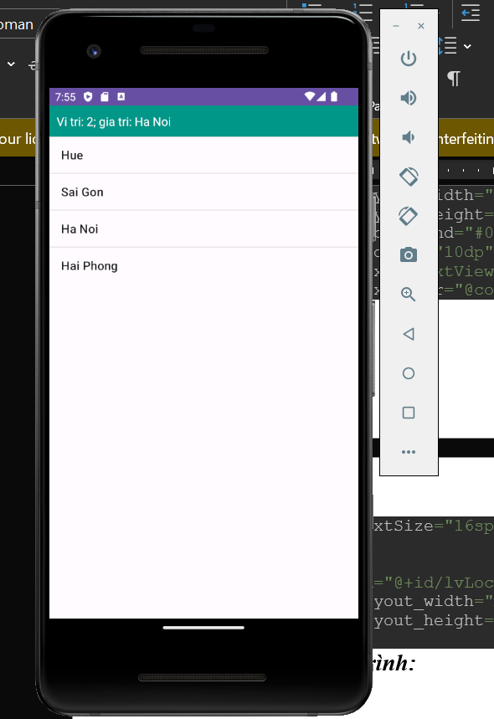

1. **Các vấn đề khác**
2. ***Nội dung đã thực hiện***

* Nội dung 1
* Nội dung 2
* …..

1. ***Các nội dung chưa thực hiện và lý do chưa hoàn thành***

* Nội dung 1………………..Lý do:…………………………………………..
* Nội dung 2………………..Lý do:………………………………………….
* ……

1. ***Ngày hoàn tất nội dung và nộp báo cáo bổ sung***
2. ***Các ý kiến đề nghị***

***Hà Nội, ngày…..tháng…...năm…..***

***Đỗ Thế Nhuận***