**Task 1**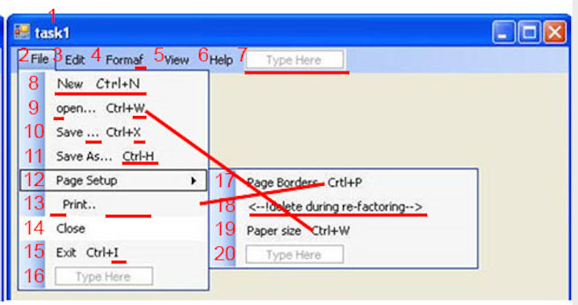

(1, 2, 3,.. etc) - Numbers elements of menu

Main menu

|  |
| --- |
| 1 name programm change to correct name (task1) -> (Database conversion), see attached picture EXPECTED RUSULT  4 name change (Formaf) -> (Formate), see attached picture EXPECTED RUSULT  7 menu create or move or delete  (For more exactly understanding for me need reading documentations about this 7 element menu) |

Menu File

|  |
| --- |
| **8** please change menu item (New Ctrl+N) in (File), see attached picture EXPECTED RUSULT   1. font (Arial Narrow, Regular, size 12) 2. align (New) on left, (Ctrl+N) on right, see attached picture 3. (New) add underline to latter N   **9** please change menu item (open… Ctrl+W) in (File), see attached picture EXPECTED RUSULT   1. please change (open… Ctrl+W) -> (Open… Ctrl+O) 2. align text on menu (Open…) on left, (Ctrl+O) on right 3. (Open) add underline to latter O   10 please change menu item (Save… Ctrl+X) in (File), see attached picture EXPECTED RUSULT   1. please change (Save… Ctrl+X) -> (Save… Ctrl+S) 2. align text on menu (Save… ) on left, (Ctrl+S) on right 3. (Save…) add underline to latter S   11 please change menu item (Save As… Ctrl-H) in (File), see attached picture EXPECTED RUSULT   1. please change (Save… Ctrl-H) -> (Save As… Shift+Ctrl+S) 2. align text on menu (Save As…) on left, (Shift+Ctrl+S) on right 3. (Save As…) add underline to latter s   **13** please change menu item (Print…) in (File), see attached picture EXPECTED RUSULT   1. please change ( Print…) -> (Print… Ctrl+P) 2. align text on menu (Print…) on left, (Ctrl+P) on right 3. please remote blank on left (Print…)   **14** please change menu item (Close) in (File), see attached picture EXPECTED RUSULT   1. please change background by default   **15** please change menu item (Exit Ctrl+I) in (File), see attached picture EXPECTED RUSULT   1. please change (Exit Ctrl+I) -> (Exit Ctrl+X) 2. align text on menu (Exit) on left, (Ctrl+X) on right 3. (Exit) add underline to latter E |

MENU (Page Setup)

|  |
| --- |
| **17** please change in (File) (Page Setup) menu item (Page Borders Ctrl+P)  (Page Borders Ctrl+P) -> (Page Borders Ctrl+Alt+B)  (Borders) add underline to latter B  align text on menu (Page Borders) on left, (Ctrl+Alt+B) on right, see attached picture  **18** please delete in (File) (Page Setup) menu item <--!delete during re-ractoring -->    **19** please change in (File) (Page Setup) menu item (Paper size Ctrl+W)  (Paper size Ctrl+W) -> (Paper Size Ctrl+Alt+S)  (Size) add underline to latter S  align text on menu (Paper Size) on left, (Ctrl+Alt+S) on right, see attached picture |

Please change items in menu

|  |
| --- |
| New Ctrl+N  Open... Ctrl+O  Close  Save... Ctrl+S  Save As... Ctrl+Shift+S  Print... Ctrl+P  Page Setup  Exit Ctrl+X |

Add separate line

|  |
| --- |
| add separate horizontal line in menu (File)  between (Close) and (Save)  between (Save As..) and (Print)  between (Page Setup) and (Exit) |

Task 2



Найбільш критичні моменти

7) Для кращого розуміння треба мені читати сторю по цьому пункту мене. Те як я розумію це кудись треба сюди у середину перенести (File, Edit, Formaf, View, Help) або розробник щось накосячив і треба зрозуміти чи це зовсім лишнє, так садно зрозуміти

18) Як я розумію розробник просто забув кусок коду видалити в програмі

Все інше більш менш криво але зрозуміло для тестування і це ремонтувати у другу чергу (1, 4, 8, 9, 10, 11, 13, 14, 15, 17, 19)