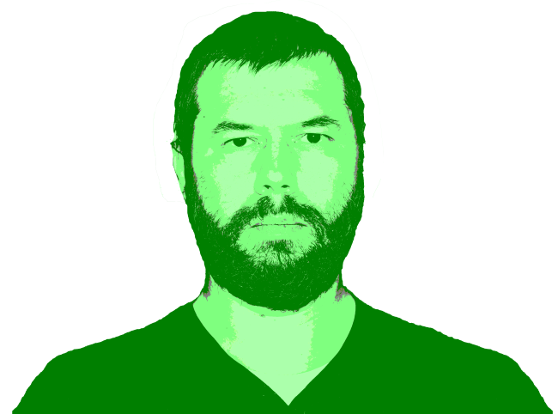
Volodymyr Tarasenko

Address: Ukraine Kyiv
Mobile phone: +38 О6З I63-7I26
E-Mail: hc158b@gmail.com
Skype: dzmitry.salko
Linkedin: linkedin.com/in/volodymyrt
Github: github.com/andreyalieksieiev
Software Engineer

IT RELATED EXPERIENCE:

Employer:: JSC The State Export-Import Bank of Ukraine (10.2017 – at present) https://www.eximb.com/

Description work:: I work with “INPAS POS Master” system. This software system provide service for “VeriFone™” equipments, this system remote control payment POS-terminals network, also hardware/software complex for payment card maintenance payment card on cash registers. And I work with “LFS” system this is EDMS - electronic document management system is a software program that manages the creation, storage and control of documents electronically.

Role:: Software Engineer

Participation:: // Setting of channels of connection between the VeriFone™ POS (point of service) terminal and bank equipments

// Installation of trade equipment at the traider

// Testing of software payment equipments and testing backend software configuration/updating software and testing software of POS terminal.

// upgrade software Update Operation system of payment terminal using

// Bug fixes and performance improvements

// Load dump file from POS terminal

// use DOS script commands files.bat, work with (USB converter to RS-232), Terminal Server (Windows Server)
Technologies:: RS-232 / DOS / scripts / batch file / VeriFone / POS Master / EDMS / batch / Terminal Server / DHCP / Initialization GSM modem with help command line / Testing

During last year when I've free time I'm learning C++ on RaspberryPi

Description:: I learn С++ on embedded device. I run OS Linux Debian on RPi and QTCreator on this board also tuning on my desktop with Windows 10 plus CLion 2020 for remote run/debag code C++ on Raspberry Pi.

Participation:: // Install and configuration QTCreator on Rasbberry Pi Linux Debian create .sh file for autoimmunization when need reinstall

// Run code “POCO WebServer” pocoproject.org configuration CMake for Debag

// Use remote access to board I use Putty ssh, VNC or FAR commander

// For сonvenience edit C++ code I use CLion editor on Windows and I edit CMake for debag code

// a lot of spent time for tuning VSCode Debag mode on Raspberry Pi and can’t run JSON file in this IDE for debag C++ code on board

Technologies:: Raspberry Pi, GitHab, C++, CMake, QT, CLion, Debug, bash, putty, ssh, ftp, s WEB serwer Poco, VNC, Linux, .sh, FAR commander, JSON, Windows, POCO WebServer

SmartHome (10.2016 - 02.2017) - 4 mos

Description work:: Try to learn C++ at the home.

Role:: Junior C++

Participation::

Technologies:: ▪ C++, Arduino

Джесс Либерти Освой самостоятельно C++ за 21 день
Git hub Raspberry\Raspberry_Cpp\Book_Cpp_Liberty

Self-employed (03.2013 – 10.2017) - 4 yrs 9 mons

Description work::

Role::

Participation::

Technologies::

electrical engineer

▪ Electrician, Network Installation Architect, Reconstruction, etc
▪ Architectural draftsman and designer, engineering plans for projects developing
Technologies:

Computer First-aid service, self-employed (08.2011-03.2013) - 1 yr 8 mos
▪ Installed/reinstalled Windows, installed drivers for devices, recovered DATA Windows, recovered DATA USB flash memory, etc.
Technologies:

Профи Газ (04.2011 – 07.2011) - 4 mons
http://profigas.ua/

Position: Service Engineer
▪ Find & fix in AUTOGAZ ECU STAG in petrol ECU driving on gas, UpGrade, DowdGrade firmware ECU STAG (www.ac.com.pl).
▪ (PCB) AUTOGAZ ECU STAG principal scheme analytics
▪ find & fix broken cars’ wiring
▪ required electronics components purchasing
▪ automotive alternator fix
Technologies:

e-commerce site E7.com.ua (09.2009 – 04.2011) - 1 yr 8 mons

Head of the e-commerce site
▪ software testing, Design UI, website testing, website promotion, network installation,
▪ company server installation on Windows 2003 Server + Firewall (Internet Security and Acceleration Server 2003), RDP, HTTP, FTP services installation
▪ client computers’ installation,
▪ Management of a small team: 2 developers (1C, PHP) team supervision, tasks creation, tasks implementation supervision)
Technologies:

JSC "The State Export-Import Bank of Ukraine" (09.2003 – 08.2009) - 6 yrs

Call Center Engineer-operator
▪ operation monitoring, payment systems (Visa, MasterCard) network channels monitoring, clients support
Technologies:

Ronex (04.2000 – 07.2002) - 2 yrs 4 mons

Senior Sales Manager

Company server installation on Windows 2000 Server + “RAID 1”, clients computers installation, 1С accounting installation, M-Deamon mail service installation, Firewall installation, chat service, IBM PC assemblage, LAN network installation, company telephone network installation and automatic telephone exchange programming.
Technologies:

EDUCATION
▪ Kyiv National Economic University, Applied statistics, Masters degree diploma M16 #019015 2016

▪ Professional Technical School, 3rd category electrician
▪ Specialized Courses, 1st category radio equipment adjuster

Sonoff
Cisco
FreeBSD

IT Skills:
English Intermediate PHP 5/7, Mysql, nosql, memcache. Yii Framework2, Zend Framework 2, CodeIgnitor, Angular 6 Html, css, js, npm, composer, webpack, gulp, grunt Git, jira, asana, confluence.

OWN_PROJECTS
Hobbies:

TECHNICAL SKILLS:
Platforms: Windows, Mac OS (base), Linux
Mobile Platforms: Android, iOS
Databases: MS SQL (writing simple queries)
Bug Tracking: Jira, Redmine, Trello, Confluence, Asana.
Development Tools: Visual Studio, Visio.
CRM systems: Amo CRM, Bitrix
Other programs and tools, technics:
MS Office Suite, G suite, SimpleMind, Creately, Google Analytics, LucidChart, VisualParadigm, Balsamiq, Draw.io, Axure RP, Mockflow.

SKILLS
▪ Hardware: IBM PC, Macintosh (Hackintosh)
▪ Operating Systems: MS Windows, Windows Server 2003, FreeBSD/Linux
▪ Network: ISA Server (RDP, FTP, HTTP, POP3, SMTP), FreeBSD (kernel configuration, SSH, proxy, firewall, DNS) etc.
▪ Programming Languages: HTML, SQL, C++, C#
▪ Experienced Eagle PCB CAD schematic capture user.
▪ Software: Adobe Photoshop, Adobe Illustrator, FinalCut, AutoCAD, Inventor, Rhinoceros 3D modeling, MS Office, VMware, Parallels Desktop, etc
▪ Other: terminal, bash, update firmware on Android device
I can update firmware OpenWrt on WiFi router
WiFi router “Xiaomi Mini”, rewrite firmware to the OpenWRT (Linux 3.10.49), (SSH+Web.Inreface)
▪ Installation network/telephone cabel (UTP, FTP, low electric 220V/380V)
▪ This is my GitHub - https://github.com/dotignore/GitHub

Languages:

Russian\Ukrainian – native
English – intermediate

Driver's license - category “B”

HOBBIES
Reading
Snowboarding
Drawing
3D-modeling

Traveling

foreign languages, sport, traveling

