Diagonal 4.60 mm (Type 1/4.0) 8 Mega-Pixel CMOS Image Sensor with Square Pixel for
Color Cameras
IMX219PQH5-C

Description
The IMX219PQH5-C is a diagonal 4.60 mm (Type 1/4.0) CMOS active pixel type image sensor with a square pixel array and 8.08M effective pixels. This chip operates with three power supplies, analogue 2.8 V, digital 1.2 V, and IF 1.8 V, and has low power consumption. High sensitivity, low dark current, and no smear are achieved through the adoption of R, G, and B primary color pigment mosaic filters. This chip features an electronic shutter with variable charge-storage time.
In addition, this product is designed for use in cellular phone and tablet pc. When using this for another application, Sony does not guarantee the quality and reliability of product. Therefore, don't use this for applications other than cellular phone and tablet pc. Consult your Sony sales representative if you have any questions.

Features
◆ Back-illuminated CMOS image sensor Exmor RTM
◆ 2-wire serial communication circuit on chip
◆ CSI2 serial data output (selection of 4lane/2lane)
◆ Timing generator, H and V driver circuits on chip ◆ CDS/PGA on chip
◆ 10-bit A/D converter on chip
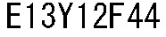
◆ Automatic optical black (OB) clamp circuit on chip

◆ PLL on chip (rectangular wave)
◆ High sensitivity, low dark current, no smear
◆ Excellent anti-blooming characteristics
◆ Variable-speed shutter function (1 H units)
◆ R, G, B primary color pigment mosaic filters on chip
◆ Max. 30 frame/s in all-pixel scan mode
◆ Pixel rate: 280 [Mpixel/s] (All-pixels mode)
◆ 180 frame/s @720p with 2x2 analog (special) binning, 60 frame/s @1080p with V-crop ◆ Data rate: Max. 755 Mbps/lane(@4lane), 912Mbps/Lane(@2lane)

* Exmor R is a trademark of Sony Corporation. The Exmor R is a Sony's CMOS image sensor with significantly enhanced imaging characteristics including sensitivity and low noise by changing fundamental structure of ExmorTM pixel adopted column parallel A/D converter to back-illuminated type.
Sony reserves the right to change products and specifications without prior notice.
This information does not convey any license by any implication or otherwise under any patents or other right.
Application circuits shown, if any, are typical examples illustrating the operation of the devices. Sony cannot assume responsibility for any problems arising out of the use of these circuits.

Device Structure
◆ CMOS image sensor
◆ Image size | : Diagonal 4.60 mm (Type 1/4.0)
◆ Total number of pixels | : 3296 (H) × 2512 (V) approx. 8.28 M pixels
◆ Number of effective pixels | : 3296 (H) × 2480 (V) approx. 8.17 M pixels
◆ Number of active pixels | : 3280 (H) × 2464 (V) approx. 8.08 M pixels
◆ Chip size | : 5.095 mm (H) × 4.930 mm (V) (w/ Scribe)
◆ Unit cell size | : 1.12 µm (H) × 1.12 µm (V)
◆ Substrate material | : Silicon

USE RESTRICTION NOTICE
This USE RESTRICTION NOTICE ("Notice") is for customers who are considering or currently using the image sensor products ("Products") set forth in this specifications book. Sony Corporation ("Sony") may, at any time, modify this Notice which will be available to you in the latest specifications book for the Products. You should abide by the latest version of this Notice. If a Sony subsidiary or distributor has its own use restriction notice on the Products, such a use restriction notice will additionally apply between you and the subsidiary or distributor. You should consult a sales representative of the subsidiary or distributor of Sony on such a use restriction notice when you consider using the Products.

Use Restrictions
- The Products are intended for incorporation into such general electronic equipment as office products, communication products, measurement products, and home electronics products in accordance with the terms and conditions set forth in this specifications book and otherwise notified by Sony from time to time.
- You should not use the Products for critical applications which may pose a life- or injury- threatening risk or are highly likely to cause significant property damage in the event of failure of the Products. You should consult your sales representative beforehand when you consider using the Products for such critical applications. In addition, you should not use the Products in weapon or military equipment.
- Sony disclaims and does not assume any liability and damages arising out of misuse, improper use, modification, use of the Products for the above-mentioned critical applications, weapon and military equipment, or any deviation from the requirements set forth in this specifications book.

Design for Safety
● Sony is making continuous efforts to further improve the quality and reliability of the Products; however, failure of a certain percentage of the Products is inevitable. Therefore, you should take sufficient care to ensure the safe design of your products such as component redundancy, anti-conflagration features, and features to prevent mis-operation in order to avoid accidents resulting in injury or death, fire or other social damage as a result of such failure.

Export Control
● If the Products are controlled items under the export control laws or regulations of various countries, approval may be required for the export of the Products under the said laws or regulations. You should be responsible for compliance with the said laws or regulations.

No License Implied
● The technical information shown in this specifications book is for your reference purposes only. The availability of this specifications book shall not be construed as giving any indication that Sony and its licensors will license any intellectual property rights in such information by any implication or otherwise. Sony will not assume responsibility for any problems in connection with your use of such information or for any infringement of third-party rights due to the same. It is therefore your sole legal and financial responsibility to resolve any such problems and infringement.

Governing Law
● This Notice shall be governed by and construed in accordance with the laws of Japan, without reference to principles of conflict of laws or choice of laws. All controversies and disputes arising out of or relating to this Notice shall be submitted to the exclusive jurisdiction of the Tokyo District Court in Japan as the court of first instance.

Other Applicable Terms and Conditions
● The terms and conditions in the Sony additional specifications, which will be made available to you when you order the Products, shall also be applicable to your use of the Products as well as to this
specifications book. You should review those terms and conditions when you consider purchasing and/or using the Products.

Contents
Description 1
Features 1
Device Structure 2
USE RESTRICTION NOTICE 3
1. Block Diagram and Pin Configuration 10
1-1 Block Diagram 10
1-2 Pin Description 10
1-3 Pin Equivalent Circuit 13
1-4 Chip Center, Optical Center and Pin Assignment 14
1-5 Pin Coordinates 15
2. Pixel Signal Output Specifications 16
2-1 CSI-2 Signalling Mode 16
2-1-1 MIPI Transmitter 16
2-1-2 Output Lane 16
3. Control Registers 17
3-1 2-wire Serial Communication Operation Specifications 17
3-1-1 Communication Protocol 17
3-1-2 2-wire serial communication read/write operation supported 19
3-1-3 2-wire serial communication block characteristics 23
3-1-4 2-wire serial communication register map 24
3-1-5 Register Synchronization (Frame Bank) 25
3-2 2-wire Serial Communication Register Map (Configuration register, Parameter limit register) 26
3-2-1 Configuration Registers – [0x0000-0x0FFF] 26
3-2-2 Set-up Registers – [0x0100-0x0147] 28
3-2-3 Frame Bank Control and Group “A” – [0x0150-0x018D] 30
3-2-4 Frame Bank Control Group “B” – [0x0254-0x028D] 32
3-2-5 Set-up Registers – [0x0300-0x0627] 33
3-3 Parameter Limit Registers – [0x1000-0x1FFF] (Read Only and Static) 36
3-3-1 Integration Time and Gain Parameter Limit Registers – [0x1000-0x1301] 36
3-4 Manufacturer Specific Registers – [0x3000-0x5FFF] 41
3-5 Frame Bank A and Bank B specific output samples 43
4. Output Data Format 47
4-1 CSI-2 Output Data Format 47
4-1-1 CSI-2 Output Data Channels 47
4-1-2 CSI-2 Frame Structure 47
4-1-3 Short Packet & Long Packet 48
4-1-4 Data type 49
4-1-5 CSI-2 Frame Format 49
4-1-6 CSI-2 Embedded Data Line 50
5-1 Pixel Array Physical Image 52
5-2 Pixel Binning Mode 53
5-3 image size 54
5-4 Readout Position 55
5-5 Frame Rate Calculation Formula 56
5-6 Black Level Control 56
5-7 Storage Time (Electronic Shutter) Settings 56
5-7-1 Storage Time (Electronic Shutter) Setting Registers 56
5-7-2 Storage Time Calculation Method 57
5-8 Gain Settings 58
5-8-1 Analogue Gain Settings 58
5-8-2 Digital gain settings 60
6. On Chip Image Processing 62
6-1 Test Pattern Generator 62
6-1-1 Test Pattern 62
6-2 Digital Gain Setting 67
6-3 Black Level Adjust 67
6-4 Defect Correction 67
6-5 Pixel Re-alignment H Direction 67
6-6 Pixel Re-alignment V Direction 68
7. NVM Memory Map 69
7-1 Block Diagram 69
7-2 NVM Functions 69
7-3 Related Registers 70
7-4 NVM Memory Map 72
7-5 Defects Address registration 75
7-5-1 Single defect address 75
7-5-2 Same Color Adjoining defect address 75
7-5-3 2x4 defect address 75
7-5-4 Example Setting 76
8. How to operate IMX219PQH5-C 77
8-1 Power on sequence 77
8-2 Power off sequence 79
9. Other Functions 81
9-1 Clock System 81
9-1-1 Clock Structure 81
9-1-2 EXCK_FREQ setting depend on INCK frequency 81
9-2 Clock Setting Example 82
9-3 Temperature Sensor 83
10. Electrical Characteristics 84
10-1 Absolute Maximum Ratings 84
10-2 Recommended Operating Conditions 84
10-3 Electrical Characteristics 85
10-4 AC Characteristics 86
10-4-1 Master Clock Waveform Diagram 86
10-5 Electrical Characteristics 86
11. Spectral Sensitivity Characteristic 87
12. Image Sensor Characteristics 88
12-1 Image Sensor Characteristics 88
12-2 Zone Definition used for specifying image sensor characteristics 88
13. Measurement Method for Image Sensor Characteristics 89
13-1 Measurement conditions 89
13-2 Color Coding of This Image Sensor and Readout 89
13-3 Definition of Standard Imaging Conditions 89
13-4 Measurement method 90
14. Spot Pixel Specification 91
15. Notice on White Pixels Specifications 92
15-1 Measurement Method for Spot Pixels 93
15-2 Spot Pixel Pattern Specifications 93
16. Chief Ray Angle Characteristics 94
17. Connection Example 95
18. Notes On Handling 96

Table of Figures
Fig. 1 Block Diagram .............................................................................................................................. 10
Fig. 2 Pin Equivalent Circuit .................................................................................................................... 13
Fig. 3 Chip Center and Optical Center..................................................................................................... 14
Fig. 4 Relationship between Output pin name and MIPI output Lane ....................................................... 16
Fig. 5 2-wire Serial Communication ......................................................................................................... 17
Fig. 6 2-wire Serial Communication Protocol ........................................................................................... 17
Fig. 7 Start Condition .............................................................................................................................. 18
Fig. 8 Repeated Start Condition .............................................................................................................. 18
Fig. 9 Stop Condition .............................................................................................................................. 18
Fig. 10 Slave Address ............................................................................................................................. 18
Fig. 11 Acknowledge and Negative Acknowledge .................................................................................... 19
Fig. 12 CCI single read from random location.......................................................................................... 20
Fig. 13 CCI single read from current location........................................................................................... 20
Fig. 14 CCI sequential read starting from random location ...................................................................... 21
Fig. 15 CCI sequential read starting from current location ....................................................................... 21
Fig. 16 CCI single write to random location ............................................................................................. 22
Fig. 17 CCI sequential write starting from random location ...................................................................... 22
Fig. 18 2-wire Serial Communication Specifications ................................................................................ 23
Fig. 19 Function Example for Frame Bank .............................................................................................. 25
Fig. 20 Frame Structure for Serial signal output ...................................................................................... 47
Fig. 21 Signaling Waveform during Line Blanking Period (CSI-2)............................................................. 48
Fig. 22 Signaling Waveform during Frame Blanking Period (CSI-2) ......................................................... 48
Fig. 23 Short Packet & Long Packet ........................................................................................................ 48
Fig. 24 Frame Format during Embedded Data Line Output ..................................................................... 50
Fig. 25 Embedded data lines alignment in RAW8 mode .......................................................................... 50
Fig. 26 Detailed Embedded Data Line Output in RAW10 Output Mode .................................................... 50
Fig. 27 Pixel Array Physical Image .......................................................................................................... 52
Fig. 28 Image of 2x2 averaged Binning Mode ......................................................................................... 53
Fig. 29 Image size .................................................................................................................................. 54
Fig. 30 Readout Position ......................................................................................................................... 55
Fig. 31 Output Image Diagrams for Vertical Flip and Horizontal Mirror ..................................................... 55
Fig. 32 Data Flow Diagram ..................................................................................................................... 62
Fig. 33 Block Diagram ............................................................................................................................ 69
Fig. 34 NVM Map structure ..................................................................................................................... 69
Fig. 35 Single defect ............................................................................................................................... 75
Fig. 36 Same Color Adjoining defect ....................................................................................................... 75
Fig. 37 2x4 defect ................................................................................................................................... 75
Fig. 38 Power-on Sequence in 2-wire Serial Communication Mode ......................................................... 77
Fig. 39 Start streaming sequence with 2-wire serial communication (external reset) ................................ 78
Fig. 40 Power-off Sequence in 2-wire Serial Communication ................................................................... 79
Fig. 41 Software Standby Operation Pattern 1 ........................................................................................ 80
Fig. 42 Software Standby Operation Pattern 2 ........................................................................................ 80
Fig. 43 Clock System Block Diagram ...................................................................................................... 81
Fig. 44 Master Clock Square Waveform Diagram .................................................................................... 86
Fig. 45 Spectral sensitivity characteristics ............................................................................................... 87
Fig. 46 Zone Definition Diagram .............................................................................................................. 88
Fig. 47 Color coding alignment................................................................................................................ 89
Fig. 48 Measurement Method for Spot Pixels .......................................................................................... 93
Fig. 49 Chief Ray Angle Characteristics .................................................................................................. 94
Fig. 50 Recommended Circuit ................................................................................................................. 95

Tables
Table 1 Pin Description ........................................................................................................................... 10
Table 2 Pin Coordinates .......................................................................................................................... 15
Table 3 Description of 2-wire Serial Communication Pins ........................................................................ 17
Table 4 R/W Bit ....................................................................................................................................... 18
Table 5 2-wire Serial Communication Address Space.............................................................................. 19
Table 6 Operations Supported by 2-wire Serial Communication .............................................................. 19
Table 7 2-wire Serial Communication Operation Specifications ............................................................... 23
Table 8 2-wire Serial Communication AC Timing (Fast mode plus (INCK[fSCK] = 11.4 to 27 MHz)) ......... 23
Table 9 2-wire Serial Communication AC Timing (Fast mode) .................................................................. 24
Table 10 2-wire Serial Communication Register Map Address Areas ....................................................... 24
Table 11 Access command sequence...................................................................................................... 41
Table 12 Number of CSI lane Setting Registers ....................................................................................... 47
Table 13 Image pixel area and data type ................................................................................................. 49
Table 14 Sync Code Settings .................................................................................................................. 49
Table 15 Embedded Data Line Tag ......................................................................................................... 51
Table 16 Mode example .......................................................................................................................... 53
Table 17 Image Orientation Register ....................................................................................................... 55
Table 18 Gain Setting Variables .............................................................................................................. 56
Table 19 Storage Time Setting Register .................................................................................................. 56
Table 20 Storage Time Offset Register.................................................................................................... 56
Table 21 Storage Time Setting (in case of Line_Length_pck = 3448) ....................................................... 57
Table 22 Gain Setting Variables .............................................................................................................. 58
Table 23 Analogue Gain Setting .............................................................................................................. 59
Table 24 Digital Gain Settings ................................................................................................................. 60
Table 25 Example of Digital Gain Setting ................................................................................................ 61 Table 26 Description of Test Pattern Registers ........................................................................................ 63
Table 27 Description of Test Patterns ...................................................................................................... 64
Table 28 Black Level Adjust Setting Register ........................................................................................... 67
Table 29 Pixel Re-alignment H Direction Setting Registers ...................................................................... 67
Table 30 Pixel Re-alignment V Direction Setting Registers ...................................................................... 68
Table 31 Functions via NVM ................................................................................................................... 69
Table 32 Related Registers ..................................................................................................................... 70
Table 33 NVM Memory capacity .............................................................................................................. 72
Table 34 NVM Memory Map Example ..................................................................................................... 72
Table 35 Example setting of defect pixel ................................................................................................. 76
Table 36 Operation Specifications 2-wire Serial Communication Mode .................................................... 78
Table 37 Initialization sequence with XCLR ............................................................................................. 78
Table 38 Operation Specifications in 2-wire Serial Communication .......................................................... 79
Table 39 EXCK_FREQ setting table ........................................................................................................ 81
Table 40 Temperature setting registers .................................................................................................... 83
Table 41 Absolute Maximum Ratings ...................................................................................................... 84
Table 42 Recommended Operating Conditions ....................................................................................... 84
Table 43 DC Characteristics .................................................................................................................... 85
Table 44 Master Clock Square Waveform Input Characteristics ............................................................... 86
Table 45 Electrical Characteristics........................................................................................................... 86
Table 46 Image Sensor Characteristics ................................................................................................... 88
Table 47 Measurement Conditions .......................................................................................................... 89
Table 48 Spot Pixel Specifications........................................................................................................... 91

1. Block Diagram and Pin Configuration

1-1 Block Diagram

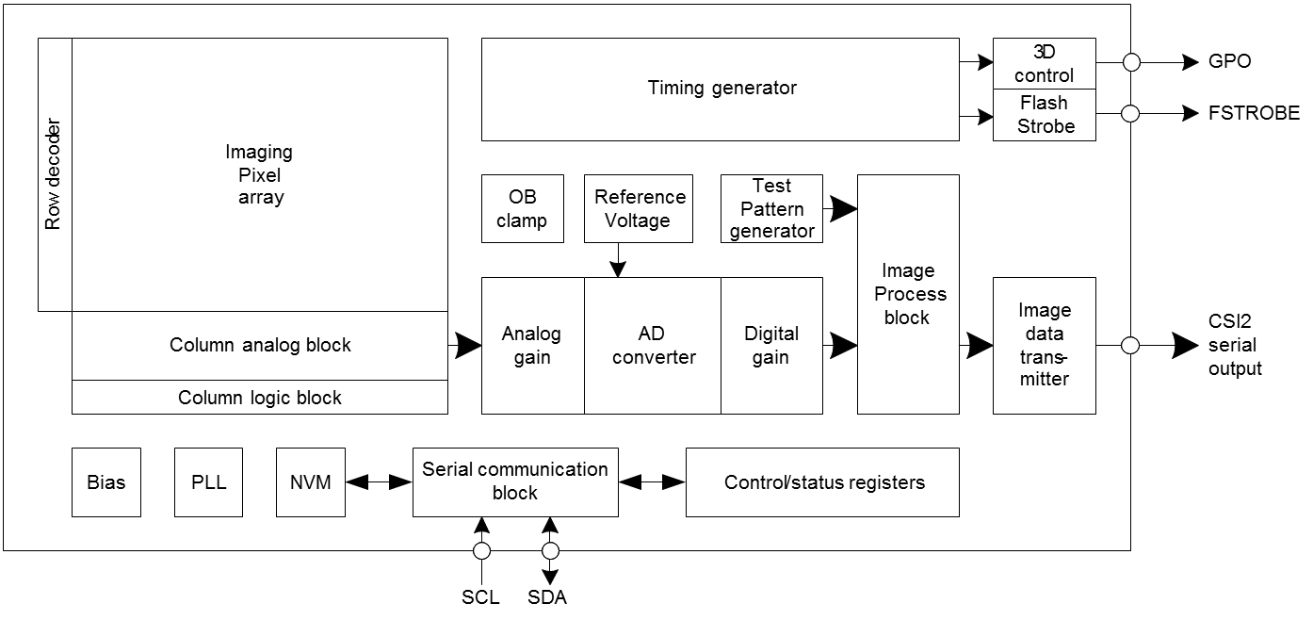

Fig. 1 Block Diagram

1-2 Pin Description
Table 1 Pin Description
Pin No. | Symbol | I/O | A/D | Description | Remarks
1 | VDDLSC1 | Power | D | 1.2 V Power
2 | VSSLSC1 | GND | D | 1.2 V GND
3 | VDDHCM1 | Power | A | 2.8 V Power
4 | VSSHCM1 | GND | A | 2.8 V GND
5 | VSSLCN1 | GND | D | 1.2 V GND
6 | VDDLCN1 | Power | D | 1.2 V Power
7 | VSSLDM1 |  |  | Dummy | NC
8 | VSSLSC2 | GND | D | 1.2 V GND
9 | VDDHFIL1 | Power | A | 2.8 V Power | = VANA
10 | VDDLCN2 | Power | D | 1.2 V Power
11 | VSSLCN2 | GND | D | 1.2 V GND
12 | VSSHCM2 | GND | A | 2.8 V GND
13 | VDDHCM2 | Power | A | 2.8 V Power
14 | VSSLSC3 | GND | D | 1.2 V GND
15 | VDDLSC3 | Power | D | 1.2 V Power
16 | VCP | O | A | Analog Output | Connect to capacitor (2.2 µF)
17 | VBO | O | A | Analog Output | Connect to capacitor (1.0 µF)
18 | VSSHSN1 | GND | A | 2.8 V GND
Pin No. | Symbol | I/O | A/D | Description | Remarks
19 | VDDHSN1 | Power | A | 2.8 V Power
20 | VSSLSC4 | GND | D | 1.2 V GND
21 | POREN | I | D | Digital Input | Connect to VDIG
22 | XCLR | I | D | Digital Input
23 | TENABLE | I | D | Digital Input | NC
24 | GPO | I/O | D | Digital Input/Output | Connect to VSSLSC when GPO is not enable
25 | FSTROBE | O | D | Digital Output
26 | SDA | I/O | D | Digital Input/Output
27 | SCL | I | D | Digital Input
28 | TEST1 | I | D | Digital Input | NC
29 | SWTCK | I | D | Digital Input | NC
30 | INCK | I | D | Digital Input
31 | VDDMCO | Power | D | 1.8 V Power
32 | VSSLSC5 | GND | D | 1.2 V GND
33 | VDDLSC5 | Power | D | 1.2 V Power
34 | VDDHFIL2 | Power | A | 2.8 V Power | = VANA
35 | VDDLSC6 | Power | D | 1.2 V Power
36 | VSSLSC6 | GND | D | 1.2 V GND
37 | VSSLDM2 |  |  | Dummy | NC
38 | VDDLSC7 | Power | D | 1.2 V Power
39 | VSSLSC7 | GND | D | 1.2 V GND
40 | VDDLIO1 | Power | D | 1.2 V Power
41 | VSSLIO1 | GND | D | 1.2 V GND
42 | DMO1N | O | D | Digital Output
43 | DMO1P | O | D | Digital Output
44 | DMO2N | O | D | Digital Output
45 | DMO2P | O | D | Digital Output
46 | VSSLIO2 | GND | D | 1.2 V GND
47 | DCKN | O | D | Digital Output
48 | DCKP | O | D | Digital Output
49 | VSSLIO3 | GND | D | 1.2 V GND
50 | DMO3N | O | D | Digital Output
51 | DMO3P | O | D | Digital Output
52 | DMO4N | O | D | Digital Output
53 | DMO4P | O | D | Digital Output
54 | VSSLIO4 | GND | D | 1.2 V GND
55 | VDDLIO2 | Power | D | 1.2 V Power
56 | VSSLSC8 | GND | D | 1.2 V GND
57 | VDDLSC8 | Power | D | 1.2 V Power

Pin No. | Symbol | I/O | A/D | Description |  | Remarks
58 | VSSHPL | GND | D | 2.8 V GND
59 | VDDHPL | Power | D | 2.8 V Power
60 | TVCDSIN | I | A | Analog Input | NC, For test
61 | TVMON | O | A | Analog Output | NC, For test
62 | VSSHAN | GND | A | 2.8 V GND
63 | VDDHAN | Power | A | 2.8 V Power
64 | VDDHSN2 | Power | A | 2.8 V Power
65 | VSSHSN2 | GND | A | 2.8 V GND

1-3 Pin Equivalent Circuit
Symbol | Equivalent circuit | Symbol | Equivalent circuit
VCP | VSSH  Analog  Output | VBO | Analog  Output  VSSH
XCLR | VDIG  Digital  Input  VSSL | INCK | VDIG  Digital  Input  VSSL
SDA SCL | Digital I/O VDIG  VSSL  VSSL  Schmitt  Buffer | GPO | VSSL  VDIG  Digital  I/O  VD  IG  VD  IG
FSTROBE | VSSL  VDIG  Digital  Output  VDIG | POREN | VD  IG  VDIG  VD  IG  Analog  Input  VSSL

VDDH: 2.8 V power supply, VDIG: 1.8 V power supply, VDDL: 1.2 V power supply
VSSH: 2.8 V GND, VSSL: 1.2 V GND

Fig. 2 Pin Equivalent Circuit

1-4 Chip Center, Optical Center and Pin Assignment
(Unit: µm)
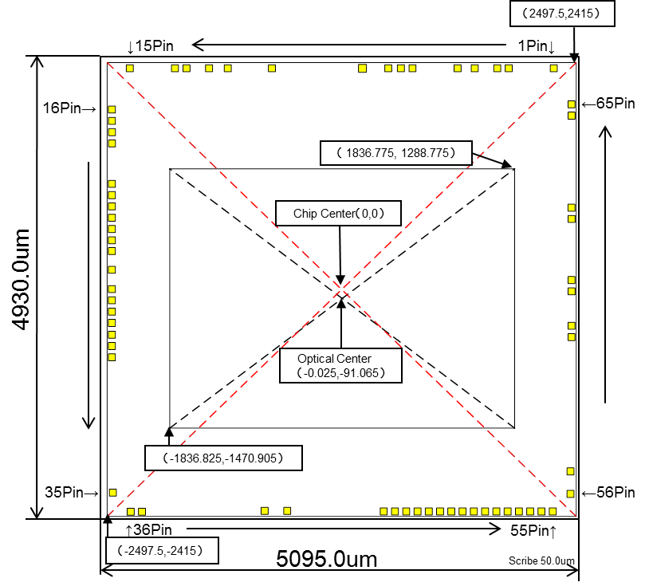

Fig. 3 Chip Center and Optical Center

1-5 Pin Coordinates
Table 2 Pin Coordinates
  Pin No. | Symbol | X (pad center) | Y (pad center)
  1 | VDDLSC1 | 2247.50 | 2355.00
  2 | VSSLSC1 | 1767.50 | 2355.00
  3 | VDDHCM1 | 1647.50 | 2355.00
  4 | VSSHCM1 | 1407.50 | 2355.00
  5 | VSSLCN1 | 1167.50 | 2355.00
  6 | VDDLCN1 | 687.50 | 2355.00
  7 | VSSLDM1 | 567.50 | 2355.00
  8 | VSSLSC2 | 447.50 | 2355.00
  9 | VDDHFIL1 | 167.50 | 2356.00
  10 | VDDLCN2 | -727.50 | 2355.00
  11 | VSSLCN2 | -1207.50 | 2355.00
  12 | VSSHCM2 | -1407.50 | 2355.00
  13 | VDDHCM2 | -1647.50 | 2355.00
  14 | VSSLSC3 | -1767.50 | 2355.00
  15 | VDDLSC3 | -2247.50 | 2355.00
  16 | VCP | -2447.50 | 1915.00
  17 | VBO | -2447.50 | 1795.00
  18 | VSSHSN1 | -2447.50 | 1675.00
  19 | VDDHSN1 | -2447.50 | 1555.00
  20 | VSSLSC4 | -2447.50 | 1125.00
  21 | POREN | -2447.50 | 1005.00
  22 | XCLR | -2447.50 | 885.00
  23 | TENABLE | -2447.50 | 765.00
  24 | GPO | -2447.50 | 645.00
  25 | FSTROBE | -2447.50 | 525.00
  26 | SDA | -2447.50 | 405.00
  27 | SCL | -2447.50 | 205.00
  28 | TEST1 | -2447.50 | 5.00
  29 | SWTCK | -2447.50 | -115.00
  30 | INCK | -2447.50 | -235.00
  31 | VDDMCO | -2447.50 | -355.00
  32 | VSSLSC5 | -2447.50 | -480.00
  33 | VDDLSC5 | -2447.50 | -600.00
  34 | VDDHFIL2 | -2447.50 | -726.00
  Pin No. | Symbol | X (pad center) | Y (pad center)
  35 | VDDLSC6 | -2447.50 | -2165.00
  36 | VSSLSC6 | -2247.50 | -2365.00
  37 | VSSLDM2 | -2127.50 | -2365.00
  38 | VDDLSC7 | -807.50 | -2365.00
  39 | VSSLSC7 | -567.50 | -2365.00
  40 | VDDLIO1 | 447.50 | -2365.00
  41 | VSSLIO1 | 567.50 | -2365.00
  42 | DMO1N | 687.50 | -2365.00
  43 | DMO1P | 807.50 | -2365.00
  44 | DMO2N | 927.50 | -2365.00
  45 | DMO2P | 1047.50 | -2365.00
  46 | VSSLIO2 | 1167.50 | -2365.00
  47 | DCKN | 1287.50 | -2365.00
  48 | DCKP | 1407.50 | -2365.00
  49 | VSSLIO3 | 1527.50 | -2365.00
  50 | DMO3N | 1647.50 | -2365.00
  51 | DMO3P | 1767.50 | -2365.00
  52 | DMO4N | 1887.50 | -2365.00
  53 | DMO4P | 2007.50 | -2365.00
  54 | VSSLIO4 | 2127.50 | -2365.00
  55 | VDDLIO2 | 2247.50 | -2365.00
  56 | VSSLSC8 | 2447.50 | -2165.00
  57 | VDDLSC8 | 2447.50 | -1925.00
  58 | VSSHPL | 2447.50 | -507.00
  59 | VDDHPL | 2447.50 | -387.00
  60 | TVCDSIN | 2447.50 | -20.00
  61 | TVMON | 2447.50 | 100.00
  62 | VSSHAN | 2447.50 | 750.00
  63 | VDDHAN | 2447.50 | 870.00
  64 | VDDHSN2 | 2447.50 | 1850.00
  65 | VSSHSN2 | 2447.50 | 1970.00

2. Pixel Signal Output Specifications
IMX219PQH5-C has CSI-2 interface and the options are 4 lanes or 2lanes.

2-1 CSI-2 Signalling Mode

2-1-1 MIPI Transmitter
Output pin of CSI-2 are shown below

Lane
1

Lane 2

Clock Lane

Lane

3

Lane 4

M
IPI

Block

DMO
1
P/
N

DMO
2
P/N

DCK
P/N

DMO3
P/N

DMO4P/N

Fig. 4 Relationship between Output pin name and MIPI output Lane

Data and clock signals are transmitted using CSI-2 interface (high speed serial interface). Detailed explanation of
CSI-2 interface is in following two documents, “MIPI Alliance Standard for Camera Serial Interface2 (CSI-2) Version 1.01” and “MIPI Alliance Specification for D-PHY Version 1.10.00”. In CSI-2 interface, one bit of data is transmitted by a pair of differential signals. In the transmitter of CSI-2 interface, differential digital signals of data or clock are converted to differential current signals. At the receiver of CSI-2 interface, inserting output resistance, which is serial to a pair of differential outputs (data or clock), or connecting the receiver block, which includes internal resistance for a pair of differential outputs (data or clock), is required. In the case of using output
resistance, output resistance is placed close to the receiver. Additionally, it is recommended that each space
between differential output lines such as DMO1P/DMO1N, DMO2P/DMO2N, DMO3P/DMO3N, DMO4P/DMO4N, or DCKP/DCKN is identical, the length of all differential output lines is same, and output line length between the transmitter and the receiver is minimum.

2-1-2 Output Lane
Two or Four data output Lanes are applied from MIPI Alliance Standard for Camera Serial Interface2 (CSI-2) Version 1.01.

2-1-2-1 2Lane Output
Outputs of data and clock come from CSI-2 output pins (DMO1P/DMO1N, DMO2P/DMO2N, DCKP/DCKN). A pair of DMO1P/DMO1N is called Lane1 data and a pair of DMO2P/DMO2N is called Lane2 data. Also, clock signals come from CSI-2 output pins, DCKP/DCKN. Maximum output data rate is 912 Mbps/lane. (1lane output is not supported).

3. Control Registers
The IMX219PQH5-C can use the 2-wire serial communication method for sensor control. These specifications are described for sensor control using the 2-wire serial communication as follows.

3-1 2-wire Serial Communication Operation Specifications
The 2-wire serial communication method conforms to the Camera Control Instance (CCI). CCI is an I2C fast-mode plus ( INCK[fSCK] = 11.4 to 27 MHz) compatible interface, and the data transfer protocol is I2C standard. This 2-wire serial communication circuit can be used to access the control-registers and status-registers of IMX219PQH5-C.

Master
IMX149
SCL
SDA
IMX219

Fig. 5 2-wire Serial Communication

Table 3 Description of 2-wire Serial Communication Pins
Symbol | Description
SDA | Serial data communication
SCL | Serial clock input

3-1-1 Communication Protocol
2-wire serial communication supports a 16-bit register address and 8-bit data message type.
S | Slave Address [7:1] | R  /  W | A | Register Address [15:8] | A | Register Address [7:0] | A | Data  [7:0] | A  /  A | P
From Master to Slave S=Start Condition A=Acknowledge
Direction Dependent on Operation (Sr=Repeated Start Condition) A=Negative Acknowledge
From Slave to Master P=Stop Condition

Fig. 6 2-wire Serial Communication Protocol

Data is transferred serially, MSB first in 8-bit units. After each data byte is transferred, A (Acknowledge)/Ā (Acknowledge) is transferred. Data (SDA) is transferred at the clock (SCL) cycle. SDA can change only while SCL is Low, so the SDA value must be held while SCL is High.
The Start condition is defined by SDA changing from High to Low while SCL is High. When the Stop condition is not generated in the previous communication phase and Start condition for the next communication is generated, that Start condition is recognized as a Repeated Start condition.

A7
A6
A5
A4
A3
A2
A1
R/W
S
MSB
LSB
Bus free state
Start Condition
The Data changeds
while the clock is Low.
Data sampling
S
D
A
S
C
L
ACK
SDA

SCL

Fig. 7 Start Condition

A7
A6
A5
A4
A3
S
MSB
Start Condition
S
D
A
S
C
L
ACK/NACK
The Stop condition is not generated.

SD
A

S
CL

Fig. 8 Repeated Start Condition

The Stop condition is defined by SDA changing from Low to High while SCL is High.

D5
D4
D3
D2
D1
D0
R/W
P
Bus free state
Stop Condition
S
D
A
S
C
L
ACK/NACK

SDA

SCL

Fig. 9 Stop Condition

  Slave Address  [7:1] | R/W
  MSB LSB
  0 | 0 | 1 | 0 | 0 | 0 | 0 | R/W

Fig. 10 Slave Address

The R/W bit indicates the data transfer direction.

Table 4 R/W Bit
R/W bit | Transfer direction
0 | Write (Master →Sensor)
1 | Read (Sensor → Master)

After transfer of each data byte, the Master or the sensor transmits an Acknowledge / Negative Acknowledge and
releases (does not drive) SDA. When Negative Acknowledge is generated, the Master must immediately generate the Stop condition and end the communication.

D1
D0
R/W
S
D
A
S
C
L
ACK
D1
D0
R/W
S
D
A
S
C
L
NACK

SDA

SCL

SDA

SCL

Fig. 11 Acknowledge and Negative Acknowledge

The registers have a 16-bit address space, and are assigned as follows.

Table 5 2-wire Serial Communication Address Space
Address area | Description
0x0000 - 0x0FFF | Configuration register
0x1000 - 0x1FFF | Parameter limit register  Read Only and Static register
0x3000 - 0xFFFF | Manufacture specific register

3-1-2 2-wire serial communication read/write operation supported
The IMX219PQH5-C supports the following four read operations and two write operations that conform to the SMIA standard.

Table 6 Operations Supported by 2-wire Serial Communication
1 | CCI Single read from random location (Single read from an optional address)
2 | CCI Single read from current location (Single read from the held address)
3 | CCI sequential read starting from random location (Sequential read starting from an optional address)
4 | CCI sequential read starting from current location (Sequential read starting from the held address)
5 | CCI single write to random location (Single write to an optional address)
6 | CCI sequential write starting from random location (Sequential write starting from an optional address)

3-1-2-1 CCI single read from random location
The sensor has an index function that indicates which address it is focusing on. In reading the data at an optional single address, the Master must set the index value to the address to be read. For this purpose it performs dummy write operation up to the register address. The upper level of the figure below shows the sensor internal index value, and the lower level of the figure shows the SDA I/O data flow. The Master sets the sensor index value to M by designating the sensor slave address with a write request, then designating the address (M). Then, the Master generates the start condition. The Start condition is generated without generating the Stop condition, so it becomes the Repeated Start condition. Next, when the Master sends the slave address with a read request, the sensor outputs an Acknowledge immediately followed by the index address data on SDA . After the Master receives the data, it generates a Negative Acknowledge and the Stop condition to end the communication.

Register
Address
[15:8]
Register
Address
[7:0]
Data
[7:0]
From Master to Slave
From Slave to Master
S=Start Condition
P=Stop Condition
Sr=Repeated Start Condition
A=Acknowledge
A=Negative Acknowledge
Slave
Address
[7:1]
0
A
S
A
A
A
P
Slave
Address
[7:1]
1
A
S
ｒ
Previous Index value
Index M
Index
M+1
Index, value M

Fig. 12 CCI single read from random location

3-1-2-2 CCI single read from current location
After the slave address is transmitted by a write request, that address is designated by the next communication and the index holds that value. In addition, when data read/write is performed, the index is incremented by the subsequent Acknowledge/Negative Acknowledge timing. When the index value is known to indicate the address to be read, sending the slave address with a read request allows the data to be read immediately after Acknowledge. After receiving the data, the Master generates a Negative Acknowledge and the Stop condition to end the communication, but the index value is incremented, so the data at the next address can be read by sending the slave address with a read request.

Previous Index value,K
Index K+1
Index
K+2
S | Slave  Address  [7:1] | 1 | A | Data  [7:0] | A | P |  | S | Slave  Address  [7:1] | 1 | A | Data  [7:0] | A | P
From Master to Slave S=Start Condition A=Acknowledge
From Slave to Master P=Stop Condition A=Negative Acknowledge

Fig. 13 CCI single read from current location

3-1-2-3 CCI sequential read starting from random location
In reading data sequentially, which is starting from an optional address, the Master must set the index value to the start of the addresses to be read. For this purpose, dummy write operation includes the register address setting. The Master sets the sensor index value to M by designating the sensor slave address with a read request, then designating the address (M). Then, the Master generates the Repeated Start condition. Next, when the Master sends the slave address with a read request, the sensor outputs an Acknowledge followed immediately by the index address data on SDA. When the Master outputs an Acknowledge after it receives the data, the index value inside the sensor is incremented and the data at the next address is output on SDA. This allows the Master to read data sequentially. After reading the necessary data, the Master generates a Negative Acknowledge and the Stop condition to end the communication.

Register
Address
[15:8]
Register
Address
[7:0]
Data
[7:0]
From Master to Slave
From Slave to Master
S=Start Condition
P=Stop Condition
Sr=Repeated Start Condition
A=Acknowledge
A=Negative Acknowledge
Slave
Address
[7:1]
0
A
S
A
A
P
Slave
Address
[7:1]
1
A
S
ｒ
Previous Index value, K
Index M
Index
(
M+L
)
Index, value M
A
Data
[7:0]
A
Data
[7:0]
A
Index M+1
Index
M
+L-1)
(
A
L bytes of data

Fig. 14 CCI sequential read starting from random location

3-1-2-4 CCI sequential read starting from current location
When the index value is known to indicate the address to be read, sending the slave address with a read request allows the data to be read immediately after the Acknowledge. When the Master outputs an Acknowledge after it receives the data, the index value inside the sensor is incremented and the data at the next address is output on SDA. This allows the Master to read data sequentially. After reading the necessary data, the Master generates a Negative Acknowledge and the Stop condition to end the communication.

Data
[7:0]
From Master to Slave
From Slave to Master
S=Start Condition
P=Stop Condition
A=Acknowledge
A=Negative Acknowledge
P
Slave
Address
[7:1]
1
A
S
Index K
Index
)
K+L
(
A
Data
[7:0]
A
Data
[7:0]
A
Index K+1
Index
(
+L-1)
K
A
L bytes of data

Fig. 15 CCI sequential read starting from current location

3-1-2-5 CCI single write to random location
The Master sets the sensor index value to M by designating the sensor slave address with a write request, and designating the address (M). After that the Master can write the value in the designated register by transmitting the data to be written. After writing the necessary data, the Master generates the Stop condition to end the communication.

Register
Address
[15:8]
Register
Address
[7:0]
Data
[7:0]
From Master to Slave
From Slave to Master
S=Start Condition
P=Stop Condition
A=Acknowledge
A=Negative Acknowledge
Slave
Address
[7:1]
0
A
S
A
A
A
/
A
P
Previous Index value
Index M
Index
M+1
Index, value M

Fig. 16 CCI single write to random location

3-1-2-6 CCI sequential write starting from random location
The Master can write a value to register address M by designating the sensor slave address with a write request, designating the address (M), and then transmitting the data to be written. After the sensor receives the write data, it outputs an Acknowledge and at the same time increments the register address, so the Master can write to the next address simply by continuing to transmit data. After the Master writes the necessary number of bytes, it generates the Stop condition to end the communication.

Register
Address
[15:8]
Register
Address
[7:0]
Data
[7:0]
From Master to Slave
From Slave to Master
S=Start Condition
P=Stop Condition
A=Acknowledge
A=Negative Acknowledge
Slave
Address
[7:1]
0
A
S
A
A
P
Previous Index value, K
Index M
Index
M+L
(
)
Index, value M
A
Data
[7:0]
A
Data
[7:0]
A
/
A
Index M+1
Index
(
M
+L-1)
A
L bytes of data

Fig. 17 CCI sequential write starting from random location

3-1-3 2-wire serial communication block characteristics
The block operation specifications for 2-wire serial communication are show below.

Repeated

SDA
SCL
t
R
t
F
t
BUF
t
HDSTA
t
LOW
t
SUDAT
t
HIGH
t
HDDAT
t
SUSTA
t
HDSTA
t
SUSTO
Start
Condition
Start
Condition
Stop
Condition

Fig. 18 2-wire Serial Communication Specifications

Table 7 2-wire Serial Communication Operation Specifications
Item | Symbol | Conditions | Min. | Max. | Unit
Low level input voltage | VIL |  | -0.5 | 0.3VDIG | V
High level input voltage | VIH |  | 0.7VDIG | VDIG+0.5 | V
Low level output voltage | VOL | VDIG < 2 V,Sink 2 mA |  | 0.25VDIG | V
High level output voltage | VOH | VDIG < 2 V,Sink 2 mA | 0.75VDIG |  | V
Output fall time | tof | Load 10 pF – 400 pF,0.7VDIG – 0.3VDIG |  | 120 | ns
Input current | II | 0.1VDIG -0.9VDIG | -10 | 10 | µA
SDA I/O capacitance | CI/O |  |  | 8 | pF
SCL Input capacitance | CI |  |  | 6 | pF

Table 8 2-wire Serial Communication AC Timing (Fast mode plus (INCK[fSCK] = 11.4 to 27 MHz))
Item | Symbol | Min. | Max. | Unit
SCL clock frequency ( INCK[fSCK] = 11.4 to 27 MHz) | fSCL | 0 | 1000 | kHz
Rise time (SDA and SCL) | t_{R} | ― | 120 | ns
Fall time (SDA and SCL) | t_{F} | ― | 120 | ns
Hold time (start condition) | tHDSTA | 0.26 | ― | µs
Setup time (rep.-start condition) | tSUSTA | 0.26 | ― | µs
Setup time (stop condition) | tSUSTO | 0.26 | ― | µs
Data setup time | tSUDAT | 50 | ― | ns
Data hold time | tHDDAT | 0 | ― | µs
Bus free time between Stop and Start condition | tBUF | 0.5 |  | µs
Low period of the SCL clock | tLOW | 0.5 |  | µs
High period of the SCL clock | tHIGH | 0.26 |  | µs

Table 9 2-wire Serial Communication AC Timing (Fast mode)
Item | Symbol | Min. | Max. | Unit
SCL clock frequency ( INCK[fSCK] = 6 to 27 MHz) | fSCL | 0 | 400 | kHz
Rise time (SDA and SCL) | t_{R} | ― | 300 | ns
Fall time (SDA and SCL) | t_{F} | ― | 300 | ns
Hold time (start condition) | tHDSTA | 0.6 | ― | µs
Setup time (rep.-start condition) | tSUSTA | 0.6 | ― | µs
Setup time (stop condition) | tSUSTO | 0.6 | ― | µs
Data setup time | tSUDAT | 100 | ― | ns
Data hold time | tHDDAT | 0 | 0.9 | µs
Bus free time between Stop and Start condition | tBUF | 1.3 |  | µs
Low period of the SCL clock | tLOW | 1.3 |  | µs
High period of the SCL clock | tHIGH | 0.6 |  | µs

3-1-4 2-wire serial communication register map

3-1-4-1 Description of 2-wire communication register map
In 2-wire serial communication, there is a 16-bit address space as follows. In IMX219PQH5-C, there are partially unreadable registers, which is described in Register map. If reading unreadable registers, the value to be read is 00h.

Table 10 2-wire Serial Communication Register Map Address Areas
Address Area | Description
0x0000 - 0x0fff | Configuration register
0x1000 - 0x1fff | Parameter limit register  Read Only and Static resister
0x3000 - 0xffff | Manufacture specific register

3-1-5 Register Synchronization (Frame Bank)
Sequence for control of frame bank is explained in this section:
- All registers on frame bank are latched by vertical synchronization (V-sync) signal.
- Any change for registers on frame bank are reflected to functions in next frame (or following next frame) if the corresponding registers are updated.

Figures for sequences of frame bank are shown in following statements.
In case that user changes analog/digital gain and integration time only, we see no “no-data” term.

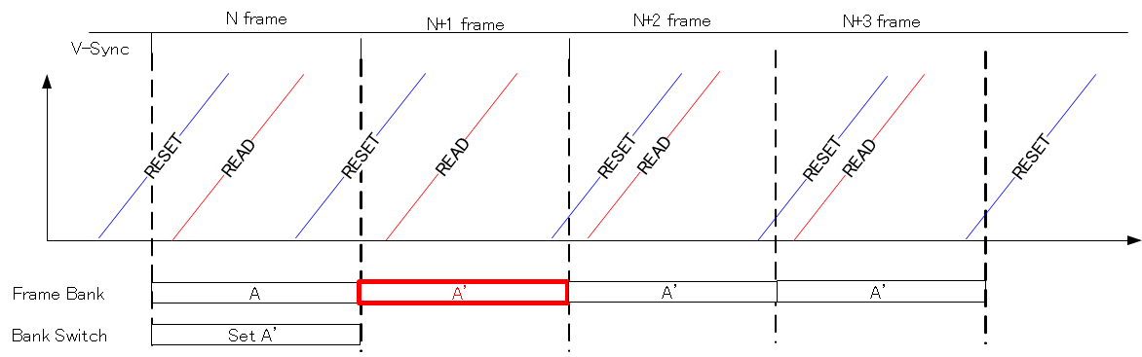

In case that user changes following registers, we may see a term in which we do not see any output from the sensor in addition to vertical blanking interval. From ISP's standing point, it seems that sensor has a bit longer vertical blanking interval.

Additional “no-data term” will be equal to coarse_integration_time + 20[H] if fast tracking mode register is activated.

List of registers is:
  - Binning related registers (especially for analog binning)
  - Sub-sampling registers (for vertical direction)
  - Vertical image orientation registers
  - Vertical ROI
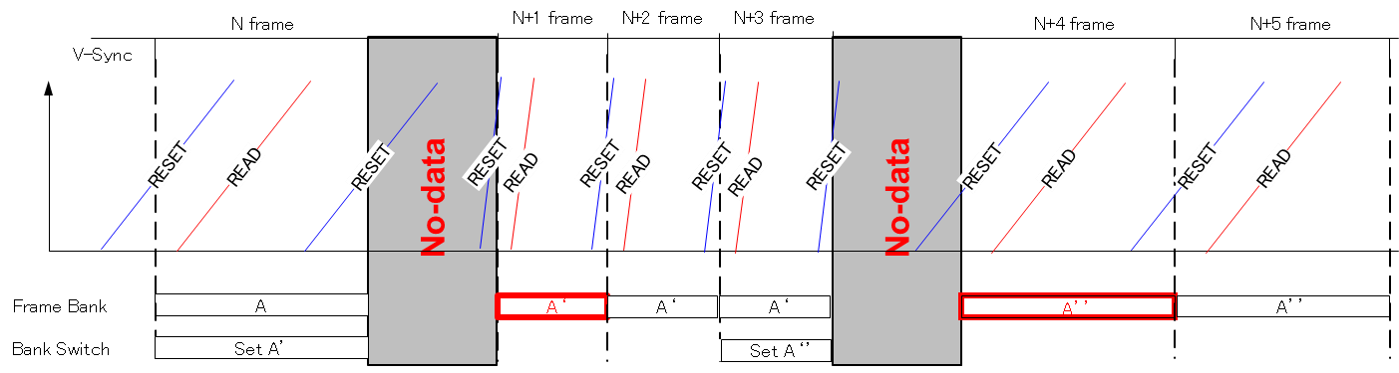
Fig. 19 Function Example for Frame Bank

3-2 2-wire Serial Communication Register Map (Configuration register, Parameter limit register)

3-2-1 Configuration Registers – [0x0000-0x0FFF]

3-2-1-1 Status Registers – [0x0000-0x001B] (Read Only Dynamic Registers)
Index | Byte | Register Name | RW | Comment | Re-  Time | Default (HEX) | Embd DL
0000 | [7:0] | MODEL_ID[15:8] | RO | model id |  | 02
0001 | [7:0] | MODEL_ID[7:0] | RO |  |  | 19
0004 | [7:0] | Lot_ID[23:16] | RO-D | Lot_ID of the sensor Copied from NVM |  | XX | ○
0005 | [7:0] | Lot_ID[15:8] | RO-D | Lot_ID of the sensor Copied from NVM |  | XX | ○
0006 | [7:0] | Lot_ID[7:0] | RO-D | Lot_ID of the sensor Copied from NVM |  | XX | ○
0007 | [7:0] | Wafer_Num | RO-D | Wafer Number of the Sensor in the Lot. Value 0x01-0x19 is available. |  | XX | ○
000D | [7:0] | Chip_Number[15:8] | RO-D | Chip ID in the wafer |  | XX | ○
000E | [7:0] | Chip_Number[7:0] | RO-D |  |  | XX | ○
0018 | [7:0] | FRM_CNT[7:0] | RO-D |  |  | FF | ○
0019 | [7:0] | PX_ORDER | RO-D |  |  | 01 | ○
001A | [1:0] | DT_PEDESTAL[9:8] | RO-D |  |  | 0 | ○
001B | [7:0] | DT_PEDESTAL[7:0] | RO-D |  |  | 40 | ○

3-2-1-2 Frame Format Description – [0x0040-0x0047]
Index | Byte | Register Name | RW | Comment | Re-  Time | Default  (HEX) | Embd DL
0x0040 | [7:0] | FRM_FMT_TYPE[7:0] | RO | frame_format_model_type |  | 01 | ○
0x0041 | [7:0] | FRM_FMT_SUBTYPE[7:0] | RO | frame_format_model_subtype |  | 12 | ○
0x0042 | [7:0] | FRM_FMT_DESC0[15:8] | RO-D | frame_format_descriptor_0 |  | 5C | ○
0x0043 | [7:0] | FRM_FMT_DESC0[7:0] |  |  |  | D0 | ○
0x0044 | [7:0] | FRM_FMT_DESC1[15:8] | RO | frame_format_descriptor_1 |  | 10 | ○
0x0045 | [7:0] | FRM_FMT_DESC1[7:0] |  |  |  | 02 | ○
0x0046 | [7:0] | FRM_FMT_DESC2[15:8] | RO-D | frame_format_descriptor_2 |  | 59 | ○
0x0047 | [7:0] | FRM_FMT_DESC2[7:0] |  |  |  | A0 | ○

3-2-1-3 Analogue Gain Description Registers – [0x0080-0x0093]
Index | Byte | Register Name | RW | Comment | Re-  Time | Default  (HEX) | Embd DL
0x0080 | ― | ― | ― |  |  | 00
0x0081 | [7:0] | analogue_gain_capability | RO | Analogue Gain Description Registers |  | 0
0x0082 | ― | Reserved | RO | Reserved |  | 00
0x0083 | ― | ― | ― |  |  | 00
0x0084 | ― | ― | ― |  |  | 00
0x0085 | [7:0] | analogue_gain_code_min | RO-D | Analogue Gain Description Registers |  | 00
0x0086 | [7:0] | analogue_gain_code_max | RO | Analogue Gain Description Registers possible to setup up to E8 (HEX) |  | 00
0x0087 | [7:0] |  |  |  |  | E0
0x0088 | [7:0] | analogue_gain_code_step | RO | Analogue Gain Description Registers |  | 00
0x0089 | [7:0] |  |  |  |  | 01
0x008A | [7:0] | analogue_gain_type | RO | Analogue Gain Description Registers |  | 00
0x008B | [7:0] |  |  |  |  | 00
0x008C | [7:0] | analogue_gain_m0 | RO | Analogue Gain Description Registers |  | 00
0x008D | [7:0] |  |  |  |  | 00
0x008E | [7:0] | analogue_gain_c0 | RO | Analogue Gain Description Registers |  | 01
0x008F | [7:0] |  |  |  |  | 00
0x0090 | [7:0] | analogue_gain_m1 | RO | Analogue Gain Description Registers |  | FF
0x0091 | [7:0] |  |  |  |  | FF
0x0092 | [7:0] | analogue_gain_c1 | RO | Analogue Gain Description Registers |  | 01
0x0093 | [7:0] |  |  |  |  | 00

3-2-1-4 Data Format Description – [0x00C0-0x00D1]
Index | Byte | Register Name | RW | Comment | Re-  Time | Default  (HEX) | Embd DL
0x00C0 | [7:0] | DT_FMT_TYPE[7:0] | RO | data_format_model_type |  | 01 | ○
0x00C1 | [7:0] | DT_FMT_SUBTYPE[7:0] | RO | data_format_model_subtype |  | 01 | ○
0x00C2 | [7:0] | DT_FMT_DESC0[15:8] | RO | data_format_descriptor_0 |  | 0A | ○
0x00C3 | [7:0] | DT_FMT_DESC0[7:0] |  |  |  | 08 | ○
0x00C4 | [7:0] | DT_FMT_DESC1[15:8] | RO | data_format_descriptor_1 |  | 0A | ○
0x00C5 | [7:0] | DT_FMT_DESC1[7:0] |  |  |  | 0A | ○

3-2-2 Set-up Registers – [0x0100-0x0147]

3-2-2-1 General Set-up Registers – [0x0100-0x0106]
Index | Byte | Register Name | RW | Comment | Re-  Time | Default  (HEX) | Embd DL
0x0100 | [4:0] | mode_select [4:0] | RW | Mode Select:  0: SW standby, 1: Streaming |  | 00 | ○
0x0101 | ― | Reserved
0x0102 | ― | Reserved
0x0103 | [0] | software_reset | RW | Software reset |  | 00 | ○
0x0104 | [0] | corrupted frame status | RO-D | corrupted frame status |  | 00 | ○
0x0105 | [0] | mask_corrupted_frames | RW | mask_corrupted_frames |  | 01 | ○
0x0106 | [0] | fast standby enable | RW | fast standby from streaming |  | 00 | ○

3-2-2-2 Output Set-up Registers – [0x0110-0x0147]
Index | Byte | Register Name | RW | Comment | Re-  Time | Default  (HEX) | Embd DL
0x0110 | [1:0] | CSI_CH_ID | RW | CSI-2 channel ID |  | 0 | ○
0x0111 | [1:0] | CSI_SIG_MODE | RO | CSI-2 signalling mode |  | 0 | ○
0x0114 | [1:0] | CSI_LANE_MODE | RW | CSI_lane_mode  0: Reserved, 1: 2-Lane, 2: Reserved, 3: 4-Lane |  | 3 | ○
0x0118 | [0] | TCLK_POST[8] | RW | Global Timing Parameters |  | 0
0x0119 | [7:0] | TCLK_POST[7:0] | RW | Global Timing Parameters |  | 6F
0x011A | [0] | THS_PREPARE[8] | RW | Global Timing Parameters |  | 0
0x011B | [7:0] | THS_PREPARE[7:0] | RW | Global Timing Parameters |  | 2F
0x011C | [0] | THS_ZERO_MIN[8] | RW | Global Timing Parameters |  | 0
0x011D | [7:0] | THS_ZERO_MIN[7:0] | RW | Global Timing Parameters |  | 57
0x011E | [0] | THS_TRAIL[8] | RW | Global Timing Parameters |  | 0
0x011F | [7:0] | THS_TRAIL[7:0] | RW | Global Timing Parameters |  | 2F
0x0120 | [0] | TCLK_TRAIL_MIN[8] | RW | Global Timing Parameters |  | 0
0x0121 | [7:0] | TCLK_TRAIL_MIN[7:0] | RW | Global Timing Parameters |  | 2F
0x0122 | [0] | TCLK_PREPARE[8] | RW | Global Timing Parameters |  | 0
0x0123 | [7:0] | TCLK_PREPARE[7:0] | RW | Global Timing Parameters |  | 2F
0x0124 | [0] | TCLK_ZERO[8] | RW | Global Timing Parameters |  | 0
0x0125 | [7:0] | TCLK_ZERO[7:0] | RW | Global Timing Parameters |  | BF
0x0126 | [0] | TLPX[8] | RW | Global Timing Parameters |  | 0
0x0127 | [7:0] | TLPX[7:0] | RW | Global Timing Parameters |  | 27
0x0128 | [0] | DPHY_CTRL | RW | MIPI Global timing setting  0: auto mode, 1: manual mode |  | 1
0x012A | [7:0] | EXCK_FREQ[15:8] | RW | INCK frequency [MHz] |  | 0C
0x012B | [7:0] | EXCK_FREQ[7:0] | RW | INCK frequency [MHz] |  | 00
0x0140 | [7] | TEMPERATURE_EN | RW | start register to measure sensor temperature |  | 0 | ○
0x0140 | [6:0] | TEMPERATURE_VAL | RO-D | result of measurement of sensor temperature |  | XX | ○
0x0142 | [7:0] | READOUT_V_CNT  [15:8] | RO-D | indicates current V-counter value for read-out |  | XX | ○
0x0143 | [7:0] | READOUT_V_CNT[7:0] | RO-D |  |  | XX | ○
0x0144 | [0] | VSYNC_POL | RW | defines polarity of V-sync signal. 0: Lo-active, 1: Hi-active |  | 0
0x0145 | ― | Reserved
0x0146 | [0] | FLASH_POL | RW | defines polarity of flash strobe signal. 0: Hi-active, 1: Lo-active |  | 0
0x0147 | [0] | VSYNC_TYPE | RW | Vsync type control  0: Vsync, 1: Reserved |  | 0

3-2-3 Frame Bank Control and Group “A” – [0x0150-0x018D]

3-2-3-1 Frame Bank Control Registers - [0x0150-0x0153]
Index | Byte | Register Name | RW | Comment | Re-  Time | Default  (HEX) | Embd DL
0x0150 | [1] | FRAME_BANK_STATUS | RO-D | indicates frame bank applied in current frame |  | X | ○
0x0150 | [0] | FRAME_BANK _ENABLE | RW | defines Frame Bank to be applied in next frame (manual switching) |  | 0 | ○
0x0151 | [7:0] | FRAME_BANK _FRM_CNT | RO-D | frame counter value for frame bank switching. |  | XX | ○
0x0152 | [0] | FRAME_BANK  _FAST_TRACKING | RW | When host changes frame_bank_enable register under ERS mode, sensor immediately stops current V-blanking and start new exposure. |  | 0 | ○
0x0153 | ― | ― | ―

3-2-3-2 Frame Bank Registers Group “A”- [0x0154-0x018D]
Index | Byte | Register Name | RW | Comment | Re-Time | Default (HEX) | Embd DL
0x0154 | [7:0] | FRAME_DURATION_A | RW | defines number of frames to apply Frame Bank-A to actual function. | frame bank | 00 | ○
0x0155 | [0] | COMP_ENABLE_A | RW | compression 10 to 8 mode 0: Disable, 1: Enable | frame bank | 0 | ○
0x0156 | ― | ― | ―
0x0157 | [7:0] | ANA_GAIN_GLOBAL_A | RW | analogue_gain_code_global | frame bank | 00 | ○
0x0158 | [3:0] | DIG_GAIN_GLOBAL_A [11:8] | RW | digital gain global | frame bank | 1 | ○
0x0159 | [7:0] | DIG_GAIN_GLOBAL_A [7:0] | RW | digital gain global | frame bank | 00 | ○
0x015A | [7:0] | COARSE_INTEGRATION_  TIME_A[15:8] | RW | coarse_integration_time | frame bank | 03 | ○
0x015B | [7:0] | COARSE_INTEGRATION_  TIME_A[7:0] | RW | coarse_integration_time | frame bank | E8 | ○
0x015C | ― | Reserved
0x015D | [0] | SENSOR_MODE_A | RO | shutter mode register. 0: ERS, 1: reserved | frame bank | X | ○
0x015E | ― | Reserved
0x015F | ― | Reserved
0x0160 | [7:0] | FRM_LENGTH_A[15:8] | RW | frame_length_lines BINNING_MODE = 0,1,2  Unit: 1Lines  BINNING_MODE = 3  Units: 2Lines | frame bank | 0A | ○
0x0161 | [7:0] | FRM_LENGTH_A[7:0] | RW |  | frame bank | A8 | ○
0x0162 | [7:0] | LINE_LENGTH_A[15:8] | RW | line_length_pck Units: Pixels | frame bank | 0D | ○
0x0163 | [7:0] | LINE_LENGTH_A[7:0] | RW | line_length_pck Units: Pixels | frame bank | 78 | ○
0x0164 | [3:0] | X_ADD_STA_A[11:8] | RW | x_addr_start  X-address of the top left corner of the visible pixel data Units: Pixels | frame bank | 0 | ○
0x0165 | [7:0] | X_ADD_STA_A[7:0] | RW |  | frame bank | 00 | ○
0x0166 | [3:0] | X_ADD_END_A[11:8] | RW | x_addr_end  X-address of the bottom right corner of the visible pixel data Units: Pixels | frame bank | C | ○
0x0167 | [7:0] | X_ADD_END_A[7:0] | RW |  | frame bank | CF | ○
0x0168 | [3:0] | Y_ADD_STA_A[11:8] | RW | y_addr_start  Y-address of the top left corner of the visible pixel data Units: Lines | frame bank | 0 | ○
0x0169 | [7:0] | Y_ADD_STA_A[7:0] | RW |  | frame bank | 00 | ○
0x016A | [3:0] | Y_ADD_END_A[11:8] | RW | y_addr_end  X-address of the bottom right corner of the visible pixel data Units: Pixels | frame bank | 9 | ○
0x016B | [7:0] | Y_ADD_END_A[7:0] | RW |  | frame bank | 9F | ○
0x016C | [3:0] | x_output_size[11:8] | RW | output image size (X-direction) Width of image data output from the sensor module Units: Pixels | frame bank | C | ○
0x016D | [7:0] | x_output_size[7:0] | RW |  | frame bank | D0 | ○
0x016E | [3:0] | y_output_size[11:8] | RW | output image size (Y-direction) Height of image data output from the sensor module Units: Lines | frame bank | 9 | ○
0x016F | [7:0] | y_output_size[7:0] | RW |  | frame bank | A0 | ○
Index | Byte | Register Name | RW | Comment | Re-Time | Default (HEX) | Embd DL
0x0170 | [2:0] | X_ODD_INC_A | RW | x_odd_inc  Increment for odd pixels 1, 3 | frame bank | 1 | ○
0x0171 | [2:0] | Y_ODD_INC_A | RW | y_odd_inc  Increment for odd pixels 1, 3 | frame bank | 1 | ○
0x0172 | [0] | IMG_ORIENTATION_A[0] | RW | image_orientation (for both direction) bit[0]: hori. direction bit[1]: vert.  direction | frame bank | 0 | ○
0x0172 | [1] | IMG_ORIENTATION_A[1] | RW |  | frame bank | 0 | ○
0x0173 | ― | Reserved
0x0174 | [1:0] | BINNING_MODE_H_A | RW | defines binning mode (H-direction). 0: no-binning, 1: x2-binning, 2: x4-binning, 3: x2-analog (special) binning | frame bank | 0 | ○
0x0175 | [1:0] | BINNING_MODE_V_A | RW | defines binning mode (V-direction). 0: no-binning, 1: x2-binning, 2: x4-binning, 3: x2-analog (special) binning | frame bank | 0 | ○
0x0176 | [0] | BINNING_CAL_MODE_H_A | RW | defines binning mode (H-direction). 0 :average, 1: sum | frame bank | 0 | ○
0x0177 | [0] | BINNING_CAL_MODE_V_A | RW | defines binning mode (V-direction). 0: average, 1: sum | frame bank | 0 | ○
0x0189 | [7:0] | ANA_GAIN_GLOBAL_SHORT  _A | RW | Analog gain (short exposure) | frame bank | 00 | ○
0x018A | [7:0] | COARSE_INTEG_TIME_SHO  RT_A [15:8] | RW | Coarse integ time (short exposure) | frame bank | 01 | ○
0x018B | [7:0] | COARSE_INTEG_TIME_SHO  RT_A [7:0] | RW | Coarse integ time (short exposure) | frame bank | F4 | ○
0x018C | [7:0] | CSI_DATA_FORMAT_A [15:8] | RW | CSI-2 data format | frame bank | 0A | ○
0x018D | [7:0] | CSI_DATA_FORMAT_A [7:0] | RW | CSI-2 data format | frame bank | 0A | ○

3-2-4 Frame Bank Control Group “B” – [0x0254-0x028D]
3-2-4-1 Frame Bank Registers Group “B”- [0x0254-0x028D]
Index | Byte | Register Name | RW | Comment | Re-Time | Default (HEX) | Embd DL
0x0254 | [7:0] | FRAME_DURATION_B | RW | defines number of frames to apply FrameBank-A to actual function. | frame bank | 00 | ○
0x0255 | [0] | COMP_ENABLE_B | RW | compression 10 to 8 mode 0: Disable, 1: Enable | frame bank | 0 | ○
0x0256 | ― | ― | ―
0x0257 | [7:0] | ANA_GAIN_GLOBAL_B | RW | analogue_gain_code_global | frame bank | 00 | ○
0x0258 | [3:0] | DIG_GAIN_GLOBAL_B[11:8] | RW | digital gain global | frame bank | 1 | ○
0x0259 | [7:0] | DIG_GAIN_GLOBAL_B[7:0] | RW | digital gain global | frame bank | 00 | ○
0x025A | [7:0] | COARSE_INTEGRATION_  TIME_B[15:8] | RW | coarse_integration_time | frame bank | 03 | ○
0x025B | [7:0] | COARSE_INTEGRATION_  TIME_B[7:0] | RW | coarse_integration_time | frame bank | E8 | ○
0x025C | ― | Reserved |  |  |  |  | ○
0x025D | [0] | SENSOR_MODE_B | RO | shutter mode register. 0: ERS, 1: reserved | frame bank | 0 | ○
0x025E | ― | Reserved
0x025F | ― | Reserved
0x0260 | [7:0] | FRM_LENGTH_B[15:8] | RW | frame_length_lines  BINNING_MODE = 0,1,2 Unit:1Lines  BINNING_MODE = 3 Units:2Lines | frame bank | 0A | ○
0x0261 | [7:0] | FRM_LENGTH_B[7:0] | RW |  | frame bank | A8 | ○
0x0262 | [7:0] | LINE_LENGTH_B[15:8] | RW | line_length_pck Units: Pixels | frame bank | 0D | ○
0x0263 | [7:0] | LINE_LENGTH_B[7:0] | RW | line_length_pck Units: Pixels | frame bank | 78 | ○
0x0264 | [3:0] | X_ADD_STA_B[11:8] | RW | x_addr_start  X-address of the top left corner of the visible pixel data Units: Pixels | frame bank | 0 | ○
0x0265 | [7:0] | X_ADD_STA_B[7:0] | RW |  | frame bank | 00 | ○
0x0266 | [3:0] | X_ADD_END_B[11:8] | RW | x_addr_end  X-address of the bottom right corner of the visible pixel data Units: Pixels | frame bank | C | ○
0x0267 | [7:0] | X_ADD_END_B[7:0] | RW |  | frame bank | CF | ○
0x0268 | [3:0] | Y_ADD_STA_B[11:8] | RW | y_addr_start  Y-address of the top left corner of the visible pixel data Units: Lines | frame bank | 0 | ○
0x0269 | [7:0] | Y_ADD_STA_B[7:0] | RW |  | frame bank | 00 | ○
0x026A | [3:0] | Y_ADD_END_B[11:8] | RW | y_addr_end  X-address of the bottom right corner of the visible pixel data Units: Pixels | frame bank | 9 | ○
0x026B | [7:0] | Y_ADD_END_B[7:0] | RW |  | frame bank | 9F | ○
0x026C | [3:0] | x_output_size[11:8] | RW | output image size (Y-direction) Height of image data output from the sensor module Units: Lines | frame bank | C | ○
0x026D | [7:0] | x_output_size[7:0] | RW |  | frame bank | D0 | ○
0x026E | [3:0] | y_output_size[11:8] | RW | output image size (Y-direction) Height of image data output from the sensor module Units: Lines | frame bank | 9 | ○
0x026F | [7:0] | y_output_size[7:0] | RW |  | frame bank | A0 | ○
0x0270 | [2:0] | X_ODD_INC_B | RW | x_odd_inc  Increment for odd pixels 1, 3 | frame bank | 1 | ○
0x0271 | [2:0] | Y_ODD_INC_B | RW | y_odd_inc  Increment for odd pixels 1, 3 | frame bank | 1 | ○
0x0272 | [0] | IMG_ORIENTATION_B[0] | RW | image_orientation bit[0]: hori. direction, bit[1]: vert.  direction | frame bank | 0 | ○
0x0272 | [1] | IMG_ORIENTATION_B[1] | RW |  | frame bank | 0 | ○
0x0273 | ― | Reserved
0x0274 | [1:0] | BINNING_MODE_H_B | RW | defines binning mode (H-direction).  0: no-binning, 1: x2-binning,  2: x4-binning, 3: x2-analog (special) binning | frame bank | 0 | ○
0x0275 | [1:0] | BINNING_MODE_V_B | RW | defines binning mode (V-direction). 0: no-binning, 1: x2-binning,  2: x4-binning, 3: x2-analog (special) binning | frame bank | 0 | ○
0x0276 | [0] | BINNING_CAL_MODE_H_B | RW | defines binning mode (H-direction). 0: average, 1: sum | frame bank | 0 | ○
0x0277 | [0] | BINNING_CAL_MODE_V_B | RW | defines binning mode (V-direction). 0: average, 1: sum | frame bank | 0 | ○
0x0289 | [7:0] | ANA_GAIN_GLOBAL_SHORT_B | RW | Analog gain (short exposure) | frame bank | 00 | ○
0x028A | [7:0] | COARSE_INTEG_TIME_SHO  RT_B [15:8] | RW | Coarse integ time (short exposure) | frame bank | 01 | ○
Index | Byte | Register Name | RW | Comment | Re-Time | Default (HEX) | Embd DL
0x028B | [7:0] | COARSE_INTEG_TIME_SHO  RT_B [7:0] |  |  |  | F4 | ○
0x028C | [7:0] | CSI_DATA_FORMAT_B [15:8] | RW | CSI-2 data format | frame bank | 0A | ○
0x028D | [7:0] | CSI_DATA_FORMAT_B [7:0] | RW | CSI-2 data format | frame bank | 0A | ○

3-2-5 Set-up Registers – [0x0300-0x0627]
3-2-5-1 Clock Set-up Registers – [0x0300-0x0313]
Index | Byte | Register Name | RW | Comment | Re-Time | Default  (HEX) | Embd DL
0x0300 | ― | ― | RW
0x0301 | [4:0] | VTPXCK_DIV | RW | vt_pix_clk_div  Video Timing Pixel Clock Divider Value |  | 05 | ○
0x0302 | ― | ― | RW
0x0303 | [1:0] | VTSYCK_DIV | RW | vt_sys_clk_div  Video Timing System Clock Divider Value |  | 1 | ○
0x0304 | [7:0] | PREPLLCK_VT_DIV | RW | pre_pll_clk_vt_div  Pre PLL clock Video Timing System Divider Value values:  Integer-N mode :  prepllck_vt_div = 1, 2, 3  For example  1: EXCK_FREQ 6 MHz to 12 MHz  2: EXCK_FREQ 12 MHz to 24 MHz  3: EXCK_FREQ 24 MHz to 27 MHz | V-sync | 2 | ○
0x0305 | [7:0] | PREPLLCK_OP_DIV | RW | pre_pll_clk_op_div  Pre PLL clock Output System Divider Value values:  Integer-N mode :  prepllck_vt_div = 1, 2, 3  For example  1: EXCK_FREQ 6 MHz to 12 MHz  2: EXCK_FREQ 12 MHz to 24 MHz  3: EXCK_FREQ 24 MHz to 27 MHz | V-sync | 2 | ○
0x0306 | [2:0] | PLL_VT_MPY[10:8] | RW | pll_vt_multiplier  PLL Video Timing System multiplier Value | V-sync | 0 | ○
0x0307 | [7:0] | PLL_VT_MPY[7:0] | RW | pll_vt_multiplier  PLL Video Timing System multiplier Value | V-sync | 75 | ○
0x0308 | ― | ― | ―
0x0309 | [4:0] | OPPXCK_DIV | RW | op_pix_clk_div  Output Pixel Clock Divider Value |  | 0A | ○
0x030A | ― | ― | RW
0x030B | [1:0] | OPSYCK_DIV | RW | op_sys_clk_div  Output System Clock Divider Value |  | 1 | ○
0x030C | [2:0] | PLL_OP_MPY[10:8] | RW | pll_op_multiplier  PLL Output System multiplier Value | V-sync | 0 | ○
0x030D | [7:0] | PLL_OP_MPY[7:0] | RW | pll_op_multiplier  PLL Output System multiplier Value | V-sync | 75 | ○

3-2-5-2 Flash Control (ERS) Registers – [0x0320-0x0338]
Index | Byte | Register Name | RW | Comment | Re-Time | Default (HEX) | Embd DL
0x0320 | [0] | FLASH_START_TRIG | RW | Flash strobe start trigger for ERS mode. |  | 0
0x0321 | [0] | FLASH_STATUS | RO-D | Flash status signal |  | 0 | ○
0x0322 | [7:0] | FLASH_STROBE_DIV[7:0] | RW | Internal divider for checking timing of flash strobe. |  | 01
0x0324 | [1:0] | FLASH_STROBE_ OUTPUT_ENABLE | RW | Flash strobe output enable. [0] ERS mode [1] reserved |  | 0
0x032E | [1:0] | FLASH_MODE | RW | Flash strobe mode setting for ERS mode.  0: shutter sync (single),  1: shutter sync (continuous mode),  2: vcnt sync (single) |  | 0
0x032F | [0] | FLASH_REF_MODE | RW | Flash strobe reference point setting for ERS mode.  exposure (0) or read-out (1) |  | 0
0x0330 | [7:0] | FLASH_STROBE_  REF[15:8] | RW | Start point of flash strobe control. |  | 00
0x0331 | [7:0] | FLASH_STROBE_  REF[7:0] | RW | Start point of flash strobe control. |  | 00
0x0332 | [7:0] | FLASH_STROBE_ LATENCY_RS[15:8] | RW | Latency control of flash strobe in ERS mode |  | 00
0x0333 | [7:0] | FLASH_STROBE_ LATENCY_RS[7:0] | RW | Latency control of flash strobe in ERS mode |  | 00
0x0334 | [7:0] | FLASH_STROBE_  HI_PERIOD_RS[15:8] | RW | active period of flash strobe in ERS mode |  | 00
0x0335 | [7:0] | FLASH_STROBE_ HI_PERIOD_RS[7:0] | RW | active period of flash strobe in ERS mode |  | 01
0x0336 | [7:0] | FLASH_STROBE_  LO_PERIOD_RS[15:8] | RW | interval between active period of flash strobe in ERS mode |  | 00
0x0337 | [7:0] | FLASH_STROBE_ LO_PERIOD_RS[7:0] | RW | interval between active period of flash strobe in ERS mode |  | 01
0x0338 | [7:0] | FLASH_STROBE_ COUNT_RS | RW | Number of events in which flash strobe is asserted. |  | 01

3-2-5-3 Even increment Registers – [0x0381-0x0383]
Index | Byte | Register Name | RW | Comment | Re-Time | Default  (HEX) | Embd DL
0x0381 | [2:0] | X_EVN_INC | RO | x_even_inc  Increment for even pixels |  | 01
0x0382 | ― | ― | ―
0x0383 | [2:0] | Y_EVN_INC | RO | y_even_inc  Increment for even pixels |  | 01

3-2-5-4 Integration Time Registers – [0x0388-0x0389]
Index | Byte | Register Name | RW | Comment | Re-Time | Default  (HEX) | Embd DL
0x0388 | [7:0] | FINE_INTEG_TIME[15:8] | RO-D | fine_integration_time |  | 01
0x0389 | [7:0] | FINE_INTEG_TIME[7:0] |  |  |  | F4

3-2-5-5 Test Pattern Registers – [0x0600-0x0627]
Index | Byte | Register Name | RW | Comment | Re-Time | Default  (HEX) | Embd DL
0x0600 | [0] | test_pattern_mode | RW | test_pattern_mode | V-sync | 0
0x0601 | [7:0] |  |  |  |  | 00
0x0602 | [1:0] | TD_R[9:8] | RW | test_data_red |  | 0
0x0603 | [7:0] | TD_R[7:0] | RW | test_data_red |  | 00
0x0604 | [1:0] | TD_GR[9:8] | RW | test_data_greenR |  | 0
0x0605 | [7:0] | TD_GR[7:0] | RW | test_data_greenR |  | 00
0x0606 | [1:0] | TD_B[9:8] | RW | test_data_blue |  | 0
0x0607 | [7:0] | TD_B[7:0] | RW | test_data_blue |  | 00
0x0608 | [1:0] | TD_GB[9:8] | RW | test_data_greenB |  | 0
0x0609 | [7:0] | TD_GB[7:0] | RW | test_data_greenB |  | 00
0x060A | [7:0] | H_CUR_WIDTH[15:8] | RW | horizontal_cursor_width |  | 0
0x060B | [7:0] | H_CUR_WIDTH[7:0] | RW | horizontal_cursor_width |  | 00
0x060C | [7:0] | H_CUR_POS[15:8] | RW | horizontal_cursor_position |  | 0
0x060D | [7:0] | H_CUR_POS[7:0] | RW | horizontal_cursor_position |  | 00
0x060E | [7:0] | V_CUR_WIDTH[15:8] | RW | vertical_cursor_width |  | 0
0x060F | [7:0] | V_CUR_WIDTH[7:0] | RW | vertical_cursor_width |  | 00
0x0610 | [7:0] | V_CUR_POS[15:8] | RW | vertical_cursor_position |  | 0
0x0611 | [7:0] | V_CUR_POS[7:0] | RW | vertical_cursor_position |  | 00
0x0612 | ― | ― | ―
0x0620 | [3:0] | TP_WINDOW_X_OFFSET[11:8] | RW | test_pattern_window_x_offset |  | 0
0x 0621 | [7:0] | TP_WINDOW_X_OFFSET[7:0] | RW | test_pattern_window_x_offset |  | 00
0x 0622 | [3:0] | TP_WINDOW_Y_OFFSET[11:8] | RW | test_pattern_window_y_offset |  | 0
0x 0623 | [7:0] | TP_WINDOW_Y_OFFSET[7:0] | RW | test_pattern_window_y_offset |  | 00
0x 0624 | [3:0] | TP_WINDOW_WIDTH[11:8] | RW | test_pattern_window_width |  | 0
0x 0625 | [7:0] | TP_WINDOW_WIDTH[7:0] | RW | test_pattern_window_width |  | 00
0x 0626 | [3:0] | TP_WINDOW_HEIGHT[11:8] | RW | test_pattern_window_height |  | 0
0x 0627 | [7:0] | TP_WINDOW_HEIGHT[7:0] | RW | test_pattern_window_height |  | 00

3-3 Parameter Limit Registers – [0x1000-0x1FFF] (Read Only and Static)

3-3-1 Integration Time and Gain Parameter Limit Registers – [0x1000-0x1301]

3-3-1-1 Integration Time Parameter Limit Registers – [0x1000-0x1007]
Index | Byte | Register Name | RW | Comment | Re-Time | Default  (HEX) | Embd DL
0x1000 | ― | integration_time_capability | RO
0x1001 | [0] | integration_time_capability | RO | 0 – coarse integration but NO fine integration |  | 0
0x1002 | ― | Reserved | RO
0x1003 | ―
0x1004 | [7:0] | coarse_integration_time_min | RO | Format: 16-bits unsigned integer |  | 00
0x1005 | [7:0] |  |  |  |  | 01
0x1006 | [7:0] | coarse_integration_time_max_ margin | RO | (Current frame length – current max coarse exp)  Format: 16-bits unsigned integer |  | 00
0x1007 | [7:0] | coarse_integration_time_max_ margin | RO |  |  | 04

3-3-1-2 Digital Gain Parameter Limit Registers – [0x1080-0x1089]
Index | Byte | Register Name | RW | Comment | Re-Time | Default  (HEX) | Embd DL
0x1080 | ― | ― | RO
0x1081 | [0] | digital_gain_capability |  | 1 – per channel digital gain * |  | 1
0x1082 | ― | Reserved | RO |  |  | 00
0x1083 | ― |  |  |  |  | 00
0x1084 | [7:0] | digital_gain_min | RO | Minimum recommended digital gain value Format: 16-bit unsigned 8.8 fixed point number |  | 01
0x1085 | [7:0] | digital_gain_min | RO |  |  | 00
0x1086 | [7:0] | digital_gain_max | RO | Maximum recommended digital gain value Format: 16-bit unsigned 8.8 fixed point number |  | 0F
0x1087 | [7:0] | digital_gain_max | RO |  |  | FF
0x1088 | [7:0] | digital_gain_step_size | RO | Digital gain step size  Format: 16-bit unsigned 8.8 fixed point number |  | 00
0x1089 | [7:0] | digital_gain_step_size | RO |  |  | 01

* Only a setup common to channel

3-3-1-3 Pre-PLL and PLL Clock Set-up Capability Registers – [0x1100-0x111F]
Index | Byte | Register Name | RW | Comment | Re-Time | Default  (HEX) | Embd DL
0x1100 | [7:0] | min_ext_clk_freq_mhz | RO | Minimum external clock frequency  Format: IEEE 32-bit float  Units: MHz  6 MHz ( = min_ext_clk_freq_mhz) |  | 40
0x1101 | [7:0] | min_ext_clk_freq_mhz | RO |  |  | C0
0x1102 | [7:0] | min_ext_clk_freq_mhz | RO |  |  | 00
0x1103 | [7:0] | min_ext_clk_freq_mhz | RO |  |  | 00
0x1104 | [7:0] | max_ext_clk_freq_mhz | RO | Maximum external clock frequency  Format: IEEE 32-bit float Units: MHz  27 MHz ( = max_ext_clk_freq_mhz) |  | 41
0x1105 | [7:0] | max_ext_clk_freq_mhz | RO |  |  | D8
0x1106 | [7:0] | max_ext_clk_freq_mhz | RO |  |  | 00
0x1107 | [7:0] | max_ext_clk_freq_mhz | RO |  |  | 00
0x1108 | [7:0] | min_pre_pll_clk_div | RO | Minimum Pre PLL divider value Format: 16-bit unsigned integer |  | 00
0x1109 | [7:0] | min_pre_pll_clk_div | RO |  |  | 01
0x110A | [7:0] | max_pre_pll_clk_div | RO | Maximum Pre PLL divider value Format: 16-bit unsigned integer |  | 00
0x110B | [7:0] | max_pre_pll_clk_div | RO |  |  | 0D
0x110C | [7:0] | min_pll_ip_freq_mhz | RO | Minimum PLL input clock frequency  Format: IEEE 32-bit float Units: MHz 6 MHz |  | 40
0x110D | [7:0] | min_pll_ip_freq_mhz | RO |  |  | C0
0x110E | [7:0] | min_pll_ip_freq_mhz | RO |  |  | 00
0x110F | [7:0] | min_pll_ip_freq_mhz | RO |  |  | 00
0x1110 | [7:0] | max_pll_ip_freq_mhz | RO | Maximum PLL input clock frequency  Format: IEEE 32-bit float Units: MHz  27 MHz ( = max_ext_clk_freq_mhz) |  | 41
0x1111 | [7:0] | max_pll_ip_freq_mhz | RO |  |  | D8
0x1112 | [7:0] | max_pll_ip_freq_mhz | RO |  |  | 00
0x1113 | [7:0] | max_pll_ip_freq_mhz | RO |  |  | 00
0x1114 | [7:0] | min_pll_multiplier | RO | Minimum PLL multiplier  Format: 16-bit unsigned integer |  | 00
0x1115 | [7:0] | min_pll_multiplier | RO | Minimum PLL multiplier  Format: 16-bit unsigned integer |  | 08
0x1116 | [7:0] | max_pll_multiplier | RO | Maximum PLL Multiplier  Format: 16-bit unsigned integer |  | 07
0x1117 | [7:0] | max_pll_multiplier | RO | Maximum PLL Multiplier  Format: 16-bit unsigned integer |  | FF
0x1118 | [7:0] | min_pll_op_freq_mhz | RO | Minimum PLL output clock frequency Format: IEEE 32-bit float  Units: MHz  432 MHz |  | 43
0x1119 | [7:0] | min_pll_op_freq_mhz | RO |  |  | D8
0x111A | [7:0] | min_pll_op_freq_mhz | RO |  |  | 00
0x111B | [7:0] | min_pll_op_freq_mhz | RO |  |  | 00
0x111C | [7:0] | max_pll_op_freq_mhz | RO | Maximum PLL output clock frequency  Format: IEEE 32-bit float  Units: MHz  916 MHz |  | 44
0x111D | [7:0] | max_pll_op_freq_mhz | RO |  |  | 65
0x111E | [7:0] | max_pll_op_freq_mhz | RO |  |  | 00
0x111F | [7:0] | max_pll_op_freq_mhz | RO |  |  | 00

3-3-1-4 Read Domain Clock Set-up Capability Registers – [0x1120-0x1137]
Index | Byte | Register Name | RW | Comment | Re-Time | Default  (HEX) | Embd DL
0x1120 | [7:0] | min_vt_sys_clk_div | RO | Minimum video timing system clock divider value  Format: 16-bit unsigned integer |  | 00
0x1121 | [7:0] | min_vt_sys_clk_div | RO |  |  | 01
0x1122 | [7:0] | max_vt_sys_clk_div | RO | Maximum video timing system clock divider value  Format: 16-bit unsigned integer |  | 00
0x1123 | [7:0] | max_vt_sys_clk_div | RO |  |  | 02
0x1124 | [7:0] | min_vt_sys_clk_freq_mhz | RO | Minimum video timing system clock frequency  Format: IEEE 32-bit float Units: MHz  200 MHz |  | 43
0x1125 | [7:0] | min_vt_sys_clk_freq_mhz | RO |  |  | 48
0x1126 | [7:0] | min_vt_sys_clk_freq_mhz | RO |  |  | 00
0x1127 | [7:0] | min_vt_sys_clk_freq_mhz | RO |  |  | 00
0x1128 | [7:0] | max_vt_sys_clk_freq_mhz | RO | Maximum video timing system clock frequency  Format: IEEE 32-bit float Units: MHz  700 MHz |  | 44
0x1129 | [7:0] | max_vt_sys_clk_freq_mhz | RO |  |  | 2F
0x112A | [7:0] | max_vt_sys_clk_freq_mhz | RO |  |  | 00
0x112B | [7:0] | max_vt_sys_clk_freq_mhz | RO |  |  | 00
0x112C | [7:0] | min_vt_pix_clk_freq_mhz | RO | Minimum video timing pixel clock frequency  Format: IEEE 32-bit float Units: MHz 80 MHz |  | 42
0x112D | [7:0] | min_vt_pix_clk_freq_mhz | RO |  |  | A0
0x112E | [7:0] | min_vt_pix_clk_freq_mhz | RO |  |  | 00
0x112F | [7:0] | min_vt_pix_clk_freq_mhz | RO |  |  | 00
0x1130 | [7:0] | max_vt_pix_clk_freq_mhz | RO | Maximum video timing pixel clock frequency  Format: IEEE 32-bit float Units: MHz 140 MHz |  | 43
0x1131 | [7:0] | max_vt_pix_clk_freq_mhz | RO |  |  | 0C
0x1132 | [7:0] | max_vt_pix_clk_freq_mhz | RO |  |  | 00
0x1133 | [7:0] | max_vt_pix_clk_freq_mhz | RO |  |  | 00
0x1134 | [7:0] | min_vt_pix_clk_div | RO | Minimum video timing pixel clock divider value Format: 16-bit unsigned integer |  | 00
0x1135 | [7:0] | min_vt_pix_clk_div | RO |  |  | 05
0x1136 | [7:0] | max_vt_pix_clk_div | RO | Maximum video timing pixel clock divider value Format: 16-bit unsigned integer |  | 00
0x1137 | [7:0] | max_vt_pix_clk_div | RO |  |  | 05

3-3-1-5 Frame Timing Parameter Limit Registers – [0x1140-0x114B]
Index | Byte | Register Name | RW | Comment | Re-Time | Default (HEX) | Embd DL
0x1140 | [7:0] | min_frame_length_ lines | RO | Minimum Frame Length allowed. Value both sensor dependent  Format: 16-bit unsigned integer Units:  Lines |  | 01
0x1141 | [7:0] | min_frame_length_ lines | RO |  |  | 00
0x1142 | [7:0] | max_frame_length_ lines | RO | Maximum possible number of lines per Frame. Value sensor dependent  Format: 16-bit unsigned integer Units:  Lines |  | FF
0x1143 | [7:0] | max_frame_length_ lines | RO |  |  | FE
0x1144 | [7:0] | min_line_length_pck | RO | Minimum Line Length allowed. Value sensor dependent. But setup is possible at a smaller value *  Format: 16-bit unsigned integer Units: Pixel Clock |  | 0D
0x1145 | [7:0] | min_line_length_pck | RO |  |  | 78
0x1146 | [7:0] | max_line_length_pck | RO | Maximum possible number of pixel clocks per line. Value sensor dependent  Format: 16-bit unsigned integer Units: Pixel Clock |  | 7F
0x1147 | [7:0] | max_line_length_pck | RO |  |  | F0
0x1148 | [7:0] | min_line_blanking_pck | RO | Minimum line blanking time in pixel clocks  Format: 16-bit unsigned integer Units: Pixel Clock |  | 00
0x1149 | [7:0] | min_line_blanking_pck | RO |  |  | A8
0x114A | [7:0] | min_frame_blanking_lines | RO | Minimum frame blanking in video timing lines  Format: 16-bit unsigned integer Units: Pixel Clock |  | 00
0x114B | [7:0] | min_frame_blanking_lines | RO |  |  | 20

* possible to setup up to D60 (HEX)

3-3-1-6 Output Clock Set-up Capability Registers – [0x1160-0x1177]
Index | Byte | Register Name | RW | Comment | Re-Time | Default (HEX) | Embd DL
0x1160 | [7:0] | min_op_sys_clk_div | RO | Minimum output system clock divider value Format: 16-bit unsigned integer |  | 00
0x1161 | [7:0] | min_op_sys_clk_div | RO |  |  | 01
0x1162 | [7:0] | max_op_sys_clk_div | RO | Maximum output system clock divider value Format: 16-bit unsigned integer |  | 00
0x1163 | [7:0] | max_op_sys_clk_div | RO |  |  | 02
0x1164 | [7:0] | min_op_sys_clk_freq_mhz | RO | Minimum output system clock frequency  Format: IEEE 32-bit float  Units: MHz 200 MHz |  | 43
0x1165 | [7:0] | min_op_sys_clk_freq_mhz | RO |  |  | 48
0x1166 | [7:0] | min_op_sys_clk_freq_mhz | RO |  |  | 00
0x1167 | [7:0] | min_op_sys_clk_freq_mhz | RO |  |  | 00
0x1168 | [7:0] | max_op_sys_clk_freq_mhz | RO | Maximum output system clock frequency  Format: IEEE 32-bit float Units: MHz  916 MHz |  | 44
0x1169 | [7:0] | max_op_sys_clk_freq_mhz | RO |  |  | 65
0x116A | [7:0] | max_op_sys_clk_freq_mhz | RO |  |  | 20
0x116B | [7:0] | max_op_sys_clk_freq_mhz | RO |  |  | 00
0x116C | [7:0] | min_op_pix_clk_freq_mhz | RO | Minimum output pixel clock frequency  Format: IEEE 32-bit float Units: MHz 20 MHz |  | 41
0x116D | [7:0] | min_op_pix_clk_freq_mhz | RO |  |  | A0
0x116E | [7:0] | min_op_pix_clk_freq_mhz | RO |  |  | 00
0x116F | [7:0] | min_op_pix_clk_freq_mhz | RO |  |  | 00
0x1170 | [7:0] | max_op_pix_clk_freq_mhz | RO | Maximum output pixel clock frequency  Format: IEEE 32-bit float Units: MHz  114.5 MHz |  | 42
0x1171 | [7:0] | max_op_pix_clk_freq_mhz | RO |  |  | E5
0x1172 | [7:0] | max_op_pix_clk_freq_mhz | RO |  |  | 00
0x1173 | [7:0] | max_op_pix_clk_freq_mhz | RO |  |  | 00
0x1174 | [7:0] | min_op_pix_clk_div | RO | Minimum output pixel clock divider value Format: 16-bit unsigned integer |  | 00
0x1175 | [7:0] | min_op_pix_clk_div | RO |  |  | 08
0x1176 | [7:0] | max_op_pix_clk_div | RO | Maximum output pixel clock divider value Format: 16-bit unsigned integer |  | 00
0x1177 | [7:0] | max_op_pix_clk_div | RO |  |  | 0A

3-3-1-7 Image Size Parameter Limit Registers – [0x1180-0x118F]
Index | Byte | Register Name | RW | Comment | Re-Time | Default  (HEX) | Embd DL
0x1180 | [7:0] | x_addr_min | RO | Minimum X-address of the addressable pixel array Format: 16-bit unsigned integer Value: Always 0 |  | 00
0x1181 | [7:0] | x_addr_min | RO |  |  | 00
0x1182 | [7:0] | y_addr_min | RO | Minimum Y-address of the addressable pixel array Format: 16-bit unsigned integer Value: Always 0 |  | 00
0x1183 | [7:0] | y_addr_min | RO |  |  | 00
0x1184 | [7:0] | x_addr_max | RO | Maximum X-address of the addressable pixel array Format: 16-bit unsigned integer |  | 0C
0x1185 | [7:0] | x_addr_max | RO |  |  | CF
0x1186 | [7:0] | y_addr_max | RO | Maximum Y-address of the addressable pixel array Format: 16-bit unsigned integer |  | 09
0x1187 | [7:0] | y_addr_max | RO |  |  | 9F
0x1188 | [7:0] | min_x_output_size | RO | Minimum x output size in pixels Format: 16-bit unsigned integer |  | 01
0x1189 | [7:0] | min_x_output_size | RO |  |  | 00
0x118A | [7:0] | min_y_output_size | RO | Minimum y output size in pixels Format: 16-bit unsigned integer |  | 01
0x118B | [7:0] | min_y_output_size | RO |  |  | 00
0x118C | [7:0] | max_x_output_size | RO | Maximum x output size in pixels Format: 16-bit unsigned integer |  | 0C
0x118D | [7:0] | max_x_output_size | RO |  |  | D0
0x118E | [7:0] | max_y_output_size | RO | Maximum y output size in pixels |  | 09
0x118F | [7:0] | max_y_output_size | RO | Format: 16-bit unsigned integer |  | A0

3-3-1-8 Sub-Sampling Parameter Limit Registers – [0x11C0-0x11C7]
Index | Byte | Register Name | RW | Comment | Re-Time | Default  (HEX) | Embd DL
0x11C0 | [7:0] | min_even_inc | RO | Minimum Increment for even pixels  Format: 16-bit unsigned integer (static) |  | 00
0x11C1 | [7:0] | min_even_inc | RO |  |  | 01
0x11C2 | [7:0] | max_even_inc | RO | Maximum increment for even pixels  Format: 16-bit unsigned integer (static) |  | 00
0x11C3 | [7:0] | max_even_inc | RO |  |  | 01
0x11C4 | [7:0] | min_odd_inc | RO | Minimum Increment for odd pixels  Format: 16-bit unsigned integer (static) |  | 00
0x11C5 | [7:0] | min_odd_inc | RO |  |  | 01
0x11C6 | [7:0] | max_odd_inc | RO | Maximum Increment for odd pixels  Format: 16-bit unsigned integer (static) |  | 00
0x11C7 | [7:0] | max_odd_inc | RO |  |  | 03

3-3-1-9 Image Compression Capability Registers – [0x1300-0x1301]
Index | Byte | Register Name | RW | Comment | Re-Time | Default  (HEX) | Embd  DL
0x1300 | ― | ― | ―
0x1301 | [0] | compression_capability | RO | compression_capability (support comp10to8) |  | 1

3-4 Manufacturer Specific Registers – [0x3000-0x5FFF]
To access this address area, it is necessary to send command sequence as below. Table 11 Access command sequence
Seq. No. | Address (Hex) | data
1 | 30EB | 05
2 | 30EB | 0C
3 | 300A | FF
4 | 300B | FF
5 | 30EB | 05
6 | 30EB | 09

Register [0x3200-0x3243]
Index (HEX) | Bit | Register Name | RW | Comment |  | Re-Timed | Default  (HEX)
3200 | [2:0] | OTPIF_CTRL | RW | OTP I/F control register  [0] enable [1]R/W [2]error clear |  |  | 0
3201 | [1:0] | OTPIF_STATUS | RO-D | OTP I/F status; [0] read ready [1] write ready |  |  | 0
3202 | [7:0] | OTPIF_PAGE_SELECT | RW | otpif_page_select |  |  | 0
3204 | [7:0] | OTPIF_DT_0 | RW | otpif_data_0 |  |  | 00
3205 | [7:0] | OTPIF_DT_1 | RW | otpif_data_1 |  |  | 00
3206 | [7:0] | OTPIF_DT_2 | RW | otpif_data_2 |  |  | 00
3207 | [7:0] | OTPIF_DT_3 | RW | otpif_data_3 |  |  | 00
3208 | [7:0] | OTPIF_DT_4 | RW | otpif_data_4 |  |  | 00
3209 | [7:0] | OTPIF_DT_5 | RW | otpif_data_5 |  |  | 00
320A | [7:0] | OTPIF_DT_6 | RW | otpif_data_6 |  |  | 00
320B | [7:0] | OTPIF_DT_7 | RW | otpif_data_7 |  |  | 00
320C | [7:0] | OTPIF_DT_8 | RW | otpif_data_8 |  |  | 00
320D | [7:0] | OTPIF_DT_9 | RW | otpif_data_9 |  |  | 00
320E | [7:0] | OTPIF_DT_10 | RW | otpif_data_10 |  |  | 00
320F | [7:0] | OTPIF_DT_11 | RW | otpif_data_11 |  |  | 00
3210 | [7:0] | OTPIF_DT_12 | RW | otpif_data_12 |  |  | 00
3211 | [7:0] | OTPIF_DT_13 | RW | otpif_data_13 |  |  | 00
3212 | [7:0] | OTPIF_DT_14 | RW | otpif_data_14 |  |  | 00
3213 | [7:0] | OTPIF_DT_15 | RW | otpif_data_15 |  |  | 00
3214 | [7:0] | OTPIF_DT_16 | RW | otpif_data_16 |  |  | 00
3215 | [7:0] | OTPIF_DT_17 | RW | otpif_data_17 |  |  | 00
3216 | [7:0] | OTPIF_DT_18 | RW | otpif_data_18 |  |  | 00
3217 | [7:0] | OTPIF_DT_19 | RW | otpif_data_19 |  |  | 00
3218 | [7:0] | OTPIF_DT_20 | RW | otpif_data_20 |  |  | 00
3219 | [7:0] | OTPIF_DT_21 | RW | otpif_data_21 |  |  | 00
321A | [7:0] | OTPIF_DT_22 | RW | otpif_data_22 |  |  | 00
321B | [7:0] | OTPIF_DT_23 | RW | otpif_data_23 |  |  | 00
321C | [7:0] | OTPIF_DT_24 | RW | otpif_data_24 |  |  | 00
321D | [7:0] | OTPIF_DT_25 | RW | otpif_data_25 |  |  | 00
321E | [7:0] | OTPIF_DT_26 | RW | otpif_data_26 |  |  | 00
321F | [7:0] | OTPIF_DT_27 | RW | otpif_data_27 |  |  | 00
3220 | [7:0] | OTPIF_DT_28 | RW | otpif_data_28 |  |  | 00
Index (HEX) | Bit | Register Name | RW |  | Comment | Re-Timed | Default  (HEX)
3221 | [7:0] | OTPIF_DT_29 | RW | otpif_data_29 |  |  | 00
3222 | [7:0] | OTPIF_DT_30 | RW | otpif_data_30 |  |  | 00
3223 | [7:0] | OTPIF_DT_31 | RW | otpif_data_31 |  |  | 00
3224 | [7:0] | OTPIF_DT_32 | RW | otpif_data_32 |  |  | 00
3225 | [7:0] | OTPIF_DT_33 | RW | otpif_data_33 |  |  | 00
3226 | [7:0] | OTPIF_DT_34 | RW | otpif_data_34 |  |  | 00
3227 | [7:0] | OTPIF_DT_35 | RW | otpif_data_35 |  |  | 00
3228 | [7:0] | OTPIF_DT_36 | RW | otpif_data_36 |  |  | 00
3229 | [7:0] | OTPIF_DT_37 | RW | otpif_data_37 |  |  | 00
322A | [7:0] | OTPIF_DT_38 | RW | otpif_data_38 |  |  | 00
322B | [7:0] | OTPIF_DT_39 | RW | otpif_data_39 |  |  | 00
322C | [7:0] | OTPIF_DT_40 | RW | otpif_data_40 |  |  | 00
322D | [7:0] | OTPIF_DT_41 | RW | otpif_data_41 |  |  | 00
322E | [7:0] | OTPIF_DT_42 | RW | otpif_data_42 |  |  | 00
322F | [7:0] | OTPIF_DT_43 | RW | otpif_data_43 |  |  | 00
3230 | [7:0] | OTPIF_DT_44 | RW | otpif_data_44 |  |  | 00
3231 | [7:0] | OTPIF_DT_45 | RW | otpif_data_45 |  |  | 00
3232 | [7:0] | OTPIF_DT_46 | RW | otpif_data_46 |  |  | 00
3233 | [7:0] | OTPIF_DT_47 | RW | otpif_data_47 |  |  | 00
3234 | [7:0] | OTPIF_DT_48 | RW | otpif_data_48 |  |  | 00
3235 | [7:0] | OTPIF_DT_49 | RW | otpif_data_49 |  |  | 00
3236 | [7:0] | OTPIF_DT_50 | RW | otpif_data_50 |  |  | 00
3237 | [7:0] | OTPIF_DT_51 | RW | otpif_data_51 |  |  | 00
3238 | [7:0] | OTPIF_DT_52 | RW | otpif_data_52 |  |  | 00
3239 | [7:0] | OTPIF_DT_53 | RW | otpif_data_53 |  |  | 00
323A | [7:0] | OTPIF_DT_54 | RW | otpif_data_54 |  |  | 00
323B | [7:0] | OTPIF_DT_55 | RW | otpif_data_55 |  |  | 00
323C | [7:0] | OTPIF_DT_56 | RW | otpif_data_56 |  |  | 00
323D | [7:0] | OTPIF_DT_57 | RW | otpif_data_57 |  |  | 00
323E | [7:0] | OTPIF_DT_58 | RW | otpif_data_58 |  |  | 00
323F | [7:0] | OTPIF_DT_59 | RW | otpif_data_59 |  |  | 00
3240 | [7:0] | OTPIF_DT_60 | RW | otpif_data_60 |  |  | 00
3241 | [7:0] | OTPIF_DT_61 | RW | otpif_data_61 |  |  | 00
3242 | [7:0] | OTPIF_DT_62 | RW | otpif_data_62 |  |  | 00
3243 | [7:0] | OTPIF_DT_63 | RW | otpif_data_63 |  |  | 00

3-5 Frame Bank A and Bank B specific output samples
Specific output examples are shown on the following pages.

Frame Bank A mode Frame Bank B mode
Addr (Hex) | Register Name | in Byte (Hex) |  | Addr (Hex) | Register Name | in Byte (Hex)
Line1 (Embedded Data Line) |  |  |  | Line1 (Embedded Data Line)
0x0000 | MODEL_ID[15:8] | X2 |  | 0x0000 | MODEL_ID[15:8] | X2
0x0001 | MODEL_ID[7:0] | 19 |  | 0x0001 | MODEL_ID[7:0] | 19
0x0002 | FABRICATION_TOP | XX |  | 0x0002 | FABRICATION_TOP | XX
0x0004 | LOT_ID_TOP[23:16] | XX |  | 0x0004 | LOT_ID_TOP[23:16] | XX
0x0005 | LOT_ID_TOP[15:8] | XX |  | 0x0005 | LOT_ID_TOP[15:8] | XX
0x0006 | LOT_ID_TOP[7:0] | XX |  | 0x0006 | LOT_ID_TOP[7:0] | XX
0x0007 | WAFER_NUM_TOP | XX |  | 0x0007 | WAFER_NUM_TOP | XX
0x000D | CHIP_NUMBER[15:8] | XX |  | 0x000D | CHIP_NUMBER[15:8] | XX
0x000E | CHIP_NUMBER[7:0] | XX |  | 0x000E | CHIP_NUMBER[7:0] | XX
0x000F | PROCESS_VERSION | XX |  | 0x000F | PROCESS_VERSION | XX
0x0011 | ROM_ID | XX |  | 0x0011 | ROM_ID | XX
0x0018 | FRM_CNT[7:0] | XX |  | 0x0018 | FRM_CNT[7:0] | XX
0x0019 | PX_ORDER | XX |  | 0x0019 | PX_ORDER | XX
0x001A | DT_PEDESTAL[9:8] | XX |  | 0x001A | DT_PEDESTAL[9:8] | XX
0x001B | DT_PEDESTAL[7:0] | XX |  | 0x001B | DT_PEDESTAL[7:0] | XX
0x0040 | FRM_FMT_TYPE[7:0] | XX |  | 0x0040 | FRM_FMT_TYPE[7:0] | XX
0x0041 | FRM_FMT_SUBTYPE[7:0] | 12 |  | 0x0041 | FRM_FMT_SUBTYPE[7:0] | 12
0x0042 | FRM_FMT_DESC0[15:8] | XX |  | 0x0042 | FRM_FMT_DESC0[15:8] | XX
0x0043 | FRM_FMT_DESC0[7:0] | XX |  | 0x0043 | FRM_FMT_DESC0[7:0] | XX
0x0044 | FRM_FMT_DESC1[15:8] | XX |  | 0x0044 | FRM_FMT_DESC1[15:8] | XX
0x0045 | FRM_FMT_DESC1[7:0] | XX |  | 0x0045 | FRM_FMT_DESC1[7:0] | XX
0x0046 | FRM_FMT_DESC2[15:8] | XX |  | 0x0046 | FRM_FMT_DESC2[15:8] | XX
0x0047 | FRM_FMT_DESC2[7:0] | XX |  | 0x0047 | FRM_FMT_DESC2[7:0] | XX
0x0100 | MODE_SEL | XX |  | 0x0100 | MODE_SEL | XX
0x0103 | SW_RESET | XX |  | 0x0103 | SW_RESET | XX
0x0104 | corrupted frame status | XX |  | 0x0104 | corrupted frame status | XX
0x0105 | mask_corrupted_frames | XX |  | 0x0105 | mask_corrupted_frames | XX
0x0106 | fast standby enable | XX |  | 0x0106 | fast standby enable | XX
0x0110 | CSI_CH_ID | XX |  | 0x0110 | CSI_CH_ID | XX
0x0111 | CSI_SIG_MODE | 00 |  | 0x0111 | CSI_SIG_MODE | 00
0x0114 | CSI_LANE_MODE | XX |  | 0x0114 | CSI_LANE_MODE | XX
0x0140 | Temperature_EN, Temperature_VAL | XX |  | 0x0140 | Temperature_EN, Temperature_VAL | XX
0x0142 | READOUT_V_CNT [15:8] | XX |  | 0x0142 | READOUT_V_CNT [15:8] | XX

Addr (Hex) | Register Name | in Byte (Hex) |  | Addr (Hex) | Register Name | in Byte (Hex)
0x0143 | READOUT_V_CNT[7:0] | XX |  | 0x0143 | READOUT_V_CNT[7:0] | XX
0x0150 | [0]: FRAME_BANK_ENABLE | XX |  | 0x0150 | [0]: FRAME_BANK_ENABLE | XX
0x0151 | FRAME_BANK _FRM_CNT | XX |  | 0x0151 | FRAME_BANK _FRM_CNT | XX
0x0152 | FRAME_BANK _FAST_TRACKING | XX |  | 0x0152 | FRAME_BANK _FAST_TRACKING | XX
Line2 (Embedded Data Line) |  |  |  | Line2 (Embedded Data Line)
0x0154 | FRAME_DURATION_A | XX |  | 0x0254 | FRAME_DURATION_B | XX
0x0155 | COMP_ENABLE_A | XX |  | 0x0255 | COMP_ENABLE_B | XX
0x0157 | ANA_GAIN_GLOBAL_A | XX |  | 0x0257 | ANA_GAIN_GLOBAL_B | XX
0x0158 | DIG_GAIN_GLOBAL_A [11:8] | XX |  | 0x0258 | DIG_GAIN_GLOBAL_B[11:8] | XX
0x0159 | DIG_GAIN_GLOBAL_A [7:0] | XX |  | 0x0259 | DIG_GAIN_GLOBAL_B[7:0] | XX
0x015A | COARSE_INTEGRATION_  TIME_A[15:8] | XX |  | 0x025A | COARSE_INTEGRATION_  TIME_B[15:8] | XX
0x015B | COARSE_INTEGRATION_  TIME_A[7:0] | XX |  | 0x025B | COARSE_INTEGRATION_  TIME_B[7:0] | XX
0x015D | SENSOR_MODE_A | XX |  | 0x025D | SENSOR_MODE_B | XX
0x0160 | FRM_LENGTH_A[15:8] | XX |  | 0x0260 | FRM_LENGTH_B[15:8] | XX
0x0161 | FRM_LENGTH_A[7:0] | XX |  | 0x0261 | FRM_LENGTH_B[7:0] | XX
0x0162 | LINE_LENGTH_A[15:8] | XX |  | 0x0262 | LINE_LENGTH_B[15:8] | XX
0x0163 | LINE_LENGTH_A[7:0] | XX |  | 0x0263 | LINE_LENGTH_B[7:0] | XX
0x0164 | X_ADD_STA_A[11:8] | XX |  | 0x0264 | X_ADD_STA_B[11:8] | XX
0x0165 | X_ADD_STA_A[7:0] | XX |  | 0x0265 | X_ADD_STA_B[7:0] | XX
0x0166 | X_ADD_END_A[11:8] | XX |  | 0x0266 | X_ADD_END_B[11:8] | XX
0x0167 | X_ADD_END_A[7:0] | XX |  | 0x0267 | X_ADD_END_B[7:0] | XX
0x0168 | Y_ADD_STA_A[11:8] | XX |  | 0x0268 | Y_ADD_STA_B[11:8] | XX
0x0169 | Y_ADD_STA_A[7:0] | XX |  | 0x0269 | Y_ADD_STA_B[7:0] | XX
0x016A | Y_ADD_END_A[11:8] | XX |  | 0x026A | Y_ADD_END_B[11:8] | XX
0x016B | Y_ADD_END_A[7:0] | XX |  | 0x026B | Y_ADD_END_B[7:0] | XX
0x016C | x_output_size[11:8] | XX |  | 0x026C | x_output_size[11:8] | XX
0x016D | x_output_size[7:0] | XX |  | 0x026D | x_output_size[7:0] | XX
0x016E | y_output_size[11:8] | XX |  | 0x026E | y_output_size[11:8] | XX
0x016F | y_output_size[7:0] | XX |  | 0x026F | y_output_size[7:0] | XX
0x0170 | X_ODD_INC_A | XX |  | 0x0270 | X_ODD_INC_B | XX
0x0171 | Y_ODD_INC_A | XX |  | 0x0271 | Y_ODD_INC_B | XX
0x0172 | IMG_ORIENTATION_A | XX |  | 0x0272 | IMG_ORIENTATION_B | XX
0x0174 | BINNING_MODE_H_A | XX |  | 0x0274 | BINNING_MODE_H_B | XX
0x0175 | BINNING_MODE_V_A | XX |  | 0x0275 | BINNING_MODE_V_B | XX
0x0176 | BINNING_CAL_MODE_H_A | XX |  | 0x0276 | BINNING_ CAL_MODE_H_B | XX

Addr (Hex) | Register Name | in Byte (Hex) |  | Addr (Hex) | Register Name | in Byte (Hex)
0x0177 | BINNING_ CAL_MODE_V_A | XX |  | 0x0277 | BINNING_ CAL_MODE_V_B | XX
0x0188 | RESERVE | XX |  | 0x0288 | RESERVE | XX
0x0189 | ANA_GAIN_GLOBAL_SHORT_A | XX |  | 0x0289 | ANA_GAIN_GLOBAL_SHORT_B | XX
0x018A | COARSE_INTEG_TIME_SHORT_A [15:8] | XX |  | 0x028A | COARSE_INTEG_TIME_SHORT_B [15:8] | XX
0x018B | COARSE_INTEG_TIME_SHORT_A [7:0] | XX |  | 0x028B | COARSE_INTEG_TIME_SHORT_B [7:0] | XX
0x018C | CSI_DATA_FORMAT_A [15:8] | XX |  | 0x028C | CSI_DATA_FORMAT_B [15:8] | XX
0x018D | CSI_DATA_FORMAT_A [7:0] | XX |  | 0x028D | CSI_DATA_FORMAT_B [7:0] | XX
0x0190 | LSC_ENABLE_A | XX |  | 0x0290 | LSC_ENABLE_B | XX
0x0191 | LSC_COLOR_MODE_A | XX |  | 0x0291 | LSC_COLOR_MODE_B | XX
0x0192 | LSC_SELECT_TABLE_A | XX |  | 0x0292 | LSC_SELECT_TABLE_B | XX
0x0193 | LSC_TUNING_ENABLE_A | XX |  | 0x0293 | LSC_TUNING_ENABLE_B | XX
0x0194 | LSC_WHITE_BALANCE_RG_A[15:8] | XX |  | 0x0294 | LSC_WHITE_BALANCE_RG_B[15:8] | XX
0x0195 | LSC_WHITE_BALANCE_RG_A[7:0] | XX |  | 0x0295 | LSC_WHITE_BALANCE_RG_B[7:0] | XX
0x0196 | RESERVE | XX |  | 0x0296 | RESERVE | XX
0x0197 | RESERVE | XX |  | 0x0297 | RESERVE | XX
0x0198 | LSC_TUNING_COEF_R_A | XX |  | 0x0298 | LSC_TUNING_COEF_R_B | XX
0x0199 | LSC_TUNING_COEF_GR_A | XX |  | 0x0299 | LSC_TUNING_COEF_GR_B | XX
0x019A | LSC_TUNING_COEF_GB_A | XX |  | 0x029A | LSC_TUNING_COEF_GB_B | XX
0x019B | LSC_TUNING_COEF_B_A | XX |  | 0x029B | LSC_TUNING_COEF_B_B | XX
0x019C | LSC_TUNING_R_A[12:8] | XX |  | 0x029C | LSC_TUNING_R_B[12:8] | XX
0x019D | LSC_TUNING_R_A[7:0] | XX |  | 0x029D | LSC_TUNING_R_B[7:0] | XX
0x019E | LSC_TUNING_GR_A[12:8] | XX |  | 0x029E | LSC_TUNING_GR_B[12:8] | XX
0x019F | LSC_TUNING_GR_A[7:0] | XX |  | 0x029F | LSC_TUNING_GR_B[7:0] | XX
0x01A0 | LSC_TUNING_GB_A[12:8] | XX |  | 0x02A0 | LSC_TUNING_GB_B[12:8] | XX
0x01A1 | LSC_TUNING_GB_A[7:0] | XX |  | 0x01A1 | LSC_TUNING_GB_B[7:0] | XX
0x01A2 | LSC_TUNING_B_A[12:8] | XX |  | 0x01A2 | LSC_TUNING_B_B[12:8] | XX
0x01A3 | LSC_TUNING_B_A[7:0] | XX |  | 0x01A3 | LSC_TUNING_B_B[7:0] | XX
0x01A4 | LSC_KNOT_POINT_FORMAT_A | XX |  | 0x01A4 | LSC_KNOT_POINT_FORMAT_B | XX
0x0301 | VTPXCK_DIV | XX |  | 0x0301 | VTPXCK_DIV | XX
0x0303 | VTSYCK_DIV | XX |  | 0x0303 | VTSYCK_DIV | XX
0x0304 | PREPLLCK_VT_DIV | XX |  | 0x0304 | PREPLLCK_VT_DIV | XX
0x0305 | PREPLLCK_OP_DIV | XX |  | 0x0305 | PREPLLCK_OP_DIV | XX
0x0306 | PLL_VT_MPY[10:8] | XX |  | 0x0306 | PLL_VT_MPY[10:8] | XX
0x0307 | PLL_VT_MPY[7:0] | XX |  | 0x0307 | PLL_VT_MPY[7:0] | XX
0x0309 | OPPXCK_DIV | XX |  | 0x0309 | OPPXCK_DIV | XX
Addr (Hex) | Register Name | in Byte (Hex) |  | Addr (Hex) | Register Name | in Byte (Hex)
0x030B | OPSYCK_DIV | XX |  | 0x030B | OPSYCK_DIV | XX
0x030C | PLL_OP_MPY[10:8] | XX |  | 0x030C | PLL_OP_MPY[10:8] | XX
0x030D | PLL_OP_MPY[7:0] | XX |  | 0x030D | PLL_OP_MPY[7:0] | XX
0x030E | RESERVE | XX |  | 0x030E | RESERVE | XX
0x0318 | RESERVE | XX |  | 0x0318 | RESERVE | XX
0x0319 | RESERVE | XX |  | 0x0319 | RESERVE | XX
0x031A | RESERVE | XX |  | 0x031A | RESERVE | XX
0x031B | RESERVE | XX |  | 0x031B | RESERVE | XX
0x031C | RESERVE | XX |  | 0x031C | RESERVE | XX
0x031D | RESERVE | XX |  | 0x031D | RESERVE | XX
0x031E | RESERVE | XX |  | 0x031E | RESERVE | XX
0x031F | RESERVE | XX |  | 0x031F | RESERVE | XX
0x0321 | FLASH_STATUS | XX |  | 0x0321 | FLASH_STATUS | XX

4. Output Data Format

4-1 CSI-2 Output Data Format

4-1-1 CSI-2 Output Data Channels
The IMX219PQH5-C can select the CSI-2 2 lanes or CSI-2 4 lanes serial signal output method that uses all pairs of differential signals for image data output.

Table 12 Number of CSI lane Setting Registers
Index | Byte | Register Name | RW | Comment | Default  (HEX) | Remark
0x0114 | [1:0] | CSI_LANE_MODE | RW | 03: 4Lane  01: 2Lane | 03 | Setting before “standby cancel”

4-1-2 CSI-2 Frame Structure
The image frame structure is shown below.

FS
FE
Pixels
(
effective pixels
)
line blanking
frame blanking
Next Frame
FS
Packet
Header
Packet
Footer
Embedded Data Lines
PH
PF

Fig. 20 Frame Structure for Serial signal output

Line Blanking
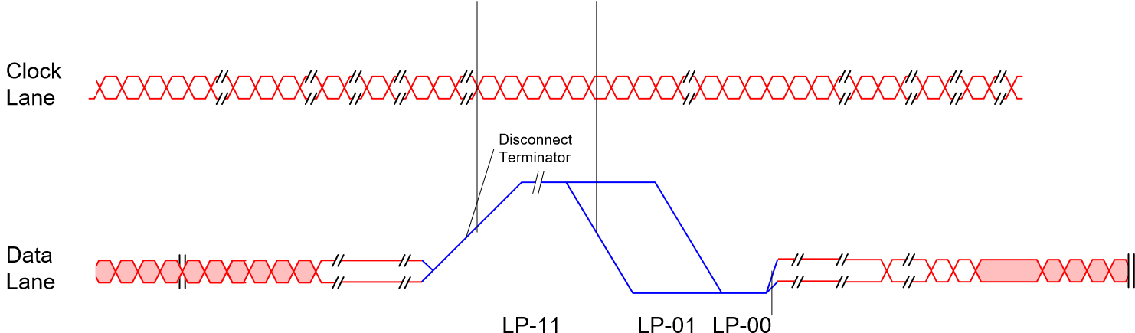

Fig. 21 Signaling Waveform during Line Blanking Period (CSI-2)

Disconnect
Terminator
Data
Lane
Clock
Lane
LP-11
LP-01
LP-00
Frame Blanking

Fig. 22 Signaling Waveform during Frame Blanking Period (CSI-2)

4-1-3 Short Packet & Long Packet

Short Packet Long Packet
4
byte
Frame Count Number
1
byte
byte
2
byte
1
PH
Data ID
Word Count
ECC
VC
Data Type
byte
4
Number of Visible Horizontal Pixels
byte
1
byte
2
byte
1
2
byte
Fixed Register Value
VC
Data Type
PH
Payload Data
PF
Data ID
Word Count
ECC
CRC
2bit 6bit 2bit 6bit

Fig. 23 Short Packet & Long Packet

4-1-4 Data type
Data types of each line are shown as below.
Table 13 Image pixel area and data type
image pixel area | Data Type
Embedded Data Lines | Embedded Data
OBside ineffective area | Null
OB area for internal use | Null
effective OB | OPB Data
Effective area side ineffective area | Null
effective pixel | RAW10 or RAW8 or COMP8

4-1-5 CSI-2 Frame Format
The data format of each line is based on CSI-2 General Frame Format.
The period from a line end sync code to the line start sync code for the next line is called the line blanking period. Likewise, the period from a frame end sync code to the next frame start sync code is called the frame blanking period. Packet header consists of the following data.

Table 14 Sync Code Settings
Header  [7:0] | Description | Setting register | Remarks
[7:6] | Virtual Channel Identifier | Addr: 0x0110 | See Register Section
[7:6] | Virtual Channel Identifier | CSI_channel_identifier | See Register Section
[5:0] | Synch Short Packet Data types | NA
6’h00 | Frame Start Code | NA
6’h01 | Frame End Code | NA
6’h12 | Embedded Data | NA | Written data in the sensor
6’h2A | RAW8 | CSI_data_format | 16’h0808
6’h2B | RAW10 | CSI_data_format | 16’h0A0A

4-1-6 CSI-2 Embedded Data Line
The value of the 2-wire serial communication configuration register can be output at the start of the frame. The output register is indicated in the “Embd DL” column of the 2-wire serial communication Register Map. The Embedded data line is output in the two lines following the sync code FS.

FS
PH | Embedded Data Lines |  | PF
Packet Header | Pixels (effective pixels) |  | Packet Footer
FE

Fig. 24 Frame Format during Embedded Data Line Output

The output method differs according to the data format.
In RAW10 mode, dummy bytes are inserted after outputting 4 bytes of data and tags.

RAW8 (top 8bit, 10b-8b compress) mode Simplified 2-Byte Tagged Data Format Data Format Code
Packet Header
0
A
Tag
Data
Tag
Data
Tag
Data
Tag
Data
07
07
07
07
Packet Footer
07
Padding Characters

Fig. 25 Embedded data lines alignment in RAW8 mode

RAW10 mode Simplified 2-Byte Tagged Data Format
Data Format Code 55h Dummy Bytes 55h Dummy Bytes
Packet Header

A
0

Tag

Data

Tag

55

Data

Tag

Data

07

55

Packet Footer

07

55

07

07

Padding Characters

Fig. 26 Detailed Embedded Data Line Output in RAW10 Output Mode

The end of the address and register value is determined according to the tags embedded in the data.

Table 15 Embedded Data Line Tag
Tag | Data Byte Description
00h | Illegal Tag. If found treat as end of Data
07h | End of Data (Data Byte Value = 07H)
aah | CCI Register Index MSB [15:8]
a5h | CCI Register Index LSB [7:0]
5ah | Auto increment the CCI index after the data byte - valid data Data byte contains valid CCI register data
55h | Auto increment the CCI index after the data byte - null data A CCI register does NOT exist for the current CCI index.  The data byte value is the 07H
ffh | Illegal Tag. If found treat as end of Data

5. Setting Required for Imaging

5-1 Pixel Array Physical Image
Pixel array physical image is shown below. It is the pixel array when upper right corner of the physical image is Pin 1. The IMX219PQH5-C has vertical OB area, which cannot read out. Readout position is explained by Readout Position session

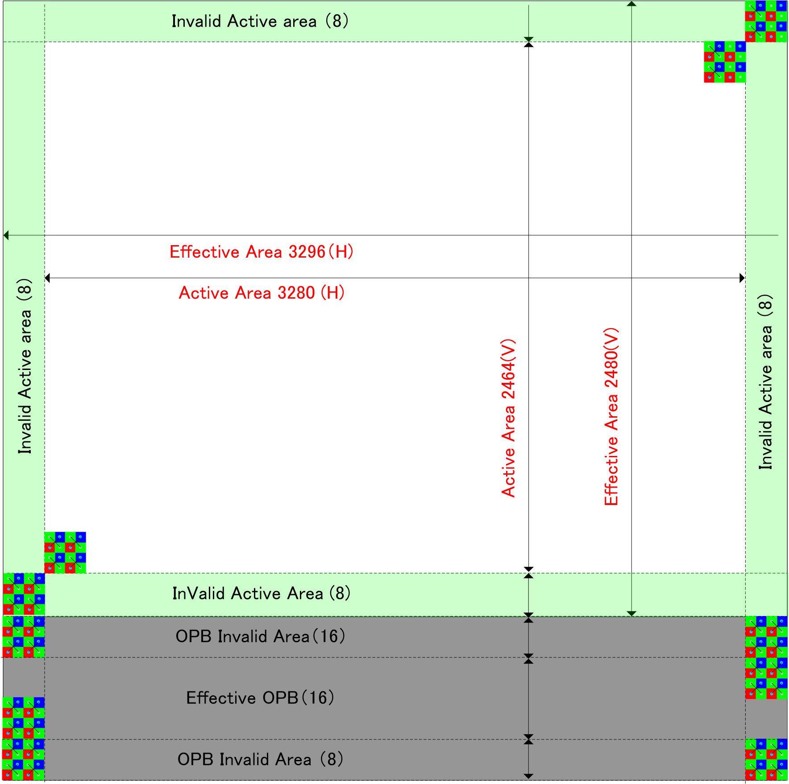

Fig. 27 Pixel Array Physical Image

5-2 Pixel Binning Mode
Binning read-out can be used to obtain an image of lower resolution for full field of view. It has advantage on frame rate than using digital scaling, and on signal-to-noise ratio than using sub-sampling. See Binning Capability Registers, for detail of available configurations.
The following diagram describes on 2x2 averaged binning operations. Pixels of two adjacent rows and columns are averaged, and read out as one output pixel.

Description of pixels in the figure  Pixels with bold lines |  |  | : Pixels read out as binned image  : Pixels just used for averaging
 |  | Other pixels
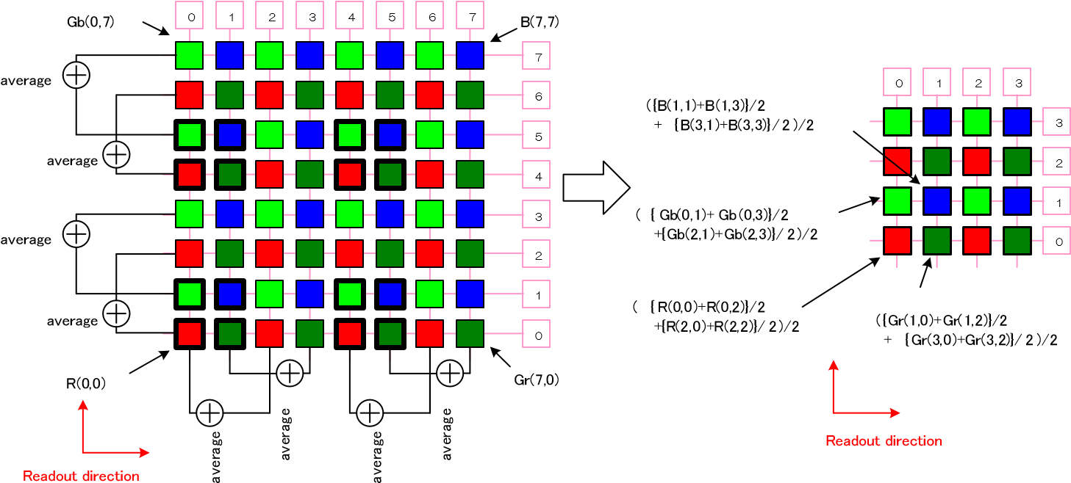
[ Image of full pixels] [ Output image of2 x2 averaged binning]

Fig. 28 Image of 2x2 averaged Binning Mode

For explanation, represent individual pixels with it's addresses in the format “color (x, y) ” - for example, The Red pixel in the lower left corner is expressed as R (0, 0).
By performing 2x2 binning, R (0, 0) after binning is obtained by the following equation.

R (0, 0) after binning = ( {R (0, 0) + R (0, 2)} /2 + {R (2,0) + R (2,2)} /2 ) / 2

And, the total number of output pixels is reduced to 1/4 of the original pixel array.

Settings mode example

Table 16 Mode example
Mode | Full | x2binning | x4binning
Frame rate | 30 frame/s | 120 frame/s | 120 frame/s
H binning | ― | Analog | Digital
H | x1 | x2 | X4
V | x1 | x2 | x4

5-3 image size
The relation of image output size and the register is shown below.

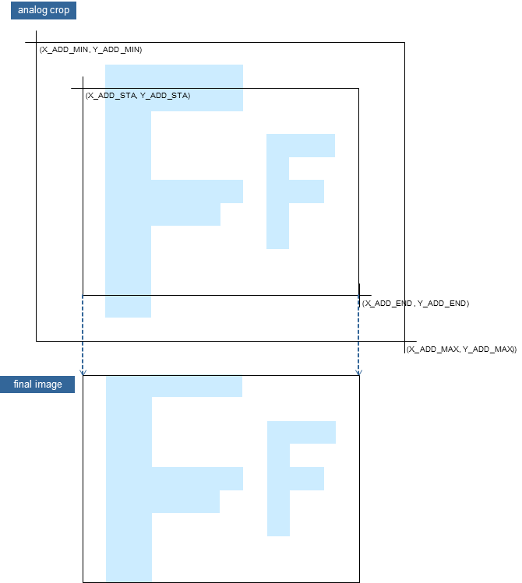

Fig. 29 Image size

5-4 Readout Position
The IMX219PQH5-C default status is readout from the lower left corner when Pin 1 is located in the upper right corner. The image is inverted vertically and horizontally by the lens, so proper image output results when Pin 1 is located in the upper right corner.

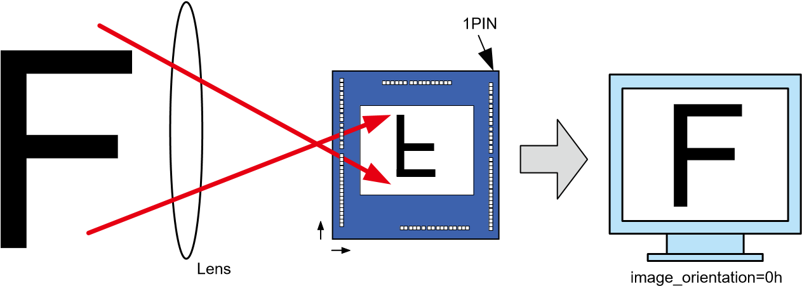

Fig. 30 Readout Position

Readout direction can be set by the registers.

Table 17 Image Orientation Register
CCI register | image_orientation  [0] | Mode
CCI register | 0 | no mirror (Readout from the left with Pin 1 in the upper right corner)
CCI register | 1 | Horizontal Mirror (Readout from the right with Pin 1 in the upper right corner)
CCI register | image_orientation  [1] | Mode
CCI register | 0 | no flip (Readout from the bottom with Pin 1 in the upper right corner)
CCI register | 1 | Vertical Flip (Readout from the top with Pin 1 in the upper right corner)


SO
NY
SONY
SO
NY
SONY
SO
NY
SONY
image_orientation=1h
image_orientation=2h
image_orientation=3h

Fig. 31 Output Image Diagrams for Vertical Flip and Horizontal Mirror

5-5 Frame Rate Calculation Formula
Frame rate in all-pixel scan mode is calculated by the followings.
Frame ate frame/s 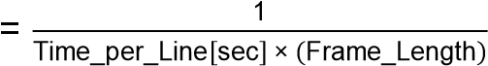
ime Per Line 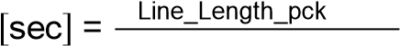 ^{[pix]}
2 Pix Clock Freq[MHz]

[ In the case of (frame_length_lines - 4 > coarse_integration_time) ]: Frame_Length = frame_length_lines
[ In the case of (frame_length_lines - 4 < coarse_integration_time) ]: Frame_Length = coarse_integration_time + 4

5-6 Black Level Control
The IMX219PQH5-C has a stable black level clamp function. The average value of the black level is adjusted to 64d. When selecting output format RAW8, Black level in the table below is divided by 4.

Table 18 Gain Setting Variables
CCI | Black Level (dec)
CCI | 64 (Fixed) RAW10, COMP8
CCI | 16 (Fixed) RAW8

5-7 Storage Time (Electronic Shutter) Settings

5-7-1 Storage Time (Electronic Shutter) Setting Registers
The storage time setting registers are shown below. The value of the register, coarse_integration_time, indicates the number of lines for the storage time.
The maximum storage time value in normal frame rate mode is obtained by subtracting “4” from the number of lines per frame (set by frame_length_lines) including the blanking period.

Table 19 Storage Time Setting Register
CCI  registers | Register name | Address | Setting value (dec) | Remarks
CCI  registers | coarse_integration_time | 0x015A  0x015B  0x025A  0x025B | 1 to frame_length_lines-4 | 0x015A = coarse_integration_time_A[15:8]  0x015B = coarse_integration_time_A[7:0]  0x025A = coarse_integration_time_B[15:8]  0x025B = coarse_integration_time_B[7:0]

The value of the register, fine_integration_time, indicates the number of pixels for the storage time. The register, fine_integration_time, is a fixed value, read only register.

Table 20 Storage Time Offset Register
CCI  registers | Register name | Address | Setting value (dec) |  | Remarks
CCI  registers | fine_integration_time | 0x0388  0x0389 | 500 | RO register

5-7-2 Storage Time Calculation Method
The storage time (T_{SH}) can be obtained from the following equation.

T_{SH} = ( Coarse_Integration_Time × ime Per Line ) + (α pix clk period ) pix_clk_period = 1/Pix_Clock_Freq [MHz]

Where α = offset time = readdable from fine_integration_time register and obtained from the following equation.
α = fine_integration_time / 2

Table 21 Storage Time Setting (in case of Line_Length_pck = 3448)
 | Number of total lines | frame_length | coarse_integration_time [15:0] | Storage time (T_{SH})
 | Dec | Dec | Dec | All-pixel scan[s]
Normal frame rate mode  (4:3 Full-Pel Raw10) | 2728 | 2728  (determined by frame_length_lines  [15:0]) | 1 | (1 x 3448/2 + α) x pix clk period
Normal frame rate mode  (4:3 Full-Pel Raw10) | 2728 | 2728  (determined by frame_length_lines  [15:0]) | N | (N x 3448/2 + α) x pix clk period
Normal frame rate mode  (4:3 Full-Pel Raw10) | 2728 | 2728  (determined by frame_length_lines  [15:0]) | : | :
Normal frame rate mode  (4:3 Full-Pel Raw10) | 2728 | 2728  (determined by frame_length_lines  [15:0]) | 2724 | (2724 x 3448/2 + α) x pix clk period
Low frame rate mode  Long-time exposure | 2729 | 2729 | 2725 | (2725 x 3448/2 + α) x pix clk period
Low frame rate mode  Long-time exposure | 2730 | 2730 | 2726 | (2726 x 3448/2 + α) x pix clk period
Low frame rate mode  Long-time exposure | : | : | : | :
Low frame rate mode  Long-time exposure | 2M+3 | 2M+3 | 2M-1 | ((2M-1) x 3448/2 + α) x pix clk period
Low frame rate mode  Long-time exposure | 2M+4 | 2M+4 | 2M | (2M x 3448/2 + α) x pix clk period
Low frame rate mode  Long-time exposure | : | : | : | :
Low frame rate mode  Long-time exposure | 65534 | 65534 | 65530 | (65530 x 3448/2 + α) x pix clk period

5-8 Gain Settings
Analogue gain and digital gain can be set independently.

5-8-1 Analogue Gain Settings
Only global analogue gain is supported.
The analogue gain is set by the following equation.
Gain analogue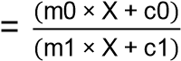
The variables are shown in the table below.

Table 22 Gain Setting Variables
C  C  I  registers |  | Register name | Address | Remarks
C  C  I  registers | m0 | analogue_gain_m0 | 0x008C/0x008D | Fixed to 0
C  C  I  registers | m1 | analogue_gain_m1 | 0x0090/0x0091 | Fixed to -1
C  C  I  registers | c0 | analogue_gain_c0 | 0x008E/0x008F | Fixed to 256
C  C  I  registers | c1 | analogue_gain_c1 | 0x0092/0x0093 | Fixed to 256
C  C  I  registers | X | ANA_GAIN_GLOBAL_A | 0x0157, | 0 to 232
C  C  I  registers | X | ANA_GAIN_GLOBAL_B | 0x0257 | 0 to 232

Therefore, the analogue gain is as follows.
Gain analogue 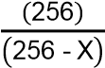
The relationship between the setting value X (analogue_gain_code_global) and the gain is shown on the following page.

Table 23 Analogue Gain Setting
ANA_GAIN_GLOBAL | Gain(times) | Gain(dB) |  | ANA_GAIN_GLOBAL | Gain(times) | Gain(dB) |  | ANA_GAIN_GLOBAL | Gain(times) | Gain(dB) |  | ANA_GAIN_GLOBAL | Gain(times) | Gain(dB)
0 | 1.00 | 0.00 |  | 64 | 1.33 | 2.50 |  | 128 | 2.00 | 6.02 |  | 192 | 4.00 | 12.04
1 | 1.00 | 0.03 |  | 65 | 1.34 | 2.54 |  | 129 | 2.02 | 6.09 |  | 193 | 4.06 | 12.18
2 | 1.01 | 0.07 |  | 66 | 1.34 | 2.59 |  | 130 | 2.03 | 6.16 |  | 194 | 4.13 | 12.32
3 | 1.01 | 0.10 |  | 67 | 1.35 | 2.64 |  | 131 | 2.05 | 6.23 |  | 195 | 4.20 | 12.46
4 | 1.02 | 0.14 |  | 68 | 1.36 | 2.68 |  | 132 | 2.06 | 6.30 |  | 196 | 4.27 | 12.60
5 | 1.02 | 0.17 |  | 69 | 1.37 | 2.73 |  | 133 | 2.08 | 6.37 |  | 197 | 4.34 | 12.75
6 | 1.02 | 0.21 |  | 70 | 1.38 | 2.77 |  | 134 | 2.10 | 6.44 |  | 198 | 4.41 | 12.90
7 | 1.03 | 0.24 |  | 71 | 1.38 | 2.82 |  | 135 | 2.11 | 6.51 |  | 199 | 4.49 | 13.05
8 | 1.03 | 0.28 |  | 72 | 1.39 | 2.87 |  | 136 | 2.13 | 6.58 |  | 200 | 4.57 | 13.20
9 | 1.04 | 0.31 |  | 73 | 1.40 | 2.92 |  | 137 | 2.15 | 6.65 |  | 201 | 4.65 | 13.36
10 | 1.04 | 0.35 |  | 74 | 1.41 | 2.96 |  | 138 | 2.17 | 6.73 |  | 202 | 4.74 | 13.52
11 | 1.04 | 0.38 |  | 75 | 1.41 | 3.01 |  | 139 | 2.19 | 6.80 |  | 203 | 4.83 | 13.68
12 | 1.05 | 0.42 |  | 76 | 1.42 | 3.06 |  | 140 | 2.20 | 6.88 |  | 204 | 4.92 | 13.84
13 | 1.05 | 0.45 |  | 77 | 1.43 | 3.11 |  | 141 | 2.22 | 6.95 |  | 205 | 5.02 | 14.01
14 | 1.05 | 0.49 |  | 78 | 1.44 | 3.16 |  | 142 | 2.24 | 7.03 |  | 206 | 5.12 | 14.19
15 | 1.06 | 0.52 |  | 79 | 1.45 | 3.21 |  | 143 | 2.26 | 7.10 |  | 207 | 5.22 | 14.36
16 | 1.07 | 0.56 |  | 80 | 1.45 | 3.25 |  | 144 | 2.29 | 7.18 |  | 208 | 5.33 | 14.54
17 | 1.07 | 0.60 |  | 81 | 1.46 | 3.30 |  | 145 | 2.30 | 7.26 |  | 209 | 5.45 | 14.72
18 | 1.07 | 0.63 |  | 82 | 1.47 | 3.35 |  | 146 | 2.32 | 7.34 |  | 210 | 5.56 | 14.91
19 | 1.08 | 0.67 |  | 83 | 1.48 | 3.40 |  | 147 | 2.35 | 7.42 |  | 211 | 5.69 | 15.10
20 | 1.08 | 0.71 |  | 84 | 1.49 | 3.45 |  | 148 | 2.37 | 7.50 |  | 212 | 5.82 | 15.30
21 | 1.09 | 0.74 |  | 85 | 1.50 | 3.50 |  | 149 | 2.39 | 7.58 |  | 213 | 5.95 | 15.50
22 | 1.09 | 0.78 |  | 86 | 1.50 | 3.56 |  | 150 | 2.41 | 7.66 |  | 214 | 6.09 | 15.70
23 | 1.10 | 0.82 |  | 87 | 1.51 | 3.61 |  | 151 | 2.44 | 7.74 |  | 215 | 6.24 | 15.91
24 | 1.10 | 0.86 |  | 88 | 1.52 | 3.66 |  | 152 | 2.46 | 7.82 |  | 216 | 6.40 | 16.12
25 | 1.11 | 0.89 |  | 89 | 1.53 | 3.71 |  | 153 | 2.48 | 7.91 |  | 217 | 6.56 | 16.34
26 | 1.11 | 0.93 |  | 90 | 1.54 | 3.76 |  | 154 | 2.51 | 7.99 |  | 218 | 6.73 | 16.57
27 | 1.12 | 0.97 |  | 91 | 1.55 | 3.82 |  | 155 | 2.53 | 8.08 |  | 219 | 6.92 | 16.80
28 | 1.12 | 1.01 |  | 92 | 1.56 | 3.87 |  | 156 | 2.56 | 8.16 |  | 220 | 7.11 | 17.04
29 | 1.13 | 1.04 |  | 93 | 1.57 | 3.92 |  | 157 | 2.58 | 8.25 |  | 221 | 7.31 | 17.28
30 | 1.13 | 1.08 |  | 94 | 1.58 | 3.97 |  | 158 | 2.61 | 8.34 |  | 222 | 7.53 | 17.54
31 | 1.14 | 1.12 |  | 95 | 1.59 | 4.03 |  | 159 | 2.64 | 8.43 |  | 223 | 7.75 | 17.79
32 | 1.14 | 1.16 |  | 96 | 1.60 | 4.08 |  | 160 | 2.66 | 8.52 |  | 224 | 8.00 | 18.06
33 | 1.14 | 1.20 |  | 97 | 1.61 | 4.14 |  | 161 | 2.69 | 8.61 |  | 225 | 8.26 | 18.34
34 | 1.15 | 1.24 |  | 98 | 1.62 | 4.19 |  | 162 | 2.72 | 8.70 |  | 226 | 8.53 | 18.62
35 | 1.16 | 1.28 |  | 99 | 1.63 | 4.25 |  | 163 | 2.75 | 8.80 |  | 227 | 8.82 | 18.92
36 | 1.16 | 1.32 |  | 100 | 1.64 | 4.30 |  | 164 | 2.78 | 8.89 |  | 228 | 9.14 | 19.22
37 | 1.17 | 1.36 |  | 101 | 1.65 | 4.36 |  | 165 | 2.81 | 8.98 |  | 229 | 9.48 | 19.54
38 | 1.17 | 1.40 |  | 102 | 1.66 | 4.41 |  | 166 | 2.84 | 9.08 |  | 230 | 9.84 | 19.87
39 | 1.18 | 1.44 |  | 103 | 1.67 | 4.47 |  | 167 | 2.88 | 9.18 |  | 231 | 10.24 | 20.21
40 | 1.18 | 1.48 |  | 104 | 1.68 | 4.53 |  | 168 | 2.91 | 9.28 |  | 232 | 10.66 | 20.56
41 | 1.19 | 1.52 |  | 105 | 1.70 | 4.59 |  | 169 | 2.94 | 9.37
42 | 1.20 | 1.56 |  | 106 | 1.70 | 4.64 |  | 170 | 2.98 | 9.47
43 | 1.20 | 1.60 |  | 107 | 1.71 | 4.70 |  | 171 | 3.01 | 9.58
44 | 1.21 | 1.64 |  | 108 | 1.73 | 4.76 |  | 172 | 3.05 | 9.68
45 | 1.21 | 1.68 |  | 109 | 1.74 | 4.82 |  | 173 | 3.08 | 9.78
46 | 1.22 | 1.72 |  | 110 | 1.75 | 4.88 |  | 174 | 3.12 | 9.89
47 | 1.22 | 1.76 |  | 111 | 1.76 | 4.94 |  | 175 | 3.16 | 10.00
48 | 1.23 | 1.80 |  | 112 | 1.78 | 5.00 |  | 176 | 3.20 | 10.10
49 | 1.23 | 1.85 |  | 113 | 1.79 | 5.06 |  | 177 | 3.24 | 10.21
50 | 1.24 | 1.89 |  | 114 | 1.80 | 5.12 |  | 178 | 3.28 | 10.32
51 | 1.25 | 1.93 |  | 115 | 1.81 | 5.18 |  | 179 | 3.32 | 10.43
52 | 1.25 | 1.97 |  | 116 | 1.83 | 5.24 |  | 180 | 3.37 | 10.55
53 | 1.26 | 2.01 |  | 117 | 1.84 | 5.30 |  | 181 | 3.41 | 10.66
54 | 1.27 | 2.06 |  | 118 | 1.85 | 5.37 |  | 182 | 3.46 | 10.78
55 | 1.27 | 2.10 |  | 119 | 1.87 | 5.43 |  | 183 | 3.50 | 10.90
56 | 1.28 | 2.14 |  | 120 | 1.88 | 5.49 |  | 184 | 3.55 | 11.02
57 | 1.29 | 2.19 |  | 121 | 1.89 | 5.56 |  | 185 | 3.61 | 11.14
58 | 1.29 | 2.23 |  | 122 | 1.91 | 5.62 |  | 186 | 3.66 | 11.26
59 | 1.30 | 2.28 |  | 123 | 1.92 | 5.69 |  | 187 | 3.71 | 11.39
60 | 1.30 | 2.32 |  | 124 | 1.94 | 5.75 |  | 188 | 3.76 | 11.51
61 | 1.31 | 2.36 |  | 125 | 1.95 | 5.82 |  | 189 | 3.82 | 11.64
62 | 1.32 | 2.41 |  | 126 | 1.97 | 5.89 |  | 190 | 3.88 | 11.77
63 | 1.32 | 2.45 |  | 127 | 1.98 | 5.95 |  | 191 | 3.94 | 11.91

5-8-2 Digital gain settings
The IMX219PQH5-C can set the digital gain for global. The registers required to set the digital gain are as follows.

Table 24 Digital Gain Settings
CCI register name | Upper byte address (Setting range:1 to15) | Lower byte address (Setting range:0 to 255)
DIG_GAIN_GLOBAL_A | 0x0158 | 0x0159
DIG_GAIN_GLOBAL_B | 0x0258 | 0x0259

Each register is comprised of 2 bytes, with the upper byte [15:8] setting the integer portion and the lower byte [7:0] setting the fractional portion of the gain. The gain for global is obtained by the following equation.
Gain digital Upperbyte+ ^{Lowerbyte}

256

The upper byte can be set to a value between 1 and 15, and the lower byte to a value between 0 and 255. Therefore, the digital gain setting range for global is as follows.
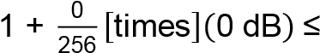Gain digital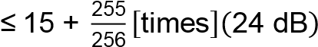

When gain is considered in log linear scale, the adjustment steps are large at low gain and extremely small at high gain. The register values are shown on the following page in case of the gain in log linear manner in 0.1 dB steps.
Table 25 Example of Digital Gain Setting
Upper byte |  | Lower byte |  | Gain(times) | Gain(dB) |  | Upper byte |  | Lower byte |  | Gain(times) | Gain(dB) |  | Upper byte |  | Lower byte |  | Gain(times) | Gain(dB) |  | Upper byte |  | Lower byte |  | Gain(times) | Gain(dB)
dec | hex | dec | hex | Gain(times) | Gain(dB) |  | dec | hex | dec | hex | Gain(times) | Gain(dB) |  | dec | hex | dec | hex | Gain(times) | Gain(dB) |  | dec | hex | dec | hex | Gain(times) | Gain(dB)
1 | 1 | 0 | 0 | 1.00 | 0.00 |  | 1 | 1 | 255 | FF | 2.00 | 6.00 |  | 3 | 3 | 251 | FB | 3.98 | 12.00 |  | 7 | 7 | 241 | F1 | 7.94 | 18.00
1 | 1 | 3 | 3 | 1.01 | 0.10 |  | 2 | 2 | 5 | 5 | 2.02 | 6.11 |  | 4 | 4 | 7 | 7 | 4.03 | 12.10 |  | 8 | 8 | 9 | 9 | 8.04 | 18.10
1 | 1 | 6 | 6 | 1.02 | 0.20 |  | 2 | 2 | 11 | B | 2.04 | 6.21 |  | 4 | 4 | 19 | 13 | 4.07 | 12.20 |  | 8 | 8 | 33 | 21 | 8.13 | 18.20
1 | 1 | 9 | 9 | 1.04 | 0.30 |  | 2 | 2 | 17 | 11 | 2.07 | 6.30 |  | 4 | 4 | 31 | 1F | 4.12 | 12.30 |  | 8 | 8 | 57 | 39 | 8.22 | 18.30
1 | 1 | 12 | C | 1.05 | 0.40 |  | 2 | 2 | 23 | 17 | 2.09 | 6.40 |  | 4 | 4 | 43 | 2B | 4.17 | 12.40 |  | 8 | 8 | 81 | 51 | 8.32 | 18.40
1 | 1 | 15 | F | 1.06 | 0.49 |  | 2 | 2 | 29 | 1D | 2.11 | 6.50 |  | 4 | 4 | 56 | 38 | 4.22 | 12.50 |  | 8 | 8 | 106 | 6A | 8.41 | 18.50
1 | 1 | 18 | 12 | 1.07 | 0.59 |  | 2 | 2 | 35 | 23 | 2.14 | 6.59 |  | 4 | 4 | 68 | 44 | 4.27 | 12.60 |  | 8 | 8 | 131 | 83 | 8.51 | 18.60
1 | 1 | 21 | 15 | 1.08 | 0.68 |  | 2 | 2 | 42 | 2A | 2.16 | 6.71 |  | 4 | 4 | 81 | 51 | 4.32 | 12.70 |  | 8 | 8 | 156 | 9C | 8.61 | 18.70
1 | 1 | 25 | 19 | 1.10 | 0.81 |  | 2 | 2 | 48 | 30 | 2.19 | 6.80 |  | 4 | 4 | 93 | 5D | 4.36 | 12.80 |  | 8 | 8 | 182 | B6 | 8.71 | 18.80
1 | 1 | 28 | 1C | 1.11 | 0.90 |  | 2 | 2 | 55 | 37 | 2.21 | 6.91 |  | 4 | 4 | 106 | 6A | 4.41 | 12.90 |  | 8 | 8 | 207 | CF | 8.81 | 18.90
1 | 1 | 31 | 1F | 1.12 | 0.99 |  | 2 | 2 | 61 | 3D | 2.24 | 7.00 |  | 4 | 4 | 120 | 78 | 4.47 | 13.00 |  | 8 | 8 | 234 | EA | 8.91 | 19.00
1 | 1 | 35 | 23 | 1.14 | 1.11 |  | 2 | 2 | 68 | 44 | 2.27 | 7.10 |  | 4 | 4 | 133 | 85 | 4.52 | 13.10 |  | 9 | 9 | 4 | 4 | 9.02 | 19.10
1 | 1 | 38 | 26 | 1.15 | 1.20 |  | 2 | 2 | 74 | 4A | 2.29 | 7.19 |  | 4 | 4 | 146 | 92 | 4.57 | 13.20 |  | 9 | 9 | 31 | 1F | 9.12 | 19.20
1 | 1 | 41 | 29 | 1.16 | 1.29 |  | 2 | 2 | 81 | 51 | 2.32 | 7.30 |  | 4 | 4 | 160 | A0 | 4.63 | 13.30 |  | 9 | 9 | 58 | 3A | 9.23 | 19.30
1 | 1 | 45 | 2D | 1.18 | 1.41 |  | 2 | 2 | 88 | 58 | 2.34 | 7.40 |  | 4 | 4 | 173 | AD | 4.68 | 13.40 |  | 9 | 9 | 85 | 55 | 9.33 | 19.40
1 | 1 | 48 | 30 | 1.19 | 1.49 |  | 2 | 2 | 95 | 5F | 2.37 | 7.50 |  | 4 | 4 | 187 | BB | 4.73 | 13.50 |  | 9 | 9 | 113 | 71 | 9.44 | 19.50
1 | 1 | 52 | 34 | 1.20 | 1.61 |  | 2 | 2 | 102 | 66 | 2.40 | 7.60 |  | 4 | 4 | 201 | C9 | 4.79 | 13.60 |  | 9 | 9 | 141 | 8D | 9.55 | 19.60
1 | 1 | 55 | 37 | 1.21 | 1.69 |  | 2 | 2 | 109 | 6D | 2.43 | 7.70 |  | 4 | 4 | 215 | D7 | 4.84 | 13.70 |  | 9 | 9 | 169 | A9 | 9.66 | 19.70
1 | 1 | 59 | 3B | 1.23 | 1.80 |  | 2 | 2 | 116 | 74 | 2.45 | 7.79 |  | 4 | 4 | 230 | E6 | 4.90 | 13.80 |  | 9 | 9 | 198 | C6 | 9.77 | 19.80
1 | 1 | 63 | 3F | 1.25 | 1.91 |  | 2 | 2 | 124 | 7C | 2.48 | 7.90 |  | 4 | 4 | 244 | F4 | 4.95 | 13.90 |  | 9 | 9 | 227 | E3 | 9.89 | 19.90
1 | 1 | 66 | 42 | 1.26 | 1.99 |  | 2 | 2 | 131 | 83 | 2.51 | 8.00 |  | 5 | 5 | 3 | 3 | 5.01 | 14.00 |  | 10 | A | 0 | 0 | 10.00 | 20.00
1 | 1 | 70 | 46 | 1.27 | 2.10 |  | 2 | 2 | 138 | 8A | 2.54 | 8.09 |  | 5 | 5 | 18 | 12 | 5.07 | 14.10 |  | 10 | A | 30 | 1E | 10.12 | 20.10
1 | 1 | 74 | 4A | 1.29 | 2.21 |  | 2 | 2 | 146 | 92 | 2.57 | 8.20 |  | 5 | 5 | 33 | 21 | 5.13 | 14.20 |  | 10 | A | 60 | 3C | 10.23 | 20.20
1 | 1 | 78 | 4E | 1.30 | 2.31 |  | 2 | 2 | 154 | 9A | 2.60 | 8.30 |  | 5 | 5 | 48 | 30 | 5.19 | 14.30 |  | 10 | A | 90 | 5A | 10.35 | 20.30
1 | 1 | 81 | 51 | 1.32 | 2.39 |  | 2 | 2 | 161 | A1 | 2.63 | 8.40 |  | 5 | 5 | 64 | 40 | 5.25 | 14.40 |  | 10 | A | 121 | 79 | 10.47 | 20.40
1 | 1 | 85 | 55 | 1.33 | 2.49 |  | 2 | 2 | 169 | A9 | 2.66 | 8.50 |  | 5 | 5 | 79 | 4F | 5.31 | 14.50 |  | 10 | A | 152 | 98 | 10.59 | 20.50
1 | 1 | 89 | 59 | 1.35 | 2.59 |  | 2 | 2 | 177 | B1 | 2.69 | 8.60 |  | 5 | 5 | 95 | 5F | 5.37 | 14.60 |  | 10 | A | 183 | B7 | 10.71 | 20.60
1 | 1 | 93 | 5D | 1.36 | 2.69 |  | 2 | 2 | 185 | B9 | 2.72 | 8.70 |  | 5 | 5 | 111 | 6F | 5.43 | 14.70 |  | 10 | A | 215 | D7 | 10.84 | 20.70
1 | 1 | 97 | 61 | 1.38 | 2.79 |  | 2 | 2 | 193 | C1 | 2.75 | 8.80 |  | 5 | 5 | 127 | 7F | 5.50 | 14.80 |  | 10 | A | 247 | F7 | 10.96 | 20.80
1 | 1 | 101 | 65 | 1.39 | 2.89 |  | 2 | 2 | 201 | C9 | 2.79 | 8.90 |  | 5 | 5 | 143 | 8F | 5.56 | 14.90 |  | 11 | B | 23 | 17 | 11.09 | 20.90
1 | 1 | 106 | 6A | 1.41 | 3.01 |  | 2 | 2 | 210 | D2 | 2.82 | 9.01 |  | 5 | 5 | 160 | A0 | 5.63 | 15.00 |  | 11 | B | 56 | 38 | 11.22 | 21.00
1 | 1 | 110 | 6E | 1.43 | 3.10 |  | 2 | 2 | 218 | DA | 2.85 | 9.10 |  | 5 | 5 | 176 | B0 | 5.69 | 15.10 |  | 11 | B | 90 | 5A | 11.35 | 21.10
1 | 1 | 114 | 72 | 1.45 | 3.20 |  | 2 | 2 | 226 | E2 | 2.88 | 9.20 |  | 5 | 5 | 193 | C1 | 5.75 | 15.20 |  | 11 | B | 123 | 7B | 11.48 | 21.20
1 | 1 | 118 | 76 | 1.46 | 3.29 |  | 2 | 2 | 235 | EB | 2.92 | 9.30 |  | 5 | 5 | 210 | D2 | 5.82 | 15.30 |  | 11 | B | 157 | 9D | 11.61 | 21.30
1 | 1 | 123 | 7B | 1.48 | 3.41 |  | 2 | 2 | 244 | F4 | 2.95 | 9.41 |  | 5 | 5 | 227 | E3 | 5.89 | 15.40 |  | 11 | B | 192 | C0 | 11.75 | 21.40
1 | 1 | 127 | 7F | 1.50 | 3.50 |  | 2 | 2 | 252 | FC | 2.98 | 9.50 |  | 5 | 5 | 245 | F5 | 5.96 | 15.50 |  | 11 | B | 227 | E3 | 11.89 | 21.50
1 | 1 | 131 | 83 | 1.51 | 3.59 |  | 3 | 3 | 5 | 5 | 3.02 | 9.60 |  | 6 | 6 | 7 | 7 | 6.03 | 15.60 |  | 12 | C | 6 | 6 | 12.02 | 21.60
1 | 1 | 136 | 88 | 1.53 | 3.70 |  | 3 | 3 | 14 | E | 3.05 | 9.70 |  | 6 | 6 | 24 | 18 | 6.09 | 15.70 |  | 12 | C | 41 | 29 | 12.16 | 21.70
1 | 1 | 140 | 8C | 1.55 | 3.79 |  | 3 | 3 | 23 | 17 | 3.09 | 9.80 |  | 6 | 6 | 42 | 2A | 6.16 | 15.80 |  | 12 | C | 77 | 4D | 12.30 | 21.80
1 | 1 | 145 | 91 | 1.57 | 3.90 |  | 3 | 3 | 32 | 20 | 3.13 | 9.90 |  | 6 | 6 | 61 | 3D | 6.24 | 15.90 |  | 12 | C | 114 | 72 | 12.45 | 21.90
1 | 1 | 150 | 96 | 1.59 | 4.01 |  | 3 | 3 | 42 | 2A | 3.16 | 10.00 |  | 6 | 6 | 79 | 4F | 6.31 | 16.00 |  | 12 | C | 151 | 97 | 12.59 | 22.00
1 | 1 | 154 | 9A | 1.60 | 4.09 |  | 3 | 3 | 51 | 33 | 3.20 | 10.10 |  | 6 | 6 | 98 | 62 | 6.38 | 16.10 |  | 12 | C | 188 | BC | 12.73 | 22.10
1 | 1 | 159 | 9F | 1.62 | 4.20 |  | 3 | 3 | 60 | 3C | 3.23 | 10.20 |  | 6 | 6 | 117 | 75 | 6.46 | 16.20 |  | 12 | C | 226 | E2 | 12.88 | 22.20
1 | 1 | 164 | A4 | 1.64 | 4.30 |  | 3 | 3 | 70 | 46 | 3.27 | 10.30 |  | 6 | 6 | 136 | 88 | 6.53 | 16.30 |  | 13 | D | 8 | 8 | 13.03 | 22.30
1 | 1 | 169 | A9 | 1.66 | 4.40 |  | 3 | 3 | 80 | 50 | 3.31 | 10.40 |  | 6 | 6 | 155 | 9B | 6.61 | 16.40 |  | 13 | D | 47 | 2F | 13.18 | 22.40
1 | 1 | 174 | AE | 1.68 | 4.50 |  | 3 | 3 | 90 | 5A | 3.35 | 10.50 |  | 6 | 6 | 175 | AF | 6.68 | 16.50 |  | 13 | D | 86 | 56 | 13.34 | 22.50
1 | 1 | 179 | B3 | 1.70 | 4.60 |  | 3 | 3 | 99 | 63 | 3.39 | 10.60 |  | 6 | 6 | 195 | C3 | 6.76 | 16.60 |  | 13 | D | 125 | 7D | 13.49 | 22.60
1 | 1 | 184 | B8 | 1.72 | 4.70 |  | 3 | 3 | 109 | 6D | 3.43 | 10.70 |  | 6 | 6 | 215 | D7 | 6.84 | 16.70 |  | 13 | D | 165 | A5 | 13.64 | 22.70
1 | 1 | 189 | BD | 1.74 | 4.80 |  | 3 | 3 | 120 | 78 | 3.47 | 10.80 |  | 6 | 6 | 235 | EB | 6.92 | 16.80 |  | 13 | D | 206 | CE | 13.80 | 22.80
1 | 1 | 194 | C2 | 1.76 | 4.90 |  | 3 | 3 | 130 | 82 | 3.51 | 10.90 |  | 7 | 7 | 0 | 0 | 7.00 | 16.90 |  | 13 | D | 247 | F7 | 13.96 | 22.90
1 | 1 | 199 | C7 | 1.78 | 5.00 |  | 3 | 3 | 140 | 8C | 3.55 | 11.00 |  | 7 | 7 | 20 | 14 | 7.08 | 17.00 |  | 14 | E | 32 | 20 | 14.13 | 23.00
1 | 1 | 205 | CD | 1.80 | 5.11 |  | 3 | 3 | 151 | 97 | 3.59 | 11.10 |  | 7 | 7 | 41 | 29 | 7.16 | 17.10 |  | 14 | E | 74 | 4A | 14.29 | 23.10
1 | 1 | 210 | D2 | 1.82 | 5.20 |  | 3 | 3 | 161 | A1 | 3.63 | 11.20 |  | 7 | 7 | 63 | 3F | 7.25 | 17.20 |  | 14 | E | 116 | 74 | 14.45 | 23.20
1 | 1 | 215 | D7 | 1.84 | 5.30 |  | 3 | 3 | 172 | AC | 3.67 | 11.30 |  | 7 | 7 | 84 | 54 | 7.33 | 17.30 |  | 14 | E | 159 | 9F | 14.62 | 23.30
1 | 1 | 221 | DD | 1.86 | 5.41 |  | 3 | 3 | 183 | B7 | 3.71 | 11.40 |  | 7 | 7 | 106 | 6A | 7.41 | 17.40 |  | 14 | E | 203 | CB | 14.79 | 23.40
1 | 1 | 226 | E2 | 1.88 | 5.50 |  | 3 | 3 | 194 | C2 | 3.76 | 11.50 |  | 7 | 7 | 128 | 80 | 7.50 | 17.50 |  | 14 | E | 246 | F6 | 14.96 | 23.50
1 | 1 | 232 | E8 | 1.91 | 5.60 |  | 3 | 3 | 205 | CD | 3.80 | 11.60 |  | 7 | 7 | 150 | 96 | 7.59 | 17.60 |  | 15 | F | 35 | 23 | 15.14 | 23.60
1 | 1 | 237 | ED | 1.93 | 5.69 |  | 3 | 3 | 217 | D9 | 3.85 | 11.70 |  | 7 | 7 | 172 | AC | 7.67 | 17.70 |  | 15 | F | 80 | 50 | 15.31 | 23.70
1 | 1 | 243 | F3 | 1.95 | 5.80 |  | 3 | 3 | 228 | E4 | 3.89 | 11.80 |  | 7 | 7 | 195 | C3 | 7.76 | 17.80 |  | 15 | F | 125 | 7D | 15.49 | 23.80
1 | 1 | 249 | F9 | 1.97 | 5.90 |  | 3 | 3 | 239 | EF | 3.93 | 11.90 |  | 7 | 7 | 218 | DA | 7.85 | 17.90 |  | 15 | F | 171 | AB | 15.67 | 23.90
 |  |  |  |  |  |  |  |  |  |  |  |  |  |  |  |  |  |  |  |  | 15 | F | 217 | D9 | 15.85 | 24.00

6. On Chip Image Processing
Data flow of our “On-Chip Image Processing” is written in following figure.
A/D-converted digital signal is input, and processed data is asserted from CSI-2.

Analog
ue

Domain

Test

Pattern

Generator

Digital

Gain

Setting

Blac
k

Level

Adjust

Defect

Correction

Pixel

Re
-
align

In

H

direction

FIFO

default mode

Fig. 32 Data Flow Diagram

6-1 Test Pattern Generator
The IMX219PQH5-C can output test signals using the internal pattern generator.

6-1-1 Test Pattern
The test pattern output function outputs fixed pattern image data from the IMX219PQH5-C. Built-in image patterns can be output by setting the necessary registers.
The registers must be set by communication to output the test pattern. There are no restrictions on the sequence for setting the registers related to test pattern output. The prescribed output is obtained by setting the necessary registers while the sensor is operating.

Table 26 Description of Test Pattern Registers
Address | Name | Description
0x0600 | test_pattern_mode | 0000h– no pattern (default)  0001h – solid color  0002h – 100 % color bars  0003h – fade to grey color bar  0004h – PN9  0005h – 16 split color bar  0006h – 16 split inverted color bar  0007h – column counter  0008h – inverted column counter  0009h – PN31
0x0601 | test_pattern_mode
0x0602 | TD_R[9:8] | test_data_red test_data_red
0x0603 | TD_R[7:0] | test_data_red test_data_red
0x0604 | TD_GR[9:8] | test_data_greenR test_data_greenR
0x0605 | TD_GR[7:0] | test_data_greenR test_data_greenR
0x0606 | TD_B[9:8] | test_data_blue test_data_blue
0x0607 | TD_B[7:0] | test_data_blue test_data_blue
0x0608 | TD_GB[9:8] | test_data_greenB test_data_greenB
0x0609 | TD_GB[7:0] | test_data_greenB test_data_greenB
0x060A | H_CUR_WIDTH[15:8] | horizontal_cursor_width horizontal_cursor_width
0x060B | H_CUR_WIDTH[7:0] | horizontal_cursor_width horizontal_cursor_width
0x060C | H_CUR_POS[15:8] | horizontal_cursor_position horizontal_cursor_position
0x060D | H_CUR_POS[7:0] | horizontal_cursor_position horizontal_cursor_position
0x060E | V_CUR_WIDTH[15:8] | vertical_cursor_width vertical_cursor_width
0x060F | V_CUR_WIDTH[7:0] | vertical_cursor_width vertical_cursor_width
0x0610 | V_CUR_POS[15:8] | vertical_cursor_position vertical_cursor_position
0x0611 | V_CUR_POS[7:0] | vertical_cursor_position vertical_cursor_position
0x0612 | FRM_RST_OFF | Frame reset control w/ PN9,PN31  0: Frame reset ON (default)  1: Frame reset OFF
0x0620 | TP_WINDOW_X_OFFSET[11:8] | test_pattern_window_x_offset
0x0621 | TP_WINDOW_X_OFFSET[7:0] | test_pattern_window_x_offset
0x0622 | TP_WINDOW_Y_OFFSET[11:8] | test_pattern_window_y_offset
0x0623 | TP_WINDOW_Y_OFFSET[7:0] | test_pattern_window_y_offset
0x0624 | TP_WINDOW_WIDTH[11:8] | test_pattern_window_width
0x0625 | TP_WINDOW_WIDTH[7:0] | test_pattern_window_width
0x0626 | TP_WINDOW_HEIGHT[11:8] | test_pattern_window_height
0x0627 | TP_WINDOW_HEIGHT[7:0] | test_pattern_window_height

6-1-1-1 Pattern Description
Table 27 Description of Test Patterns

100
% color bar
test_pattern_mode = 0002h
Embedded data line

fade to gray colo
r bar
test_pattern_mo
de = 0003h

Embedded data line

16 split Color Bar Chart test_pattern_mode = 0005h
Embedded data line

Inversed 16 split Color Bar Chart test_pattern_mode = 0006h
Embedded data line

column counter
test_pattern_mode = 0007h
Embedded data line

inverted column counter test_pattern_mode = 0008h
Embedded data line

6-2 Digital Gain Setting
See Digital gain settings section.

6-3 Black Level Adjust
The register required to set the Black Level Adjust is as follows.

Table 28 Black Level Adjust Setting Register
Index (HEX) | Bit | Register Name | RW | Comment | Re-Timed | Default (HEX)
D1EA | [1:0] | DT_PEDESTAL[9:8] | RW | Set Black Level |  | 0
D1EB | [7:0] | DT_PEDESTAL[7:0] | RW | Set Black Level |  | 40

6-4 Defect Correction
The registers required to set the Defect Correction are as follows.
3 different functions are implemented; (Please refer to “7-5 Defects Address registration” session);
1.Static single defect pixel correction
2.Static same color adjoin pixel correction
3.Static 2x4 defect pixel correction

Defect addresses for mapped_couplet_correct (couplet defect: two adjacent defect pixels of the same color) are stored in NVM , and sensor processes them in itself.

6-5 Pixel Re-alignment H Direction
The registers required to set the Pixel Re-alignment H Direction are as follows.

Table 29 Pixel Re-alignment H Direction Setting Registers
Index | Byte | Register Name | RW | Comment | Re-Time | Default (HEX) | Embd DL
0x0164 | [3:0] | X_ADD_STA_A[11:8] | RW | x_addr_start | Frame Bank | 0 | ○
0x0165 | [7:0] | X_ADD_STA_A[7:0] | RW | x_addr_start | Frame Bank | 00 | ○
0x0166 | [3:0] | X_ADD_END_A[11:8] | RW | x_addr_end | Frame Bank | C | ○
0x0167 | [7:0] | X_ADD_END_A[7:0] | RW | x_addr_end | Frame Bank | CF | ○
0x0264 | [3:0] | X_ADD_STA_B[11:8] | RW | x_addr_start | Frame Bank | 0 | ○
0x0265 | [7:0] | X_ADD_STA_B[7:0] | RW | x_addr_start | Frame Bank | 00 | ○
0x0266 | [3:0] | X_ADD_END_B[11:8] | RW | x_addr_end | Frame Bank | C | ○
0x0267 | [7:0] | X_ADD_END_B[7:0] | RW | x_addr_end | Frame Bank | CF | ○
0x0174 | [0] | BINNING_MODE_H_A | RW | defines binning mode (H-direction).  0: no-binning,  1: x2-binning  2: x4-binning  3: x2-analog (special) binning | Frame Bank | 0 | ○
0x0274 | [0] | BINNING_MODE_H_B | RW | defines binning mode (H-direction).  0: no-binning,  1: x2-binning  2: x4-binning  3: x2 analog (special) binning | Frame Bank | 0 | ○

6-6 Pixel Re-alignment V Direction
The registers required to set the Pixel Re-alignment H Direction are as follows.

Table 30 Pixel Re-alignment V Direction Setting Registers
Index | Byte | Register Name | RW | Comment | Re-Time | Default (HEX) | Embd DL
0x168 | [3:0] | Y_ADD_STA_A[11:8] | RW | y_addr_start | Frame Bank | 00 | ○
0x169 | [7:0] | Y_ADD_STA_A[7:0] | RW |  | Frame Bank | 00 | ○
0x16A | [3:0] | Y_ADD_END_A[11:8] | RW | y_addr_end | Frame Bank | 09 | ○
0x16B | [7:0] | Y_ADD_END_A[7:0] | RW |  | Frame Bank | 9F | ○
0x268 | [3:0] | Y_ADD_STA_B[11:8] | RW | y_addr_start | Frame Bank |  | ○
0x269 | [7:0] | Y_ADD_STA_B[7:0] | RW |  | Frame Bank |  | ○
0x26A | [3:0] | Y_ADD_END_B[11:8] | RW | y_addr_end | Frame Bank |  | ○
0x26B | [7:0] | Y_ADD_END_B[7:0] | RW |  | Frame Bank |  | ○
0x175 | [0] | BINNING_MODE_V_A | RW | defines binning mode (V-direction).  0:no-binning  1:x2-binning  2:x4-binning  3:x2 analog (special) binning | Frame Bank |  | ○
0x275 | [0] | BINNING_MODE_V_B | RW | defines binning mode (V-direction). 0:no-binning  1:x2-binning  2:x4-binning  3:x2 analog (special) binning | Frame Bank |  | ○

7. NVM Memory Map

7-1 Block Diagram
CCI
Control
Block
NVM
Access
Control
ECC
(
)
NVM
Pipeline
Pixel Controller

Fig. 33 Block Diagram

NVM is composed of 12 pages (from 0 to 11) and 64 bytes per page. ECC is also applied for every 16 address (bytes), 4 rows in 1 page.

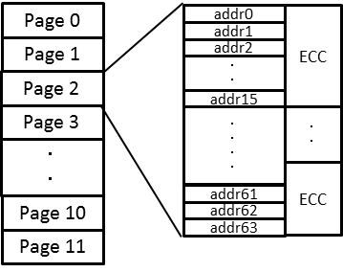
Fig. 34 NVM Map structure

7-2 NVM Functions
NVM block has following functions.
Table 31 Functions via NVM
No | Item | Description
1 | Data Interface | User can write/read data via CCI by the unit of page
2 | Writing Reg. Value | Writing assigned address and values which are transferred into the assigned registers.  (Please refer to Related Registers session “Then when writing; ”)
3 | Writing Defect address | Writing assigned address, whose values are used for defect corrections (Please refer to Defects Address registration session)
4 | Reading | Reading NVM data by the unit of page, not ECC region  (Please refer to Related Registers session “Then when reading;”)
5 | ECC Function | Can apply ECC for each 16 bytes (1-row) block. 1-bit per 16 bytes can be corrected.
6 | ECC status | Can check while reading/writing that ECC is applied by page.  - Read data is correct. No ECC is applied.  - Read data is correct with 1-bit correction of ECC.  - Read data is incorrect though ECC is applied (means >2 bits per a unit of 16-byte (row) are incorrect).

7-3 Related Registers
Table 32 Related Registers
Index | Byte | Register Name | RW | Comment | Re-Time | Default (HEX) | Embd DL | Comments
0100 | [0] | Mode_sel | RW | Mode select  0: SW- Standby  1: Streaming |  | 0
3300 | [7:0] | SYSOTP_IF_MODE1 | RW | OTP mode setting  [1:0]: control access cycle to fuse cell  00: INCK cycle  01: INCK/2 cycle  10: INCK/4 cycle  11: INCK/8 cycle  [3]: ECC disable switch  0: ECC on,1:ECC off  [5]:write mode;  0: test mode  1: recommended |  | 00
5E54 | [7:0] | OUTF | RW | Monitor Output Enable |  | C0
5E59 | [7:0] | TESTMNT1 | RW | Monitor Output |  | 00
4053 | [7:0] | TEST_FSTRB | RW | Set FStrobe pin to monitor |  | 00
012A | [7:0] | EXCK_FREQ [15:8] | RW | input_clk_frequency_mhz (default = 7.6[MHz]) |  | 07
012B | [7:0] | EXCK_FREQ [7:0] | RW | input_clk_frequency_mhz (default = 7.6[MHz]) |  | 99
3302 | [7:0] | SYSOTP_IF_WRCNT[15:8] | RW | OTP write clock setting |  | 00
3303 | [7:0] | SYSOTP_IF_WRCNT[7:0] | RW | OTP write clock setting |  | 00
3200 | [2:0] | OTPIF_CTRL | RW | OTP I/F control register [0] enable [1]R/W [2]error clear |  | 0
3201 | [1:0] | OTPIF_STATUS | RO-D | OTP I/F status; [0] read ready  - write ready  - 0: normal  1: Data error exists, and cannot be corrected by ECC.  Read data is incorrect. |  | 0
3202 | [2:0] | OTPIF_PAGE_SELECT | RW | otpif_page_select |  | 0
3204 | [7:0] | OTPIF_DT_0 | RW | otpif_data_0 |  | 00
(DT_1 to DT_62)
3243 | [7:0] | OTPIF_DT_63 | RW | otpif_data_63 |  | 00 |  | Trigger to start write sequence

Before writing / reading following steps are required
- Set Sensor being SW-Standby by 0x0100 = 0h
- Wait one frame time (See t0 in 8-2 Power off sequence session) when previous status is streaming.
- Set monitor output to check writing pulse by 0x5E54=00h and 0x5E59=FFh, 4053=0Ah. (option, debug purpose only)
- Set OTP write clock setting. (target = 25 µS)
(When INCK = 12.0 MHz, “wrcnt” should be set to 012Ch (target = 25µs : 300d) at 0x3302, 0x3303)

Then when writing;
- Set controller "ECC ON" or ECC OFF" by 0x3300 = "20h" (ECC ON) or "28h" (ECC OFF)
- Set Write by 0x3200 = "3h." 3. Set page from 0 to 11 by 0x3202.
- Set 0x3204 to 0x3243 OTPIF_DT_0to 63 = xxh (Data to Write) Please overwrite all values when you program next page.
OTP controller does NOT clear previous values automatically.
- Set last byte of OTP buffer 0x3243 need to write again with same value of step4 6. Wait write sequence finish ( >12.8msec:target [25µs /bit] x 8 bit x 16btye x 4row)
7. Repeat the above (3) – (6) sequence again for twice write process.

Then when reading;
- Set controller “ECC ON” or “ECC OFF” by 0x3300 = 00h (ECC ON), 08h (ECC OFF) ;
- Set Read by 0x3200 = "1h." 3. Set page from 0 to 11 by 0x3202.
4. Set 0x3204 to 0x3243 OTPIF_DT_0to 63 = xxh (Data to Write)

7-4 NVM Memory Map

Table 33 NVM Memory capacity
Capacity | data Owner
768 byte | Total
672 byte | Integrator
96 byte | Sony

Table 34 NVM Memory Map Example
Page (dec) | Row  (dec) | Addr (hex) | Category | Name | Value (hex) | data Owner
0 | 0-3 | 000 - 03F |  |  |  | Integrator
1 | 4-7 | 040 - 07F |  |  |  | Integrator
2 | 8-11 | 080 - 0BF |  |  |  | Integrator
3 | 12-15 | 0C0 - 0FF |  |  |  | Integrator
4 | 16-19 | 100 - 13F |  |  |  | Integrator
5 | 20-23 | 140 - 17F |  |  |  | Integrator
6 | 24-27 | 180 - 1BF |  |  |  | Integrator
7 | 28-31 | 1C0 - 1FF |  |  |  | Integrator
8 | 32-35 | 200 - 23F |  |  |  | Integrator
9 | 36-39 | 240 - 27F |  |  |  | Integrator
10 | 40-41 | 280 - 29F |  |  |  | Integrator
10 | 42 | 2A0 | memcfg1 | Defines availability of each data  [7:1] reserved  [0]: defect address available  Value 0x00 makes sensor skip copying data from NVM to register. | 01 | Integrator
10 | 42 | 2A1 | Defect Correction | defect_num[7:0] |  | Integrator
10 | 42 | 2A2 | Defect Correction | {DFCT_SRC_10[1:0]CP_DFCT_DIR_10[1:0]  H_DFCT_ADDR_10[11:9]} |  | Integrator
10 | 42 | 2A3 | Defect Correction | H_DFCT_ADDR_10[7:0] |  | Integrator
10 | 42 | 2A4 | Defect Correction | V_DFCT_ADDR_10[11:4] |  | Integrator
10 | 42 | 2A5 | Defect Correction | {V_DFCT_ADDR_10[3:0]  DFCT_SRC_11[1:0]CP_DFCT_DIR_11[1:0]} |  | Integrator
10 | 42 | 2A6 | Defect Correction | H_DFCT_ADDR_11[11:4] |  | Integrator
10 | 42 | 2A7 | Defect Correction | {H_DFCT_ADDR_11[3:0], V_DFCT_ADDR_11[11:8]} |  | Integrator
10 | 42 | 2A8 | Defect Correction | V_DFCT_ADDR_11[7:0] |  | Integrator
10 | 42 | 2A9 | Defect Correction | {DFCT_SRC_12[1:0]CP_DFCT_DIR_12[1:0]  H_DFCT_ADDR_12[11:8]} |  | Integrator
10 | 42 | 2AA | Defect Correction | H_DFCT_ADDR_12[7:0] |  | Integrator
10 | 42 | 2AB | Defect Correction | V_DFCT_ADDR_12[11:4] |  | Integrator
10 | 42 | 2AC | Defect Correction | {V_DFCT_ADDR_12[3:0]  DFCT_SRC_13[1:0]CP_DFCT_DIR_13[1:0]} |  | Integrator
10 | 42 | 2AD | Defect Correction | H_DFCT_ADDR_13[11:4] |  | Integrator
10 | 42 | 2AE | Defect Correction | {H_DFCT_ADDR_13[3:0], V_DFCT_ADDR_13[11:8]} |  | Integrator
10 | 42 | 2AF | Defect Correction | H_DFCT_ADDR_13[7:0] |  | Integrator
10 | 43 | 2B0 | please don't write | Defect number |  | Sony
10 | 43 | 2B1 | please don't write | Defect address (single, 2 adjacent in same color , 2x4 static),10 address |  | Sony

Page (dec) | Row  (dec) | Addr (hex) | Category | Name | Value (hex) | data Owner
10 | 43 | 2B2 | please don't write | Defect address (single, 2 adjacent in same color , 2x4 static),10 address |  | Sony
10 | 43 | 2B3 | please don't write | Defect address (single, 2 adjacent in same color , 2x4 static),10 address |  | Sony
10 | 43 | 2B4 | please don't write | Defect address (single, 2 adjacent in same color , 2x4 static),10 address |  | Sony
10 | 43 | 2B5 | please don't write | Defect address (single, 2 adjacent in same color , 2x4 static),10 address |  | Sony
10 | 43 | 2B6 | please don't write | Defect address (single, 2 adjacent in same color , 2x4 static),10 address |  | Sony
10 | 43 | 2B7 | please don't write | Defect address (single, 2 adjacent in same color , 2x4 static),10 address |  | Sony
10 | 43 | 2B8 | please don't write | Defect address (single, 2 adjacent in same color , 2x4 static),10 address |  | Sony
10 | 43 | 2B9 | please don't write | Defect address (single, 2 adjacent in same color , 2x4 static),10 address |  | Sony
10 | 43 | 2BA | please don't write | Defect address (single, 2 adjacent in same color , 2x4 static),10 address |  | Sony
10 | 43 | 2BB | please don't write | Defect address (single, 2 adjacent in same color , 2x4 static),10 address |  | Sony
10 | 43 | 2BC | please don't write | Defect address (single, 2 adjacent in same color , 2x4 static),10 address |  | Sony
10 | 43 | 2BD | please don't write | Defect address (single, 2 adjacent in same color , 2x4 static),10 address |  | Sony
10 | 43 | 2BE | please don't write | Defect address (single, 2 adjacent in same color , 2x4 static),10 address |  | Sony
10 | 43 | 2BF | please don't write | Defect address (single, 2 adjacent in same color , 2x4 static),10 address |  | Sony
11 | 44 | 2C0 | please don't write | Defect address (single, 2 adjacent in same color , 2x4 static),10 address |  | Sony
11 | 44 | 2C1 | please don't write | Defect address (single, 2 adjacent in same color , 2x4 static),10 address |  | Sony
11 | 44 | 2C2 | please don't write | Defect address (single, 2 adjacent in same color , 2x4 static),10 address |  | Sony
11 | 44 | 2C3 | please don't write | Defect address (single, 2 adjacent in same color , 2x4 static),10 address |  | Sony
11 | 44 | 2C4 | please don't write | Defect address (single, 2 adjacent in same color , 2x4 static),10 address |  | Sony
11 | 44 | 2C5 | please don't write | Defect address (single, 2 adjacent in same color , 2x4 static),10 address |  | Sony
11 | 44 | 2C6 | please don't write | Defect address (single, 2 adjacent in same color , 2x4 static),10 address |  | Sony
11 | 44 | 2C7 | please don't write | Defect address (single, 2 adjacent in same color , 2x4 static),10 address |  | Sony
11 | 44 | 2C8 | please don't write | Defect address (single, 2 adjacent in same color , 2x4 static),10 address |  | Sony
11 | 44 | 2C9 | please don't write | Defect address (single, 2 adjacent in same color , 2x4 static),10 address |  | Sony
11 | 44 | 2CA | please don't write | Defect address (single, 2 adjacent in same color , 2x4 static),10 address |  | Sony
11 | 44 | 2CB | please don't write | Defect address (single, 2 adjacent in same color , 2x4 static),10 address |  | Sony
11 | 44 | 2CC | please don't write | Defect address (single, 2 adjacent in same color , 2x4 static),10 address |  | Sony
11 | 44 | 2CD | please don't write | Defect address (single, 2 adjacent in same color , 2x4 static),10 address |  | Sony
Page (dec) | Row  (dec) | Addr (hex) | Category | Name | Value (hex) | data Owner
11 | 44 | 2CE | please don't write | Defect address (single, 2 adjacent in same color , 2x4 static),10 address |  | Sony
11 | 44 | 2CF | please don't write | Defect address (single, 2 adjacent in same color , 2x4 static),10 address |  | Sony
11 | 45 | 2D0 | please don't write | Defect address (single, 2 adjacent in same color , 2x4 static),10 address |  | Sony
11 | 45 | 2D1 | please don't write | Defect address (single, 2 adjacent in same color , 2x4 static),10 address |  | Sony
11 | 45 | 2D2 | please don't write | Defect address (single, 2 adjacent in same color , 2x4 static),10 address |  | Sony
11 | 45 | 2D3 | please don't write | Defect address (single, 2 adjacent in same color , 2x4 static),10 address |  | Sony
11 | 45 | 2D4 - 2DF | please don't write | Sony Calibration Area |  | Sony
11 | 46 | 2E0 - 2E5 | please don't write | Sony Calibration Area |  | Sony
11 | 46 | 2E6 | Fabrication, copy to 0x0002 | Sony Calibration Area |  | Sony
11 | 46 | 2E7 | Lot ID, copy to 0x0004 | Sony Calibration Area |  | Sony
11 | 46 | 2E8 | Lot ID, copy to 0x0005 | Sony Calibration Area |  | Sony
11 | 46 | 2E9 | Lot ID, copy to 0x0006 | Sony Calibration Area |  | Sony
11 | 46 | 2EA | Wafer Number, copy to 0x0007 | Sony Calibration Area |  | Sony
11 | 46 | 2EB | Chip Number, copy to 0x000D | Sony Calibration Area |  | Sony
11 | 46 | 2EC | Chip Number, copy to 0x000E | Sony Calibration Area |  | Sony
11 | 46 | 2ED | Process revision, 0x000F | Sony Calibration Area |  | Sony
11 | 46 | 2EE - 2EF | please don't write | Sony Calibration Area |  | Sony
11 | 47 | 2F0 - 2FF | please don't write | Sony Calibration Area |  | Sony

7-5 Defects Address registration
The single defect, the same color adjoining (SCA) defect and 2 x 4 defect are stored into NVM and corrected.

7-5-1 Single defect address
1. Target Address; (x, y) = (xt, yt)
*Output area is Effective Area
Output size is 3280x2464 (0,0) - (3279,2463) x = image area address + offset; offset = 8d
y = image area address + offset; offset = 48d (not include embedded lines)

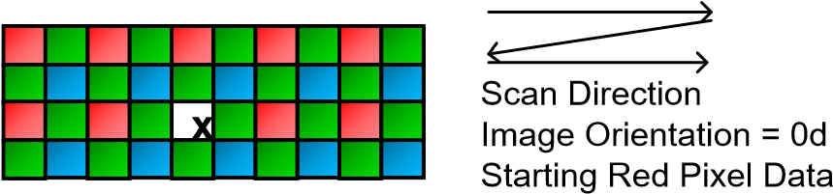

Fig. 35 Single defect

7-5-2 Same Color Adjoining defect address
- Target Address; (x, y) = (xt, yt)
*Output area is Effective Area
Output size is 3280x2464 (0,0) - (3279,2463) x = image area address + offset; offset = 8d y = image area address + offset; offset = 48d (not include embedded lines)

- Directions are also described in the following figure
0d = defect in right adjoining
1d = defect in right bottom adjoining
2d = defect in bottom adjoining
3d = defect in left bottom adjoining
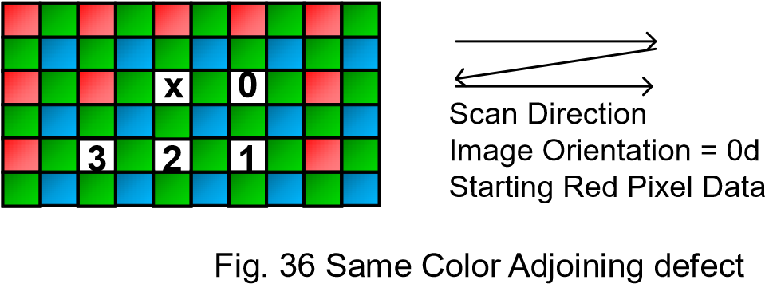

7-5-3 2x4 defect address
- Target Address; (x, y) = (xt, yt)
*Output area is Effective Area
Output size is 3280x2464 (0,0) - (3279,2463) x = image area address + offset; offset = 8d y = image area address + offset; offset = 48d (not include embedded lines)

- Only upper left pixel address needed in this case, always RED pixels

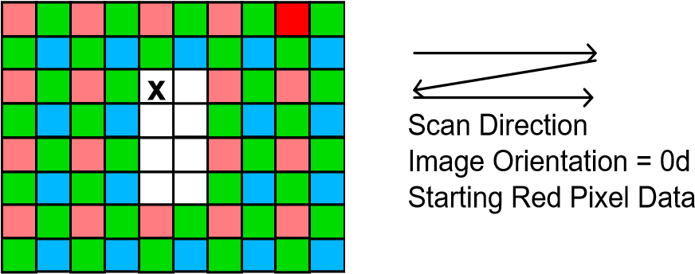

Fig. 37 2x4 defect

7-5-4 Example Setting
Example when defect addr are
1st: (228d, 522d), func: adjoin, dir: 1
2nd: (2846d, 1460d), func: 2x4
3rd: (26d, 20d), single

→ Offset values are (physical address)
1st: (236d, 570d) , func: adjoin, SRC = 2, DIR = 1, H_ADR = ECh, V_ADR = 23Ah
2nd: (2854d, 1508d) , func:2x4 SRC = 3, DIR = 0, H_ADR = B26h, V_ADR = 5E4h 3rd: (34d, 68d), func: single SRC = 1, DIR = 0, H_ADR = 22h, V_ADR = 44h

Table 35 Example setting of defect pixel
Addr (hex) | description | Value (hex)
2A0 | Defines availability of each data  [7:1] reserved  [0]: defect address available  Value 0x00 makes sensor skip copying data from NVM to register. | 01
2A1 | defect_num[7:0] | 3
2A2 | {DFCT_SRC_10[1:0]CP_DFCT_DIR_10[1:0]  H_DFCT_ADDR_10[11:9]} | 90
2A3 | H_DFCT_ADDR_10[7:0] | EC
2A4 | V_DFCT_ADDR_10[11:4] | 23
2A5 | {V_DFCT_ADDR_10[3:0]  DFCT_SRC_11[1:0]CP_DFCT_DIR_11[1:0]} | AC
2A6 | H_DFCT_ADDR_11[11:4] | B2
2A7 | {H_DFCT_ADDR_11[3:0], V_DFCT_ADDR_11[11:8] | 65
2A8 | V_DFCT_ADDR_11[7:0] | E4
2A9 | {DFCT_SRC_12[1:0]CP_DFCT_DIR_12[1:0]  H_DFCT_ADDR_12[11:8]} | 40
2AA | H_DFCT_ADDR_12[7:0] | 22
2AB | V_DFCT_ADDR_12[11:4] | 04
2AC | {V_DFCT_ADDR_12[3:0]  DFCT_SRC_13[1:0]CP_DFCT_DIR_13[1:0]} | 40
2AD | H_DFCT_ADDR_13[11:4] | 00
2AE | {H_DFCT_ADDR_13[3:0], V_DFCT_ADDR_13[11:8] | 00
2AF | H_DFCT_ADDR_13[7:0] | 00

8. How to operate IMX219PQH5-C

8-1 Power on sequence
Power on sequence of IMX219PQH5-C is below figure.

Startup Sequence in 2-wire Serial Communication Mode

Perform power-on according to the following sequence.
The XCLR pin must be released (Low → High) after all the power supplies (VANA,VDIG,VDDL) are completed.

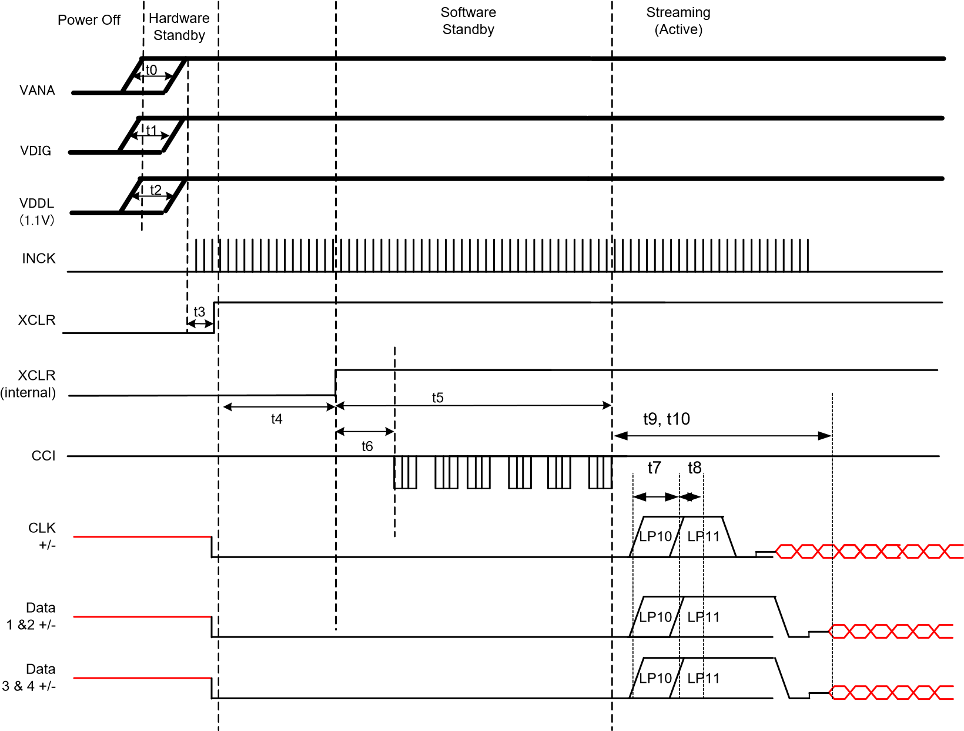

Fig. 38 Power-on Sequence in 2-wire Serial Communication Mode

Table 36 Operation Specifications 2-wire Serial Communication Mode
Constraint | Label | Min. | Max. | Units | Comment
Sequence free of VDDs rising | t0, t1, t2 | VANA, VDIG, VDDL may rise in any order. |  | ns
XCLR rising | t3 | 0.5 | ― | µs
Internal XCLR is Low to High after VDDs & XCLR supplied | t4 |  | 200 | µs
releasing software standby after XCLR Low to High | t5 | 6 | ― | ms | charge up VRL
Initializing time of silicon | t6 | ― | 32000 | clocks | clock is INCK  Case of INCK = 6[MHz],  5.3[msec]
D-PHY power-up | t7 | 1 | 1.1 | ms
D-PHY init | t8 | 100 | 110 | µs
After releasing software standby to data streaming time | t9 | 1.2 ms + exposure time | ―
Quick launch up time | t10 | ― | 1 | frame | stable time until optimal image quality

Start streaming sequence with 2-wire serial communication
IMX219PQH5-C requires the command sequence below to output image data.
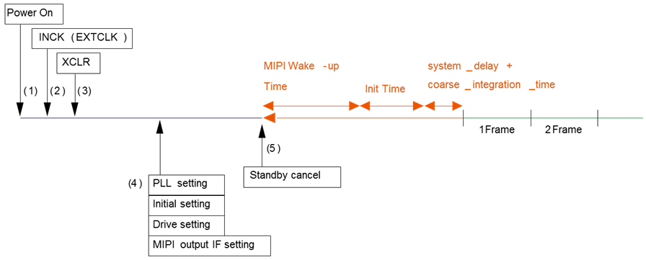

Fig. 39 Start streaming sequence with 2-wire serial communication (external reset)

Table 37 Initialization sequence with XCLR
(1) to (3) | Refer power up sequence timing diagram
(4) | Set PLL parameters
(4) | Basic setting (operation-critical setting)
(4) | Set Readout mode (start/end position, size, mode, integration time, and gain)
(4) | Set MIPI interface parameters
(5) | Start streaming with 0x0100 (mode_select = 1)
st
After “Wake Up ime” + “Init ime”, 1 frame starts and images come out

8-2 Power off sequence
Perform the power-off in the sequence shown below.

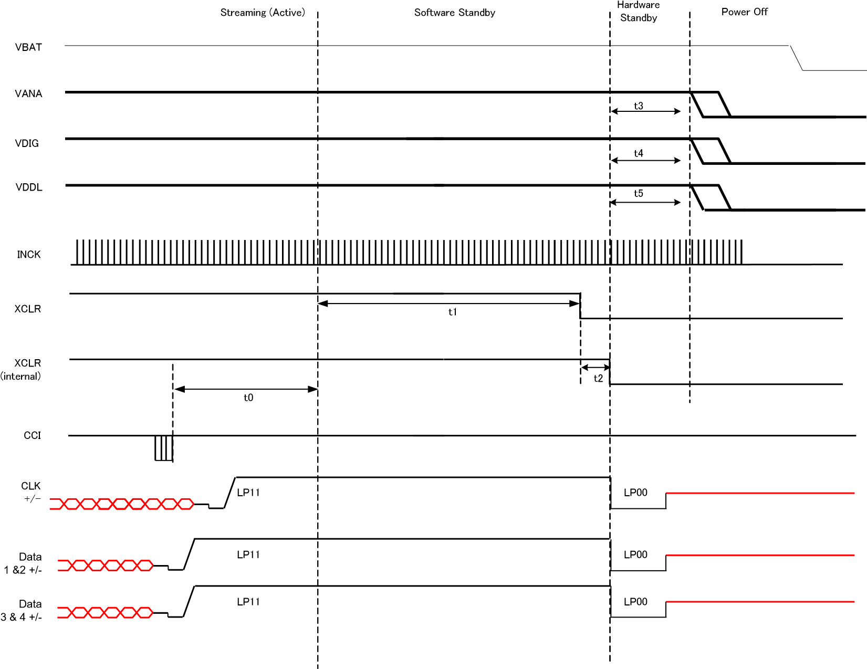

Fig. 40 Power-off Sequence in 2-wire Serial Communication

Table 38 Operation Specifications in 2-wire Serial Communication
Constraint | Label | Min. | Max. | Units | Comment
Communication end – Software standby | t0 |  | One frame time (*1) | s | Until frame output
Software standby - XCLR H → L | t1 | 0 |  | ns
Falling time of internal XCLR after  XCLR H → L | t2 |  | 10 | µs
VANA falling - VDIG falling - VDDL falling | t3,t4,t5 | VANA, VDIG and VDDL may fall in any order. |  | ns

(*1) One frame time = 1/(Frame_Rate[frame/s])

Can set fast standby mode when fast standby register (0x0106)] set to enable (0x01).
Sequence for fast standby mode;
- 0x0106 set to 0x01 ( fast standby mode is enable)
- 0x0100 set to 0x00 ( SW standby )
- Can change to SW standby after read out of current line.
To in power-off sequence varies depending on the CCI communication end timing as shown below.

1. When the CCI communication is performed with Software Standby between SOF and EOF, all communicated frame data is output and the status is converted to Software Standby.

S
O
F
E
O
F
N
0
xFF
SDA
SCL
CSI2
DATA
Frame
Counter
Enter
Stop
Frame_length_lines

Fig. 41 Software Standby Operation Pattern 1

2. When the CCI communication is performed with Software Standby during FrameBlanking, the status is converted to Software Standby immediately after communication.

Frame
Blanking
S
O
F
E
O
F
N
0
xFF
SDA
SCL
CSI2
DATA
Frame
Counter
Enter
Stop
Frame_length_lines

Fig. 42 Software Standby Operation Pattern 2

9. Other Functions

9-1 Clock System

9-1-1 Clock Structure

The IMX219PQH5-C clock system has the following structure.
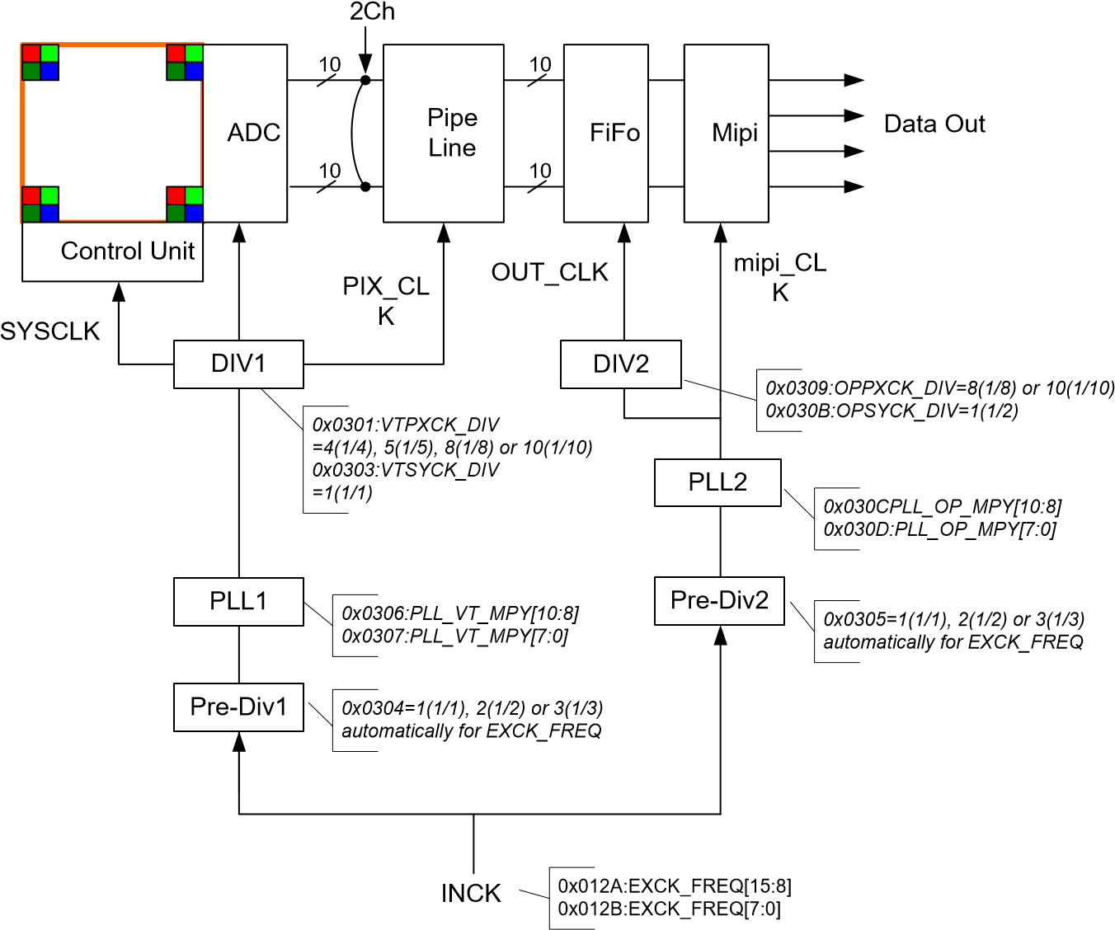

Fig. 43 Clock System Block Diagram

The IMX219PQH5-C is comprised of 2 ch Pipe-Line, and 2 PLL for both pixel read domain and Output data domain. See following section (Clock Setting Example) for detail.

Relationships between 2 domains are the followings;
1 If, Pix Rate of PLL1 domain < Data Rate of PLL2 domain, data is always correctly output from the sensor 2 If Pix Rate of PLL1 domain > Data rate of PLL2 domain, Else If de-rating (binning and sub-sampling without resize), FiFo can handle.

9-1-2 EXCK_FREQ setting depend on INCK frequency
The IMX219PQH5-C has the function that automatically set Pre-Div1 and Pre-Div2 by setting the register by setting the register of EXCK_FREQ, case of changing INCK frequency.

Table 39 EXCK_FREQ setting table
INCK  (Input Pin) | EXCK_FREQ  (0x012A/0x012B) | PREPLLCK_VT_DIV  (0x0304) | PREPLLCK_OP_DIV  (0x0305) | Remark
6 to 12[MHz] | 6d to 12d (06h to 0Ch) | 01h (auto set) | 01h (auto set)
12 to 24[MHz] | 12d to 24d (0Ch to 18h) | 02h (auto set) | 02h (auto set)
24 to 27[MHz] | 24d to 27d (18h to 1Bh) | 03h (auto set) | 03h (auto set)

9-2 Clock Setting Example
Interface | CSI-2 | CSI-2 | CSI-2
ADC bit width | 10 | 10 | 10
Data Mode | Raw10 | Raw10 | Raw10
FPS | 30 frame/s | 180 frame/s | 21 frame/s (*)
Lanes | 4 | 4 | 2
Bin | Full-Pel | 2 (V) X2 (H) analog (special) binning | Full-Pel
Sub | Full-Pel | 2 (V) X2 (H) analog (special) binning | Full-Pel
Output Size (H, V) | 3280 x 2464 | 1408 x 792 | 3280 x 2464
pll1_vt_freq | 702 MHz | 702 MHz | 456 MHz
EXCK_FREQ | 12 | 12 | 12
VTSYCK_DIV | 1 | 1 | 1
vt_pix_clk_div | 5 | 5 | 10
Pix Rate | 280.8M pix | 280.8M pix | 182.4M pix
Actual freq (VTCK) | 140.4 MHz | 140.4 MHz | 91.2 MHz
pll2_op_freq | 726 MHz | 726 MHz | 912 MHz
op_sys_clk_div | 1 | 1 | 1
op_pix_clk_div | 10 | 10 | 10
de-rating | 1 | 1 | 1
Output Lanes | 4 | 4 | 2
Actual freq (OPCK) | 72.6 MHz | 72.6 MHz | 91.2 MHz
Actual MIPI-freq (byte) | 90.75 MHz | 90.75 MHz | 114 MHz
Speed/Lane (Ch) | 726 Mbps | 726 Mbps | 912 Mbps
Total Output Rate | 2.904 Gbps | 2.904 Gbps | 1.824 Gbps
*

9-3 Temperature Sensor
Registers to be related about temperature sensor are the followings. Table 40 Temperature setting registers
Index | Byte | Register Name | RW | Comment | Re-Time | Default  (HEX) | Embd DL | Comments
0x0140 | [7] | TEMPERATURE_EN | RW | start register to measure sensor temperature |  | 0
0x0140 | [6:0] | TEMPERATURE_VAL | RO-D | result of measurement of sensor temperature |  | 00

The temperature sensor measures the junction temperature of the sensor silicon. The target range is -10 to 95 degrees in C, with +/- 5 degree in C deviation. The sensor is operated immediately after streaming mode, and the value will be stored in the register.
The following table shows the relationship between temperature and stored value.

Temperature[℃] | temperature_val[dec] | temperature_val[hex]
-10 | 0 | 0
-5 | 6 | 6
0 | 12 | C
5 | 18 | 12
10 | 24 | 18
15 | 30 | 1E
20 | 36 | 24
25 | 43 | 2B
30 | 49 | 31
35 | 55 | 37
40 | 61 | 3D
45 | 67 | 43
50 | 73 | 49
55 | 79 | 4F
60 | 85 | 55
65 | 91 | 5B
70 | 97 | 61
75 | 104 | 68
80 | 110 | 6E
85 | 116 | 74
90 | 122 | 7A
95 | 128 | 80

10. Electrical Characteristics

10-1 Absolute Maximum Ratings

Table 41 Absolute Maximum Ratings
Item | Symbol | Min. | Typ. | Max. | Unit | Remarks
Supply voltage (analogue) | VANA | -0.3 |  | 3.3 | V
Supply voltage (Core) | VDDL | -0.3 |  | 2.0 | V
Supply voltage (IF) | VDIG | -0.3 |  | 3.3 | V
Input voltage | V_{I} | -0.3 |  | 3.3 | V
Output voltage | V_{O} | -0.3 |  | 3.3 | V
Operating temperature (function) | Topr | -20 |  | 60 | ˚C | Junction temperature
Storage temperature | Tstg | -30 |  | 80 | ˚C | Junction temperature
Performance guarantee temperature | Tspec | -20 |  | 60 | ˚C | Junction temperature

10-2 Recommended Operating Conditions
Table 42 Recommended Operating Conditions
Item | Symbol | Min. | Typ. | Max. | Unit | Remarks
Supply voltage (analogue) | VANA | 2.6 | 2.8 | 3.0 | V
Supply voltage (Core) | VDDL | 1.08 | 1.2 | 1.3 | V
Supply voltage (IF) | VDIG | 1.62 | 1.8 | 1.98 | V

10-3 Electrical Characteristics
Table 43 DC Characteristics
Item | Pins | Symbol | Min. | Typ. | Max. | Unit | Comment
Supply voltage | VDDHFIL1,2 | VANA | 2.6 | 2.8 | 3.0 | V
Supply voltage | VDDHCM1,2
Supply voltage | VDDHAN
Supply voltage | VDDHPL
Supply voltage | VDDHSN1,2
Supply voltage | VDDMCO | VDIG | 1.62 | 1.8 | 1.98 | V
Supply voltage | VDDLSC1-8 | VDDL | 1.08 | 1.20 | 1.30 | V
Supply voltage | VDDLCN1,2
Supply voltage | VDDLIO1,2
Digital input/output voltage | SCL, SDA,  GPO | VIL | -0.5 |  | 0.3V_{DIG} | V
Digital input/output voltage | SCL, SDA,  GPO | VIH | 0.7V_{DIG} |  | V_{DIG} + 0.5 | V
Digital input/output voltage | SCL, SDA,  GPO | VOL |  |  | 0.25V_{DIG} | V
Digital input/output voltage | SCL, SDA,  GPO | VOH | 0.75V_{DIG} |  |  | V
Digital output voltage | FSTROBE | VOL |  |  | 0.45 | V
Digital output voltage | FSTROBE | VOH | V_{DIG} - 0.45
Digital input voltage | XCLR,INCK | VIL | -0.3 |  | 0.35V_{DIG} | V
Digital input voltage | XCLR,INCK | VIH | 0.65V_{DIG} |  | V_{DIG} + 0.3

10-4 AC Characteristics

10-4-1 Master Clock Waveform Diagram

10-4-1-1 INCK Square Waveform Input Specifications
Input specifications are shown below when square-wave inputs directly into the external pin INCK.

tp

0.35
VDIG

0.65
VDIG

fRIS
fFA
0.5
VDIG

Fig. 44 Master Clock Square Waveform Diagram

Table 44 Master Clock Square Waveform Input Characteristics
Item | Symbol | Min. | Typ. | Max. | Unit | Comment
Frequency | fSCK | 6 | 18 | 27 | MHz
jitter (period, peak-to-peak) | Tjitter |  |  | 600 | ps
Rise Time | fRISE | 1 |  | 10 | ns
Fall Time | fFALL | 1 |  | 10 | ns
Duty Cycle | fDUTY | 40 |  | 60 | %
Input Leakage | fILEAK | -10 |  | 10 | µA

10-5 Electrical Characteristics
Table 45 Electrical Characteristics
(V_{ANA} = 3.0 V, V_{DDL} = 1.3 V, V_{DIG} = 1.98 V, Tj = 60 ˚C)
Item | Symbol | Min. | Typ. | Max. | Unit | Comment
Current consumption (Full,30 frame/s) | IVAVA_strm |  | 33 | 38 | mA | VTmax is max speed read out from pixel array CSI2 4 lanes, V_{ANA} current
Current consumption (Full,30 frame/s) | IVDDL_strm |  | 100 | 160 | mA | VTmax is max speed read out from pixel array CSI2 4 lanes, V_{DDL} current  Defect Correction, L.S.C.  function off
HW-Standby current | ISTB_ana |  |  | 50 | µA | XCLR = Lo, V_{ANA} current
HW-Standby current | ISTB_dig |  |  | 10 | µA | XCLR = Lo, V_{DIG} current
HW-Standby current | ISTB_Iddl |  |  | 50 | µA | XCLR = Lo, V_{DDL} current

Note) Measurement conditions

11. Spectral Sensitivity Characteristic
(Neither lens characteristics nor light source characteristics is included.)
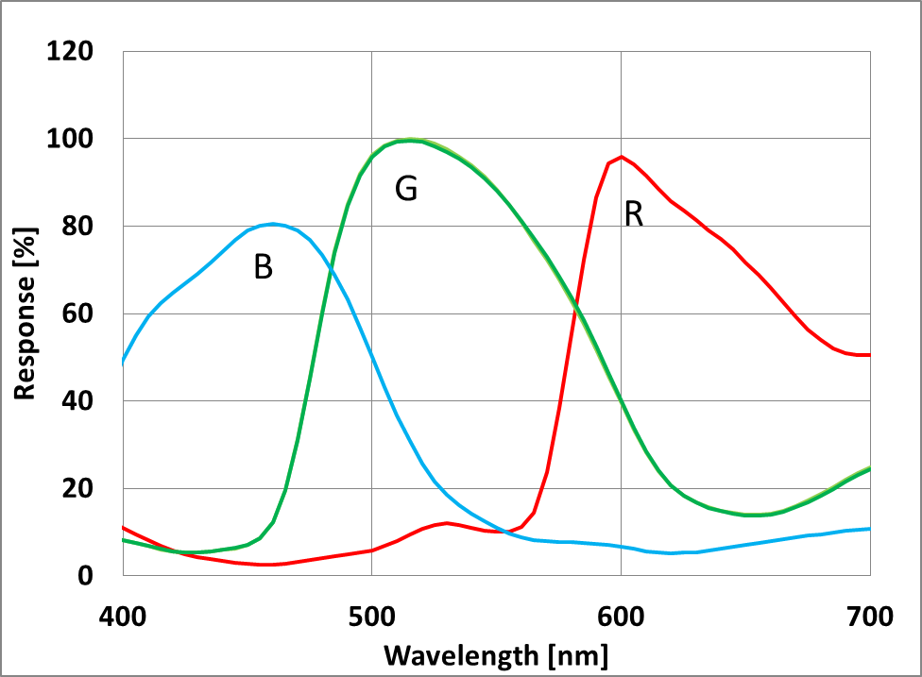
Fig. 45 Spectral sensitivity characteristics

12. Image Sensor Characteristics

12-1 Image Sensor Characteristics
Table 46 Image Sensor Characteristics
(30 frame/s, V_{ANA} = 2.8 V, V_{DIG} = 1.2 V, V_{IF} = 1.8 V, Tj = 60 ˚C)
Item | Symbol | Min. | Typ. | Max. | Unit | Range | Measur ement method | Remarks
Sensitivity | S | 205 |  |  | LSB | Center | 1 | 1/120 s storage
Sensitivity ratio | RG | 0.45 | 0.51 | 0.57 |  | Center | 2
 | BG | 0.40 | 0.46 | 0.52
Saturation signal | Vsat | 1023 |  |  | LSB | Zone1 | 3
Video signal shading | SH |  |  | 70 | % | Zone2D | 4 | Design assurance
Dark signal | Vdt |  |  | 0.5 | LSB | Zone2D | 5 | When operation at  15 frame/s

LSB is the abbreviation of Least Significant Bit. 10 bits = 1023 digital is the maximum output code for the output unit.
The base gain in which the saturation signal output matches with 1023 LSB is 0[dB] when the OB level is 64 LSB (standard recommended value). The data described at this image sensor characteristics are the measurement standard without base gain setting, and indicates the results evaluated with OB as a reference.

12-2 Zone Definition used for specifying image sensor characteristics

Zone1
Zone2D
Zone3
16
16
OB side ignored area
Effective OB
2
8
OB side ignored area
Dummy
43)
(1
,
(9
,
51)
(413
,
291)
(3296
,
2522)
(2884
,
2274)
(3288
,
2514)
,
11)
(9
(3288
,
26)

Fig. 46 Zone Definition Diagram

13. Measurement Method for Image Sensor Characteristics

13-1 Measurement conditions
The device operation conditions are at the typical values of the bias and clock voltage.

Table 47 Measurement Conditions
Supply voltage | Analog 2.8 V, digital 1.2 V, IF 1.8 V
Clock | INCK (EXTCLK) 18 MHz

In the following measurements, spot pixels are excluded and, unless otherwise specified, the optical black (OB) level is used as the reference for the signal output, which is taken as the value of the Gr, Gb, R and B digital signal outputs of the measurement system.
As an example of 1 LSB, the typical value is 1 LSB ≈ 0.357 mV in all-pixel output 10-bit operation mode.

13-2 Color Coding of This Image Sensor and Readout
The primary color filters of this image sensor are arranged in the layout shown in the figure below. Gr and Gb denote the G signals on the same line as the R signal and the B signal, respectively. The R signal and Gr signal lines and the Gb signal and B signal lines are output successively. All pixel signals are output successively in a 1/15 s period.
Gb | B | Gb | B | Gb | B
R | Gr | R | Gr | R | Gr
Gb | B | Gb | B | Gb | B
R | Gr | R | Gr | R | Gr
Gb | B | Gb | B | Gb | B
R | Gr | R | Gr | R | Gr
Fig. 47 Color coding alignment

13-3 Definition of Standard Imaging Conditions

Standard imaging condition I
Use a pattern box (luminance: 706 cd/m2, color temperature of 3200 K halogen source) as a subject. (Pattern for evaluation is not applicable.) Use a testing standard lens with CM500S (t = 1.0 mm) as an IR cut filter and image at F2.8. The luminous intensity to the sensor receiving surface at this point is defined as the standard sensitivity testing luminous intensity.

Standard imaging condition II
A testing lens with CM500S (t = 1.0 mm) is used as an IR cut filter for light source with 3200 K color temperature. The luminous intensity to the sensor receiving surface is adjusted to the luminous intensity level shown in each measurement item by the light source output, lens aperture or storage time control by the electronic shutter.

Standard imaging condition III
A recommended testing lens with CM500S (t = 1.0 mm) is used as an IR cut filter for light source with 3200 K color temperature. The luminous intensity to the sensor receiving surface is adjusted to the luminous intensity level shown in each measurement item by the light source output or storage time control by the electronic shutter.

13-4 Measurement method

Sensitivity
Set the measurement condition to the standard imaging condition I. After setting the luminous intensity of 10 times that of the standard imaging condition and the electronic shutter mode with a shutter speed of 1/150 s, measure the Gr and Gb signal outputs (VGr, VGb) at the center of imaging area, and substitute the values into the following formula.

S = {((VGr + VGb)/2) × (1/10) × (150/120)} [LSB]

Sensitivity ratio
Set the measurement condition to the standard imaging condition II. After adjusting so that the average value of the Gr and Gb signal output is 333 [LSB], measure the R signal output (VR [LSB]), the Gr and Gb signal outputs (VGr, VGb [LSB]) and the B signal output (VB [LSB]) at the imaging area Center in frame readout mode, and substitute the values into the following formulas.

VG = (VGr + VGb)/2

RG = VR/VG

RB = VB/VG

Saturation signal
Set the measurement condition to the standard imaging condition II. After adjusting the luminous Intensity to 20 times the intensity with the average value of the Gr, Gb signal outputs, 333 [LSB], measure the average value of the Gr, Gb, R and B signal outputs.

Video signal shading
Set the measurement condition to the standard imaging condition III. With the lens diaphragm at F2.8, adjust the luminous intensity so that the average value of the Gr and Gb signal outputs is 333 [LSB]. Then measure the maximum value (Gmax [LSB]) and minimum value (Gmin [LSB]) of the Gr and Gb signal outputs, and substitute the values into the following formula.

SH = ((Gmax – Gmin)/Gmax) × 100 [%]

Dark signal
Measure the output difference between 1/15 [s] signal output (Va) and 1/15000 or less [s] signal output
(Vb) at the device ambient temperature of 60 ˚C and the device in the light-obstructed state, and calculate the signal output at 1/15 [s] storage by them using the following approximate formula. Then, this is Vdt [LSB].

Vdt = (Va – Vb) × (1/15)/(1/15) – (1/15000) ≈ (Va –Vb) [LSB]

14. Spot Pixel Specification
Table 48 Spot Pixel Specifications
(15 frame/s, V_{ANA} = 2.8 V, V_{DIG} = 1.2 V, V_{IF} = 1.8 V, Tj = 60 ˚C)
Type of distortion | Level Note 1) | Maximum distorted pixels in each zone |  |  |  | Measurement method | Remarks
Type of distortion | Level Note 1) | Zone2D | Zone3 | Ineffective  OB | Effective  OB | Measurement method | Remarks
Black or white pixels at high light | 30 % ≤ D | 40 | No evaluation criteria applied |  |  | 2
White pixels in the dark | 28 (LSB) ≤ D | 600 | No evaluation criteria applied |  |  | 2 | 1/30 s storage Note 2)

Note) 1. D...Spot pixel level.
- Continuous same color pixels in the horizontal or vertical direction are NG.
- he above chart (hereinafter referred to as the “Spot Pixel Specifications”) is the standard only for sorting image sensor products in this specification book (hereinafter referred to as the “P ODUC S”) before shipment from a manufacturing factory. Sony Corporation and its distributors (collectively hereinafter referred to as the “Seller”) disclaim and will not assume any liability even if actual number of distorted pixels of the PRODUCTS delivered to you exceeds the maximum number set forth in the White and Black Pixel Specifications. You are solely liable for any claim, damage or liability arising from or in connection with such distorted pixels. If the Seller separately has its own product warranty program for the P ODUC S (the “Program”), the conditions in this specification book shall prevail over the Program and the Seller shall not assume any liability under the Program to the extent there is contradiction.

15. Notice on White Pixels Specifications
After shipment inspection of CMOS image sensors, pixels of CMOS image sensors may be distorted and then distorted pixels may cause white point effects in dark signals in picture images. (Such white point effects shall be hereinafter referred to as "White Pixels.") Cosmic radiation is one of the causes of White Pixels. Unfortunately, it is not possible with current scientific technology for CMOS image sensors to prevent such distorted pixels. It is recommended that when you use CMOS image sensors, you should consider taking measures against White Pixels, such as adoption of automatic compensation systems for White Pixels and establishment of quality assurance standards.
White Pixels may be also caused by alpha radiation, which will be emitted in a process of decay of radioactive isotopes which inevitably exist in the air in minute amounts and may exist in materials or parts of CMOS image sensor devices (e.g. packaging materials, seal glass, wiring materials and IC chips). It is recommended that you should use materials or parts which do not include radioactive isotopes, which are sources of alpha radiation, and consider taking measures, such as adoption of vacuum packaging technologies in order to ensure that the PRODUCTS are not exposed to the air. As the density of radioactive isotopes in the air of the underground space may become thicker than that on the ground, it is highly recommended to ensure the PRODUCTS are not exposed to the air in using or storing the PRODUCTS at the underground space.

[For Your Reference] The Annual number of White Pixels Occurrence Caused by Cosmic Radiation The data in the below chart shows the estimated annual number of White Pixels occurrence caused by cosmic radiation in a single-story building in Tokyo at an altitude of 0 meters. The data shows estimated number of White
Pixels based on records of past field tests calculated taking structures and electrical properties of each device into account. However, the data in the chart is for your reference purpose only, and shall not be construed as part of any CMOS image sensor product specifications which the Seller warrants.

Example of Annual Number of Occurrence

White Pixel Level (in case of integration time = 1/30 s)  (Tj = 60 ˚C) | Annual number of occurrence
5.6 mV or higher  10.0 mV or higher 24.0 mV or higher 50.0 mV or higher  72.0 mV or higher | 0.8 pcs 0.5 pcs 0.3 pcs 0.2 pcs  0.1 pcs

Note 1) The above data indicates the number of White Pixels occurrence when a CMOS image sensor is left for a year.
Note 2) The annual number of White Pixels occurrence fluctuates depending on the CMOS image sensor storage environment (such as altitude, geomagnetic latitude and building structure), time (solar activity effects) and so on. Moreover, there may be statistic errors. Please take notice and understand that this is an example of test data with experiments that have being conducted over a specific time period and in a specific environment.
Note 3) This data does not guarantee the upper limits of the annual number of White Pixels occurrence.
Note 4) As this data does not take occurrence of White Pixels caused by alpha radiation into account, White Pixels are likely to occur at higher value than the rate set forth in such data.

For Your Reference:
The annual number of White Pixels occurrence caused by cosmic radiation at an altitude of 3,000 meters will be from 5 to 10 times higher than that at an altitude of 0 meters because of the density of the cosmic rays. In addition, in high latitude geographical areas such as London and New York, the density of cosmic rays increases due to a difference in the geomagnetic density, so the annual number of White Pixels occurrence caused by cosmic radiation in such areas approximately doubles when compared with that in Tokyo.

15-1 Measurement Method for Spot Pixels
Measure under the standard imaging condition II.

15-2 Spot Pixel Pattern Specifications

Black or white pixels at high light
After adjusting the average value of the Gr/Gb signal output to 333 [LSB], measure the local dip point (black pixel at high light, VXB) and peak point (white pixel at high light, VXK) in the Gr/Gb signal output Vx (x = Gr/Gb), and substitute the values into the following formula.

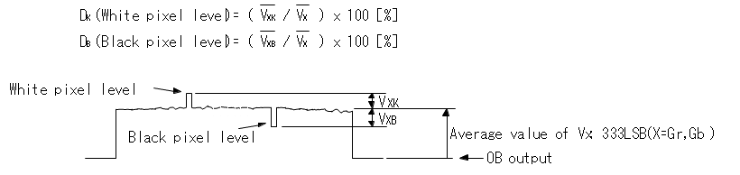

Fig. 48 Measurement Method for Spot Pixels

White pixels in the dark
Set the device to a dark setting and measure the local peak point of the signal output waveform using the average value of the dark signal output as a reference.

16. Chief Ray Angle Characteristics


0
10
20
30
40
0
10
20
30
40
50
60
70
80
90
100
Angle
［
°
］

Image Height
［
%
］

IMX219 CRA

Fig. 49 Chief Ray Angle Characteristics

17. Connection Example
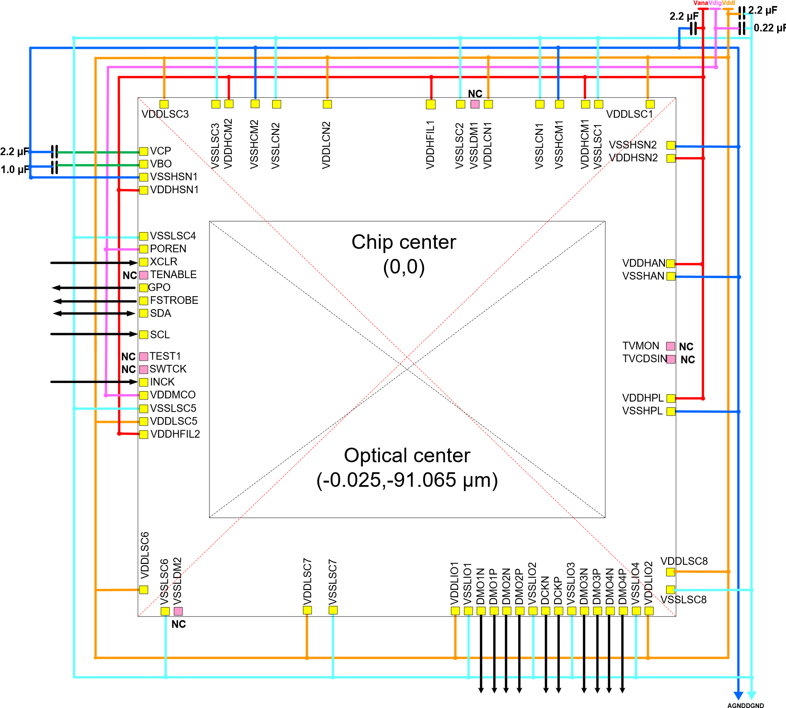

Fig. 50 Recommended Circuit

Pad open size | 75 µm × 75 µm ^{*1}
Pad pitch | 120 µm
*1
85 µm × 85 µm (Only VDDHFIL1 pad)

Note) When fixing the voltage of chip back side, fix it to VDDHSN voltage Note) GPO must be connected to GND, when GPO function is not enable.

18. Notes On Handling

1. Static charge prevention
Image sensors are easily damaged by static discharge. Before handling be sure to take the following protective measures.
- Either handle bare handed or use non-chargeable gloves, clothes or material.
Also use conductive shoes.
- Use a wrist strap when handling directly.
- Install grounded conductive mats on the floor and working table to prevent the generation of static electricity.
- Ionized air is recommended for discharge when handling image sensors.
- For the shipment of mounted boards, use boxes treated for the prevention of static charges.

2. Protection from dust and dirt
- Perform all work in a clean environment.
- Do not touch the chip surface with hand and make any object contact with it.
- Keep in a dedicated case to protect from dust and dirt. To prevent dew condensation, preheat or precool when moving to a room with great temperature differences.

3. Others
- Do not expose to strong light (sun rays) for long periods, as the color filters of color devices will be discolored.
- Exposure to high temperature or humidity will affect the characteristics. Accordingly avoid storage or use in such conditions.
- This product is precision optical parts, so care should be taken not to apply excessive mechanical shocks or force.
- Reliability assurance of this product should be ignored because it is a bare chip.
- Note that imaging characteristics of the sensor may be affected when approaching strong electromagnetic wave or magnetic field during operation.
- Note that X-ray inspection may damage characteristics of the sensor.
- Note that the sensor may be damaged when using ultraviolet ray and infrared laser for mounting it. (8) Note that image may be affected by the light leaked to optical black when using an infrared cut filter that has transparency in near infrared ray area during shooting subjects with high luminance.

Max. frame rate is 21 frame/s

