**HOLY CROSS OF DAVAO COLLEGE**Sta. Ana Avenue, Davao City



College of Engineering and Technology Department

**LorenZone**

Author:

John Mar Lorenzo

Instructor:

Ms. Nancy Mozo

September 4, 2017

TABLE OF CONTENTS

I. INTRODUCTION 1

II. WEBSITE INFORMATION 2

Content Sections

Target Audience

Objectives

Technical Specifications

Sitemap 3

Screenshots 4

IlI. Appendices 6

Curriculum Vitae

**I. Introduction**

Social interaction isgood. But we can’t deny the fact that there are some people who have a hard time talking face to face or they just hate becauseit is time and energy consuming. Thus, ideas are jailed into their heads. Many studentsof Holy Cross Of Davao College exhibits this kind of character. In fact, they’d rather play on internet cafes than join events in the school for it is time consuming as well as energy draining. So, I was motivated to create a website that would not only update them about my life, but also inform latest news about our school and notify them the latest trends in technology.

Humbly, my website isn’t that much over the edge than some. But to discuss the pros and cons is a must, the advantages and disadvantages. So, to start off I derived my concept in making this website from Sean Halpin’s Portfolio, the minimalistic design and the smoothness of the website makes it visually entertaining and will easily draw your attention. But what makes mywebsite better than? It isn’t the overall of mine but one thing is lacking from him that I implemented on my website and that is, the animation. Not only is the design simple and great but as well as its interaction with pixels and its frames of animated images.

Make the page’s content as relevant as possible, common phrases and words is visible on my website by doing these my website can be easily viewed by customers; this is probably called Search Engine Optimization. Bring in advertisements, this will help me monetize my website even more, I would bring in ads and whenever a user would click on an ad I will earn a dime.

**II. Website Information**

1. *Content Sections*

* Home – Small introduction, a summary of the website.
* About – Full information about the author and the website.
* Blog – Interaction, news updated and added by the author will go here all contents from the table blogcontent will go here and the comment table wherein the comments left by viewers.
* Contact – Contact information of the author and the website.

1. *Target Audience*

Target audience are BSIT students of Holy Cross of Davao College but it is not restricted to that, target audiences are introverts or people who are just tired of going to events. I will supply them the latest news and updates.

1. *Objectives*

* To get a job in the IT industry specifically in the web design field
* Update viewers the latest news and trends.
* Interact visually with ease.

1. *Technical Specifications*

Softwares:

* Atom – Text Editor
* Sublime Text Editor
* Photoshop CS3
* Paint.net

Languages:

* PHP
* JavaScript
* JQuery
* AJAX
* HTML
* CSS

Hosting:

* Localhost

Minimum Browser:

* Mozilla Firefox
* IE 9.0

Recommended Browser:

* Google Chrome

*E. Sitemap*



*F. Screenshots*

Home:

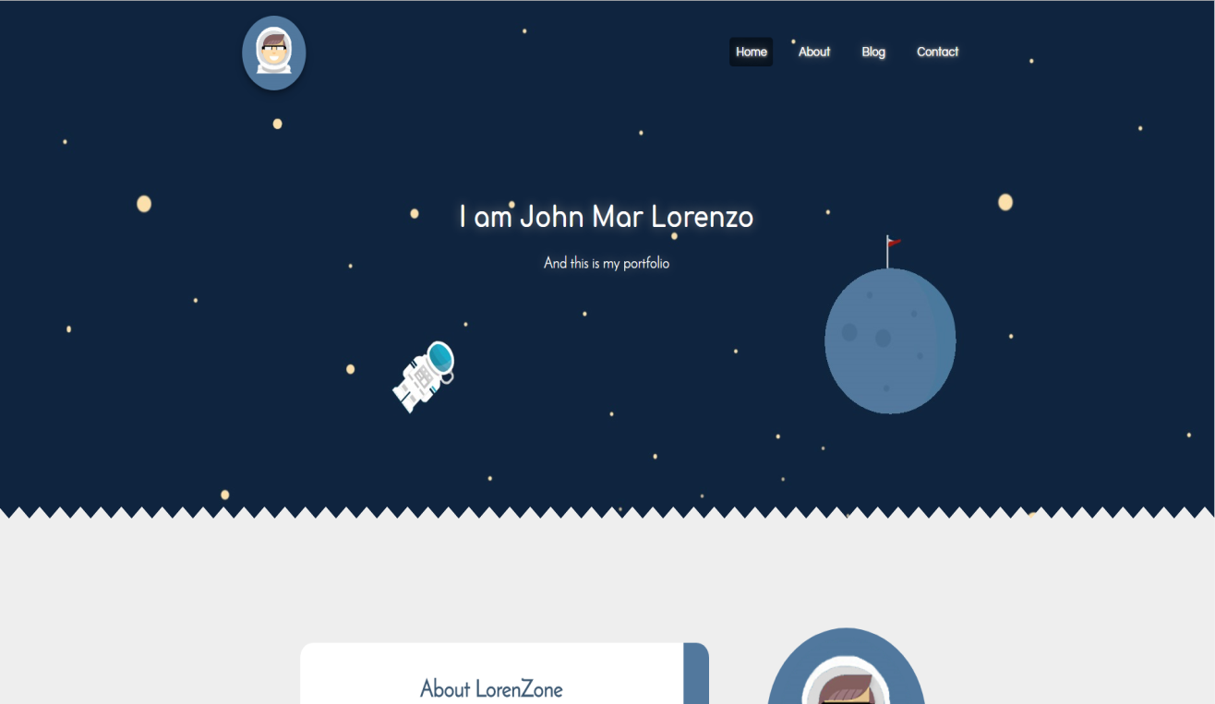

About:

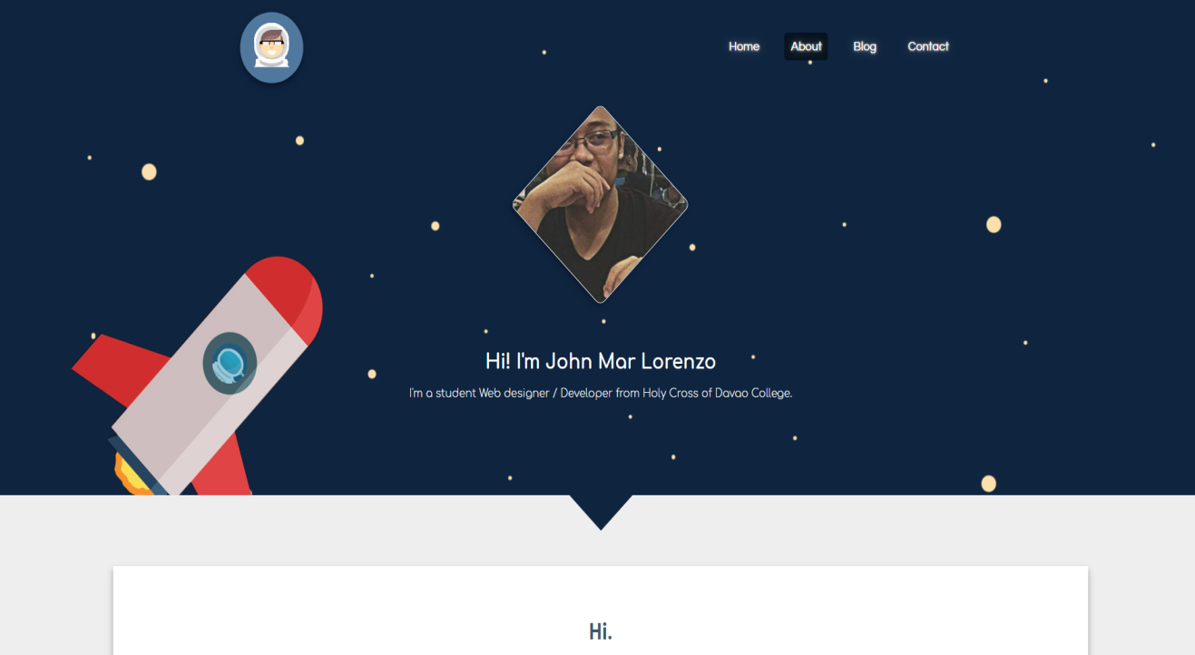

Blog:

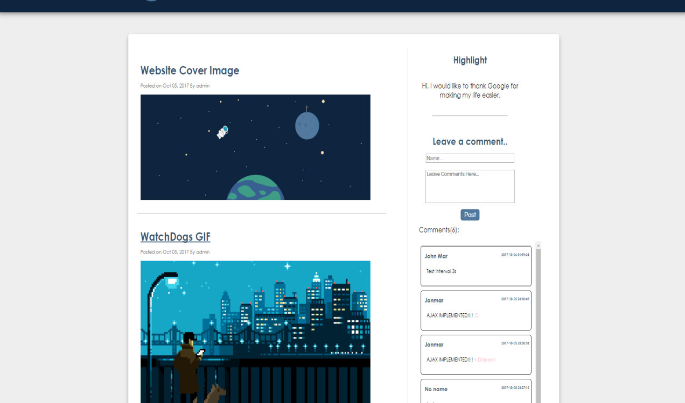

Contact:

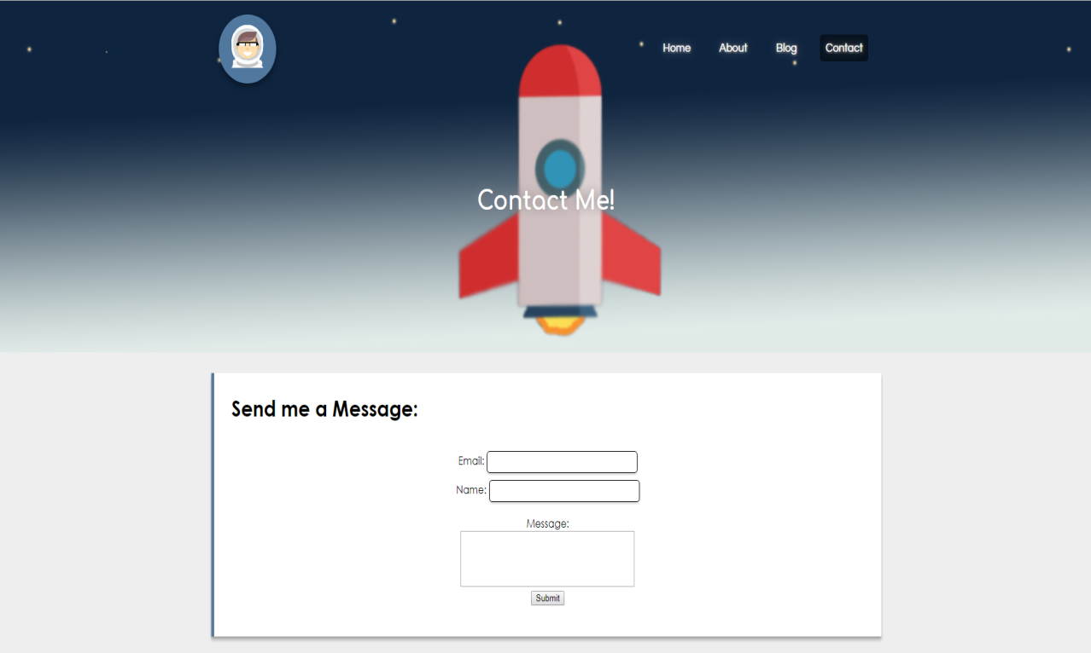

**III. Appendices**

Name: John Mar Lorenzo

E-mail address: lorenzojohnmar321@gmail.com

Address: Bangkal, Davao City

Contact No.: 09167060859

**PERSONAL INFORMATION**

Nickname: John/Mar Religion: Roman Catholic

Place of Birth: Davao City Age: 18 years old

Birthdate: June 15, 1999 Gender: Male

Civil Status: Single Citizenship: Filipino

Height: 5’ 5” Language: Visayan, Tagalog, English

Weight: 65 kg.

**EDUCATIONAL INFORMATION**

**Elementary**

A. Mabini Elementary School (2010- 2011)

Davao City

**Secondary**

A. Mabini National High School (2014-2015)

Davao City

**Tertiary**

Holy Cross of Davao College Inc. (2015 – present)



Sta. Ana Ave., Davao City