Dusty Bones Whitepaper

Dusty Bones is a community of NFT enthusiasts on @MultiversX. 90% of rewards are donated to holders. Only art and fun here.
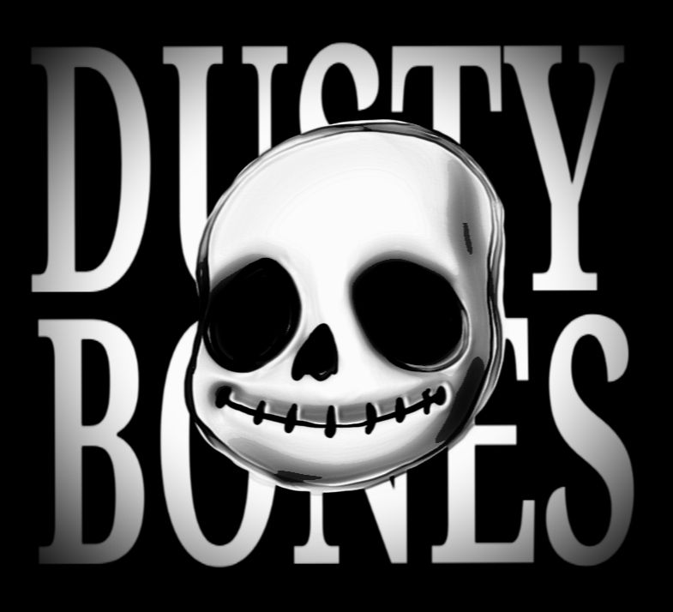

Objectives :

- Create a community motivated by the discovery of MultiversX:
  - https://multiversx.com/
- Invest in the Hatom protocol to generate rewards for our holders:
  - https://beta.hatom.com/
- Manage the DAO wallet collaboratively with all team members using xSafe:
  - https://xsafe.io/
- Provide fun 3D illustrations
- Collaborate with various NFT community actors of MultiversX
- Engage the community by conducting votes on certain decisions through FrameIt:
  - https://www.frameit.gg/
- Have fun and support each other

Roadmap :
- Create the xSafe wallet to manage funds
- Create Twitter, Discord, and the website
- Release the NFT collection
- Invest funds in Hatom protocol farms
- Reward holders with farm interests
- Vote on decisions via a smart contract on FrameIt
- Collaborate with other MultiversX actors

Strategy :
- Thursday, July 20, 4 PM UTC: Launch of the collection on FrameIt for WL members. Mint price: 0.3 EGLD & Max: 5 NFTs per wallet.
- Friday, July 21, 4 PM UTC: Opening of the public session. Mint price: 0.4 EGLD & Max: 50 NFTs per wallet.
- 90% of the mint funds are injected into a liquidity pool of the Hatom protocol to earn $HTM, sEGLD, or hsEGLD. 10% of the funds go directly to the team, which commits to participating in the mint during the WL session to ensure its success.
- All WL members who mint 5 NFTs during the WL session will receive a "Dusty OG" SFT that grants them benefits in DAOs and for the future of the project.
- An initial wave of liquidity will be created with the financial funds from the first days to quickly start farming. Rewards will be automatically distributed to all holders every 2-3 months on a random date to encourage holding. Holders must have their NFTs in their wallets.
- A DAO vote will be proposed to holders after the opening of the public mint session to decide whether to reinject 10% of the rewards into the pools each month to allow the liquidity to grow each month.

Team :

- Stan : Designer
- Pentaxx : Social Manager
- Mobo : Developer

Links :

- Twitter : https://twitter.com/DBones_mvx
- Discord : https://discord.gg/7hmqG7Cz
- FrameIt : https://www.frameit.gg/marketplace/DUSTYBONES-c1fc90
- Website : https://dusty-bones.netlify.app/

