1. Double click on Eclipse.exe to start Eclipse:

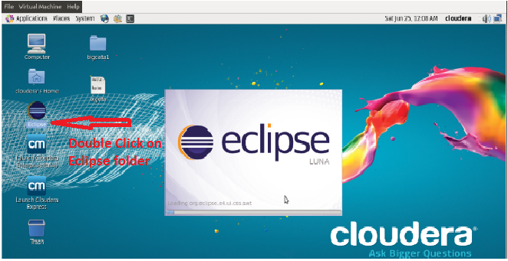

2. Browse and Select the location for Workspace and click OK:

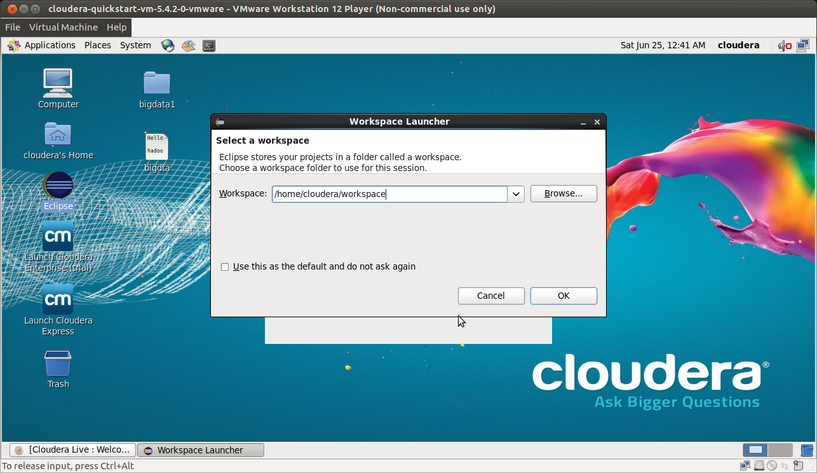

3. Create java Project: Click on File → New → Java Project.

Enter Project Name and click on Finish.

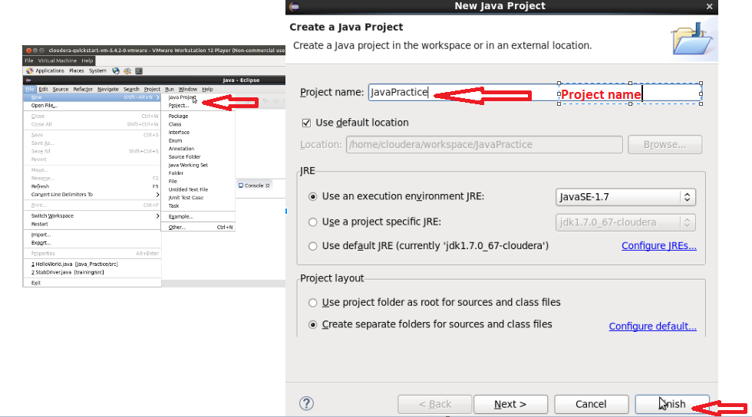

4. Create Java class: Expand the Java project and right Click on src → New → Class.

Enter the Package Name (Optional). Enter the class Name.

Select Public radio button and check the Public static void main(String[]args) check box.

Click Finish.

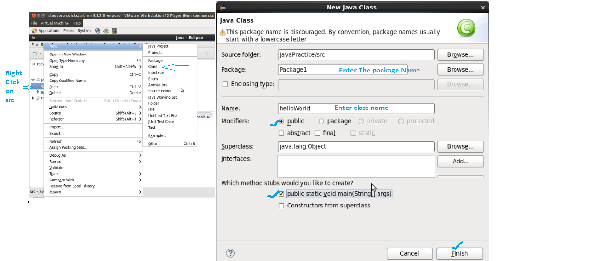

5. Write a code to Print “Hello World” inside Main method.

*System.out.println(“Hello World”);*

Save and Click on run button to execute the Program.

You can see the output on console below.

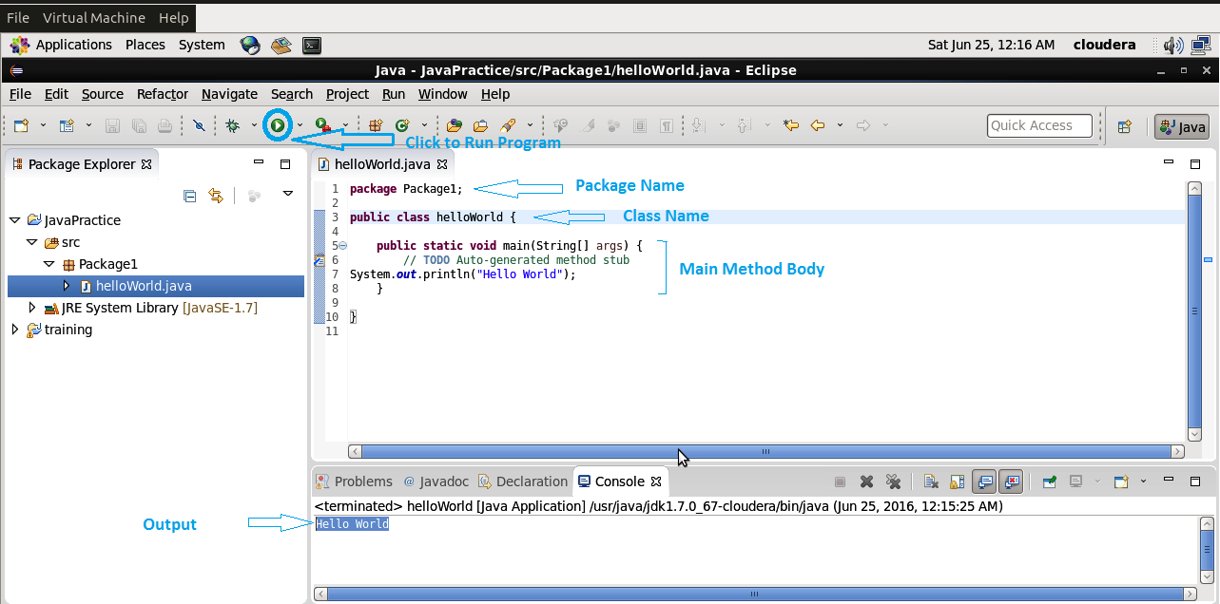

6. 2nd Method:

Declare an instance variable ‘s’, with Data type String.

Create a method with String as a return type and return the variable ‘s’ created

Create an object of helloworld class.

Call the method using the object.

Check the output in console.

Note: Please Find below the whole code.

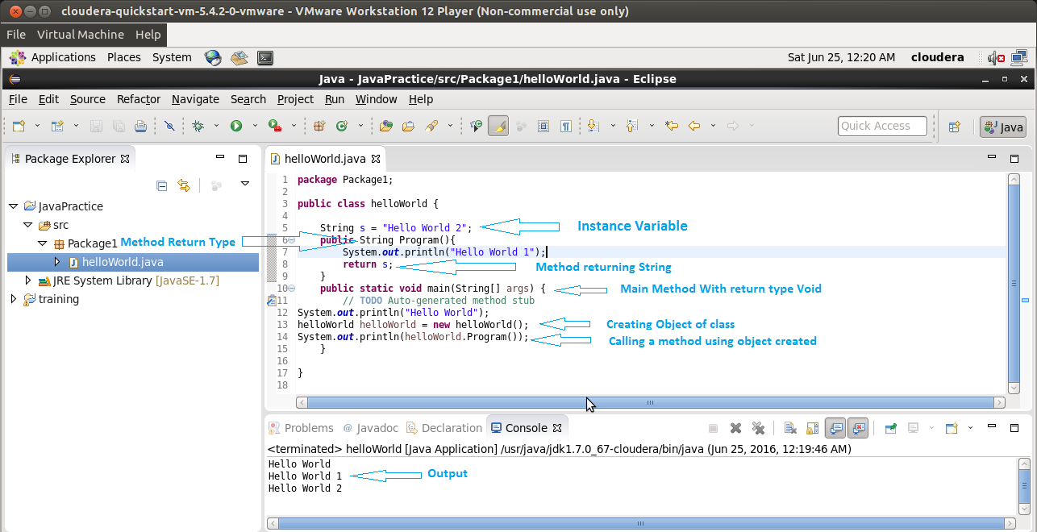

**HelloWorld code available here:**

package Package1;

public class helloWorld {

String s = "Hello World 2";

public String Program(){

System.out.println("Hello World 1");

return s;

}

public static void main(String[] args) {

// TODO Auto-generated method stub

System.out.println("Hello World");

helloWorld helloWorld = new helloWorld();

System.out.println(helloWorld.Program());

}

}