Open XML Package Editor Power Tool for Visual Studio 2012
v1.0.1.1

Description
This is a Visual Studio add-in to allow parsing and editing of Open Packaging Conventions files, including Word, Excel and PowerPoint documents. Features include:
- Open any Office 2007, 2010, or 2013 Open XML Package file, or XPS Package file directly in Visual Studio 2012.
- Intuitive, browsable tree view of the Package file.
- Open any XML part directly in Visual Studio's rich XML editor.
- Easy to use user interface for adding and removing parts and relationships.
- Import and export part contents to and from files.
- Detects when a Package file that is opened in Visual Studio is modified externally. Prompts user to reload without having to close any open XML part editors.
- Create new Office Packages from a set of templates using Visual Studio's File > New dialog.
Figure 1 shows the treeview that is provided when you open an Open XML Package file in Visual Studio:
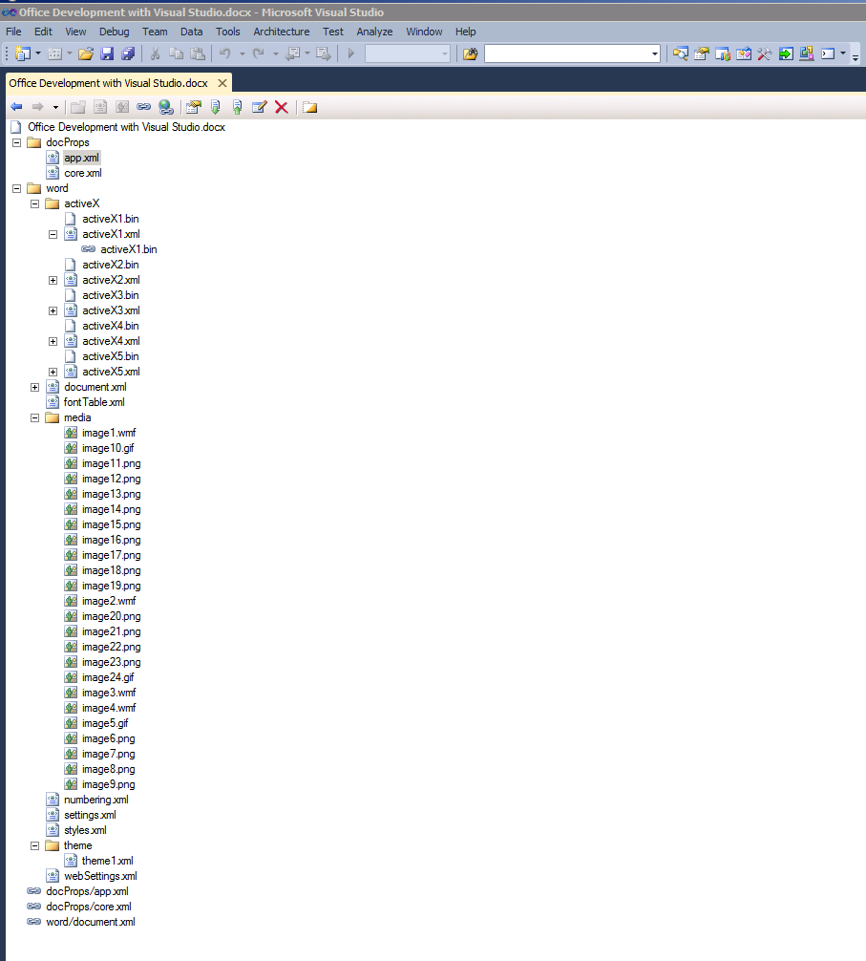
Figure 1 – Open XML Package treeview in Visual Studio
From the treeview, if if you double-click on any XML part in the file, that part will be opened in the standard Visual Studio XML editor, as shown in Figure 2:
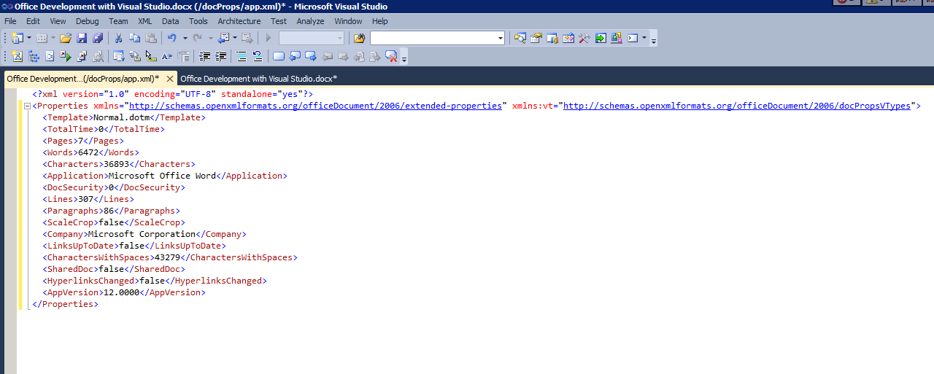
Figure 2 - XML part open in the Visual Studio XML editor

