Here is a picture of the subflow. You define the input schema on the subflow input node and just make sure to have a subflow output node at the end

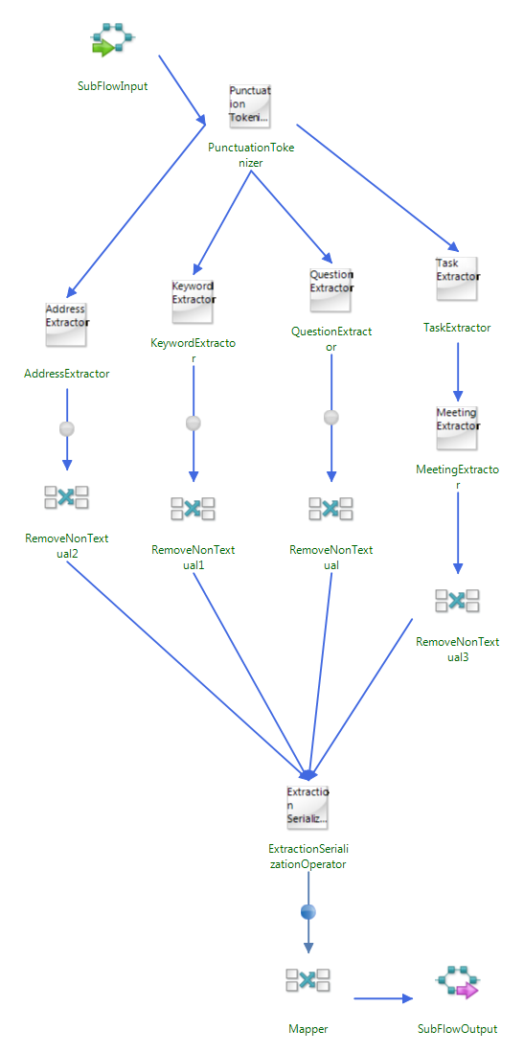

Set up subflow input

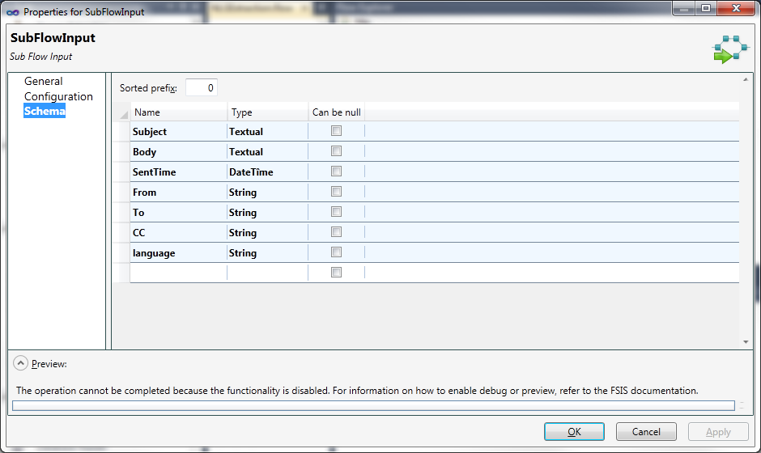

Then in the main flow you create a subflow node and set it up to point at the sub flow you created. You can pick from any flow deployed to the server. I also here have a “flow bypass” mapper which I used to keep fields from my main flow “filename/outputfilename” that the subflow doesn’t consume. These get combined correctly on the other end.

