# How to run this Sample in Visual Studio w/ Azure Simulator

## Before Compiling: Install the needed Orleans packages

1. Open Visual Studio in Administrator mode (admin mode appears to be required in later steps)
2. Open HelloGeoSample.sln
3. In Visual Studio, Right-Click Solution, choose “Manage NuGet Packages for Solution…”
4. If the yellow bar at the top says you are missing packages, you have to restore packages. If this bar does not appear, you already have the Orleans packages installed and you can skip this step.
   1. Make sure that the package paths will pick up Orleans packages in the right place. If you are using online published packages, chances are your settings are already finding them. If you are using locally built packages, however:
      1. Make sure you have built the Orleans packages. You can do this in (rootfolder) or in (rootfolder)/src by typing “build” in a Developer Command Prompt for Visual Studio. This creates NuGet packages in the folder (rootfolder)/Binaries/Nuget.Packages.
      2. While you are in the “Manage NuGet Packages for Solution…” dialog, make sure you have an entry on the left, under Online, saying “Local Orleans Build” (or whatever you named it when you created it). If you don’t have such an entry, hit Settings , and create it by hitting the + button and then editing the entry to give it a name (such as “Local Orleans Build”) and point it to the directory (rootfolder)/Binaries/Nuget.Packages
   2. Hit the button in the yellow bar to restore packages. This installs the required Orleans packages into your solution, putting them into (rootfolder)/Samples/packages/

Note: *If you need to reinstall packages* (for example, after making changes to the Orleans runtime and rebuilding the packages), just manually delete all Orleans packages from (rootfolder)/Samples/packages/ and go back to step 3.

You can then compile as usual, build solution.

## Before Running: Configure the Azure Simulator

Right-click Deployment1, choose “Properties”, then go to the “Web” settings and make sure to choose Express settings as shown below

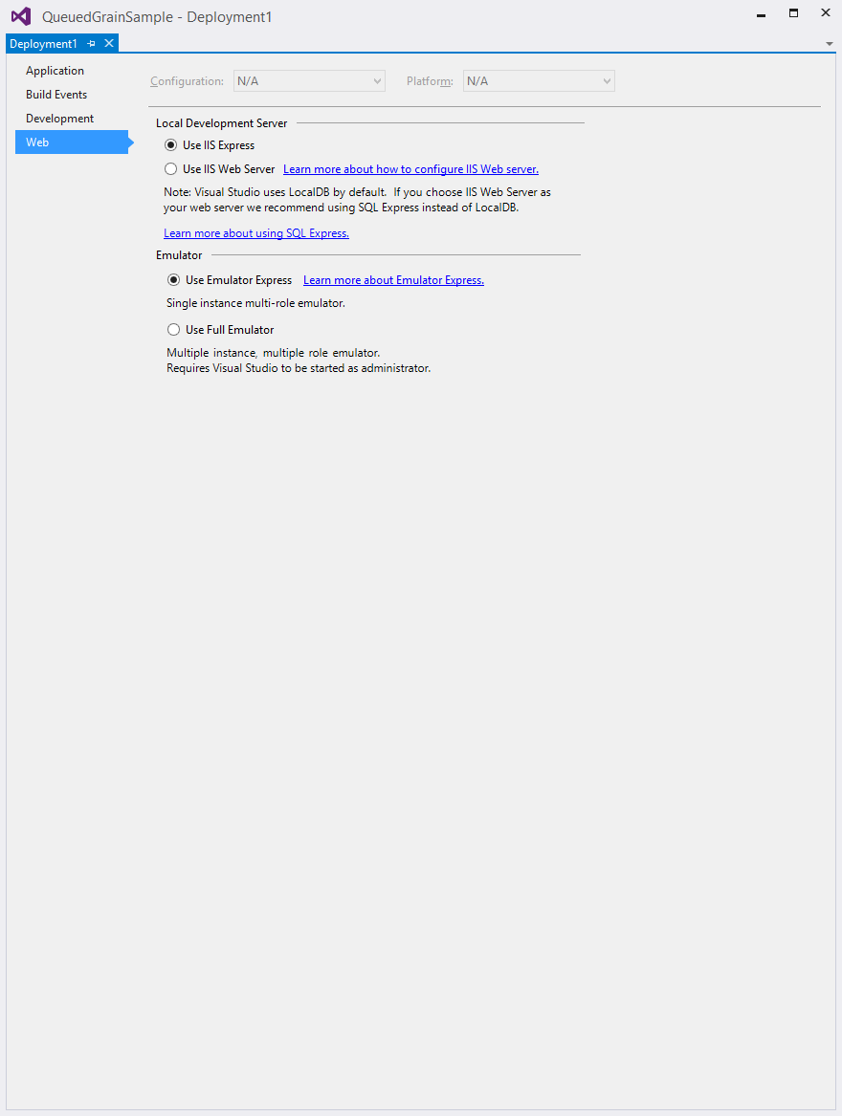

# To run a single deployment

1. Right-click “Deployment1” and choose “set as Start-Up project”
2. Hit the Start button or F5

# To run all 3 deployments

1. Important: **Make sure you have started Visual Studio in Administrator Mode**. For some reason, emulation of multiple websites does not work otherwise. If you have started the emulator in non-admin mode, it is possible you need to shut it down before restarting it in admin mode.
2. Right-click Solution and choose “Set Start-Up Projects…”
3. Choose multiple startup projects as shown below

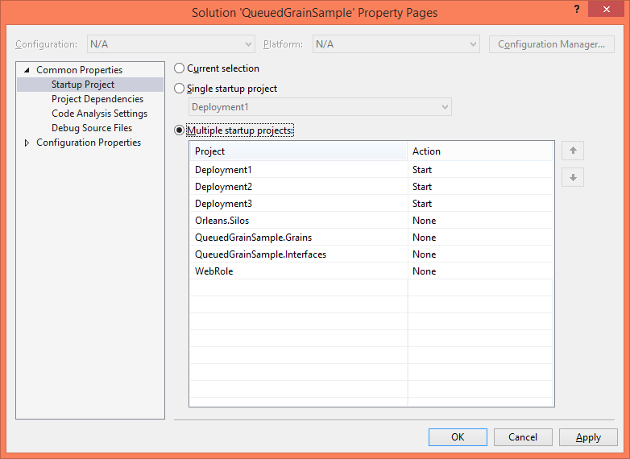

1. Hit the start button or F5

## Known Issues

Sometimes TimeoutException is thrown, especially when starting in Azure Simulator the first time. In our experience, these exceptions go away if you just try again (perhaps the simulator starts faster the second time around).