**What am I going to achieve?**

**As a** customer/ call centre representative **I should be** able to edit my enterprise workflow **so that** I he/she can set custom actions.

**Sequence Diagram**

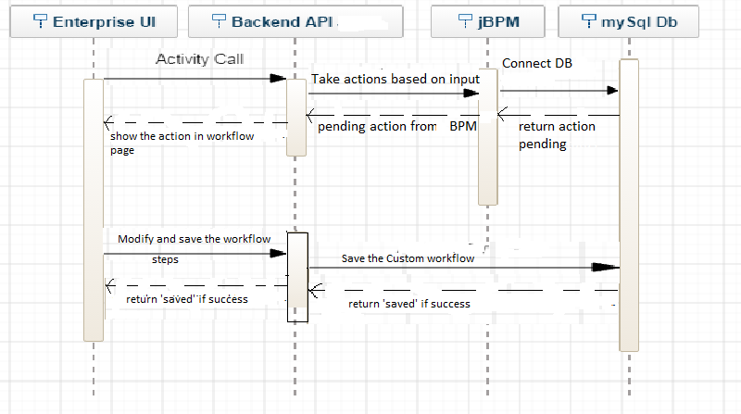

**Schema Changes**

1. Workflowsteps

* WorkflowStepId int identity primary key
* Account Number varchar(255)
* WorkflowId int foreign key references Workflow(WorkflowId)
* Active boolean

1. Workflow

* WorkflowId int primary key
* WorkflowName varchar(255)
* WorkflowDescription varchar(255)

**Screenshots**