

Investment home

For the Airbnb Rental



June 23, 2020

Eren SOYLU

Nicosia, TRNC

Investment Home for Airbnb Rental

Table of Contents

Introduction 1

Data 1

Methodology 2

Results 4

Discussion 6

Conclusion 7

References 7

# Introduction

Airbnb is a global service that gives a chance to rent your home or your room and provide service for guests at reasonable prices. It is much more profitable daily. My business plan is to create a company that provides house and hotel-grade service with housekeeping in Istanbul. My company decided to buy 4 houses at various locations in Istanbul. Istanbul is a historical and popular place to visit. For that reason, we are wondering which locations are suitable. We are evaluating these locations with AirBnB House data in Istanbul data and hotel distribution.

# Data

I'm using the AirBnB Istanbul data (AirBnB, 2020) for first and locating popular neighborhoods. I've used the k-means clustering algorithm for determining centroids of Airbnb houses. After that, I've evaluated hotels around centroid locations with Foursquare API (Foursquare, 2020). Hotels are normally distributed in popular places. I'm using the number of hotels around AirBnB data centroids for evaluating locations and creating data models. Then, I'll be comparing AirBnB incomes (Price and ) with House price indexes at these locations from Endeksa (Endeksa, 2020).

Airbnb data consists of 16 columns and 16251 rows. The columns are id, name, host_id, host_name, neighbourhood_group, neighbourhood, latitude, longitude, room_type,price, minimum_nights, number_of_reviews, last_review, reviews_per_month, calculated_host_listings_count, availability_365. We are using geospatial data, price, room type, and neighborhood values from this dataset. We only evaluated Entire home rentals in this data set. After the cleaning NaN values and room_type filtering, 7191 rows remain.

We have used Hotel data for calculating the popularity of neighborhoods on the tourist level. Hotel number increases with popularity and historical importance. Tourists want to stay inside the popular and historical places at İstanbul. Hotel data has been retrieved from the Foursquare API.

House prices and monthly rental prices can be retrieved from Endeksa. Endeksa provides house prices and monthly rental price from statistical data and investigations.

# Methodology

First of all, we have investigated all houses over Istanbul. The results can be seen in Figure 1. According to Figure 1, Airbnb places can be found all over Istanbul. We should limit this value. There are lots of outliners and irrelevant places all over Istanbul we should limit these places.

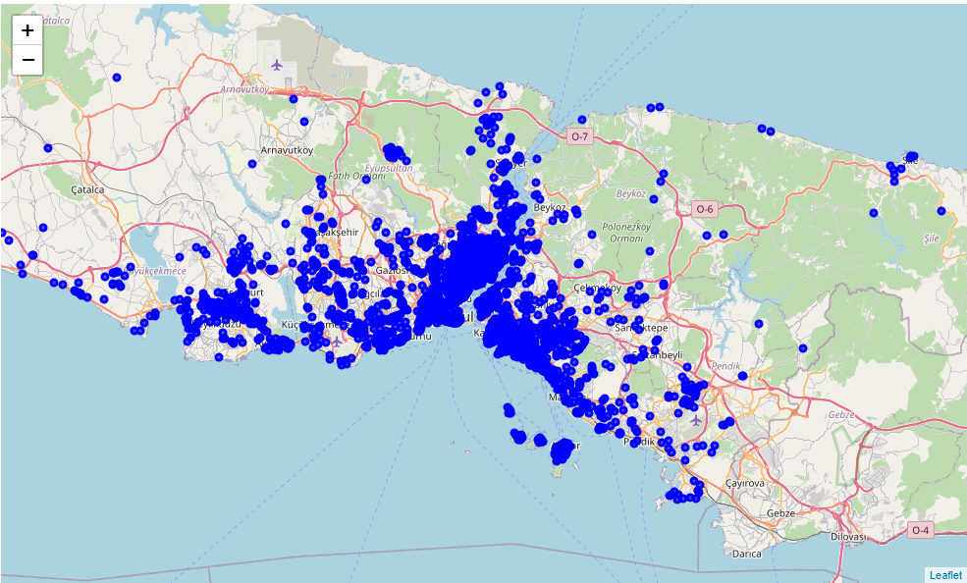

Figure 1 - AirBnB Rentals over Istanbul

We limit these values according to a neighborhood basis. We select the neighborhoods has more than 500 AirBnB rentals for popularity reasons.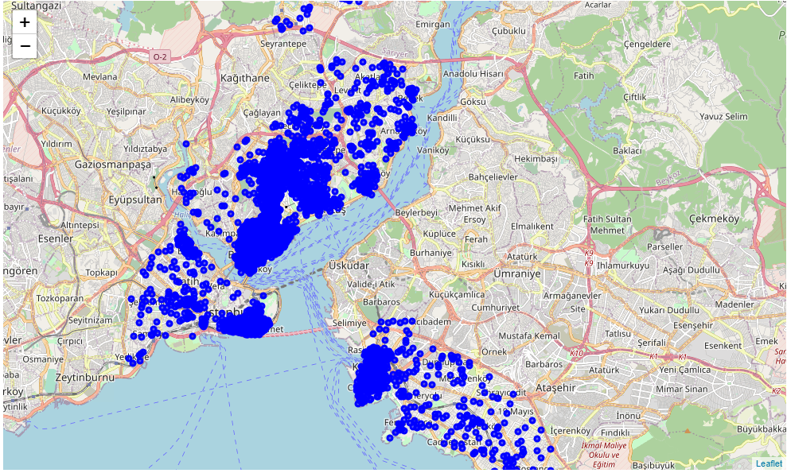

Figure 2 - AirBnB Rentals based on Neighbourhood Limitation

We have found the most AirBnB rentals at Beyoğlu, Şişli, Fatih, Kadıköy and Beşiktaş.

We use the k-means clustering algorithm for finding centroids. We assume there is 30 cluster at the limited dataset. Specifications of the K-means algorithm can be found in Figure 3.



Figure 3 - K-means Specifications

We try the centroid number from 10 to 40. We decided the best value for this dataset is 30 clusters. The clusters can be seen in Figure 4.

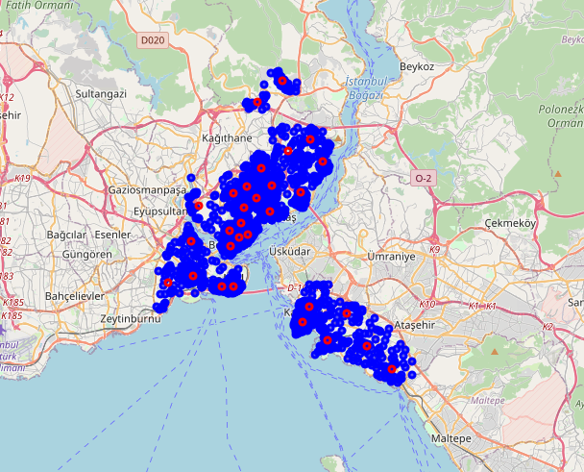

Figure 4 - K-means Centroids According to Datasets

The tourist popularity of the places can be evaluated with hotel numbers around it. According to that hypothesis, we decided to find centroids that have more 10 hotels in a 100m radius. The candidate centroids according to our hypothesis can be seen in Figure 5.

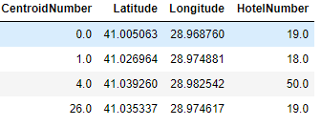

Figure 5 - Hotel Popularity index of Centroids

# Results

Candidate Places can be seen in Figure 6.

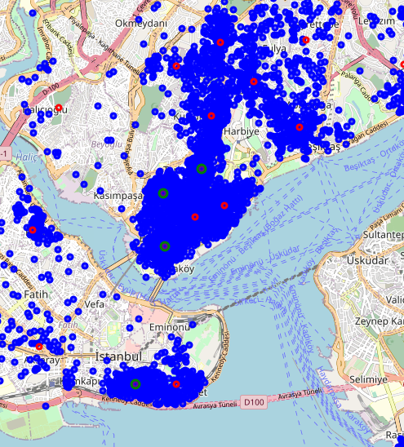

Figure 6 - Candidate Places according to Hotel Popularity Index

Candidate places at İstanbul are in Fatih and Beyoglu. When we look deeply the place at Fatih is located at Kumkapı. On the other side, The places at Beyoglu is located at Taksim, Tepebaşı, and Tarlabaşı. Mean AirBnB prices at Fatih and Beyoglu can be investigated for monthly Airbnb Rental.

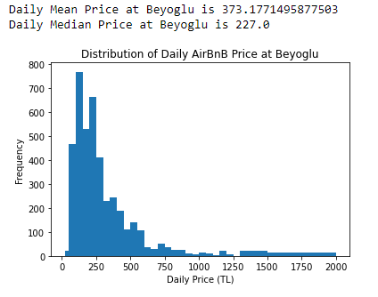

Figure 7 - AirBnB Monthly Rental Price Distribution at Beyoğlu

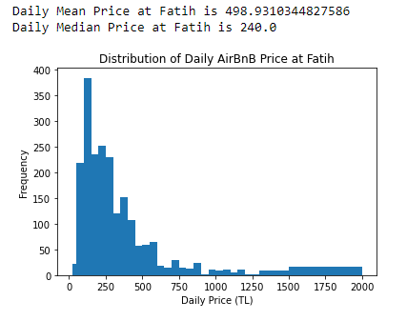

Figure 8 - - AirBnB Monthly Rental Price Distribution at Fatih

According to frequency, prices located between 100 and 500 TL per day. Daily Rental for Beyoglu is selected 450 TL per day and Daily Rental for Fatih is Selected 500 TL per day. The occupancy rate monthly is assumed %45 percent of the month. Monthly Airbnb rental prices of Beyoglu and Fatih is 6075.0 TL and 6750.0 TL per month, respectively.

The prices of the houses have been calculated for 120 m^2 home. The values based on per m^2 is gained from (Endeksa, 2020). According to Candidate Places, there are 4 Positions. These are Kumkapı, Tarlabaşı, Tepebaşı, and Taksim. The prices can be found in Figure 9.

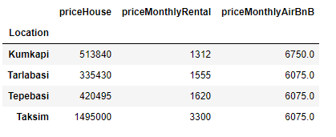

Figure 9 - Prices of the Candidate Places (in Turkish Liras)

# Discussion

We are assuming we are taking load from a Turkish bank with a %1.35 monthly interest rate for 120 months for these locations with an amortization loan plan. For amortizing loans, the Future Value of the loan for each house can be found in Figure 10.

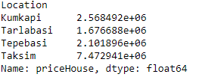

Figure 10 - Future Values of the Loan of Each Houses

For amortizing loans, monthly basis payment for loans can be found in Figure 11.

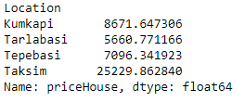

Figure 11 - Monthly Basis Payment For Loan

According to assuming and prices, the only profitable place is Tarlabasi with %6.8 on monthly basis. Turkey's inflation rate is %12 according to TUIK data. We can calculate the net present value of the profit from the house at Tarlabasi. Net Present Value of Tarlabasi investment is 29160 TL.

# Conclusion

Airbnb is a great service if you rent your own houses but it is not a profitable investment. We can profit %8.6 if we invest in a house at Tarlabasi. The payback period of the investment is 102 months. It is a very low-profit when compared with the inflation rate in Turkey. Other financial tools and stock markets are much more profitable in comparison with house investment. For Other Places, we make a loss. For Kumkapı, Tepebaşı, and Taksim, we make loss %28.4, %16.8, and %315 on monthly basis.

# References

AirBnB. (2020, 06 23). *Kaggle*. http://www.kaggle.com adresinden alındı

Endeksa. (2020, 06 23). *Endeksa*. Endeksa: https://www.endeksa.com/ adresinden alındı

Foursquare. (2020, 06 23). *Foursquare Developer API*. Foursquare : https://developer.foursquare.com/ adresinden alındı