4.1 News Service System
As mentioned before, this systems main purpose is to facilitate a simple, easy to browse last news around the world and introduce this news to the customers . In this section we will explain the main methods , which the system comprises, in hope of making future enhancement and development of the system possible.
4.2 Design Overview and Technologies
The systems UI's (user interfaces), were mainly designed with Adobe Flash CS4, Oracle JDeveloper 11g and Adobe Photoshop CS4.The designs main platform was JSP (Java Server Pages), with all the flexibility, efficiency and power that comes along with it.
Within this platform, design was based on the Master Pages design technique, alongside themes using CSS (Cascading Style Sheets) for a consistent look and feel throughout the website. Essentially, a master page is the blueprint for part of the website. Using a master page, we defined the web page layout, complete with all the usual details such as headers, menu bars, and banners. Figure 4.1 shows the Master Page used throughout the website.

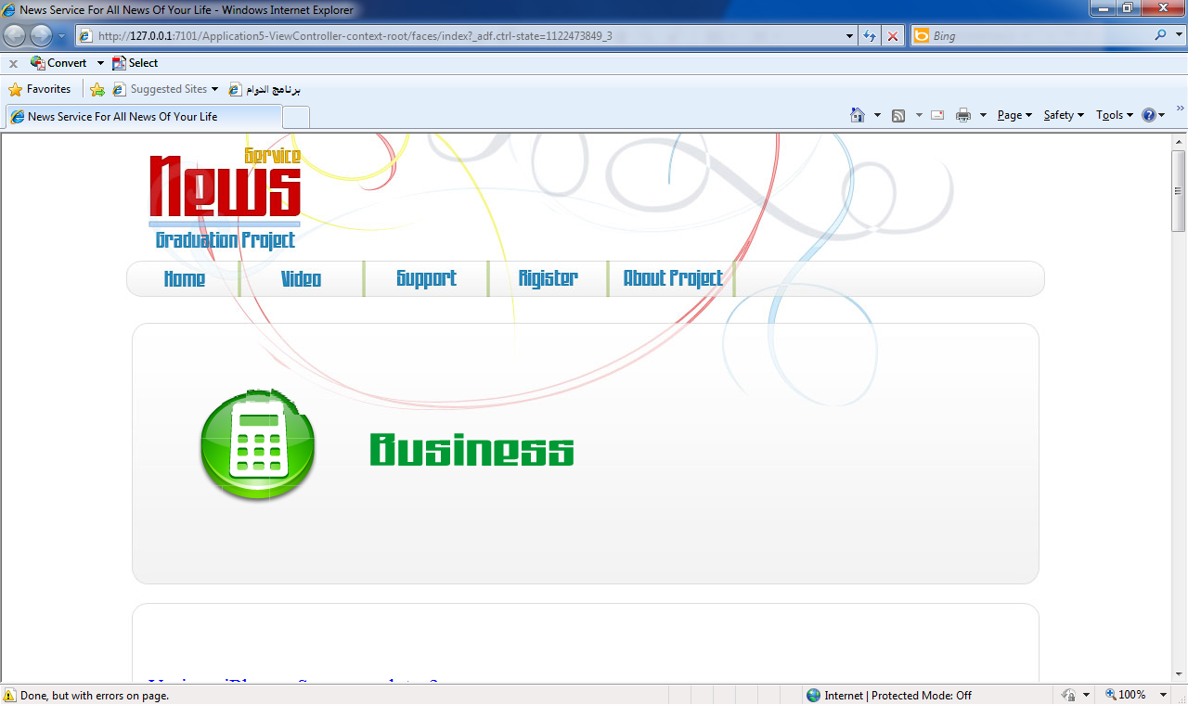
Fig 4.1
Master Page Of News System Web Site

4.2.1 News Page:
The news system provide organize news to all customer
around The World . fig 4.2 show how the news system organize the news by source, Category and Writers. To be more easy to the customers. and user can be knew last news around the world from more sources.
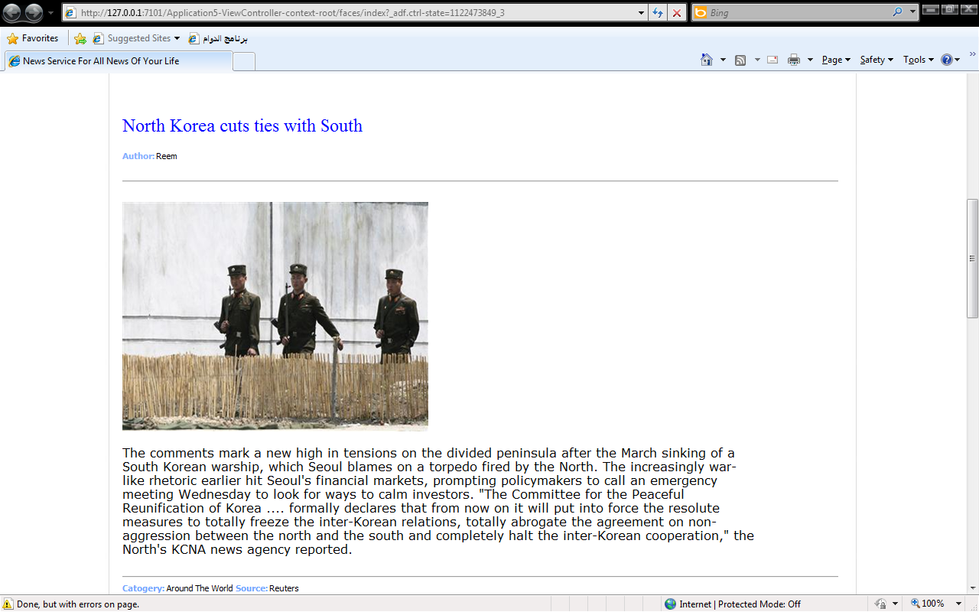
Fig 4.2 News Page
4.2.2 Video News Page:
Fig 4.3 Shows how the video news page provide video news to all the users and customers .The video is more familiar to user and the user can be saw and listened to news . news system fetch news from many recourses.
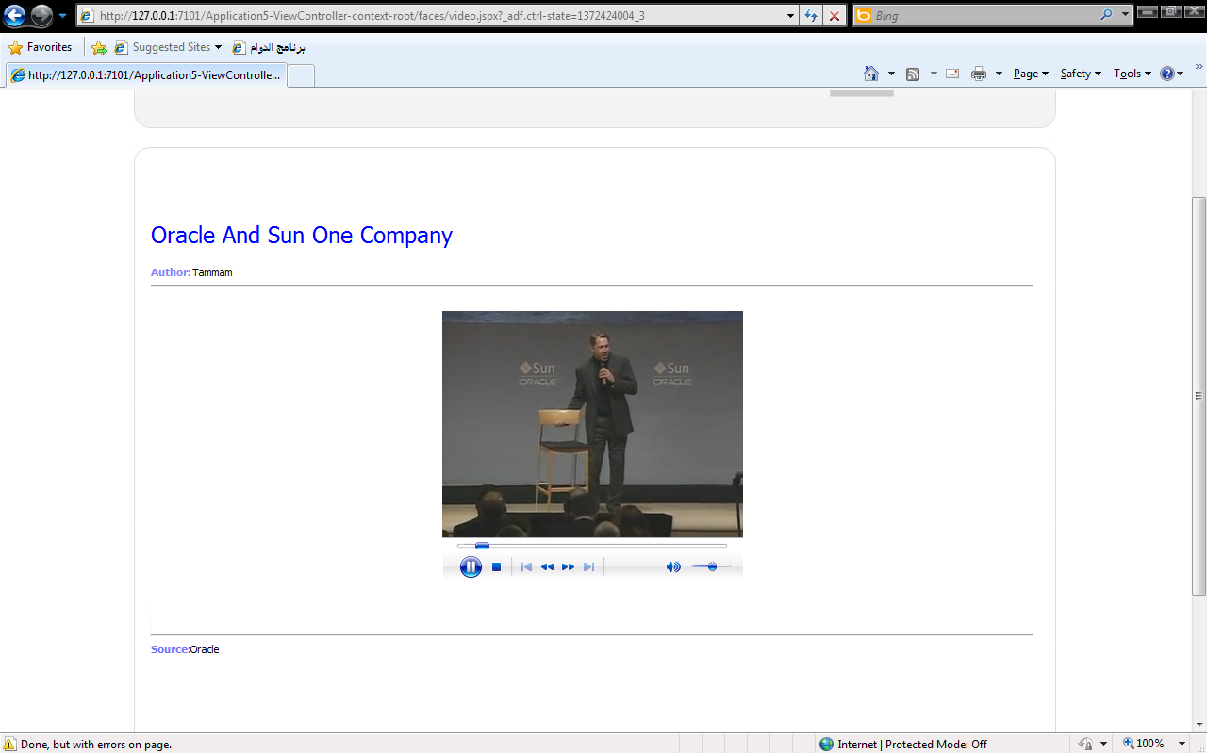
Fig 4.3 Video News Page

4.2.3 Support Page:
In this page we see login form to writer and customer can be use news system tools this form link with Admin control panel, writers control panel And customer control panel. With support tools the customers , admin And writers can be control of all service in the system.

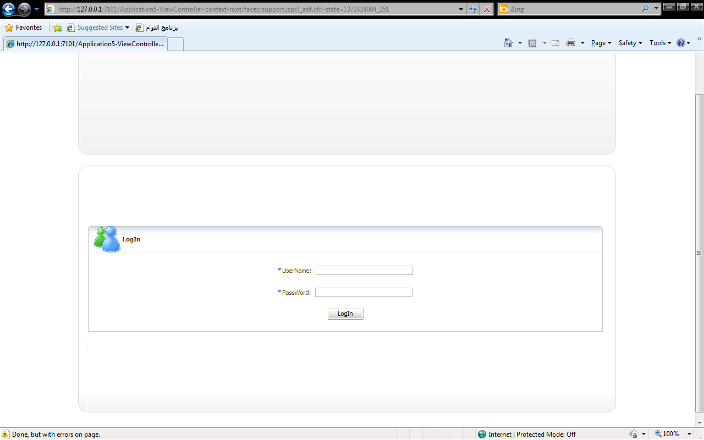
Fig 4.4 Support Page
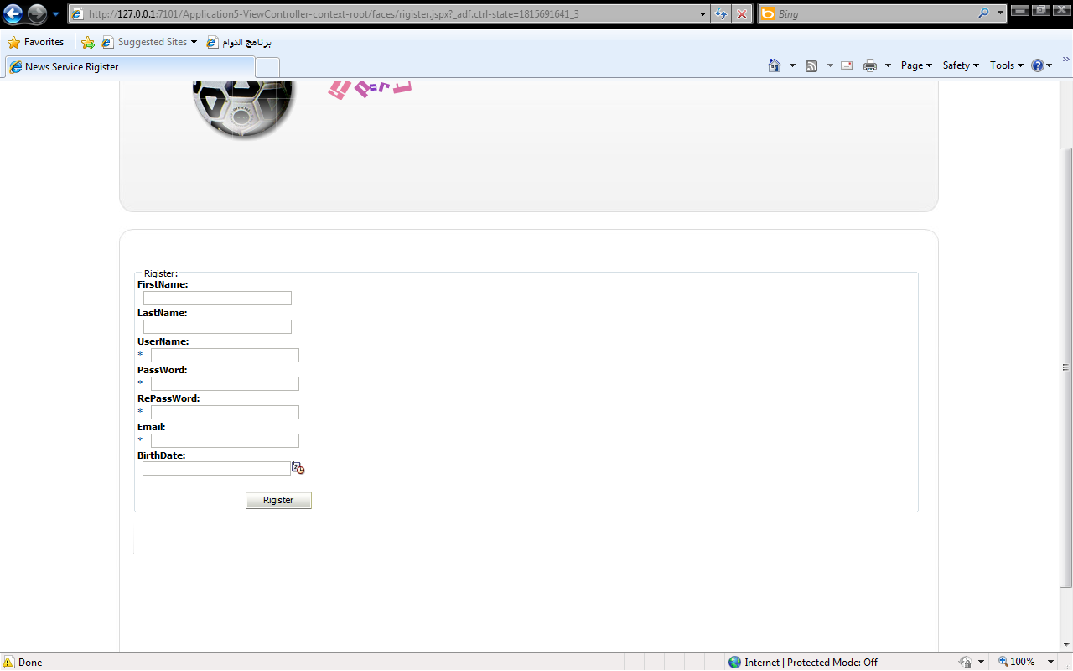
Fig 4.5 Register Page
4.2.4 Register Page:
This page specified for all people want to be customer in the news system if the user register in the news system then he can use all the services in it an he can be control of own services. Fig 4.5 shows register form.
4.2.5 Writers Page :
In this page the writer can be add news to the news system. Then All customer can by use this news .There are many types of writer like newsman ,Web Writers , Sport writers And others. For example sport writers writes sport news and tech Writers writes tech news. Fig 4.6 show the writers page.
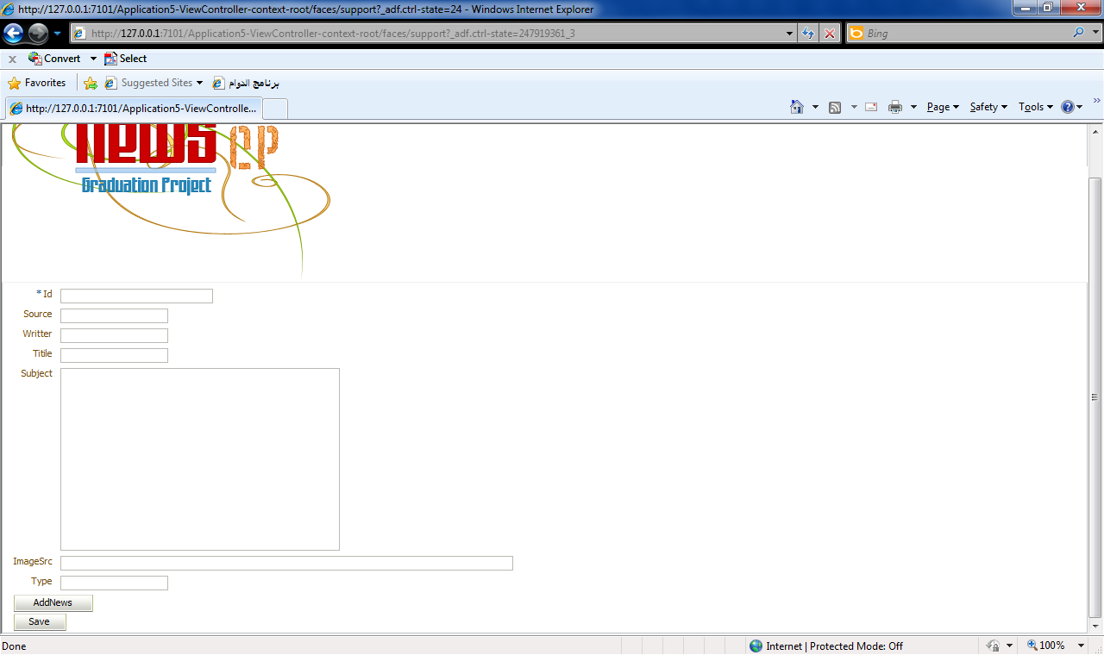
Fig 4.6 Writers Page.
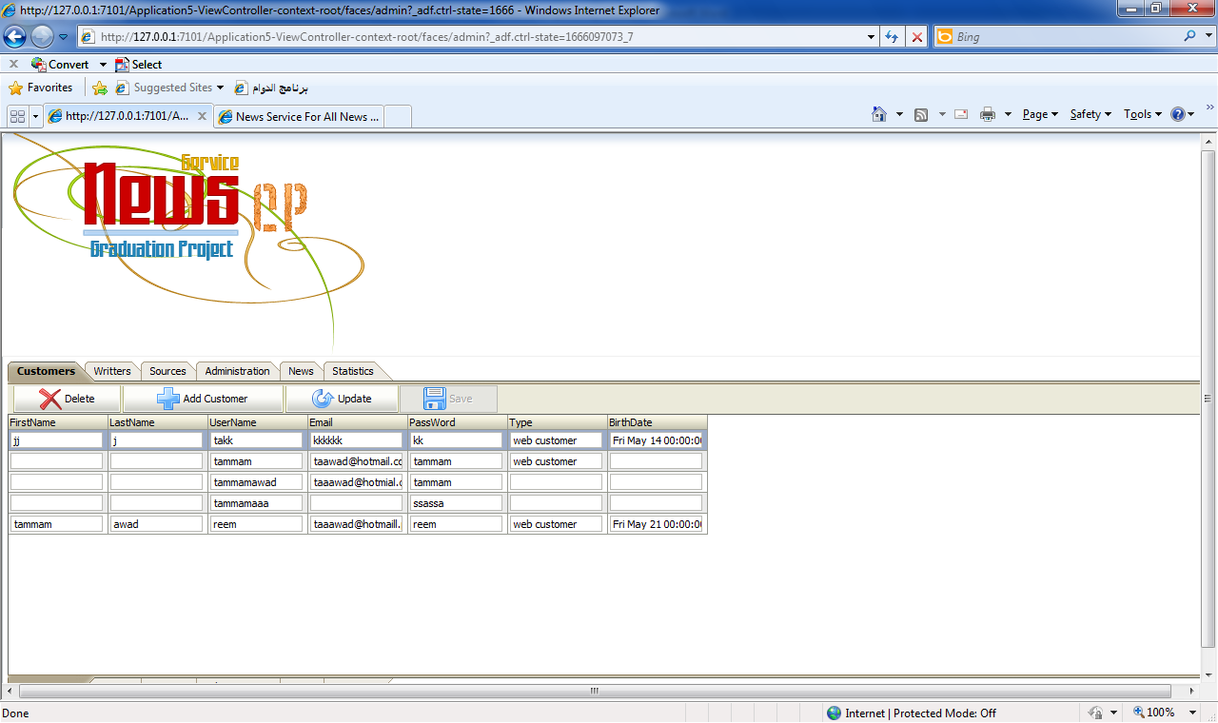
Fig 4.7 Control Panel
4.3 Control Panel :
Control panel is specified for administrator .its provide many tools to administration the system like writers tools , customer tools, source tools ,news tools , administrator tools ,And its show the statistics of the system. Fig 4.7 Shows the control panel.
4.3.1 Customers Control Panel:
In this page we can control of all the information about the Customers .We can Add ,Update And Delete the Customers. In this page we have full control for everything about Customers.fig 4.8 shows Customers control panel.
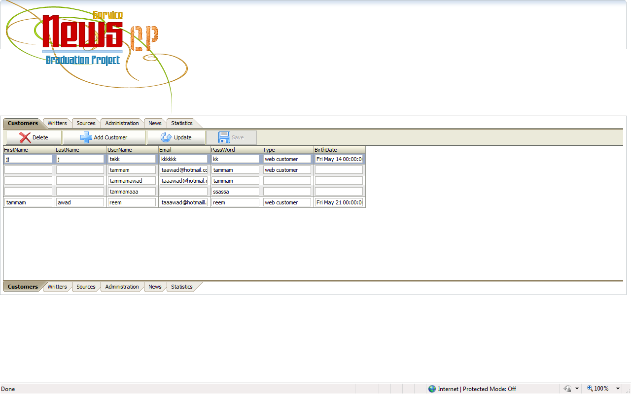
Fig 4.8 Customers control panel.
4.3.2 Writers Control Panel
In this page we can control of all the information about the writers .We can Add ,Update And Delete the writers. In this page we have full control for everything about writers.fig 4.9 shows writers control panel.
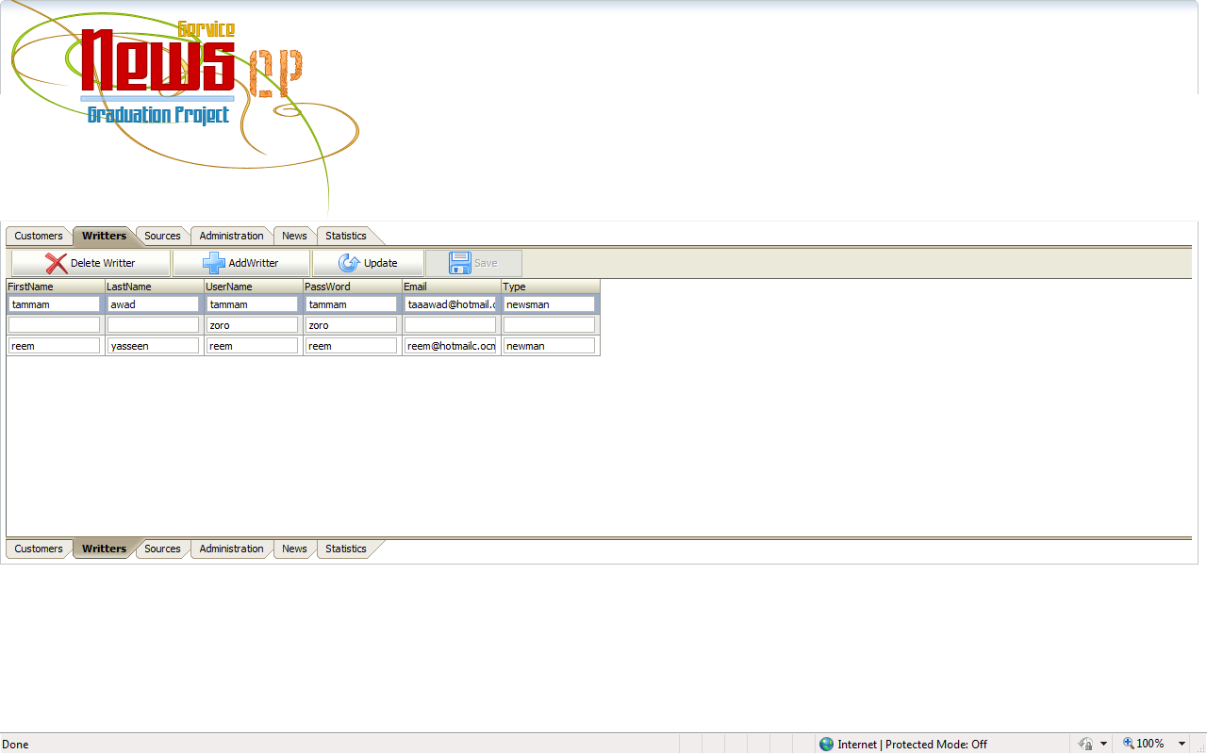
Fig 4.9 Writers Control Panel
4.3.3 Sources Control Panel:
In this page we can control of all the information about the Sources .We can Add ,Update And Delete the Sources. In this page we have full control for everything about Sources.fig 4.10 shows Sources control panel.
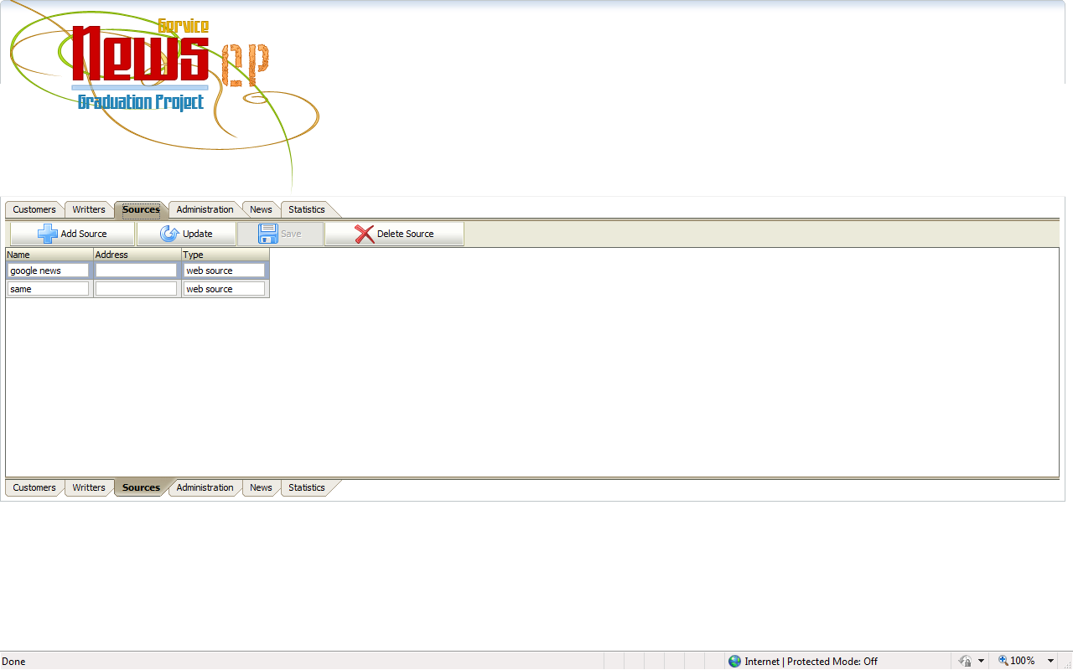
Fig 4.10 Sources control panel.
4.3.4 Administration Control Panel:
In this page we can control of all the information about the administrators .We can Add ,Update And Delete the administrators. In this page we have full control for everything about administrators.fig 4.11 shows administrators control panel.
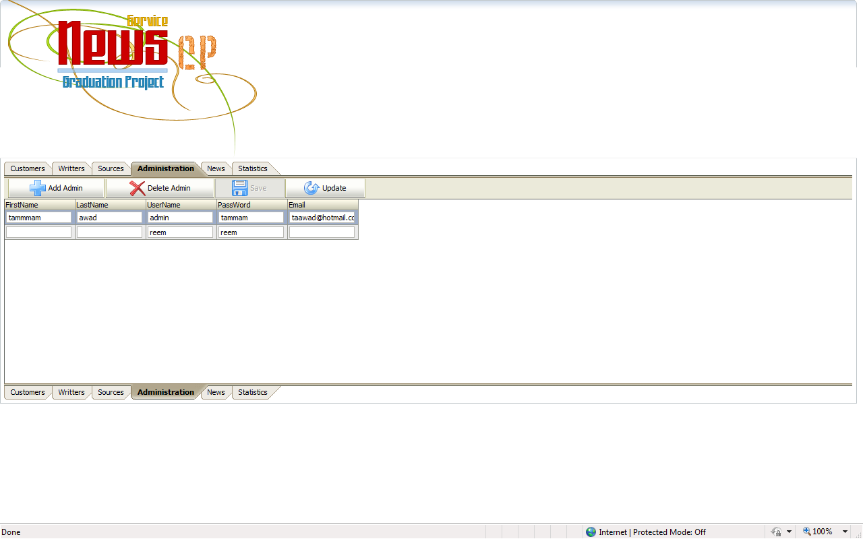
Fig 4.11 administrators control panel
4.3.5 News Control Panel:
In this page we can control of all the information about the News .We can Add ,Update And Delete the News. In this page we have full control for everything about News.fig 4.12 shows News control panel.
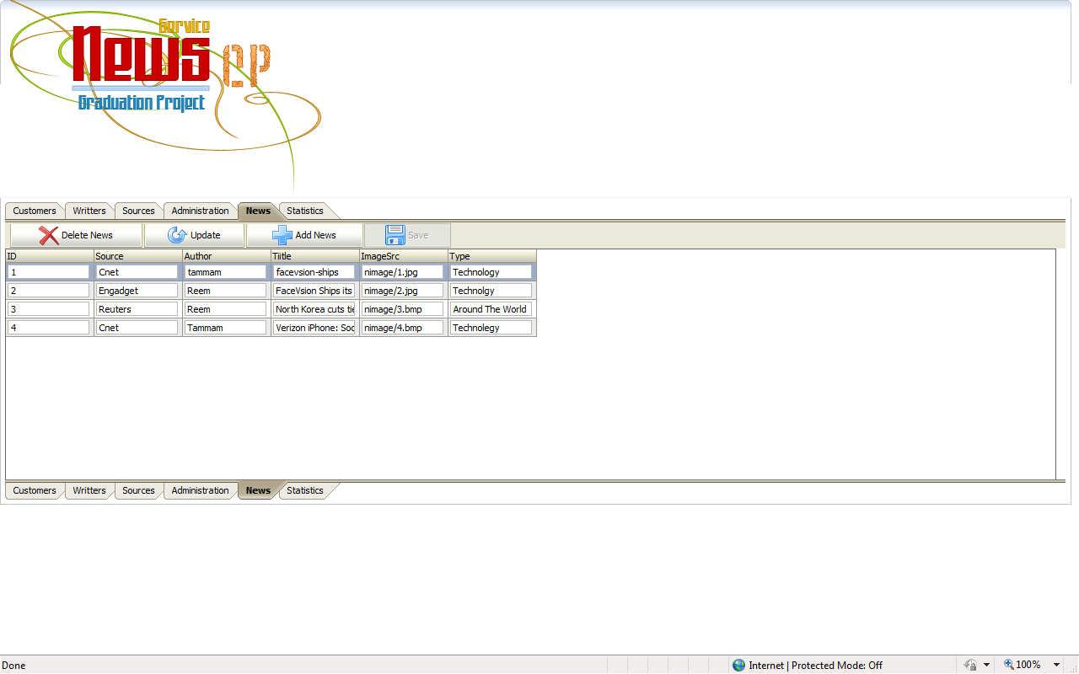
Fig 4.12 News Control Panel
4.3.6 Statistics Page :
In this page we can see the statistics of the news service .we can know all information about all customer whom they used the news service. This part of system is very important because, we need know all information about our system and if it successful or not. Fig 4.13 shows statistics page
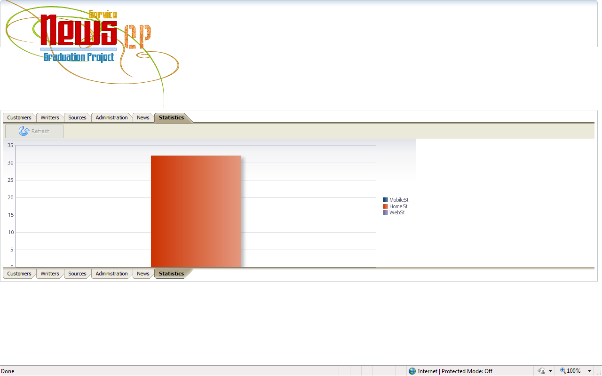
Fig 4.13 statistics page
4.4 mobile application:
Mobile application is build by using j2me technology this application shows the ability of the news service and how can by used anywhere. This application contains
we will shown below .
4..4.1 Mobile Main Form.
This form contains only logo of our system but in core it contains the connection with service and it fetch all last news to can be used.fig 4.14 show this form.
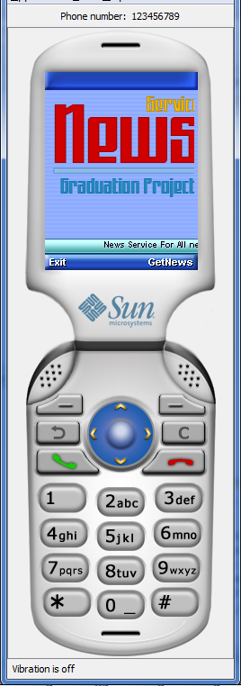
Fig 4.14 Mobile Main Form
4.4.2 Mobile Chose News Type Form:
This form contains the type of the news in the news service .the mobile application fetch news type from service by using the getType() method from web Service.this method gets all news type from the news service.fig 4.15 shows this form .
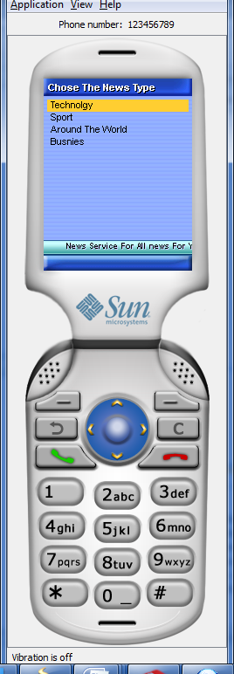
Fig 4.15 Chose News Type Form
4.4.4 Mobile News Form:
This form show all last news of the news type has been chosen .In this form the application fetch the news from service by using getnew() method . fig 4.16 show this form .
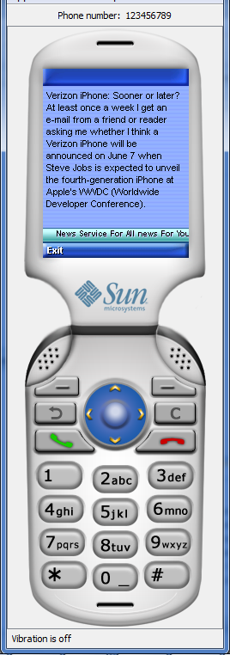
Fig 4.16 News Form

