INTRODUCTION
Java EE is a standard, robust, scalable, and secure platform that forms the basis form any of today’s enterprise applications. Java EE provides a set of specifications for building multi-tier applications using the JavaTM language. In the past, there was a direct correlation between the robust nature of an application to the complexity required to achieve it. However, with the advent of the Oracle ADF frame work, you are able to provide the implementation of extremely rich Java EE applications, adhering to standard patterns and practices with greatly reduced effort. Additionally, the increased need for organizations to build composite applications that utilize Service Oriented Architecture (SOA) principles has forced developers to create applications that are extremely agile. Implementing these best practices in agile applications usually involves writing a significant amount of infrastructure e code, adding another obstacle for developers building their first Java EE application. In addition to providing robust, perform ant, and maintainable applications; Oracle Application Development Framework also provides the best of breed infrastructure code to implement agile SOA based applications thereby removing the effort involved in an organization “rolling their own” and allowing a team to jump right into adding value versus building an infrastructure.
Oracle ADF – Making Java EE Development Simpler
Oracle Application Development Framework (Oracle ADF) is an innovative, yet mature Java EE development framework available from Oracle and unlike most other frameworks is directly supported and enabled by the award winning development environment, Oracle JDeveloper 11g. Oracle ADF simplifies Java EE development by minimizing the need to write code that implements the application’s infrastructure allowing the users to focus on the features of the actual application. Oracle ADF provides these infrastructure implementations as part of the framework. To recognize a set of runtime services is not enough, Oracle ADF is also focused on the development experience to provide a visual and declarative approach to Java EE development through the Oracle JDeveloper 11g development tool.
For example, Oracle ADF makes it easy to develop agile applications that expos edata as services by coupling a service interface to the built-in business services in ADF. This separation of business service implementation details is performed in Oracle ADF via metadata. Use of this metadata-driven architecture enables application developers to focus on the business logic and user experience, rather than the details of how services are accessed. Creating the user experience is as simple as drag-and-dropping the desired data controls onto the page design and indicating what type of component should represent that data. In the example illustrated, we are able to take a database table exposed as a business service, and request JDeveloper to render the data as a table simply by dragging-and dropping the control on the page and responding to the automatic popup by indicating a table as the desired rendering component. Oracle ADF takes care of the rest.
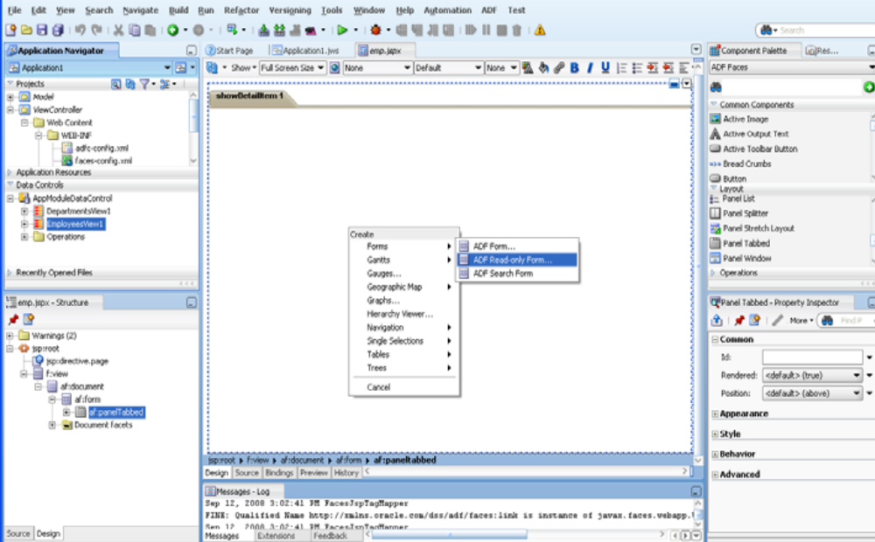
Fig 2.25 Oracle ADF
By using Oracle ADF, the implementation details of these services are stored in metadata in the ADF Model layer. This enables developers to exchange services without modifying the user interface, making the application extremely agile. Additionally, the developer creating the user interface does not need to bother with business service access details. Instead they can focus on developing the application interface and interaction logic.
THE ORACLE ADF ARCHITECTURE
Oracle ADF is based on the Model-View-Controller (MVC) design pattern. An
MVC application is separated into:
- a model layer that handles interaction with data-sources and runs the business logic.
2) a view layer that handles the application user interface.
3) a controller that manages the application flow and acts as the interface between the Model and the View layers.
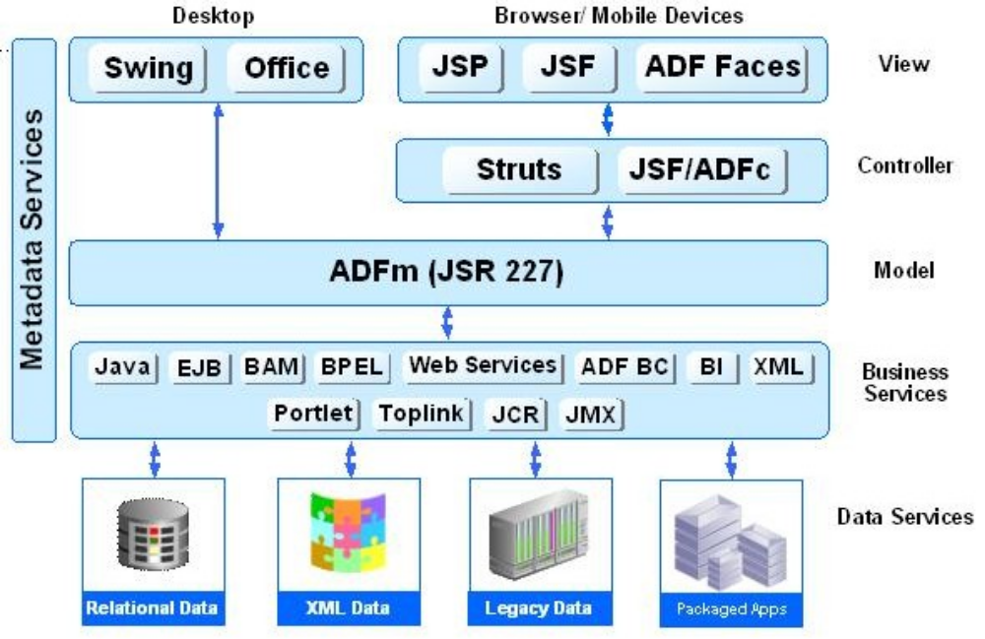
Fig ADF ARCHITECTURE
Oracle ADF lets developers choose the technology they prefer to use when implementing each of the layers. The diagram above shows the various options available for developers when building Oracle ADF applications. The glue that integrates the various components of Java EE applications and makes development so flexible is the Oracle ADF model layer. EJB, Web Services, JavaBeans, and JPA/ EclipseLink/ TopLink objects and many others can all be used as Business Services for the Oracle ADF Model. View layers can include Swing applications and MS Office integration as well as HTML interfaces using JSP, Java Server Faces (JSF) and ADF Faces.
The Business Services Layer
The Business Services layer manages interaction with a data persistence layer. It provides such services as data persistence, object/relational mapping, transaction management, and business logic execution. The Business Services layer in Oracle ADFcan be implemented in any of thefollowing options: As simple Java classes, EJB 2.1/3.0, Web services, JPA objects, and Oracle ADF Business Components.
The Controller Layer
The controller layer manages the applications flow and handles user input. For example, when you click a Search button on a page, the controller determines what action to perform (do a search) and where to navigate to (the results page). There are three controller options for web-based applications in JDeveloper: Oracle ADF Controller, which provides the most functionality; the un augmented JSF controller or the Apache Struts. Whichever controller you use, you will typically design your application flow by laying out pages and navigation rules on a diagram. Using ADF controller you can break your application's flow into smaller, reusable task flows; include non-visual components such as method calls in your flow; and create "page fragment" flows that run inside a region of a single containing page. This approach encourages maximum reusability for user interface fragments and simplified integration into portals and mashup applications.
The View Layer
The View layer represents the user interface of the application. The view layer can
be based on HTML, JSP, JavaServer Faces (JSF), rich Java components, or XML
and its variations to render the user interface. The View layer can be a Web client, a
client-server desktop application, or a wireless implementation for a mobile devicesuch as a phone.
The Model Layer
The model layer connects the business services to the objects that use them in the other layers. Oracle ADF provides a model layer implementation that sits on top of business services, providing a single interface that can be used to access any type of business service. The model layer consists of two components, data controls and data bindings, which utilize metadata files to define the interface. Data controls abstract the business service implementation details from clients. Data bindings expose data control methods and attributes to UI components, providing a clean separation of the view and model. Due to the metadata architecture of the model layer, developers get the same development experience when binding any type of Business Service layer implementation to the View and Controller layers. The Model layer in Oracle ADF also serves as the basis for JSR-227 “A Standard Data

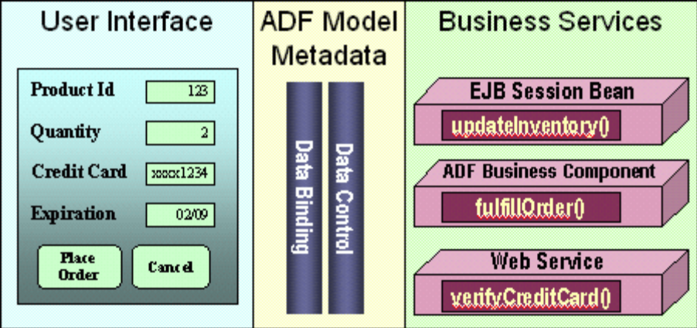
Fig ADF Model Layer
Productivity with Choice
Developers can choose different technologies to implement each of Oracle ADF‘s layers, and still get the same productive development experience. For example, thesame gestures and methods would be used to create an ADF Swing application based on ADF Business Components as would be used to create a ADF Faces application based on Enterprise JavaBeans. In addition to the choice of technologies implemented, developers can choose their development style (declarative, visual, or by coding), their development environment (JDeveloper or another IDE, such as Eclipse), and their deployment environment (any Java EE compliant server).

Visual and Declarative Java EE Development
A critical aspect of making a development framework useful is having a development tool that simplifies the creation of applications using this framework. Oracle offers visual and declarative tools for each layer of Oracle ADF. These tools, which are integrated into the JDeveloper IDE, benefit Java developers even if they don’t use the runtime features of Oracle ADF.
Business Services Development
Oracle JDeveloper includes a variety of ways to construct business services including: EJB/JPA, web services, simple Java objects, and ADF BC, among\ others. “Productivity with Choice” is a cornerstone to this approach. When generating these, it is possible to make use of a wizard-driven approach to generate Business Services that provide Java interfaces to these tables with simply a right click these interfaces can then be exposed as web services. Additionally, keeping with the theme of being visual and declarative, it is also possible to accomplish the same thing via visual modeling to generate these interfaces.
Oracle ADF Business Components is a framework focused on creating objects, which implement the Business Services layer on top of a data source, in a more declarative way. It provides out-of-the-box services such as transaction management, resource pooling, locking, declarative validation rules, translation, and object-relational mapping. Oracle ADF BC should feel familiar to developers with a background in 4gl declarative database driven development, offering such features as defining java objects based on SQL, declarative definition of validation rules, and pre-defined events where code can be injected into the business service life cycle. ADF BC development is done through declarative dialogs and property inspectors. With built-in implementation of common JAVA EE design patterns in the framework, the performance and scalability of the application is assured.
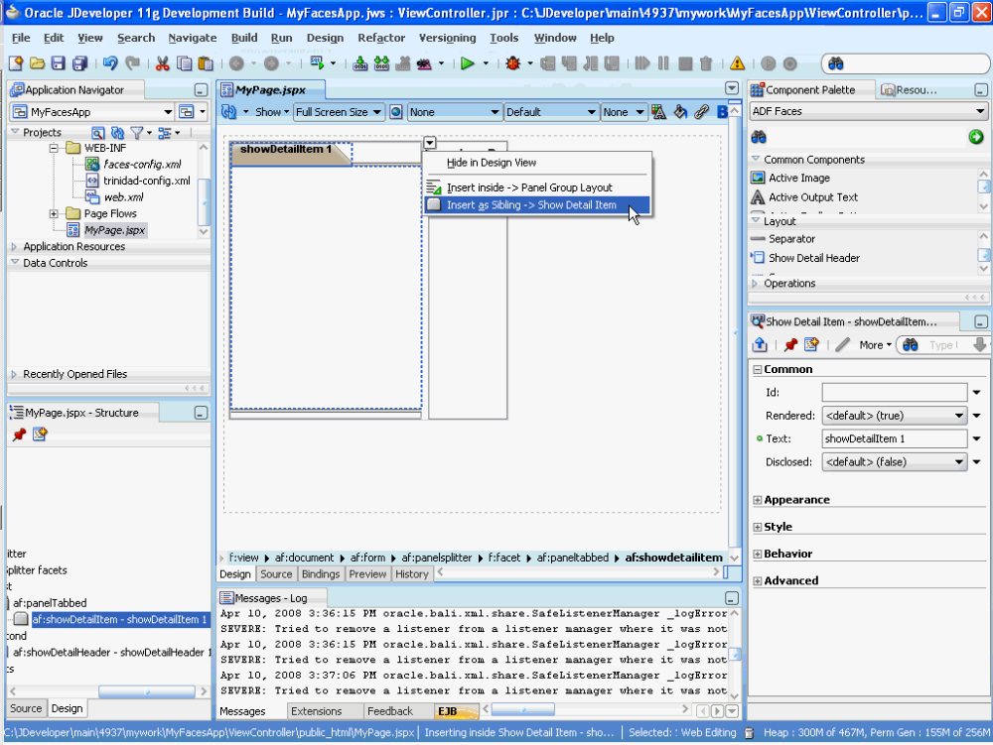
Fig Oracle ADF with JDeveloper

