WebService Code:
public class NewsWebService {
public Connection getConnection() throws SQLException {
String username = "system";
String password = "tammam";
String thinConn = "jdbc:oracle:thin:@localhost:1521:XE";
DriverManager.registerDriver(new OracleDriver());
Connection conn =
DriverManager.getConnection(thinConn, username, password);
conn.setAutoCommit(false);
return conn;
}
public int Auth(String user,String pass) throws Exception
{
int x=0;
int mob=0;
Connection c=getConnection();
PreparedStatement p=c.prepareStatement("SELECT * FROM customer WHERE cname=? AND cpass=?");
p.setString(1, user);
p.setString(2, pass);
ResultSet r=p.executeQuery();
while(r.next())
{
if(user.equals(r.getObject("cname").toString()))
{
x=1;
Statement s=c.createStatement();
ResultSet rr=s.executeQuery("SELECT * FROM STATISTICS");
PreparedStatement pp=c.prepareStatement("UPDATE STATISTICS SET mobile_st=?");
while(rr.next())
{
mob=Integer.parseInt(rr.getObject("mobile_st").toString());
}
mob++;
pp.setInt(1, mob);
pp.executeUpdate();
c.commit();
}
}
return x;
}

@WebMethod(operationName = "getnews")
public Map getnews(@WebParam(name = "user")
String user, @WebParam(name = "pass")
String pass) {
Map p=new HashMap();
try{
if(Auth(user, pass)==1)
{
Statement s=getConnection().createStatement();
ResultSet r=s.executeQuery("SELECT * FROM news");
while(r.next())
{
p.put(r.getObject("tittle"),r.getObject("subject"));
}
}
}catch(Exception e)
{
e.printStackTrace();
}
return p;
}
@WebMethod(operationName = "getnews_1")
@RequestWrapper(className = "NewsWebService.getnews_1")
@ResponseWrapper(className = "NewsWebService.getnews_1Response")
public Map getnews(@WebParam(name = "user")
String user, @WebParam(name = "pass")
String pass, @WebParam(name = "type")
String type) {
Map m=new HashMap();
try{
if(Auth(user, pass)==1)
{
Connection c=getConnection();
PreparedStatement p=c.prepareStatement("SELECT * FROM news WHERE ntype=?");
p.setString(1, type);
ResultSet r=p.executeQuery();
while(r.next())
{
m.put(r.getObject("tittle"),r.getObject("subject"));
}
}
}catch(Exception e)
{
e.printStackTrace();
}
return m;
}

@WebMethod(operationName = "getType")
public Vector getType() {
Vector v=new Vector();
try{
Statement s=getConnection().createStatement();
ResultSet r=s.executeQuery("SELECT * FROM newstype");
while(r.next())
{
v.addElement(r.getObject("type"));
}
}catch(Exception e)
{
System.out.println(e.getMessage());
}
return v;
}
}

Admin .java
public Connection getConnection() throws SQLException {
String username = "system";
String password = "tammam";
String thinConn = "jdbc:oracle:thin:@localhost:1521:XE";
DriverManager.registerDriver(new OracleDriver());
Connection conn =
DriverManager.getConnection(thinConn, username, password);
conn.setAutoCommit(false);
return conn;
}
public String commandButton1_action() {
// Add event code here...
try {
Connection c = getConnection();
PreparedStatement p=c.prepareStatement("INSERT INTO customer(cfname,clname,cname,cpass,cemail,ctype,bdate) VALUES(?,?,?,?,?,'web customer',?)");
if(inputText6.getValue().equals(inputText4.getValue())) {
p.setString(1,inputText1.getValue().toString());
p.setString(2,inputText2.getValue().toString());
p.setString(3,inputText3.getValue().toString());
p.setString(4,inputText6.getValue().toString());
p.setString(5,inputText5.getValue().toString());
p.setString(6,inputDate1.getValue().toString());
p.executeUpdate();
c.commit();
message1.setMessageType("confirmation");
message1.setMessage("Successfully Rigistered");
}else{
message1.setMessageType("error");
message1.setMessage("Password not properly confirmed, enter your password two times exactly the same");
}
} catch (SQLException e) {
message1.setMessageType("error");
message1.setMessage("This Customer is already exist");
}
return null;
}
Support.java
public String commandButton1_action() throws SQLException {
Connection c=getConnection();
String n="";
try {
PreparedStatement Admin=c.prepareStatement("SELECT * FROM admin WHERE uname=? AND pass=?");
PreparedStatement writter=c.prepareStatement("SELECT * FROM Writters WHERE wname=? AND wpass=?");
Admin.setString(1,inputText1.getValue().toString());
Admin.setString(2,inputText2.getValue().toString());
ResultSet r1=Admin.executeQuery();
writter.setString(1,inputText1.getValue().toString());
writter.setString(2,inputText2.getValue().toString());
ResultSet r2=writter.executeQuery();
String n1="";
String n2="";
while(r1.next()){
n1=r1.getObject("uname").toString();
}
while(r2.next()){
n2=r2.getObject("wname").toString();
}
if(n1.equals(inputText1.getValue().toString())) {
n="cp";
return "cp";
}else if(n2.equals(inputText1.getValue().toString())) {
n="writter";
return "writter";
}else{
message1.setMessage("User Name Or PassWord Incorrect");
}
}
catch (SQLException e) {
message1.setMessageType("error");
message1.setMessage("Connection Error");
}finally{
try{
c.close();
}catch(Exception e)
{
e.printStackTrace();
}}
DataBase Diagram:
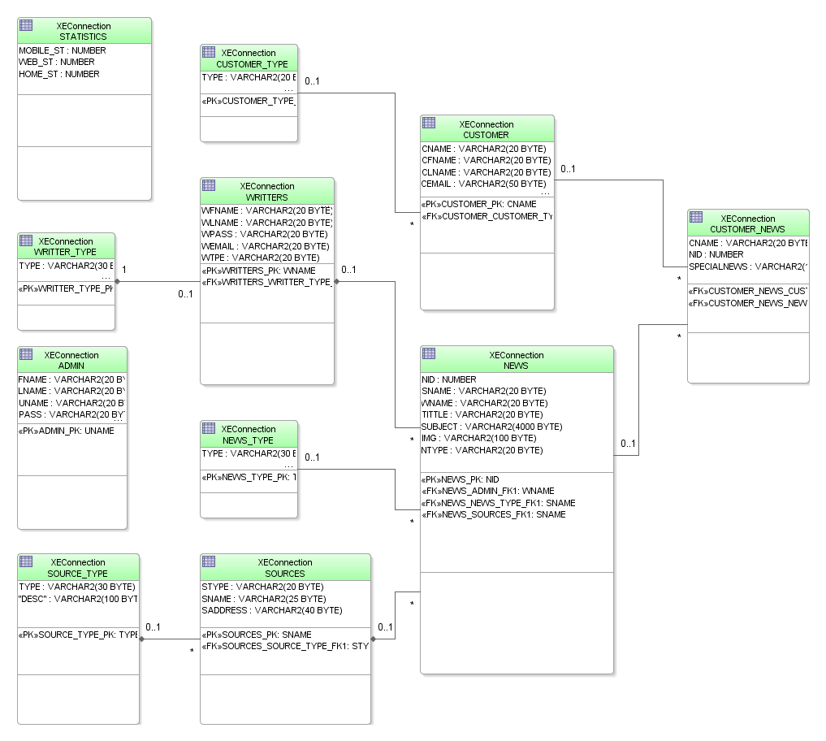
Sequence diagrams:
