**Thumbnail Scroller (with PHP Admin)**

A very customizable Thumbnail Scroller, that can be edited from a PHP Admin. The scroller is completely resizable and is compatible with all browsers and devices (iPhone, iPad and Android smartphones). You will be able to insert it into your website with an inbuilt HTML code generator. If you like this plugin, feel free to rate it five stars at [CodeCanyon](http://codecanyon.net/item/thumbnail-gallery-with-php-admin/2396252?ref=DOTonPAPER) in downloads section. If you encounter any problems please do not give a low rating but [contact us](mailto:support@dotonpaper.zendesk.com) first so we can help you.

**How to install it**

1. Copy the folder **dopts** somewhere on your server (preferably in the same

folder with the page you want to add the gallery to).

1. Change the permission of the **dopts/data** & **dopts/uploads** with **all subfolders** to **777**
2. Change the following setings in **dopts/config.php**:

define("DOPTS_ADMIN_USERNAME", "add username here"); // Add admin username.

define("DOPTS_ADMIN_PASSWORD", "add password here"); // Add admin password.

define("DOPTS_URL", "add url here"); // Add URL to dopts folder (must end with /).

define("DOPTS_ABSOLUTE_PATH", "add absolute path here"); // Add ABSOLUTE PATH to dopts folder (must end with /).

**Note:** The URL and ABSOLUTE PATH are found in the **dopts/paths.php** that is opened by

your browser.

1. Go to **http://www.your_url.com/dopts/admin** to login.

**How to use it**

After installation login with the username and password from the 3rd installation step and hover/click the mouse over the Question Mark icons for instructions.

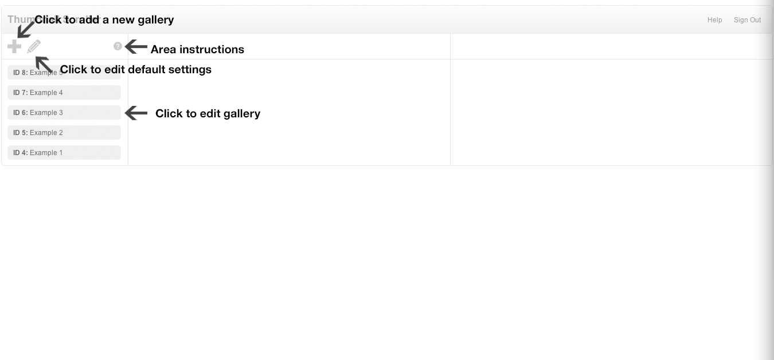

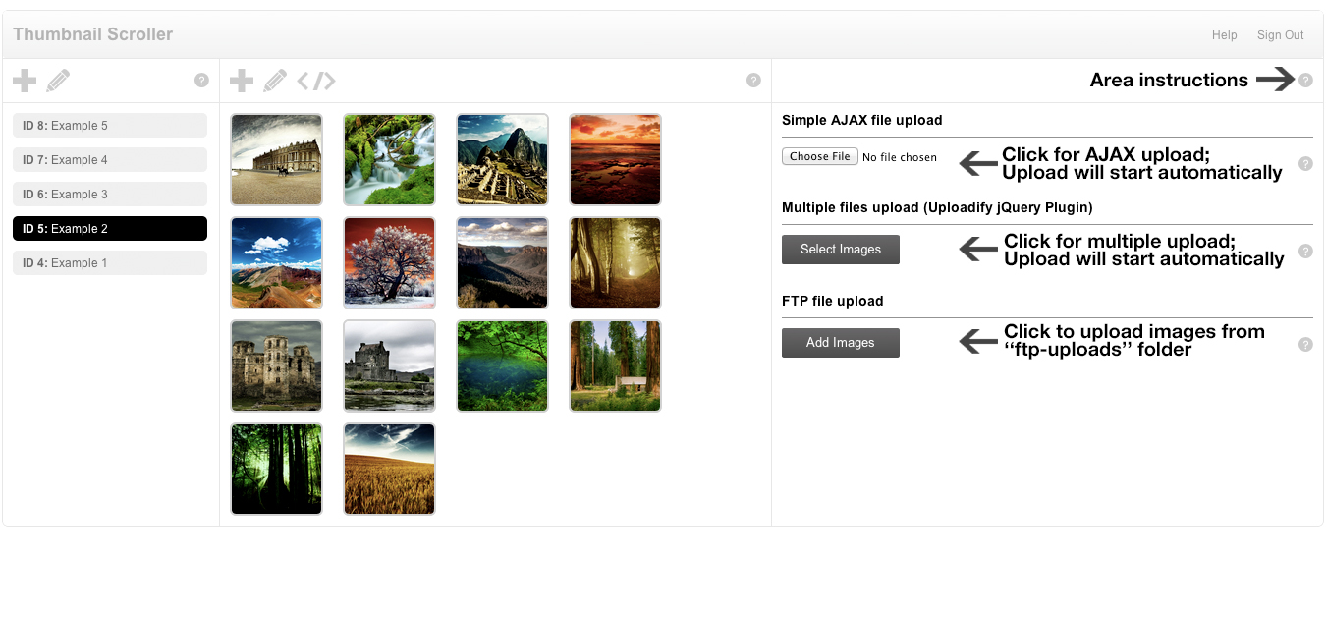

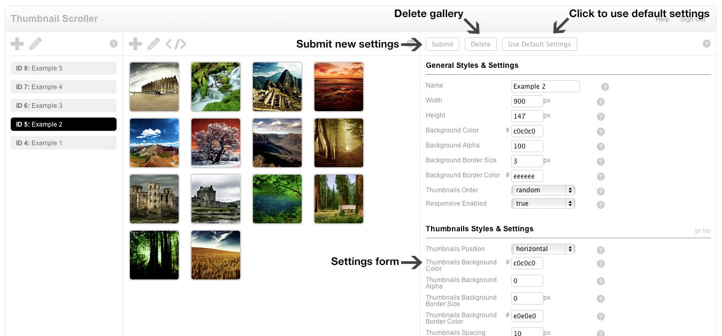

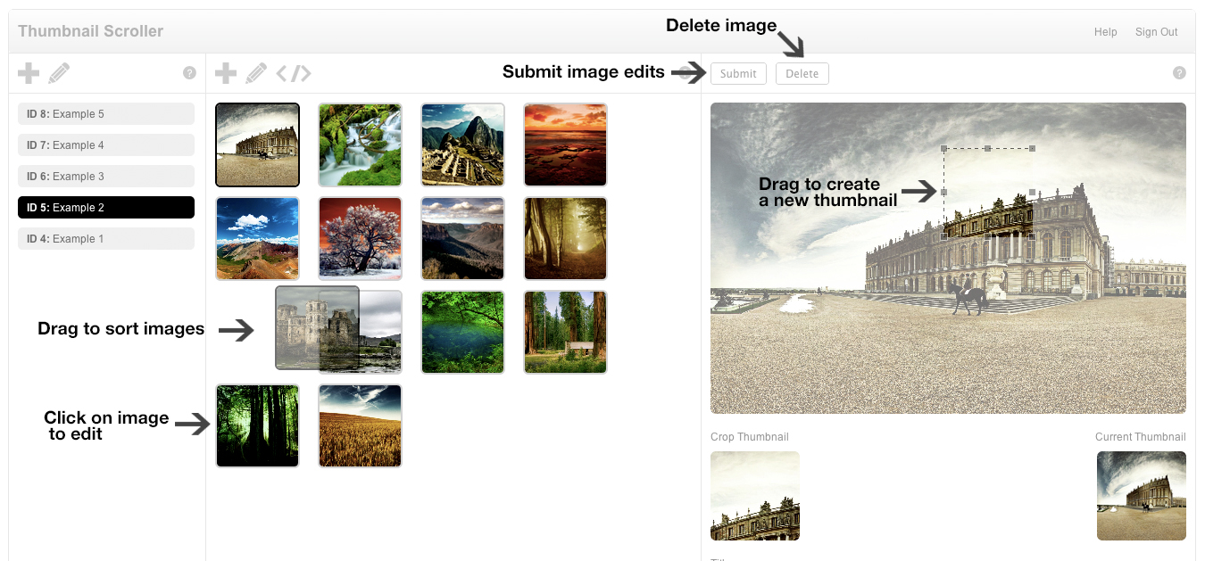

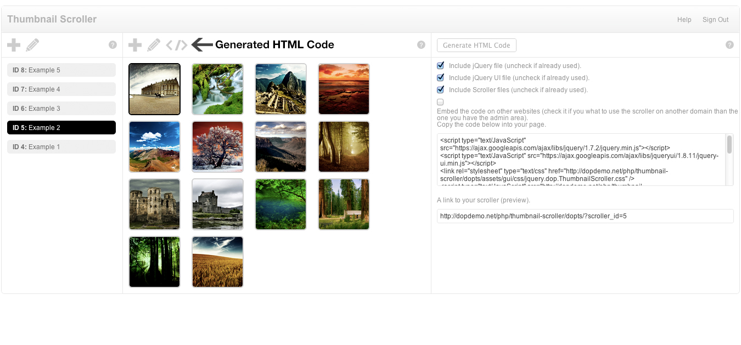

**FAQ**

1. **How to install the scroller?**

Please view this [video](http://www.youtube.com/watch?v=BBWfbZmN5No&hd=1).

1. **How do I create a scroller and add images to it?**

Please view this [video](http://www.youtube.com/watch?v=ifyfIuZs9zk&hd=1).

1. **How do I create a new thumbnail?**

Please view this [video](http://www.youtube.com/watch?v=vr-gYhw3N1g&hd=1).

1. **How do I add media to a scroller item? Embed videos (YouTube, Vimeo, ...), and HTML code, ...**

Please view this [video](http://www.youtube.com/watch?v=q7-U3e82q4M&hd=1).

1. **How do I change scroller settings? (Some examples)**

Please view this [video](http://www.youtube.com/watch?v=RJCPVz8zTfA&hd=1).

1. **How can I integrate this admin into my own CMS?**

You change the session condition in **dopts/admin/index.php**.

1. **Why can’t I upload images to my scroller?**

Make sure that folders **dopts/uploads** with **all subfolders** inside it & **dopts/data/** have the permissions set to **777**. If the folder has the right permissions try another upload method from the ones provided (AJAX, Uploadify, FTP).

1. **Why don’t the images appear after upload is complete?**

Make sure that you have the GD Library enabled in PHP.

1. **Why I receive an IO Error when I upload images using Uploadify?**

The IO Error is a Flash error caused when the upload connection gets cut short. Usually happens with slow internet connections.

1. **Why doesn't the scroller show in my website?**
2. If the scroller doesn't show it might be because there is a problem with the JavaScript in your website. If you can't identify the problem contact me with a link. I will identify the problem for you, but I will not fix the problems that aren't caused by this plugin.
3. Another reason might be that you load more than one jQuery file into your theme.
4. **How do I change the language?**

You can change the translation in the file **dopts/admin/assets/php/translation.php**.

1. **Known issues**

1. On **localhost** servers, depending on the configuration admin might be slow, you will not be able to upload pictures…

2. Uploadify will not display the progress bar and image processing will go slower if you have a firewall enabled.

3. On some servers the images names that contain other characters different from alphanumeric ones will not be uploaded. Change the names for them to work.

4. The Back End section has some display issues in IE 7 (please update to a new version).

1. **What I can do when nothing works?**

[Contact our Support Team](mailto:support@dotonpaper.zendesk.com) :)

Before we can offer support we will need to **confirm your purchase**. The reason for this is because we receive a lot of support requests from people that get the items from other sites and is a great way to sort the tickets and offer faster support to the actual buyers.

There are 2 ways to do this:

1. Send us a Private Message from our [Profile Page](http://codecanyon.net/user/DOTonPAPER?ref=DOTonPAPER) ... the right-bottom form. If you don’t see it you need to Sign In into your Envato Account.

2. Send your Envato Username & Item Purchase Code that came with the Licence Certificate when you bought the item to our [Support Team](mailto:support@dotonpaper.zendesk.com). You can get it from CodeCanyon -> Sign In into your Account -> Downloads -> Licence Certificate on the purchased item.

**Please add in your message** a link were you use the item, admin and/or FTP log in info, or any other stuff that might be relevant.

We will try to answer your questions in less than 48 hours. If you don’t receive an answer in 48 hours please view our [Profile Page](http://codecanyon.net/user/DOTonPAPER?ref=DOTonPAPER) for a reason.

**PS: Don’t forget to rate this item.**