Instructions for the Use of PLPLOT and MYIMSL

- Introduction

This document describes how to link the plplot and myimsl libraries into your own codes using MS Visual C++ on PCs running MS Windows 98/XP(this version may work on other versions of Windows).

Plplot is a scientific plotting package which can be used to create standard x-y plots, semilog plots, log-log plots, contour plots, 3D surface plots, mesh plots, bar charts and pie charts. The plplot package is distributable under the terms of the GNU Library General Public License (LGPL) with some exceptions. For more information about “Copyright” and “on-line manual”, please see the home page(http://plplot.sourceforge.net).

Myimsl is a small-sized package solving special problems which is coded and distributed by Gang Gyoo Jin, Korea Maritime University. The myimsl library contains modules for eigenvalues, polynomial roots, sort, norms, FFT, cubic spline, ODEs, real-coded genetic algorithm(RCGA), symbolic-coded genetic algorithm(SCGA), Simulated Annealing, fuzzy control, etc. Myimsl includes the new vector and matrix classes coded by Alexander Volya(http://www.nscl.msu.edu/~volya/alexander/) for easy manipulations of real and complex vectors and matrices.

2. Requirements

You’ll need MS Visual C++ version 5, 6 or higher for linking two libraries created on release mode.

3. Contents of plplot.zip and myimsl.zip

3.1 plplot.zip
For the detailed information, please see the above home page.

3.2 myimsl.zip
Below you can find simplified descriptions of this library.
readme.txt- file to read
myimsl.lib- library file
anneal.h- prototypes for simulated annealing
cmatrix.h- prototypes of the functions using complex matrix and vector classes
complex.h- prototypes for complex numbers
diffeqs.h- prototypes for ODEs and difference equations
fuzzy.h- prototypes for fuzzy control
imsl.h- prototypes of the functions using vector and matrix array
rcgas.h- prototypes for RCGAs
realtype.h- prototypes and codes for some basic functions
rmatrix.h- prototypes of the functions using real matrix and vector classes
scgas.h- prototypes for SCGAs

4. Installation and setting instructions

4.1 Unzip the two zipped files into the directories, c:\plplot and c:\myimsl, respectively. You can extract the files of myimsl in any directory you want, but not plplot.

4.2 During execution of your programme, plplot find the font files (located in c:\plplot\lib with the extension .fnt). You have to set the environmental variable PLPLOT_HOME as SET PLPLOT_HOME= ”C:\PLPLOT” as shown in the figures and restart your PC or simply put the font files in the same directory where your plplot programme is executed.

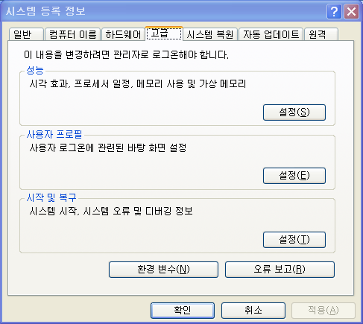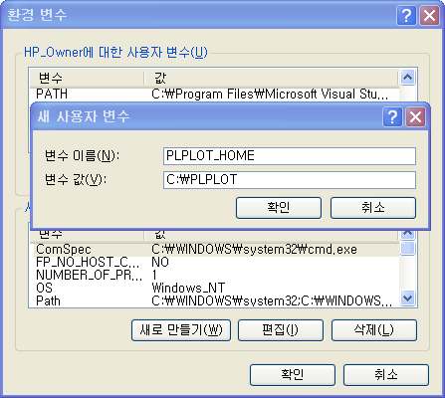

4.3 Run MS Visual C++ and create an empty project for win32 console applications. When library functions are used in your code, you need to include related header files with #include preprocessor directive(see demo programmes).

4.4 Add two include and library directory paths to MS Visual C++.
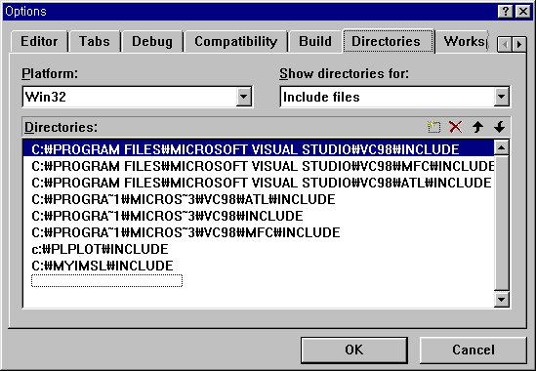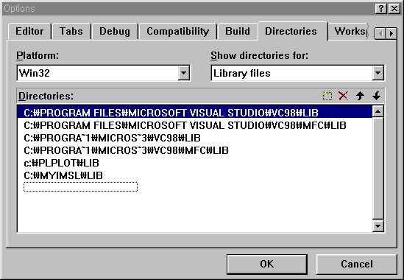

4.5 When calling functions in a library, the library name must be included in the library module box as shown in the figure.
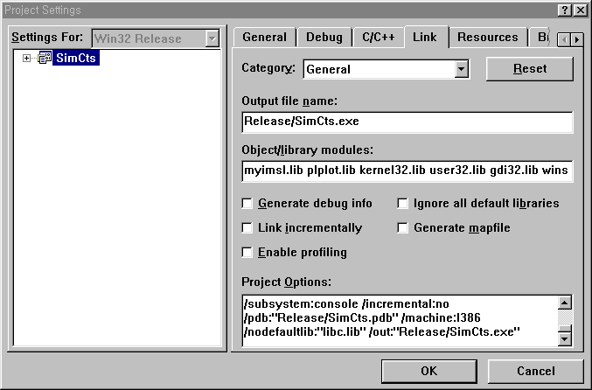
4.6 When you have some link errors(‘conflicts with use of other libs’) during the link process, add /nodefaultlib:”libc.lib” for the release mode or /nodefaultlib:”libcd.lib” for the debug mode in the project option box as shown in the figure. This is due to the lower version of plplot.

5. Comments and suggestions

If you have comments or suggestions on the myimsl library, please do not hesitate to contact me via email(ggjin@mail.hhu.ac.kr).

10 March 2006
Gang Gyoo Jin
Professor, Korea Maritime University

