**Name: Đỗ Trung Kiên**

**Email: dotrungkien9c@gmail.com**

**Answer sheet EX1**

|  |  |
| --- | --- |
| **Question** | **Answer** |
| 1 | From table Users  Where the value year from column user_birth_date equal to 2000  Select user_name column  And select Year value from user_birth_date column |
| 2 | Select T2.Emp_ID,  Case  when left(T1.emp_id, 1) = 'E' Then 'Employee'  when left(T1.emp_id, 1) = 'S' Then 'Supervisor'  End as 'Employee/Supervisor',  Datediff(month, Convert(date, T2.Joining_date), getdate()) as [Number of months in Bank]  From Table1 T1  Join Table2 T2  On CAST(Substring(T1.emp_id, 2 ,20) AS int) = T2.Emp_id |
| 3 | select * from(SELECT Emp_ID, first_name, ROW_Number () over (order by Emp_ID)  AS srNo FROM Table1) as sub1  where sub1.srNo % 2 = 0 |
| 4 | WITH T AS  (  Select top 2 table2.Emp_ID,  Datediff(month, Convert(date, table2.Joining_date), getdate()) as [Number of months in Bank]  from table2 order by [Number of months in Bank] DESC  )  SELECT TOP 1 * FROM T ORDER BY [Number of months in Bank]; |
| 5 | Maybe you called a column whose name appears in many different tables, you can try using tableName.columnName to debug this error |
| 6 | **Atomicity**: No matter how many operations are done, it will only be packaged into 1 transaction and cannot be broken down, either success or failure.  **Consistency**: if the data is modified, it must also meet the requirements, if the modification is unreasonable, the data will not be modified.  **Isolation**: Transactions ensure isolation, isolation from external data and is not related to the outside  **Durability**: data is always protected, committed data would not be lost, even after power falure.  In the past i used sql server and in sql there is support for ACID by commands Commit, Rollback, XACT_ABORT, TRANSACTION  With programing language: I use try-catch to test |
| 7 | Normalization is a scaling technique applied during data preparation to change the values of numeric columns in the dataset to use a common scale.  Variables that are measured at different scales do not contribute equally to the model fitting & model learned function and might end up creating a bias. Normalization can be prevent it.  Min-Max Scaling: helps the dataset to shift and rescale the values of their attributes between [0:1] or [-1:1]  Standardization scaling: values are centered around the mean with a unit standard deviation |
| 8 | My example is about a class learn Chinese and a class learn English  Inner join: it mean you call all student in both class to one area and after that filter student learn both Chinese and English, another student is ignore  Left join/Right join: it will call student learn Chinese and after that find student learn English in Chinese class.  Full Join: it call all student in both class to one area and after that filter student learn both Chinese and English, another student is append after it  Before joining 2 tables I will check the possibility of using where to filter data first and reduce the number of joins to the lowest, check if 2 tables have a foreign key-primary key connection, check for it is the same data type and see if it's possible to set an index or not |
| 9 | The thermal spectrum ranges from about 57 degrees to 78 degrees  The lowest and highest temperatures are 57 and 78 . respectively  Oscillation range is 21 degrees  The median of the temperature range is about 70 degrees (Or it can be said that the most frequent temperature is 70 degrees Celsius).  The temperature range from 67 degrees to 75 degrees accounts for 50% of the value of the entire sample |

**EX2 Result**

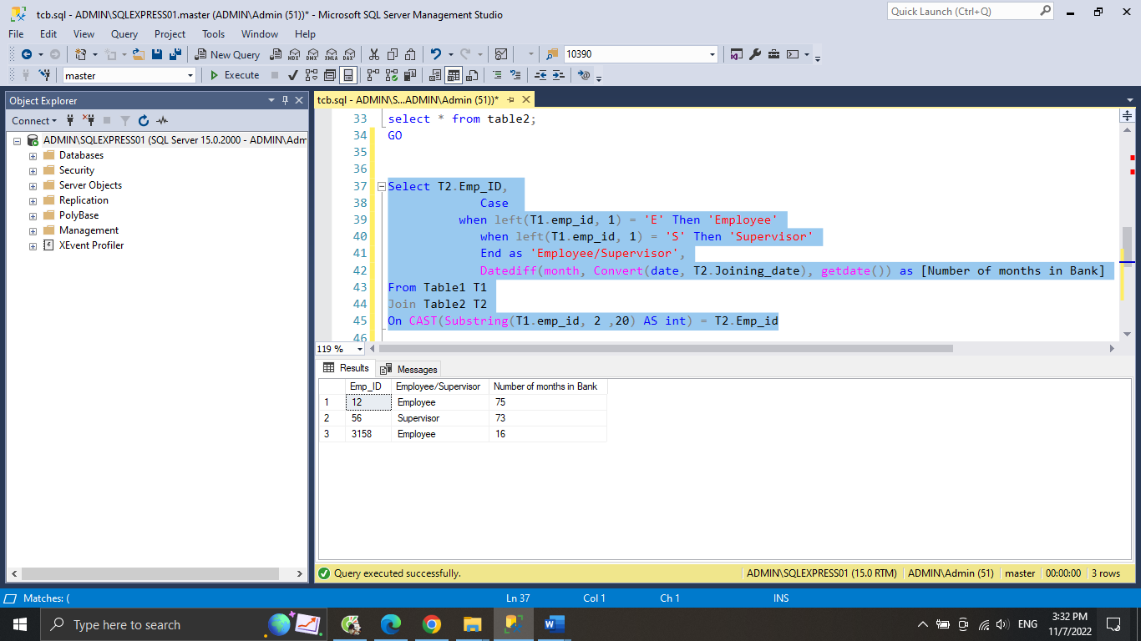

**EX3 results**

**EX4 Results**

