Getting Started

Opening Hand
Shuffle your deck and draw 4 cards. You may discard a card from your hand and draw a new card if you dislike anything in your opening hand. You may repeat this process 3 times. You’ll typically want at least 1 card of each basic LVL (1, 2, 3) in your starting hand.

Game Board
Pecto consists of 6 zones. 3 front-row zones, and 3 back-row zones. Cards in the front-row can attack, while back-row cards contribute to your resources directly.

Starting Stats
Both players start at 10 Life and have a LVL Cap of 1. Whoever reaches 0 Life first loses.

Taking your turn

LVL Cap
Your LVL Cap indicates what kind of cards you can play. At the start of each turn, your LVL Cap is set to whatever the highest LVL card you control is and cannot go below 1. When you play a card from your hand, your LVL Cap increases by 1 for the rest of the turn.

Card Specific Actions
After your LVL Cap is initially set for the turn, all your cards become active (represented by facing upwards). Then any cards with BEGIN triggers activate. If you have multiple cards with BEGIN triggers, you may order the triggers in any way you wish.

Drawing Cards
After your card specific actions, draw a card. In addition to this card, draw cards equal to the number of back-row cards you control.
The first time you destroy an opposing card each turn, draw a card.
If your deck is empty when you draw a card, shuffle your discard face down and replace your deck with it. This is called recycling your deck. After you recycle your deck, draw however many cards need to be drawn. If you were to draw cards but your deck and discard are empty, you lose the game.

Setting Cards
All cards have a LVL in the upper left corner, represented by a black and blue box. If a card’s LVL is less than or equal to your LVL Cap, you may play it from your hand. When you play a card from your hand, you set it in an open zone you control (setting means a card entering play). If all your zones are full, you cannot play any cards.
If a card has a ritual cost, you must complete the conditions of the ritual in addition to meeting the LVL requirements. A ritual is represented by a red badge followed by a red text box.

Moving Cards
Once per turn, you can swap the positions of 2 active cards you control.

Game Actions

Attacking
At any point during your turn if you control an active card in the front-row, it may attack. When you declare an attack, your card becomes inactive (represented by tilting the card sideways), and then you choose a zone to target. You may attack an opposing zone in the same column as the card declaring the attack if that zone has a card in it. If the opposing front-row zone is empty, you may attack the opponent directly. Before your card attacks, your opponent gets a chance to respond. If your card is alive after your opponent’s response, your attack resolves.
When an attack resolves against another card, those cards fight. When cards fight, they deal damage to each other equal to their FORCE stat, plus any additional damage they may deal. A card’s FORCE is shown by the number in the top right corner of a card, represented with a pink square. When a card takes damage, it loses that much FORCE. If a card takes as much damage as their FORCE, it perishes. If the targeted card leaves play before your attack resolves, deal the combat damage to the opponent instead (they lose Life equal to the damage).

Skills
If a card has a special box at the bottom (usually pink or green), that means the card has an activated ability known as a skill. When you activate a skill, your card becomes inactive, and your opponent gets a chance to respond. If your card is still alive after your opponent’s response, your skill’s effect (displayed within the skill’s text box) resolves.
If your card’s skill is in a green box and has a cycle symbol before the name, it becomes active again after the skill resolves.

Casting
If a card has a CAST badge followed by a blue text box, you may cast the card. To cast a card, you send the card from the board to the discard. This does not count as the card perishing. Compared to skills and attacking a cast effect immediately resolves. Your opponent can only respond after your cast effect resolves.

Triggers
Represented by a yellow badge followed by a yellow text box, triggers occur when specific actions happen. For example, a card with a PERISH trigger is activated when that card perishes. Triggers cannot be responded to by the opponent. The specific type of trigger is represented by the text in its badge.

Card Anatomy
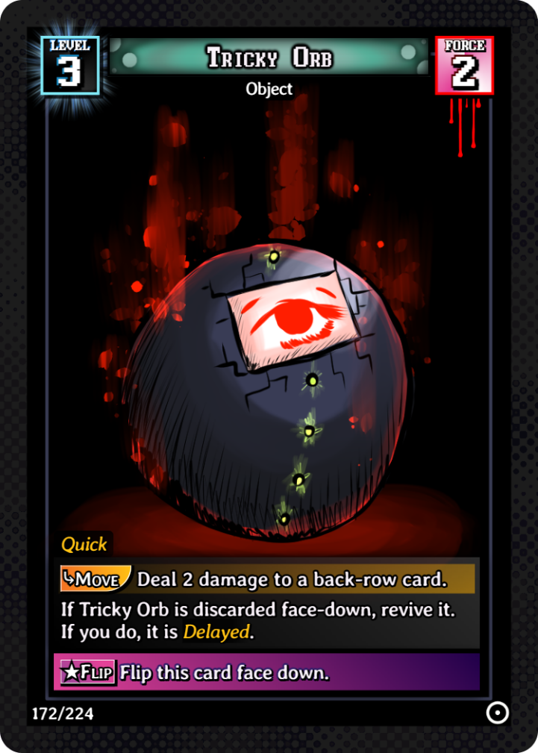

Glossary

Active/Inactive – If a card starts active. While active, a card can use any of its activated abilities, like attacking, casting, or skills. When you activate an ability, the card becomes inactive.
Begin – Triggers at the start of your turn during your upkeep.
Bleed – When this card deals damage to a target, that target gains a wound.
Control – Any cards that exist on your side of the board are under your control, and only you can use them.
Counters – Occasionally cards require an extra stat to be tracked besides FORCE and LVL. Typically a dice is used to track this.
Delayed – This card enters inactive.
Discard a card – Send a card from your hand to the discard.
Doom – When this card perishes, it is sent to the void instead of the discard.
End – Triggers when you end your turn.
Enter – Triggers when this card is set.
FORCE – Represents a card’s base damage, and health.
Fragile – All damage dealt to this card is lethal.
Harmless – This card cannot declare attacks
Heal – You gain life equal to the heal amount.
Immortal – At the end of your turn, this card gains FORCE equal to the damage it took this turn.
Is Discarded/Is Voided – This occurs when the card enters the discard/void without perishing, often from the deck or hand directly.
Leech – When this card deals combat damage to a player, you heal 1 life.
LVL – The basic requirement to play a card from your hand.
Move – Triggers when the card is moved.
Muted – This card cannot declare attacks targeting the player.
Perish – Triggers when the card perishes. Also refers to when a card takes damage greater than or equal to their FORCE or is sacrificed.
Quick – If this card has FORCE greater than or equal to the card it’s attacking, it doesn’t take damage.
Recycle your deck – Shuffle your discard and replace it with your deck.
Revive – Set a card from your discard.
Ritual – An additional cost to playing the card from your hand.
Sacrifice – When a card is required to be sacrificed, choose however many cards are needed to be sacrificed among cards you control. Those cards then immediately perish, but do not take damage.
Safe – This card cannot take non-combat damage.
Set – When a card enters your grid. If a card is set, all its costs have been completed.
Sick – At the start of your turn, this card takes damage equal to half its FORCE, rounded down.
Victor – Triggers when this card enters combat and survives.
Void – An alternate card pile where cards typically cannot be interacted with in any way. When your deck is recycled, you do not shuffle cards from your void into your deck.
Void a card – Send a card from your hand to the void.
Warden – The back-row card behind this one cannot be targeted for attacks.
Wounds – When damage is dealt to a target with wounds, it takes additional damage equal to the wounds at the same time, then all wounds are removed. Players with wounds can only take damage this way via combat.

