# **Understanding & Comparing**

## Gradient Descent

Gradient Descent is an iterative optimization algorithm used to find the minimum of a function. The Gradient Descent work as follows:

* Step 1: Initialize a random value for the weights (parameters) of the function.
* Step 2: Calculate the gradient of the function with respect to each parameter. Update the parameters by subtracting the product of the gradients and the learning rate from the current parameters.
* Step 3: Repeat steps 2 and 3 until the function converges to the minimum value. If the function is convex, the algorithm will converge to a global minimum, otherwise it may reach a local minimum.

The learning rate is a hyperparameter that determines the extent of adjustment to the weights in relation to the loss gradient. A lower value results in slower travel along the downward slope.

## SGD (Stochastic Gradient Descent)

Stochastic Gradient Descent is a simple yet very efficient approach to fitting linear classifiers and regressors under convex loss functions such as (linear) Support Vector Machines and Logistic Regression. SGD has been successfully applied to large-scale and sparse machine learning problems often encountered in text classification and natural language processing.

The basic idea behind SGD is to update the parameters of the model using the gradient of the error with respect to a single training example, rather than the sum of the gradients for all the training examples. This makes SGD faster and more scalable to large data sets. The Stochastic Gradient Descent work as follows:

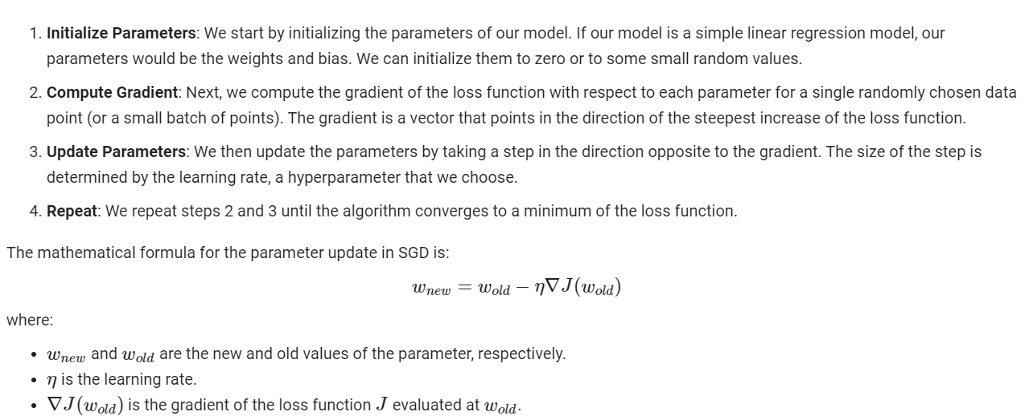

One of the main advantages of SGD is its efficiency, which is basically linear in the number of training examples. On the other hand, one of its main weaknesses is that it requires a number of hyperparameters such as the regularization parameter and the number of iterations. Also, SGD is sensitive to feature scaling.

## Adam (Adaptive Moment Estimation)

Adam is an optimization algorithm that can be used instead of the classical stochastic gradient descent procedure to update network weights iteratively based on training data. Adam is like an extension of SGD. but it is different from classical SGD because it computes adaptive learning rates for different parameters. While SGD maintains a single learning rate for all weight updates and the learning rate does not change during training, Adam adapts the learning rate for each weight individually, using estimates of first and second moments of the gradients. This makes it particularly effective when dealing with sparse gradients on noisy problems. Adam combines the best properties of the AdaGrad and RMSProp algorithms to provide an optimization algorithm that can handle sparse gradients on noisy problems. Adam is relatively easy to configure where the default configuration parameters do well on most problems. Adam introduces a few key enhancements over basic SGD:

1. **Momentum**: Adam computes an exponentially decaying average of past gradients, similar to momentum. This can help accelerate learning and overcome local minima or saddle points in the loss landscape.

2. **Adaptive Learning Rates**: Adam adapts the learning rate for each parameter individually based on the first and second moments of the gradients. This can lead to more efficient learning, especially for problems with sparse gradients or noisy data.

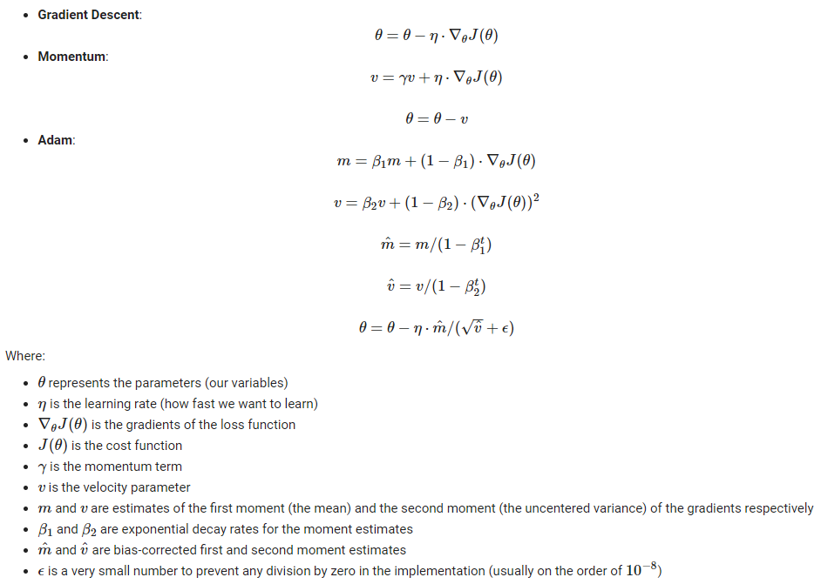

## Gradient Descent vs Stochastic Gradient Descent vs Adam

Comparison of **Gradient Descent (GD)**, **Stochastic Gradient Descent (SGD)**, and **Adam**:

**Computation**:

* **GD** computes the gradient using the entire dataset, which can be slow for large datasets.
* **SGD** and **Adam**, on the other hand, use a single sample or a mini-batch to compute the gradient, which is faster and allows for online learning.

**Learning Rate**:

* The learning rate in **GD** and **SGD** is typically constant or manually decayed over time.
* **Adam** uses an adaptive learning rate for different parameters, which can lead to better performance and convergence.

**Noise Handling**:

* **GD** can get stuck in shallow areas with noisy data or complex models.
* **SGD** can handle noisy data and complex models better than GD.
* **Adam** handles noisy data and complex models well, often finding good solutions faster.

**Hyperparameters**:

* **GD** and **SGD** have fewer hyperparameters (mainly learning rate), but may require careful tuning.
* **Adam** has more hyperparameters (like the decay rates for the moving averages), but the default values often work well.

**Memory**:

* **GD** requires more memory because it needs to store all the gradients of the entire dataset.
* **SGD** and **Adam** require less memory because they only need to store the gradients of one sample or a mini-batch of samples.

**Convergence**:

* **GD** converges to the minimum of the basin the initialization point is located in. The path to the minimum is direct and does not oscillate.
* **SGD** and **Adam**, even though they will get close to the optimal parameters, they will continue to oscillate around these values and will not settle down. This is due to the noise in the estimates of the gradient.

**Parallelization**:

* **GD** is hard to parallelize computation because each step depends on all data.
* **SGD** and **Adam** are easy to parallelize because updates are made after each sample.

In conclusion, while **GD** is simpler and easier to understand, **SGD** and **Adam** are more efficient and often perform better on large datasets or complex models like deep neural networks.

## Example to distinguish between 3 learning models

In this example, I use a simple quadratic function to demonstrate the optimization paths of different algorithms (Gradient Descent, Stochastic Gradient Descent, and Adam). As for library, i use Pytorch and Matplotlib

* PyTorch is a popular open-source machine learning library that provides tensor computation with strong GPU acceleration and deep neural networks built on a tape-based autograd system. It is primarily used for applications such as natural language processing and artificial neural networks. PyTorch is known for its simplicity and ease of use, as well as its seamless transition between CPUs and GPUs. In this code, PyTorch is used to define and update the parameters of the optimization algorithms
* Matplotlib is a plotting library for Python and its numerical mathematics extension NumPy. It provides an object-oriented API for embedding plots into applications using general-purpose GUI toolkits like Tkinter, wxPython, Qt, or GTK. In this code, Matplotlib is used to visualize the optimization paths of the algorithms.

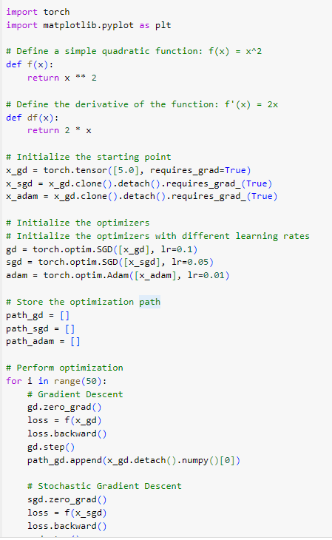

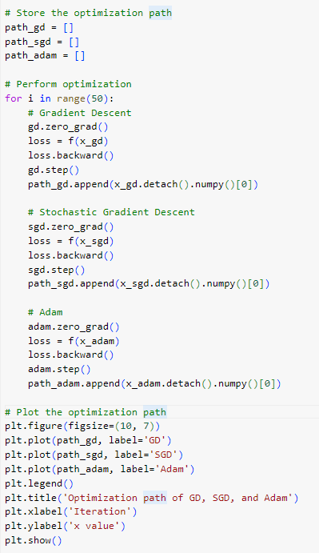

**Result of the code:**

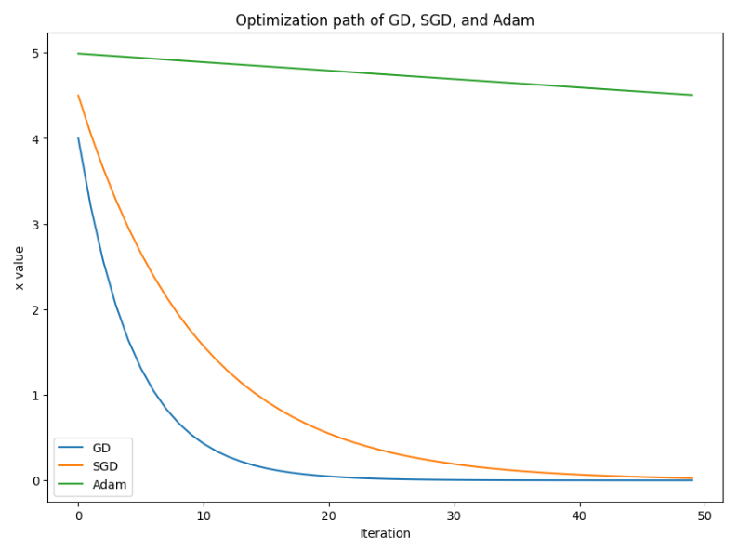

## Continual Learning and Test Production

**Definition:**

Continual Learning

Continual learning is a model which learns from a stream of data over time. This learning process is continuous, allowing the model to adapt to new patterns in the data, while retaining the knowledge it has already acquired.

In traditional machine learning, models are trained on a fixed dataset and then used for prediction. However, in continual learning, the model continues to learn and update its knowledge as new data comes in.

One of the main challenges in continual learning is the problem of catastrophic forgetting, where the model tends to forget the previously learned knowledge when new data is introduced. Various strategies have been proposed to mitigate this issue, such as elastic weight consolidation, experience replay, and knowledge distillation.

Continual learning is a key aspect of artificial intelligence systems that need to operate in dynamic, real-world environments where data patterns can change over time. It's an active area of research in the field of machine learning and artificial intelligence.

Test Production

This is one of the phases in the software development lifecycle where the developed software is tested in a production-like environment. It’s a crucial step before the software is released to the actual production environment. During test production, the software is subjected to real-world conditions and loads to identify any issues or bugs that might not have been caught during earlier testing stages. This helps ensure that the software is stable and reliable when it’s finally deployed to the production environment.

Input data for the Continual Learning

The input data for continual learning models would be the new data that reflects the changes in the environment. For example, in the case of autonomous vehicles, it could be new data about road conditions or traffic rules. In healthcare, it could be new patient data or medical research, and in recommendation systems, it could be new user interaction data; and in fraud detection, it could be new transaction data.

Continual Learning in real life

Continual learning can be applied in various real-life situations where data is continuously evolving and the model needs to adapt to these changes. Here are a few examples:

1. **Autonomous Vehicles**: Autonomous vehicles operate in dynamic environments where road conditions, traffic rules, and vehicle behavior can change over time. Continual learning can help these vehicles adapt to new situations without forgetting previously learned driving skills.
2. **Healthcare**: In healthcare, new medical research and patient data are constantly being generated. A continual learning system can help in updating the medical diagnosis models with the latest information without forgetting the previous knowledge.
3. **Recommendation Systems**: Online platforms like e-commerce or streaming services often need to adapt their recommendation systems to the changing preferences of their users. Continual learning can be used to update the recommendation models as new user interaction data becomes available.
4. **Fraud Detection**: In banking and finance, fraud patterns can evolve over time. Continual learning can help in updating the fraud detection models to recognize new types of fraudulent activities while still being able to detect older fraud patterns.
5. **Chatbot Tech**: In some of the cases, chatbots are designed to learn and improve over time as they interact with more and more users. They can use continual learning methods to adapt their responses based on new interactions, without forgetting the previous interactions. This can help in improving the chatbot's performance and making the interactions more natural and engaging for the users.

Example for Continual Learning

In this example, I use the PyTorch library and the MNIST dataset. This code trains a model on one class of the MNIST dataset, then another, continually learning and adapting to new classes.

* The MNIST (Modified National Institute of Standards and Technology) dataset is a large database of handwritten digits that is commonly used for training various image processing systems.
* PyTorch is a popular open-source machine learning library that provides tensor computation with strong GPU acceleration and deep neural networks built on a tape-based autograd system. It is primarily used for applications such as natural language processing and artificial neural networks. PyTorch is known for its simplicity and ease of use, as well as its seamless transition between CPUs and GPUs.

