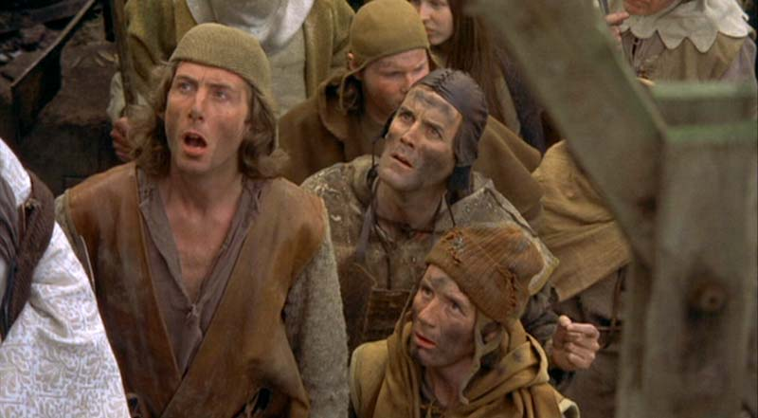

# Witch Assessment

* Presiding Peasant: ***Dennis***
* Assessment Depot: ***Swampy Castle*** (might be sinking)

## Weight

3-year-old Egyptian Goose

## Warts?

None visible

## Popular Consensus

|  |  |  |
| --- | --- | --- |
|  | Audience 1 | Audience 2 |
| Likes gravy | X |  |
| Attends church | X | X |
| Looks remarkably like a newt |  | X |