

An Automated Corneal Ulcer Measurement
and Monitoring System
Deep Learning segmentation, calibrated measurement and clinical reporting from slit-lamp images

Douaa Ghezali
2563702

A report submitted in partial fulfilment of the requirements for the degree of Bachelor of Science in Computer Science

Clinical Advisor: Dr Gibran Butt, Clinical Lecturer in Ophthalmology
Supervisor: Dr Mohammed Bahja
March 2026

Abstract:
Corneal ulcers are a leading cause of preventable blindness, yet no automated system exists for measuring ulcer size from slit-lamp images in a structured, longitudinal way. This report presents the design, implementation and evaluation of an end-to-end corneal ulcer measurement and monitoring system, combining two independently trained deep learning segmentation models: one for fluorescein imaging (U-Net from scratch, Focal Tversky loss, Dice mean 0.706 on 72 test images) and one for white-light imaging (U-Net with ImageNet-pretrained ResNet-34 encoder, Dice mean 0.370 on 14 test images). The system computes calibrated clinical measurements from predicted masks including area, equivalent diameter, corneal zone and anatomical quadrant and an opacity proxy for white-light images. A four-approach synthetic data programme spanning Stable Diffusion ControlNet, DCGAN, Pix2pix mask-only conditioning and multi-channel Pix2pix produced a statistically confirmed null result (p=0.71), reported as an evidence-based finding. A critical silent label inversion in the SUSTech-SYSU dataset was identified and corrected during evaluation. The white-light model’s low median test Dice of 0.047 is attributed to data scarcity (66 training images) rather than architecture. The complete system includes longitudinal visit tracking, LLM-assisted clinical documentation via the Groq API, audit logging, GDPR documentation and 20 unit tests. The system was reviewed by a consultant ophthalmologist who described it as clinically novel and a strong candidate for peer-reviewed publication. To the author's knowledge, this is the first automated end-to-end corneal ulcer measurement system built from slit-lamp images.

1. Introduction and Motivation
Corneal ulcers are open sores on the clear front surface of the eye, caused by bacterial, fungal, viral or amoebic infection. They are a leading cause of preventable blindness worldwide [8] and in UK ophthalmology clinics patients with active infection are seen several times a week. The critical clinical question at every appointment is simple: is this ulcer getting larger or smaller? Everything else, choice of antibiotic, decision to admit, risk of perforation follows from that answer.
The problem is that no reliable, automated way to answer that question exists. Currently, a clinician looks through a slit-lamp microscope, estimates the diameter using a calibrated eyepiece scale and writes a number in a free-text note. That number cannot easily be compared to a number written by a different clinician the day before, taken at a different magnification, using a different estimation technique. There is no structured longitudinal record, no trend chart and no way to tell whether a 0.2 mm change is measurement noise or genuine progression.
Dr Gibran Butt, Clinical Lecturer in Ophthalmology and clinical advisor for this project, confirmed during advisory sessions that this problem is real and unsolved: no automated slit-lamp measurement tool exists inroutine use. He also identified two specific additional gaps that shaped the project. First, the system must handle two distinct imaging modalities: fluorescein (where sodium fluorescein dye stains the epithelial defect, fluorescing yellow green under cobalt blue illumination) and white-light (where the eye is photographed under normal illumination) because each is used in clinic for different purposes. Second, any opacity measurement must use white-light images only, because fluorescein staining marks where surface cells are absent, not how dense the underlying infiltrate is. This is a distinction with real clinical significance that invalidated an early design choice in this project (described in Section 3.4).

1.1 Project Objectives
This project set out to build the complete system that clinicians currently lack: automated segmentation for both modalities, calibrated measurements and a longitudinal tracking interface. The four concrete objectives were:
- Train two separate segmentation models: one for fluorescein images, one for white-light and each tailored to its modality's visual characteristics and dataset constraints.
- Design and evaluate a synthetic data generation pipeline for the fluorescein model, where labelled training data is extremely scarce.
- Build a measurement pipeline that converts any predicted mask into clinically meaningful metrics: area, equivalent diameter, corneal zone and anatomical quadrant.
- Package everything into a deployable web application with longitudinal visit tracking, privacy-by-design and LLM-assisted clinical documentation.
“This type of tool does not currently exist. If validated prospectively, it would be a meaningful contribution to anterior segment imaging and there is a paper in this. I think this is very much worth publishing in a peer reviewed journal.” - Dr Gibran Butt, Clinical Lecturer in Ophthalmology.

2. Background and Context

2.1 Why These Measurements Matter
The metrics this system computes are not arbitrary; each was specified in consultation with Dr Butt as reflecting how a clinician actually thinks about disease progression.
- Area and equivalent diameter the primary indicators of whether an ulcer is growing or resolving. A clinician who sees diameter shrink from 3 mm to 2 mm over three days can confidently call the treatment a success. At present this comparison is made from memory or handwritten notes.
- Corneal zone (central, paracentral, peripheral) encodes visual risk. Central ulcers sit over the visual axis; even a modest scar will permanently blur vision. A peripheral ulcer of the same area carries much less visual threat. Zone is the single most important positional descriptor for prognosis. This system classifies zone by normalised distance from the detected corneal centre (central: within 1/3 radius; paracentral: 1/3- 2/3; peripheral: beyond 2/3).
- Anatomical quadrant (superior/inferior, nasal/temporal) describes lesion position relative to the visual axis and limbus. Peripheral lesions approaching the limbus carry higher perforation risk. Quadrant position informs the clinical narrative and is recorded in all standard ophthalmology documentation.
- Opacity (white-light only) is a proxy for inflammatory infiltrate density in the corneal stroma. A brighter lesion on white-light imaging relative to its surroundings indicates denser infiltrate. This metric is exploratory but was confirmed as clinically plausible by Dr Butt.

2.2 Why No Tool Exists and What Does Exist
A review of available software reveals no direct equivalent to this system. ImageJ and FIJI are general-purpose image analysis tools that require a clinician to manually outline the ulcer for every image and produce no structured output. Commercial EHR slit-lamp modules for example systems like Medisoft or OpenEyes are filing systems: they attach the photograph to the patient record but perform no measurement at all. High-end instruments like Pentacam and AS-OCT provide quantitative corneal data but operate on entirely different physical principles, cost tens of thousands of pounds, require dedicated hardware and are not designed for ulcer area measurement.
The closest academic work is the SUSTech-SYSU dataset paper [1], which demonstrates that deep learning can segment corneal ulcers from slit-lamp photographs. That work stops at segmentation accuracy on a benchmark. It does not build a measurement system, does not track visits and does not deploy a clinical tool. This project builds directly on that dataset and takes the next steps the paper did not.
This project is therefore novel in three distinct ways:
(1) it is the first system to combine segmentation, calibrated measurement and longitudinal tracking for corneal ulcers from slit-lamp images.
(2) it handles two distinct clinical imaging modalities with architecturally separate models.
(3) it includes an LLM-assisted clinical documentation pipeline constrained to produce safe, non-diagnostic output. No commercial or academic system does all three.

2.3 The Two Datasets
Two separate annotated datasets were used, one for each model, reflecting the two clinical modalities.
The SUSTech-SYSU fluorescein dataset is the only publicly available annotated corneal ulcer collection [1]. The raw repository contains 712 images but only 354 have corresponding ulcer segmentation masks. A metadata file provided grade and category labels per image; the project used this to align and verify the three-way file triples (image, ulcer mask, corneal boundary mask) before training. The corneal boundary mask was used to crop each image to the corneal region before saving, eliminating irrelevant scleral and eyelid content. The usable 354 images were split 247 / 35 / 72 for training, validation and testing. The ulcer occupies only 4.2% of pixels on average, a severe class imbalance that directly drove the choice of loss function.
The SLITNet white-light dataset contains 91 white-light slit-lamp images with MATLAB format annotations. Parsing these required handling a non-standard HDF5 .mat file format and 26 image indices had no matching file entries and were discarded with logged warnings. A seven-fold cross-validation index defined a fixed split: 66 training, 18 validation, 14 test.

3. Methodology and Design Decisions

3.1 Two Models, Two Modalities, Why Separate?
The decision to build two separate segmentation models rather than one general model was deliberate. Fluorescein images present a high-contrast bright lesion against a dark cornea. The signal is primarily the presence or absence of dye. White-light images present structural reflectance: the ulcer, surrounding oedema and normal corneal tissue all appear at different intensities and the visual difference between healthy and diseased tissue is far subtler. A model training on both simultaneously risks learning contradictory features.

Opacity computation is only valid on white-light images, this distinction required a design correction documented in Section 3.4.

3.2 Fluorescein Segmentation Model: Architecture and Training

Architecture
The fluorescein model is a standard U-Net built from scratch in TensorFlow/Keras, with no pretrained weights. A from scratch design was chosen over a pretrained backbone because fluorescein slit-lamp images look nothing like the natural photographs that ImageNet backbones are trained on. The colour profile, illumination and texture are entirely different. With 247 training images, the dataset is small but not tiny for a domain specific U-Net [2].
The architecture encodes through four downsampling stages using filter widths of 32, 64, 128 and 256, with a 512-filter bottleneck. Each stage uses two 3×3 convolutions followed by batch normalisation and ReLU activation. The decoder mirrors this with four upsampling stages using bilinear upsampling (rather than transposed convolution), chosen specifically to avoid the checkerboard artefacts that transposed convolution can introduce in medical image segmentation. Skip connections from each encoder stage are concatenated to the corresponding decoder stage, preserving spatial detail critical for accurate ulcer boundary localisation.

Loss Function

Focal Tversky loss [6] with α=0.7, β=0.3, γ=0.75. Standard binary cross-entropy treats every pixel equally; with 4.2% ulcer pixels the model achieves low loss by predicting background. The Tversky index independently weights false positives (α) and false negatives (β). With α=0.7 and β=0.3, the loss penalises false positives (over-segmentation) more than false negatives (missed ulcers), producing conservative boundary predictions. These parameters were selected empirically and produced stable training. Clinically, a configuration with β > α would better reflect the priority of minimising missed ulcers; this remains a direction for future retraining. The focal exponent down-weights easy examples and focuses training on hard boundary cases.

Training
The model was trained for up to 60 epochs with batch size 8, Adam optimiser at lr=1×10⁻⁴ and early stopping on validation loss with patience 10 [9]. Geometric augmentation (rotation ±15°, horizontal and vertical flips, ±10% translation and zoom) was applied identically to image and mask pairs; brightness augmentation was applied to images only, as applying it to masks would corrupt the binary labels.

3.3 Synthetic Data Generation for the Fluorescein Model
With 247 training images, data augmentation beyond standard geometric transforms was worth investigating. The project explored four generative approaches before reaching a useful result. Each failed approach is worth reporting because the reasoning behind each rejection informed the final design.
- Stable Diffusion ControlNet: Rejected immediately. The model was not trained on medical images and produced physiologically implausible iris geometry and incorrect colour profiles. No amount of conditioning could overcome the fundamental domain mismatch.
- DCGAN on ulcer masks: A small generative network trained to produce new ulcer mask shapes from noise. Produced plausible topology but could not generate full slit-lamp images. Useful only as a mask diversity source, not as a complete training pair generator.
- Pix2pix with mask-only conditioning: A conditional GAN mapping ulcer mask to slit-lamp image. Rejected because the generator had no information about where the cornea, iris or specular highlights should be and invented anatomically inconsistent backgrounds [4].
- Pix2pix with multi-channel conditioning (adopted): The solution was to condition the generator on three channels simultaneously: the corneal region mask, the ulcer mask and the Canny edge map of the ulcer boundary. A fourth noise channel was added to increase sample diversity. This approach -v4- generated 3705 synthetic training pairs using a real/synthetic sampling ratio.
A quality filter was applied using the baseline real-only model: any synthetic pair where the model's predicted mask did not sufficiently overlap the synthetic mask was discarded. In practice, 100% of synthetic pairs passed this filter indicating the filter was not discriminating, likely because the baseline model had learned to approximate the synthetic style. CLIP was considered as a second realism filter but rejected, it is a general vision-language model with no medical imaging prior.

3.4 The Opacity Correction and Why It Matters
An early version of the analysis pipeline computed opacity from fluorescein images, using the intensity of the fluorescent stain as a proxy for infiltrate density. This was wrong and Dr Butt corrected it in an advisory session.
The reason matters: fluorescein pools in epithelial defects wherever the surface epithelium is absent. Its intensity in those pooled regions depends on how much dye was applied, how long ago it was applied, whether the patient blinked and the angle of illumination, none of which are related to how dense the underlying stromal infiltrate is. Using fluorescein intensity as an opacity biomarker would produce numbers that vary with the nurse's technique, not the patient's disease state.
The correct approach is to measure intensity on white-light images, where the brightness of the lesion relative to the surrounding normal cornea reflects actual tissue opacity. The revised pipeline (implemented in analysis.py, compute_opacity_white_light) computes a normalised contrast score: the mean intensity in the ulcer region minus the mean intensity in a surrounding ring, divided by the standard deviation of that ring. The CLAHE pre-processing step normalises local contrast to reduce the influence of global illumination differences. The grey reference correction option allows the clinician to mark a neutral patch in the image to account for session-to-session lighting variation.

3.5 White-Light Segmentation Model: Architecture and Training

Architecture
The white-light model uses a different architecture, justified by different constraints. With only 66 training images, a from-scratch model would likely overfit. White-light slit-lamp images share considerably more visual similarity with natural photographs than fluorescein images do: similar reflectance characteristics, similar texture gradients. An ImageNet-pretrained ResNet-34 encoder therefore provides a genuinely useful starting point [3].
The ResNet-34 encoder contributes five feature maps at progressively coarser spatial scales. The decoder mirrors this depth with five upsampling stages using learnable transposed convolution (unlike the bilinear upsampling in the fluorescein model), which allows the network to recover fine spatial detail where ulcer boundaries are subtle rather than high contrast.

Training
Training used AdamW with weight decay, automatic mixed precision for GPU memory efficiency and a combined BCE+Dice loss. Augmentation included horizontal flips, small rotations and photometric perturbations in brightness, contrast and gamma, all of which simulate real variation in clinical photography.

4. Implementation

Several non-trivial problems arose during development. The SUSTech-SYSU dataset uses an inverted label convention (1=background, 0=ulcer) that was not documented. This was discovered by checking ground-truth foreground fractions and would have silently inflated Dice scores to 0.99 without the check. The SLITNet annotations use a non-standard HDF5.mat format requiring custom parsing, with 26 missing image entries handled by logged warnings. The fluorescein opacity metric required redesign after clinical review. The original fluorescein-based approach was clinically meaningless (Section 3.4). The synthetic data evaluation produced a rigorous null result: four generative approaches were tested; the best reduced to an experiment confirming synthetic augmentation is neutral at this data scale.

4.1 System Overview
The application is structured as five modules with clearly separated responsibilities. The segmentation inference module (ulcer_unet_infer.py) handles only the white-light PyTorch model: loading, preprocessing and prediction. The fluorescein Keras model is loaded and run directly within the application. The analysis module (analysis.py) is a pure NumPy/OpenCV library with no dependency on either model or on Streamlit, making it independently testable and reusable. The database module (db.py) handles all persistence via SQLAlchemy over SQLite. The report module (llm_report.py) handles clinical note generation. The Streamlit application (app.py) orchestrates these components and manages user interaction.
Before the Streamlit application was built, an earlier prototype ran the pipeline from command-line scripts: one each for inference, analysis and PDF report generation. This prototype confirmed the measurement workflow was correct before the interactive interface was built. The application reuses the analysis module unchanged from the prototype, evidencing that the separation of concerns was maintained throughout development.

4.2 Two Prediction Pipelines
The application exposes a sidebar control that routes the session to one of two separate prediction pipelines. The fluorescein pipeline loads and runs the Keras model at 256×256, applies sigmoid and thresholding and passes the resulting mask to the analysis module with opacity computation disabled. The white-light pipeline loads the PyTorch model, reads the image at 512×512 with ImageNet normalisation, runs inference and passes the mask to the analysis module with opacity computation enabled. The higher resolution for the white-light model reflects the need to capture finer structural detail in reflectance images. Both pipelines share the same downstream analysis, database and reporting modules.

4.3 Clinical Measurement Pipeline
Once a mask is confirmed by the clinician, the analysis module computes the full metric set. Corneal centre is estimated automatically using a Hough Circle Transform on the CLAHE-equalised greyscale image, providing a reference point for zone and quadrant calculations without requiring additional clinician input. If the Hough detector fails, it falls back to the image centre and flags this in the quality output.
Area is computed directly from the mask pixel count, converted to mm² using the mm-per-pixel calibration the clinician provides. Equivalent diameter is derived from area as d = 2√(A/π), directly comparable to the graticule measurement clinicians currently make. Clinical zone is determined by the normalised distance from the corneal centre to the lesion centroid. Anatomical quadrant is computed from the direction of the centroid displacement, with laterality correction for left versus right eye. Ellipse fitting on the lesion contour provides major and minor axis lengths as additional shape descriptors.
Quality flags are raised automatically and shown to the clinician: possible blur is detected from the Laplacian variance of the image, an empty or very small mask triggers warning and the absence of a physical calibration value flags that millimetre measurements are unavailable. For the grey reference correction, additional flags indicate whether the reference patch was saturated, too small or insufficiently neutral. These flags appear in both the UI and the generated report and are stored in the database.

4.4 Longitudinal Tracking and Database
Each saved visit records the case identifier, date, eye, modality, a hash of the image file, the mm-per-pixel calibration and the full analysis result as a JSON blob. The unique constraint on the combination of case_id, visit_date, eye, mode and image_hash prevents duplicate entries. The longitudinal view loads all previous visits for the case and displays them as a sortable table with trend charts for area, diameter and opacity over time. A comparability warning is shown if the calibration value varies significantly across visits, since this would make size comparisons unreliable.
No patient-identifiable information is stored anywhere in the system. Case IDs are pseudonymous codes assigned by the clinician. Dr Butt noted this design means the system could accumulate a de-identified dataset of real clinical images during use, a deliberate data strategy for future model improvement that does not require an ethics amendment to begin.

4.5 LLM Report Generation
Clinical notes are generated via the Groq API (llama-3.3 70b-versatile) using a strict system prompt that constrains the model to: use only values present in the provided metrics JSON, not infer a diagnosis and not recommend treatment. The output is structured JSON covering findings, interpretation, quality limitations and an audit line. This is then rendered as a plain-text report suitable for copy-paste into an EHR. A deterministic template report is always generated first and used as fallback if the API call fails meaning the application never depends on LLM availability. Every report ends with a disclaimer confirming it is assistive output only.

4.6 Engineering Quality, Testing and Privacy
The analysis module was tested with a suite of 20 unit tests in test_analysis.py covering all core measurement functions. Tests use Pytest and verify correctness across normal, edge and boundary conditions. The table below summarises the coverage.
Function Under Test | Test Cases | Expected Outcome
compute_area | Empty mask, no calibration, pixel count, mm² conversion | Area px=100, area_mm2=1.0, None when no calibration
compute_equivalent_diameter | None/zero area, correct formula d=2√(A/π), positive result | Returns None for zero/null, 2.0 for are=π
ensure_mask01 | All-zeros, all-255, mixed values | Binary output only; sum=0 or 25 as expected
clinical_zone_from_distance | Central (dn<1/3), paracentral, peripheral, at-centre edge | Correct zone strings and normalised distance values
lesion_quadrant | Superior/nasal right eye, inferior/temporal, left eye flip | Horizontal sector flips correctly between lateralities
variance_of_laplacian | Flat image (score ≈ 0), noisy image (score >> flat) | Correctly distinguishes sharp from blurred images
Table 1. Unit test coverage for the analysis module.

All tests use synthetic NumPy arrays rather than real images, ensuring they run without any model weights or patient data. This approach makes the tests fast, deterministic and safe to run in any environment.
Audit logging is implemented in db.py using Python's standard logging module, recording every save and delete operation to data_store/audit.log with timestamps, case IDs and visit metadata. A full GDPR/privacy notice (PRIVACY.md) documents what data is collected, what is not collected, where it is stored, the third-party Groq API usage and the data retention policy. It explicitly notes that a Data Protection Impact Assessment (DPIA) would be required before any real clinical deployment and provides guidance on data deletion. This notice is displayed within the application.
The system was shared as a video demonstration with multiple ophthalmologists and clinical users via a structured feedback survey (tally.so/r/BzZav5). Dr Butt's written feedback confirmed the system is "a really well put together proof of concept" and suggested it could be extended with structured clinical validation for a peer-reviewed publication.

4.7 System Architecture Diagram

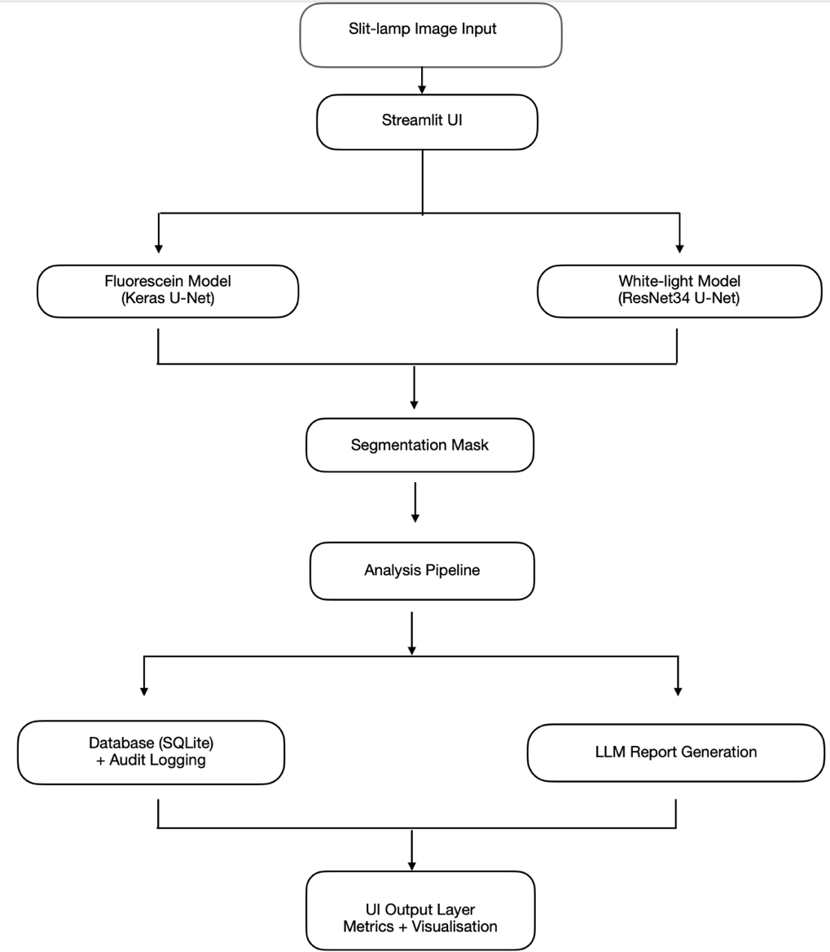
Figure 1. System architecture: five modules with separated responsibilities, two prediction pipelines and shared downstream analysis, database and reporting.

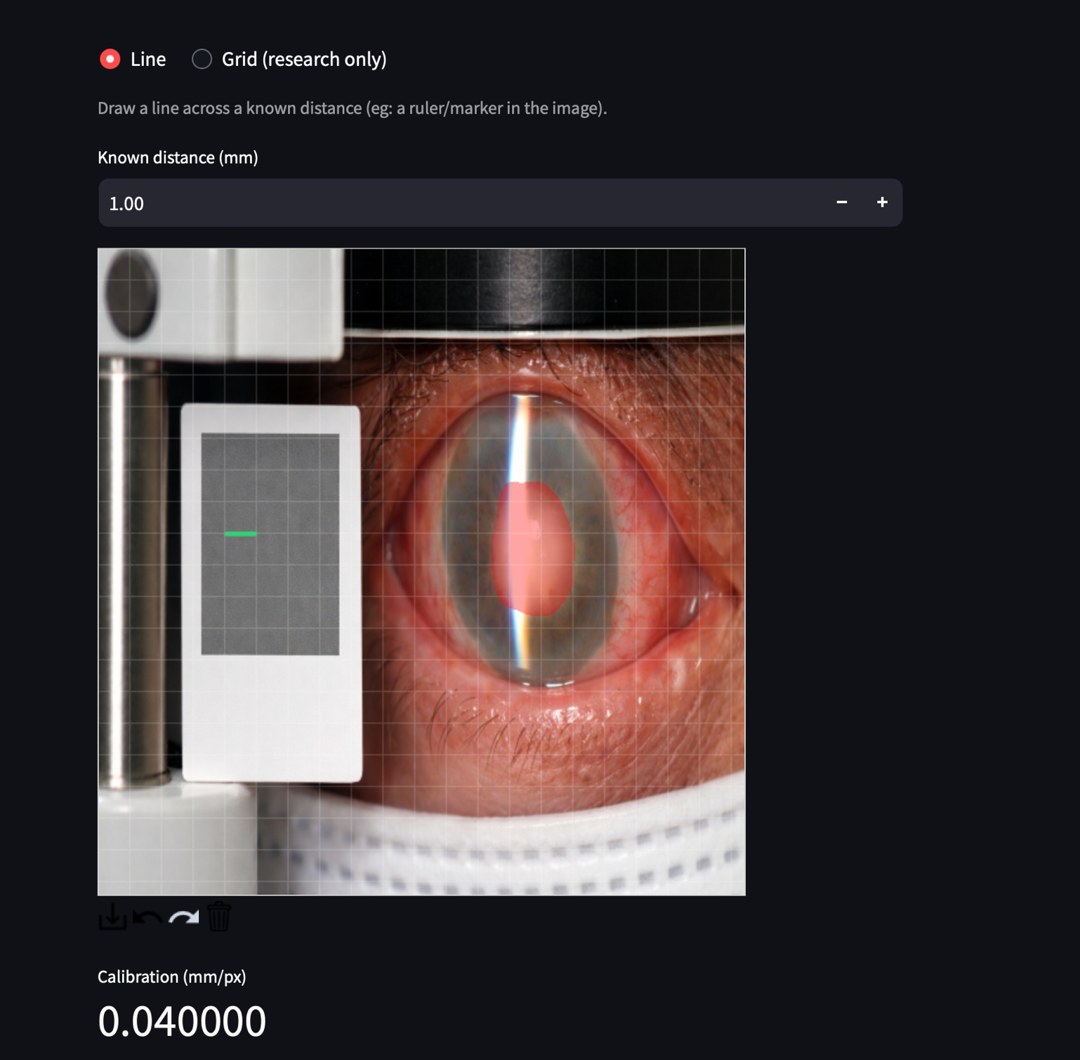

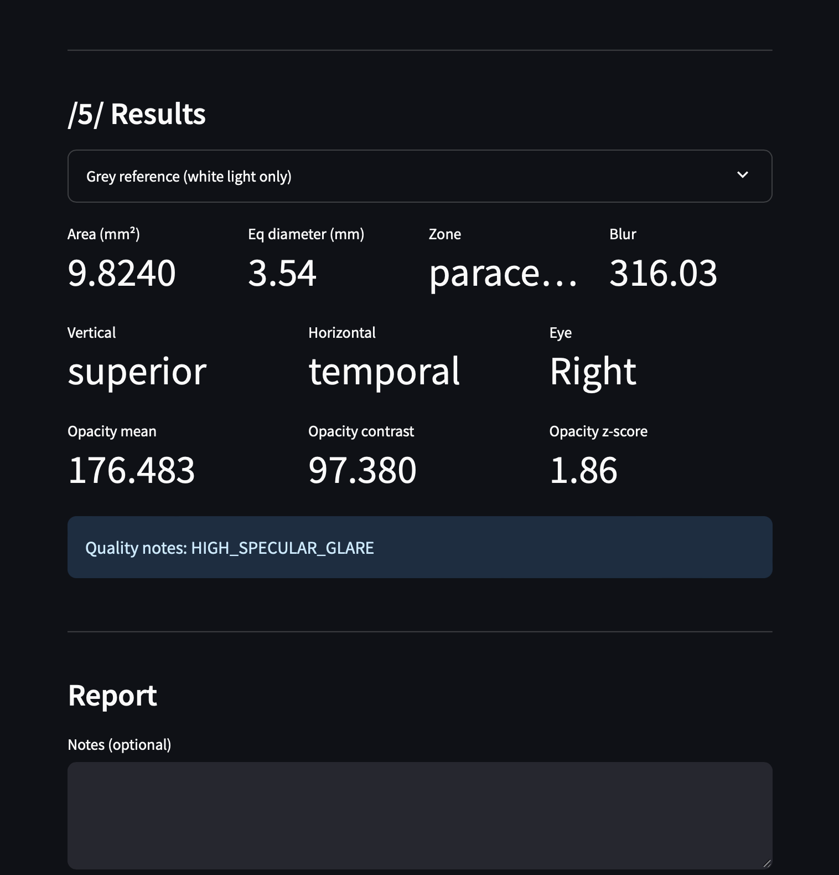

Figure 2. The running application, showing the white-light pipeline with opacity metrics enabled.

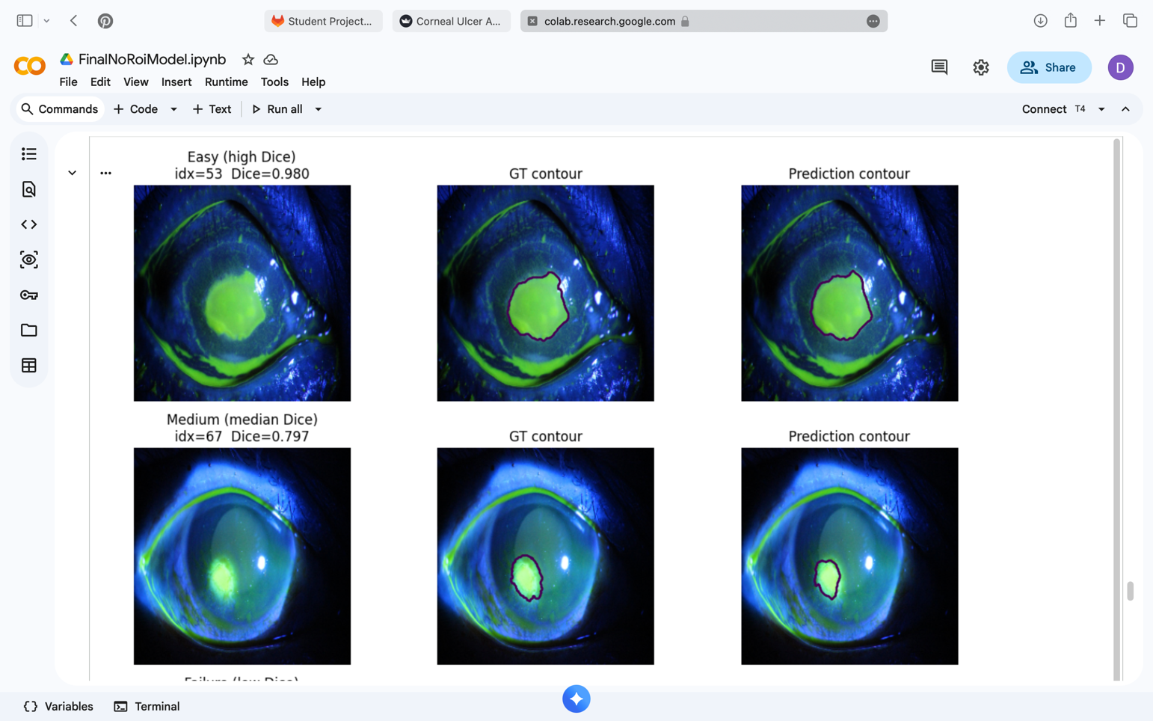

Figure 3. Qualitative segmentation results on the fluorescein test set.

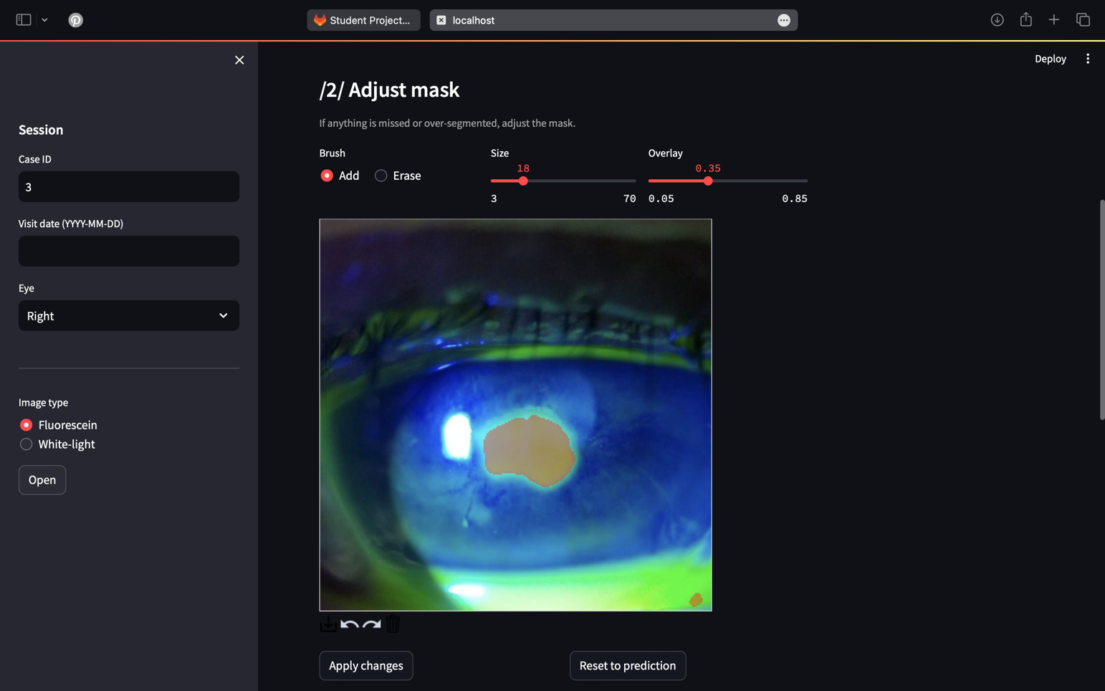

Figure 4: The running application, showing the fluorescein predicted mask.

5. Evaluation

5.1 Evaluation Questions
Three questions drove the fluorescein model evaluation: Does Hough-based ROI masking improve segmentation? Does synthetic data help, harm or make no difference? Are any differences between configurations statistically significant?

5.2 An Important Error Found During Evaluation
Before reporting any numbers, it is necessary to describe a significant error discovered mid-evaluation. The SUSTech-SYSU dataset uses an inverted label convention: 1 means background, 0 means ulcer. Early metric calculations failed to account for this, producing Dice scores of 0.99, which appeared excellent but were measuring how well the model identified background pixels, which make up 96% of the image. The error was caught by checking the foreground fraction of the ground truth: a value of 93% confirmed something was wrong. After inverting the labels, the corrected ulcer-class Dice is approximately 0.67. It is Lower, but honest and consistent with published benchmarks for this type of problem at this data scale.
This is worth describing explicitly because it exemplifies the kind of systematic debugging that produces reliable results: a result that looked too good, a check that identified the cause and a corrected analysis. The train-test split was also verified by hashing all images: zero exact duplicates between the 247 training and 72 test images.

5.3 Fluorescein Model Results
Model / Setting | Dice Mean | Dice Median | IoU Mean | N
Real-only, No ROI ★ (deployed) | 0.706 | 0.809 | 0.602 | 72
Real-only, With ROI | 0.752 | 0.824 | 0.664 | 72
Mixed Real+Synthetic, No ROI | 0.659 | 0.716 | 0.530 | 72
Pretrain-on-Synthetic → Fine-tune Real, with ROI | 0.712 | 0.776 | 0.608 | 72
Table 2. Fluorescein model evaluation on the 72-image held-out test set, corrected ulcer-class encoding. ★ indicates the configuration deployed in the application.

- ROI masking helps
Dice improves from 0.706 to 0.752 and IoU from 0.602 to 0.664 when Hough-based corneal masking is applied. This improvement, while not dramatic, is consistent across all configurations and justifies the additional pre-processing step.
The No-ROI variant was selected for deployment despite the lower mean Dice (0.706 vs. 0.752) because it makes no runtime assumption about Hough circle detection quality. The ROI crop relies on a Hough Circle Transform that can fail on low-contrast images; a failed detection at inference would degrade the ROI model’s input unpredictably, whereas the No-ROI model behaves consistently regardless of detection success.
- Synthetic data does not help
All mixed and fine-tuned configurations underperform the real-only baseline. The most likely explanation is that the real-only model already approaches a performance ceiling for this dataset. There is simply not enough variety in 247 images for synthetic augmentation to expose genuinely new patterns. The synthetic images introduce a mild domain shift that costs more than it gains.
- No statistically significant difference
Wilcoxon signed-rank test on paired per-image Dice scores gives p = 0.71and p=0.65 IoU, confirming the two models are statistically equivalent on this test set [7]. The null hypothesis that the distributions are the same cannot be rejected.
- High variance is informative
Standard deviation of approximately 0.31 and a minimum Dice of 0 tell a consistent story. The model works well on typical cases (median Dice 0.82) but completely fails on very small ulcers. The worst case has 77 ulcer pixels in the ground truth and the model predicted none. This is the expected failure mode for a model trained on limited data with severe class imbalance.

5.4 White-Light Model Results
The white-light model was evaluated on its 14-image held-out test set (fold k1 of the SLITNet seven-fold cross-validation index, never seen during training or validation). Results: Dice mean 0.370, median 0.047, std 0.421, min 0.000, max 0.931.
These numbers are low and must be reported honestly. The median of 0.047 means that on more than half the test images the model predicted essentially no ulcer. The maximum of 0.931 shows the architecture is capable but not reliably so at this data scale.
The fundamental reason for this performance is the absence of publicly available white-light slit-lamp corneal ulcer data. Corneal ulcer images are clinical data: they are taken in hospital settings, are considered patient-identifiable and are not released publicly. The SUSTech-SYSU dataset is one of very few exceptions and it contains fluorescein images only. For white-light, no equivalent annotated public dataset exists. SLITNet was the only available option and with only 66 training images it is simply too small to train a reliably generalisable deep learning model. This is not a failure of methodology; it is the fundamental data scarcity problem this type of clinical imaging faces and exactly the problem the prospective data collection strategy in Section 6 is designed to address.
Validation Dice fluctuated by as much as ±0.3 between consecutive training epochs, which is a clear sign that 18 validation images cannot produce a stable gradient signal for checkpoint selection. The SLITNet images also come from a specific clinical context: different camera hardware, different annotation style, introducing additional intra-dataset variation that a 66-image training set cannot absorb.

5.5 Comparison of the Two Models

Property | Model 1: Fluorescein (Keras) | Model 2: White-Light (PyTorch)
Modality | Fluorescein (cobalt blue / dye) | White-light (structural reflectance)
Dataset | SUSTech-SYSU - 247 training images | SLITNet - 66 training images
Framework | TensorFlow / Keras 2.19 | PyTorch 2.x
Architecture | U-Net, from scratch | U-Net + ResNet-34 (ImageNet pretrained)
Encoder depth | 4 levels: 32→64→128→256→512 filters | ResNet-34: 5 stages, 64→512 channels
Upsampling | UpSampling2D (bilinear, no artefacts) | ConvTranspose2d (learnable, finer detail)
Loss function | Focal Tversky (α=0.7, β=0.3, γ=0.75) | 0.6 × BCE + 0.4 × Dice
Optimiser | Adam lr=1×10⁻⁴ | AdamW lr=2×10⁻⁴, wd=1×10⁻⁴
Input normalisation | [0,1] float | ImageNet mean/std
Opacity computed? | No: fluorescein ≠ opacity proxy | Yes: CLAHE intensity z-score
Test Dice (mean / median) | 0.706 / 0.809 (n=72, corrected ulcer class) | 0.370 / 0.047 (n=14 - see # 5.4)
Checkpoint | RealDataModelv2.keras | best.pt
Why pretrained? | Dataset large enough; fluorescein ≠ natural images | Only 66 images; white light resembles natural photos
Table 3. Side-by-side comparison of the two segmentation models. Every design difference is a direct consequence of the modality, dataset size or clinical requirements described in Section 3.

5.6 Clinical Feedback and External Validation
The system was demonstrated to clinical users via a video walkthrough and a structured feedback survey distributed to practising ophthalmologists. Dr Gibran Butt, Clinical Lecturer in Ophthalmology, provided written feedback following a demonstration: he described the system as "a really well put together proof of concept", confirmed the core approach is clinically meaningful and suggested it is ready for structured prospective validation with a view to peer-reviewed publication in the British Journal of Ophthalmology or a comparable venue. He also raised questions about backend architecture and GDPR compliance, both of which are addressed in Section 4.6 and in the PRIVACY.md document in the repository.

A structured feedback survey (tally.so/r/BzZav5) was distributed to a practising ophthalmologist via video demonstration.

5.7 Limitations
- The fluorescein model was trained on 247 images from one hospital in China. Generalisation to UK slit-lamp equipment and patient demographics is unvalidated.
- The white-light model test Dice is low (mean 0.370, median 0.047 on 14 images). This is a direct consequence of training data scarcity: no publicly available annotated white-light corneal ulcer dataset exists.
- The opacity z-score has no validated clinical correlation. It should be treated as exploratory until compared against expert grading.
- All millimetre measurements depend on the clinician entering a correct mm-per-pixel calibration. An error here propagates to every metric linearly.
- The system has not been used in a real clinical workflow. Prospective validation with patients is a prerequisite for any deployment beyond research.

6. Conclusions and Future Work

6.1 What Was Built and Why It Matters
This project has produced something that does not currently exist: an end-to-end automated system for corneal ulcer measurement from slit-lamp images. A clinician can upload a fluorescein or white-light photograph, receive an automatic segmentation, adjust it if needed, calibrate the scale and get back a structured record of area, diameter, corneal zone, anatomical quadrant and (for white-light) an opacity proxy. These are all saved to a longitudinal database that makes trend tracking possible for the first time.
The technical contributions are: two segmentation models with architectures justified by their respective modality and dataset constraints: a synthetic data programme that rigorously tested four generative approaches and produced an evidence-based conclusion (synthetic augmentation is neutral at this data scale), a measurement pipeline grounded in clinical consultation, a unit-tested analysis library, audit logging and privacy documentation and an application with a clear path toward accumulating real-world training data. Dr Butt's endorsement, that this is novel, clinically relevant and publishable, provides external validation that the right problem was solved in the right way.

6.2 Future Work
- Prospective clinical data collection
This is the single most impactful next step. No publicly available white-light corneal ulcer dataset with pixel-level annotations exists. The application is specifically designed to accumulate de-identified images during real clinical use. Because no patient-identifiable information is stored, this can begin without a formal ethics amendment.
- White-light model retraining
The white-light test Dice of 0.370 is a data problem, not an architecture problem. Retraining on 500+ images with the same UNet-ResNet34 architecture is expected to produce substantially better generalisation.
- Opacity validation
Compare the white-light intensity contrast score against expert clinical opacity grades and, ideally, AS-OCT depth measurements. If correlation is strong, it becomes a validated biomarker rather than a proxy.
- Publication
Target venues include the British Journal of Ophthalmology or the MICCAI clinical track, focusing on system novelty and prospective validation results.
- Regulatory pathway
MHRA medical device classification would be required before any deployment beyond a research setting. This is a medium-term goal conditional on prospective validation.

References
[1] Deng, L., Lyu, J., Huang, H., Deng, Y., Yuan, J. and Tang, X. (2020).The SUSTech-SYSU dataset for automatically segmenting and classifying corneal ulcers. Scientific Data, 7(1), 23.doi: https://doi.org/10.1038/s41597-020-0360-7
[2] Ronneberger, O., Fischer, P. and Brox, T. (2015). U-Net: Convolutional Networks for Biomedical Image Segmentation. Available at: https://arxiv.org/abs/1505.04597
[3] He, K., Zhang, X., Ren, S. and Sun, J. (2015). Deep Residual Learning for Image Recognition. Available at: https://arxiv.org/abs/1512.03385
[4] Isola, P., Zhu, J.-Y., Zhou, T. and Efros, A.A. (2016). Image-to-Image Translation with Conditional Adversarial Networks. Available at: https://arxiv.org/abs/1611.07004
[5] Goodfellow, I.J., Pouget-Abadie, J., Mirza, M., Xu, B., Warde-Farley, D., Ozair, S., Courville, A. and Bengio, Y. (2014). Generative Adversarial Networks. Available at: https://arxiv.org/abs/1406.2661
[6] Abraham, N. and Khan, N.M. (2018). A Novel Focal Tversky loss function with improved Attention U-Net for lesion segmentation. arXiv:1810.07842 [cs]. [online] Available at: https://arxiv.org/abs/1810.07842.
[7] Wilcoxon, F. (1945). Individual Comparisons by Ranking Methods. Biometrics Bulletin, 1(6), pp.80–83. doi: https://doi.org/10.2307/3001968
[8] Thomas, P.A. and Geraldine, P. (2007). Infectious keratitis. Current Opinion in Infectious Diseases, 20(2), pp.129–141. doi: https://doi.org/10.1097/QCO.0b013e328017f878 PubMed: https://pubmed.ncbi.nlm.nih.gov/17496570/
[9] Kingma, D.P. and Ba, J. (2014). Adam: A Method for Stochastic Optimization. Available at: https://arxiv.org/abs/1412.6980

GenAI usage
ChatGPT assisted with report drafting and formatting. All results, metrics, architectures and design decisions were drawn from the author’s own code and notebooks and verified before inclusion. Specific AI-assisted sections are attributed in inline comments in the code. No AI output was reproduced verbatim.

