**120090516 YangYin**

**Assignment 1 Report**

**Program1:**

Design

1. Use fork function to fork a child process.
2. Check whether the process is parent process or child process
   1. Pid=0: Child process. Execve the test program and raise SIGHLD signal.
   2. Pid!=0: Parent process. Wait for child process terminates and output how did the child process terminates and what signal was raised in child process.

Set Up Environment

I used a VM environment (with Linux Kernel Version 5.10.146, GCC version 5.4.0).

Makefile is used to compiler the program.

Output

abort

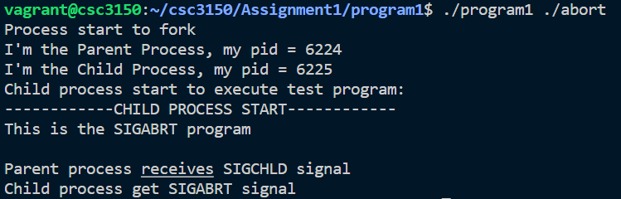

Alarm

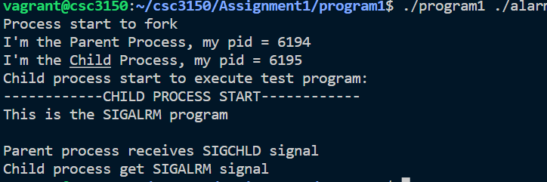

bus

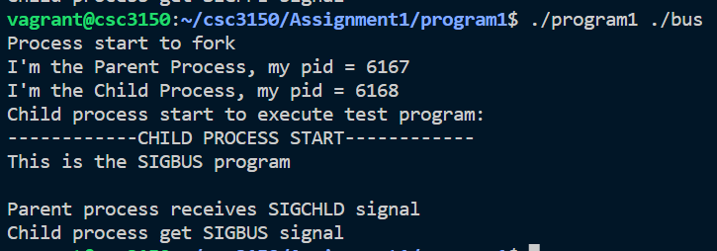

Floating

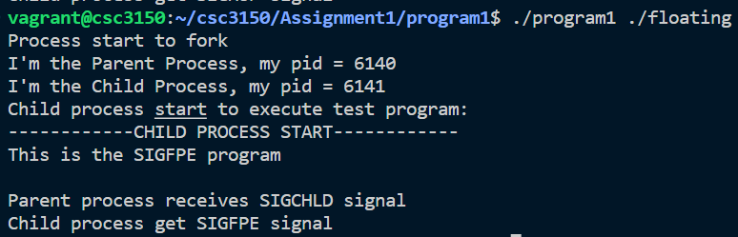

Hangup

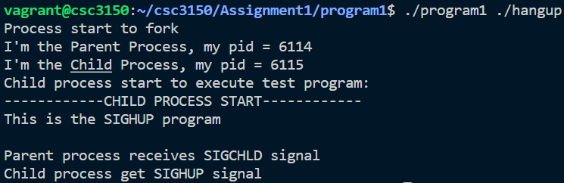

Inllegal_instr

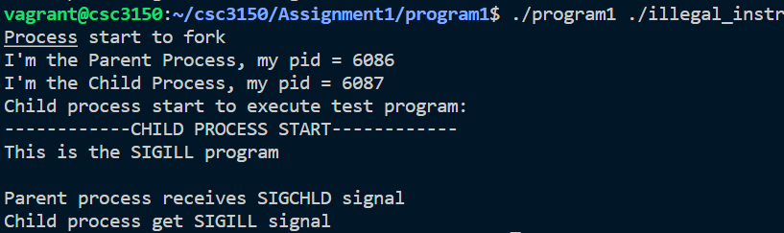

Interrupt

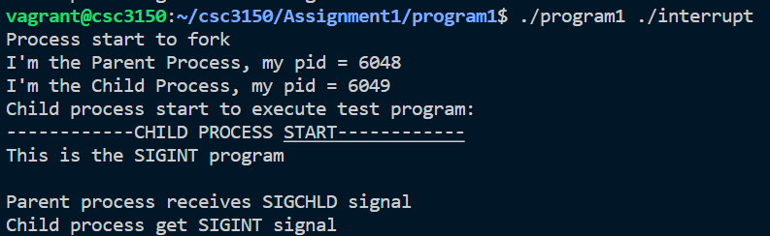

Kill

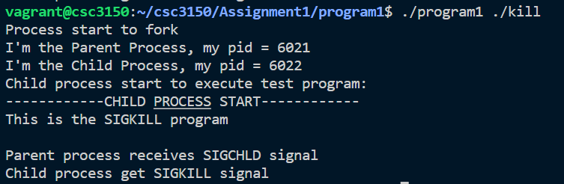

Normal

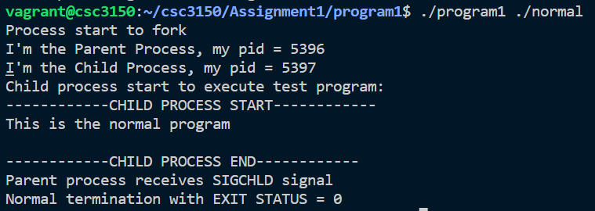

Pipe

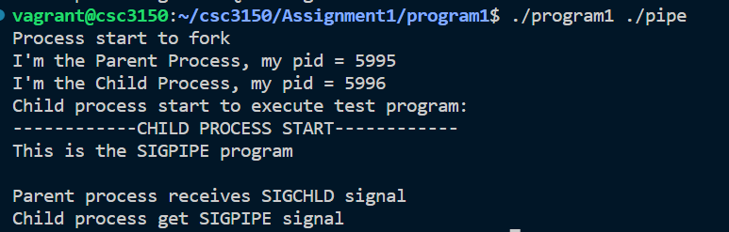

Quit

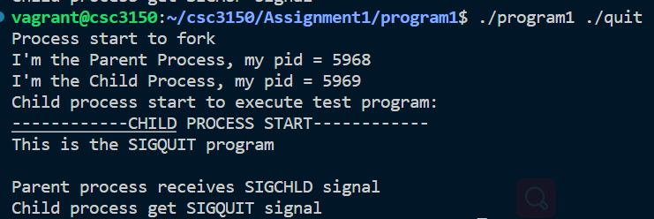

Segment_fault

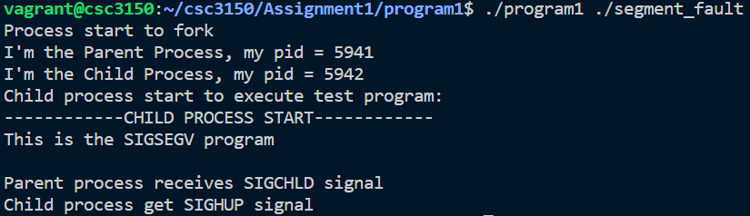

Stop

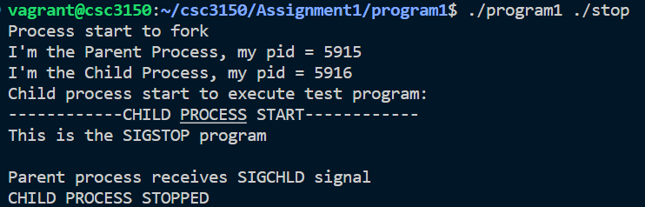

Terminate

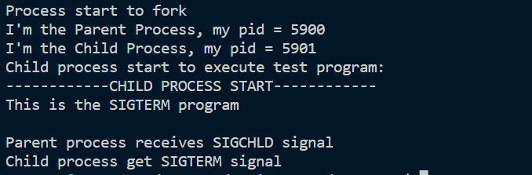

Trap

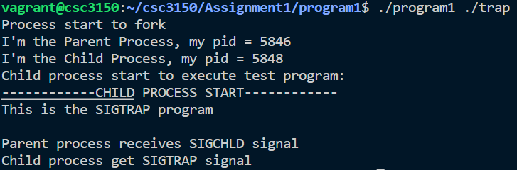

**Program2:**

Design

1. Initialize a program2 module and when it is initializing, use kthread_create function to create a thread run my_fork function.
2. Within my_fork, use kernel_clone to fork a new process which is used to run my_exec function.
   1. Output the pid of both child and parent process in kernel.
   2. Use parent_wait function to wait for the child process terminate.
3. Within my_exce function,
   1. Use getfilename_kernel to get the test file name.
   2. Use do_exceve to exceve the test program.
4. Within parent_wait function, use do_wait to wait child process terminate. After waiting, output the signal was raised in child process in kernel.

Set Up Environment

1. Use chmod 777 to edit the kernel code.
2. Export kernel_clone, getfilename_kernel, do_execve, do_wait function.
3. Build kernel Image and modules, install kernel modules and kernel.
4. Reboot the VM.

Output

Abort

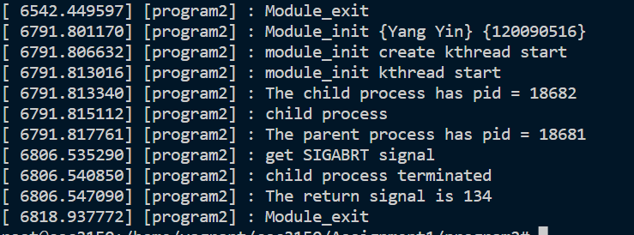

Alarm

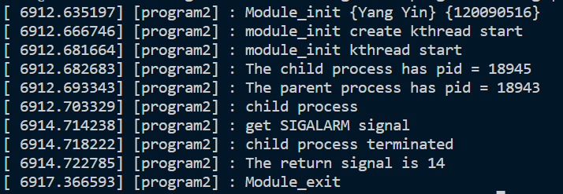

Bus

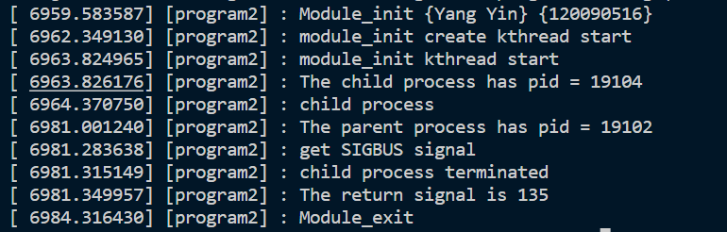

Floating

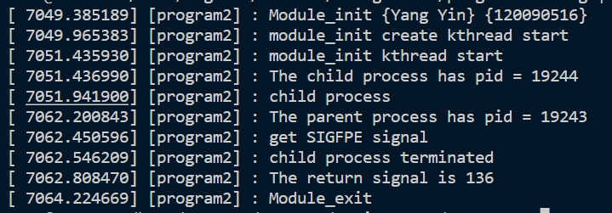

Hangup

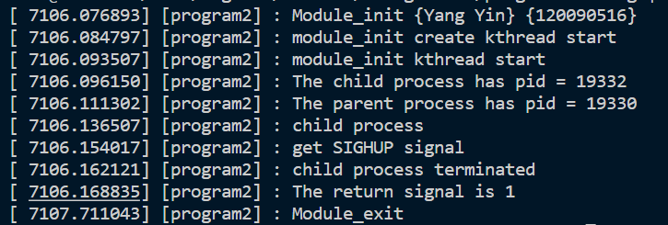

Illegal_instr

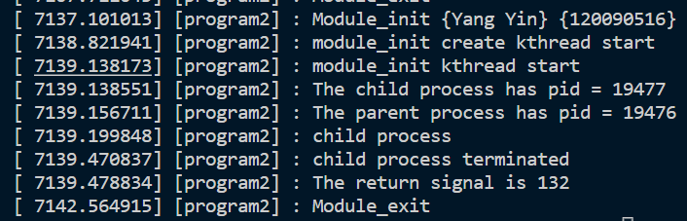

Interrupt

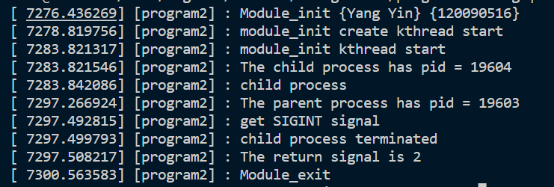

Kill

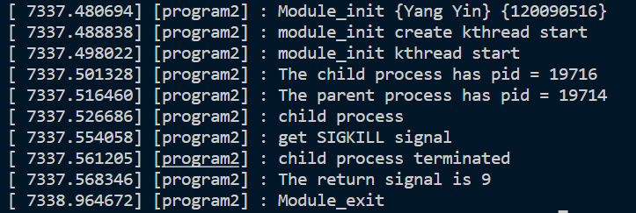

Normal

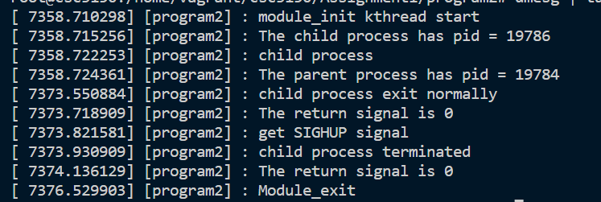

Pipe

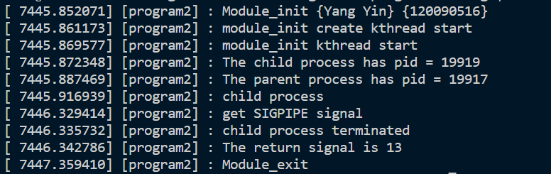

**NOTES**