CSC3150 Operating System

Assignment Report #2

Name: Yang Yin

Student ID: 120090516

Date: 2022.10.24

The Chinese University of Hong Kong, Shenzhen

1. Design

Some functions:

* 1. createlogs: Generate random logs on map during initialization.
  2. check: check point(x,y) status, the point is where frog is.
     1. Return 0 means game continues.
     2. Return 1 means reach the finish line.
     3. Return 2 means lose the game (go over the edge or fall into the river).
     4. Return 4 means something wrong.
  3. Khbit: Check for input
  4. print_map: Update the map on the screen
  5. logs_move:
     1. t=0: log move. The pattern in area 1 to ROW-1 moves left and right regularly. if frog is in this area, the frog needs to update its position. Check whether the frog can continue the game after updating its position
     2. t=1: check player input and do respond. Responds to W, S, A, D, Q input.

Some variables:

* 1. game_status: Record the state of the game.

0 means play, 1 means win, 2 means lose, 3 means quit, 4 means error

* 1. frog: x,y represents the position of frog.
  2. map: represent the map
  3. logs: the ID of pthread to move logs
  4. player: the ID of pthread to read player input
  5. mutex: the object for mutex.

1. Environment
2. Linux Version: Ubuntu 16.04.7
3. Linux Kernel Version: 5.10.146
4. GCC Version: 5.4.0
5. Flow chart

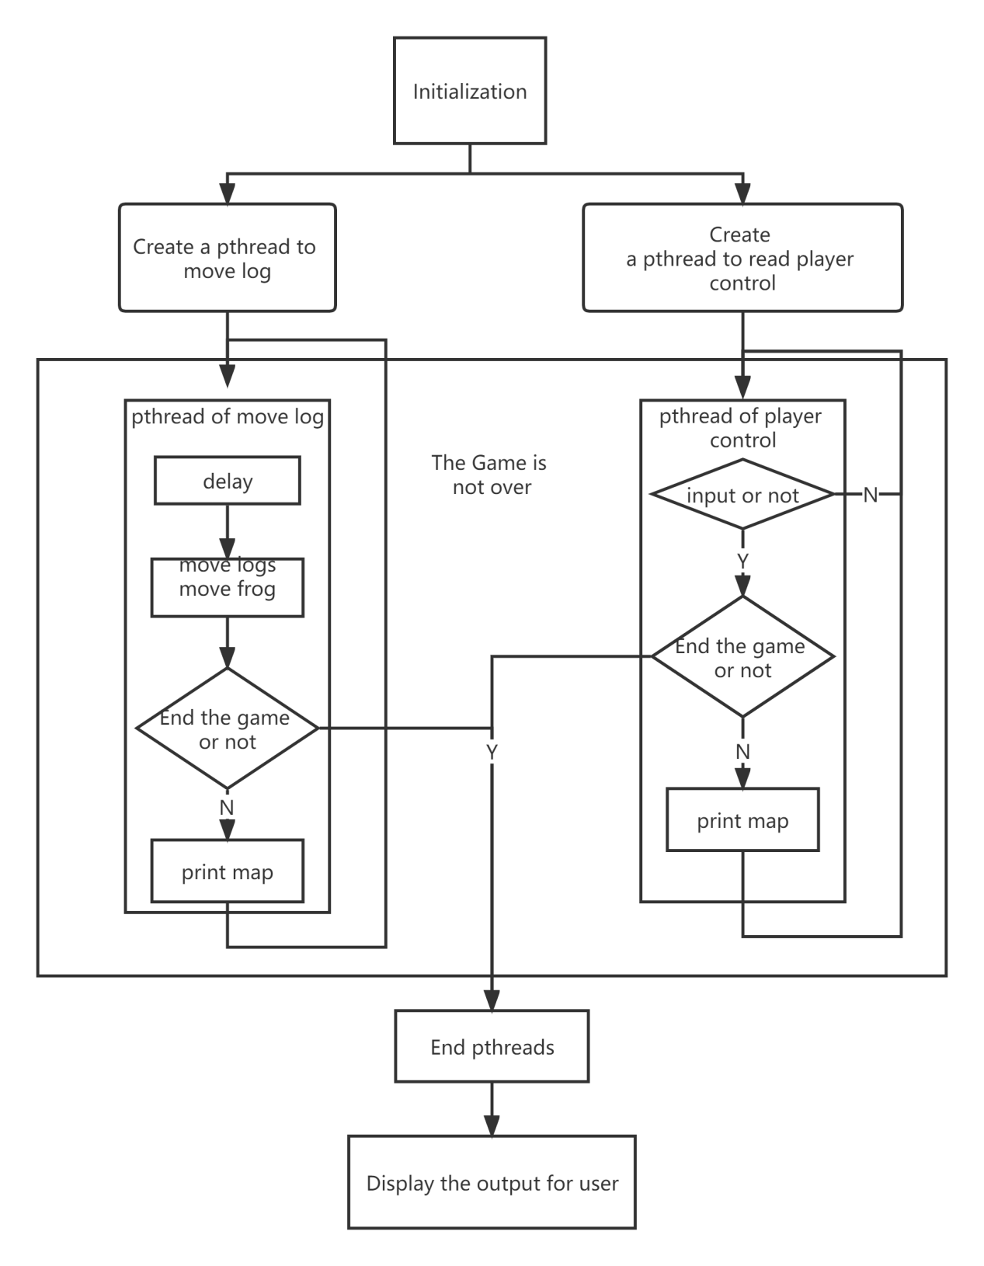

Graph 1: flow chart

1. Screenshot
   1. static output

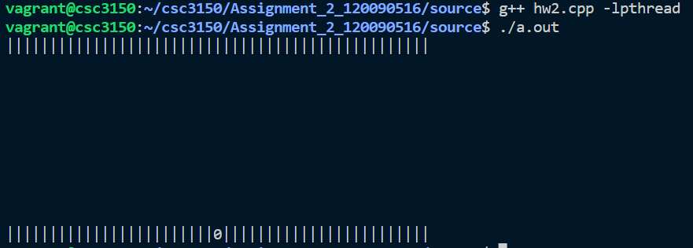

Graph 2: static output

* 1. Initial (random)

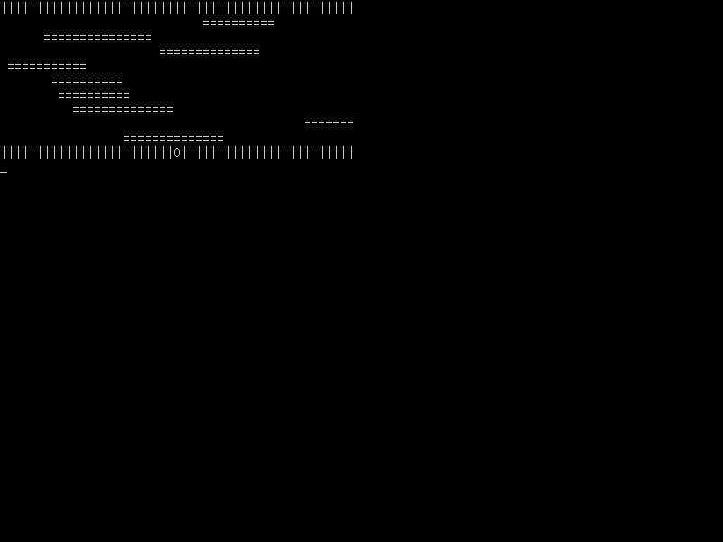

Graph 3

* 1. Win

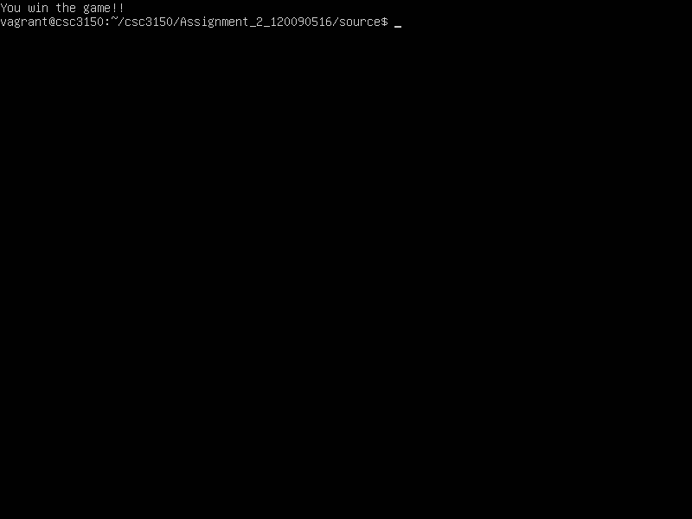

Graph 4

* 1. Lose

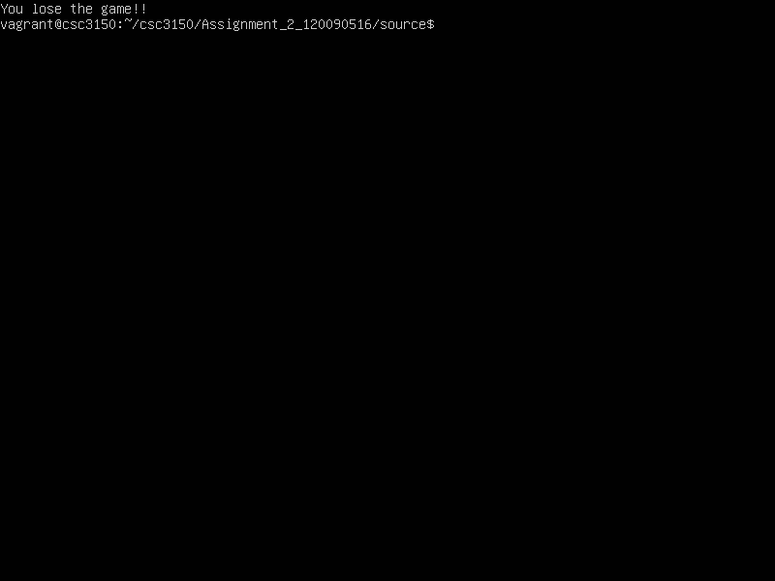

Graph 5

* 1. Quit

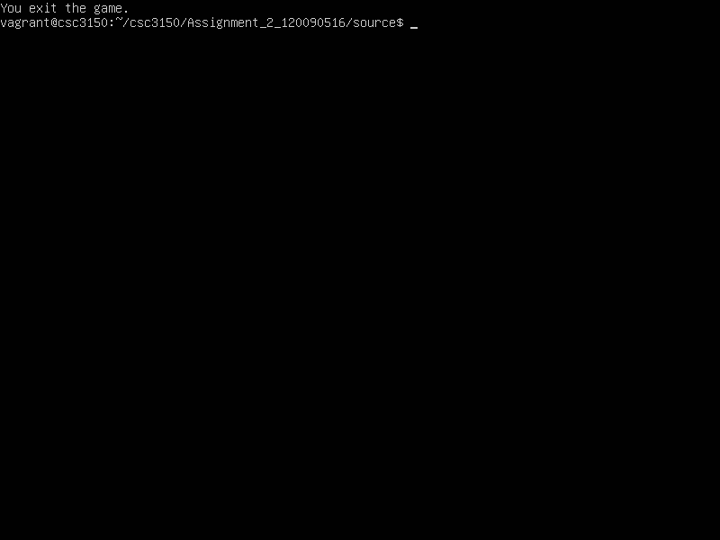

1. Others

I learned to create a process, use mutex, and use usleep for Delay.