Iesim: simulating and understanding real world events in a game environment
Joana Simões, Chris Skelly and João Simões
Iesim is a software platform designed to simulate real-world community events in a friendly game-like environment. It can be used for evaluating the effectiveness of interventions and predict and understand how events will unfold, and it can also be a valuable tool for training/education.
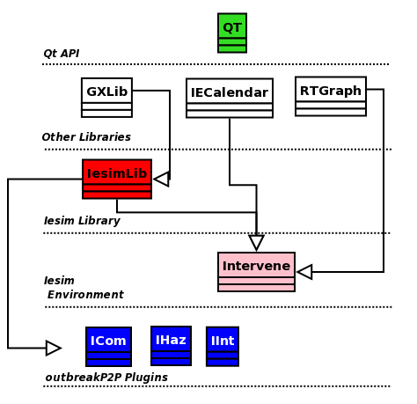
Figure 1 - Structure of Iesim Software

OutbreakP2P is a package for peer-to-peer diseases simulation, that demonstrates the potentialities of Iesim, for users and developers. It is constituted by a user interface (Intervene) and a set of plugins that implement the different aspects of the model: community, hazard and intervention (ICom, Ihaz and IInt).
Figure 1 shows the structure of the software: on a first level, Nokia Qt provides a set of classes to develop the UI and other aspects (multithreading, etc); IesimLib is the library which puts together the core functionality split into small libraries (GIS, graphics, etc) and that is used to build both, the main application and the plugins;
The program was fully implemented in C++ and apart from Qt it has no other dependencies, which means it is truly cross-plattform (see figure 2).
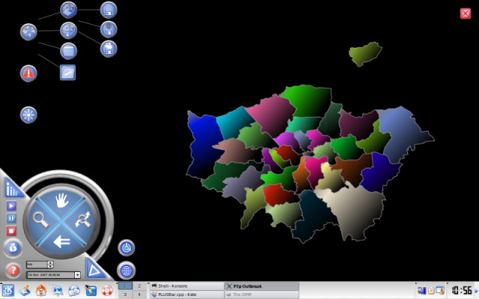
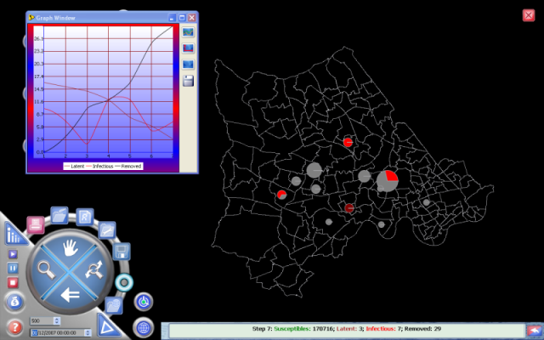
Figure 2 – Screenshots of OutbreakP2P, running in a) Linux and b) Windows desktop.

One of the main concerns on the development of this product was to have an intuitive user interface (like in games), that does not require the user to go through complicated manuals for setting up a simulation. Another concern, was to be able to cope with the lack of data, so common when dealing with real case studies, by means of “generating”information in an automatic or assisted way, just like it happens in games (e.g., “Sim City”). The idea was to have a model which will be as accurate as possible in the event of data availability, but that can also serve as a tool for training or education in the event of no data, creating and exploring fictitious scenarios (see figure 3).
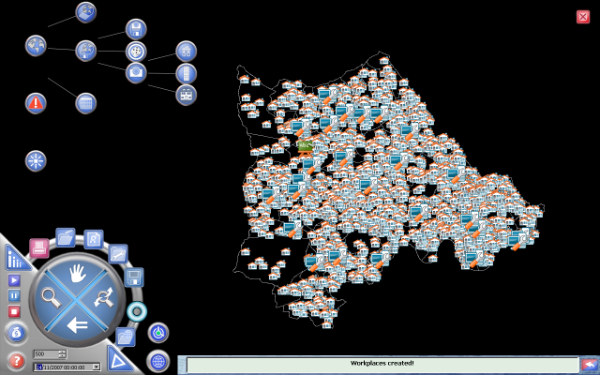
Figure 3 – Creating Communities: generating spatially distributed households and linking them to workplaces;
The model underneath OutbreakP2P is a spatially explicit agent based model (ABM) for the spreading of infectious diseases in human populations. Human-environment systems, are characterized by heterogeneity, nonlinear relationships, and hierarchical structures that give rise to difficulties in understanding system behavior in response to exogenous factors (Li, 2005). This kind of systems, that we define broadly as complex systems, are composed of many parts coupled together in a nonlinear fashion and tipically present self organization, a behavior in which order may arise from low level interactions without any supervision from higher-order structures (Nowak and Lewenstein , 1996). The bottom-up approach is the “natural” way of studying these systems (Simoes, 2007); however, the fact that there are a lot of random components has the consequence that the results cannot be reproduced like in deterministic models, and therefore each run of the model is often unique.
There are two assumptions that are crucial to the development of this model; one is that the spread of the disease relies strongly on social networks that are nowhere near random, but present a certain structure – this led us to the development of a community model; the other was to relax the common assumptions of homogeneous mixing in an homogenous space and create a scenario with an irregular distribution of individuals in an irregular space; the strong spatial component of the model, which in itself brings a lot of complexity led to the development of a Geographic Information Systems (GIS) in-house library;
One of the advantages of this kind of simulation tools is the ability to introduce and evaluate intervention strategies, such as vaccination (Simoes, 2007); Like in the other input, this can be done by reading data, generating data with sub-models or simply and quickly clicking on the screen.
A realistic spatial simulation model can be the basis for simulating spatial intervention strategies and therefore be an important tool for planners and policy makers in any field (Simoes, 2007). Learning the lesson from computer games, we also hope to have created a software that is easy to use by "non-technical" users, through a user-friendly user interface.
References:
Li An and D. Brown and W. Rand and S. Page (2005, August), Can statistical methods on land-Use change patterns calibrate agent-based models? 8th International Conference on GeoComputation. University of Michigan, Eastern Michigan University, USA
Nowak, A. and M. Lewenstein (1996, January). Computer simulations from the philos ophy of science point of view, pp. 249–285. Dodrecht, Netherlands: Kluwer Academic.Publishers.http://cognitrn.psych.indiana.edu/rgoldsto/complex/nowak.pdf; accessed 23 August, 2006.

Simoes, J., 2007, An agent-based approach to spatial epidemics through GIS. PhD thesis, Department of Geography,

e-GEO, Faculdade de Ciencias Sociais e Humanas, UNL; Avenida de Berna, 26-C 1069-061 Lisboa, Portugal;
CASA, University College London, 1 - 19 Torrington Place, London WC1E 7HB, UK;
??
CERN?
http://www.iesim.co.uk
http://qt.nokia.com/products
http://en.wikipedia.org/wiki/SimCity_%28series%29

