## Computer Architectures



## Amdahl's Law











## Gustafson-Barsis's Law









## Parallelisation Paradigms

1. Task-Farming/Master-Worker
2. Single-Program Multiple-Data (SPMD)
3. Pipelining
4. Divide and Conquer
5. Speculation
6. Parametric Computation

Task-Farming structure:

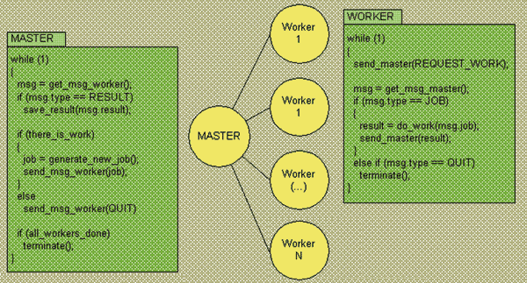

## Erroneous Assumptions of Distributed Systems

1. The network is reliable

2. Latency is zero

3. Bandwidth is infinite

4. The network is secure

5. Topology doesn't change

6. There is one administrator

7. Transport cost is zero

8. The network is homogeneous

9. Time is ubiquitous