#1

*Test Plan

1.Introduction

The Test Plan has been created to planning the automated testing of the Insurance/Travel function

2.Scope

Automate these following manual test cases:

-TC_Travel_01

-TC_Travel_02

-…

3.Test strategy

- Automation framework: Page Object Model or Hybrid framework (details will be discussed in the interview)

- Testing framework: TestNG

4.Resources/role and responsibilities

…

5.Tools

- Selenium (selected language: Java)

6.Schedule

- Business research: 1/2 day

- Manual practical: 1/2 day

- Review manual bug report: 1/2 day

- Auto sample test case: 1 day

- Develop auto framework: 5-7 days

- Develop 90% Test case of Travel: 5 days

- Run and analysis reports: 3 days

7.Environment

…

8.Deliverables

…

9.Risk

…

10.Test Data

…

11.Reports/results

…

*The tool(s) you would use to test it:

- Selenium

*The architecture of the test scripts in that tool.

- Page Object Model or Hybrid framework + TestNG, language: Java

Page Object Model framework

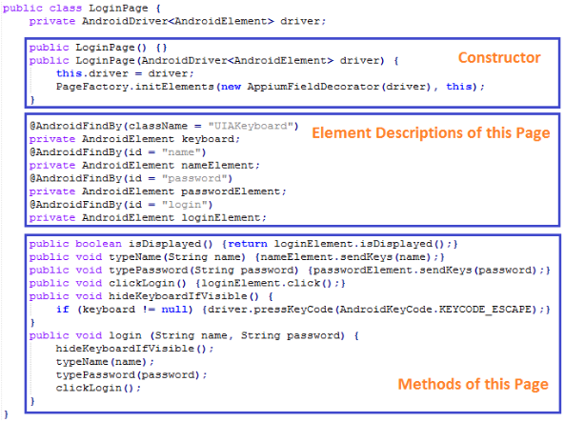

Hybrid framework: Keywork framework + Data Driven framework

Keywork framework

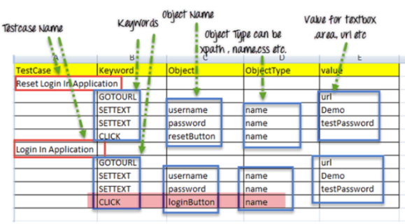

Data Driven framework: all of test data is generated from some external files like Excel, CSS, XML or some database table