Accelerating Catalyst Discovery with Artificial Intelligence Using Molecular Dual-Atom Site Catalysts as a Case Study
Denis Savchenko,¹ Bruno Inácio da Silva Roux Leite,¹ Timmo-Henrik Pukk,¹ Ba Long Nguyen,¹ Vladislav Ivanistsev,^{2†} Nadezda Kongi,^{1†}
¹ Institute of Chemistry, University of Tartu, Ravila 14a, 50411 Tartu, Estonia
² Department of Chemistry, University of Latvia, Jelgavas iela 1, Riga, LV-1004, Latvia
Corresponding authors: vladislav.ivanistsev@lu.lv; nadezda.kongi@ut.ee

Abstract
Accelerating catalyst discovery with artificial intelligence (AI) includes, in addition to catalyst screening, the communication of scientific results. We connect these tasks through a case study of the oxygen reduction reaction (ORR) on molecular dual-atom site catalysts (DASCs). We used density functional theory (DFT) calculations for 88 molecular catalysts to establish adsorption energetics, then trained machine learning (ML) regression models to predict adsorption potential energies for 1,260 optimized molecular structures. The predictions identified Fe adsorption centers and S-containing molecular structures as promising candidates for further investigation. We then guided a large language model (LLM) to prepare this complete article from the verified results, figures, literature, and writing instructions. We developed those instructions through repeated scientific and editorial review and checked the resulting text against the scientific inputs. This article demonstrates how AI can accelerate catalyst discovery through ML screening and scientific writing, allowing researchers to concentrate on scientific questions and methods.
Keywords: artificial intelligence; density functional theory; machine learning; large language models; oxygen reduction reaction; molecular dual-atom site catalysts.
Graphical abstract
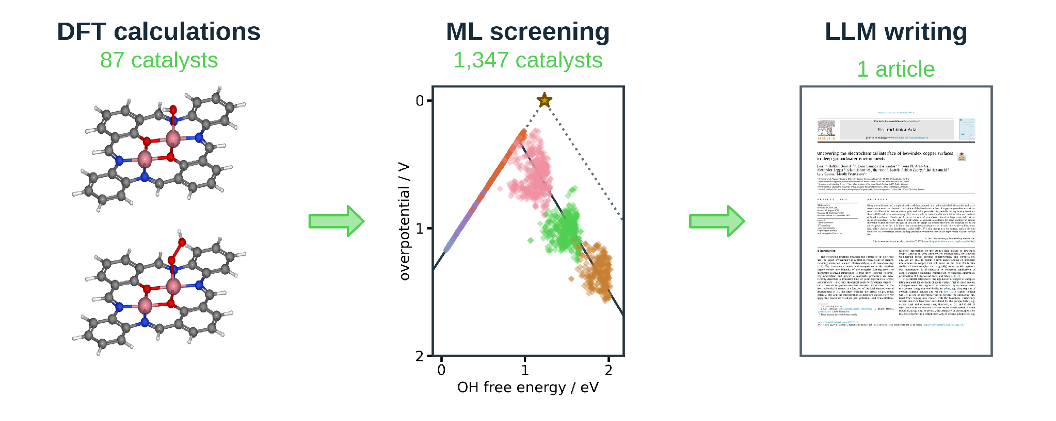

1. Introduction
Accelerating catalyst discovery with artificial intelligence (AI) requires attention to how scientific results are produced and communicated. In the mid 2020s, DFT calculations describe adsorption energetics, and ML predictions help researchers select structures for further study. Scientific writing then makes those results available for examination and reuse. The later stage adds time to a publication process that already takes months: independent studies reported an average submission to publication interval of approximately nine months in one chemistry journal sample and a median of six months for chemistry articles published by PLOS [10.1016/j.joi.2013.09.001; 10.1007/s11192-023-04640-6].
Herewith, scientific editors place a coherent story and carefully selected figures at the center of an effective article [10.1038/nphys724; 10.1021/acsenergylett.8b02322; 10.1021/acsenergylett.1c02401; 10.1038/s41551-018-0202-5]. We agree that readers need a clear explanation of the evidence and its meaning. Yet, we question the weight given to an author’s storytelling skill when the scientific contribution rests on reliable data and methods. Our thesis is that the story must follow the data. With this case study, we aim to demonstrate that a guided LLM can take on article writing once researchers have directed the scientific investigation.
The basics of scientific writing are taught to early-stage researchers in a standard, conventional way [10.5194/hess-20-2965-2016, Coursera Scientific Writing]. In this case study, we applied the same conventions to the LLM: we provided guidance on article structure, paragraph purpose, evidence, and scientific explanation. This gave us a way to delegate the writing while we developed and checked the scientific argument.
That division of work depends on scientific data that can be examined and reused. Notably, researchers can combine datasets, reevaluate data points, and test interpretations beyond the questions chosen by the original authors [10.1038/sdata.2016.18]. For example, a catalyst database preserves molecular structures and calculated values. In contrast, an article presents a particular analysis of those data – thus, reusable databases support scientific questions that extend beyond that original article.
LLM writing makes this connection between text and evidence essential. Vocabulary analyses of published abstracts have documented changes associated with LLM assistance [10.1126/sciadv.adt3813], while editorials have warned that a persuasive story can conceal conflicting observations [10.1038/nmeth.2726]. However, Ifargan et al. showed that interacting LLM agents can prepare papers whose claims can be checked against annotated data [10.1056/aioa2400555]. We extend that idea to a complete electrochemistry article based on verified DFT calculations, ML predictions, databases, the literature, and figures.
Figure 1 shows the writing process through which those inputs become an article. We utilized the LLM throughout manuscript preparation and to develop the Python scripts used to check the text. We guided the scientific argument and checked its connection to the calculations and predictions at each stage.
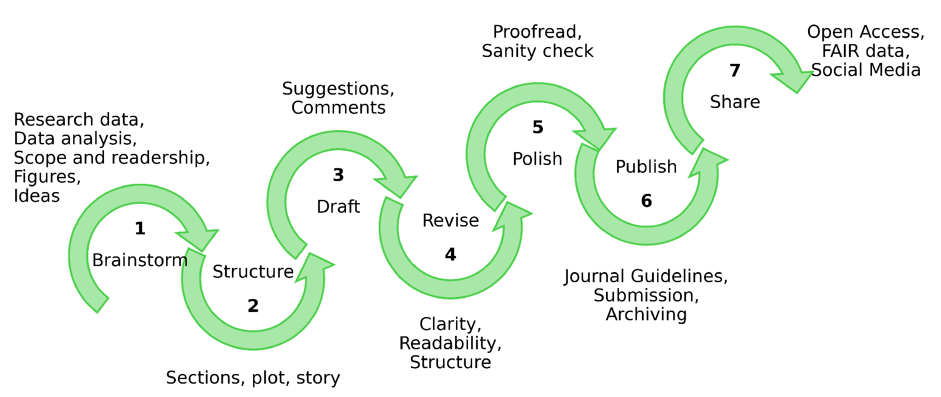
Figure 1. Seven stages of scientific writing: brainstorm, structure, draft, revise, polish, publish, and share. The surrounding text identifies the inputs and decisions associated with each stage. An LLM can contribute throughout this process as a member of the writing team. In this study, the LLM was guided by reusable writing instructions and article-specific facts, and its contribution extended throughout manuscript preparation.
Below we demonstrate this use of AI through three connected stages. DFT calculations establish ORR adsorption energetics for 88 molecular catalysts, and ML predictions extend the investigation to 1,260 optimized molecular structures. We then use a guided LLM to prepare the complete article from the verified scientific inputs. Together, these stages show how AI can guide catalyst selection and accelerate the scientific writing that communicates the results.

2. Computational methods

2.1. Catalyst structures
The molecular dual-atom site catalysts (DASC) were assembled from the components shown in Figure 2. Structural variables B1 and B2 denote the 1,2-phenylenediamine and 1,8-naphthalenediamine fragments, respectively, following the notation of the previous data article [10.1016/j.dib.2026.112806]. A2, the 2-hydroxyisophthalaldehyde fragment, was used as the fixed dialdehyde fragment in the DFT adsorption set. Two metal-atom adsorption centers were present in each DASC. The metal positions were occupied by Cr, Mn, Fe, Co, Ni, or Cu, and the two bridge positions contained N, O, or S. Every clean and adsorbate structure included in the DFT analysis was fully optimized. Three linked molecular catalyst datasets were used: the published structure dataset, the fixed DFT adsorption set of 88 catalysts, and the extended dataset used for predictions on 1,260 optimized molecular structures. The optimized structures and energies were stored in Atomic Simulation Environment (ASE) databases with molecular component and charge metadata.

2.2. DFT calculations and adsorption structures
Spin-polarized DFT calculations were performed with GPAW 24.6 and ASE 3.23.0 software [10.1063/5.0182685; 10.1088/1361-648X/aa680e]. The projector augmented wave method, revised Perdew–Burke–Ernzerhof functional, and D4 dispersion correction were used [10.1063/1.5090222]. A plane wave cutoff of 550 eV, real space grid spacing of 0.15 Å, and 6 Å of vacuum were applied. Each atomic structure was optimized until the maximum force fell below 0.05 eV Å⁻¹. Only calculations that converged with these parameters were included in the fixed DFT set. The setup followed earlier work on related molecular catalysts [10.26434/chemrxiv.15001712/v1]. A total charge of +2 was assigned to every modeled DASC, including N bridged structures. The thermodynamic comparison was therefore restricted to this charge assignment and the spin states reached during optimization. Extension of this comparison in the future would require examining other charge assignments, mixed oxidation states, and spin states, together with water coadsorption at the second metal-atom adsorption center.
O, OH, and OOH were placed at either metal-atom adsorption center, and each adsorbed structure was fully optimized. Gas phase H₂ and H₂O reference structures were calculated with the same settings. Total energies were matched by catalyst name and ads_site keyword, so that every reaction pathway was assembled from values for the same molecular structure and adsorption center.
Adsorption energies for O, OH, and OOH were calculated from the potential energies of the corresponding adsorbed structure, clean catalyst, H₂, and H₂O:
$ΔE_{OH} = E_{*OH} + (1/2) E_{H_{2}} - E_{*} - E_{H_{2}O}$ (1)
$ΔE_{O} = E_{*O} + E_{H_{2}} - E_{*} - E_{H_{2}O}$ (2)
$ΔE_{OOH} = E_{*OOH} + (3/2) E_{H_{2}} - E_{*} - 2E_{H_{2}O}$ (3)
In Eqs. 1–3, the left side is the adsorption potential energy of the named intermediate. The terms on the right are the electronic total energies of the clean and adsorbed catalysts and the gas-phase references; the asterisk (*) marks the DASC on which adsorption occurs.

2.3. Adsorption free energies and ORR thermodynamics
Adsorption potential energies were converted to adsorption free energies by adding combined zero-point energy and entropy corrections and an empirical solvation contribution:
$ΔG_{X} = ΔE_{X} + ΔE_{ZPE,X} - TΔS_{X} + ΔG_{solv,X}$ (4)
In Eq 4, X denotes O, OH, or OOH; E and G denote potential energy and Gibbs free energy; T is temperature; S is entropy; ZPE identifies the zero-point energy correction; solv identifies solvation. The adopted combined zero-point energy and entropy corrections were 0.35 eV for OH, 0.05 eV for O, and 0.40 eV for OOH at 300 K [10.1016/j.chemphys.2005.05.038]. Solvation corrections of −0.30 eV were applied to OH and OOH; no solvation correction was applied to O [10.1039/c1cp21228a]. The resulting net additions were 0.05, 0.05, and 0.10 eV for OH, O, and OOH, respectively. These rounded combined corrections were applied consistently to the DFT and ML adsorption energies. The adopted reaction corrections include gas phase reference contributions. The four reduction potentials were evaluated with the computational hydrogen electrode (CHE) method [10.1021/jp047349j]:
$U_{1} = (4.92 eV - ΔG_{OOH}) / e, U_{2} = (ΔG_{OOH} - ΔG_{O}) / e,U_{3} = (ΔG_{O} - ΔG_{OH}) / e, U_{4} = ΔG_{OH} / e$ (5)
Eq. 5 defines the positive reduction potentials for the four steps O₂ to OOH, OOH to O, O to OH, and OH to H₂O; and e is the elementary charge. The limiting potential is defined as the lowest of the four step potentials:
$U_{L} = min(U_{1}, U_{2}, U_{3}, U_{4})$ (6)
The symbol on the left of Eq. 6 denotes the limiting potential. The ORR overpotential was evaluated relative to the equilibrium potential of 1.23 V:
$η_{ORR} = 1.23 V - U_{L}$ (7)
Equation 7 defines the ORR overpotential. Chemical subscripts in Eqs. 5–7 identify the adsorbed intermediate or reaction quantity.

2.4. Scaling and thermodynamic activity analyses
The relations of O and OOH adsorption free energies to OH adsorption free energy were evaluated by ordinary least squares:
$ΔG_{O} = α_{O} ΔG_{OH} + β_{O}, ΔG_{OOH} = α_{OOH} ΔG_{OH} + β_{OOH}$ (8)
In Eq. 8, α and β are the slope and intercept for the intermediate identified by the subscript. The fitted relations were propagated through the four ORR steps to obtain the scaling-based activity curve in Figures 3 and 4. An ideal reference relation was defined with an OOH–OH free energy separation of 2.46 eV:
$Δ{G_{OOH}}^{ideal} = ΔG_{OH} + 2.46 eV, η_{ideal} = 1.23 V - min(ΔG_{OH} / e, (2.46 eV - ΔG_{OH}) / e)$ (9)

2.5. Regression analysis and catalyst family screening
From the 88 DFT catalyst structures, 50 were selected for training and 10 for validation. Separate ridge regression models were fitted for OH, O, and OOH adsorption potential energies. Descriptors of the clean catalysts represented electron population, charge, spin, metal pair polarization, and ligand environment. Eight predictors were used for OH and O, and six for OOH. The training medians, means, standard deviations, standardized coefficients, and ridge parameters were retained in the parameter tables. The ridge parameter was 0.10 for OH and 1.00 for O and OOH. Predictions were obtained for 1,260 optimized molecular structures from the extended dataset, selected from [10.1016/j.dib.2026.112806] and reoptimized at the DFT level.
The predicted OH, O, and OOH adsorption potential energies were joined with the catalyst name and the ads_site keyword. They were converted to adsorption free energies with the corrections in Section 2.3 before the CHE step potentials, and overpotentials were evaluated. Complete combinations of catalysts and adsorption centers were selected before the electronic adsorption energy filters were applied. For comparison of structural families, the most active pool in each DFT or ML dataset was defined as the lowest 10% of retained overpotentials, rounded up to a whole catalyst-adsorption center combination.

2.6. LLM manuscript generation
An LLM accessed through OpenAI Codex was used to prepare the complete manuscript from the calculations, predictions, figures, literature, and project instructions. A related procedure with interacting LLM agents and claims linked to scientific inputs was reported by Ifargan et al. [10.1056/aioa2400555]. For the present study, the writing procedure was developed and tested through repeated author guidance, and then consolidated into a single prompt for complete article generation.
The instructions were developed over approximately two weeks. Scientific terminology, analysis code, figure construction, article structure, and writing style were checked against the data, literature, and journal requirements. Ten operational roles were defined for scientific preparation, writing, editing, and document construction. These were joined by a simulated journal editor and scientific reviewer. The roles worked in successive turns on a shared draft, with the editors’ guiding revisions and the Author role integrating them. Specific review issues and the checks of their corrections were retained outside the manuscript.
The writing instructions were informed by the conventions taught in H. Glasman-Deal’s Science Research Writing for Non-Native Speakers of English (2010) and Barbara Minto’s The Minto Pyramid Principle (2010). Paragraph purpose, the order of claims and evidence, and direct language were specified. These instructions were tested through successive drafts and incorporated into the consolidated prompt.
Finally, the complete article was generated from the consolidated prompt and verified scientific inputs. The text was checked by the authors against DFT calculations, ML predictions, figures, sources, and scientific interpretation.

3. Results and discussion

3.1. Molecular structures and adsorption centers
Figure 2 shows the common molecular structure and the four component classes used to assemble the catalysts. In the 88 catalyst DFT set, we varied the metal identities, bridge atoms, and diamine fragment (B1, B2) while keeping the dialdehyde fragment (A2) fixed. Each molecule is a DASC with two metal-atom adsorption centers.
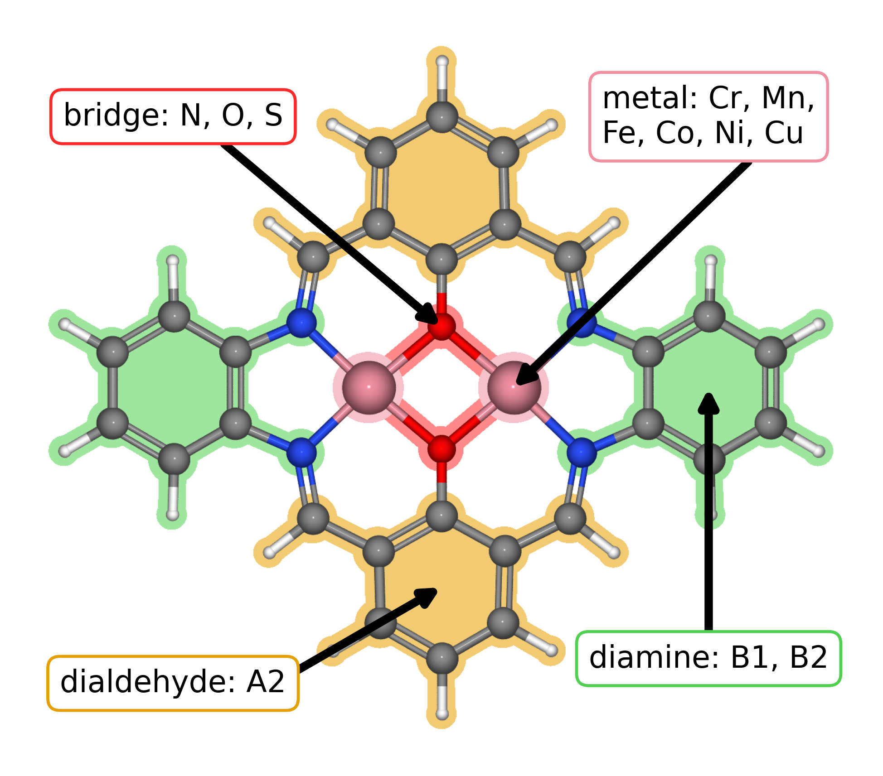
Figure 2. Modular molecular structure of a DASC used for DFT calculations. Colored regions identify the metal positions (pink), bridge atoms (red), diamine fragments (green), and dialdehyde fragments (orange). Related complexes are synthesized from diamines, dialdehydes, and metal salts [10.26434/chemrxiv.15001712/v1]. The metal positions contain Cr, Mn, Fe, Co, Ni, or Cu, and the bridge atoms are N, O, or S. B1 and B2 denote the 1,2-phenylenediamine and 1,8-naphthalenediamine fragments; A2 denotes 2-hydroxyisophthalaldehyde. The component notation is defined in the data article [10.1016/j.dib.2026.112806].

3.2. Adsorption scaling relations and calculated ORR thermodynamics
We first examined how O and OOH adsorption free energies vary with OH adsorption free energy (Figure 3a). The OOH–OH fit has a slope of 0.69 and an intercept of 3.05 eV, while the O–OH fit has a slope of 1.66 and an intercept of 1.17 eV. These slopes are below the commonly used values of 1 and 2, yet similar variations in slope and intercept have also been reported for metal–nitrogen–carbon catalysts [10.1039/D5CS00597C]. Within our molecular dataset, O adsorption changes more strongly than OOH adsorption as OH binding changes. We propagated both fitted relations through the four CHE steps to obtain the overpotential curve in Figure 3b.
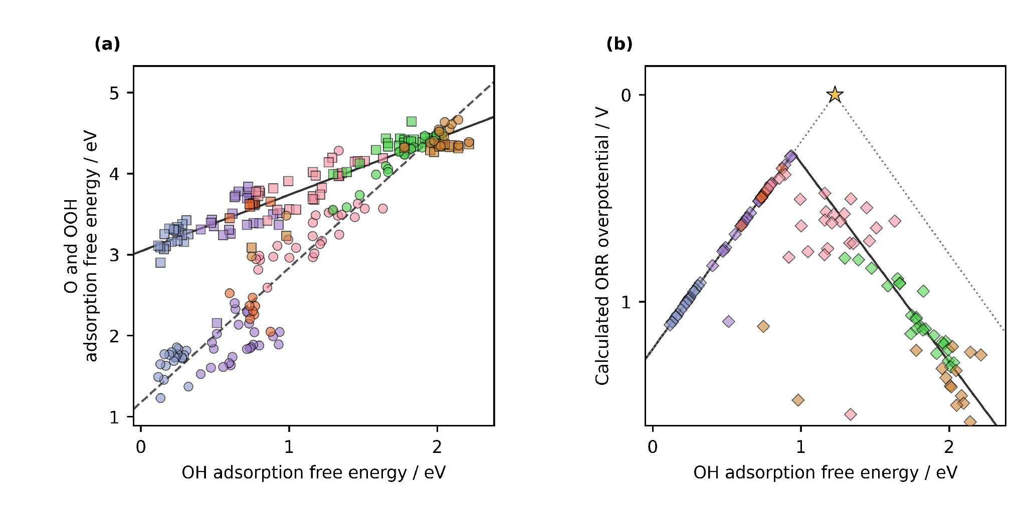
Figure 3. DFT adsorption scaling relations and conventional CHE overpotential volcano for molecular DASCs. (a) Calculated O and OOH adsorption free energies versus OH adsorption free energy. Circles denote O and squares denote OOH. Jmol colors identify the adsorption center metal: Cr, blue gray; Mn, violet; Fe, orange; Co, pink; Ni, green; and Cu, brown. The solid and dashed lines are the fits for the OOH–OH and O–OH scaling relations, respectively. (b) Calculated ORR overpotentials for the same catalyst and adsorption center combinations, shown as diamonds with the same color key. The solid curve follows the four CHE steps evaluated with the fitted scaling relations. The dotted curve follows the ideal relation in Eq. 9; the star marks zero overpotential at an OH adsorption free energy of 1.23 eV. Figure 2 explains the structural components.
The three lowest calculated CHE overpotentials belong to a Cr–Mn DASC with S bridge atoms and 1,2-phenylenediamine at the Mn adsorption center (0.29 V), a Mn–Mn DASC with S bridge atoms and 1,2-phenylenediamine at the Mn adsorption center (0.34 V), and an Fe–Cu DASC with S bridge atoms and 1,8-naphthalenediamine at the Fe adsorption center (0.36 V). All three contain S bridge atoms, while their metal pairs and diamines differ. To compare catalyst families, we considered the lowest overpotential decile in each analysis. The DFT decile contains 12 catalyst-adsorption center combinations: five Co, four Mn, and three Fe. Seven contain S bridge atoms, four contain N–N bridges, and one contains an O–O bridge. We used these calculated examples to examine whether favorable activity extends across related molecular structures in the following regression predictions.

3.3. Regression predictions across catalyst families

We then used the ML predictions to examine those structural trends across the extended molecular dataset (Figure 4). Fe adsorption centers predominate among the lowest predicted overpotentials, while S bridges and the B1 fragment identify families for further calculations and synthesis; B1 denotes 1,2-phenylenediamine in the data article [10.1016/j.dib.2026.112806]. The Fe and S trends connect the screen to the calculated examples, while the diamine preference emerges in the extended predictions. We interpret these features together as guides for candidate selection under the charge and spin treatment in Section 2.2.
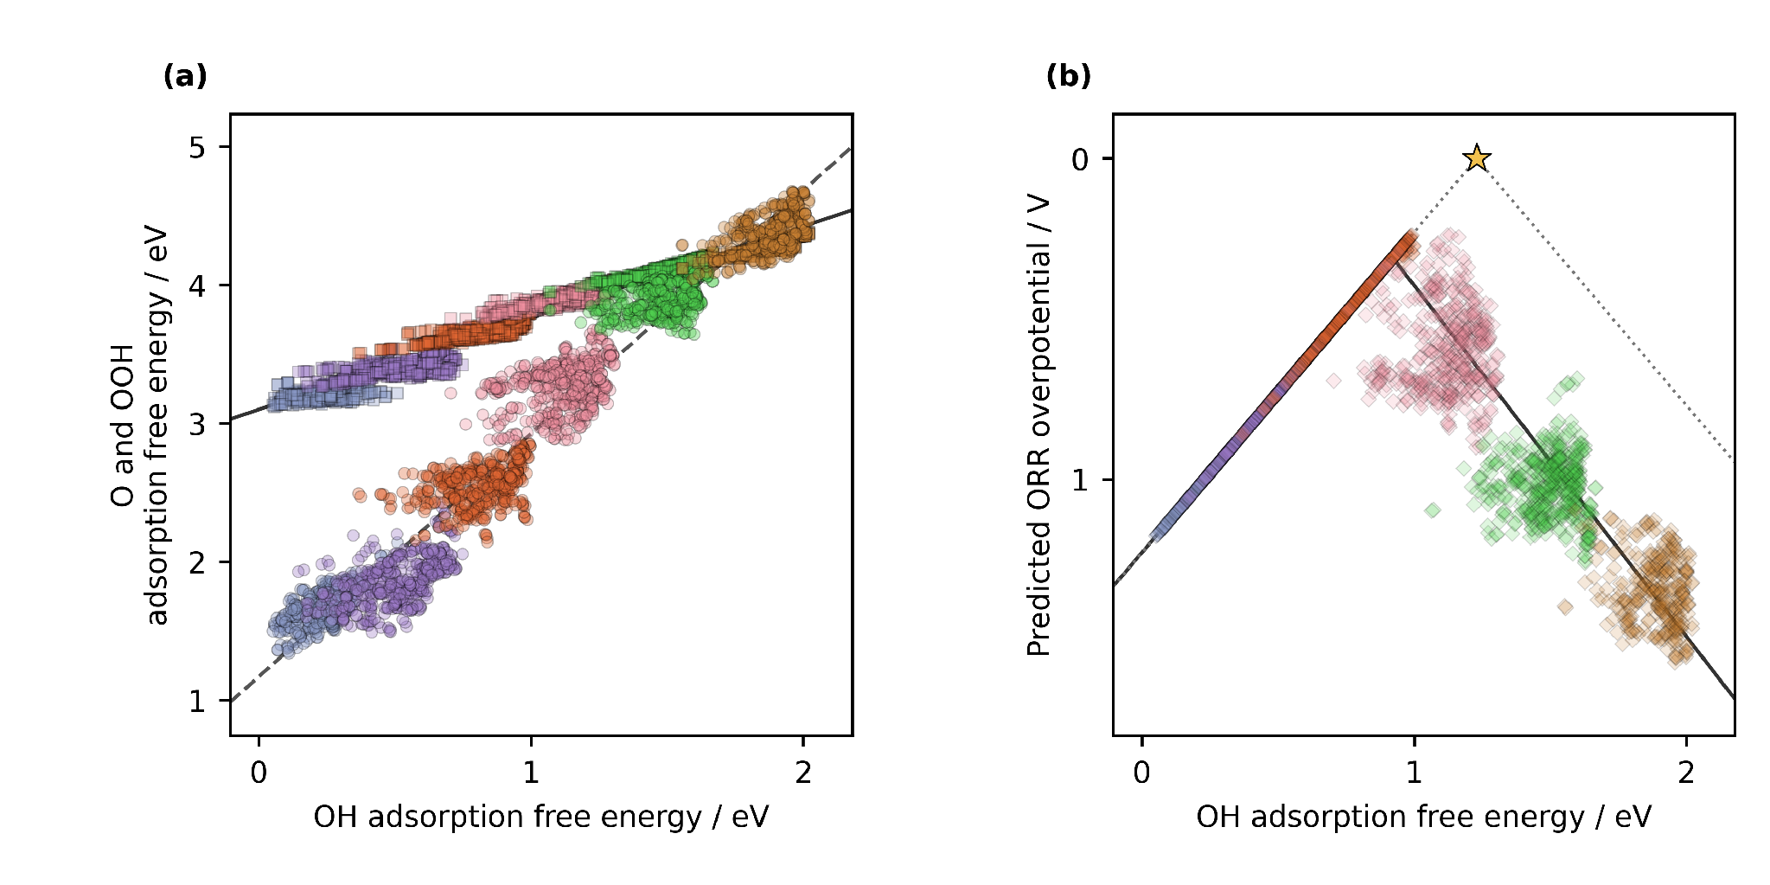
Figure 4. ML predicted adsorption scaling relations and conventional CHE overpotential volcano for molecular DASCs. (a) Predicted O and OOH adsorption free energy values versus predicted OH adsorption free energy. Circles denote O and squares denote OOH. Jmol colors identify the adsorption center metal: Cr, blue gray; Mn, violet; Fe, orange; Co, pink; Ni, green; and Cu, brown. The solid and dashed lines are the fits for the OOH–OH and O–OH scaling relations, respectively. (b) Predicted ORR overpotentials, shown as diamonds with the same color key. The solid curve follows the four CHE steps evaluated with the fitted scaling relations. The dotted curve follows the ideal relation in Eq. 9; the star marks zero overpotential at an OH adsorption free energy of 1.23 eV. Figure 2 explains the structural components. Predicted adsorption potential energies were converted to free energies with the corrections in Section 2.3.

3.4. Molecular catalyst design in context
Our earlier study of this molecular DASC family linked the diamine structure to the distance between Co centers, the binding geometry of oxygen intermediates, and ORR selectivity [10.26434/chemrxiv.15001712/v1]. Sun et al. and Li et al. discussed bidentate OOH binding and changes in metal coordination with bridge and ligand structure of the same Co-containing DASC [10.1021/jacs.4c12705; 10.1021/acscatal.6c00046]. We did not obtain that bidentate OOH geometry in the present DFT calculations. Also, our earlier O bridged Co–Co catalyst had a total charge of +4, in agreement with experimental evidence, and a lower calculated ORR overpotential than those in the present set with fixed +2 charge of each DASC. Besides, in all named studies, the free energies were evaluated with a different correction convention. So notably, while all these studies can reproduce the OH–OOH scaling relation intercept of 3 eV, Žoglo et al. and Sun et al. identified Co-containing DASCs with a lower intercept value, which could signify the breaking of the OH- OOH scaling relation. These individual examples and the global fit of a molecular dataset describe different aspects of adsorption energetics, and they motivate further exploration of the presented family of DASCs.
Similarly to our study, Zhang et al. used DFT calculations to guide ML screening [10.1002/adma.202403549]. They evaluated 60 homonuclear DASCs assembled from ten metals, diamine, and dialdehyde fragments, similar to those used in this study. DFT oxygen evolution reaction (OER) free energies and scaling relations were combined with XGBoost ranking of 27 descriptors and an interpretable model from the Sure Independence Screening and Sparsifying Operator (SISSO). Diferently from their approach, our case study includes homo- and heteronuclear metal pairs and extends the 88 catalyst DFT investigation to predictions for 1,260 optimized molecular structures.
Notably, Zhang et al. reported the OOH–OH scaling relation with a slope of 0.96 and an intercept of 2.98 eV, compared with 0.69 and 3.05 eV for our retained ORR combinations. Their additional metals extend the OH adsorption energy range into much stronger binding. This sampling difference helps explain why similar intercepts can accompany different slopes, although reaction and free energy conventions also affect the comparison.
Related screening of extended phthalocyanine DASCs used 81 DFT structures to support predictions for 360 additional metal pairs and identified Fe as an adsorption center that regulates activity [10.1002/adma.74833]. Our screen likewise extends the comparison of metal pairs and ligands beyond the adsorption DFT set. ML supplies preliminary adsorption predictions for the extended dataset, so subsequent DFT calculations and experiments can focus on the selected DASCs. This is a vivid example of how ML accelerates catalyst screening in this and similar studies of DASCs.
This use of ML becomes common across electrocatalysis. For details, see how Jia et al. reviewed data-driven OER studies [10.1002/adfm.77325], Chen et al. combined DFT, ML, and experimental validation for ORR screening [10.1021/acscatal.6c02383], and Benarbia et al. classified molecular complexes for hydrogen evolution with unsupervised ML [10.1039/d6ra03405e]. While these studies provide context for our regression analysis, none of them extended the use of AI assistance to the scientific writing that communicates the calculations and predictions.

3.5. Closing the scientific communication gap
To accelerate communication, we supplied the verified DFT calculations and ML predictions, along with molecular identities, figures, methods, and relevant literature, as inputs to the LLM for writing this article.
Over approximately two weeks, we developed instructions for scientific writing and tested them against successive drafts. We corrected terminology, checked the scientific explanations, and refined the paragraph structure with reference to the databases, analysis outputs, and literature. The corrections became reusable writing rules and article-specific instructions. We consolidated them into a single prompt, provided in the supporting information, that generated the complete article. The preparation of that prompt was the work that made its execution useful.
This article demonstrates how an LLM can carry out the writing under researchers’ guidance, allowing them to redirect their effort more towards research rather than written communication. Note that LLM writing must be very carefully guided and strictly verified, as in our experience, at the current stage it is incompetent at producing sound scientific texts with its standard settings. Moreover, such a division between research and communication is only possible when the input data is of excellent quality.

3.6. Data and alternative interpretations
Findable, Accessible, Interoperable, and Reusable (FAIR) data enable researchers to exploit them. Besides feeding it to an LLM, let us highlight the interpretability of FAIR data. For example, our data allow us to examine activity using different thermodynamic descriptors, providing alternative interpretations. The conventional CHE overpotential depends on the least favorable individual reduction step. Calle-Vallejo’s electrochemical step symmetry index evaluates the distribution of reaction free energy among the electrochemical steps. In contrast, Exner’s free energy span identifies the largest cumulative uphill change across consecutive reaction states at a selected potential [10.1016/j.coelec.2018.03.025; 10.1021/acscatal.2c03997]. Researchers can apply these descriptors to the same identified adsorption energies to compare different properties of the ORR pathway. Our databases preserve the molecular structure and adsorption center associated with each calculated energy, enabling researchers to test alternative descriptors, compare catalyst rankings, and ask questions beyond those addressed in this article. Interestingly, different approaches provide distinct rankings of the most active catalysts, as we show in the SI. Thus, the scientific value of the data extends beyond the particular analysis presented here. Herewith, such analysis, leading to alternative interpretations, can also be run using AI to accelerate the rediscovery of catalysts missed in original screening studies.

4. Conclusions
We used a guided large language model to prepare this complete scientific article from verified research inputs, including machine learning-based screening. Thus, with the article itself, we demonstrate accelerating catalyst discovery with artificial intelligence through scientific writing and catalyst screening.
Our density functional theory calculations established oxygen reduction adsorption energetics for 88 molecular catalysts. Machine learning extended the investigation to 1,260 optimized molecular structures and identified promising families associated with Fe adsorption centers and S bridge atoms for future research.
Most notably, we showed how scientific writing conventions can guide a large language model in preparing a scientific article. We believe that the scientific method and obtained data establish the base contribution of catalyst discovery, while communication can be largely delegated to AI without losing scientific credibility. This division of work would allow researchers to concentrate on scientific questions and accelerate the discovery of catalysts with AI assistance in screening and writing.

CRediT authorship contribution statement
Denis Savchenko: methodology, software, formal analysis, visualization, and development of the regression model. Bruno Inácio da Silva Roux Leite: investigation, data curation, formal analysis, and generation of DFT results. Timmo-Henrik Pukk: investigation, data curation, formal analysis, and generation of DFT results. Ba Long Nguyen: investigation, software, data curation, formal analysis, visualization, and generation of DFT results. Vladislav Ivanistsev: conceptualization, supervision, and funding acquisition. Nadezda Kongi: conceptualization, supervision, and funding acquisition. All authors validated and approved the final manuscript text.

Declaration of competing interests
The authors declare no competing interests.

Data availability
Three linked molecular catalyst datasets were used in this study. The published parent structure dataset is available from Zenodo [10.5281/zenodo.18601379]. The DFT databases for the 88 catalysts, the extended bare catalyst database, and the CSV files with ML predictions are available from the project repository (https://github.com/doublelayer/EActa_2026_AI-acceleration). The current larger dataset is deposited in Zenodo [10.5281/zenodo.23408498].

Declaration of generative AI and AI-assisted technologies in the manuscript preparation process
During the preparation of this work, we used OpenAI Codex, an LLM, to organize and write the complete scientific article and to assist with reproducible analysis and figure code using project data, the literature, and instructions. We reviewed the text against the calculations, model predictions, methods, figures, and sources and took full responsibility for the article’s content.

Acknowledgments
This work was supported by the National Research Program BioPhoT through the project Nr. OSI_PIP_BioPhoT-2025/2-0069. This work was also supported by the Estonian Ministry of Education and Research (TK210) and the Estonian Research Council (PRG3174, TEM-TA306). This publication is based on work from COST Action EU-CONCERT (CA24103), supported by COST (European Cooperation in Science and Technology). We acknowledge the University of Latvia Artificial Intelligence and Computing Center and the High-Performance Computing Center of the University of Tartu for providing computational resources.

References
S. Jia et al., Machine Learning Reveals Role-Asymmetric Electronic Cooperation in Fe-Based Dual-Atom Catalysts, Advanced Materials 36 (2026) e74833. [10.1002/adma.74833]
Z. Zhang et al., Design and Synthesis of Electrocatalysts Based on Catalysis-Unit Engineering, Advanced Materials 36 (2024) 2403549. [10.1002/adma.202403549]
X. Chen et al., Leveraging DFT and Machine Learning for Accelerated Screening of Cluster-Modified Single-Atom Catalysts in Oxygen Reduction Reactions, ACS Catalysis 16 (2026) 14399–14410. [10.1021/acscatal.6c02383]
J. K. Nørskov, J. Rossmeisl, A. Logadottir, L. Lindqvist, J. R. Kitchin, T. Bligaard, H. Jónsson, Origin of the Overpotential for Oxygen Reduction at a Fuel-Cell Cathode, Journal of Physical Chemistry B 108 (2004) 17886–17892. [10.1021/jp047349j]
L. Jia, Z. Jin, Y. Tan, Z. Zhang, Y. Pu, Y. Wang, L. Huang, From Data to Discovery: Crafting Data-Driven Frameworks for Advancing OER Electrocatalysts, Advanced Functional Materials 36 (2026) e77325. [10.1002/adfm.77325]
A. Benarbia, A. Alshami, A. Mustafa, O. S. Tomomewo, Can machine learning uncover viable non-platinum catalysts for hydrogen evolution? An unsupervised clustering approach to transition metal–ligand complexes, RSC Advances 16 (2026) 42403. [10.1039/d6ra03405e]
Q. Sun et al., Well-Defined Co₂ Dual-Atom Catalyst Breaks Scaling Relations of Oxygen Reduction Reaction, Journal of the American Chemical Society 146 (2024) 35295–35304. [10.1021/jacs.4c12705]
N. Žoglo et al., Intersite Geometry Controls Activity and Selectivity in the Oxygen Reduction Reaction on Dual-Atom-Site Catalysts, ChemRxiv preprint (2026). [10.26434/chemrxiv.15001712/v1]
L. X. Chen, P. Christopher, F. De Angelis, S. Jin, Y.-S. Hu, N.-G. Park, D. Das Sarma, Y.-K. Sun, P. V. Kamat, We Editors Are Authors, Too, ACS Energy Letters 4 (2019) 249–250. [10.1021/acsenergylett.8b02322]
Elements of style, Nature Physics 3 (2007) 581. [10.1038/nphys724]
C. M. Biegel, P. V. Kamat, Five common pitfalls to avoid while composing scientific figures, ACS Energy Letters 6 (2021) 4309–4310. [10.1021/acsenergylett.1c02401]
Storytelling in research, Nature Biomedical Engineering 2 (2018) 53. [10.1038/s41551-018-0202-5]
Should scientists tell stories?, Nature Methods 10 (2013) 1037. [10.1038/nmeth.2726]
B. L. Nguyen, T. K. Madsen, V. Ivanistsev, N. Kongi, Dataset of molecular dual-atom site complexes for catalysis, Data in Brief 66 (2026) 112806. [10.1016/j.dib.2026.112806]
[dataset] B. L. Nguyen, T. K. Madsen, V. Ivanistsev, N. Kongi, Dataset of molecular dual-atom site complexes for catalysis, Zenodo, version 1.0, 2026. [10.5281/zenodo.18601379]
J. J. Mortensen et al., GPAW: An open Python package for electronic structure calculations, Journal of Chemical Physics 160 (2024) 092503. [10.1063/5.0182685]
A. H. Larsen et al., The Atomic Simulation Environment—A Python Library for Working with Atoms, Journal of Physics: Condensed Matter 29 (2017) 273002. [10.1088/1361-648X/aa680e]
E. Caldeweyher, S. Ehlert, A. Hansen, H. Neugebauer, S. Spicher, C. Bannwarth, S. Grimme, A generally applicable atomic-charge dependent London dispersion correction, Journal of Chemical Physics 150 (2019) 154122. [10.1063/1.5090222]
N. Govindarajan, J. M. García-Lastra, E. J. Meijer, F. Calle-Vallejo, Does the breaking of adsorption energy scaling relations guarantee enhanced electrocatalysis?, Current Opinion in Electrochemistry 8 (2018) 110–117. [10.1016/j.coelec.2018.03.025]
S. Razzaq, K. S. Exner, Materials screening by the descriptor Gmax(η): The free energy span model in electrocatalysis, ACS Catalysis 13 (2023) 1740–1758. [10.1021/acscatal.2c03997]
M. D. Wilkinson et al., The FAIR guiding principles for scientific data management and stewardship, Scientific Data 3 (2016) 160018. [10.1038/sdata.2016.18]
D. Kobak, R. González-Márquez, E.-Á. Horvát, J. Lause, Delving into LLM-assisted writing in biomedical publications through excess vocabulary, Science Advances 11 (2025) eadt3813. [10.1126/sciadv.adt3813]
T. Ifargan, L. Hafner, M. Kern, O. Alcalay, R. Kishony, Autonomous LLM-Driven Research: from Data to Human-Verifiable Research Papers, NEJM AI 2 (2025). [10.1056/aioa2400555]
B.-C. Björk, D. Solomon, The publishing delay in scholarly peer-reviewed journals, Journal of Informetrics 7 (2013) 914–923. [10.1016/j.joi.2013.09.001]
J. Ding, D. Du, A study of the correlation between publication delays and measurement indicators of journal articles in the social network environment: based on online data in PLOS, Scientometrics 128 (2023) 1711–1743. [10.1007/s11192-023-04640-6]
J. Rossmeisl, A. Logadottir, J. K. Nørskov, Electrolysis of water on (oxidized) metal surfaces, Chemical Physics 319 (2005) 178–184. [10.1016/j.chemphys.2005.05.038]
F. Calle-Vallejo, J. I. Martínez, J. Rossmeisl, Density functional studies of functionalized graphitic materials with late transition metals for oxygen reduction reactions, Physical Chemistry Chemical Physics 13 (2011) 15639. [10.1039/c1cp21228a]
Scientific writing article, Hydrology and Earth System Sciences 20 (2016), starting at p. 2965. [10.5194/hess-20-2965-2016]
University of Sargodha, Week 09 scientific writing lesson. [course page]
Coursera, Scientific Writing course. [course page]
H. Glasman-Deal, Science Research Writing for Non-Native Speakers of English, Imperial College Press, London and Hackensack, NJ, 2010.
B. Minto, The Minto Pyramid Principle: Logic in Writing and Thinking, Prentice Hall, 2010.
V. Ivanistsev, R. Cepitis, J. Rossmeisl, N. Kongi, Twenty years after: scaling relations in oxygen electrocatalysis and beyond, Chemical Society Reviews 54 (2025) 10956–10976. [10.1039/D5CS00597C]

