Accelerating Catalyst Discovery with Artificial Intelligence Using Molecular Dual-Atom Site Catalysts as a Case Study
Denis Savchenko,¹ Bruno Inácio da Silva Roux Leite,¹ Timmo-Henrik Pukk,¹ Ba Long Nguyen,¹ Vladislav Ivanistsev,^{2†} Nadezda Kongi,^{1†}
¹ Institute of Chemistry, University of Tartu, Ravila 14a, 50411 Tartu, Estonia
² Department of Chemistry, University of Latvia, Jelgavas iela 1, Riga, LV-1004, Latvia
Corresponding authors: vladislav.ivanistsev@lu.lv; nadezda.kongi@ut.ee

Abstract
Accelerating catalyst discovery with artificial intelligence (AI) requires accurate density functional theory (DFT) calculations, useful machine learning (ML) predictions, and clear scientific writing. We demonstrate this with the oxygen reduction reaction (ORR) on molecular dual-atom site catalysts (DASCs). DFT calculations for 88 molecular catalysts established ORR adsorption energetics. Ridge regression models trained on these computational results predicted adsorption potential energies for 1260 optimized molecular catalysts, which enabled their ranking. In the lowest predicted overpotential decile, iron (Fe) adsorption centers predominated, while sulfur (S) bridge atoms and 1,2-phenylenediamine were enriched relative to the full predicted set. We then guided a large language model (LLM) to write this whole article using verified computational results, ML predictions, three databases, supplied literature summaries, and figures. This case study illustrates two ways in which AI can accelerate catalyst discovery: first, ML-based screening; second, LLM assisted scientific writing.
Keywords: artificial intelligence; density functional theory; machine learning; large language models; oxygen reduction reaction; molecular dual-atom site catalysts.
TOC figure (draft)
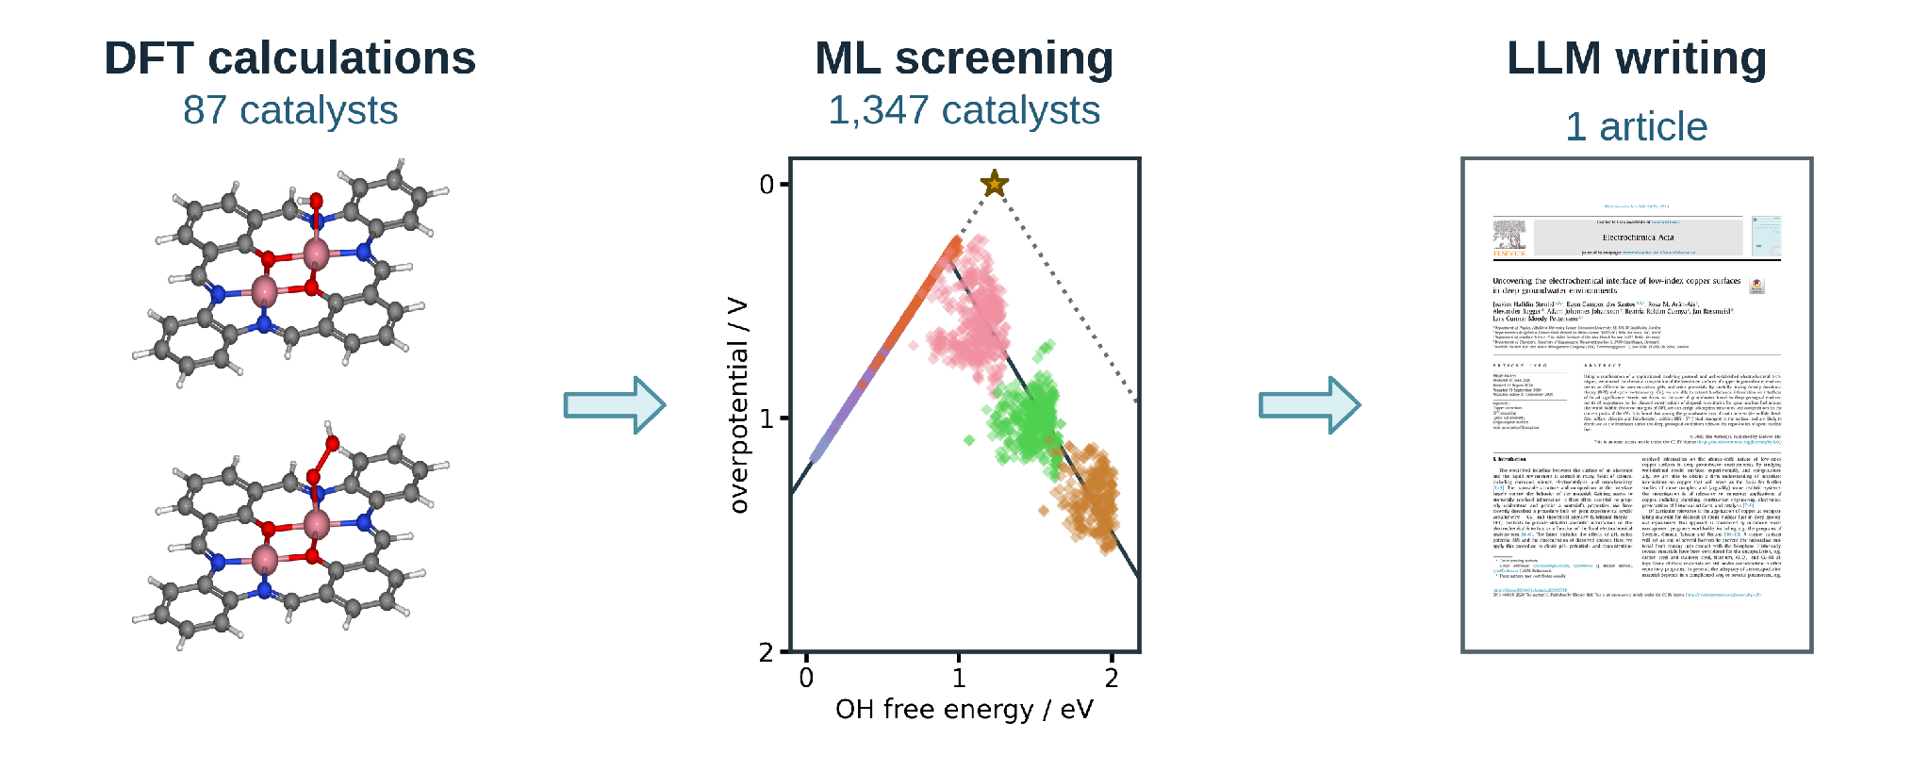

1. Introduction
Independent analyses place chemistry publication timelines at several months after submission. One journal sample reported an average interval of approximately nine months, while a study of chemistry articles published by PLOS reported a median submission to publication interval of 154 days [1,2]. These measurements begin at submission and exclude preparation of the first manuscript and revisions after rejection. Manuscript preparation therefore adds time before the publication interval even begins.
Editors have argued that a coherent scientific story and carefully selected figures help readers understand a paper [3,4,5,6]. Clear writing supports research, but writing skill alone does not establish scientific value. Our thesis is direct: the story must follow the data. We can delegate article writing to a guided LLM when DFT calculations, ML predictions, and reusable data support every claim.
Scientific writing can be taught to early career researchers because research articles follow conventions that can be learned. An article on scientific writing in Hydrology and Earth System Sciences [7], a university lesson [8], and a scientific writing course [9] illustrate that such conventions can be taught explicitly. We used this teachability as our starting point: we guided the LLM through the accepted structure of a research paper and required each sentence to follow our analysis. Coherent storytelling does help readers understand a result; however, the scientific methods and reusable data establish what that result means.
Catalyst databases can support analyses that their creators did not anticipate. Researchers can combine datasets, re-evaluate data points, and test new interpretations [10]. A database preserves molecular structures and calculated values; each article presents specific analyses of those data. Reusable databases let researchers test further questions against the same scientific results.
Vocabulary analyses of published abstracts have documented changes associated with LLM assisted writing [11]. Editorials also warn that story driven selection can hide conflicting observations [12]. Ifargan et al. showed that interacting LLM agents can prepare human verifiable papers from annotated data [13]. We build on this work by supplying the LLM with verified DFT calculations, ML predictions, three databases, literature, figures, and project instructions.
Figure 1 follows manuscript preparation from research data and ideas through planning, drafting, revision, publication, and sharing. We used the LLM to develop the Python scripts to check the article, while we guided the scientific thesis and verified its content.
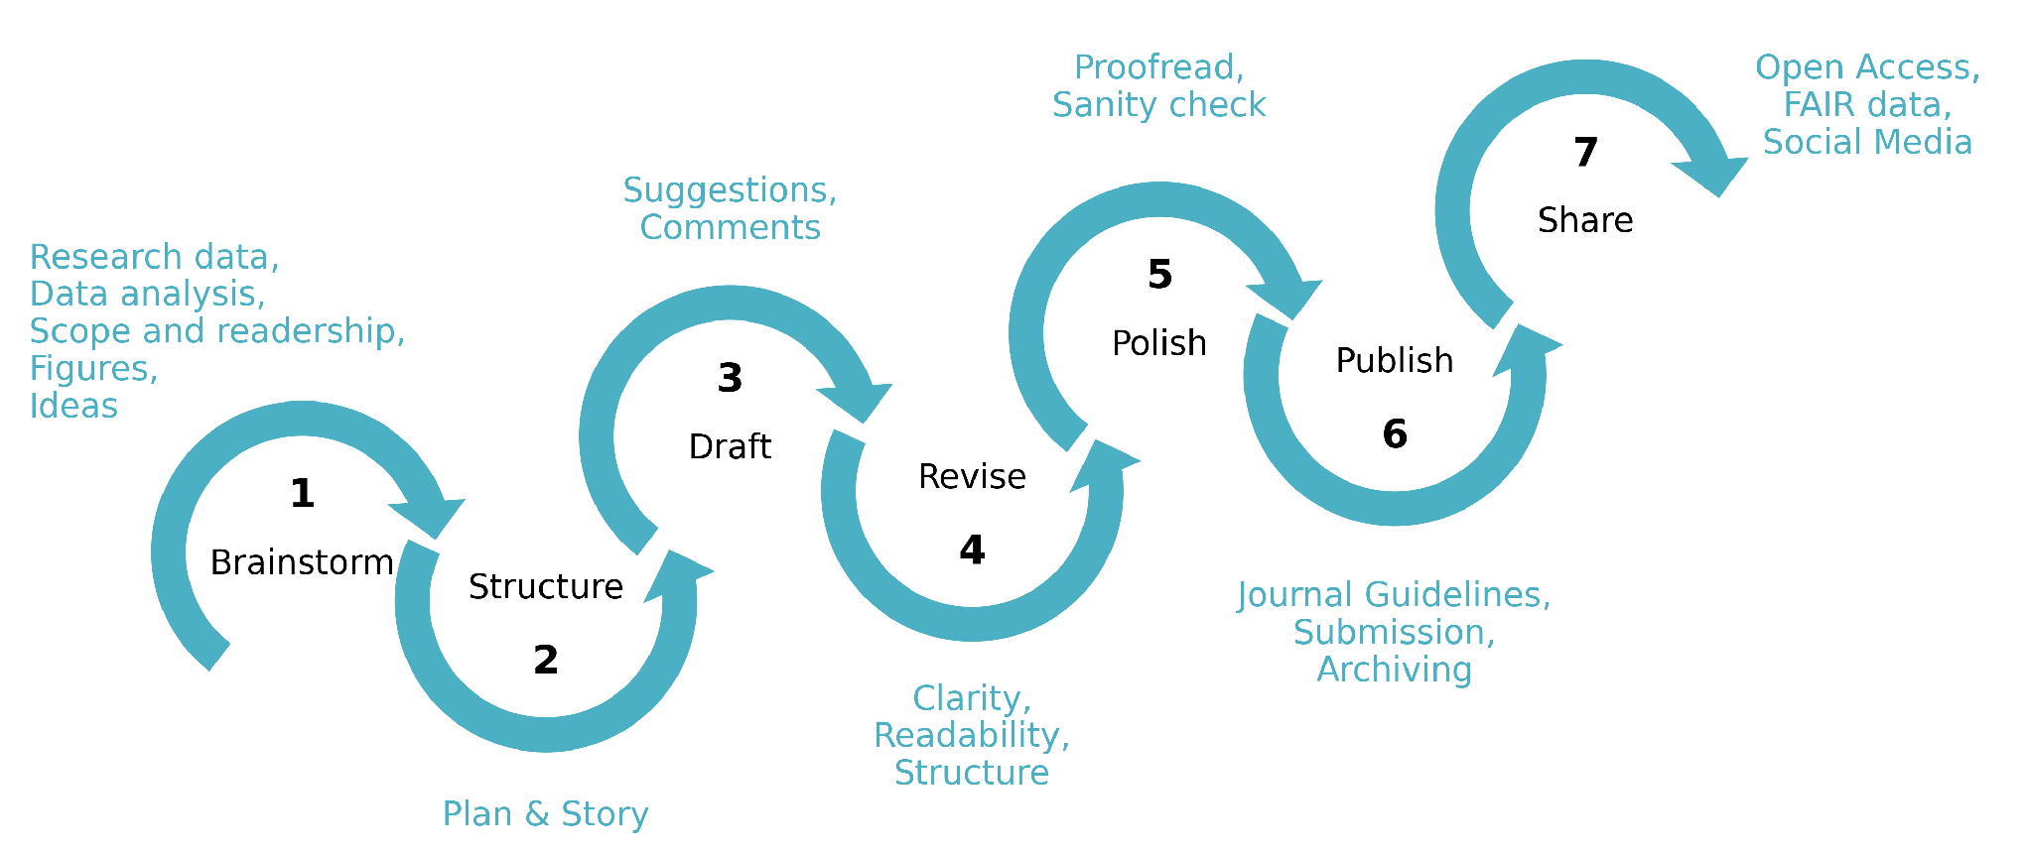
Figure 1. Seven stages of scientific writing, adapted from the authors’ lecture slide: brainstorm, structure, draft, revise, polish, publish, and share. The surrounding annotations identify the inputs and decisions at each stage. The LLM contributed to every stage under the general guidelines in the knowledge bases and the article-specific instructions and facts in one prompt.
DFT calculations and ML predictions advance catalyst discovery when we make their results available for examination and reuse. Manuscript preparation is therefore part of the research process, and it takes time that we could devote to new questions. Our study links three stages: DFT calculations establish adsorption energetics for 88 molecular catalysts; ML predictions extend the analysis to 1,260 additional optimized molecular structures; and a guided LLM prepares the complete article from the verified results. Together, these stages show two ways AI can accelerate catalyst discovery: ML predictions guide us away from less promising structures, and guided LLM writing communicates verified results.

2. Computational methods

2.1. Catalyst structures
The molecular catalysts were assembled from the components shown in Figure 2. Our previous data article defined B1 as the 1,2-phenylenediamine fragment and B2 as a 1,8-naphthalenediamine fragment [14]. A2 is 2-hydroxyisophthalaldehyde fragment. Each molecule contains one dual-atom site with two metal-atom adsorption centers. The two metal positions were occupied by Cr, Mn, Fe, Co, Ni, or Cu, and each of the two bridge positions contained N, O, or S. Every clean and adsorbate structure in the DFT analysis was fully optimized. Three linked molecular catalyst databases were used: the published structure database, the fixed DFT dataset of 88 catalysts, and 1,260 additional structures selected from the previous molecular dataset and reoptimized at the reported DFT level for ML predictions. Each optimized structure and its energy were stored in an Atomic Simulation Environment (ASE) database with the catalyst name, metal identities, ligand components, and charge metadata. The ads_site field identifies the metal-atom adsorption center occupied by each intermediate.

2.2. DFT calculations and adsorption structures
Spin polarized DFT calculations were performed with GPAW 24.6 and ASE 3.23.0 software [15,16]. The projector augmented wave method, revised Perdew–Burke–Ernzerhof functional, and D4 dispersion correction were used [17]. A plane wave cutoff of 550 eV, real space grid spacing of 0.15 Å, and 6.00 Å of vacuum were applied. Each atomic structure was optimized until the maximum force fell below 0.05 eV Å⁻¹, and only calculations that converged with these parameters entered the fixed DFT set. The setup follows earlier work on related molecular catalysts [18]. The total charge was set to +2 for every modeled catalyst, including N bridged structures. This consistent cohort represents one charge assignment and the spin states reached by the spin polarized optimizations. A broader electronic structure survey should compare alternative charges, mixed oxidation states, and spin states.
O, OH, and OOH were placed at either metal-atom adsorption center in the active site , and each structure was fully optimized. Gas phase H₂ and H₂O reference structures were calculated with the same settings. Total energies were matched by catalyst name and ads_site, so each reaction pathway contains values for the same molecular structure and adsorption center.
Adsorption energies for O, OH, and OOH were calculated from the total energies of the corresponding adsorbed structure, clean catalyst, H₂, and H₂O:
$ΔE_{OH} = E_{*OH} + (1/2) E_{H_{2}} - E_{*} - E_{H_{2}O}$ (1)
$ΔE_{O} = E_{*O} + E_{H_{2}} - E_{*} - E_{H_{2}O}$ (2)
$ΔE_{OOH} = E_{*OOH} + (3/2) E_{H_{2}} - E_{*} - 2E_{H_{2}O}$ (3)
In Eqs 1–3, the left side is the adsorption potential energy of the named intermediate. The terms on the right are the electronic total energies of the clean and adsorbed catalysts and the gas-phase references; * denotes the catalyst, either clean or with the named intermediate at the selected adsorption center.

2.3. Adsorption free energies and ORR thermodynamics
Adsorption potential energies were converted to adsorption free energies by adding combined zero point energy and entropy corrections and an empirical solvation contribution:
$ΔG_{X} = ΔE_{X} + ΔE_{ZPE,X} - TΔS_{X} + ΔG_{solv,X}$ (4)
In Eq 4, X denotes O, OH, or OOH; E and G denote potential energy and Gibbs free energy; T is temperature; S is entropy; ZPE identifies the zero point energy correction; solv identifies solvation. The adopted combined zero point energy and entropy corrections were 0.35 eV for OH, 0.05 eV for O, and 0.40 eV for OOH at 300 K, using the tabulated reference convention [19]. Solvation corrections of −0.30 eV were applied to OH and OOH; no solvation correction was applied to O [20]. The resulting net additions were 0.05, 0.05, and 0.10 eV for OH, O, and OOH, respectively. These rounded combined corrections were applied consistently to the DFT and ML adsorption energies. The adopted reaction corrections include gas-reference contributions. The four reduction potentials were evaluated with the computational hydrogen electrode (CHE) method [21]:
$U_{1} = (4.92 eV - ΔG_{OOH}) / e U_{2} = (ΔG_{OOH} - ΔG_{O}) / e U_{3} = (ΔG_{O} - ΔG_{OH}) / e U_{4} = ΔG_{OH} / e$ (5)
Equation 5 defines the positive reduction potentials for the four steps O₂ to OOH, OOH to O, O to OH, and OH to H₂O; identifies an adsorbed intermediate and e* is the elementary charge. The limiting potential is defined as the lowest of the four step potentials:
$U_{L} = min(U_{1}, U_{2}, U_{3}, U_{4})$ (6)
The symbol on the left of Eq 6 denotes the limiting potential. The ORR overpotential was evaluated relative to the equilibrium potential of 1.23 V:
$η_{ORR} = 1.23 V - U_{L}$ (7)
Equation 7 defines the ORR overpotential. Chemical subscripts in Eqs 5–7 identify the adsorbed intermediate or reaction quantity.

2.4. Scaling and thermodynamic activity analyses
The relations of O and OOH adsorption free energies to OH adsorption free energy were evaluated by ordinary least squares:
$ΔG_{O} = α_{O} ΔG_{OH} + β_{O} ΔG_{OOH} = α_{OOH} ΔG_{OH} + β_{OOH}$ (8)
In Eq 8, α and β are the slope and intercept for the intermediate identified by the subscript. The fitted relations were propagated through the four ORR steps to obtain the scaling based activity curve in Figures 3 and 4. An ideal reference relation was defined with an OOH–OH free energy separation of 2.46 eV:
$Δ{G_{OOH}}^{ideal} = ΔG_{OH} + 2.46 eV η_{ideal} = 1.23 V - min(ΔG_{OH} / e, (2.46 eV - ΔG_{OH}) / e)$ (9)
In Eq 9, OH removal defines the left branch and OOH formation defines the right branch. The branches meet at an OH adsorption free energy of 1.23 eV and zero overpotential. Catalyst activity was interpreted thermodynamically; kinetic activity also depends on activation barriers.

2.5. Regression analysis and catalyst family screening
Of the 88 DFT catalyst structures, 50 structures were selected for model training and 10 for validation. Separate ridge regression models were fitted for OH, O, and OOH. Descriptors of the clean catalysts represented the electron population, charge, spin, metal pair polarization, and ligand environment. Eight predictors were used for OH and O, and six were used for OOH. The ridge parameter was 0.10 for OH and 1.00 for O and OOH. The models were applied to the separate database of 1260 optimized structures described in Section 2.1.
The predicted OH, O, and OOH values were joined by catalyst name and ads_site and converted from adsorption potential energies to free energies with the same corrections in Section 2.3 before the CHE step potentials and overpotentials were evaluated. Complete catalyst and adsorption center combinations were selected before the stated energy filters were applied to the predictions. For comparison of structural families, the most active pool in each DFT or ML dataset was defined as the lowest 10% of retained overpotentials, rounded upward to a whole catalyst and adsorption center combination.

2.6. LLM manuscript generation
An LLM accessed through OpenAI Codex was used to prepare the complete manuscript from the calculations, model predictions, figures, literature, and project instructions. Data to paper generation with interacting LLM agents and source linked outputs has been reported by Ifargan et al. [13]. The present procedure was developed and tested by us before it was consolidated into one prompt that generates a complete electrochemistry article.
The manuscript instructions were developed through repeated guidance from us over approximately two weeks. Scientific terminology, source authority, database matching, analysis code, figure construction, journal requirements, article structure, and writing style were tested and corrected. Ten defined functions covered project curation, scientific auditing, programming, figure preparation, supervision, drafting, literature synthesis, document construction, style editing, and release auditing.
The writing instructions were informed by the conventions taught in H. Glasman-Deal's Science Research Writing for Non-Native Speakers of English (2010)[22] and Barbara Minto's The Minto Pyramid Principle (2010)[23]. Paragraph purpose, the order of claims and evidence, and direct language were specified for the LLM. These instructions were tested through successive drafting and then incorporated into the consolidated prompt.
The LLM generated the complete article with a single prompt from verified scientific inputs and tested instructions. We then checked how the DFT calculations, ML predictions, figures, citations, terminology, and scientific interpretation were conveyed before submitting the article.

3. Results and discussion

3.1. Molecular structures and adsorption centers
Figure 2 shows the common molecular structure and the four component classes used to build the catalyst dataset. Each molecule contains one dual-atom site with two metal-atom adsorption centers. The metal identities, bridge atoms, and diamine vary in the 88 catalyst DFT set, while A2 remains the fixed dialdehyde. The database retains the occupied adsorption center when an intermediate binds at either metal atom.
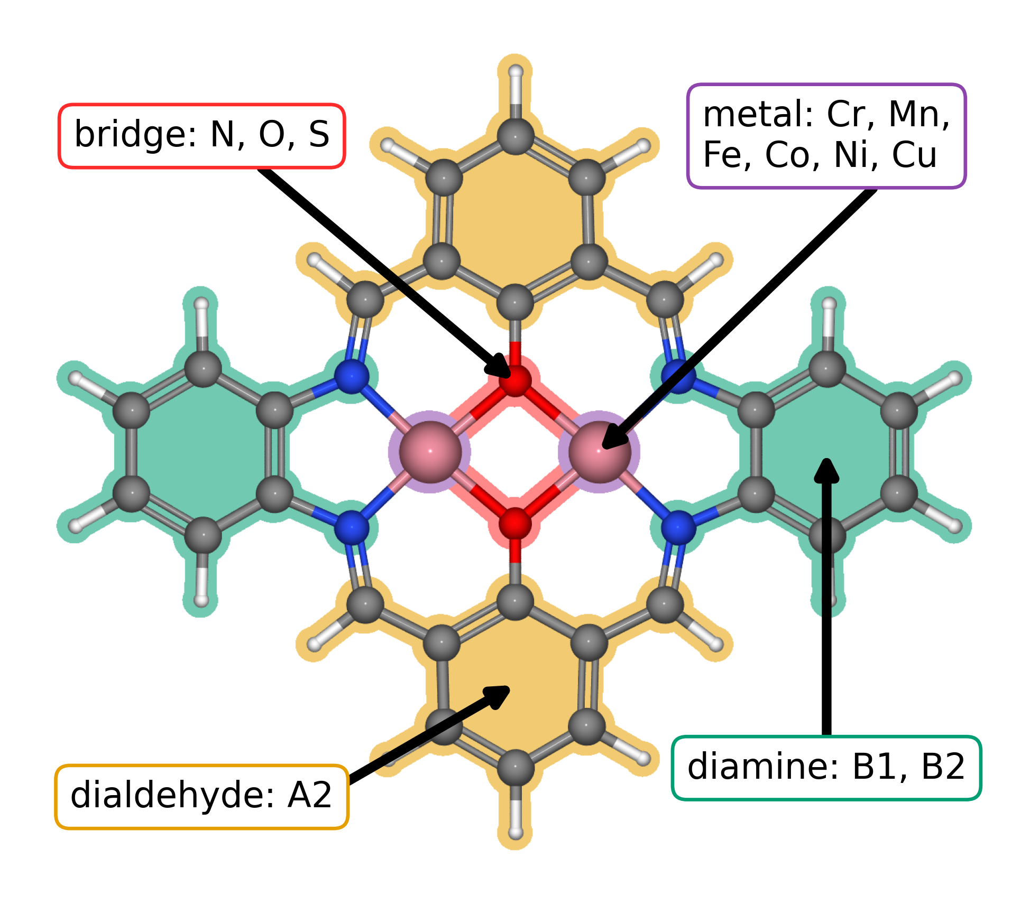
Figure 2. Modular molecular structure of the studied DASCs. Colored regions and arrows identify the metal positions (purple), bridge atoms (red), diamine derived region (green), and dialdehyde derived region (orange). Related complexes are synthesized from diamines, dialdehydes, and metal salts [18]. The metal positions can contain Cr, Mn, Fe, Co, Ni, or Cu; the bridge atoms can be N, O, or S. B1 and B2 denote the 1,2-phenylenediamine and 1,8-naphthalenediamine fragments, respectively; A2 is 2-hydroxyisophthalaldehyde. These labels and additional component combinations are defined in the data article [14].
The 88 catalyst structures were matched by catalyst and adsorption center. We applied the stated electronic adsorption energy filters before fitting the scaling relations and evaluating the ORR overpotentials in Figure 3.

3.2. Adsorption scaling and calculated ORR thermodynamics
Figure 3a relates the DFT calculated O and OOH adsorption free energies to OH adsorption free energy for the retained catalyst and adsorption center combinations. The OOH–OH fit has a slope of 0.69 and an intercept of 3.05 eV, while the O–OH fit has a slope of 1.66 and an intercept of 1.17 eV. The slopes are below the commonly used values of 1 and 2; material-dependent slopes and intercepts also occur in metal–nitrogen–carbon catalysts [24]. The steeper O–OH relation gives O binding the larger response to changes in OH binding. Figure 3 carries both fits through the four CHE steps to show the overpotential volcano.
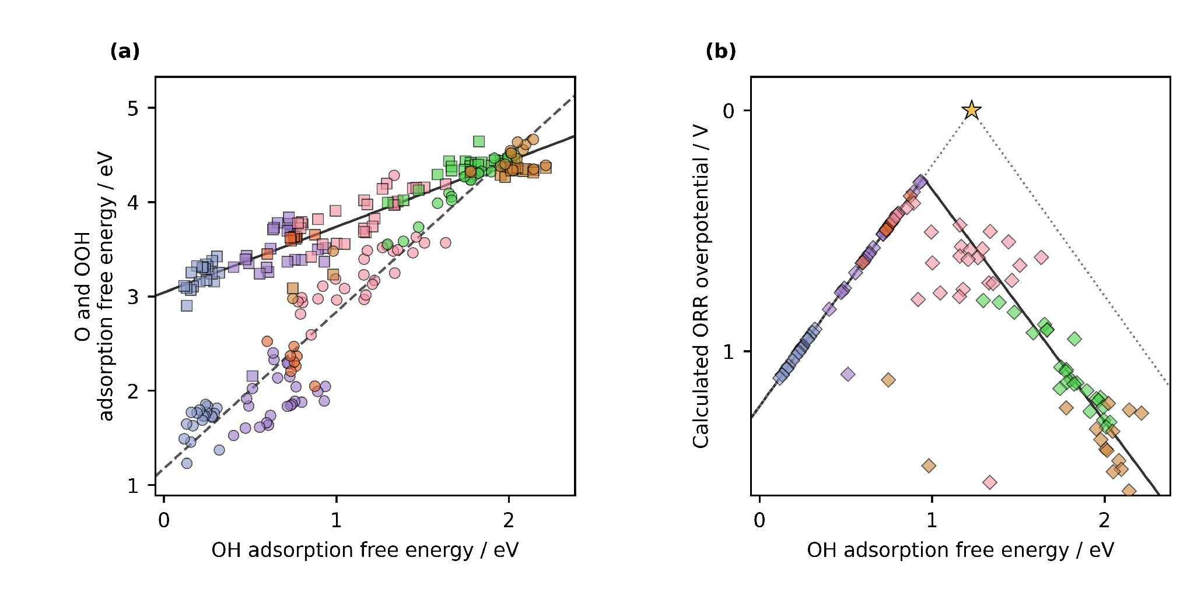
Figure 3. DFT adsorption scaling relations and conventional CHE overpotential volcano for the studied DASCs. (a) Calculated O and OOH adsorption free energies versus OH adsorption free energy for the retained pathways. Circles denote O and squares denote OOH. Jmol colors identify the adsorption center metal: Cr, blue gray; Mn, violet; Fe, orange; Co, pink; Ni, green; and Cu, brown. The solid and dashed black lines are the OOH–OH and O–OH linear fits. (b) Calculated ORR overpotentials for the same combinations, shown as diamonds with the same metal colors. The solid black curve propagates the two fitted scaling relations through the four reaction steps. The gray dotted line is the ideal scaling relation, and the star marks zero overpotential at an OH adsorption free energy of 1.23 eV. Structural components are explained in Figure 2.
The three lowest calculated CHE overpotentials belong to a Cr–Mn DASC with S bridge atoms and 1,2-phenylenediamine at the Mn adsorption center (0.29 V), a Mn–Mn DASC with S bridge atoms and 1,2-phenylenediamine at the Mn adsorption center (0.34 V), and an Fe–Cu DASC with S bridge atoms and 1,8-naphthalenediamine at the Fe adsorption center (0.36 V). All three contain S bridge atoms, while their metal pairs and diamines differ. The lowest DFT overpotential decile contains 12 catalyst and adsorption center combinations. Five have Co adsorption centers, four have Mn, and three have Fe; none have Cr, Ni, or Cu adsorption centers. Seven contain S–S bridges, four contain N–N bridges, and one contains an O–O bridge. The 1,2-phenylenediamine and 1,8-naphthalenediamine each occur six times. The DFT pool therefore selects a restricted set of adsorption center metals and moderately favors S bridge atoms, while it shows no preference between the diamines.

3.3. Regression predictions across catalyst families
The ML predictions guide catalyst selection across the larger molecular dataset. Fe adsorption centers predominate among the lowest predicted overpotentials, while S bridges and the 1,2-phenylenediamine fragment identify families for further calculations and synthesis. These trends are model predictions under the charge and spin treatment described in Section 2.2.
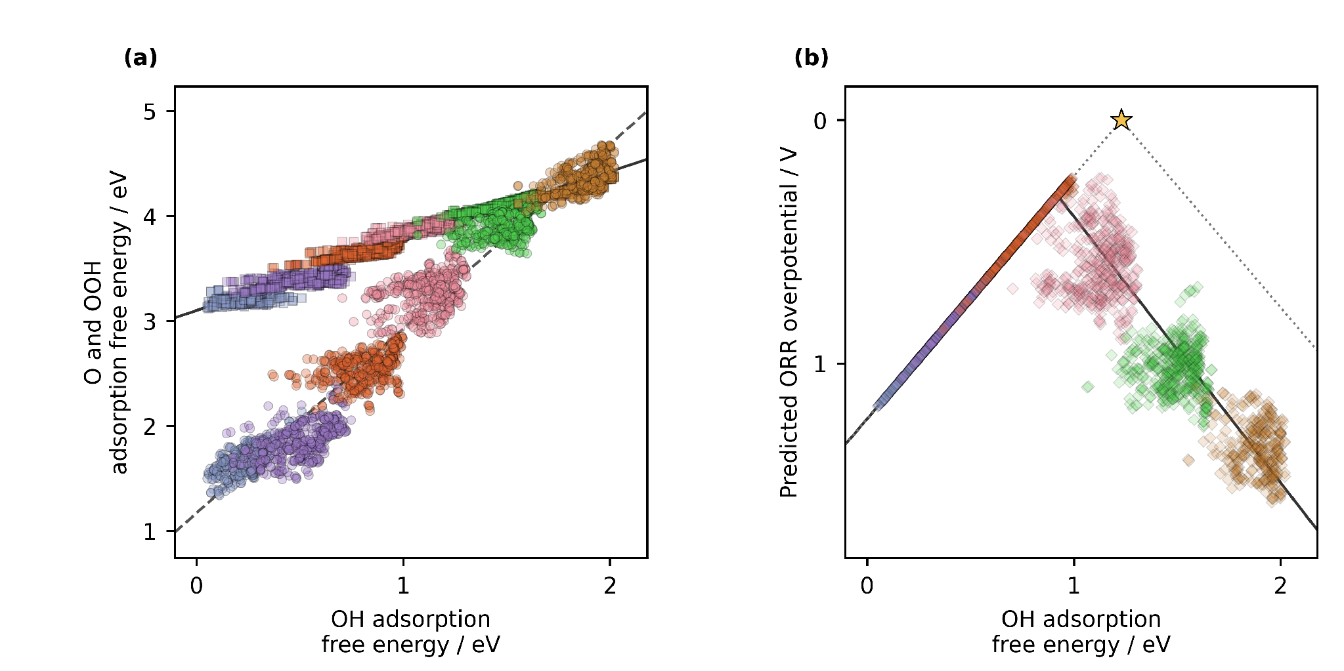
Figure 4. ML predicted adsorption scaling relations and conventional CHE overpotential volcano for the molecular catalyst dataset. (a) Predicted O and OOH adsorption free energies versus predicted OH adsorption free energy. Circles denote O and squares denote OOH. Jmol colors identify the adsorption center metal: Cr, blue gray; Mn, violet; Fe, orange; Co, pink; Ni, green; and Cu, brown. The solid and dashed black lines are the predicted OOH–OH and O–OH linear fits. (b) Predicted ORR overpotentials, shown as diamonds with the same metal colors. The solid black curve propagates the predicted scaling relations through the four reaction steps. The gray dotted line is the ideal scaling relation, and the star marks zero overpotential at an OH adsorption free energy of 1.23 eV. Structural components are explained in Figure 2. Predicted adsorption potential energies were converted to free energies with the corrections in Section 2.3.

3.4. Molecular catalyst design in context
Our previous research on the studied molecular catalyst family found that phenylene and naphthalene diamines used in synthesis alter the distance between Co centers, oxygen intermediate binding geometry, and ORR selectivity [18]. Sun et al. interpret bidentate OOH binding in a molecular Co₂ catalyst, a geometry we did not obtain in our DFT calculations [25]. Li et al. examine bridge and coordination effects in single-metal Fe–N₄ macrocycles [26]. Herewith, our earlier Co–Co study explored a related O-bridged molecular catalyst at a total charge of +4, outside the +2 charge set screened here. Its DFT analysis suggested a lower ORR overpotential than those found in the present set, although that study did not apply the same empirical free-energy corrections used here . The values therefore illustrate the scope for further exploration rather than a directly comparable ranking. That study and Sun's Co–Co complex show that specific OOH binding geometries can give an OOH–OH free-energy separation below 3 eV; such local behavior does not describe the global fit of the present dataset .
Zhang et al. provide the closest precedent through catalysis-unit engineering [27]. They evaluated 60 homonuclear salphen units for the oxygen evolution reaction (OER), used DFT and ML to rank their properties, and incorporated selected Ni and Co units into covalent organic materials. Our ORR study covers 88 molecular catalysts in the DFT stage, includes homo- and heteronuclear metal pairs, resolves adsorption at either metal center, and extends prediction to 1,260 additional optimized structures. The reactions and regression models differ, yet both studies show how DFT results can train ML models to identify structural trends across catalyst families.
Zhang et al. OOH–OH scaling relation has a slope of 0.96 and an intercept of 2.98 eV . The corresponding fit across our filtered ORR pathways has a slope of 0.69 and an intercept of 3.05 eV. Zhang et al. included additional metals resulting in a wider OH adsorption energy range, which gives the regression more leverage at strong adsorption, while differences in reaction, catalyst selection, and free-energy treatment also affect a direct comparison. Both studies show that a fitted slope must be read together with the chemical domain from which it was obtained.
That division is also visible in recent screening of extended phthalocyanine dual-atom catalysts, where 81 DFT structures supported predictions for 360 additional metal pairs and identified Fe as an adsorption anchor whose neighboring metal regulates activity [28]. In our data, DFT establishes the favorable S bridged examples, and ML carries the metal and ligand comparison across an order of magnitude more molecular structures. The regression screen therefore substitutes fast predictions for many preliminary adsorption calculations; targeted DFT and experiment can then concentrate on the families selected from that screen. This is the specific way in which ML accelerates catalyst discovery in the present study.
ML-assisted catalyst screening is already well established. Jia et al. review data-driven oxygen evolution studies [29]; Chen et al. combine DFT, ML, and experimental validation for ORR catalyst screening [30]; and Benarbia et al. use unsupervised ML to classify molecular complexes for hydrogen evolution [31]. These examples place our regression screen in an established field. Our additional contribution is to carry verified DFT and ML results through to a complete article prepared by a guided LLM.

3.5. Closing the scientific communication gap
The catalyst study gives the LLM verified DFT calculations and ML predictions to communicate. The DFT calculations describe adsorption energetics for the 88 catalyst dataset, and ML predictions extend the analysis to 1,260 additional optimized structures. The databases preserve molecular structures, adsorption center identities, and calculated or predicted values. The article presents these results with the methods, figures, and literature needed to interpret them.
Over approximately two weeks, we taught the LLM the project terminology, evidence hierarchy, scientific methods, journal rules, figure standards, and storytelling. We checked successive drafts against the ASE databases, analysis outputs, literature, and our scientific interpretation. Those corrections became reusable instructions and the consolidated prompt, available in the supporting information, that generated the complete article.
We chose the research questions, produced and verified the DFT results, directed the ML analysis, interpreted the structural trends, and decided what the evidence supports, while we let the LLM compose the article from those verified inputs. By doing so, we showed that we can concentrate on scientific discovery while delegating communication to an LLM. Overall, the article in front of the reader is the principal demonstration of this work.

3.6. Data and alternative interpretations
The same DFT calculations, matched by catalyst and adsorption center, support several thermodynamic analyses of ORR. The conventional CHE overpotential is set by the least favorable individual reduction step. Calle-Vallejo's electrochemical step symmetry index evaluates how evenly the four step potentials divide the 1.23 V reaction free energy, while Exner's free energy span identifies the largest cumulative uphill change across consecutive reaction states at a selected potential [32,33]. Each descriptor asks a different question of the same adsorption free energies. Because catalyst and adsorption center identities remain attached to every value, the released dataset allows independent scientists to apply these analyses directly.
The DFT dataset preserves calculated adsorption energies with the matching catalyst and adsorption center identities. Its database structure allows us and independent scientists to apply other ORR descriptors and compare the results with the analyses reported here.

4. Conclusions
We demonstrate accelerating catalyst discovery with artificial intelligence by using a guided LLM to generate the article from verified DFT calculations, ML predictions, databases, literature, and figures. We directed the investigation and checked the article against its scientific inputs. This completed study shows that a developed LLM can prepare the scientific writing while we direct the scientific work, analysis, and conclusions.
DFT calculations for 88 molecular catalysts established ORR adsorption energetics. ML predictions extended the analysis to 1260 molecular catalysts and associated the lowest predicted overpotentials with Fe adsorption centers, S bridge atoms, and 1,2-phenylenediamine. These predictions guide selection of structures for further study. Together, the DFT calculations, ML predictions, and LLM assisted scientific writing demonstrate how artificial intelligence can accelerate catalyst discovery.
The same writing conventions we teach scientists can guide an LLM. In this study, that guidance let us delegate article composition while we concentrated on the calculations, predictions, and scientific decisions. Reliable data can then reach other scientists faster through clear writing without making the authors' skill at storytelling the measure of scientific worth.

CRediT authorship contribution statement
Denis Savchenko: methodology, software, formal analysis, visualization, and development of the regression model. Bruno Inácio da Silva Roux Leite: investigation, data curation, formal analysis, and generation of DFT results. Timmo-Henrik Pukk: investigation, data curation, formal analysis, and generation of DFT results. Ba Long Nguyen: investigation, software, data curation, formal analysis, visualization, and generation of DFT results. Vladislav Ivanistsev: conceptualization, supervision, and funding acquisition. Nadezda Kongi: conceptualization, supervision, and funding acquisition.

Declaration of competing interest
The authors declare no competing interests.

Data availability
The published parent structure dataset is available from Zenodo [34]. The present DFT and extended structure dataset comprises 1,348 bare structures, including 88 DFT catalysts and 1,260 additional prediction structures, together with converged O, OH, and OOH adsorption structures for selected catalysts across five ASE databases; it is available at [35]. Current local snapshots of the Figure 4 analysis and prediction CSVs are in source_data/figure4/.

Declaration of generative AI and AI assisted technologies in the manuscript preparation process
During the preparation of this work, we used OpenAI Codex with an LLM to organize and write the complete scientific article and to assist with reproducible analysis and figure code from the project data, literature, and instructions. We reviewed the text against the calculations, model predictions, methods, figures, and sources and take full responsibility for the article's content.

Acknowledgments
This work was supported by the National Research Program BioPhoT through the project Nr. OSI_PIP_BioPhoT-2025/2-0069. This work was supported by the Estonian Ministry of Education and Research (TK210) and the Estonian Research Council (PRG3174, TEM-TA306 ). This publication is based on work from COST Action EU-CONCERT (CA24103), supported by COST (European Cooperation in Science and Technology). We acknowledge the University of Latvia Artificial Intelligence and Computing Center and the High Performance Computing Center of the University of Tartu for providing computational resources.

References
[1] B.-C. Björk, D. Solomon, The publishing delay in scholarly peer-reviewed journals, Journal of Informetrics 7 (2013) 914–923. 10.1016/j.joi.2013.09.001
[2] J. Ding, D. Du, A study of the correlation between publication delays and measurement indicators of journal articles in the social network environment: based on online data in PLOS, Scientometrics 128 (2023) 1711–1743. 10.1007/s11192-023-04640-6
[3] Elements of style, Nature Physics 3 (2007) 581. 10.1038/nphys724
[4] L. X. Chen, P. Christopher, F. De Angelis, S. Jin, Y.-S. Hu, N.-G. Park, D. Das Sarma, Y.-K. Sun, P. V. Kamat, We Editors Are Authors, Too, ACS Energy Letters 4 (2019) 249–250. 10.1021/acsenergylett.8b02322
[5] C. M. Biegel, P. V. Kamat, Five common pitfalls to avoid while composing scientific figures, ACS Energy Letters 6 (2021) 4309–4310. 10.1021/acsenergylett.1c02401
[6] Storytelling in research, Nature Biomedical Engineering 2 (2018) 53. 10.1038/s41551-018-0202-5
[7] Scientific writing article, Hydrology and Earth System Sciences 20 (2016), starting at p. 2965. 10.5194/hess-20-2965-2016
[8] University of Sargodha, Week 09 scientific writing lesson. course page
[9] Coursera, Scientific Writing course. course page
[10] M. D. Wilkinson et al., The FAIR guiding principles for scientific data management and stewardship, Scientific Data 3 (2016) 160018. 10.1038/sdata.2016.18
[11] D. Kobak, R. González-Márquez, E.-Á. Horvát, J. Lause, Delving into LLM-assisted writing in biomedical publications through excess vocabulary, Science Advances 11 (2025) eadt3813. 10.1126/sciadv.adt3813
[12] Should scientists tell stories?, Nature Methods 10 (2013) 1037. 10.1038/nmeth.2726
[13] T. Ifargan, L. Hafner, M. Kern, O. Alcalay, R. Kishony, Autonomous LLM-Driven Research: from Data to Human-Verifiable Research Papers, NEJM AI 2 (2025). 10.1056/aioa2400555
[14] B. L. Nguyen, T. K. Madsen, V. Ivanistsev, N. Kongi, Dataset of molecular dual-atom site complexes for catalysis, Data in Brief 66 (2026) 112806. 10.1016/j.dib.2026.112806
[15] J. J. Mortensen et al., GPAW: An open Python package for electronic structure calculations, Journal of Chemical Physics 160 (2024) 092503. 10.1063/5.0182685
[16] A. H. Larsen et al., The Atomic Simulation Environment—A Python Library for Working with Atoms, Journal of Physics: Condensed Matter 29 (2017) 273002. 10.1088/1361-648X/aa680e
[17] E. Caldeweyher, S. Ehlert, A. Hansen, H. Neugebauer, S. Spicher, C. Bannwarth, S. Grimme, A generally applicable atomic-charge dependent London dispersion correction, Journal of Chemical Physics 150 (2019) 154122. 10.1063/1.5090222
[18] N. Žoglo et al., Intersite Geometry Controls Activity and Selectivity in the Oxygen Reduction Reaction on Dual-Atom-Site Catalysts, ChemRxiv preprint (2026). 10.26434/chemrxiv.15001712/v1
[19] J. Rossmeisl, A. Logadottir, J. K. Nørskov, Electrolysis of water on (oxidized) metal surfaces, Chemical Physics 319 (2005) 178–184. 10.1016/j.chemphys.2005.05.038
[20] F. Calle-Vallejo, J. I. Martínez, J. Rossmeisl, Density functional studies of functionalized graphitic materials with late transition metals for oxygen reduction reactions, Physical Chemistry Chemical Physics 13 (2011) 15639. 10.1039/c1cp21228a
[21] J. K. Nørskov, J. Rossmeisl, A. Logadottir, L. Lindqvist, J. R. Kitchin, T. Bligaard, H. Jónsson, Origin of the Overpotential for Oxygen Reduction at a Fuel-Cell Cathode, Journal of Physical Chemistry B 108 (2004) 17886–17892. 10.1021/jp047349j
[22] H. Glasman-Deal, Science Research Writing for Non-Native Speakers of English, Imperial College Press, London and Hackensack, NJ, 2010.
[23] B. Minto, The Minto Pyramid Principle: Logic in Writing and Thinking, Prentice Hall, 2010.
[24] V. Ivanistsev, R. Cepitis, J. Rossmeisl, N. Kongi, Twenty years after: scaling relations in oxygen electrocatalysis and beyond, Chemical Society Reviews 54 (2025) 10956–10976. 10.1039/D5CS00597C
[25] Q. Sun et al., Well-Defined Co₂ Dual-Atom Catalyst Breaks Scaling Relations of Oxygen Reduction Reaction, Journal of the American Chemical Society 146 (2024) 35295–35304. 10.1021/jacs.4c12705
[26] Q. Li, Q. Zhao, A. Pedersen, Z. Lin, M. Zhang, D. Di Tommaso, Y. Xu, M.-M. Titirici, C. R. Jones, Investigating the Effect of the Coordination Environment and Bridging Atoms in Fe–N₄ Macrocycles Applied to Alkaline Oxygen Reduction Reaction, ACS Catalysis 16 (2026) 9913–9929. 10.1021/acscatal.6c00046
[27] Z. Zhang et al., Design and Synthesis of Electrocatalysts Based on Catalysis-Unit Engineering, Advanced Materials 36 (2024) 2403549. 10.1002/adma.202403549
[28] S. Jia et al., Machine Learning Reveals Role-Asymmetric Electronic Cooperation in Fe-Based Dual-Atom Catalysts, Advanced Materials 36 (2026) e74833. 10.1002/adma.74833
[29] L. Jia, Z. Jin, Y. Tan, Z. Zhang, Y. Pu, Y. Wang, L. Huang, From Data to Discovery: Crafting Data-Driven Frameworks for Advancing OER Electrocatalysts, Advanced Functional Materials 36 (2026) e77325. 10.1002/adfm.77325
[30] X. Chen et al., Leveraging DFT and Machine Learning for Accelerated Screening of Cluster-Modified Single-Atom Catalysts in Oxygen Reduction Reactions, ACS Catalysis 16 (2026) 14399–14410. 10.1021/acscatal.6c02383
[31] A. Benarbia, A. Alshami, A. Mustafa, O. S. Tomomewo, Can machine learning uncover viable non-platinum catalysts for hydrogen evolution? An unsupervised clustering approach to transition metal–ligand complexes, RSC Advances 16 (2026) 42403. 10.1039/d6ra03405e
[32] N. Govindarajan, J. M. García-Lastra, E. J. Meijer, F. Calle-Vallejo, Does the breaking of adsorption energy scaling relations guarantee enhanced electrocatalysis?, Current Opinion in Electrochemistry 8 (2018) 110–117. 10.1016/j.coelec.2018.03.025
[33] S. Razzaq, K. S. Exner, Materials screening by the descriptor Gmax(η): The free energy span model in electrocatalysis, ACS Catalysis 13 (2023) 1740–1758. 10.1021/acscatal.2c03997
[34] [dataset] B. L. Nguyen, T. K. Madsen, V. Ivanistsev, N. Kongi, Dataset of molecular dual-atom site complexes for catalysis, Zenodo, version 1.0, 2026. 10.5281/zenodo.18601379
[35] [dataset] Zenodo record 23408498 (2026). 10.5281/zenodo.23408498

