Accelerating Catalyst Discovery and Design with Artificial Intelligence: Molecular Dual-Atom Site Catalysts as a Case Study
Bruno Inácio da Silva Roux Leite,¹ Denis Savchenko,¹ Timmo-Henrik Pukk,¹ Ba Long Nguyen,¹ Vladislav Ivanistsev,^{2†} Nadezda Kongi,^{1†}
1 Institute of Chemistry, University of Tartu, Ravila 14a, 50411 Tartu, Estonia
2 Department of Chemistry, University of Latvia, Jelgavas iela 1, Riga, LV-1004, Latvia
Corresponding authors: nadezda.kongi@ut.ee; vladislav.ivanistsev@lu.lv

Abstract
Artificial intelligence can accelerate catalyst research through both prediction and scientific writing. We examine these roles using oxygen reduction on molecular dual-atom site catalysts. We analyze adsorption free energy scaling and reaction thermodynamics from density functional theory, then apply a simpler ridge regression analysis to predict the same quantities across the molecular library. Both analyses show systematic changes with the metal at the adsorption site and identify candidates near the thermodynamic activity maximum. The regression extends the comparison to sites with available clean catalyst descriptors. Artificial intelligence generated the complete manuscript text from the research record under the guidance of the researchers. This case illustrates how reusable data can support rapid analysis and article preparation while human judgment remains essential for selecting methods, interpreting results, and verifying claims.
Keywords: artificial intelligence; computational hydrogen electrode; density functional theory; machine learning; oxygen reduction reaction; molecular dual-atom site catalysts

1. Introduction
Catalyst discovery combines calculations that resolve candidate structures with decisions about which candidates to examine next. Density functional theory provides adsorption energies for defined structures, while regression models summarize patterns across a related catalyst set [1,2] [3]. Artificial intelligence can also generate a research article from such records. This raises a practical question: can rapid article generation remain reliable when structural identity, methods, data, and citations are explicit and verifiable?
We use the oxygen reduction reaction (ORR) to examine this problem. The four electron pathway depends on the relative stabilization of oxygen intermediates, whose correlated adsorption free energies constrain thermodynamic activity estimates [4]. Molecular dual-atom site catalysts provide a chemically defined set in which metal identity, bridge, diamine, and adsorption site can be varied. Studies of related molecular catalysts show that binding geometry and the second metal can alter oxygen intermediate energetics [5,6]. A valid comparison therefore keeps each adsorbate value tied to the same catalyst and adsorption site.
Scientific editors have argued that a coherent theme and carefully selected figures help readers follow the question, evidence, and interpretation [7,8] [9,10]. Yet a polished story can hide conflicting evidence or uncertainty when authors select observations to fit a narrative [11]. The relevant test is whether AI can produce a coherent account while keeping claims traceable to data, methods, and sources.
Here, we examine that question using site matched adsorption records for a molecular catalyst library. Figure 1 defines the catalyst structure, Figure 2 presents adsorption scaling and oxygen reduction thermodynamics from DFT, and Figure 3 presents the corresponding quantities from a simpler ridge regression analysis. We discuss the Calle-Vallejo and Exner descriptors as examples of how reusable data support alternative interpretations. The entire manuscript text was generated by AI from materials supplied by the researchers. Human researchers guided the analysis and checked the evidence and its interpretation.

2. Computational methods

2.1. Catalyst structures
The molecular catalyst library was assembled from two metal centers, a fixed A2 dialdehyde, a B1 or B2 diamine, and two N, O, or S bridge atoms. The current clean catalyst database contains 88 structures with Cr, Mn, Fe, Co, Ni, or Cu at the two metal positions. The parent structures were generated by modular assembly and spin polarized GFN2-xTB optimization; selected DFT optimized structures were reused as templates, with one metal substituted at a time. An xTB optimized geometry was used when a suitable DFT template was unavailable [12].
We retained the catalyst identity, metal positions, ligand components, and charge metadata in the Atomic Simulation Environment (ASE) database.

2.2. Density functional theory calculations
We performed spin polarized DFT calculations with the GPAW and ASE framework [13,14]. The calculations used the projector augmented wave method, the revised Perdew–Burke–Ernzerhof functional, and the D4 dispersion correction [15]. A plane wave basis with a 550 eV kinetic energy cutoff and a real space grid spacing of 0.16 Å were used. Molecules were placed in isolated cells with 6.00 Å vacuum and Γ point sampling. We relaxed the atomic positions and converged the electronic density self consistently. Gas phase H₂ and H₂O reference molecules were calculated with the same settings. This setup follows the GPAW methodology used for related molecular catalysts [6].

2.3. Adsorption structures and database matching
We optimized O, OH, and OOH on each available metal atom. Two initial OOH geometries, OOH-x and OOH-z, were tested. We joined records by the exact pair (catalyst name, adsorption site label), selected the lower total energy OOH orientation separately for each pair, and retained its orientation label. A pathway was accepted only when its reconstructed values agreed with the corresponding raw database records within 10⁻⁸ eV. The observation unit throughout the analysis was one catalyst and one adsorption site combination.
We defined adsorption energies from the total energies of the clean catalyst, adsorbed structures, and gas phase references using Eqs. (1)–(3). An asterisk denotes the clean adsorption site or a bound intermediate, as appropriate. The analysis used the supplied corrected adsorption free energies directly for scaling, filtering, and thermodynamic activity estimates.
$$ΔE_{OH} = E_{*OH} + (1/2) E_{H_{2}} − E_{*} − E_{H_{2}O}$$ (1)
$$ΔE_{O} = E_{*O} + E_{H_{2}} − E_{*} − E_{H_{2}O}$$ (2)
$$ΔE_{OOH} = E_{*OOH} + (3/2) E_{H_{2}} − E_{*} − 2E_{H_{2}O}$$ (3)

2.4. Adsorption free energies and ORR thermodynamics
Adsorption free energies include zero point energy and entropy contributions as expressed in Eq. (4), where X denotes O, OH, or OOH, E denotes electronic energy, G Gibbs free energy, T temperature, and S entropy. The subscript ZP denotes the zero point contribution. For this analysis, we treated the supplied values as already corrected. The computational hydrogen electrode (CHE) represents the chemical potential of a proton and electron pair by one half of that of H₂ at zero potential [4].
For the associative four electron ORR pathway, Eq. (5) defines the step reduction potentials from the adsorption free energies and the elementary charge. Their minimum gives the limiting potential in Eq. (6). The overpotential in Eq. (7) is referenced to the equilibrium potential of 1.23 V. Chemical subscripts identify the adsorbed intermediate.
$$ΔG_{X} = ΔE_{X} + ΔE_{ZP,X} − TΔS_{X}$$ (4)
$$\begin{aligned}U_{1} = (4.92 eV − ΔG_{OOH}) / e \\ U_{2} = (ΔG_{OOH} − ΔG_{O}) / e \\ U_{3} = (ΔG_{O} − ΔG_{OH}) / e \\ U_{4} = ΔG_{OH} / e\end{aligned}$$ (5)
$$U_{L} = min(U_{1}, U_{2}, U_{3}, U_{4})$$ (6)
$$η_{ORR} = 1.23 V − U_{L}$$ (7)

2.5. Scaling and thermodynamic activity analyses
We fitted O–OH and OOH–OH adsorption free energy scaling relations by ordinary least squares using Eq. (8). We retained sites with OH adsorption free energy of at least 0.00 eV and O adsorption free energy no greater than 4.92 eV. The curves in Figures 2 and 3 propagate the corresponding global scaling fits through all four CHE steps. The electrochemical step symmetry index and free energy span offer complementary thermodynamic interpretations of the same adsorption records [16,17].
The dotted ideal reference in Eq. (9) assumes an OOH–OH free energy separation of 2.46 eV. OH removal defines its left branch and OOH formation its right branch. The branches meet at OH adsorption free energy 1.23 eV and zero overpotential. This reference illustrates balanced binding; the catalyst points and fitted volcano curves use all four reaction steps. Thermodynamic rankings describe reaction free energies, while kinetic activity also depends on activation barriers.
$$\begin{aligned}ΔG_{O} = α_{O} ΔG_{OH} + β_{O} \\ ΔG_{OOH} = α_{OOH} ΔG_{OH} + β_{OOH}\end{aligned}$$ (8)
$$\begin{aligned}Δ{G_{OOH}}^{ideal} = ΔG_{OH} + 2.46 eV \\ η_{ideal} = 1.23 V − min(ΔG_{OH} / e, (2.46 eV − ΔG_{OH}) / e)\end{aligned}$$ (9)

2.6. Simpler regression analysis
We used separate ridge regression models for OH, O, and OOH adsorption free energies. The models use clean catalyst descriptors of Bader charge and electron population, local spin, and ligand charge distribution. The supplied models contain eight predictors for OH and O and six for OOH. We applied their saved training medians, means, standard deviations, and coefficients to all available catalyst and adsorption site records. We joined the three predictions at each site and evaluated the overpotential with Eqs. (5)–(7). The same energy filters were applied to the predicted pathways. This simpler analysis is distinct from linear regression with second-order polynomial features.
Figure 3 includes every available site that passes these filters, including sites used for model fitting. It describes predicted trends across the library. We used the supplied validation predictions to check reproduction of the saved models; the all-site figure itself does not measure independent predictive accuracy.

2.7. AI assisted manuscript generation
OpenAI Codex, using an OpenAI language model, generated the complete manuscript text from the research question, calculations, databases, figures, source material, and writing instructions supplied by the researchers. The authors report that they reviewed and verified the manuscript text and take responsibility for its claims.

3. Results and discussion

3.1. Molecular design space and site identity
Figure 1 shows the molecular scaffold and its modular components. The two metal positions use Cr, Mn, Fe, Co, Ni, or Cu; the bridge is N, O, or S; and the diamine is B1 or B2. The dialdehyde is fixed as A2. In each molecular catalyst, an adsorption site is a metal atom within the organic ligand framework at which an ORR intermediate is bound. The two metal atoms therefore define separate observations when both have adsorption data.
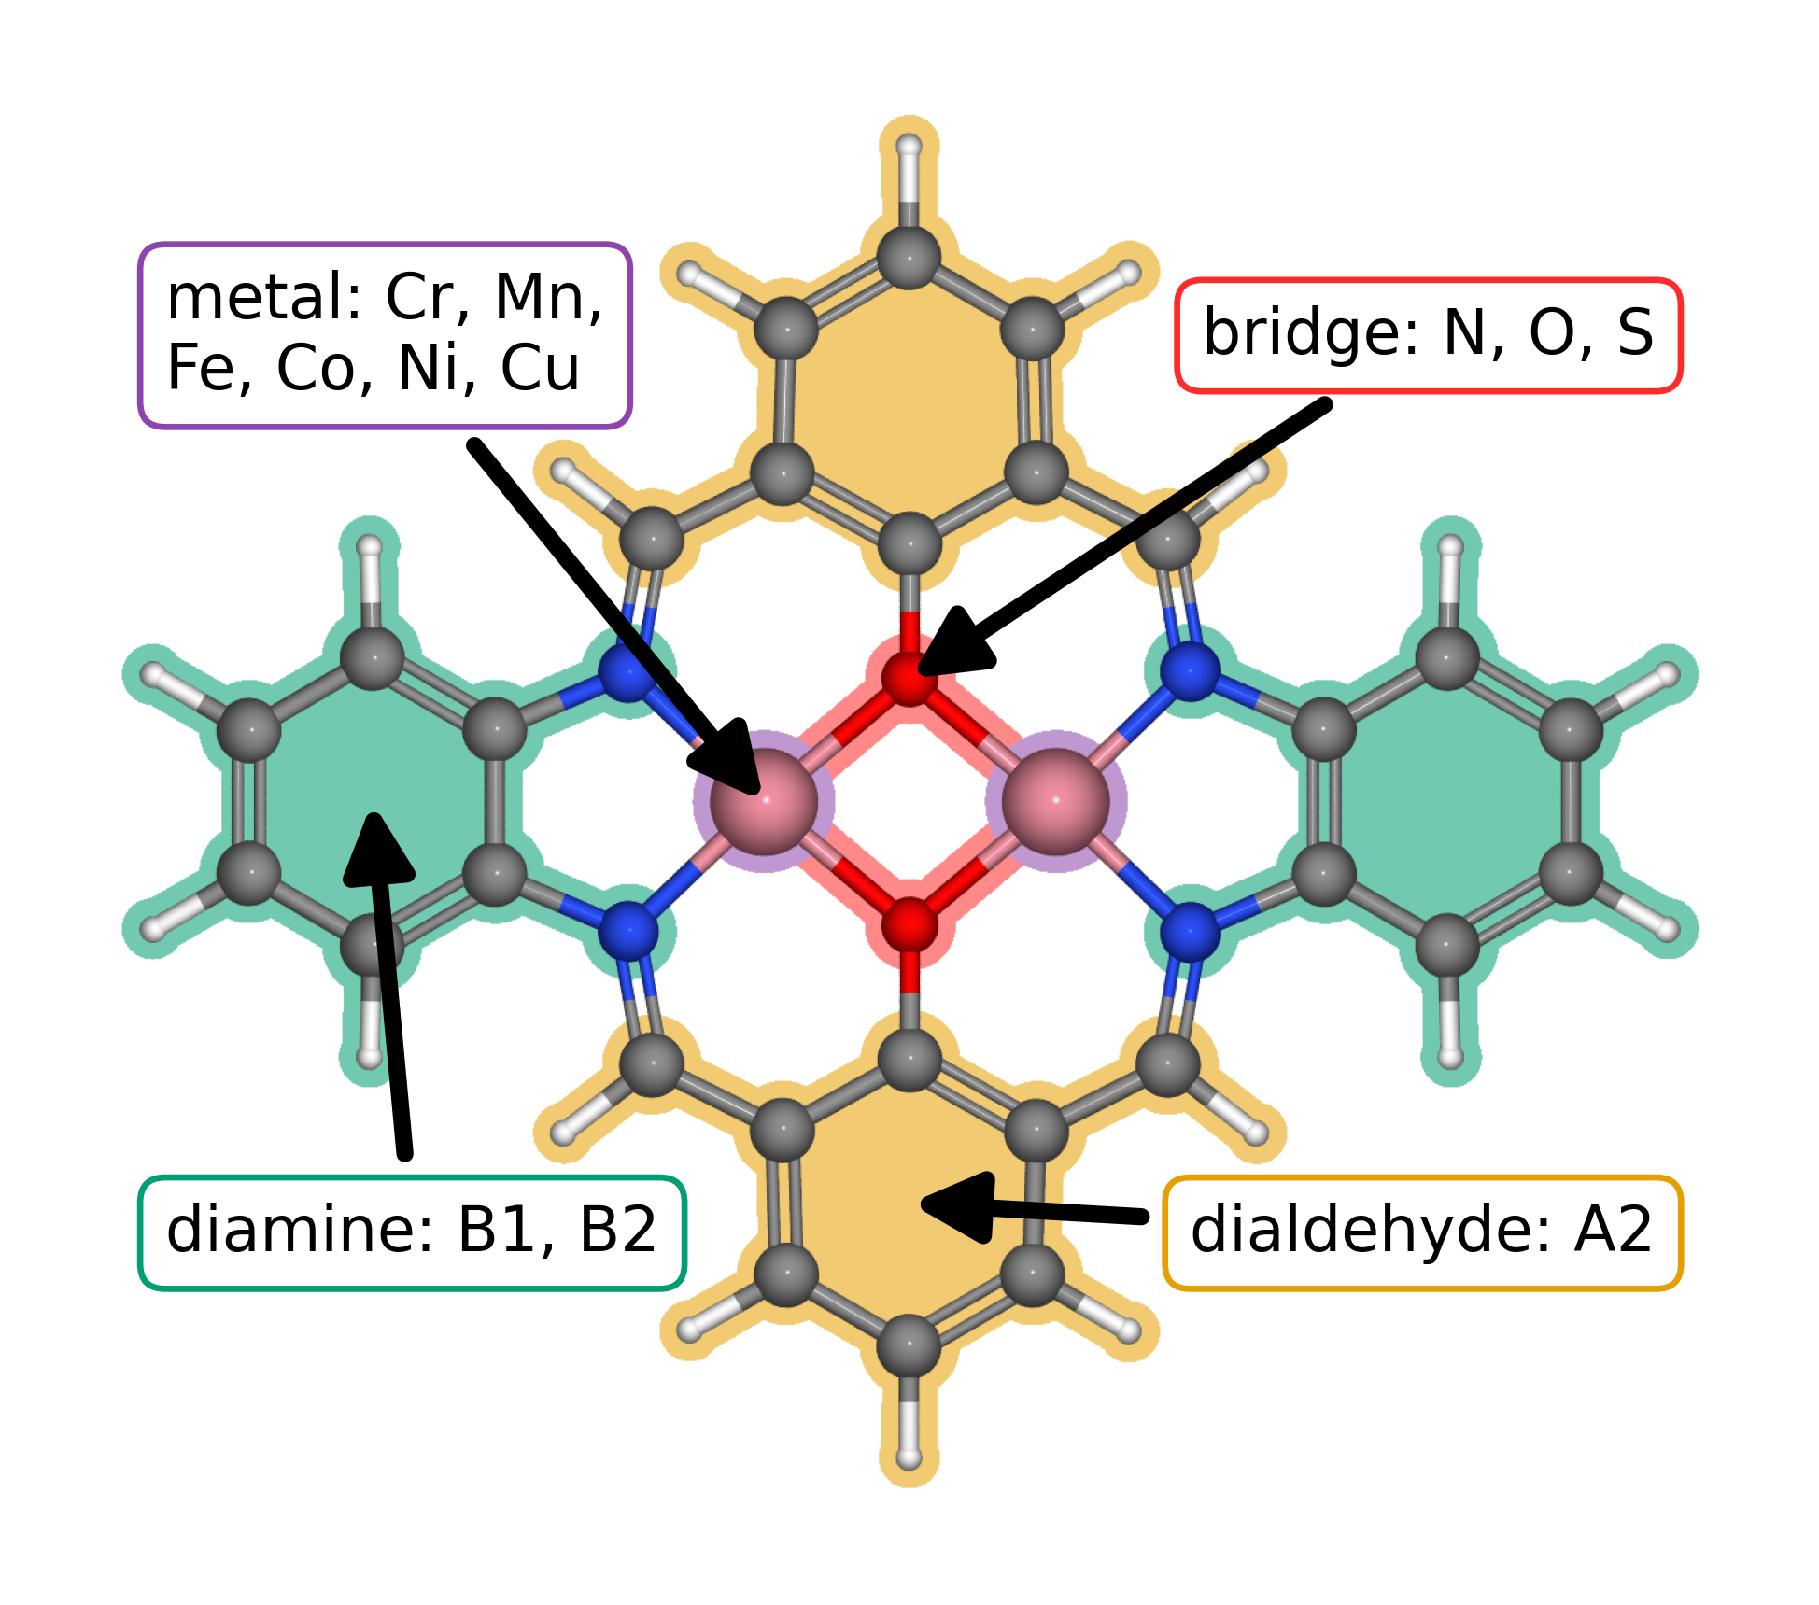
Figure 1. Modular molecular structure of the catalyst library. The metal list gives the elements available at the two metal positions; bridge atoms are N, O, or S; diamines are B1 or B2; and the dialdehyde is fixed as A2. The arrows identify the metal region, bridge, diamine, and lower aromatic ring assigned to A2.
The clean database contains 88 catalyst structures. Exact matching of the raw adsorption databases produced 123 complete pathways across 82 catalysts. The energy filters retained 118 pathways across 79 catalysts for Figure 2. Figure 3 extends the analysis to sites with available clean catalyst descriptors.

3.2. Adsorption scaling and calculated ORR thermodynamics
Figure 2a compares O and OOH adsorption free energies with OH adsorption free energy. The OOH–OH relation has a slope of 0.69 and an intercept of 2.98 eV; the O–OH relation has a slope of 1.66 and an intercept of 1.20 eV. The adsorption site families occupy different parts of these trends, with scatter around the global relations. Related molecular catalysts can alter OOH binding geometry and adsorption scaling through their paired metal centers [5,2]. The present trends provide a basis for examining such structural effects within a common molecular scaffold.
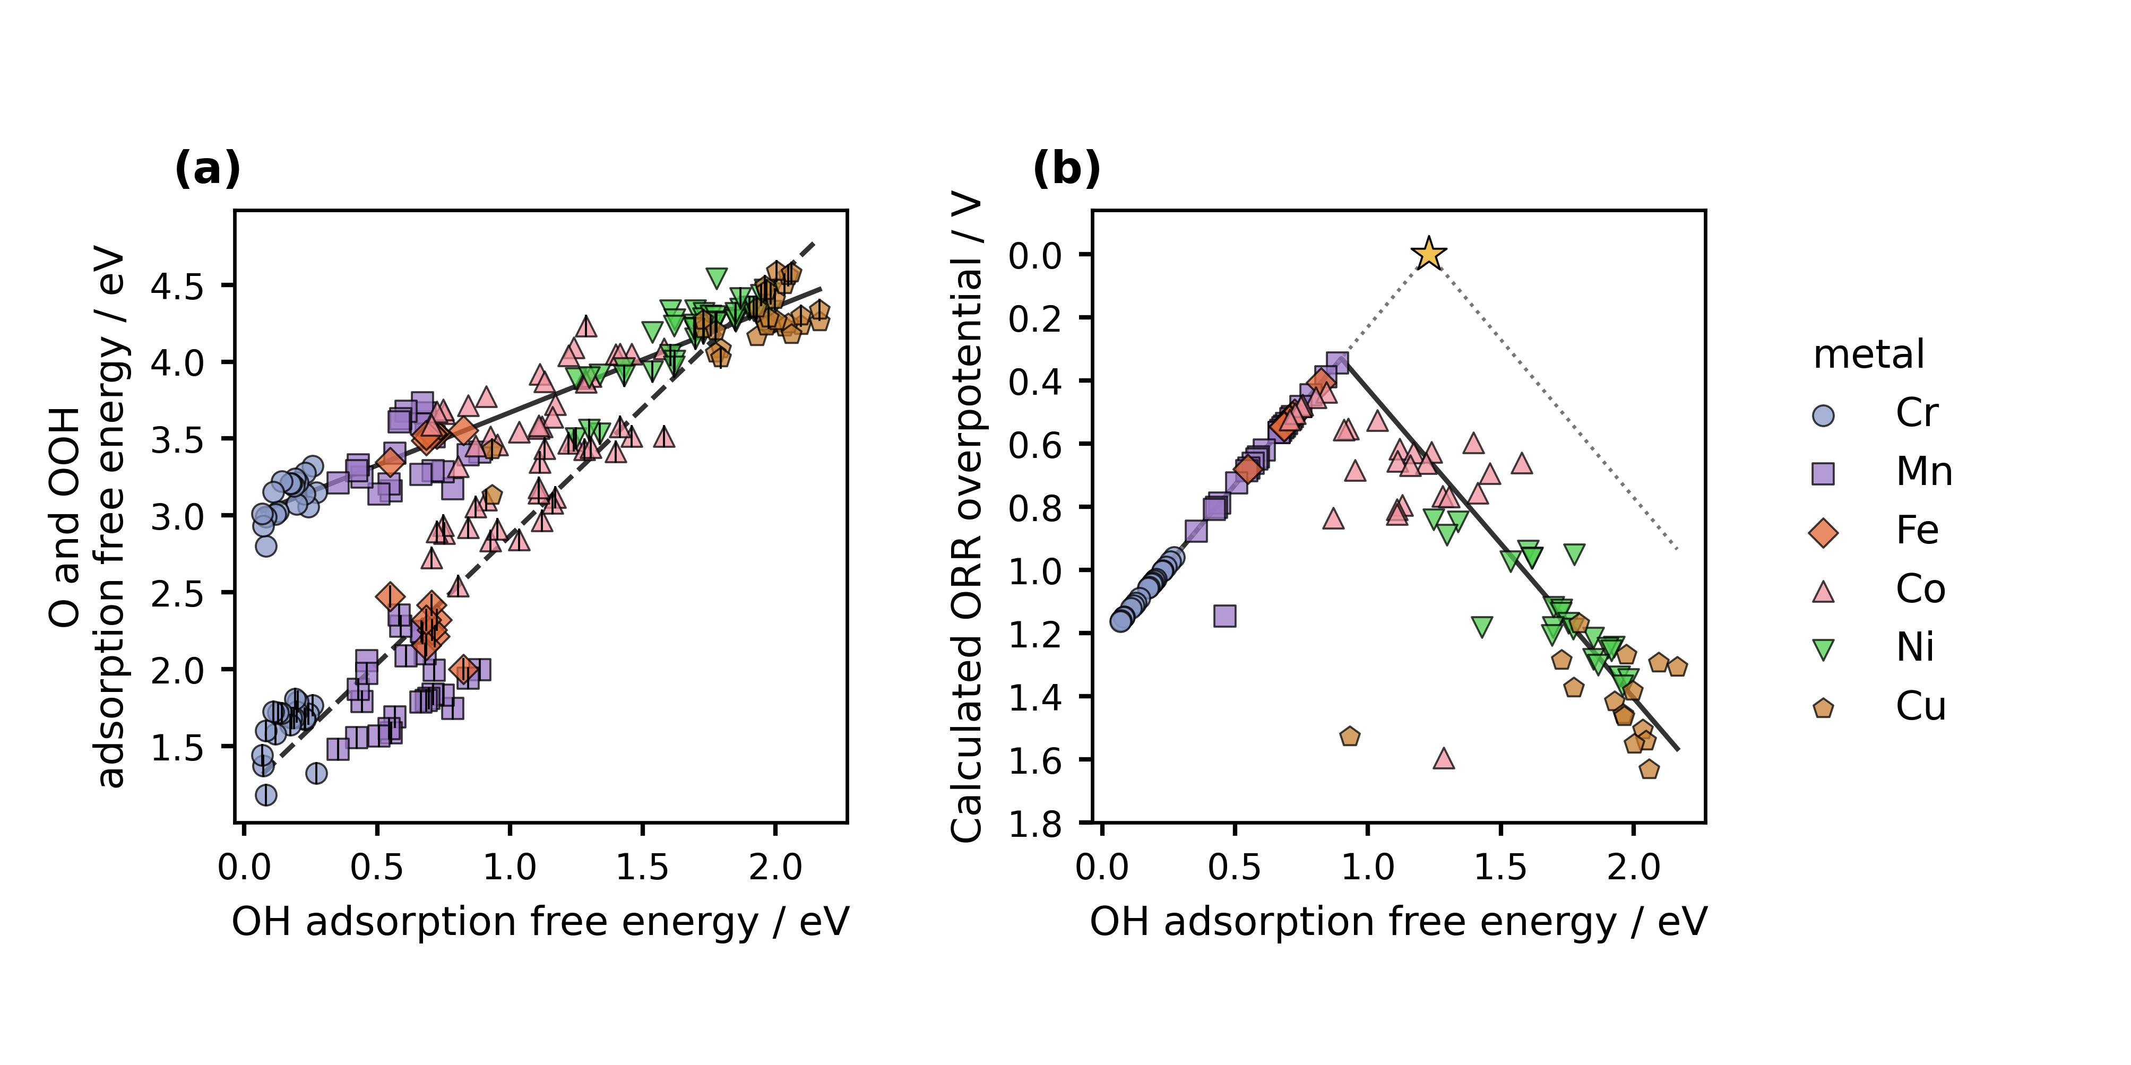
Figure 2. Adsorption scaling and oxygen reduction thermodynamics from DFT. Figure 1 defines the structural components. (a) O and OOH adsorption free energies versus OH adsorption free energy. Color and marker shape identify the metal at the adsorption site; the centered vertical stroke denotes O. Solid and dashed lines are OOH–OH and O–OH scaling fits. (b) CHE overpotential for the same catalyst and adsorption site combinations. The solid curve follows the global scaling fits through all four reaction steps. The dotted ideal reference assumes an OOH–OH separation of 2.46 eV, with OH removal and OOH formation defining its left and right branches. The star marks zero overpotential at 1.23 eV. Lower overpotential appears higher on the reversed axis.
Figure 2b shows the calculated conventional computational hydrogen electrode overpotential, with the vertical axis reversed. The lowest value in the filtered working dataset is 0.34 V at the Mn adsorption site of a Cr–Mn catalyst with an S–S bridge and B1 diamine. Its stored adsorption quantities are 0.89 eV for OH, 1.99 eV for O, and 3.41 eV for OOH; the OH to water step determines the limiting potential. This thermodynamic ranking applies to the present structures, corrections, matching rules, and filters. The curve propagates the global scaling fits through the four step reaction model, as described in the Figure 2 caption.

3.3. Scaling and activity from regression predictions
Figure 3 presents the scaling relations and oxygen reduction volcano obtained from the simpler regression models. Complete predictions were available for 148 sites across 88 catalysts; the filters retained 144 sites across 87 catalysts. The predicted OOH–OH slope and intercept are 0.67 and 2.98 eV, while those for O–OH are 1.73 and 1.14 eV. These trends resemble those obtained directly from the adsorption calculations in Figure 2. The regression gives smoother trends across the metal families, as expected when a small set of descriptors summarizes the variation in adsorption free energies.
The lowest predicted overpotentials occur near the crossover between strong and weak binding. In this dataset, the lowest value is 0.30 V at the Fe adsorption site of an Fe–Mn catalyst with S bridge atoms and B1 diamine. Figure 2 instead places its lowest DFT derived overpotential at a Mn site. This difference makes the ranking useful for selecting calculations that examine whether the descriptors preserve the relevant distinctions among candidate sites. The all-site predictions describe the represented library; transfer to new chemical families requires a separate evaluation.
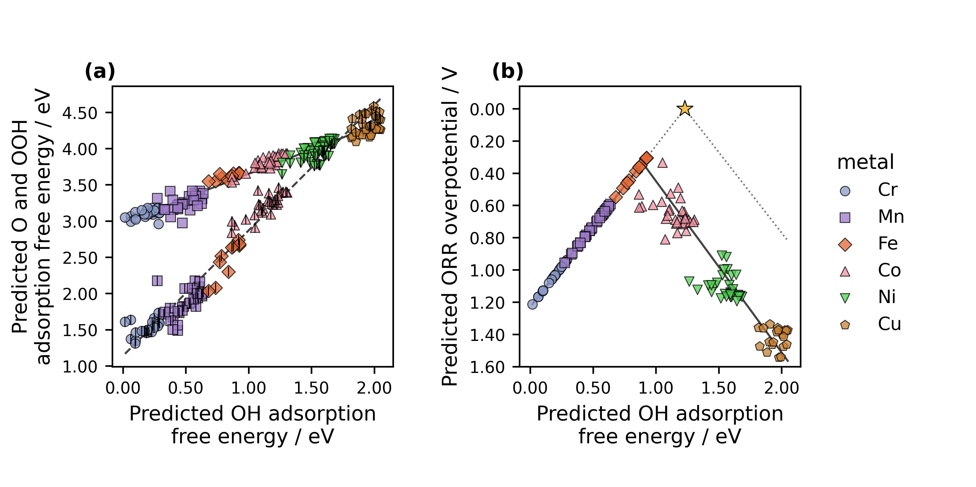
Figure 3. Adsorption scaling and oxygen reduction thermodynamics from the simpler ridge regression analysis. (a) Predicted O and OOH adsorption free energies versus predicted OH adsorption free energy. (b) Overpotentials derived from the three predictions for each catalyst and adsorption site combination. All available sites passing the energy filters are shown. Colors, markers, line conventions, and the ideal reference follow Figure 2. The solid volcano curve uses the scaling fits to the predicted energies. The figure includes sites used for model fitting and describes trends across the molecular library.

3.4. Reanalysis from reusable data
The exact, site matched adsorption records support the conventional CHE calculation and the alternative Calle-Vallejo and Exner analyses. With catalyst identity, adsorption site, OOH orientation, and energy convention retained, researchers can recalculate these descriptors from stored energies without repeating DFT. Changes to molecular geometry, charge state, or adsorption structure require new calculations.
The planned release will include catalyst structures and results as an Atomic Simulation Environment (ASE) database and machine readable JSON, together with code for reconstructing the joins and figures. These formats support findable, accessible, interoperable, and reusable data practices [18]. A documented schema lets a language model prepare an alternative analysis or plot at low computational cost; researchers can then check its inputs, equations, code, and results before interpretation.
The authors report that prompt development took about two weeks and generation of the integrated draft took less than one hour. They recall comparable manual writing efforts that took months. These time figures are project specific and qualitative; comparison with human writing requires a matched study.

4. Conclusions
The adsorption calculations reveal distinct scaling trends for atomic oxygen and hydroperoxyl and show how binding strength constrains oxygen reduction thermodynamics within this molecular catalyst library. The simpler regression reproduces the broad trends and extends the comparison to sites with available clean catalyst descriptors. Differences between the calculated and predicted rankings identify candidates for further electronic structure calculations. These results support candidate prioritization within the represented chemical space.
Artificial intelligence generated the research narrative from the supplied calculations, data, figures, and literature under the guidance of the researchers. Reusable records allowed the same structural information to support direct thermodynamic analysis, regression predictions, and alternative activity descriptors. The case illustrates how rapid article preparation can place greater emphasis on the quality of the underlying research: explicit methods, traceable data, and human judgment about what the results establish.

Funding
This work was supported by the Estonian Ministry of Education and Research (TK210) and the Estonian Research Council (PRG3174).

CRediT authorship contribution statement
Bruno Inácio da Silva Roux Leite: investigation, data curation, formal analysis, and generation of DFT results. Denis Savchenko: methodology, software, formal analysis, visualization, and development of the regression model. Timmo-Henrik Pukk: investigation, data curation, formal analysis, and generation of DFT results. Ba Long Nguyen: investigation, software, data curation, formal analysis, visualization, and generation of DFT results. Vladislav Ivanistsev: conceptualization, supervision, and funding acquisition. Nadezda Kongi: conceptualization, supervision, and funding acquisition. Validation of the manuscript text: all authors. All authors approved the final text.

Declaration of competing interest
The authors declare no competing interests.

Data availability
The parent molecular dual-atom site catalyst dataset is available from Zenodo [19]. The final adsorption databases, processed site matched data, machine readable JSON records, analysis notebooks, and model predictions will be deposited with the final article. The databases used for the present working analysis are provisional.

Declaration of generative AI and AI assisted technologies in the manuscript preparation process
OpenAI Codex, using an OpenAI language model, generated the complete manuscript text from project records, figures, literature, and author supplied instructions. The authors report that they reviewed and verified the text and take responsibility for its content.

Acknowledgments
We acknowledge the University of Latvia Artificial Intelligence and Computing Center and the High Performance Computing Center of the University of Tartu for providing computational resources.

References
[1] S. Jia et al., Machine Learning Reveals Role-Asymmetric Electronic Cooperation in Fe-Based Dual-Atom Catalysts, Advanced Materials 36 (2026) e74833. https://doi.org/10.1002/adma.74833
[2] Z. Zhang et al., Design and Synthesis of Electrocatalysts Based on Catalysis-Unit Engineering, Advanced Materials 36 (2024) 2403549. https://doi.org/10.1002/adma.202403549
[3] X. Chen et al., Leveraging DFT and Machine Learning for Accelerated Screening of Cluster-Modified Single-Atom Catalysts in Oxygen Reduction Reactions, ACS Catalysis 16 (2026) 14399–14410. https://doi.org/10.1021/acscatal.6c02383
[4] J. K. Nørskov, J. Rossmeisl, A. Logadottir, L. Lindqvist, J. R. Kitchin, T. Bligaard, H. Jónsson, Origin of the Overpotential for Oxygen Reduction at a Fuel-Cell Cathode, Journal of Physical Chemistry B 108 (2004) 17886–17892. https://doi.org/10.1021/jp047349j
[5] Q. Sun et al., Well-Defined Co₂ Dual-Atom Catalyst Breaks Scaling Relations of Oxygen Reduction Reaction, Journal of the American Chemical Society 146 (2024) 35295–35304. https://doi.org/10.1021/jacs.4c12705
[6] N. Žoglo et al., Intersite Geometry Controls Activity and Selectivity in the Oxygen Reduction Reaction on Dual-Atom-Site Catalysts, ChemRxiv preprint (2026). https://doi.org/10.26434/chemrxiv.15001712/v1
[7] L. X. Chen, P. Christopher, F. De Angelis, S. Jin, Y.-S. Hu, N.-G. Park, D. Das Sarma, Y.-K. Sun, P. V. Kamat, We Editors Are Authors, Too, ACS Energy Letters 4 (2019) 249–250. https://doi.org/10.1021/acsenergylett.8b02322
[8] Elements of style, Nature Physics 3 (2007) 581. https://doi.org/10.1038/nphys724
[9] C. M. Biegel, P. V. Kamat, Five common pitfalls to avoid while composing scientific figures, ACS Energy Letters 6 (2021) 4309–4310. https://doi.org/10.1021/acsenergylett.1c02401
[10] Storytelling in research, Nature Biomedical Engineering 2 (2018) 53. https://doi.org/10.1038/s41551-018-0202-5
[11] Should scientists tell stories?, Nature Methods 10 (2013) 1037. https://doi.org/10.1038/nmeth.2726
[12] B. L. Nguyen, T. K. Madsen, V. Ivanistsev, N. Kongi, Dataset of molecular dual-atom site complexes for catalysis, Data in Brief 66 (2026) 112806. https://doi.org/10.1016/j.dib.2026.112806
[13] J. J. Mortensen et al., GPAW: An open Python package for electronic structure calculations, Journal of Chemical Physics 160 (2024) 092503. https://doi.org/10.1063/5.0182685
[14] A. H. Larsen et al., The Atomic Simulation Environment—A Python Library for Working with Atoms, Journal of Physics: Condensed Matter 29 (2017) 273002. https://doi.org/10.1088/1361-648X/aa680e
[15] E. Caldeweyher, S. Ehlert, A. Hansen, H. Neugebauer, S. Spicher, C. Bannwarth, S. Grimme, A generally applicable atomic-charge dependent London dispersion correction, Journal of Chemical Physics 150 (2019) 154122. https://doi.org/10.1063/1.5090222
[16] N. Govindarajan, J. M. García-Lastra, E. J. Meijer, F. Calle-Vallejo, Does the breaking of adsorption energy scaling relations guarantee enhanced electrocatalysis?, Current Opinion in Electrochemistry 8 (2018) 110–117. https://doi.org/10.1016/j.coelec.2018.03.025
[17] S. Razzaq, K. S. Exner, Materials screening by the descriptor Gmax(η): The free energy span model in electrocatalysis, ACS Catalysis 13 (2023) 1740–1758. https://doi.org/10.1021/acscatal.2c03997
[18] M. D. Wilkinson et al., The FAIR guiding principles for scientific data management and stewardship, Scientific Data 3 (2016) 160018. https://doi.org/10.1038/sdata.2016.18
[19] [dataset] B. L. Nguyen, T. K. Madsen, V. Ivanistsev, N. Kongi, Dataset of molecular dual-atom site complexes for catalysis, Zenodo, version 1.0, 2026. https://doi.org/10.5281/zenodo.18601379

