Accelerating Catalyst Discovery and Design with Artificial Intelligence: Molecular Dual-Atom Site Catalysts as a Case Study
Bruno Inácio da Silva Roux Leite,¹ Denis Savchenko,¹ Timmo-Henrik Pukk,¹ Ba Long Nguyen,¹ Vladislav Ivanistsev,^{2†} Nadezda Kongi,^{1†}
1 Institute of Chemistry, University of Tartu, Ravila 14a, 50411 Tartu, Estonia
2 Department of Chemistry, University of Latvia, Jelgavas iela 1, Riga, LV-1004, Latvia
Corresponding authors: nadezda.kongi@ut.ee; vladislav.ivanistsev@lu.lv

Abstract
Accelerating catalyst discovery and design with artificial intelligence (AI) requires more than generating predictions. Reliable data must also reach readers quickly enough to guide the next calculation or experiment. We use molecular dual-atom site catalysts to show how density functional theory (DFT) data can support machine learning (ML) models and a complete article generated by a large language model (LLM) under our direction. Adsorption free energies calculated with DFT and predicted with ML recover the same broad scaling trends but prioritize different adsorption sites. This disagreement identifies specific candidates for further computational or laboratory tests. The LLM transformed the research record into analysis code, figures, and manuscript text; we chose the questions, methods, and interpretations and verified every output. The case demonstrates how AI can accelerate catalyst discovery and design by shortening the path from reusable data to a complete manuscript while researchers retain responsibility for science.
Keywords: AI; DFT; ML; LLM; oxygen reduction reaction; molecular dual-atom site catalysts

1. Introduction
Accelerating catalyst discovery and design with artificial intelligence (AI) should make the research itself faster. Scientific publishing, however, often treats the story as the intellectual center of a paper. Editors at Nature Physics state that the story should organize the entire article; editors at ACS Energy Letters ask authors to build the discussion around a coherent theme; other editorials call figures the backbone or the most persuasive part of an article [10.1038/nphys724; 10.1021/acsenergylett.8b02322; 10.1038/s44160-022-00067-8; 10.1038/s41567-021-01332-x]. These editorials establish the thesis we challenge. We agree that a clear story helps readers understand a research result. The scientific value of the research resides in the data, methods, and decisions that let readers test that story.
Researchers can spend substantial time turning completed calculations into a publication. That delay slows data sharing just when larger, reusable datasets are needed to train and test AI models. We therefore ask whether a guided large language model (LLM) can assume most of the scientific writing task when the data are structured, the methods are explicit, and the sources are linked. Ifargan and colleagues showed that interacting LLM agents can move from annotated data to papers that humans can verify and that human guidance becomes more important as research questions grow more complex [10.1056/aioa2400555]. In our study, the LLM organizes the evidence and drafts the article; we formulate the research question, produce the data, choose the analysis, interpret the results, and verify the final text.
LLM fluency also creates an obvious danger: polished language can conceal weak evidence, omit an inconvenient result, or attach a plausible figure to an unsupported statement. Nature Methods warned that storytelling can distort science before generative AI made polished prose inexpensive [10.1038/nmeth.2726]. We control that risk by linking the text to inspectable data, calculation rules, executable code, and sources. In this article, the story must answer the record.
We examine this thesis through the oxygen reduction reaction (ORR). Its four electron pathway depends on the binding of O, OH, and OOH, so correlated adsorption free energies constrain thermodynamic activity [10.1021/jp047349j]. Molecular dual-atom site catalysts give us a defined set in which metal identity, bridge, diamine, and adsorption site vary, see Figure 1. Related molecular catalysts show how binding geometry and the second metal can change oxygen intermediate energetics [10.1021/jacs.4c12705; 10.26434/chemrxiv.15001712/v1]. We follow these changes through density functional theory (DFT) data in Figure 2 and machine learning (ML) predictions in Figure 3. The LLM writes the account, while the data limit what the text can say. This article therefore tests whether AI can accelerate catalyst discovery and design by moving structured catalyst data toward a verifiable publication without outsourcing scientific judgment.

2. Computational methods

2.1. Catalyst structures
We assembled the molecular catalysts from the components shown in Figure 1. Following the notation introduced in our data article [10.1016/j.dib.2026.112806], A2 denotes the fixed dialdehyde and B1 and B2 denote the two diamines. Each molecule contains two metal centers chosen from Cr, Mn, Fe, Co, Ni, and Cu and bridge atoms selected from N, O, or S. The same article describes the molecular assembly and initial structure preparation. We fully optimized all structures used in the DFT analysis, including the clean catalysts and structures containing adsorbed intermediates. The clean database used here contains 88 molecular catalysts.
We retained the catalyst identity, metal positions, ligand components, and charge metadata in the Atomic Simulation Environment (ASE) database.

2.2. DFT calculations and adsorption structures
We performed spin polarized DFT calculations with GPAW 26.7 and ASE 3.29.0 software [10.1063/5.0182685; 10.1088/1361-648X/aa680e]. We used the projector augmented wave method, the revised Perdew–Burke–Ernzerhof functional, and the D4 dispersion correction [10.1063/1.5090222]. The calculations used a plane wave cutoff of 550 eV, a real space grid spacing of 0.16 Å, and 6.00 Å vacuum. We fully optimized every atomic structure until the maximum force was below 0.05 eV Å⁻¹. We previously used the same calculation setup for related molecular catalysts [10.26434/chemrxiv.15001712/v1].

We placed O, OH, and OOH at the metal adsorption sites identified in Figure 1 and fully optimized each structure. We calculated gas phase H₂ and H₂O with the same settings. We joined all total energies by catalyst name and adsorption site label, so each reaction pathway refers to one metal atom in one molecular catalyst.
We obtained the adsorption energies of O, OH, and OOH from the total energies of the corresponding adsorbed structure, clean catalyst, H₂, and H₂O:
$$ΔE_{OH} = E_{*OH} + (1/2) E_{H_{2}} - E_{*} - E_{H_{2}O}$$
(1)
$$ΔE_{O} = E_{*O} + E_{H_{2}} - E_{*} - E_{H_{2}O}$$
(2)
$$ΔE_{OOH} = E_{*OOH} + (3/2) E_{H_{2}} - E_{*} - 2E_{H_{2}O}$$
(3)
In Eqs. (1)–(3), the left side is the adsorption energy of the named intermediate. The terms on the right are the total energies of the adsorbed catalyst, the clean catalyst, gas phase H₂, and gas phase H₂O; * denotes the adsorption site. We used the supplied corrected adsorption free energies for scaling and thermodynamic analyses.

2.3. Adsorption free energies and ORR thermodynamics
We converted adsorption energies to adsorption free energies by adding the zero point and entropic corrections:
$$ΔG_{X} = ΔE_{X} + ΔE_{ZP,X} - TΔS_{X}$$
(4)
In Eq. (4), X denotes O, OH, or OOH; E and G denote electronic energy and Gibbs free energy; T is temperature; S is entropy; and ZP identifies the zero point contribution. The supplied adsorption free energies already include these corrections. We evaluated the four reduction potentials for the associative four electron ORR pathway with the computational hydrogen electrode (CHE) method [10.1021/jp047349j]:
$$\begin{aligned}U_{1} = (4.92 eV - ΔG_{OOH}) / e \\ U_{2} = (ΔG_{OOH} - ΔG_{O}) / e \\ U_{3} = (ΔG_{O} - ΔG_{OH}) / e \\ U_{4} = ΔG_{OH} / e\end{aligned}$$
(5)
Equation (5) lists the positive step reduction potentials for four reductions: O₂ to OOH, OOH to O, O to OH, and OH to H₂O; e is the elementary charge. The limiting potential is the lowest of the four step potentials:
$$U_{L} = min(U_{1}, U_{2}, U_{3}, U_{4})$$
(6)
The symbol on the left of Eq. (6) is the limiting potential. We evaluated the ORR overpotential relative to the 1.23 V equilibrium potential:
$$η_{ORR} = 1.23 V - U_{L}$$
(7)
Equation (7) gives the ORR overpotential. Chemical subscripts in Eqs. (5)–(7) identify the adsorbed intermediate or the reaction quantity.

2.4. Scaling and thermodynamic activity analyses
We described the correlations of O and OOH adsorption free energies with OH adsorption free energy by ordinary least squares:
$$\begin{aligned}ΔG_{O} = α_{O} ΔG_{OH} + β_{O} \\ ΔG_{OOH} = α_{OOH} ΔG_{OH} + β_{OOH}\end{aligned}$$
(8)
In Eq. (8), α and β are the slope and intercept for the intermediate identified by the subscript. The curves in Figures 2 and 3 propagate the corresponding global fits through the four reaction steps. We also considered the electrochemical step symmetry index and free energy span as complementary thermodynamic interpretations [10.1016/j.coelec.2018.03.025; 10.1021/acscatal.2c03997]. For comparison, we defined an ideal relation with an OOH–OH free energy separation of 2.46 eV and the corresponding two-branch overpotential:
$$\begin{aligned}Δ{G_{OOH}}^{ideal} = ΔG_{OH} + 2.46 eV \\ η_{ideal} = 1.23 V - min(ΔG_{OH} / e, (2.46 eV - ΔG_{OH}) / e)\end{aligned}$$
(9)
In Eq. (9), OH removal defines the left branch and OOH formation the right branch. They meet at an OH adsorption free energy of 1.23 eV and zero overpotential. This reference represents balanced binding; the catalyst points and fitted curves use all four reaction steps. Thermodynamic rankings describe reaction free energies, while kinetic activity also depends on activation barriers.

2.5. ML regression analysis
For the ML analysis, we used fitted ridge regression models for OH, O, and OOH adsorption free energies. Their clean catalyst descriptors represent Bader charge and electron population, local spin, and ligand charge distribution. The supplied models contain eight predictors for OH and O and six for OOH. We applied the saved training medians, means, standard deviations, and coefficients to all available catalyst and adsorption site records. We then joined the three predictions at each site and evaluated the overpotential with Eqs. (5)–(7).
Figure 3 shows predicted trends across the molecular library, including sites used for model fitting. The supplied validation predictions confirmed that the saved models were reproduced; the figure containing all predicted sites does not measure independent predictive accuracy.

2.6. AI assisted manuscript generation
We used an LLM accessed through OpenAI Codex to generate the complete manuscript and assist with analysis and figure code under our direction. The central test was whether an LLM could turn a traceable scientific record into a coherent article while leaving research decisions with the authors. Ifargan and colleagues showed that interacting LLM agents can formulate hypotheses, write analysis code, and produce verifiable manuscripts from annotated data [10.1056/aioa2400555]. Kobak and colleagues found vocabulary changes consistent with widespread LLM assisted writing, which shows why this capability now requires explicit controls [10.1126/sciadv.adt3813].
We gave the LLM the research question, databases, regression coefficients, literature, and writing instructions. It performed three defined tasks: it organized the evidence, generated reproducible analysis and figure code, and drafted and revised the complete article. We chose the scientific questions, methods, activity measures, and interpretations, then verified the calculations, figures, citations, and text. The manuscript is therefore the object of the test as well as its report.

3. Results and discussion

3.1. Molecular design space and site identity
Figure 1 gives us a common molecular structure in which to compare the effects of changing individual components. Both metal positions draw from the same six elements, while the bridge and diamine provide further variation and the dialdehyde remains fixed. We define an adsorption site as the metal atom within the organic ligands to which an ORR intermediate binds. Keeping that atom identifiable lets us distinguish the two possible pathways in the same molecule.
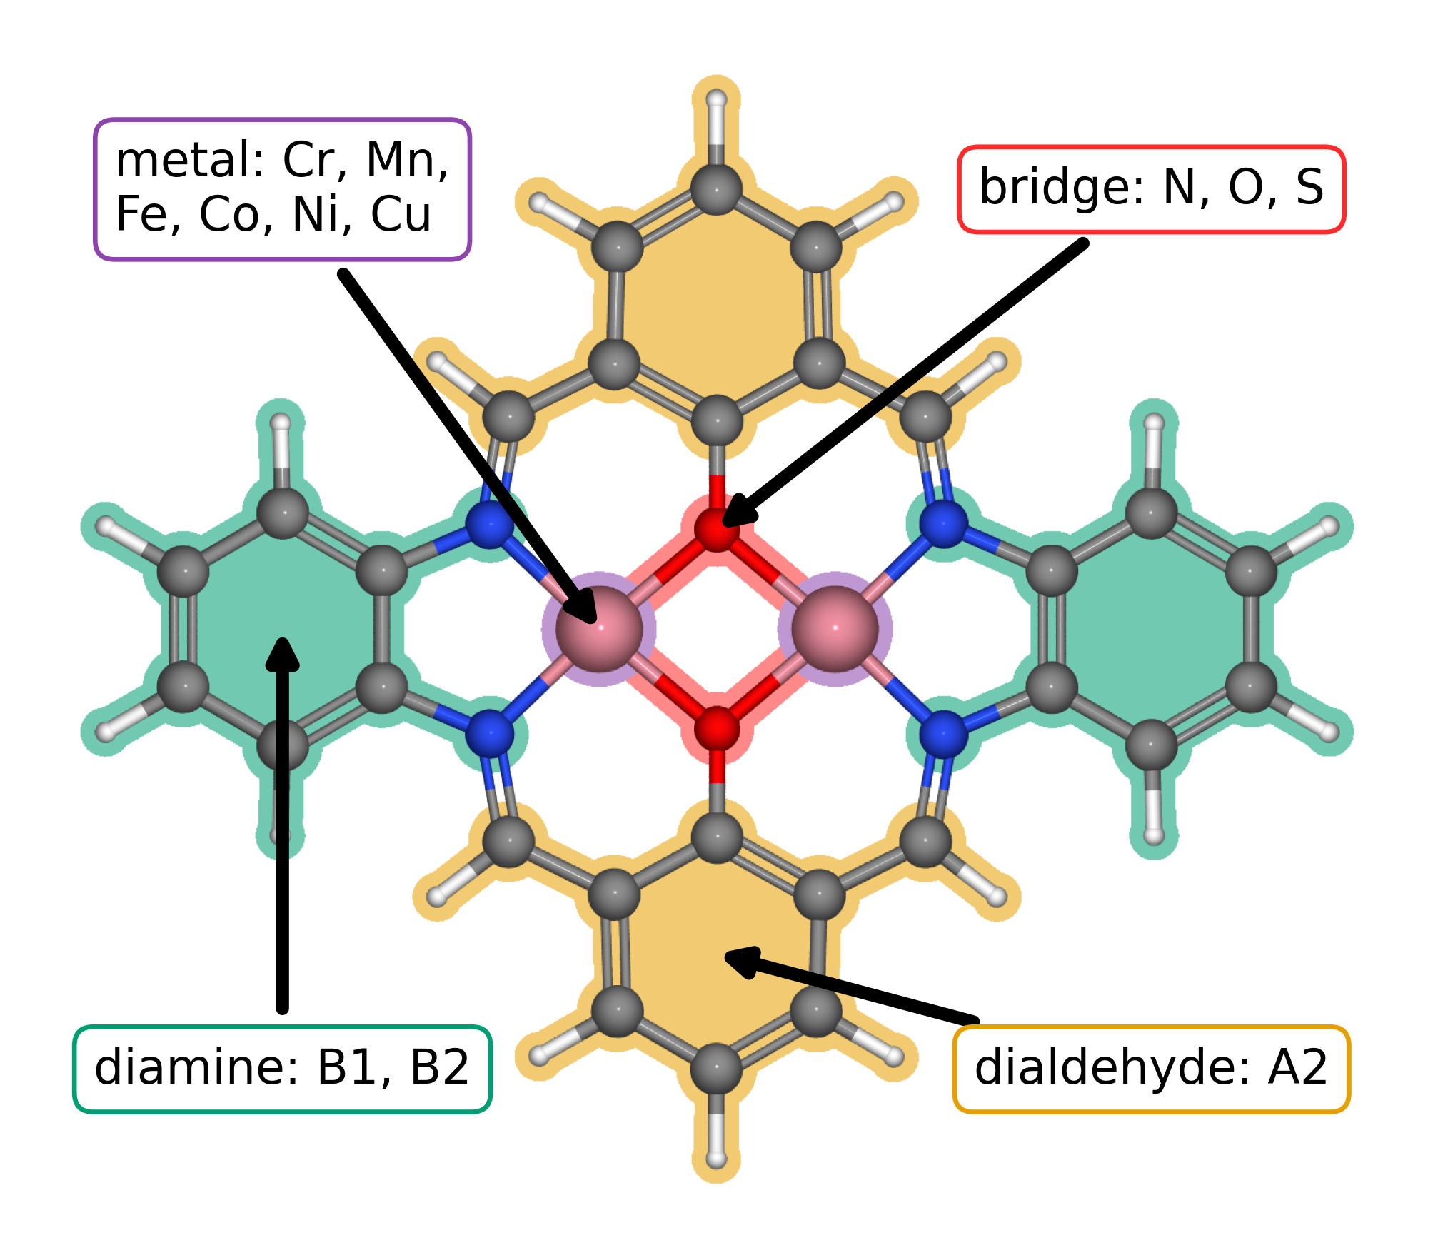
Figure 1. Modular molecular structure of the catalyst library. The metal list gives the elements available at the two metal positions; bridge atoms are N, O, or S. A2, B1, and B2 follow the dialdehyde and diamine notation introduced in our data article [10.1016/j.dib.2026.112806]. The arrows identify the metal region, bridge, diamine, and lower aromatic ring assigned to A2.
The clean database contains 88 catalyst structures. Exact matching of the raw adsorption databases produced 123 complete pathways across 82 catalysts. Figure 2 contains 118 pathways across 79 catalysts, and Figure 3 contains 144 predicted sites across 87 catalysts.

3.2. Adsorption scaling and calculated ORR thermodynamics
Figure 2a compares O and OOH adsorption free energies with OH adsorption free energy. The OOH–OH relation has a slope of 0.69 and an intercept of 2.98 eV; the O–OH relation has a slope of 1.66 and an intercept of 1.20 eV. The adsorption site families occupy different parts of these trends, with scatter around the global relations. Related molecular catalysts can alter OOH binding geometry and adsorption scaling through their paired metal centers [10.1021/jacs.4c12705; 10.1002/adma.202403549]. The present trends provide a basis for examining such structural effects within a common molecular structure.
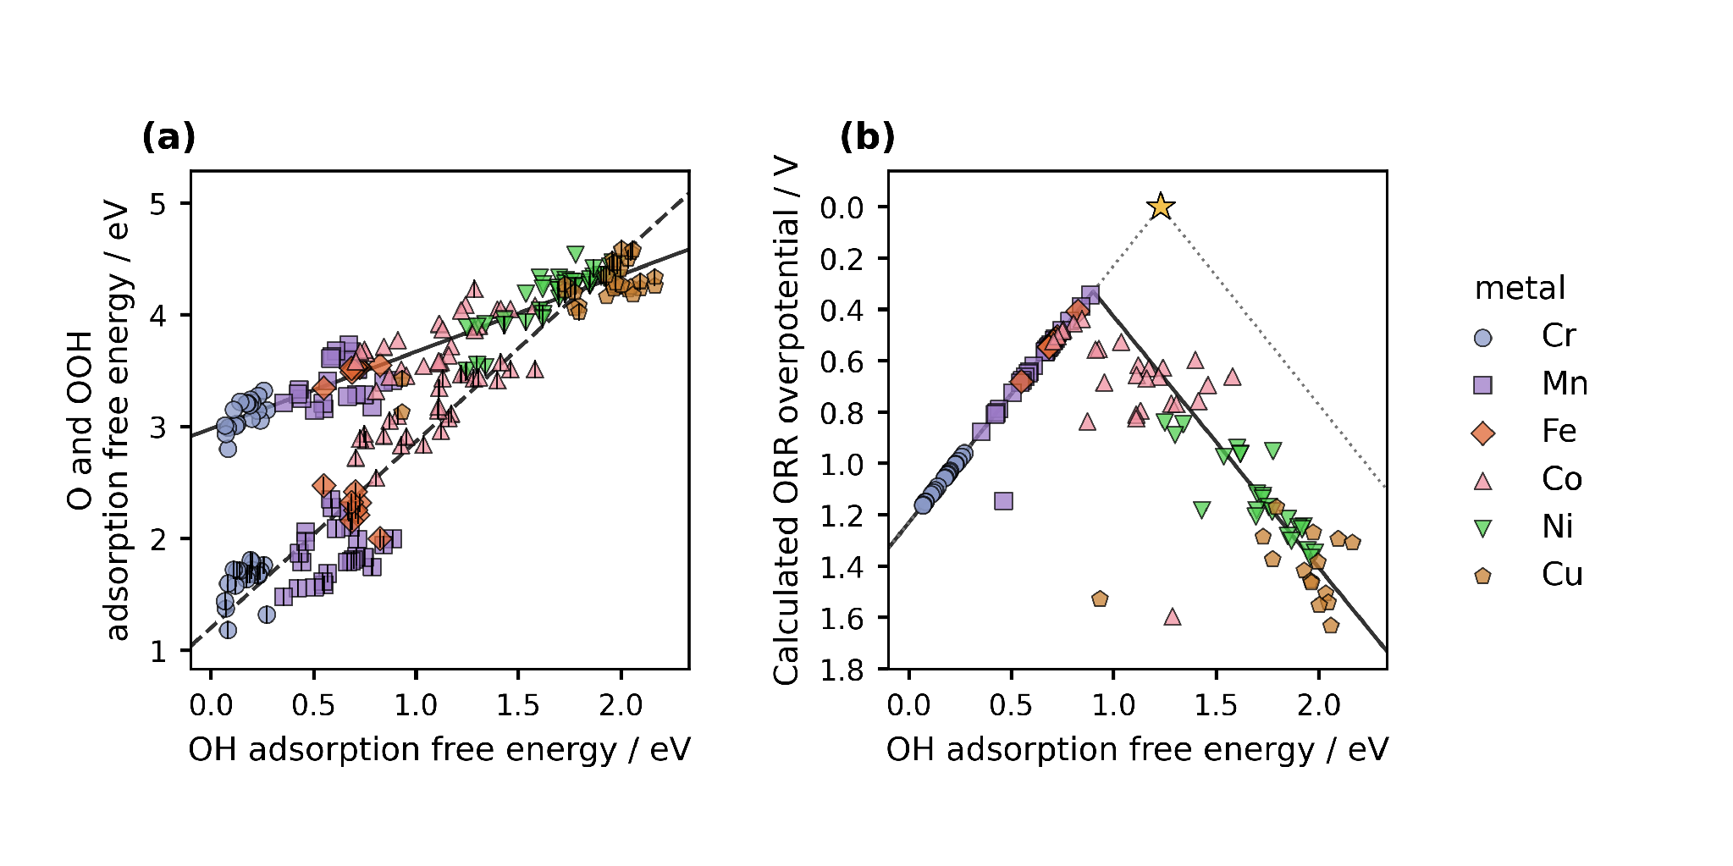
Figure 2. Adsorption scaling and oxygen reduction thermodynamics from DFT. Figure 1 defines the structural components. (a) O and OOH adsorption free energies versus OH adsorption free energy. Color and marker shape identify the metal at the adsorption site; the centered vertical stroke denotes O. Solid and dashed lines are OOH–OH and O–OH scaling fits. (b) CHE overpotential for the same catalyst and adsorption site combinations. The solid curve follows the global scaling fits through all four reaction steps. The dotted ideal reference assumes an OOH–OH separation of 2.46 eV, with OH removal and OOH formation defining its left and right branches. The star marks zero overpotential at 1.23 eV. Lower overpotential appears higher on the reversed axis.
Figure 2b shows the calculated conventional computational hydrogen electrode overpotential, with the vertical axis reversed. The lowest value in the plotted dataset is 0.34 V at the Mn adsorption site of a Cr–Mn catalyst with S bridge atoms and B1 diamine. Its adsorption free energies are 0.89 eV for OH, 1.99 eV for O, and 3.41 eV for OOH. The corresponding step potentials are 1.51, 1.42, 1.10, and 0.89 V, so reduction of OH to water determines the limiting potential. This Mn site approaches the balance required by the CHE volcano more closely than the other plotted sites. Establishing a causal role for the bridge or diamine requires comparisons across matched structures. The ranking applies to the present structures, corrections, matching rules, and plotted dataset.

3.3. Scaling and activity from regression predictions
We next ask how much of this pattern the regression recovers. Figure 3 applies the same analysis to predicted adsorption free energies for 144 sites across 87 catalysts. The predicted OOH–OH slope and intercept are 0.67 and 2.98 eV, while those for O–OH are 1.73 and 1.14 eV. Their proximity to the DFT relations in Figure 2 shows that the descriptors retain the broad variation across the molecular library. The narrower spread of the predictions also prompts a closer look at the individual rankings.
Near the volcano maximum, the distinction becomes consequential. The lowest predicted overpotential is 0.30 V at the Fe site of an Fe–Mn catalyst with S bridge atoms and B1 diamine. The DFT analysis in Figure 2 instead prioritizes a Mn site. We can use this disagreement to select a useful next calculation: inspect the binding structures and descriptors of these candidates, then test whether the predicted order survives. Figure 3 therefore helps us direct further research while displaying the broad trends that the regression has learned. Its predictions for all sites include fitted records, so the figure describes the represented library rather than establishing transfer to new chemical families.
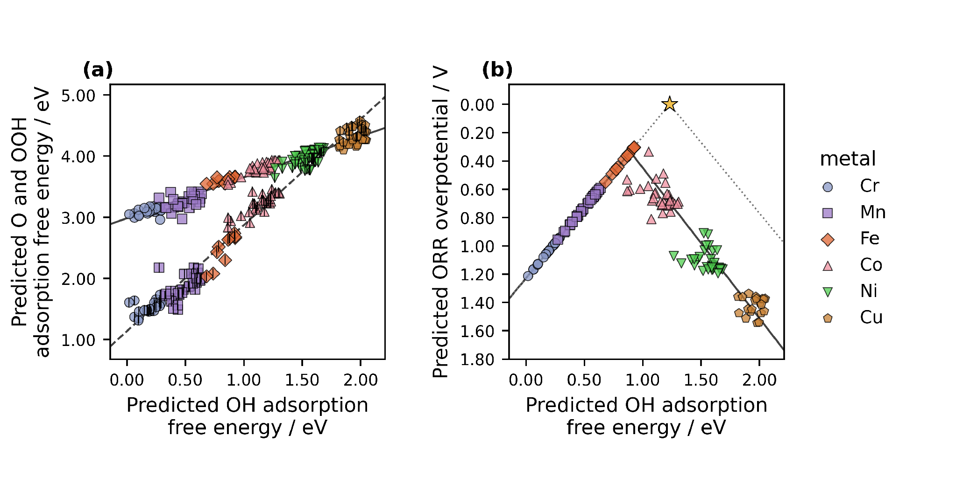
Figure 3. Adsorption scaling and oxygen reduction thermodynamics from ML predictions. (a) Predicted O and OOH adsorption free energies versus predicted OH adsorption free energy. (b) Overpotentials derived from the three predictions for 144 catalyst and adsorption site combinations. Colors, markers, and the ideal reference follow Figure 2. The solid and dashed lines in (a) are the OOH–OH and O–OH fits; the solid curve in (b) follows those fits through the four reaction steps. All trend lines extend across the displayed descriptor range. The figure includes sites used for model fitting.

3.4. From reusable data to the next research question
The comparison between Figures 2 and 3 raises a further question: how much does candidate selection depend on the activity measure we choose? We can examine it with the same site matched records. The Calle-Vallejo electrochemical step symmetry index and the Exner free energy span emphasize different features of the reaction energetics [10.1016/j.coelec.2018.03.025; 10.1021/acscatal.2c03997]. Once the energies are stored with their molecular and site identities, researchers can implement either analysis directly or instruct an LLM to draft the code, then inspect the code and compare the resulting rankings. We reserve new DFT calculations for questions that change the geometry, charge state, or adsorption structure.
We will release the structures and results as an ASE database and machine readable JSON, together with code that reconstructs the analysis. These formats support findable, accessible, interoperable, and reusable data practices [10.1038/sdata.2016.18]. They also make our interpretation open to revision: another researcher can choose a different descriptor, regenerate the figures, and identify where the conclusions change. The value of the record grows when it can answer a question that we did not originally ask.
We developed the project instructions over about two weeks and estimate that an integrated draft can be generated from them in less than one hour. In our experience, writing comparable articles without LLM assistance has taken months. These times record our project experience; no controlled comparison was performed. The practical result is that we can revise an analysis and its explanation together while concentrating on the assumptions and decisions that determine what the result means.

4. Conclusions
Accelerating catalyst discovery and design with AI includes shortening the path from reliable data to a complete manuscript. In this catalyst case study, the DFT data show OOH–OH and O–OH scaling across site resolved records, and the lowest calculated ORR overpotential is 0.34 V at a Mn adsorption site. The regression recovers the broad scaling trends but predicts its lowest overpotential, 0.30 V, at an Fe site. This disagreement defines a specific next calculation instead of a forced consensus. Reusable ASE and JSON records also allow the same sites to be evaluated with alternative activity measures. An LLM can assist with prescribed analyses and describe their trends, yet fluent text can still answer the wrong scientific question. Researchers must decide which questions and conclusions matter.
Publishers commonly present a convincing story as central to a scientific paper. We tested that thesis by assigning the complete scientific writing task to a guided LLM. The model connected the figures, methods, results, and sources because the research record constrained the text. This case shows how AI can accelerate catalyst discovery and design by shortening the time from reusable data to a complete manuscript. Storytelling remains necessary for communication, and its drafting can be delegated. Researchers can then concentrate on planning and conducting high-quality research, producing reusable data, testing interpretations, and verifying every claim.

CRediT authorship contribution statement
Bruno Inácio da Silva Roux Leite: investigation, data curation, formal analysis, and generation of DFT results. Denis Savchenko: methodology, software, formal analysis, visualization, and development of the regression model. Timmo-Henrik Pukk: investigation, data curation, formal analysis, and generation of DFT results. Ba Long Nguyen: investigation, software, data curation, formal analysis, visualization, and generation of DFT results. Vladislav Ivanistsev: conceptualization, supervision, and funding acquisition. Nadezda Kongi: conceptualization, supervision, and funding acquisition. Validation of the manuscript text: all authors. All authors approved the final text.

Declaration of competing interest
The authors declare no competing interests.

Data availability
The parent molecular dual-atom site catalyst dataset is available from Zenodo [10.5281/zenodo.18601379]. The final adsorption databases, processed site matched data, machine readable JSON records, analysis notebooks, and model predictions will be deposited with the final article. The databases used for the present working analysis are provisional.

Declaration of generative AI and AI assisted technologies in the manuscript preparation process
We used OpenAI Codex with an LLM to generate the complete manuscript text and assist with analysis and figure code from our project records and instructions. We guided the work, reviewed and verified the text, and take responsibility for its content.

Acknowledgments
This work was supported by the Estonian Ministry of Education and Research (TK210) and the Estonian Research Council (PRG3174). We acknowledge the University of Latvia Artificial Intelligence and Computing Center and the High Performance Computing Center of the University of Tartu for providing computational resources.

References
S. Jia et al., Machine Learning Reveals Role-Asymmetric Electronic Cooperation in Fe-Based Dual-Atom Catalysts, Advanced Materials 36 (2026) e74833. [10.1002/adma.74833]
Z. Zhang et al., Design and Synthesis of Electrocatalysts Based on Catalysis-Unit Engineering, Advanced Materials 36 (2024) 2403549. [10.1002/adma.202403549]
X. Chen et al., Leveraging DFT and Machine Learning for Accelerated Screening of Cluster-Modified Single-Atom Catalysts in Oxygen Reduction Reactions, ACS Catalysis 16 (2026) 14399–14410. [10.1021/acscatal.6c02383]
J. K. Nørskov, J. Rossmeisl, A. Logadottir, L. Lindqvist, J. R. Kitchin, T. Bligaard, H. Jónsson, Origin of the Overpotential for Oxygen Reduction at a Fuel-Cell Cathode, Journal of Physical Chemistry B 108 (2004) 17886–17892. [10.1021/jp047349j]
Q. Sun et al., Well-Defined Co₂ Dual-Atom Catalyst Breaks Scaling Relations of Oxygen Reduction Reaction, Journal of the American Chemical Society 146 (2024) 35295–35304. [10.1021/jacs.4c12705]
N. Žoglo et al., Intersite Geometry Controls Activity and Selectivity in the Oxygen Reduction Reaction on Dual-Atom-Site Catalysts, ChemRxiv preprint (2026). [10.26434/chemrxiv.15001712/v1]
L. X. Chen, P. Christopher, F. De Angelis, S. Jin, Y.-S. Hu, N.-G. Park, D. Das Sarma, Y.-K. Sun, P. V. Kamat, We Editors Are Authors, Too, ACS Energy Letters 4 (2019) 249–250. [10.1021/acsenergylett.8b02322]
Elements of style, Nature Physics 3 (2007) 581. [10.1038/nphys724]
C. M. Biegel, P. V. Kamat, Five common pitfalls to avoid while composing scientific figures, ACS Energy Letters 6 (2021) 4309–4310. [10.1021/acsenergylett.1c02401]
Storytelling in research, Nature Biomedical Engineering 2 (2018) 53. [10.1038/s41551-018-0202-5]
Should scientists tell stories?, Nature Methods 10 (2013) 1037. [10.1038/nmeth.2726]
B. L. Nguyen, T. K. Madsen, V. Ivanistsev, N. Kongi, Dataset of molecular dual-atom site complexes for catalysis, Data in Brief 66 (2026) 112806. [10.1016/j.dib.2026.112806]
J. J. Mortensen et al., GPAW: An open Python package for electronic structure calculations, Journal of Chemical Physics 160 (2024) 092503. [10.1063/5.0182685]
A. H. Larsen et al., The Atomic Simulation Environment—A Python Library for Working with Atoms, Journal of Physics: Condensed Matter 29 (2017) 273002. [10.1088/1361-648X/aa680e]
E. Caldeweyher, S. Ehlert, A. Hansen, H. Neugebauer, S. Spicher, C. Bannwarth, S. Grimme, A generally applicable atomic-charge dependent London dispersion correction, Journal of Chemical Physics 150 (2019) 154122. [10.1063/1.5090222]
N. Govindarajan, J. M. García-Lastra, E. J. Meijer, F. Calle-Vallejo, Does the breaking of adsorption energy scaling relations guarantee enhanced electrocatalysis?, Current Opinion in Electrochemistry 8 (2018) 110–117. [10.1016/j.coelec.2018.03.025]
S. Razzaq, K. S. Exner, Materials screening by the descriptor Gmax(η): The free energy span model in electrocatalysis, ACS Catalysis 13 (2023) 1740–1758. [10.1021/acscatal.2c03997]
M. D. Wilkinson et al., The FAIR guiding principles for scientific data management and stewardship, Scientific Data 3 (2016) 160018. [10.1038/sdata.2016.18]
[dataset] B. L. Nguyen, T. K. Madsen, V. Ivanistsev, N. Kongi, Dataset of molecular dual-atom site complexes for catalysis, Zenodo, version 1.0, 2026. [10.5281/zenodo.18601379]
D. Kobak, R. González-Márquez, E.-Á. Horvát, J. Lause, Delving into LLM-assisted writing in biomedical publications through excess vocabulary, Science Advances 11 (2025) eadt3813. [10.1126/sciadv.adt3813]
T. Ifargan, L. Hafner, M. Kern, O. Alcalay, R. Kishony, Autonomous LLM-Driven Research: from Data to Human-Verifiable Research Papers, NEJM AI 2 (2025). [10.1056/aioa2400555]

