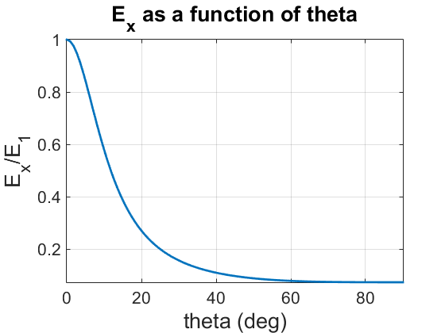

As shown in the above plot, the Elastic modulus in the reference x-coordinate strongly depends on the angle between reference and principal material coordinates. The y-axis above is normalized to the given Elastic modulus in principal material 1-direction, E_1, thus at 0 degrees theta, the two coordinates are aligned, and the normalized strength is 1. As expected, the strength of the fibers drops extremely quickly, to just 27% original strength by 20 degrees and 15% at 30 degrees. In the extrema, the fibers provide virtually nothing to material strength, 7% original strength when loads are perpendicular to fiber direction.

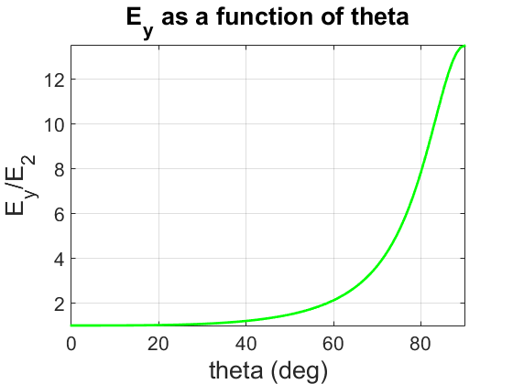

In the y-direction, the opposite to x is occurring. The y-axis is normalized to the Elastic Modulus in principal material 2-direction; in other words, the final strength in the x-direction at theta=90 degrees. Thus it starts at 1 at 0 degrees and approaches full strength as the fibers become more aligned with the reference y-direction. At 90 degrees, the final value of E_y becomes 13.5 times the original strength, or 1 over the final strength in the x-direction.

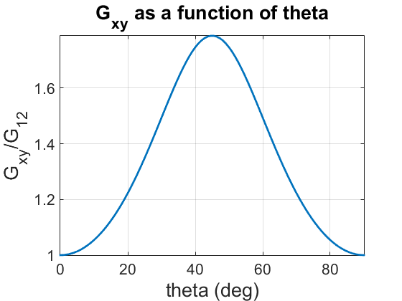

In terms of Shear Modulus, G_xy, the plot above again proves our expectations. Starting with a relative Shear modulus of 1 when fibers are aligned with reference directions, the value peaks at 1.788 times this strength when rotated 45 degrees. This sharp peak occurs because in this orientation, the fibers in the principal material 1-direction are aligned with the shear loads, and thus provide additional strength. The modulus returns to its original strength as theta approaches 90 degrees, because the fibers become more aligned with reference coordinates.

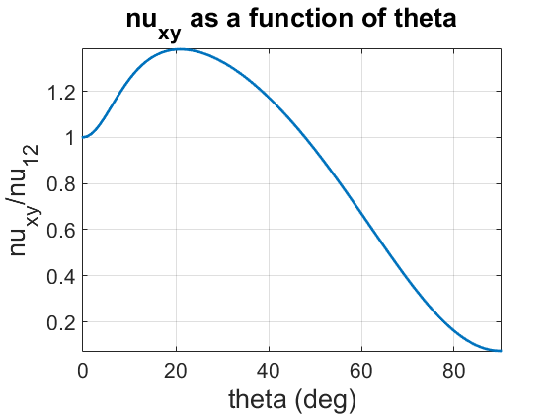

The above plot shows a normalized Poisson’s Ratio for the material as a function of theta. As expected, initially the fibers are aligned with the reference coordinates and the normalized strength is 1. As theta increases to 20 degrees, nu increases as the fibers allow for some additional shear strain along the principal material 1-direction. Beyond 20 degrees, however, the fibers begin to align with the y-direction, providing much more strength to resist this strain.

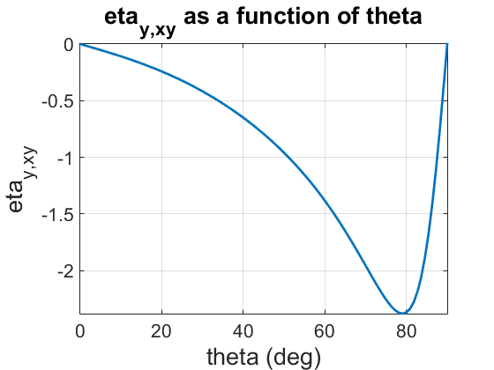

This plot shows the shear coupling coefficient eta_y_xy as a function of theta. When the fibers are aligned with the reference x-direction, there is no shear coupling, thus the coefficient is zero. As theta increases, the coupling effect gets stronger, peaking at 80 degrees before returning to zero when fully rotated to 90 degrees.