2.

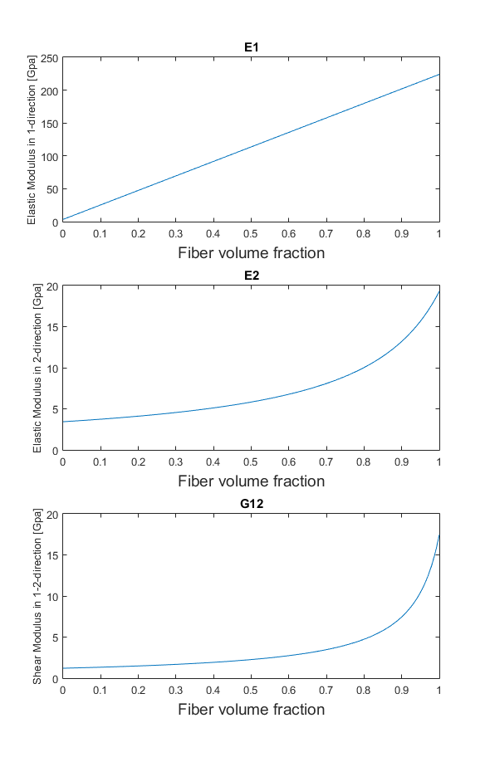

2.

The first plot show E1 as a function of fiber volume fraction. As the FVF increases, the modulus of the composite approaches that of the fiber linearly. This is because no correction is made for maximum packing volume, merely a simple analysis of what the modulus would be if you could scale it purely linearly.

The second plot shows E2 as a function of fiber volume fraction; this time the stiffness approaches the transverse modulus of fiber exponentially, as a result of the inverse rule of mixture. Again, this make the assumption that a FVF of 1 is possible, while in reality it is not.

The third plot shows the shear modulus as a function of FVF. Again it approaches the value of fiber, even though that is not realistic. It again rises exponentially as a result of the inverse rule of mixture.

3.

Ei =

35.168e+9 Pa

% Define material properties

E1 = 135.77e9;

Ef1 = 224e9;

Em = 3.43e9;

% fiber volume fraction from HW4

FVF = 0.5690;

% fiber radius from HW4

fiber_r = 3.4631e-6;

% Interphase thickness

t_i = 500e-9;

% RVE includes only fiber and interphase, no matrix. Therefore

MVF = 0;

% Calculate interphase volume fraction IVF

total_RVE_area = pi * (fiber_r + t_i)^2;

IVF = (total_RVE_area - pi * fiber_r^2) / total_RVE_area;

Ei = (E1 - Ef1*FVF - Em*MVF) /IVF

Code for Problem 2

function [ ] = composite_props_ressler( Ef1,Ef2,Em,Gf12,Gm )

%composite_props_ressler Takes fiber and matrix properties and plots the

%composite properties as a function of fiber volume fraction.

% Define fiber volume fraction array

FVF = linspace(0,1);

% Calculate Matrix volume fraction

MVF = 1 - FVF;

% Plot E1

E1 = Ef1*FVF + Em*MVF;

% Plot E1

subplot(3,1,1)

plot(FVF,E1)

title('E1')

xlabel('Fiber volume fraction','FontSize',14)

ylabel('Elastic Modulus in 1-direction [Gpa]','FontSize',10)

% Plot E2

E2 = (FVF/Ef2 + MVF/Em).^-1;

subplot(3,1,2)

plot(FVF,E2)

title('E2')

xlabel('Fiber volume fraction','FontSize',14)

ylabel('Elastic Modulus in 2-direction [Gpa]','FontSize',10)

% Plot G12

G12 = (FVF/Gf12 + MVF/Gm).^-1;

subplot(3,1,3)

plot(FVF,G12)

title('G12')

xlabel('Fiber volume fraction','FontSize',14)

ylabel('Shear Modulus in 1-2-direction [Gpa]','FontSize',10)

end