# III: Small: A System for Accessing Online Screenshot Instructions using Keywords and Screenshots

Learning never ceases. In this increasingly digitalized world, we often encounter unfamiliar tasks we need to perform using a computer application. Every such encounter is a learning opportunity. For example, we may want to learn how to set up a laptop to access a virtual private network or how to configure a printer to print in the duplex mode. Sometimes it may be the first time we need to perform the task. But often we have done the same task a while ago and simply have trouble remembering the details. In both cases, we may want to find a relevant step-by-step instruction so that we can acquire anew or refresh the knowledge needed to perform the task.

Knowledge about computer applications moves through a similar four-stage life cycle described by Birkinshaw and Sheehan (2002) as it becomes accessible to more and more people. These four stages are creation, mobilization, diffusion and commoditization. In the *creation* stage, knowledge about a computer application is implicitly conceived as the application is designed and developed. Knowledge in this stage is often volatile since the application may still undergo several design iterations before it is released. In the *mobilization* stage, as the application is getting closer to be released, developers may begin to explicitly codify the knowledge by writing instructions to explain each task that can be performed using the application. While knowledge in this stage takes on a concrete form, its content is often controlled by developers and made available only to a trusted community typically consisting of beta testers and early adopters. In the *diffusion* stage, as more users begin to use the application, they may begin to share knowledge about the application over the Internet. Knowledge in this stage propagates at a much accelerated pace since it can be created and read by to anyone. Finally, in the *commoditization* stage, the knowledge about the application may be so thoroughly diffused that it has become common sense. At this stage, many users no longer need to rely on instructions when they try to perform tasks using the application.

One of the most effective forms of codified computer knowledge is an **online screenshot instruction**, which we define as any webpage or web video where the textual contents are instructions and visual contents are screenshots. Figure 1 shows examples of online screenshot instructions. Instructions containing screenshots have been found to help users learn and perform task faster than do text-only instructions (Harrison, 95). When screenshot instructions on published online, they offer advantages over printed forms such as books and manuals in that they are more comprehensive and up-to-date. Software developers regularly publish screenshot instructions about their software products to complement built-in documentation. Institutions such as companies and schools often post screenshot instructions to teach their members how to perform important tasks ranging from installing anti-virus software to configuring email clients. Perhaps the most prolific creators of screenshot instructions are altruistic expert volunteers who frequently offer tutorials and share tips about software applications on forums, blogs, or social network sites for the benefits of all.

Not only do screenshot instructions help users in general, but also they provide stronger benefits to children and seniors in particular. For example, the International Children’s Digital Library (<http://www.childrenslibrary.org/>) gives screenshot instructions to teach children how to use its site to search for books. The senior health website created by the National Institutes of Health (<http://nihseniorhealth.gov/>) contains instructional webpages of videos with screenshots to teach seniors how to find health-related information on the site.

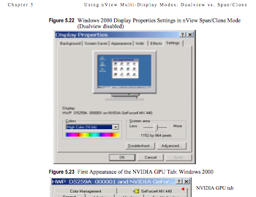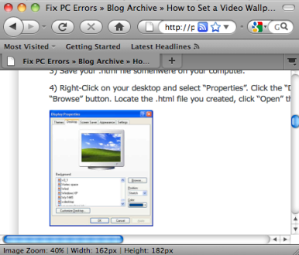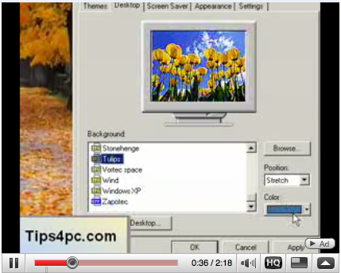

**Figure 1: Examples of online screenshot instructions in a pdf file (left), a webpage (center) and an online video (right).**

# Needs for Research

There are tens of millions of screenshot instructions available online. These screenshot instructions represent a tremendous amount of collective knowledge about computer applications. However, existing information systems, in particular text-based search engines, pose several limitations that impede the mobilization and the diffusion in the knowledge life cycle of screenshot instructions. We have identified five such limitations as the motivating factors for the needs for research:

**1. Screenshot instructions are scattered all over the Web.** To the best of our knowledge, there has not been a systematic effort to aggregate online screenshot instructions and build a centralized index. As a result, finding relevant screenshot instructions can be a frustrating experience for many users. Users may need to visit several technical support sites and browse through the directory before they can find what they want. Even if they use a search engine, they may retrieve many irrelevant pages that do not offer any instruction and need to painstakingly sift through them. Therefore, there is a need for research on how to construct a centralized, searchable knowledge repository of screenshot instructions.

**2. Keyword queries are difficult to formulate.** To search screenshot instructions using a conventional keyword-based search engine, users must come up with the right keywords to indicate both the context (which screenshot) and topic (what instruction) they desire to find in a webpage or a video. The context such as the type of operating system, the name of the application, and the name of the window may require several words to clearly specify. The topic may require even more words to describe. The result is a long list of words, which is not only mentally and physically tedious for users to generate and type but also prone to ambiguity (e.g., does the word “setup” refer to a program or a topical action?). This difficulty is even more severe for older users. Therefore, there is a need for research for a better querying method to reduce users’ input efforts.

**3. Text search does not capture screenshot relevance.** Current full-text approach to document search relies on words as the primary key to index documents. However, since screenshot instructions contain both images and text, using only words as primary keys will only capture the text content partially. A retrieved document that matches the text queries perfectly may not necessarily contain the right screenshot. Therefore, there is a need for research to identify suitable visual features to index screenshot instructions.

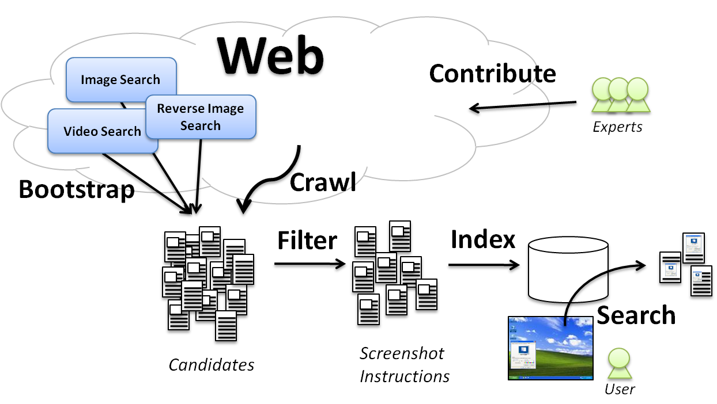**Figure 2: An overview of the scope of the propsoed research.**

**4. Text excerpts in search results are not informative.** A typical search result returned by a search engine is a list of links accompanied by short excerpts. As users browse through the list, they rely on these excerpts to decide which links are likely to be relevant with respect to their search objectives and worth exploring. However, current excerpts are text-oriented and provide no evidence regarding the visual relevancy of the search results. It can be difficult for users to judge what results are really relevant. Therefore, there is a need for research for methods to generate more informative excerpts to simplify relevancy judgment.

**5. Following instructions while interacting with a program is difficult.** As users try to follow the steps outlined in an instruction, they often need to switch back and forth between the application and the browser periodically, which can be a tedious exercise. The experience can be even more frustrating for videos because of the constant need to pause and play the video between steps. Moreover, as users perform an action and see the next screen, there is no automatic way to scroll to the part of the page or fast-forward to the segment in the video corresponding to that screen. Therefore, there is a need for research to provide effective supports for viewing screenshot instructions.

# Research Activities

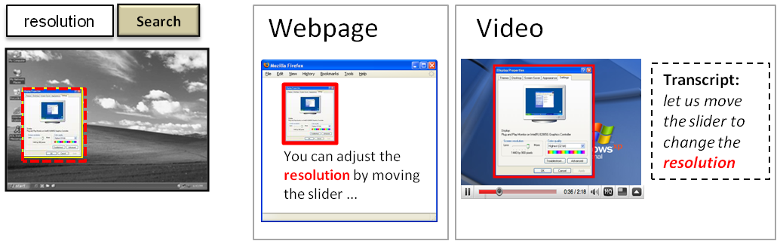**Figure 3:** **We propose to allow users to search for online screenshot instructions using a hybrid query consisting of a screenshot and one or more keywords.**

The proposed research focuses on the process and the technology involved in the use of the knowledge in screenshot instructions. Figure 2 gives an overview of the scope of our research activities. The goal of the these activities is two-fold:

1. to simplify the **process** in which users acquire knowledge from online screenshot instruction, and
2. to develop the **technology** necessary to enable the simplified process.

## Simplifying the Knowledge Acquisition Process

Given a novel task needed to be performed using a computer program, a user typically goes through a three-step process to search for a relevant online screenshot instruction to learn how to perform the task. These three-step process includes (1) *query formulation*, where the user formulates a query and submits it to a search engine, (2) *result reviewing*, where the user reviews a list of candidates returned by the engine and selects the most relevant one, and (3) *learning*, where the user reads and follows the selected instruction while using the program to accomplish the task.

### Simplifying Query Formulation

We propose to simplify query formulation by allowing users to formulate a *hybrid* query by incorporating a screenshot as an additional search term (see Figure 3). Our approach is related to several previous works also aimed to provide users with multiple search modalities instead of just keywords. For example, Narayan et al (2004) developed a multi-modal mobile interface combining speech and text for accessing web information through a personalized dialog. Dowman et al (2005) dealt with the problem of indexing and searching radio and television news using both speech and text. In the proposed research, we explore the potential of the particular modality pair of keywords and screenshots. Users can capture the screenshot of an arbitrary application window simply by stretching out a rectangle around it on the desktop screen. The captured screenshot can be submitted along with keywords to a search engine. This hybrid query including both a screenshot and keywords can provide several advantages over keyword-only queries:

* **Less input effort.** Since many of the identifying features such as the title and the visual layout are contained in a screenshot, users no longer need to enter keywords to describe the application to identify the context. Users only need to enter keywords to describe the desired topic, which requires less input effort.
* **High learnability.** The standard input method of specifying a capturing region is analogous to drawing a rectangle in a typical graphic editor. This method is already familiar to many users and is easy to learn. In contrast, learning what keywords are needed to adequately describe an application for the purpose of searching its screenshots can be more difficult.
* **Consistency across applications and platform.** Screen capturing is a common feature supported by almost every operating system. Also, screenshots are simply pixel data that can be obtained directly from the screen buffer without interfacing the underlying application. Thus, users can apply this method consistently regardless of the application and the operating system.
* **Context-topic separation.** Users will be able to use a screenshot to indicate the context and keywords to specify the desired topic. They do not need to worry about the ambiguity resulted from using only keywords to describe both the context and the topic.

### Simplifying Result Reviewing

We propose to improve the process of result reviewing by including screenshots in the excerpts. After submitting a query and receiving a list of candidate results from a search engine, users need to review the list and identify those candidates that are indeed relevant to the query. Search engines often provide an informative excerpt for each candidate to assist users to make such identification. Researchers have found adding the dominant image to the excerpt of a webpage can help users better judge the relevance of the webpage (Li, Shi, Zhang, 2008). While this finding mainly applies to keyword-based search, we expect it to hold for hybrid search. In hybrid search, a query consists of a screenshot and keywords. An informative excerpt must be able to convey the relevance of a webpage or a video to the query both visually and textually. Figure 4 (a) and (b) show our porposed designs for webpage and video excerpts respectively. In a webpage excerpt, a thumbnail of the matched screenshot on the page is displayed for users to check if the matched screenshot is correct. Keywords are highlighted in the title and surrounding snippets for users to check if these keywords are in a relevant context. A tiny thumbnail of the matched screenshot is shown for users to visualize its layout relationship with the surrounding text snippets. Similarly in a video excerpt, to help users verify the relevance of the video, a thumbnail of the matched video segment is shown and keywords in the title and the transcript snippets are highlighted. In addition, to help users visualize the context, the segments before and after are shown. The positions of the segments and the transcript snippets are marked in a timeline.

### Simplifying Learning

After reviewing the candidate list and identifying a relevant screenshot instruction, the user can finally view the instruction using a web browser or a video player and learn how to perform the task at hand. We propose to introduce two enhancements to the viewing tools to simplify the learning process.

**(a)**

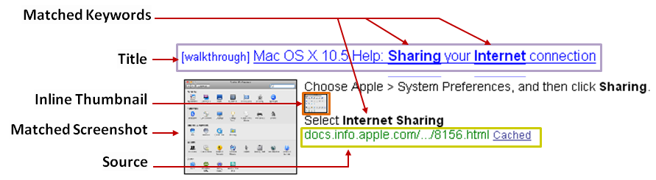

**(b)**

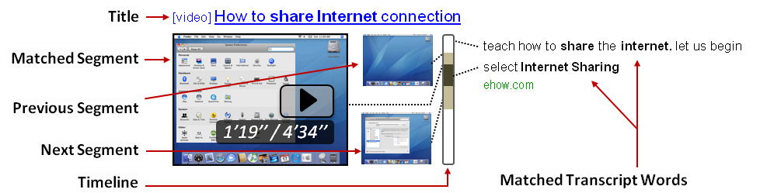

**Figure 4: Informative excerpts for (a) a webpage result and (b) a video result aimed to help users judge the relevance of the result.**

* **Visual find.** Most Web browsers provide the *find* function that allows users to find the location of a relevant keyword in the webpage and automatically scroll to that location. The *find* function is especially convenient when the webpage is long or when the keyword occurs multiple times. Likewise, since a screenshot instruction can be long and can contain multiple screenshots, users may not always see the relevant screenshot immediately at the top of the page or the beginning of the video when an instruction is opened in the viewer. In this situation, a *visual find* function that can automatically scroll the page or fast-forward the video to a relevant screenshot can provide the same desirable convenience as one provided by the standard *find* function (see Figure 5).
* **Synchronized viewing**. The goal of synchronized viewing is to free users from the tedious exercise of switching back and forth between an application and a web browser or video player. As a user moves from one step to the next, the system will synchronize the content in the browser or the video player with the visual appearance of the next application screen. The user no longer needs to manually scroll the browser or pause/play the video (see Figure 6).

### Designing for Older Adults

The design improvements proposed above are mainly geared toward general users. However, older adults have needs and abilities different from the general user population. It is necessary to design a specialized version of the interface in order to accommodate their unique needs and abilities.

To design a specialized interface for older adults, we will involve the Old Adult Team (OAT) in a participatory design process. OAT is a group of seniors recruited from the computer training courses we have been giving at a local public library (Xie & Bugg, 2009; Xie, White, Stark, Piper, & Norton, in press). The original purpose of these training courses is to understand how older adults learn and use computers and the Internet, and to improve their learning and use of technology. The creation of OAT is motivated by our desire to involve users early in the design process. We have invited advanced students who have completed the basic computer training courses to join the team. Currently, OAT consists of 23 seniors aged between 60 and 82. All but one are African Americans living in Prince George’s County, Maryland.

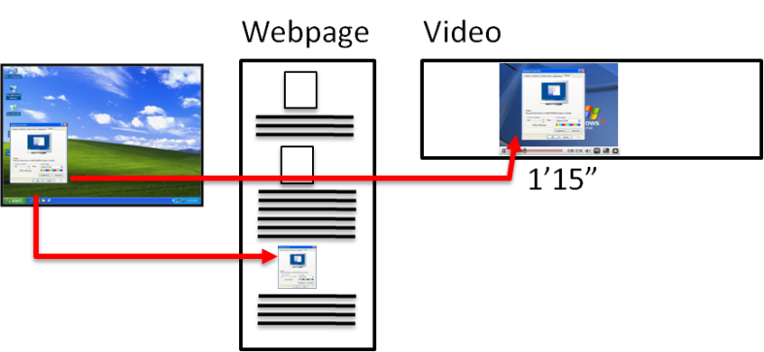

**Figure 5: Visual find. Users can find the location of a relevant screenshot in a webpage or a video and directly jump to that location.**

The goal of the participatory design is to understand the needs and abilities of seniors and to form a set of design requirements. In terms of needs, we will characterize the types of tasks seniors often need to perform. In terms of abilities, we will identify the cognitive and physical difficulties they encounter using the current search engines as well as using the standard version of our proposed interface. Once we have obtained these design requirements from OAT, we will adapt the interface accordingly and evaluate the product with OAT.

**Step 1 Step 2 Step 3**

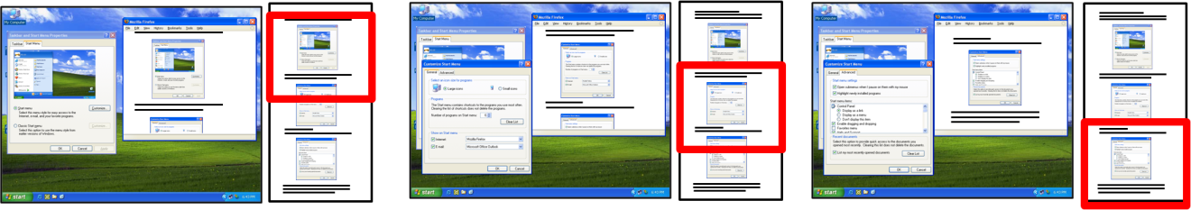

**Figure 6:** **Synchronized viewing. The content shown in a web browser is automatically scrolled as a user goes through each step in the instruction.**

### Understanding the Knowledge Life Cycle

An adequate understanding of the life cycle of computer knowledge manifested in screenshot instructions can provide valuable insight as we try to manage these resources. To gain such understanding, we will choose a number of applications due to be released in the near future to perform a longitudinal study. The goal of the study is to track the growth of the screenshot instructions for the chosen applications published on the Web. By tracking such growth and analyzing the people contributing to the growth, we hope to obtain a picture of the how knowledge moves through the cycle.

## Developing the Enabling Technology

The proposed design improvements to simplify the process of searching online screenshot instructions pose two technical challenges: (1) how can we aggregate online screenshot instructions into a centralized collection, and (2) how can we index and search the collection by both visual and textual features in order to support hybrid queries. We will outline our research plan to address these two challenges.

### Aggregating Online Screenshot Instructions

We will address the challenge of aggregating online screenshot instructions in three steps. First, we will use existing search engines as bootstraps to collect a large pool of candidate web pages or videos that are likely to contain screenshot instructions. Then, we will develop an algorithm to determine whether each candidate is indeed a screenshot instruction by analyzing its content. Finally, given a set of screenshot instructions found, we will systematically crawl their source sites in order to collect other screenshot instructions hosted on the same sites.

In the first step, we will use three types of search engines as bootstraps:

* **Image Search** An image search engine such as Google Image Search (<http://images.google.com>) takes a set of words as search terms and returns a list of links to online images discovered on pages containing these words. To use an image search engine to collect candidate pages, we will manually compile a keyword list consisting of words sampled from the title bars of various computer application windows. Some examples of these keywords can be properties, preferences, option, settings, wizard, installation, network, sound, and keyboard. We will append to the list additional keywords that are commonly found in computer instructions such as tutorial, guide, and manual. Then, we will systematically submit different combinations of the keywords in the list to an image search engine. The rationale is that these keywords are likely to retrieve screenshot images of a variety of application windows. The pages containing these screenshots are likely to provide useful computer instructions related to these application windows, thus our candidates.
* **Video Search** A video search engine such as Google Video Search (<http://videos.google.com>) in principle works like an image search engine. It takes keywords as search terms and retrieve links to online videos that may be titled or tagged with related keywords. We will use the same set of keywords as above to retrieve candidates of videos offering computer instructions.
* **Reverse Image Search** A reverse image search engine such as TinEye (<http://tineye.com>) takes an image as the query and returns a list of links to online images visually similar to the query image. To use a reverse image search engine to collect candidate pages, we will create a list of query images by manually capturing the screenshots of a wide variety of common application windows across popular OS platforms (XP, Vista, and MacOS). We will submit each screenshot as the query to a reverse image search engine to retrieve a list of similar screenshot images and links to their source pages. These pages will be the candidate pages.

Next, once a significant number of candidates are obtained using existing search engines, we need to examine each candidate and remove false positives. While an image or video search engines can retrieve candidates containing textually relevant images, there is no guarantee every image is a computer screenshot. For example, the word “display properties” can retrieve screenshots of the display properties window as well as images of properties displayed by realtors. On the other hand, given screenshots as queries, a reverse image search engine can almost guarantee every retrieved candidate must contain a screenshot. But there is no guarantee the screenshot is part of an instruction; it can be from a software catalog.

To remove false positives, we will develop an algorithm that combines computer vision and text analysis. Given a candidate web page or video as input, the goal of the algorithm is to determine whether the text content is about instructions and whether the visual content contains computer screenshots. To determine whether the text is about computer instructions, we will consider word frequency features and build topical models. To determine whether the image is a screenshot, we will consider visual features such as the size, shape, color, and texture of the image and the presence of salient visual components such as title bars, buttons, and checkboxes. In addition, we will consider the structural relationship between textual and visual features. For example, if a web page exhibits the pattern of short sentences interspersed with screenshots, it can be a sign that the page contains step-by-step instructions. We will manually label a large sample of candidates as training examples and use them to train binary classifiers such as SVM.

Finally, after obtaining sizable and filtered collection of screenshot instructions, we will further expand the collection by crawling. We will treat the source sites of the screenshot instructions currently found and use a spider to systematically visit all the links in these seed sites in order to discover other screenshot instructions.

### Indexing and Searching by Visual and Textual Features

After aggregating a large collection of online screenshot instructions, we will need to deal with the technical challenge of actually indexing and searching them using both visual and textual features. We plan to proceed in two steps. First, we will identify suitable visual and textual features as primary keys for building an index offline. Second, we will learn how to incorporate other auxiliary features to rank each result by its relevance to a query online.

A type of feature suitable for the primary key typically has the following properties: discriminative, robust to variations, can be quantized, and can be efficiently searched by similarity. We will experiment with four types of features that possess these properties for indexing screenshot instructions.

* **Word.** Many techniques have been established to use words effectively as primary keys for text document retrieval. For example, to make words discriminative, we can use a stop list to ignore common words. To make words robust to variations such as inflection, we can compute stemmed words. Words are naturally quantized and can be efficiently compared to find matching words.
* **Visual Word.** Several types of visual features have been proposed in the computer vision literature that can act as “visual words” for large-scale image retrieval applications. One notable type of such feature is the SIFT feature (Lowe, 1999). SIFT features can be extracted from salient image regions (see Figure 7) and have been shown to be discriminative in many visual analysis tasks such as object recognition. SIFT features are robust to variations in scale, translation, and rotation. For screenshots, robustness to scale and translation is particularly important because screenshots tend to be resized or cropped. Several clustering techniques such as K-mean clustering have been used successfully to quantize SIFT features (Sivic & Zisserman, 2003). Several efficient data-structures have been proposed to store SIFT features to allow fast lookup of matching features (Nister & Stewenius, 2006). Algorithms built on top of these techniques have been applied to organize other kinds of online visual resources such as geotagged photos (Crandall et. Al., 2009) and landmark images (Kennedy & Naamam, 2009).

|  |  |  |  |  |
| --- | --- | --- | --- | --- |
|  | **(a)** | **::::Desktop:Screen shot 2009-12-04 at 11.26.28 AM.png** | **(b)** | **::::Desktop:Screen shot 2009-12-04 at 11.27.51 AM.png** |

Figure 7: A typical screenshot and its (a) visual words, and (b) OCR words.

* **OCR Word.** In a computer screenshot, text can often be found in the title bar or the button of the application window in the screenshot. It is possible to extract such text using an optical character recognition (OCR) program and compute stemmed words as the primary key to index the screenshot. However, current OCR systems are optimized for analyzing text documents. We have found that their recognition accuracy is much lower when applied to screenshots because of the large amount of non-textual features such as icons and boxes also present in the screenshots (see Figure 7). Therefore, instead of using raw strings extracted by OCR, we will compute 3-grams from the characters in these strings. For example, the word “system” might be incorrectly recognized as “system”. But when represented as a set of 3-grams over characters, these two terms are {sys, yst, ste, tem} and {sys, yst, ste, ten} respectively, which results in a 75% match, rather than a complete mismatch. These 3-grams can help discriminate the screenshots while providing robustness to variations caused by OCR errors. Like regular words, these 3-grams can be easily quantized and efficiently retrieved. Moreover, the recognition accuracy can be further improved by exploiting cross-modality redundancy. For example, we can give higher weights to the OCR words that also appear as regular words in the text.
* **Speech Word.** Since videos often have voice commentary, this commentary can be analyzed to extract the words spoken in the commentary. Given the inherent unreliability of speech recognition, we can take an approach similar to the one above for OCR words to generate primary keys.

Given a hybrid query that consists of a screenshot and keywords, we can compute the four types of words as described above and lookup those documents or videos that share these words. Since there can be multiple documents or videos sharing the same words, it is important to rank them before presenting them to users.

Ranking must take into account textual and visual relevance with respect to the query. Text-based search engines rank results only by textual relevance, whereas content-based image retrieval systems rank results only by visual relevance. Neither ranking scheme is suitable here. The former may retrieve instructions with the wrong screenshots, while the latter may find the right screenshots but on a wrong topic.

We identify the following auxiliary features that may be important for ranking:

* **Text features:** the number of matched keywords, the number of action words (e.g., click, open), and the number of steps.
* **Image features:** the similarity value of the matching screenshot, the size ratio between the query and the matching screenshot.
* **Video features:** the total length of the video, the number of matching video segments, and the length of each matching video segment.
* **Multimodal features:** the number of words per screenshot, the number of lines between the matching keyword and the matching screenshot, and the spatial relationship between words and screenshots (i.e., linear or grid).
* **Page features:** the number of words on the page, the number of other screenshots on the page.
* **Site features:** the number of other computer instructions hosted on the site, the popularity of the site.

While each of the features identified above may play a role in how users judge the relevancy of a result, we do not know which features are more important than the others. We will need to learn how to assign weights to features to reflect their relative importance. To learn these weights, we will apply the RankSVM technique developed by Jochims (2002). This learning technique is able to learn feature weights from a set of subjective ordering constraints inferred from user click-through data. Since we do not have any click-through data initially, we will recruit annotators to provide us with subjective ratings of unranked results for a set of test queries. The results will be shuffled so that the annotators would not be influenced by the ordering bias. A list of ordering constraints can be inferred from the rating data. These constraints than can be provided as input to the RankSVM learner to obtain a set of weights needed for ranking search results in a way that meets users’ expectations.

# Deliverables

1. A search engine that supports hybrid queries for online screenshot instructions.
2. An enhanced viewer that provides visual seeking and synchronized browsing.
3. A specialized interface for seniors.
4. An algorithm for detecting screenshot instructions.
5. An algorithm for ranking screenshot instructions.

# Evaluation Plan

Each deliverable will undergo rigorous empirical evaluation. Wherever appropriate, comparative evaluation will be carried out against baseline systems including keyword-only and image-only search engines. Below we list the empirical questions we want to address and hypotheses we seek to test.

1. **Hybrid queries.** How much simpler it is to specify hybrid queries for searching online screenshot instructions? Our hypotheses are (a) users will spend less time specifying queries, (b) users will enter fewer keywords, (c) users will enjoy higher success finding relevant screenshot instructions, and (d) users will favor hybrid queries over keyword queries in typical usability measures such as ease-of-use and learnability.
2. **Enhanced viewer.** How much can our enhanced viewer improve users’ experience in following screenshot instructions? Our hypotheses are (a) users will spend less time following instructions to complete a task, (b) users will make fewer errors, and (c) users will prefer viewers with enhanced features to standard viewers.
3. **Specialized interface for seniors.** How much can the specialized interface help seniors? Our hypothesis is that in all the usability metrics we measure, the specialized interface will achieve higher scores compared to those achieved by the standard interface.
4. **Screenshot instruction detection algorithm.** What is the accuracy of our algorithm in detecting pages or videos that are screenshot instructions? Our hypothesis is that using both visual and textual features will achieve the highest accuracy.
5. **Ranking algorithm.** What is the effectiveness of the ranking algorithm? Our hypothesis is that our algorithm will produce a ranking judged more favorably by users than those produced by baseline approaches.

# Preliminary Studies

We have conducted two preliminary studies to evaluate the potential of the proposed project in terms of technological feasibility and usability.

For technological feasibility, we studied the idea using a small collection of screenshot instructions contained in electronic books. We were able to apply standard image-matching techniques to index more than 50,000 pages. A significant number of these pages do contain screenshots and can be considered as examples of screenshot instructions. We found indexing using regular words, visual words, and OCR words provided the best retrieval performance based on a small test set of 500 queries. We shared the result as a poster at SIGIR 2009 (Yeh and Katz, 2009).

For usability, we recruited 15 subjects to try a Web-based simulator to experience taking screenshot and typing keywords to search for screenshot instructions. All the subjects we studied found the multimodal search method novel and easy to learn. We also measured statically significant reduction in task completion time in formulating multimodal queries than in formulating keyword-only queries. These findings point to the potential usability of a search system fully taking advantage of the multimodal nature of screenshot instructions. We have published the result as a part of a full paper publication at UIST 2009 (Yeh et al., 2009).

While these preliminary studies were limited in scale (50,000 pages), in scope (only books), and in diversity (only young adults as subjects) due to resource constraints, the findings are encouraging and warrant further investigation. Therefore, we request funding to enable us to expand the project in these three dimensions. In scale, we wish to scale up to tens of millions of screenshot instructions. In scope, we wish to extend from books to web pages and videos. In diversity, we wish to involve seniors and minorities. Funding from the III program is crucial for fully realizing the broader impacts of the proposed project.

# Management Plan

The project team will consist of PI. Prof. Larry S. Davis of the Department of Computer Science, co-PI. Prof. Bo Xie of the College of Information Studies, senior research personnel Dr. Tom Yeh, and two graduate students. The composition of the team reflects the project’s synergetic nature by bringing together researchers of information science and computer vision. Prof. Davis will supervise the research and development of the necessary technology components, in particular, the algorithms for indexing and searching screenshots in web pages and videos. With her expertise on information management and computer literacy, Prof. Xie will supervise the research activities aimed to improve the process in which users can access and learn from online screenshot instructions. Also, she will lead the participatory design with the Old Adult Team (OAT). Profs. Davis and Xie will be assisted by Dr. Yeh, who will lead the integration efforts between the two sides given his successful prior involvements in similar multi-disciplinary research collaborations. In addition, Dr. Yeh will organize a regular reading group on cross-disciplinary topics. This reading group will be a forum for students from information science, computer vision, and HCI who are interested in cross-disciplinary research to meet and pursue collaborative research opportunities.

We request funding to support two graduate students, one full-time and the other part-time. The full-time graduate student will be jointly supervised by Prof. Davis and Dr. Yeh. He or she will be responsible for researching and developing all the technical components described in the proposal. The part-time graduate student will be supervised by Prof. Xie. The student will examine all issues related to the usability of the proposed information system. The two students will be required to work closely together. This collaboration will provide both students valuable learning experience conducting multi-disciplinary research.

# Work Plan

The table below outlines the three-year work plan for carrying out the proposed research. The plan is roughly divided into two parts, process and technology, that are led respectively by Prof. Xie and Prof. Davis. As a team, we will conduct bi-weekly meetings to discuss and review the progress of the project.

|  |  |  |
| --- | --- | --- |
|  | **Process**  **(Prof. Xie)** | **Technology**  **(Prof. Davis)** |
| **Fall**  **2010** | Design and implement the interface components to facilitate the process of accessing online screenshot instructions.  Begin the longitudinal study on the knowledge life cycle of screenshot instructions in the context of a real-world application. | Aggregate screenshot instructions from the Web.  Develop the algorithm to classifying online screenshot instructions. |
| **Spring 2010** | Engage in participatory design with the Older Adult Team to identify design requirements specifically for older users. | Develop the algorithm for indexing online screenshot instructions using both visual and textual features. |
| **Fall**  **2011** | Design specialized interface components according to the requirements identified by the OAT. | Develop the algorithm for ranking online screenshot instructions. |
| **Spring 2011** | Evaluate the first prototype system with both regular users and older users. | Develop the first integrated prototype system. |
| **Fall 2012** | Refine the design based on the user feedback from the prototype evaluation.  Conclude the study on the knowledge life cycle. | Improve algorithms based on problems identified in the prototype evaluation. |
| **Spring 2012** | Evaluate the final system with both regular users and older users. | Develop the final integrated system |

# Summary of Contributions

## Appropriateness for the III Program

The proposed research project is appropriate for the Information Integration and Informatics Program for the following reasons:

* This project **focuses on the processes and technologies** involved in creating, managing, visualizing, and understanding a useful class of digital content–online screenshot instructions.
* This project **relates to all stages of the knowledge life cycle** by examining the role of online screenshot instructions in each stage.
* This project **involves multi-disciplinary collaboration** among qualified researchers of information technology, computer vision, and HCI where data (i.e., screenshot instructions) plays a central part.
* This project **is grounded in a useful application domain** that can benefit a diverse group of users in learning various computer-related tasks.

## Intellectual Merits

The key contribution of the proposed project is to bring improvement to the process people access online screenshot instructions and to innovate in the technology needed to implement the process. As part of the contribution, the project will provide answers to the following important research questions:

1. What is the role of online screenshot instructions in the life cycle of knowledge related to the user of computers and the Internet?
2. What are the different usability requirements for an information system that address the needs and abilities of general users and older adults?
3. What are the defining characteristics of screenshot instructions that a machine classifier can use to automatically identify them on the Web?
4. How can we deal with the technical challenges in indexing and screenshot instructions using both visual and textual features?

## Broader Impacts

**Advance Discovery and Understanding While Promoting Teaching, Training and Learning.** Screenshot instructions are effective resources for teaching and training a broad range of users how to use computers to perform various tasks. This project specifically aims to understand the role of these resources in the life cycle of computer knowledge and discover ways to use them more effectively.

**Broaden participation of underrepresented group.** Older adults are often underrepresented in the development of modern technology. With the participation of the Older Adult Team, the project makes a strong effort to understand the needs and abilities of older adults and adapt the system accordingly.

**Enhance infrastructure for research and education.** This project identifies and establishes collaboration across several disciplines computer vision, information science, and HCI. Graduate students involved in this project can gain valuable experiences working with researchers in other disciplines.

**Broad Dissemination to Enhance Scientific and Technological Understanding.** Results and findings of the project will be published in academic conferences in all disciplines involved. In fact, early results from our preliminary studies have been well received by audience in both IR and HCI conferences.

**Benefits to the society.** This project creates a new system optimized for screenshot instructions that can positively affect the way of a broad range of users share and access knowledge about computer use. This system can potentially accelerate the pace such knowledge is diffused and propagated across the population.