ISO TC 20/SC 14 N
Date: 2007-08-22
ISO/CD 22009.10
ISO TC 20/SC 14/WG 4
Secretariat: ANSI
Space Environment (Natural and Artificial) — Model of the Earth's magnetospheric magnetic field

Warning
This document is not an ISO International Standard. It is distributed for review and comment. It is subject to change without notice and may not be referred to as an International Standard.
Recipients of this draft are invited to submit, with their comments, notification of any relevant patent rights of which they are aware and to provide supporting documentation.

Copyright notice
This ISO document is a working draft or committee draft and is copyright-protected by ISO. While the reproduction of working drafts or committee drafts in any form for use by participants in the ISO standards development process is permitted without prior permission from ISO, neither this document nor any extract from it may be reproduced, stored or transmitted in any form for any other purpose without prior written permission from ISO.
Requests for permission to reproduce this document for the purpose of selling it should be addressed as shown below or to ISO's member body in the country of the requester:
[Indicate the full address, telephone number, fax number, telex number, and electronic mail address, as appropriate, of the Copyright Manger of the ISO member body responsible for the secretariat of the TC or SC within the framework of which the working document has been prepared.]
Reproduction for sales purposes may be subject to royalty payments or a licensing agreement.
Violators may be prosecuted.

tents Page
Foreword v
Introduction v
1 Scope 1
2 Terms and definitions 1
2.1 Internal magnetic field 1
2.2 External magnetic field 1
2.3 Magnetospheric sources of magnetic field 2
2.4 Geomagnetic dipole tilt angle 2
2.5 Solar-magnetospheric coordinates 2
2.6 Magnetopause stand-off distance 2
3 General concepts and assumptions 2
3.1 Magnetic field induction in the Earth's magnetosphere 2
3.2 Magnetospheric magnetic field standardisation: process based approach 3
4 Model requirements 3
4.1 The magnetospheric magnetic field sources 3
4.2 Parameterization 3
4.3 Magnetospheric dynamics 3
4.4 Model testing and comparison with measurements 3
5 List of criteria 3
Annex A (informative) Paraboloid model of the magnetospheric magnetic field: Calculation of Induction of the Magnetic Field of the Magnetospheric Currents 5
A.1 Paraboloid model of the magnetic field of magnetospheric currents 5
A.1.1 Parameters 5
A.1.2 Submodels 6
A.2 Magnetic field of the magnetopause currents screening the geomagnetic dipole 6
A.3 Magnetic field of the tail current system 7
A.4 Ring current magnetic field 7
A.5 Magnetic field of the magnetopause currents screening the ring current 8
A.6 Magnetic field of field-aligned currents 8
A.7 Accuracy of the model 9
A.8 The other relevant models 9
A.9 References 9
Annex B (informative) Submodels 11
B.1 Submodels: Calculation of the Main Parameters of Magnetospheric Current Systems 11
B.1.1 The tilt angle of geomagnetic dipole 11
B.1.2 The distance from the Earth to the subsolar point on the magnetopause 11
B.1.3 The distance to the earthward edge of the geomagnetic tail current sheet 12
B.1.4 Magnetic flux through the magnetotail lobes 12
B.1.5 The ring current magnetic field at the Earth's centre 12
B.1.6 The total Region 1 field-aligned current 12
B.2 References 13
Annex C (informative) 14
C.1 Spherical coordinates (1) 14
C.2 Spherical coordinates (2) 14
C.3 Parabolic coordinates 14
C.4 Magnetic Field of Geomagnetic Dipole 15
C.5 Dataset for model testing 15
C.6 References 15

Foreword
ISO (the International Organization for Standardization) is a worldwide federation of national standards bodies (ISO member bodies). The work of preparing International Standards is normally carried out through ISO technical committees. Each member body interested in a subject for which a technical committee has been established has the right to be represented on that committee. International organizations, governmental and non-governmental, in liaison with ISO, also take part in the work. ISO collaborates closely with the International Electrotechnical Commission (IEC) on all matters of electrotechnical standardization.
International Standards are drafted in accordance with the rules given in the ISO/IEC Directives, Part 2.
The main task of technical committees is to prepare International Standards. Draft International Standards adopted by the technical committees are circulated to the member bodies for voting. Publication as an International Standard requires approval by at least 75 % of the member bodies casting a vote.
Attention is drawn to the possibility that some of the elements of this document may be the subject of patent rights. ISO shall not be held responsible for identifying any or all such patent rights.
ISO 22009 was prepared by Technical Committee ISO/TC 20, Aircraft and space vihicles, Subcommittee SC 14, Space systems and operations.
This second/third/... edition cancels and replaces the first/second/... edition (ISO 4:2005, ISO 22009:2006, ISO 22009:2006, ISO 22009:2006), [clause(s) / subclause(s) / table(s) / figure(s) / annex(es)] of which [has / have] been technically revised.
Introduction
This standard describes the main requirements to the Earth's magnetospheric magnetic field model. The model satisfying the set of requirements is described in the Annex as working example. The model can be used in scientific and engineering applications and is intended to calculate the magnetic induction field generated from a variety of current systems located on the boundaries and within the boundaries of the Earth's magnetosphere under a wide range of environmental conditions, quiet and disturbed, affected by Solar-Terrestrial interactions simulated by Solar activity such as Solar Flares and related phenomena which induce terrestrial magnetic disturbances such as Magnetic Storms.

Space Environment (Natural and Artificial). Model of Earth's Magnetic Field.

Scope
Standard describes the main magnetospheric large-scale current systems and the magnetic field in the Earth's magnetosphere and provides the main requirements to the model of the magnetospheric magnetic field. The standard gives in Annex the working example of the model and establishes the parameters of magnetospheric large-scale current systems which are changing in accordance with conditions in the space environment. Standard can be used to develop the new models of magnetospheric magnetic field. Such models are useful in investigate physical processes in the Earth's magnetosphere as well as in calculations, developing, testing and estimating the results of exploitation of spacecrafts and other equipment operating in the space environment.
The main goals of standardisation of the Earth's magnetospheric magnetic field are:
  - providing the unambiguous presentation of the magnetic field in the Earth's magnetosphere;
  - providing compatibility of results of interpretation and analysis of space experiments;
  - providing less labour-consuming character of calculations of the magnetic field of magnetospheric currents in the space at geocentric distances of 1.5-6.6 Earth's radii (R_{E});
  - providing the most reliable calculations of all elements of the geomagnetic field in the space environment.
Magnetic field model presented in the Annex of this standard can be used to forecast radiation situation in the space, including the periods of intense magnetic disturbances (magnetic storms) when developing systems of spacecraft magnetic orientation, when forecasting the influence of magnetic disturbances on transcontinental piping and power transmission lines.

Terms and Definitions

Internal Magnetic Field
Internal (main) magnetic field is the magnetic field produced by the sources inside the Earth's core. It can be presented in the form of a series of spherical harmonic functions. The expansion coefficients (IGRF model) undergo very slight changes in time. The International Association of Geomagnetism and Aeronomy (IAGA) is responsible for IGRF model development and modifications and approves its coefficients every 5 years. Internal magnetic field is not the subject of this Standard.

External Magnetic Field
External (magnetospheric) magnetic field is the magnetic field produced by magnetospheric sources of magnetic field.

Magnetospheric Sources of Magnetic Field
Magnetospheric sources of magnetic field are
  - Currents flowing over the magnetopause and screening the geomagnetic dipole magnetic field.
  - Currents flowing inside the Earth's magnetosphere:
      - tail current, produced by currents across the geomagnetic tail and closure currents on the magnetopause;
      - ring current, including symmetrical ring current, circling around the Earth and carried by trapped particles and partial ring current, produced by currents flowing outside the region of symmetrical ring current, mostly in the pre-midnight sector of equatorial plane, closured by field-aligned and ionospheric currents;
      - Field-aligned currents, produced by currents flowing along the auroral magnetic field lines, closured by currents on the magnetopause and in the ionosphere.
  - Currents flowing over the magnetopause and screening the ring current and partial ring current magnetic fields.
  - Ionospheric currents.
The ionospheric currents contribute to the magnetic field variation at altitudes below 1000km. In the region above 1.5 Re effect of ionospheric current is insignificant. Magnetic field of ionospheric currents is not the subject of this Standard.

Geomagnetic Dipole Tilt Angle
Geomagnetic dipole tilt angle is the angle of inclination of the geomagnetic dipole to the plane orthogonal to the Earth-Sun line.

Solar-Magnetospheric Coordinates
Solar-magnetospheric (GSM) coordinates are the Cartesian geocentric coordinates, where X-axis is directed to the Sun, Z-axis lies in the one plane with OX axis and geomagnetic dipole axis and Y-axis supplements the X and Z axes to the right-hand system.

Magnetopause Stand-off Distance
Magnetopause stand-off distance is the geocentric distance to the subsolar point on the magnetopause.

General Concepts and Assumptions

Magnetic Field Induction in the Earth's Magnetosphere
Vector of magnetic field induction 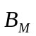 in the Earth's magnetosphere is calculated by the formula
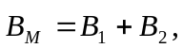 nT , (1)
where 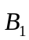 is the vector of induction of the internal magnetic field,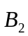 is the vector of induction of the external magnetospheric magnetic field. The magnetic field of the magnetospheric currents (external magnetic field),, is calculated in terms of the quantitative model of the magnetosphere.

Magnetospheric Magnetic Field Standardisation: Process Based Approach
The magnetospheric magnetic filed standard does not specify a single magnetospheric model, theoretical or empirical. In order to encourage continual improvements in magnetospheric modelling, this standard is process-based standard for determining the magnetospheric magnetic field. Magnetospheric magnetic field model, after its development, may satisfy the requirements in Section 4 and the list of criteria presented in Section 5. The working example of the model is presented in the Annex A and must be reconsidered every 5 years on the base of competitions of the candidate models. The current working example is presented in the Annex A.

Model Requirements
- The model of the magnetic field of magnetospheric currents (referred to below as "model") presents the vector of induction of magnetospheric currents in solar-magnetospheric coordinates.
- The model describes a regular part of the magnetic field in the region from 1.5 R_{E} to 6.6 R_{E} .
- The model reflects compression of the Earth's magnetosphere in the dayside due to interaction with the solar wind, day-night asymmetry (the field on the nightside is weakened), day and season variations.
- The model takes into account geomagnetic dipole tilt angle, varying in the range from -35º to +35º.

The magnetospheric Magnetic Field Sources
The standardised magnetospheric magnetic field is produced by currents described in Section 2.3.

Parameterization
Each magnetospheric source of magnetic field depends on parameters which are calculated from empirical data.

Magnetospheric Dynamics
The magnetospheric dynamics is determined to be a sequence of its instant states.

Model Testing and Comparison with Measurements
The model testing is carrying out with the help of databases which include the spacecraft based and on-ground measurements. The dataset used for the model testing is presented in the Annex C.

List of Criteria
The compliance criteria for this standard consist from the activities common for any candidate magnetospheric magnetic field model. These criteria specify the compliance process which includes the model documenting, publishing and testing.
- The candidate model is required to include the statement of the modeling approach used (empirical or theoretical model). The empirical models are required to include a clear specification of the input data used to derive the model and where these data were measured. Theoretical models are required to include a description of the physical principles and approaches that are used as the basis of the model.
- The statement about the candidate model area of application and domain applicability should be included.
- The statement about the rms errors during the model calculations comparison with observational data obtained from measurements should be included. For empirical models, the comparisons should also be made with data, different from those from which the model was built.
- The description and implementation of the magnetospheric magnetic field model should be published in internationally-accessible refereed journals.
- (informative)
Paraboloid Model of the Magnetospheric Magnetic Field: Calculation of Induction of the Magnetic Field of the Magnetospheric Currents
The magnetospheric magnetic field calculated by paraboloid model is the solution of the magnetostatic problem inside the paraboloid of revolution.
  - Paraboloid Model of the Magnetic Field of Magnetospheric Currents
Vector of induction of the magnetic field of magnetospheric currents is calculated by formula
. (2)
Here
  - 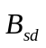 is the magnetic field of currents on the magnetopause screening the dipole field;
  - 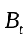 is the magnetic field of the magnetospheric tail;
  - 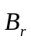 is the magnetic field of the ring current;
  - 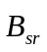 is the magnetic field of currents on the magnetopause, screening the ring current field;
  - 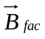is the magnetic field of Region 1 field-aligned currents.
The components of the magnetic field of magnetospheric currents, , , , , are calculated separately in terms of the paraboloid model of the magnetosphere in the form of series in the Bessel functions or Legendre polynomials.

    - Parameters
The components of the magnetic field of magnetospheric currents, , , , , 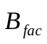are determined by the values of parameters of the magnetospheric current systems:
  -  is the geomagnetic dipole tilt angle, degrees;
  - 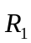 is the distance to the subsolar point at the magnetopause, R_{E};
  - 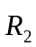 is the distance to the earthward edge of the magnetospheric tail current sheet, R_{E};
  - 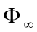 is the magnetic flux in the tail lobes, defining the current intensity in the magnetotail, Wb;
  - b_{r} is the intensity of the ring current magnetic field at the Earth's centre, nT;
  -  being for total Region 1 field-aligned currents intensity, MA.
    - Submodels
The instant values of the parameters of the magnetospheric current systems, , , , , b_{r} , are determined using a limited set of empirical data in terms of the so-called submodels (see Annex B).

  - Magnetic Field of the Magnetopause Currents Screening the Geomagnetic Dipole
The, , is calculated as
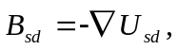
where the scalar potential 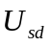 of the magnetic field of magnetopause currents is presented in spherical coordinates 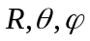 (see Annex C.1):
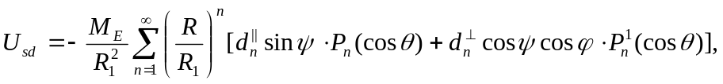 (3)

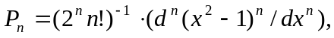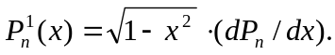
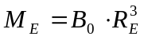 is the magnetic moment of the geomagnetic dipole, 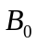 is the magnetic field at the geomagnetic equator of the Earth. The first six dimensionless coefficients 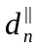 and 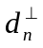 are listed in Table 1.
Table A.1 — Expansion coefficients for the scalar potential of the magnetic
field of magnetopause currents
n
1  2  3  4  5  6 | 0.6497  0.2165  0.0434  -0.0008  -0.0049  -0.0022 | 0.9403  0.4650  0.1293  -0.0148  -0.0160  -0.0225

  - Magnetic Field of the Tail Current System
The magnetic field of the tail current system is calculated from the equation
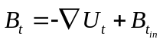 (4)
Where 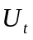 is determined by the series
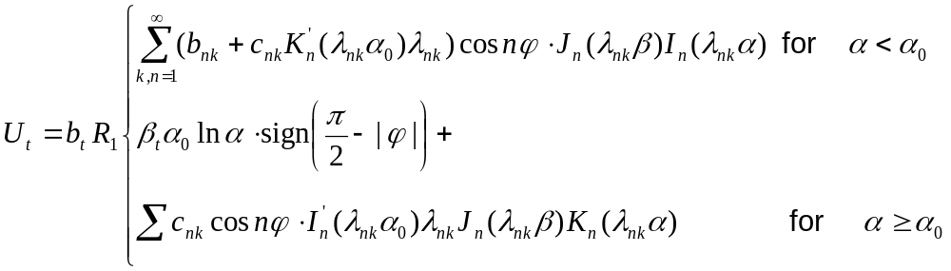

here 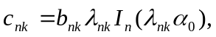 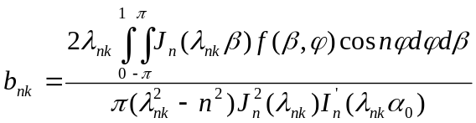.
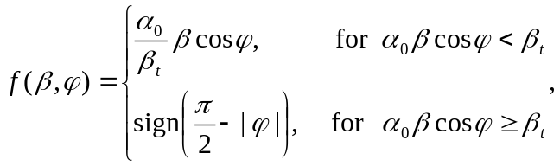
where 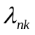 are zeros of the 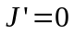 equation, 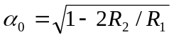 is the parabolic α-coordinate of the inner edge of the tail current sheet, 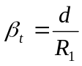, is the half thickness of the current sheet, 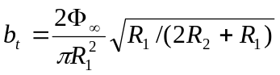, is a magnetic field in the tail lobe at the inner edge of the tail current sheet.
The magnetic field inside the current sheet, Bt_{in}, is calculated from the relations
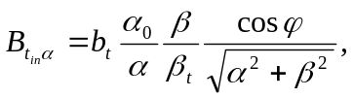 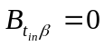, 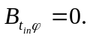
Description of the paraboloid coordinates is presented in the Annex C.3.
  - Ring Current Magnetic Field
The ring current magnetic field is determined by the expressions
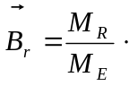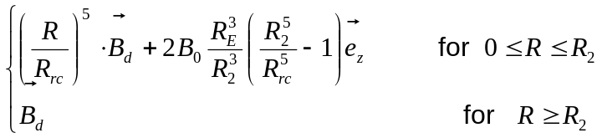 (5)
where 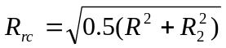, 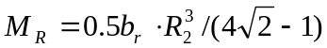 is the magnetic moment of the ring current, 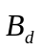 is the magnetic field of the geomagnetic dipole, 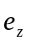 being a unite vector directed oppositely to the geomagnetic dipole.
Expressions for and in the solar-magnetospheric coordinates are presented in Annex C.4.
  - Magnetic Field of the Magnetopause Currents Screening the Ring Current
The magnetic field of the magnetopause currents screening the ring current is calculated from the equation
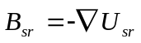,
where the scalar potential 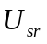 of the magnetic field of magnetospheric currents presented in spherical coordinates (see Annex C.2) reads
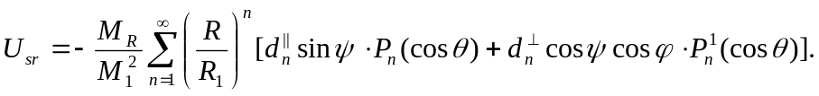 (6)
Coefficients and are listed in Table 1.
  - Magnetic Field of Field-Aligned Currents
The magnetic field of field-aligned currents is calculated from the equation
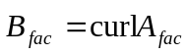
where the vector potential 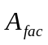of the magnetic field of field-aligned currents is presented in spherical coordinates with polar axis directed opposite the Earth's dipole (see Annexes C2, C.4):
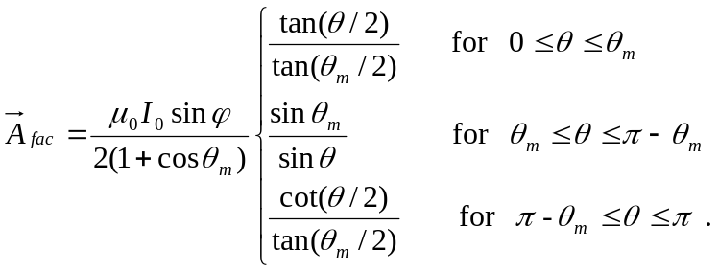
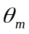- is polar cap radius in radians: 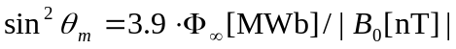.
  - Accuracy of the Model
  - Comparison with the Large Magnetosphere Magnetic Field Data Base [Faierfield et al., 1994].
Analysis of distribution of relative discrepancies integral over the whole experimental material have the discrepancy mean value about +3%, σ of the distribution is about 80%.

  - Comparisons with Dst and satellite measurements
RMS errors are about 10% -15% of peak Dst for different magnetic storms.

The comparison of the model calculations with the empirical data is presented in detail in the Explanatory Report and published in [Alexeev et al., 2001; Alexeev et al., 2003; Kalegaev et al., 2005; Feldstein et al., 2005].

  - The other Relevant Models
  - Semi-empirical T96 model by [Tsyganenko, 1995];
  - Semi-empirical T01 model by [Tsyganenko, 2001a; 2001b];
  - Semi-empirical T04 model by [Tsyganenko, 2005].
The models parameterization is performed using large magnetospheric databases, different for different models. Several model revisions reflect the different mathematical description of the major sources of the magnetospheric field and their different parameterization. The most popular T01 model parameters are geomagnetic dipole tilt angle, IMF By and Bz components, solar wind dynamic pressure, and Dst - index. An attempt is made to take into account the prehistory of the solar wind by introducing two functions, G1 and G2, that depend on the IMF Bz and solar wind velocity and their time history.
  - References
  - Alexeev, I. I. and Feldstein, Y. I.: Modelling of geomagnetic field during magnetic storms and comparison with observations, J. Atmos. Sol.-Terr. Phys., 63, 331–340, 2001.
  - Alexeev I. I., Kalegaev V. V., Belenkaya E. S., Bobrovnikov S. Y., Feldstein Y. I., and Gromova L. I.: Dynamical model of the magnetosphere: case study for 9–12 January 1997, J. Geophys. Res., 106, 25 638–25 693, 2001.
  - Alexeev I.I., E.S.Belenkaya, S.Y.Bobrovnikov, V.V.Kalegaev, Modelling of the electromagnetic field in the interplanetary space and in the Earth's magnetosphere, Space Science Review, 107, N1/2, 7-26, 2003.
  - Belenkaya E. S., I. I. Alexeev, and C. R. Clauer Jr, Field-aligned current distribution in the transition current system, J. Geophys. Res., 109, A11207, doi:10.1029/2004JA010484, 2004.
  - Faierfield et al., A large magnetosphere magnetic field database, J. Geophys. Res., 99, 11,319, 1994.
  - Feldstein, Y.I., A.I. Levitin, J.U. Kozyra, B.T. Tsurutani, A. Prigancova, L. Alperovich, W.D. Gonzalez, U. Mall, I.I. Alekseev, L.I. Gromova,and L.A. Dremukhina, Self-consistent modeling of the large-scale distortions in the geomagnetic field during the 24–27 September 1998 major magnetic storm, J. Geophys. Res., 110, A11214, doi:10.1029/2004JA010584, 2005.
  - Kalegaev V.V., N. Yu. Ganushkina,T. I. Pulkkinen, M. V. Kubyshkina, H. J. Singer, C. T. Russell, Relation between the ring current and the tail current during magnetic storms. Annales Geophysicae, V. 23, No. 2, p. 523-533, 2005.
  - Tsyganenko, N.A., Modeling the Earth's magnetospheric magnetic field confined within a realistic magnetopause, J. Geophys. Res., 100, 5599, 1995.
  - Tsyganenko, N. A., A model of the near magnetosphere with a dawn-dusk asymmetry: 1. Mathematical structure, J. Geophys. Res., 107, 1179, 10.1029/2001JA0002192001, 2002a.
  - Tsyganenko, N.A., A model of the near magnetosphere with a dawn-dusk asymmetry: 2. Parameterization and _tting to observations, J. Geophys. Res., 107, 1176, 10.1029/2001JA900120, 2002b.
  - Tsyganenko N.A., Sitnov M.I., Modeling the dynamics of the inner magnetosphere during strong geomagnetic storms, J. Geophys. Res., 110, doi:10.1029/2004JA010798, 2005.

- (informative)
Submodels
  - Submodels: Calculation of the Main Parameters of Magnetospheric Current Systems
In the paraboloid model of the magnetosphere the values of parameters of the magnetospheric current systems are calculated using submodels. The submodels represent empirical relations or auxiliary models to relate parameters of the magnetospheric current systems to the measured data. While the magnetic field dependence on parameters is fixed, the parameters dependence on empirical data can be changed by model's user. Below are the simple submodels allowing calculating the model input parameters. These submodels are not the standardisation objects.
    - The Tilt Angle of Geomagnetic Dipole
The tilt angle of geomagnetic dipole, , is calculated by the formula
(7)
where
- 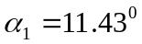 is the angle between the Earth's axis and the geomagnetic dipole moment,
- 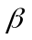 is the Sun's deflection (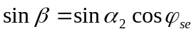),
- 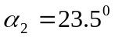 is the angle between the Earth's axis and the normal to the ecliptic plane,
- 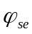 = 0.9856263(172 – I _{day} ) is angle between Earth-Sun line and the projection of the Earth's axis at the ecliptic plane,
- I _{day} is the number of the day in a year,
- 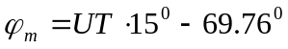 is the angle between the midnight geographic meridian plane and northern magnetic pole meridian plane,
- 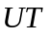 is the universal time in hours.
    - The Distance from the Earth to the Subsolar Point on the Magnetopause
The geocentric distance  to the subsolar point is calculated using solar wind data: solar wind dynamical pressure and IMF Bz component [Shue et al., 1998]:
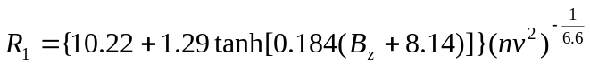.

Here B_{z} is IMF z-component in nT, n,v are solar wind concentration and velocity in cm⁻³ and km/s, respectively.

    - The Distance to the Earthward Edge of the Geomagnetic Tail Current Sheet
The distance to the earthward edge of the geomagnetic tail current sheet,, is calculated by the formula
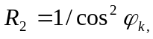 (9)
where is expressed in 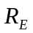, and 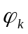 is the latitude of the equatorward boundary of the auroral oval at midnight.
    - Magnetic Flux Through the Magnetotail Lobes
Magnetic flux through the magnetotail lobes, , is calculated by the formula
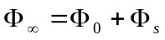 (10)
where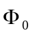 is the magnetic flux in the magnetotail during quiet periods, 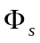 being the time-dependent magnetic flux in the lobes associated with intensification of the magnetotail current system during disturbances

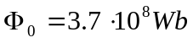
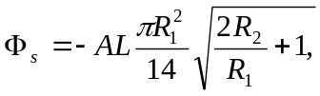 (11)

where AL is the auroral index of geomagntic activity.
    - The Ring Current Magnetic Field at The Earth's Centre
The ring current intensity is characterised by the value of ring current magnetic field at the Earth's centre, which is calculated by the Dessler-Parker-Scopke relation
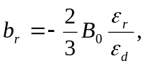 (12)
where 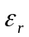 is the total energy of ring current particles, 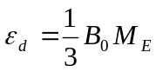 is the geomagnetic dipole energy.
    - The Total Region 1 Field-Aligned Current
The total Region 1 field-aligned current intensity is calculated by the formula
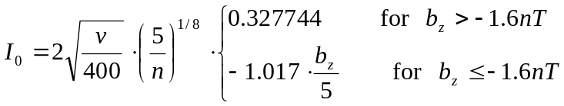 (13)
where 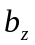 is IMF north-south component, nT, solar wind velocity v and proton concentration n are the same as in B.1.2.
  - References
  - Alexeev, I. I. and Feldstein, Y. I.: Modelling of geomagnetic field during magnetic storms and comparison with observations, J. Atmos. Sol.-Terr. Phys., 63, 331–340, 2001.
  - Alexeev I. I., Kalegaev V. V., Belenkaya E. S., Bobrovnikov S. Y., Feldstein Y. I., and Gromova L. I.: Dynamical model of the magnetosphere: case study for 9–12 January 1997, J. Geophys. Res., 106, 25 638–25 693, 2001.
  - Alexeev I.I., E.S.Belenkaya, S.Y.Bobrovnikov, V.V.Kalegaev, Modelling of the electromagnetic field in the interplanetary space and in the Earth's magnetosphere, Space Science Review, 107, N1/2, 7-26, 2003.
  - Belenkaya E. S., I. I. Alexeev, and C. R. Clauer Jr, Field-aligned current distribution in the transition current system, J. Geophys. Res., 109, A11207, doi:10.1029/2004JA010484, 2004.
  - Shue J.-H., Song P., Russel C. T., Steinberg J .T., Chao J. K., Zastenker G., Vaisberg O. L., Kokubun S., Singer H. S., Detman T. R., Kawano H., Magnetopause location under extreme solar wind conditions, J. Geophys. Res., 103,17691-17700, 1998.

- (informative)
  - Spherical Coordinates (1)
Spherical coordinates with the polar axis plotted along the Sun-Earth axis are determined by the expressions
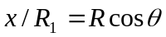
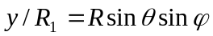 (14)
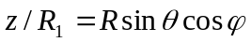
where 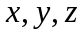 are the solar-magnetospheric (GSM) coordinates, is the polar angle plotted from axis, being the azimuths angle plotted counterclockwise from axis.
  - Spherical Coordinates (2)
Spherical coordinates with the polar axis plotted opposite the Earth dipole moment are determined by the expressions
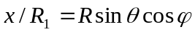
(15)
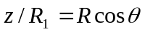
where are the solar-magnetic (SM) coordinates, is the polar angle plotted from z axis, being the azimuths angle plotted counterclockwise from x axis.
  - Parabolic Coordinates
Parabolic coordinates 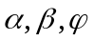 with the polar axis plotted along the Sun-Earth axis are determined by the expressions
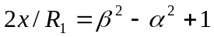
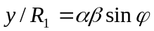 (16)
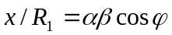
where are the GSM coordinates, being the azimuths angle plotted counterclockwise from axis. In the magnetospheric paraboloid model the magnetopause is the 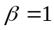 surface.
  - Magnetic Field of Geomagnetic Dipole
and 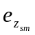 in the solar-magnetospheric coordinates are described by the expressions
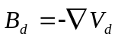
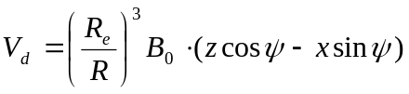 (17)
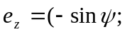 0; 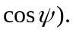
  - Dataset for Model Testing
The Large Magnetospheric Data Base [Fierfield et al., 1994] is used for the testing of the candidate models.
  - References
  - Faierfield et al., A large magnetosphere magnetic field database, J. Geophys. Res., 99, 11,319, 1994.

