ART 3870 PROJECT SUBMISSION TEMPLATE
complete this template, export to pdf and submit on blackboard

NAME: Yixin Zhang
NET ID: sd4669
COURSE: YEAR (2017)/ QUARTER (FA, WI, SP) /SECTION (01, 02)
2017/Winter/01
Project Title:
Realist Manifesto
Project Description:
Animation about Realist Manifesto
Project URL on github.com: https://github.com/doudouz94/art3870-wi17
Project URL on github.io: https://github.com/doudouz94/art3870-wi17
Project URL on ada.csueastbay.edu:

Project Sketches:
(one for each page in the project – scaled to take the whole page width, not distorted/stretched)

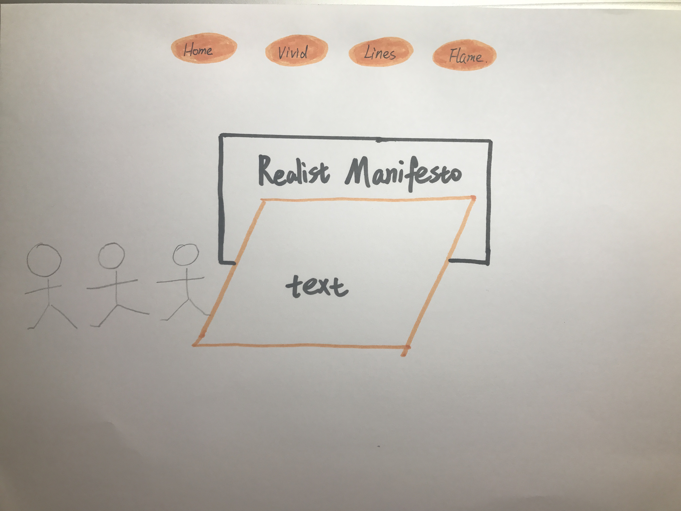

Project Design considerations:
(Explain 3 of your major design decisions)
Realist Manifesto reflects in several aspects:
The vivid color/different lines/ flame

Project Screenshots:
(one for each page in the project – scaled to take the whole page width, not distorted/stretched)
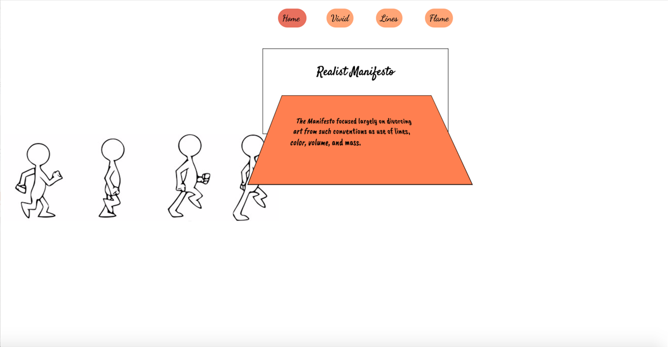
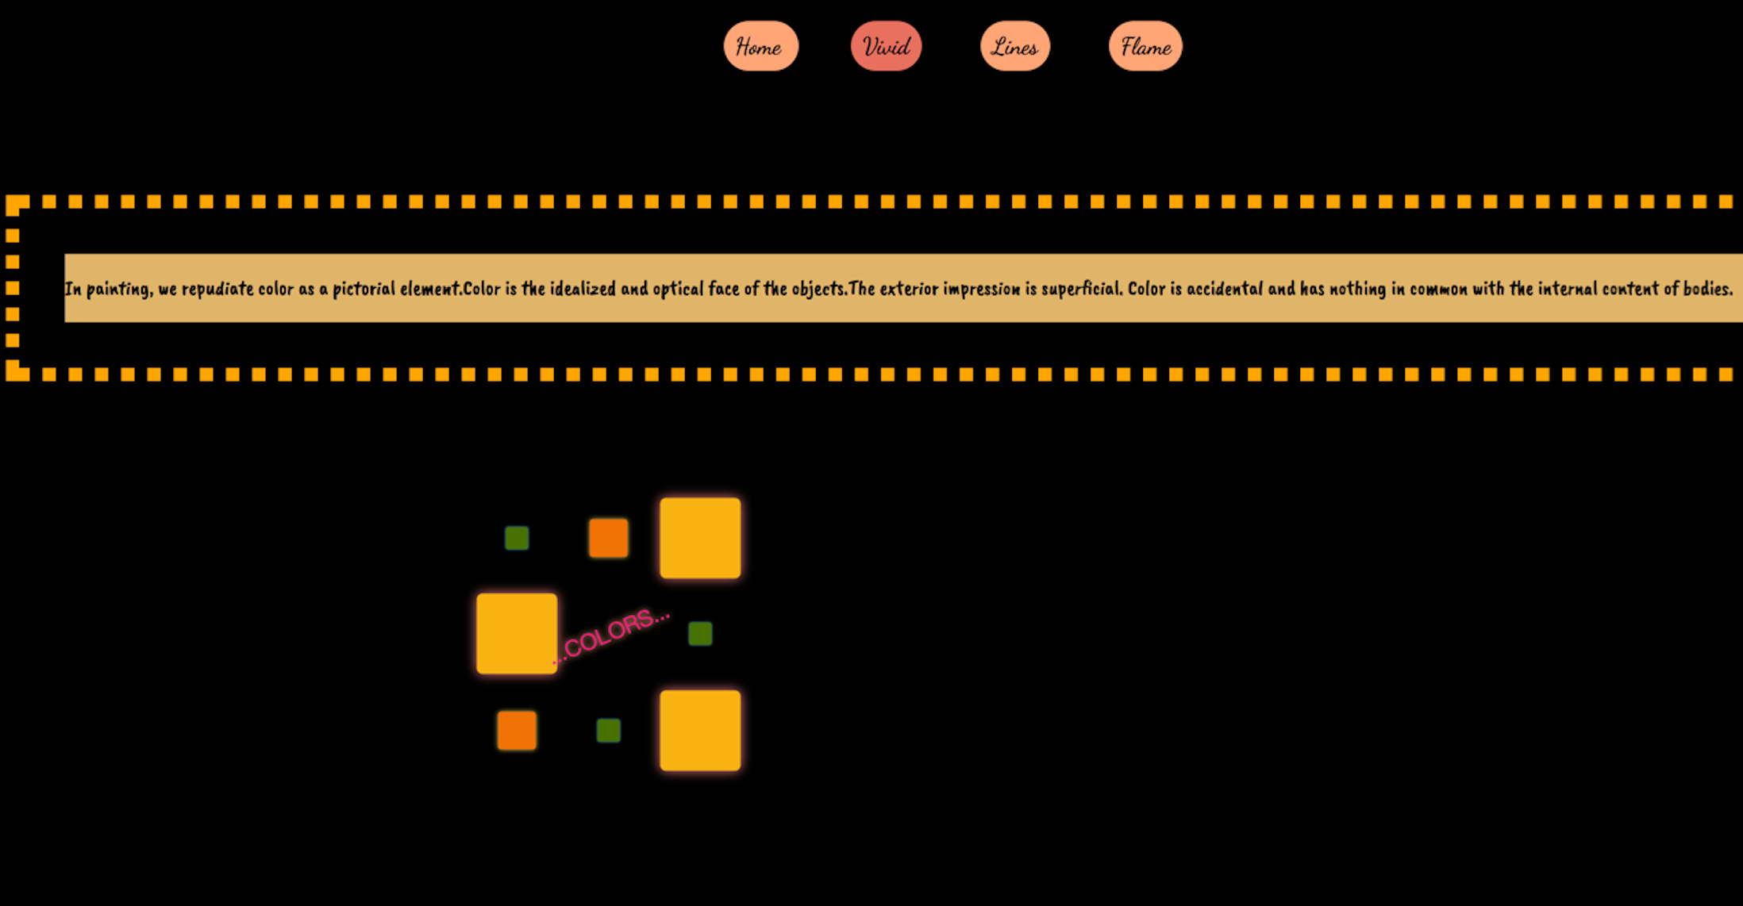
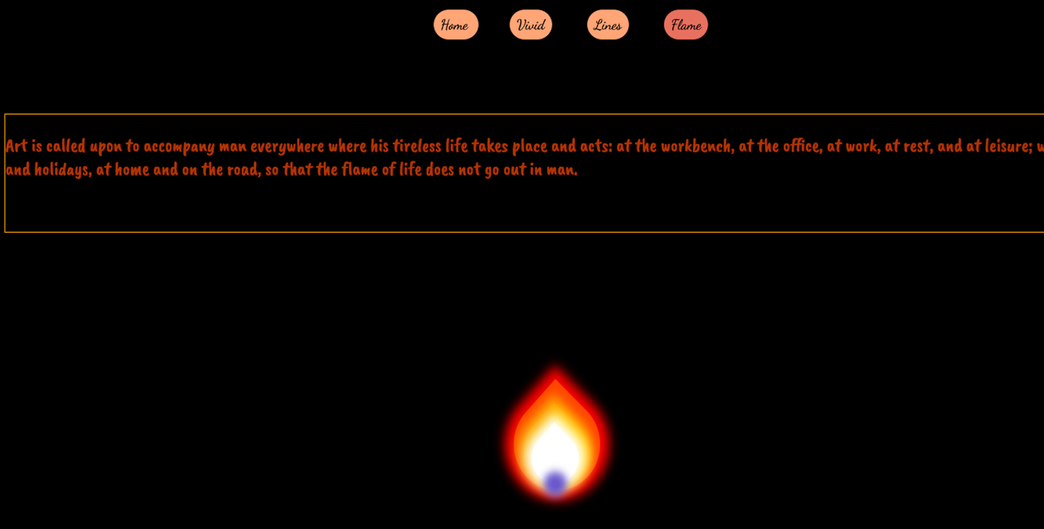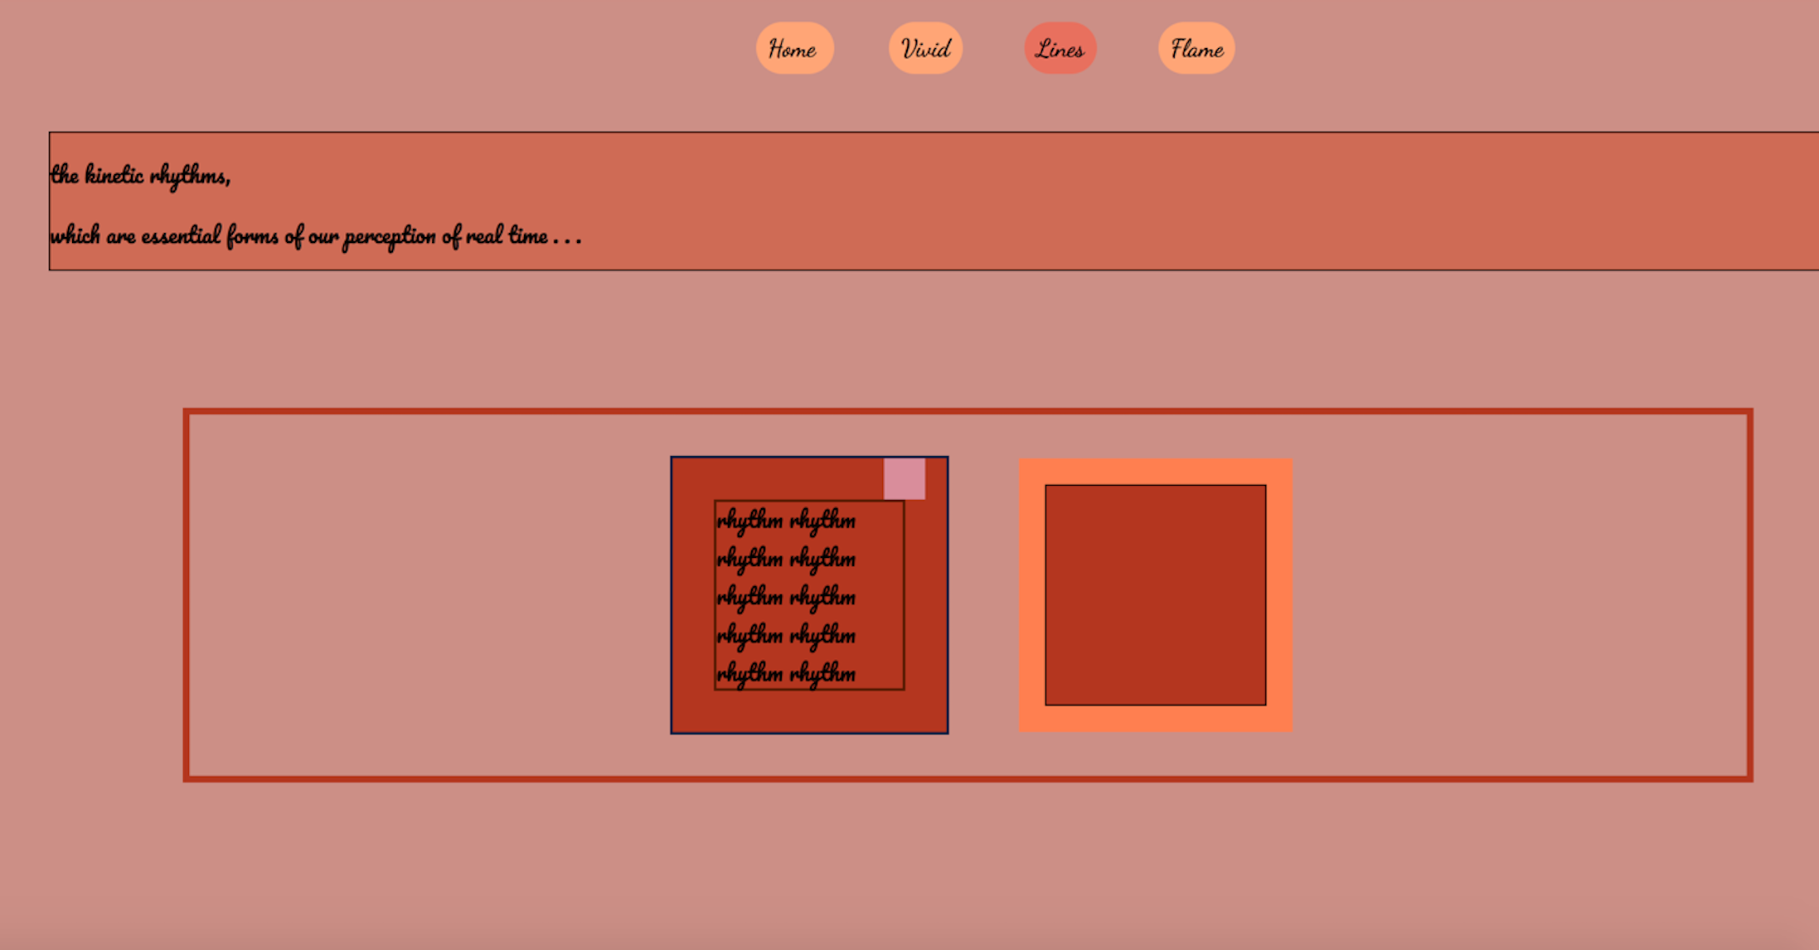
Project Reflection:
(250 words – reflective writing –What was the most challenging part? What was the most exciting part now that the project is done? What did you learn in this assignment, what is your biggest takeaway?)
In this project, my theme is Realist Manifesto, and there are some definitions of the theme in my project: 1. Color is the idealized and optical face of the objects. The exterior impression is superficial. Color is accidental and has nothing in common with the internal content of bodies. 2. We acknowledge the line only as the direction of static forces that are hidden in the objects, and of their rhythms. 3. Art is called upon to accompany man everywhere where his tireless life takes place and acts: at the workbench, at the office, at work, at rest, and at leisure; work days and holidays, at home and on the road, so that the flame of life does not go out in man. The most excited part is in the line’s page. There are several boxes are contained in to others, and it is really hard to control each one’s size. That takes time to fix the transforms in each box.

