### [M5 Assignment — Graphic Redesign](https://mymasonportal.gmu.edu/webapps/assignment/uploadAssignment?content_id=_12830228_1&course_id=_421977_1&group_id=&mode=view) Report

I. Introduction

I chose to redesign an infographic on US income inequality for the module five redesign project. The original graphic is quite long, so I have cropped it to focus on the radial bar chart that I remade. This graphic comes from the website *yourlawyer.com* and was published in August 2020. Data was sourced from a report by the Economic Policy Institute (EPI) titled *The New Gilded Age* published in July 2018.

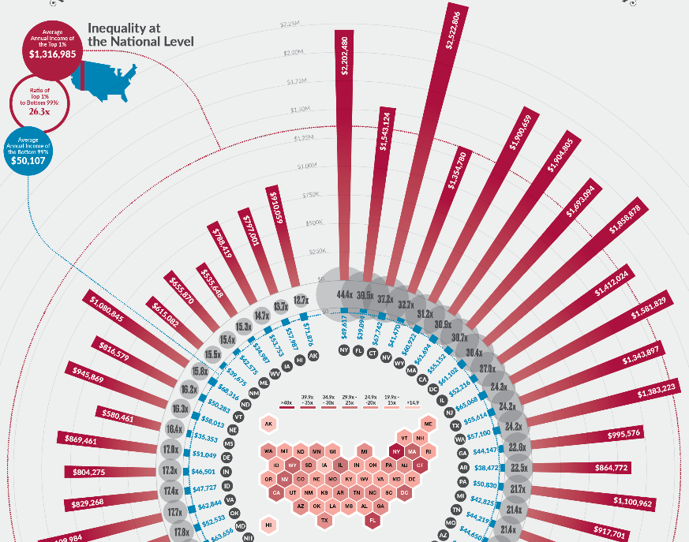  
Figure 1: Original Infographic Cut to Focus on Radial Bar and Hexbin Plots

II. Original Graphic Analysis

This bar chart does a few things well. It is visually appealing with bold red and blue colors and features a large radial bar chart surrounding a hexbin choropleth US state map. The states have been sorted by their income inequality ratios – highest to lowest going clockwise. The colors red and blue have been fairly consistently used to represent the top one percent and bottom ninety-nine percent, respectively. However, the middle hexbin plot also uses gradients of red to encode income ratios. The bar plot uses length encoding to show the average annual incomes for each group and includes radial grid lines and dashed national average lines as well. The infographic does a good job with the callouts highlighting the top one percent and bottom ninety-nine percent national averages and tying them to the dashed circular lines. Unfortunately, nowhere is it mentioned that the incomes are 2015 incomes. Units of measure are included – US dollars are denoted with a *$* and ratios with an *x* after the ratio number. I like how the hexbin plot enables examination of regional or geographical trends, but I would have preferred a divergent color scheme with a broader range of colors – like green to purple – as the dark red to pink does not provide enough contrast. The income ratio gray bubbles do provide us with some way to compare ratios among states, but they are so big they overlap each other and parts of the red and blue income bars. Speaking of the income bars, they do use the length encoding so the scales are accurate for state to state comparison, but the comparisons are not easy. To see the state the bar is tied to we need to zoom in more and by then we can no longer see all the red bars around the plot to compare them! There is just too much going on here, too much complexity for the sake of visual appeal.

III. Special Efforts

Data used in the infographic comes from a long (more than 60 pages) report by the EPI where data is shown in many tables. Unfortunately, it was not accessible in a convenient format like a csv or Excel file. This required locating the correct income tables and copying and pasting them into an Excel workbook. Dollar signs, quotes, and percent signs were then removed from data frame columns in R to display correctly in the subsequent plots created. Compared to classmates’ descriptions of their munging efforts, mine seems to have been a bit less strenuous as my R program was only about 100 lines long including formatting the data and creating the linked micromaps. Making the national income trends time-series plot took more work to produce with all the added annotations that aid in comprehension.

IV. Redesigned Graphics

As shown in my oral presentation, I created several iterations of a linked micromap along with the national income time-series plot. First, I started with a replica of the radial bar plot showing the income ratios and the respective top one percent and bottom ninety-nine percent average annual incomes, but showing these as bars on varying scales was not much of an improvement (if at all). Since I’ve never created micromaps before, I relied on the excellent R documentation and examples from *rdocumentation.org* and *rdrr.io* to aid my redesign.

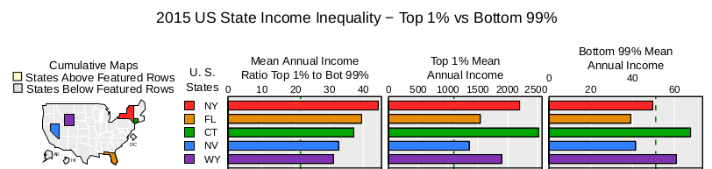  
Figure 2: Linked Micromap Version 1 – Replica of Original

Since micromaps seem to be better at showing percentages than comparing absolute values like in Figure 2 above, I returned to the EPI report to grab some time-series data and add income share trends. Also, bars on all three columns was taking up a lot of real-estate, so dots and arrows were used in version two below. Already this looks better to me as the dots can zoom in on the full data range with no constraint of including 0 like bar charts. We can more easily facilitate comparisons across states than what the gray bubbles were attempting to do on the original graphic. This is due to the superiority of a length encoding versus a size encoding. With dots we can now add a dashed line to show the mean income for all the states and highlight which are above and below that line. Now the middle column can reveal income trends over time, but is almost duplicated in the right hand column, with the former representing absolute change and the latter percent change.

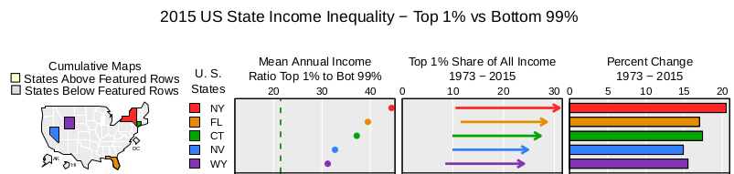  
Figure 3: Linked Micromap Version 2 – Dots and Time-series

Figure 4 is the final version and it shows income inequality trends over 87 years – inequality reduction in the first half of the twentieth century (1928 - 1973) and the reversal of those trends in the second half (1973 - 2015). The hexbin choropleth plot is not as effective as this linked micromap plot in showing comparisons of income ratio inequality across the US states. From this redesign we can clearly see that a few states at the top have much higher income ratios than the majority of the other states and tend to reside more on the coasts. This trend was not apparent from the original graphic’s gray bubbles or the hexbin plot showing the income ratios.

After seeing the two income share trends going in opposite directions, I wanted to investigate the income trends more. This led me to create another plot (Figure 5) – a line plot of the top one percent and bottom ninety-nine percent incomes from 1928 to 2015. I added dots and labels to the three timeframe cutoff points - the beginning incomes in 1928, incomes at 1973, and ending incomes in 2015. The trend we see here is quite striking. The top one percent’s annual income begins its big rise in the mid 1970s and grows by almost 200% over 40 years. Many annotations were added to this plot to help the viewer see the contrast in trends over time between the two groups.

V. Summary

The redesigned graphic facilitates quick and accurate comparisons across states while also examining income inequality trends over time and across regions, while reducing complexity with perceptual grouping and proximity linking. The individual top one percent and bottom ninety-nine percent bars were dropped, but the ratio encompasses this information, so not much is lost. The added time-series plot with annotations increases our context by showing the income inequality trends over time, not just at one particular point in time. However, all the graphics presented here only cover the symptom of income inequality, not any factors that might be contributing to it. Some next steps would be to find more data to investigate causes of this inequality, research events that may have made such a drastic shift in incomes possible, fit regression models, and test several hypotheses to identify the existence of variable relationships and their respective intensities.

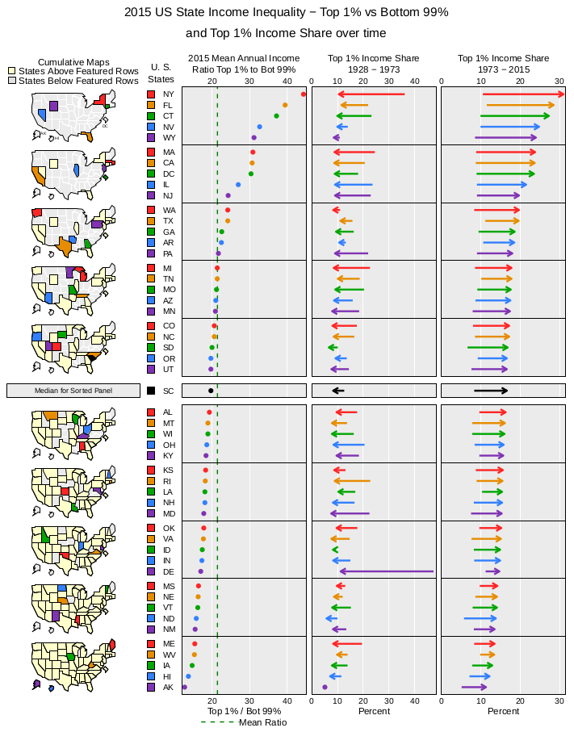  
Figure 4: Linked Micromap Version 3 – Inequality Trend Reversals

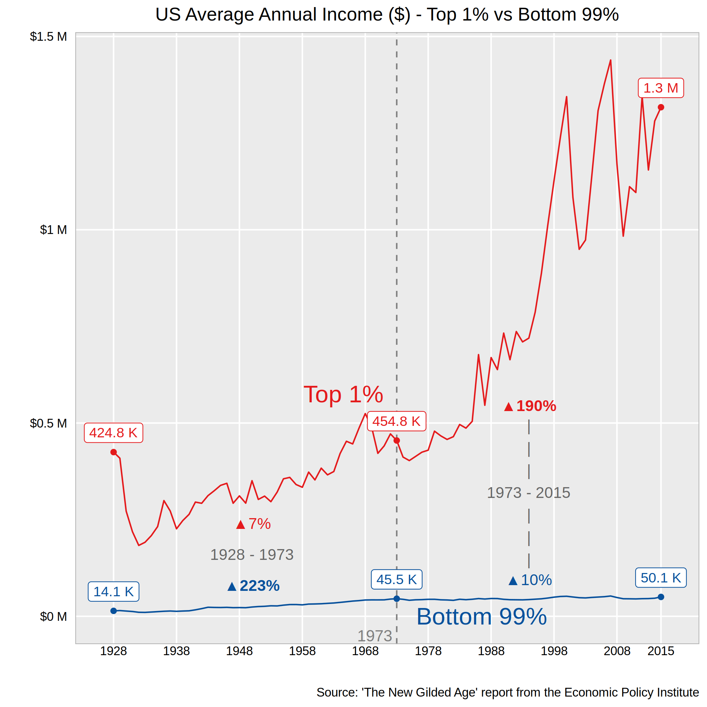Figure 5: Line Plot - National Income Inequality Trends

***References:***

Income Inequality Between the 1% and the 99% in the United States - YourLawyer.com - Infographic. (2020). [Blog]. Retrieved from https://www.yourlawyer.com/library/united-states-income-inequality/

micromapST function - RDocumentation. Retrieved 2 April 2021, from https://www.rdocumentation.org/packages/micromapST/versions/1.1.1/topics/micromapST

micromapST: Linked Micromap Graphics Package in micromapST: Linked Micromap Plots for General U. S. and Other Geographic Areas. Retrieved 2 April 2021, from https://rdrr.io/cran/micromapST/man/micromapST.html

Sommeiller, E., & Price, M. (2018). *The New Gilded Age*. Economic Policy Institute. Retrieved from https://www.epi.org/publication/the-new-gilded-age-income-inequality-in-the-u-s-by-state-metropolitan-area-and-county/