AIT580 – Data Analysis Individual Project

Deliverable 1 – Data Selection:

- Dataset Metadata (size, item meanings, types)

Data was pulled from the OpenDota API for 986 professional Dota 2 eSports matches played between June 2 and Sep. 17 of 2020. The raw dataset in json format takes up 270 megabytes (MB). After my Python program parses this dataset for the information I need and saves it as a tab-separated file (tsv) its size was reduced to 1.1 MB.
Table 1: Dataset fields - meanings and data types
Deliverable 2 – Data Analysis:

- Descriptive Statistics and Visualizations

Summary statistics
Figure 1 below shows the summary statistics for the Dota 2 dataset including Tukey’s five number summary for quantitative values – min, first quantile, median, third quantile, max – as well the median and number of NA’s (if present). For a given match, the combination of match_id and player_slot (0-5 or 128-132) can be used to uniquely identify each record. We can see that most fields have a right skew to them with generally small numbers and a few larger outliers influencing the mean to be greater than the median. There are no missing values in any fields. From the radiant.win field, we can see that there may be a disadvantage to being on the Radiant side of the arena (bottom left side) as more Radiant teams lost their matches. Exploring descriptive statistics and visualizations is part of the Exploratory Data Analysis (EDA) process and is key to truly understanding a dataset and conducting accurate and thorough analyses.
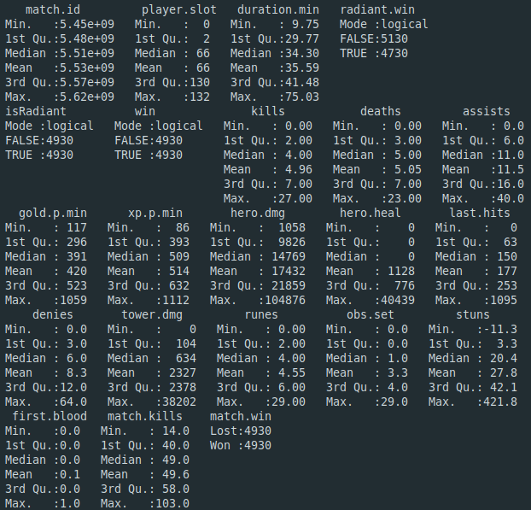Figure 1: Summary statistics for dataset using R summary() function
Descriptive visualizations
We can build on our dataset knowledge and do sanity checks by visually looking at frequency counts for each column. In my case, match.kills was originally centered around 250 with each player getting about 5 kills per match. With only 10 players in each match (50 total kills), these numbers didn’t match up.. this led me to correct a bug in my program and correct the match.kills column. This highlights just one of many reasons to do EDA in the data analysis process.
Hero.dmg looks to have the largest range (from 0 to over 90,000), while kills has the smallest range (0- 30). As we saw in the previous summary statistics, many fields have a right skew where the majority of the data lies in the smaller ranges , but has a few larger outliers to the right side. Experience per minute (xp.p.min) seems to be the most normally distributed, along with match.kills and duration.min. From the distributions below, we can surmise that a typical match lasts about 35 minutes with 50 total kills with individual players amassing 10 assists, 5 deaths, 5 kills, 15,000 hero damage, 150 minion kills (last hits), 5 minion denies, 400 gold per minute, and 500 xp per minute.
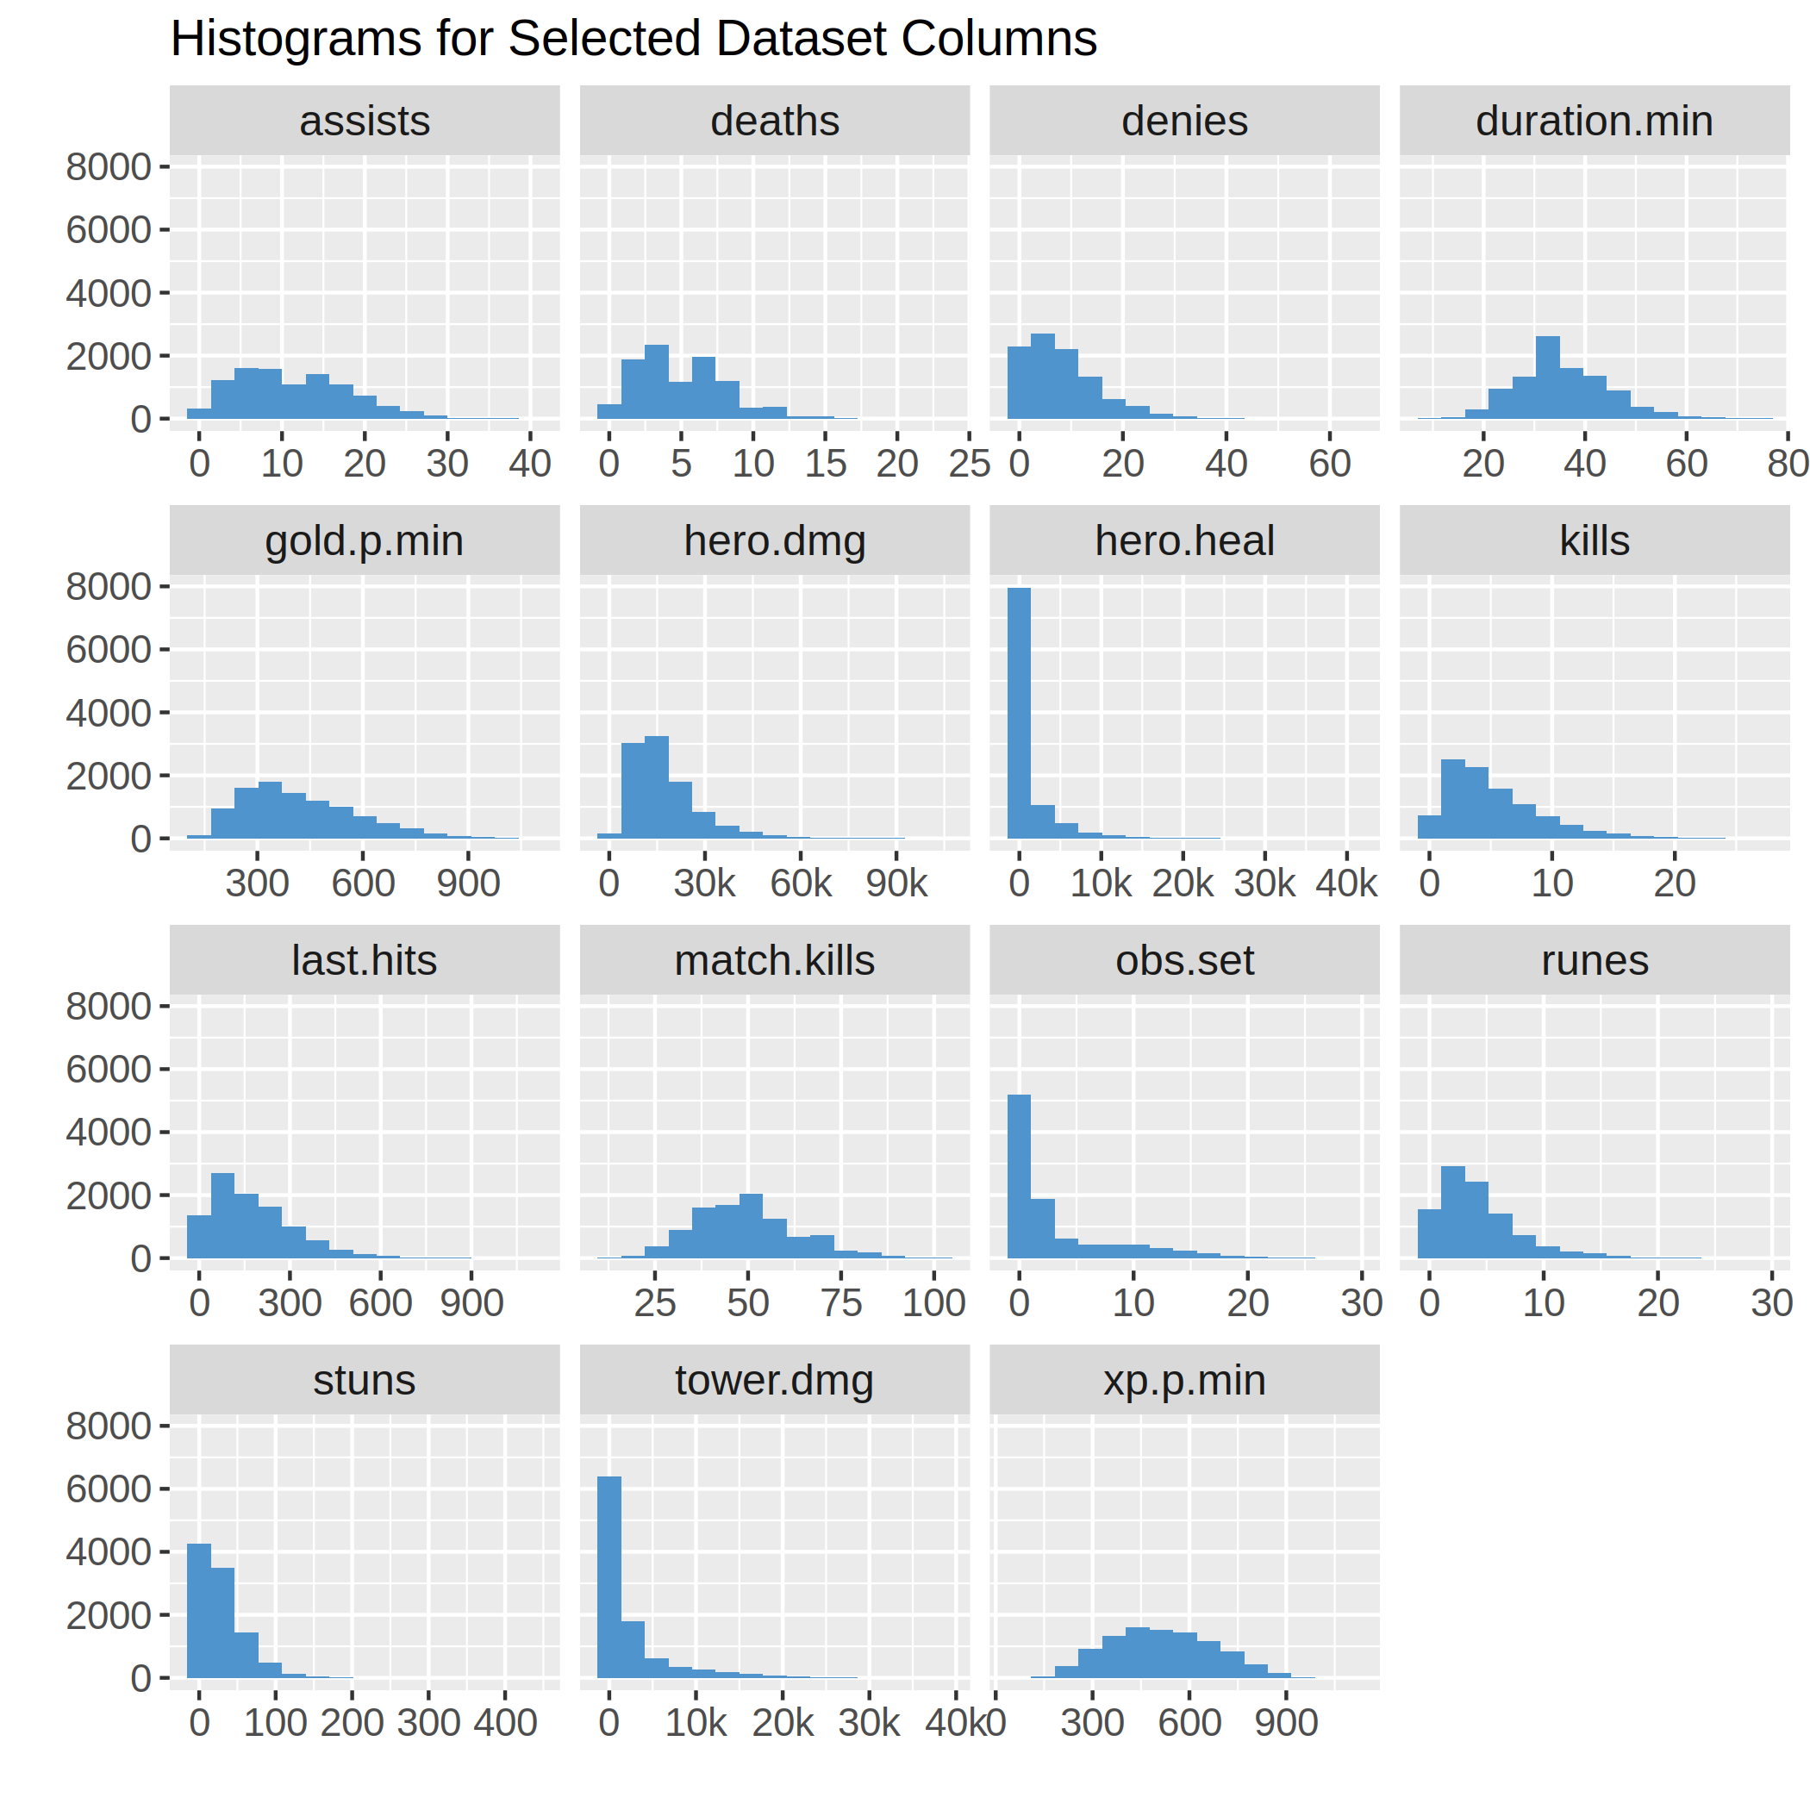Figure 2: Histograms for many dataset columns
Boxplots for a few columns with similar ranges
Boxplots – like summary statistics and histograms – show the distribution of values for a given column, but from a slightly different perspective. Below in Figure 3 we can see the distribution for an individual player’s assists, deaths, denies (minion denies), kills (hero kills), and runes. Each is on a very similar scale ranging from 0-65 with most values around 5-10. While both boxplots and histograms show a column’s distribution, boxplots excel at highlighting where the majority of the points lie (the middle 50%) and where there are outliers above or below this middle set. Outliers are denoted with dots above or below the whiskers – the vertical lines coming out of the boxes on either side. We can see quite a few outliers for each column highlighted below. While we already looked at the histogram visual, this boxplot also makes it easy to see that each of these 5 columns have a right skew to them.
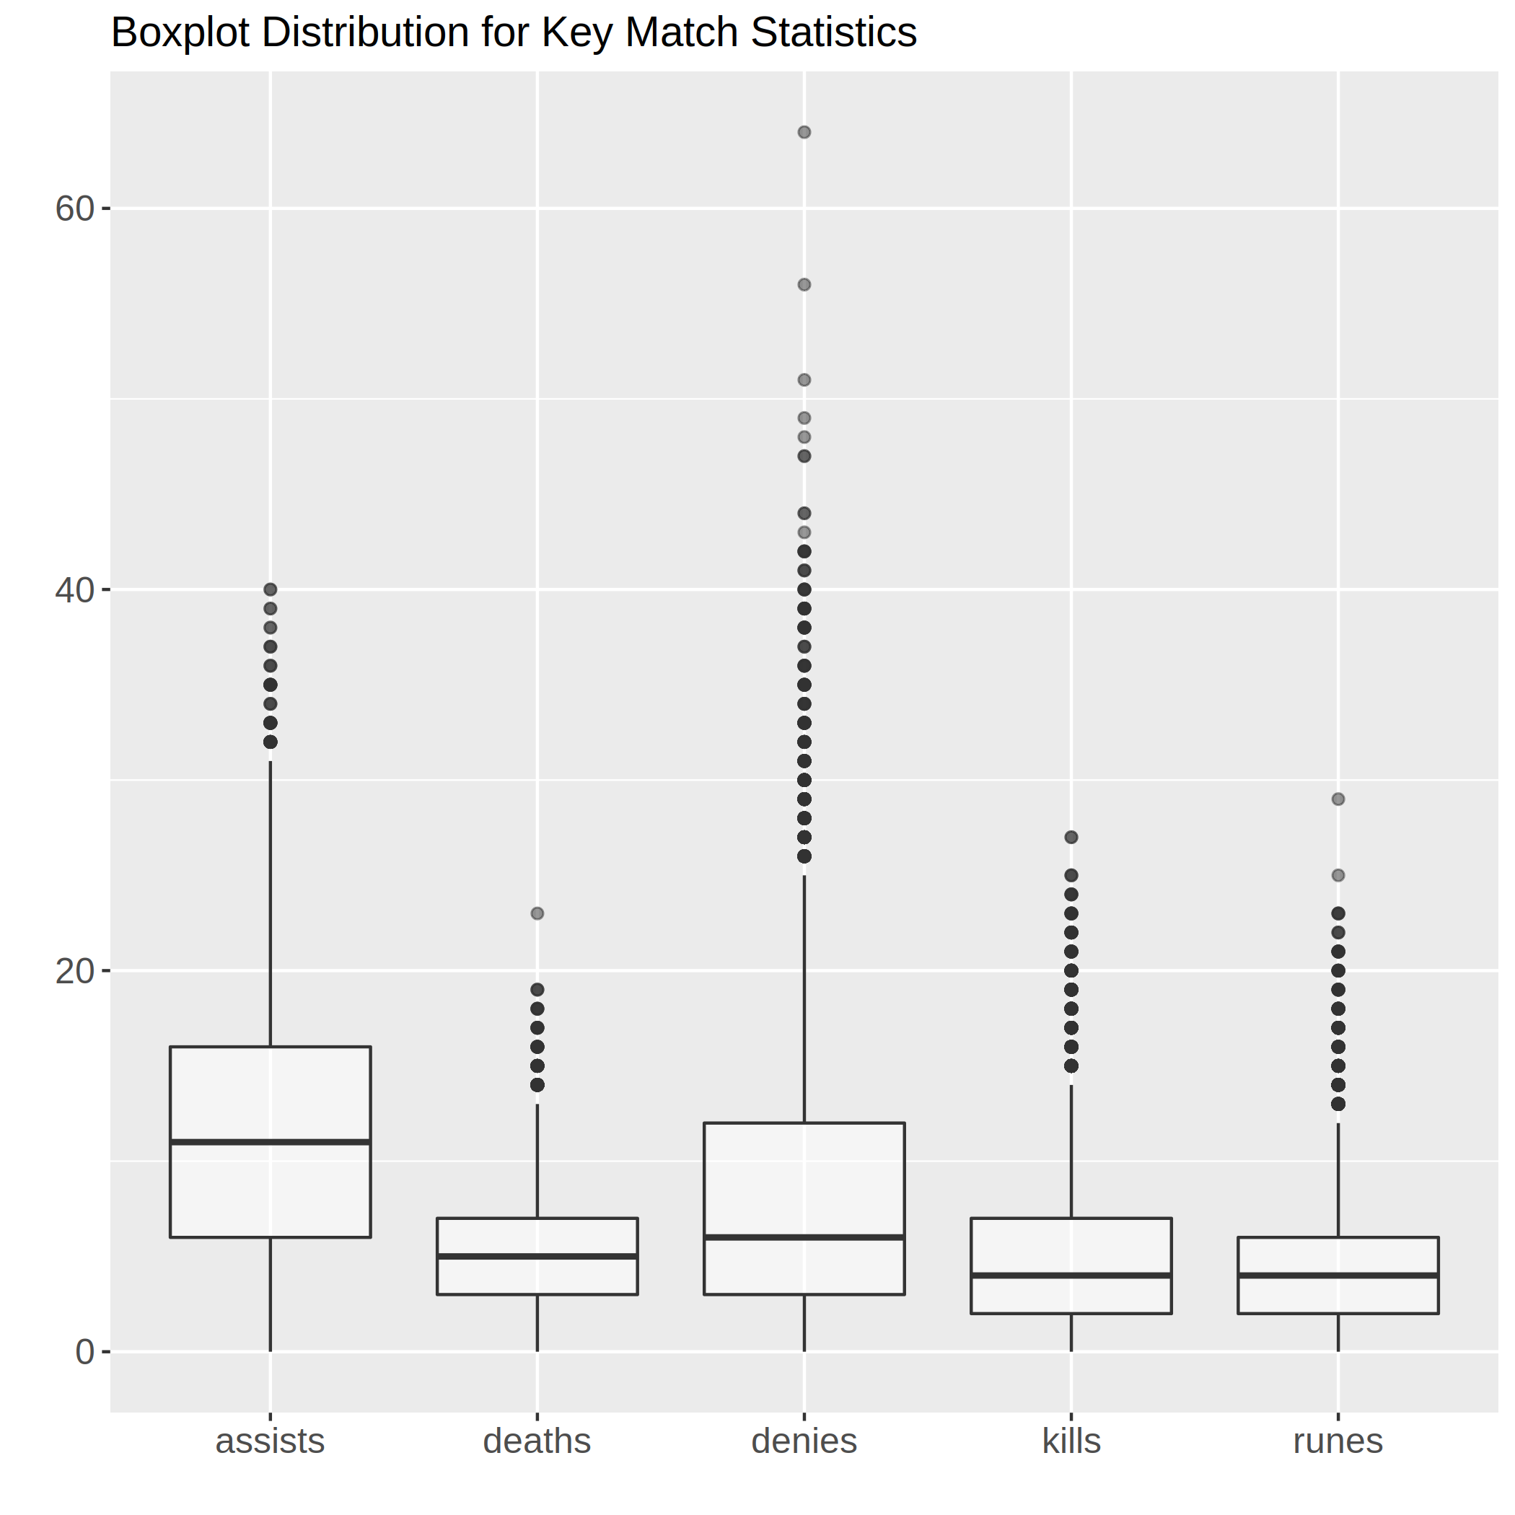Figure 3: Boxplots for a few columns with similar value ranges

Correlation Matrix
After we have explored the dataset and determined if there are any inaccuracies we need to investigate (missing data, column range out of line with expectations, outliers), we can move to identifying relationships among the variables. Figure 4 shows the correlation matrix among many variables and indicates a strong correlation with a darker color (blue or red) while indicating the direction by the color – blue being positive and red being negative. The strongest relationship (0.88) appears to be between a player’s gold and xp per minute, which intuitively makes sense; if a player is getting a lot of gold and kills and not dying much, they will naturally level up faster than other players. We can see kills and deaths have a moderate relationship to gold and xp per minute, though in opposite directions. If you have never played a game like Dota 2 before, you can still gain a small understanding of good and bad things to happen in a match, like deaths has a negative (red) correlation with many other columns so it is probably bad, while kills and assists have mainly positive ones. From this introductory analysis, assists (damaging enemy heroes while teammate gets killing blow) seem to correlate most strongly with winning a match.
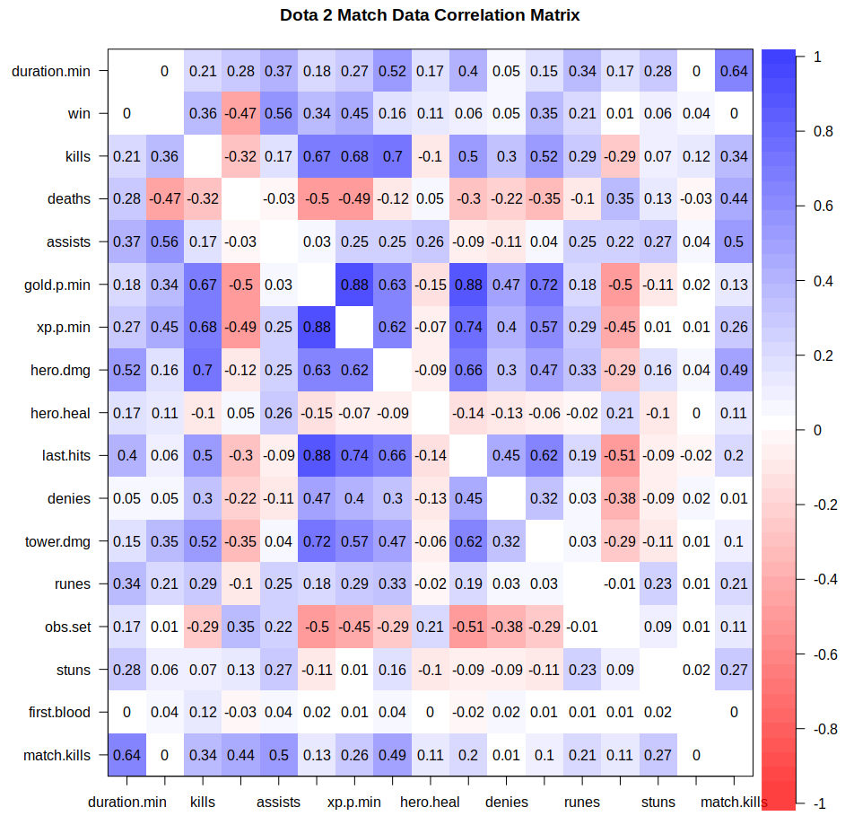Figure 4: Correlation matrix of selected numeric columns
SQL Schema for Dataset
A SQL schema defines the columns of a dataset along with their data types, type lengths (if applicable), primary keys, and not null designations. Table 2 below defines the SQL schema for the dataset. While I don’t use the field match.id.slot in any of my data analysis, it is the key that makes every row unique and was useful in my Python program to update the first.blood column with every player that scored a first blood kill with a 1 (after initializing every row to 0). I typically use an underscore in my Python program column names, but I am doing my exploratory analyses and visualizations in R where I like using periods.

Table 2: Dataset SQL Schema

SQL-based queries of dataset (Oracle SQL syntax)
- Count number of games and calculate average match duration:
SELECT
COUNT(DISTINCT "MATCH.ID") "NUM.MATCHES",
AVG("DURATION.MIN") "AVG.MATCH.DURATION"
FROM DOTA2_DATA;

- Find minimum kills, maximum kills, and average hero damage for each player slot for players that won the game:
SELECT DISTINCT
"PLAYER.SLOT",
MIN(KILLS) "MIN.KILLS",
MAX(KILLS) "MAX.KILLS",
AVG("HERO.DMG") "AVG.HERO.DMG"
FROM DOTA2_DATA
WHERE WIN = TRUE
GROUP BY "PLAYER.SLOT";

- Find the match ids, total last hits, total denies for all matches for the Radiant teams that got first blood (first kill in the match):
SELECT DISTINCT
"MATCH.ID",
SUM("LAST.HITS") "MATCH.LAST.HITS"
SUM("DENIES") "MATCH.DENIES",
FROM DOTA2_DATA
WHERE "ISRADIANT" = TRUE
AND "FIRST.BLOOD" = TRUE;

- Find the average gold per minute, xp per minute, and total hero damage for all matches with at least 25 total kills and at least 1 player with at least 500 gold per minute who picked up 2-5 runes:
SELECT DISTINCT
AVG("GOLD.P.MIN") "AVG.GPM",
AVG("XP.P.MIN") "AVG.XPM"
SUM("HERO.DMG") "TOTAL.HERO.DMG"
FROM DOTA2_DATA TA1
WHERE "MATCH.KILLS" >= 25
AND "MATCH.ID" IN (
SELECT "MATCH.ID"
FROM DOTA2_DATA TA2
WHERE "GOLD.P.MIN" >= 500
AND "RUNES" BETWEEN 2 AND 5);

- Interpret the Results and Draw Conclusions

Q1. What is the mean number of kills in a Dota 2 match stratified by match duration?

Overall, the mean kills per match is almost 50 – 49.65 to be exact. Once we stratify by match duration, the story is a bit more clear – the mean kills per match increases with increasing match duration. Logically, this makes sense as a longer game will generally feature more kills as there is more time to kill the enemy characters. Interestingly, the highest duration category featured fewer kills and bucked the positive trend, though only 2 matches were in that highest category. The number of matches for each duration category is at the base of each bar, so we can tell that the majority of matches lasted 20 to 60 minutes with about 50 kills each. Only 3 times did the matches last less than 10 minutes or greater than 69 minutes.

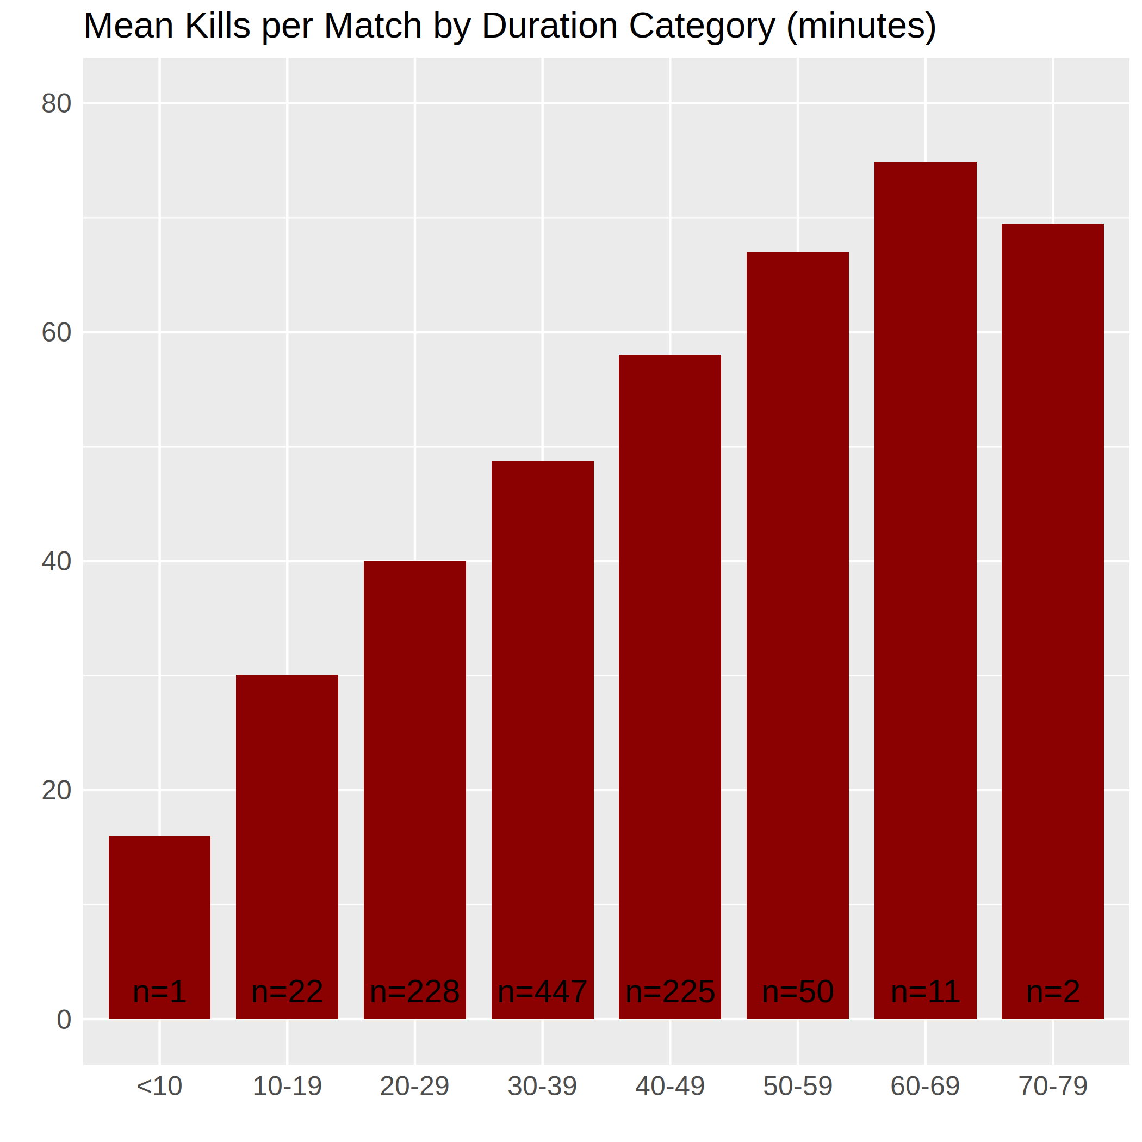Figure 5: Bar Plot of Mean Kills per Match Split by Duration Bin
Q2. What is the distribution of match durations?

From the last question, we got a little idea of the match duration distribution, but here we can look more closely at it. Figure 6 below shows the distribution of match durations; we see it is close to being normally distributed with a median of 34.3. The tails are fairly tight meaning the standard deviation is small relative to the mean. We can tell that the vast majority of these professional Dota 2 matches last between 20 and 60 minutes.
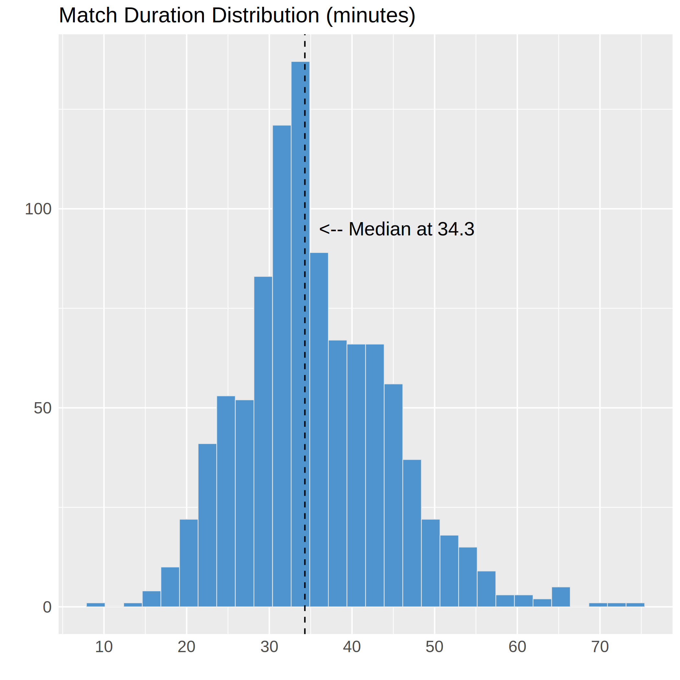Figure 6: Histogram of Match Duration (mins)

Q3. How does kill death assist ratio (KDA) correlate with experience per minute (XPM)?

The KDA is calculated using a piecewise function (to handle 0 deaths case):
KDA = { if deaths > 0: (kills + assists) / deaths,
else: kills + assists }

I first calculated the correlation coefficient between these 2 variables and the result is 0.5276, meaning the R² value is 0.278. This indicates there is a weak to moderately strong relationship between a player’s KDA and their experience gained per minute (XPM). Since there are almost 1,000 matches represented in the Figure 7 plot, an alpha transparency value was applied to the scatter plot to better show each individual point and clusters of points. The blue line is a linear regression line added with R’s geom_smooth function with the ‘lm’ parameter to force a linear model to be used instead of ‘loess’ smoothing. With this scatter plot we can visually see the weak relationship as the points generally trend upwards, but there is a lot variance along both axes.

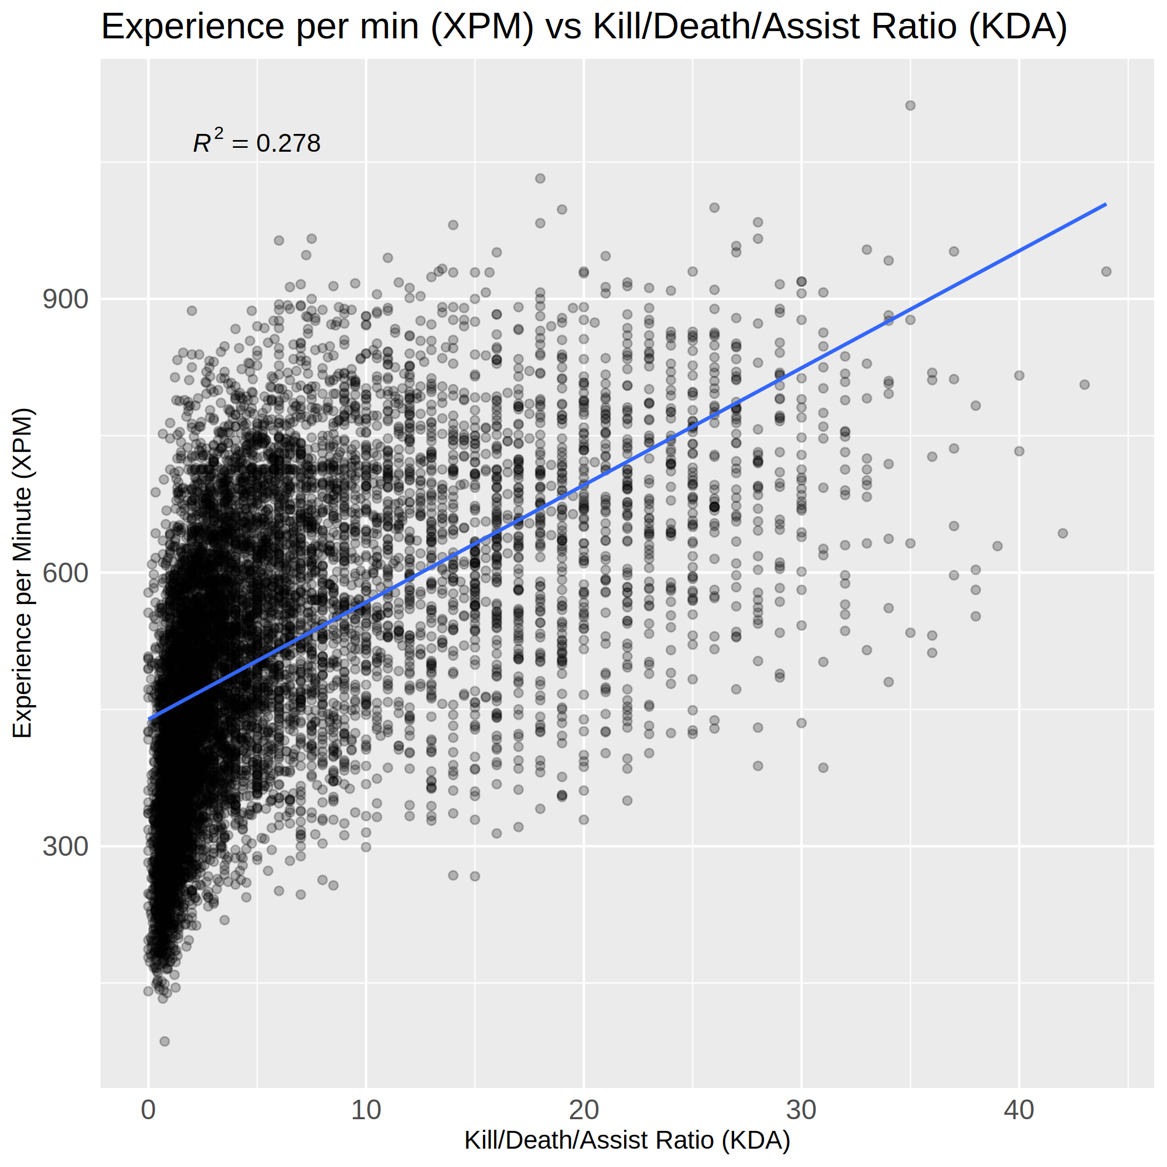Figure 7: Scatter Plot of XPM vs KDA
Q4. Does the team that drew first blood (got the first enemy kill) win more often?

I had a feeling that teams that drew first blood (scored the first enemy character kill) would win more often, but 57% is a significant advantage. This seems to indicate that scoring the first blood kill may lead to a snowball effect where the team gets a small advantage and continually builds upon it culminating in a victory. Honestly, for a long time my program calculated a 96% win rate for teams with first blood kills, until I reviewed my Python parsing program and corrected a bug where a first blood kill was defined by finding the last kill (max kill time in a log of kills and times) instead of the first kill (min kill time). It definitely makes sense that the wrong version indicated a 96% win rate as a winning team will be stronger and very often gets the final kill in a match to destroy all the towers and the enemy’s ancient to win the match. These corrected numbers seem a lot more reasonable and it should have been a red flag that the results were almost too strong, too good to be true.

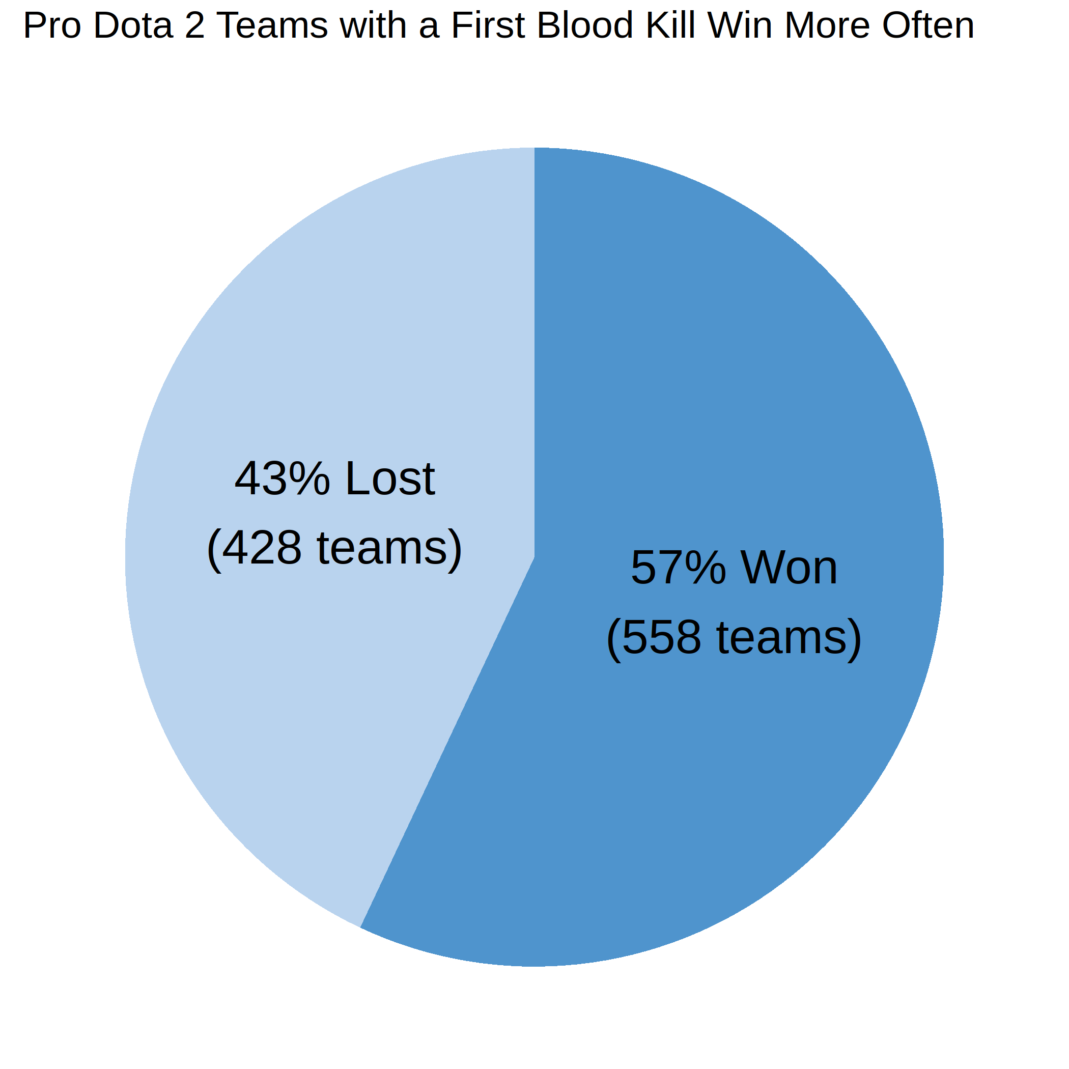Figure 8: Pie chart of Win % for Teams Who Drew First Blood

Q5. Does gold per minute (GPM) or experience per minute (XPM) have a higher correlation with a match win?

I looked at the correlation coefficient R and R² value for both cases – Win vs GPM had a correlation coefficient R of 0.342 and R² of 0.1169, while Win vs XPM had a higher correlation (R of 0.4471 and R² of 0.1999). Neither one of these relationships are very strong, though. This could be due to the fact that GPM, XPM, and a Win are all after the fact indicators aggregating decision making during a match; none of them can tell a player where to improve, only that accumulating more gold and experience per minute is good and leads to wins.

What I found interesting in trying to answer this question was the visual of GPM and XPM for winning and losing teams. Figure 9 below shows that players on winning teams have higher GPMs and XPMs relative to players on losing teams, as expected.
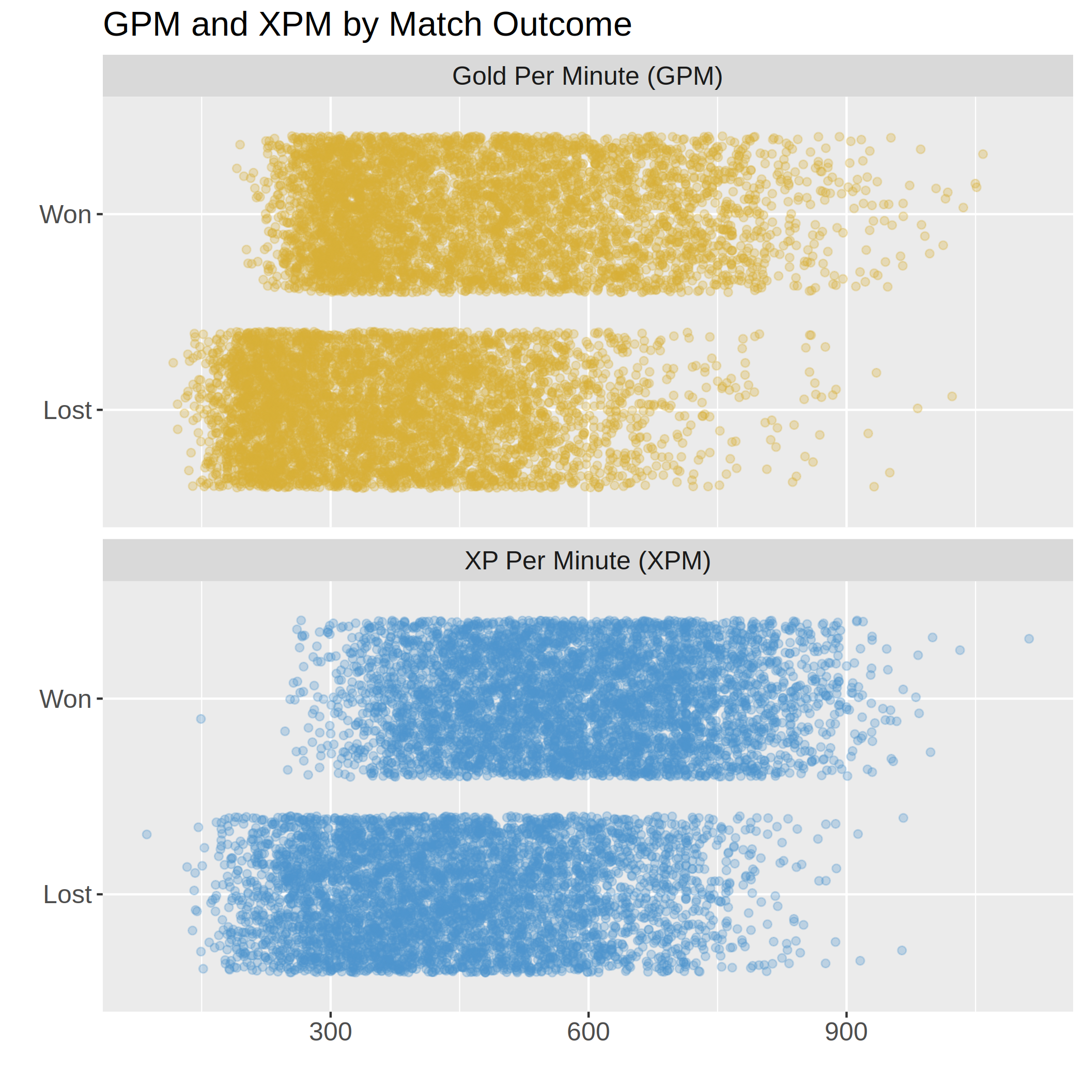Figure 9: Jittered Scatter Plot of GPM and XPM by Match Outcome
Q6. Do players with 500 or more GPM win matches more often than players with less than 500 GPM?

Though the relationship between a players having greater than or equal to 500 GPM and winning a game is quite weak (R² of 0.067), it does seem like (from Table 3) players with at least 500 GPM do win their matches more often. Since this analysis is at the player level and not all players on a team will reach 500 GPM but can still win, a better question to answer is do winning teams have a significant difference in median team GPM? We can investigate that in Q7 below.
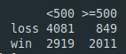Table 3: GPM vs Win

Q7. Do winning teams have a significant difference in median GPM?

H_{o} (null) : there is no significant difference in median GPM between winning and losing teams
Median GPM_{win} = Median GPM_{lose}
H_{A} (alternative) : there is a significant difference in median GPM between winning and losing teams
Median GPM_{win} ≠ Median GPM_{lose}

Testing Assumptions of Student’s T Test:
1. Normality with Shapiro-Wilk test:
H_{o} (null) = groups are normally distributed
H_{A} (alternative) = groups are not normally distributed

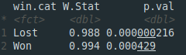Table 4: Results of Shapiro-Wilk test
We can see in Table 4 above that both p-values are significant, so we must reject the null hypothesis and conclude that both groups are not normally distributed. We can visually see this in quantile-quantile (QQ) plots on the next page in Figure 10.
Figure 10 shows a quantile-quantile (QQ) plot of median team GPM. Most points fall roughly across the line, however several are outside the 95% confidence interval bands for the Lost group. This confirms our previous Shapiro-Wilk test findings of student’s t-test normality violations.
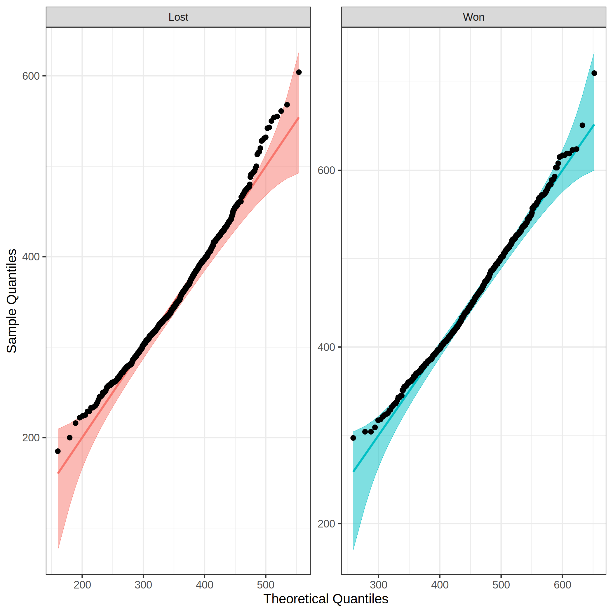Figure 10: QQ Plot Testing Normality of Median Team GPM
Wilcoxon Rank Sum Test
Since normality is violated, a student’s t-test is no longer an appropriate test to perform on this dataset. A non-parametric version is available in the Wilcoxon Rank Sum Test ("Independent Samples T-test in R | Statistical Methods", n.d.).
H_{o} (null) = equal medians between Won and Lost groups
H_{A} (alternative) = medians of the 2 populations are not equal

Figure 11 below shows the results of a Wilcoxon rank sum test for median team gpm by win category (Won, Lost). The p-value is very significant, so we reject the null hypothesis and can conclude that the medians of the Won and Lost distributions do indeed differ.
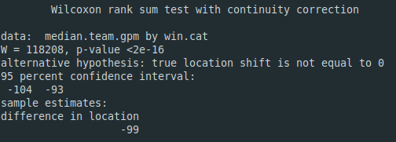Figure 11: Wilcoxon Rank Sum Test Results
Q7. What features lead to an edge in winning (> 50% accuracy)?

Exploring available features and their correlations
Data was aggregated to the team level from the individual player level to better distinguish good team play features that lead to win or are illustrative of winning teams. Figure 12 below shows an initial correlation matrix of some features to consider using in our model to predict wins. Immediately we can see a few features that highly correlated with a win – kills, assists, tower.dmg – and a few that are highly correlated with each other – kills, assists, hero.dmg – and may need to be combined to produce a better model. On the next page this matrix will be pared down to fewer features that seem to correlate most strongly with the response variable target.win.

Figure 12: Initial Correlation Matrix of Dataset Features
Selecting good model features
Version 2 of feature correlation is shown below in Figure 13 in a pairs plot, captured after we have thrown out kills in favor of assists, removed low correlation features – drew.fb, hero.dmg, hero.heal, last.hits, denies, obs.set, and stuns. Also, the tower damage column was divided by 1,000 and renamed to tower.dmg.1k to bring its scale in line with other columns.

Figure 13: Pairs Plot after Narrowing Feature Set

Fitting a logistic regression to predict a match win
First, we will try a univariate logistic regression model only using the predictor tower.dmg.1k. Figure 14 below shows the univariate model results – an Akaike Information Criterion (AIC) of 895.3 and a 95% confidence interval (CI) for tower.dmg.1k of 1.325 to 1.407.
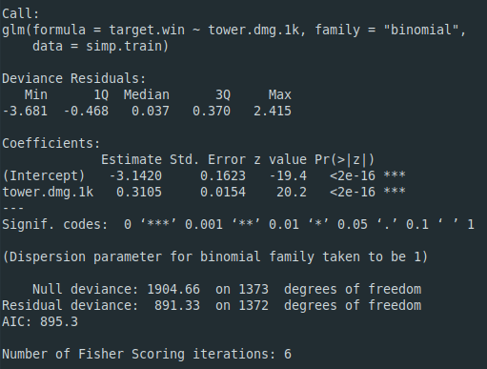Figure 14: Univariate Model Results with Predictor Tower Damage 1k
By exponentiating the model coefficients, we can talk about the predictor influence on the response variable. For this univariate model, we can say that the odds of winning a match increase by about 36% for every 1,000 units of tower damage done by a team. This is calculated using Figure 15:
% (in/de)crease in response per unit of predictor = percent(exp(coef) – 1 )
= percent(1.3641 – 1) = 36.41% (a positive value indicates an increase in odds)

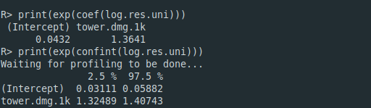Figure 15: Model Interpretation by Exponentiating Coefficients and CI
After creating a multivariate model on the next page, we can compare the model results – the AIC relative quality of the model, power of the model looking at CI widths, and the model goodness of fit with Hosmer-Lemeshow fit tests (Koh, 2020).
Figure 16: First Logistic Regression Model Results
Now a logistic regression model is fit with 4 predictors and the results are shown above in Figure 16. Assists, deaths, and tower damage 1k are all very significant indicators of a match win, while runes is barely significant at the 95% confidence level. Figure 17 below gives us a better idea of what this model is saying. If we focus on deaths for instance, we can conclude that after adjusting for all the confounders (all model features besides deaths), the odds of winning a match decrease by about 24% (0.7576 - 1 as a percent) for every team death. Runes also decrease the odds of winning by 5% for every rune picked up, after adjusting for all the confounders besides runes. This is unexpected and surprising as these runes can be quite powerful when used during a match. The 2 positive relationships lie with assists and tower.dmg.1k that increase the odds of winning (after adjusting for confounders) by 8% per assist and 34% per 1000 tower damage, respectively.
Figure 17: Model Interpretation by Exponentiating Coefficients and CI
Comparing to our first model (univariate with tower.dmg.1k predictor variable), this multivariate model seems to be a better model. It has a lower AIC (308.8 vs 893.5) indicating a higher relative model quality, but with an increased number of predictors the new model has widened the 95% CI for tower.dmg.1k from 1.325 to 1.407 to now 1.2659 to 1.4295 (Koh, 2020). Lastly, we can compare the goodness of fit for each model with a Hosmer-Lemeshow Goodness of fit test.
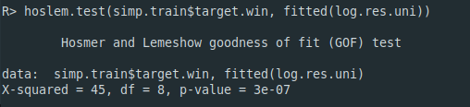Figure 18: Univariate Model Goodness of fit Test Results
Figure 18 above shows the univariate model results from a Hosmer-Lemeshow Goodness of fit test. Since the p-value is very significant (3e-07 is quite small), we reject the null hypothesis and conclude that there is significant evidence to show that the model is a poor fit to the data (Koh, 2020). For the multivariate model, the results in Figure 19 below indicate that it also has significant evidence to show that the model is a poor fit to the data.
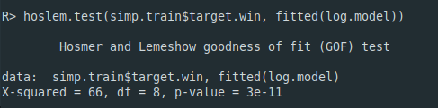Figure 19: Multivariate Model Goodness of fit Test Results

Using multivariate model in predictions
- Probability of winning a match with 4 assists, 0 deaths, 5000 tower damage, and 1 rune:

(log odds)
(odds ratio – 8:1 odds of winning match)
p = 0.8899 = 88.99% ~ 89% (probability of win)

- Probability of winning a match with 10 assists, 11 deaths, 7234 tower damage, and 4 rune:

(log odds)
(odds ratio – 1:1 odds of winning match)
p = 0.4999 = 49.99% ~ 50% (probability of win)
Residual plotting, testing model fit
In his journal article on residuals and logistic regression, Zhang (2016) recommends performing a lack-of-fit test in addition to the standard residuals against predictors or fitted values plots. Zhang points out that
“Visual inspection is only a rough estimation and cannot be used as a rule to modify the model, [but the R function residualPlots from car package] performs formal statistical testing (lack-of-fit test) to see if a variable has a relationship with residuals”.

Figure 20: Initial Multivariate Model Lack-of-fit Test Results
As shown in Figure 20 above, running the residualPlots() function on the multivariate model from above results in 2 variables (deaths, assists) that are statistically significant and that adding a quadratic term for each is reasonable. Figure 21 below shows the updated model with quadratic terms for both deaths and assists. We can see that now there are 2 more variables that the fit test suggests adding squared terms for – deaths² and tower.dmg.1k.
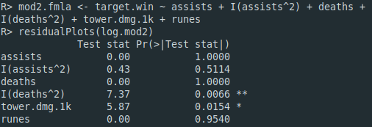Figure 21: Multivariate Model V2 After Adding 2 Squared Terms
For the third iteration, deaths³ and tower.dmg.1k² are added to the model formula. Figure 22 below shows the results and finally it says that the model is properly specified.
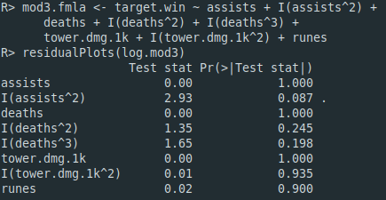Figure 22: Multivariate Model V3 After Adding 2 More Terms
Outliers testing using studentized residuals
We can also test the model for outliers at 95% confidence level. Outliers due to their extreme values can have significant impacts on model fitting (Zhang, 2016). The test indicates that there were no studentized residuals with Bonferroni p < 0.05, therefore no significant outliers were present in this model.
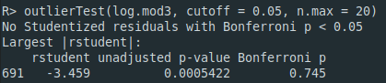Figure 23: Outlier Testing using Car Package

Goodness of fit testing
Previously our first 2 models had significant evidence to show that the models were a poor fit for the data, and now our latest model iteration (Figure 24 below) no longer has a significant p-value. This means we fail to reject the null hypothesis and conclude that there is no significant evidence to show that this model is a poor fit for the data.
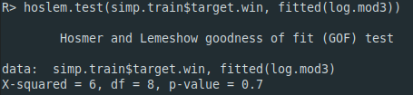Figure 24: Hosmer-Lemeshow Goodness of Fit Test Results

Final model results
Now let’s take a look at the actual model summary for this f inal iteration. Figure 25 below shows that our AIC is now 267.9 – down from our initial multivariate model’s AIC of 308.8. We have added 4 more terms to our model formula and made it more complex with a total of 8 terms now.
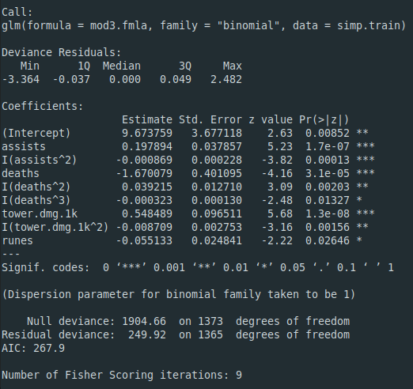Figure 25: Multivariate Model V3 Results Summary
The final model coefficients are below in Table 5. We can see that each death affects the biggest change in odds of winning a match (an 81% decrease). On the positive side, the odds of winning increase by almost 22% for each assist a team gets and about 73% for each 1,000 units of tower damage a team inflicts on enemy structures. From this analysis, it seems like deaths, assists, and tower damage are the most important factors contributing to a team winning a professional Dota 2 match. Kills (discarded in favor of assists) would probably be important as well.

Table 5: Final Model Coefficients
How well does it predict a win though?
The predict.glm function in R allows us to add a prediction column to the test data and see how well our model performs on new data. In Figure 26 below, we find a confusion matrix that shows the various model statistics. With an accuracy of 0.969 (percentage of correct predictions), a sensitivity of 0.973 (also called precision or true positive rate), and a specificity of 0.965 (true negative rate), it seems like this model does quite well at predicting a match win.
- Sensitivity (how often were positive predictions correct) = TP / (TP + FP)
= 674 / (674 + 19) = 0.973
- Specificity (how often were negative predictions correct) = TN / (TN + FN)
= 657 / (657 + 24) = 0.965

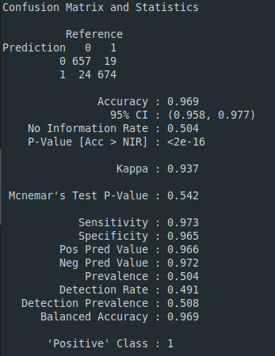Figure 26: Model Predictions Confusion Matrix

Value obtained from this study
While one can argue about whether video games or eSports are important in today’s world, there is no doubt that there are millions of people that enjoy video games and a select few play Dota 2 competitively. I collected about 1,000 professional Dota 2 matches and found many insights that highlight important components of a winning strategy – like working with your team to kill your enemies (assists), avoiding deaths, and hitting the enemy towers a lot (tower damage). In performing this analysis, I did a fair amount of research about creating and refining models and interpreting their results while practicing EDA and good visual design. This project has added value to my own life through improved knowledge and skills in many parts of the data science process. Due to my limited hardware and software resources at home, I could learn about dealing with big data, but could not physically practice working with big data through NoSQL or its alternatives.
Explanation of Terms
- Abilities – special actions a hero can take with varying cooldowns
- Assists – damaged an enemy hero right before they were killed, but did not make the final blow to kill the enemy hero
- Deaths – an enemy hero damages a hero more than their total health causing hero to lose gold and sit out a temporary amount of time (5 – 120 seconds)
- Dire – the top right of the battle arena where trees are bare and flowers dead (evil side)
- Dota 2 – a popular eSports multiplayer online battle arena video game from Valve
- Experience (XP) – killing enemies or small minions gains a hero experience making the hero and its abilities incrementally stronger
- Gold – in-match currency earned by heroes for killing enemies or small minions, can be traded for items or power ups that enhance a hero’s abilities
- First blood – the first enemy hero kill in a Dota 2 match
- Hero – a character controlled by each player that grows stronger throughout a match by killing smaller minions and enemy heroes to accumulate gold and experience
- Kills – damaging an enemy hero more than their total health, earning the killer and his teammate accomplices gold and experience
- Kill/Death/Assist ratio (KDA) – a rough measure of a player’s performance or match contribution calculated by adding kills and assists together and then dividing by deaths
- Observer wards – little lamps that illuminate parts of the arena for a short period of time giving one team an advantage in sight and information on where the enemies may be hiding
- Radiant – the bottom left side of the battle arena where flowers blossom (good side)
- Runes – power ups that spawn near the middle of the map periodically to give heroes a small temporary boost in some trait – making a hero run very fast, going invisible, doubling a hero’s attack damage, regenerating health, etc
- Towers – physical structures protecting parts of the arena; damaging them will eventually destroy them and lead to victory

Code used in this analysis
Python was used for data collection, cleaning, and preparation, while R was used for analyses and visualizations. All code can be viewed on my github at https://github.com/doug-cady/gmu_daen/tree/master/AIT580/Analysis_Project

References:
FAQ: How do I interpret odds ratios in logistic regression?. UCLA Statistical Consulting Group. Retrieved 5 March 2021, from https://stats.idre.ucla.edu/other/mult-pkg/faq/general/faq-how-do-i-interpret-odds-ratios-in-logistic-regression/
Independent Samples T-test in R | Statistical Methods. Retrieved 5 March 2021, from https://stat-methods.com/home/independent-samples-t-test-r-2/
Koh, C. (2020). Interpreting results from logistic regression in R using Titanic dataset. Retrieved 5 March 2021, from https://medium.com/@conankoh/interpreting-results-from-logistic-regression-in-r-using-titanic-dataset-bb9f9a1f644c
Zhang, Z. (2016). Residuals and regression diagnostics: focusing on logistic regression. Annals Of Translational Medicine, 4(10), 195-195. doi: 10.21037/atm.2016.03.36

