This is an exercise used to roughly measure your SQL aptitude. You may write your solution in any SQL variant, but the sample data and schema given uses SQL Server syntax. You may solve the problems using any manner you want, but it is possible to solve all 4 problems with a simple SQL query without changing the schema, without using temp tables, CTEs, explicit pivot tables and without using a cursor. You should have received scripts that will create the tables as well as populate the test data. You may have to modify them in order to run them on your preferred implementation of SQL.

**Problem #1**: We are looking for attendance information for students based on the day of the week. If a person is absent for at least one class on a specific day they will be counted as absent for that day. For purposes of this problem, Saturday and Sunday will be grouped together as Weekend.

**Note**: Each record in the table ***AttendanceRecord*** denotes a single student absence for a given class on a given day. A student absent on a given day may have her ID associated with more than one record for that day: one for each class that she missed.

If you were to run this query over the sample data, it would return:

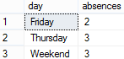

**Problem #2.0**: We would like a list of every student, along with his or her parents. The format should be: child name, parent name.

If you were to run this query over the sample data, it would return:

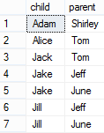

**2.1:** Now, we would like to return the same information, with both parents (if applicable). We want child name, parent name 1, parent name 2. If a child doesn’t have a parent, just display null.

If you were to run this query over the sample data, it would return:

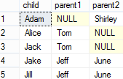

**Problem #3:** Please calculate the number of students who are male, and the number of students who are female. A student is a person with an enrollment record.

If you were to run this query over the sample data, it would return:



**Problem #4:** The school in question has two different ways of promoting gifted students in the middle of the school year. The first to simply promote them to the next grade; the other is to "dual enroll" them in two grades at once. However, when we give the students their schedule, we just want to report the highest grade in which the student is enrolled. The query should return said information for any date.

If you were to run this query over the sample data for ‘01/15/2013’, it would return:

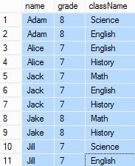

Schema Diagram

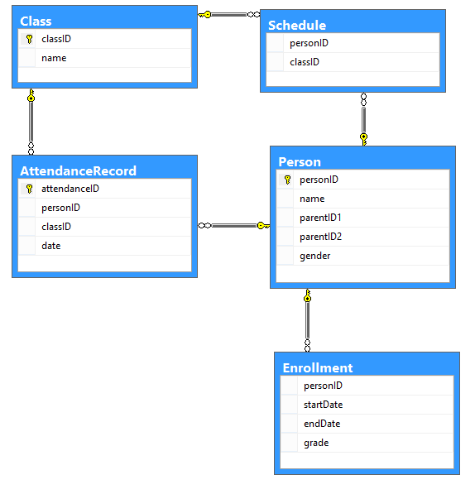

Sample Data

Person

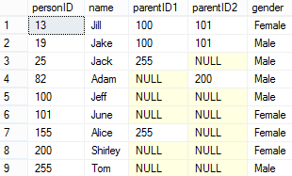

Class

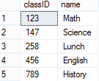

AttendanceRecord

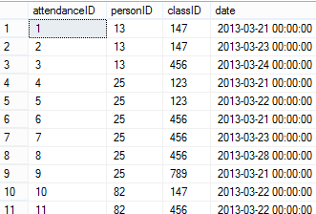

Schedule

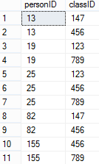

Enrollment

