6 Degrees
Requirements Specification Document
CSCI 4830-- Software engineering

Submitted by:
Team 3
Douglas Martin
Justin Hamilton
Joshua Wiley
Anna Buhman

1. Introduction
This document details the requirements for the 6 Degrees of Separation application. It describes what is needed to complete the system, as well as describing the system itself and providing diagrams demonstrating how the system works. The 6 Degrees of Separation application provides a social-networking site linked to facebook where people can see the connections between facebook friends. When a user signs up for the application, it will connect to facebook and obtain their friends list. Then it will build a representation of the connections between the people who signed up, their friends, and the friends of other clients.

2. Glossary
facebook- a social networking site where users connect with other people online.
friends list (facebook) - a list of contacts obtained by a user on facebook.
connection path- shows how two users are connected by following a series of friends from one to the other.
facebook friend- a connection on facebook. It shows which users know each other.
api- a way that can be used to connect two different kinds of software. For this specific project, we are connecting the 6 Degrees website with facebook.
social network api- a way that can be used to connect a social network to some other type of software.
hash- a method of storing data in which the data is passed through an algorithm to create a number by which it shall be known. These numbers are stored in order and allow the data to be retrieved quickly.
6 Degrees Website- the software that is being developed by our group. It is a website that shows connections between its users and their friends in order to show a web of contacts.
6 Degrees Account- an account created by the user that puts their information online and allows them to view others’ information
User Page-a page that displays a 6 Degrees Account with information and any possible interactions for such person

3. User Requirements
3.1 Functional Requirements (these Requirements are numbered to match up to the Scenarios)

1. 6 Degrees Users must be able to create an account on the 6 Degrees website.
2. The website may be able to validate user information added to it in order to prevent such things as invalid e-mail addresses from being entered.
3. 6 Degrees Users must be able to connect and their 6 Degrees account with facebook in order to get their their friends list from facebook onto 6 Degrees.
4. 6 Degrees Users must be able to log in to a previously created account.
5. 6 Degrees Users must be able to view the account information obtained when the account was created.
6. 6 Degrees Users must be able to follow a series of friends through a connection path to another user.
7. 6 Degrees Users shall be able to send messages to each other.
3.2 Nonfunctional Goals
1. 6 Degrees shall be able to handle a large amount of users.
2. 6 Degrees shall be able to handle a dense series of relationships between users.
3. 6 Degrees shall be able to handle a large amount of friends per user.
3.3 Scenarios
The above requirements will allow for the following scenarios

1. Create a new account:
Jane would go to the 6 Degrees website home page. From there she would be linked to an account creation page. On the new account creation page, she will fill out her name, birth date, e-mail address, and sex, and also create a username and password. Using a link on the page to a pop-up, she will log in to facebook. Then she can create her account and the 6 degrees website will add her friends list.

2. Validate information during account creation
Jane mistypes her email address as usernameemail.com instead of username@email.com. The site informs her that this is not a proper e-mail address and asks her to re-enter it. Jane will not be able to create an account unless she enters correctly-formatted information.

3. Connect to facebook
When she creates her account, Jane’s profile information, such as her friends list, will be gathered by 6 Degrees. Then it will be added to her profile as well as stored by 6 Degrees.

4. Log into an already existing account:
Jane navigates to the 6 Degrees home page. She is asked to provide the username and password she made when she created her account. If she provides an incorrect username or password, the site will inform her she has typed incorrectly. If she provides the correct username-password pair, she will be allowed to access her account.

5. View account information:
After Jane has logged in to her account, she will be allowed to view her profile information. This is the same information she entered when creating her account, which is stored by 6 degrees. Other users will also be able to view Jane’s information and find out about her.

6. View connection path
Jane wants to get into contact with Jack, but doesn’t know how. She uses 6 degrees to find out that Johnny is friends with Jessica, and that Jessica is friends with Jack. Now Jane knows by what means she can get into contact with Jack, and can ask Johnny to obtain the contact information.

7. Send message
Jane wants to send a message to Johnny and ask whether he will put her into contact with Jessica. She enters text into 6 Degrees and clicks the send button. Johnny will receive the message the next time he logs in to 6 Degrees.

4. Systems Architecture
Within the 6 Degrees architecture, there are three subsystems that compose it. These are the interface, logic, and the database. The interface will be how a user of the 6 Degrees Website will interact. It will allow the user interact with the other systems to create an account, log into an account, view friends, sync Facebook friends with 6 Degree database, create and find main and alternative connection paths to people, and also link friends on 6 Degree. The interface will be html and javascript based. The database system will not be interacted directly by the user. It will help store the list of friends from Facebook, which includes the person’s name and Facebook id. The database will also keep track of who is friends within the 6 Degree system, as well as storing connection paths of two people. The logic system is actually composed of three subsystems in itself, which include the interface/validation logic, the path-finding logic, and the social network api logic. The main/validation logic will help validate information from the database and the interface, and will also help with coordinating the other systems. The social network api system is to allow the user to connect the 6 Degree system to Facebook. After the user has allowed the 6 Degree Facebook application to access their Facebook user information, it will store the list of friends into the system database. The user will not interact with the path-finding system directly but very closely interacting indirectly via the interface. The path-finding system will use a breadth-first search algorithm to find a path from one person to another with friends being the connecting link using the database system. The path-finding system will also be able to create modified alternate paths by avoiding friend connections that the user has designated.

5. System Models
5.1 Object Model
See Appendix A
5.2 Use Case Diagram
See Appendix A
5.3 Use Cases

1. Create New Account
Name: createAccount
User: User
Entry Conditions: None
Flow of Events:
-user clicks on the register button
-enters user information (username, password, email)
-clicks register
Exit Condition: the user’s information is not valid or is already being used (i.e. username)
Exceptions: the email is not valid, the username and/or email is already being used
Corresponds to: Functional Requirement 1

2. Login to Account
Name:login
User: User
Entry Conditions: None
Flow of Events:
-user clicks on the login button
-enters login credentials (username, password)
-clicks login
Exit Condition: the users information matches and is valid in the database
Exceptions: the user’s information is not valid or in the database
Corresponds to: Functional Requirement 4

3. Find Path
Name: findPath
User: User
Entry Conditions: know the name of the person to connect to
Flow of Events:
- the user enters the name of the person to search for
- the searched person is showed to confirm the correct person
- the user confirms that is the person
- the system is sent the two people to connect, the user and the searched person, and any people to not include in the path
- the system uses the path-finding logic to find the connection path
- the system stores the path in the database
- the system returns the connection path
Exit Condition: the connection path is found and returned
Exceptions: cannot find the person in 6 Degrees database, no connection exists
Corresponds to: Functional Requirement 6

4. Send Message
Name: addMessage
User: User
Entry Conditions: a person is chosen to send a message
Flow of Events:
- the user clicks on the send message on a person’s user page
- the user clicks the account (i.e. Facebook) that the person wishes to use to send the message
- a new page is opened with a message form ready to be filled out on the chosen social
network
Exit Condition: none
Exceptions: social network security for the selected person does not allow sending a message
Corresponds to: Functional Requirement 7

6. System Requirements
6.1 Web
1. Users will start on a login screen.
1.1 New users can click a link to create a new account. (Functional Requirement 1)
1.1.1 New users will provide information about themselves and create a username and password. (Functional Requirement 1)
1.1.2 New users will connect to facebook by logging in from the account creation page. (Functional Requirement 3)
1.1.3 The site will validate information about the user, for example, checking to see that the e-mail address provided is in an acceptable e-mail address format. (Functional Requirement 2)
1.2 Users who already have an account can log in by providing their username and password. (Functional Requirement 4)
2. Users shall be able to view their account information. (Functional Requirement 5)
3. Users shall be able to trace how different users are connected. This shall be viewed graphically as a chain of users in order from the starting point user to the endpoint user. (Functional Requirement 6)
6.2 Node and mongoDB
1. The program shall be able to connect to facebook using the facebook API. (Functional Requirement 3) Information about the facebook API can be found at http://developers.facebook.com/docs/api.
1. 6 Degrees shall send its credentials to facebook.
2. 6 Degrees shall receive a cookie from facebook.
3. 6 Degrees shall send a cookie for authorization and query for facebook information
4. 6 Degrees shall receive and parse the information
5. 6 Degrees shall make requests to facebook, such as requesting the user’s profile picture or friends list
2. The program shall be able to obtain the friend lists of its users (Functional Requirement 3)
3. The program shall be able to find out which people are connected to which (Functional Requirement 6)
4. The program shall be able to store multiple users (Nonfunctional Goal 1)
5. The program shall be able to store the friends lists of each user (Nonfunctional Goal 3)
6. The program shall be able to store connection path between each user (Nonfunctional Goal 2 and Functional Requirement 6)
7. The program may be able to hash the users in order to store them

7. Appendix A
1. Object Model

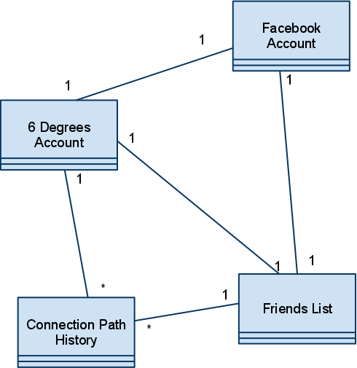

2. Use Case Diagram

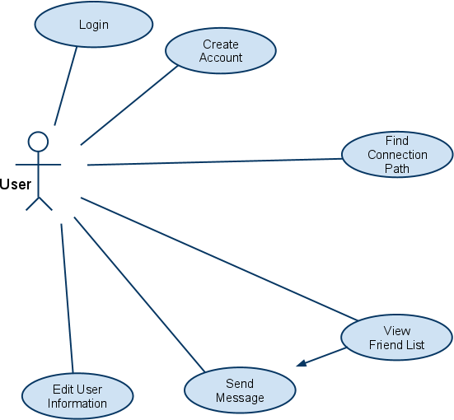

3. Create New Account (Functional Requirement 1)
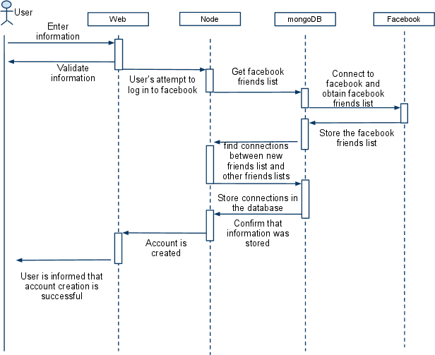

4. Login to Account (Functional Requirement 4)
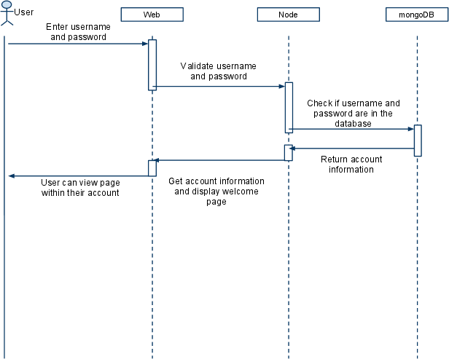

5. Find Path (Functional Requirement 6)
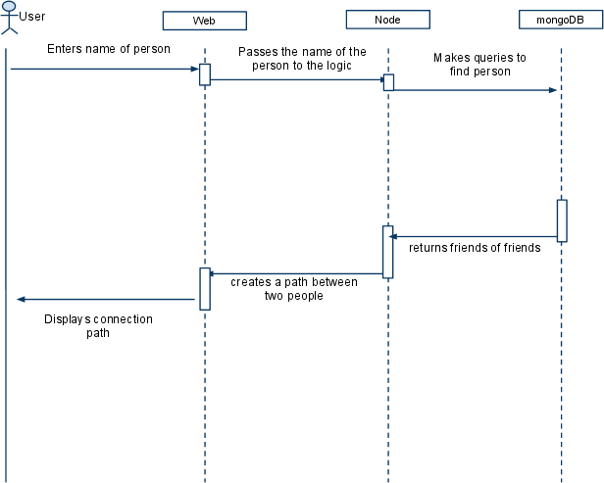

6. Send Message (Functional Requirement 7)
