6 Degrees
Requirements Specification Document
CSCI 4830-- Software engineering

Submitted by:
Team 3
Douglas Martin
Justin Hamilton
Joshua Wiley
Anna Buhman

1. Introduction
This document details the requirements for the 6 Degrees of Separation application. It describes what is needed to complete the system, as well as describing the system itself and providing diagrams demonstrating how the system works. The 6 Degrees of Separation application provides a social-networking site linked to facebook where people can see the connections between facebook friends. When a user signs up for the application, it will connect to facebook and obtain their friends list. Then it will build a representation of the connections between the people who signed up, their friends, and the friends of other clients.

2. Glossary
facebook- a social networking site where users connect with other people online.
friends list (facebook) - a list of contacts obtained by a user on facebook.
connection path- shows how two users are connected by following a series of friends from one to the other.
alternative path- a connection path that avoids certain specific friends designated by the user.
facebook friend- a connection on facebook. It shows which users know each other.
6 Degree friend- a connection on 6 Degrees. It shows which 6 degrees users know each other.
api- a way that can be used to connect two different kinds of software. For this specific project, we are connecting the 6 Degrees website with facebook.
social network api- a way that can be used to connect a social network to some other type of software.
hash- a method of storing data in which the data is passed through an algorithm to create a number by which it shall be known. These numbers are stored in order and allow the data to be retrieved quickly.
6 Degrees Website- the software that is being developed by our group. It is a website that shows connections between its users and their friends in order to show a web of contacts.
6 Degrees Account- an account created by the user that puts their information online and allows them to view others’ information
User Page-a page that displays a 6 Degrees Account with information and any possible interactions for such person

3. User Requirements
3.1 Functional Requirements

1. Testers must be able to create an account on the 6 Degrees website.
2. Testers must be able to connect and their 6 Degrees account with facebook.
3. Testers must be able to get their friends list from facebook onto 6 Degrees.
4. Testers must be able to see the relationships between individuals on 6 Degrees.
5. The website may be able to validate user information added to it in order to prevent such things as invalid e-mail addresses from being entered.
6. Testers must be able to designate other users on 6 degrees as friends.
7. Testers must be able to log in to a previously created account.
8. Testers must be able to follow a series of friends through a connection path to another user.
9. Testers must be able to designate certain users to be left out of a connection path in order to create an alternate path.
3.2 Scenarios
The above requirements will allow for the following scenarios

1. Create a new account:
Jane would go to the 6 Degrees website home page. From there she would be linked to an account creation page. On the new account creation page, she will fill out her name, birth date, e-mail address, and sex, and also create a username and password. Using a link on the page to a pop-up, she will log in to facebook. Then she can create her account and the 6 degrees website will add her friends list.

2. Validate information during account creation
Jane mistypes her email address as usernameemail.com instead of username@email.com. The site informs her that this is not a proper e-mail address and asks her to re-enter it. Jane will not be able to create an account unless she enters correctly-formatted information.

3. Log into an already existing account:
Jane navigates to the 6 Degrees home page. She is asked to provide the username and password she made when she created her account. If she provides an incorrect username or password, the site will inform her she has typed incorrectly. If she provides the correct username-password pair, she will be allowed to access her account.

4. View account information:
After Jane has logged in to her account, she will be allowed to view her profile information. This is the same information she entered when creating her account, which is stored by 6 degrees. Other users will also be able to view Jane’s information and find out about her.

5. View connections with others:
Jane can view which friends are connected on facebook. This depends on people having created accounts on 6 degrees, because only people who have signed up for 6 degrees and their friends will be shown with their connections. Jane can use this information to find out whether and how she is connected to others.

6. Create friends on 6 degrees
Jane decides to designate another user, Johnny, as her friend on 6 degrees. 6 degrees will store Johnny and any other friends of Jane, showing they are connected. This will further increase the web of people shown by adding more connections than just those shown on facebook.

7. View connection path
Jane wants to get into contact with Jack, but doesn’t know how. She uses 6 degrees to find out that Johnny is friends with Jessica, and that Jessica is friends with Jack. Now Jane knows by what means she can get into contact with Jack, and can ask Johnny to obtain the contact information.

8. View alternate path
Jane has created a connection path to Jack, but a friend along the way, Jessica, is not very friendly. Jane can ask 6 degrees to create an alternate path to Jack. 6 degrees connects her through a longer path that avoids going through Jessica.

4. Systems Architecture
Within the 6 Degrees architecture, there are three subsystems that compose it. These are the interface, logic, and the database. The interface will be how a user of the 6 Degrees Website will interact. It will allow the user interact with the other systems to create an account, log into an account, view friends, sync Facebook friends with 6 Degree database, create and find main and alternative connection paths to people, and also link friends on 6 Degree. The interface will be html and javascript based. The database system will not be interacted directly by the user. It will help store the list of friends from Facebook, which includes the person’s name and Facebook id. The database will also keep track of who is friends within the 6 Degree system, as well as storing connection paths of two people. The logic system is actually composed of three subsystems in itself, which include the interface/validation logic, the path-finding logic, and the social network api logic. The main/validation logic will help validate information from the database and the interface, and will also help with coordinating the other systems. The social network api system is to allow the user to connect the 6 Degree system to Facebook. After the user has allowed the 6 Degree Facebook application to access their Facebook user information, it will store the list of friends into the system database. The user will not interact with the path-finding system directly but very closely interacting indirectly via the interface. The path-finding system will use a breadth-first search algorithm to find a path from one person to another with friends being the connecting link using the database system. The path-finding system will also be able to create modified alternate paths by avoiding friend connections that the user has designated.

5. System Models
5.1 Object Model
See Appendix A
5.2 Use Case Diagram
See Appendix A
5.3 Use Cases

1. Create New Account
Name: createAccount
User: User
Entry Conditions: None
Flow of Events:
-user clicks on the register button
-enters user information (username, password, email)
-clicks register
Exit Condition: the user’s information is not valid or is already being used (i.e. username)
Exceptions: the email is not valid, the username and/or email is already being used

2. Login to Account
Name:login
User: User
Entry Conditions: None
Flow of Events:
-user clicks on the login button
-enters login credentials (username, password)
-clicks login
Exit Condition: the users information matches and is valid in the database
Exceptions: the user’s information is not valid or in the database

3. Sync to Facebook Friend List
Name: syncFriends
User: User
Entry Conditions: none
Flow of Events:
- the user is either prompted to sync to facebook or chooses the option to sync Facebook
- the user logs into the facebook if not already logged in (checked by cookie)
- the system fetches the list of friends from facebook
- the system stores the friends list in the database
Exit Condition: the last friend in the facebook list is stored in the database
Exceptions: facebook login is not validated

4. Befriend User on 6 Degrees
Name: befriend
User: User
Entry Conditions: know which person is to be befriended
Flow of Events:
- the user click the befriend link on another person’s user page
- the system adds each’s 6 Degree friend to their lists
Exit Condition: the people have been added the lists correctly
Exceptions: the two people are already friendds

5. Find Path
Name: findPath
User: User
Entry Conditions: know the name of the person to connect to
Flow of Events:
- the user enters the name of the person to search for
- the searched person is showed to confirm the correct person
- the user confirms that is the person
- the system is sent the two people to connect, the user and the searched person, and any people to not include in the path
- the system uses the path-finding logic to find the connection path
- the system stores the path in the database
- the system returns the connection path
Exit Condition: the connection path is found and returned
Exceptions: cannot find the person in 6 Degrees database, no connection exists

6. View Friend List
Name: viewFriends
User: User
Entry Conditions: none
Flow of Events:
- the user clicks on the view friends link
- the systems returns the list of friends and displays it
Exit Condition: the last friend in the list is returned
Exceptions: none

7. Send Message
Name: sendMessage
User: User
Entry Conditions: a person is chosen to send a message
Flow of Events:
- the user clicks on the send message on a person’s user page
- the user clicks the account (i.e. Facebook) that the person wishes to use to send the message
- a new page is opened with a message form ready to be filled out on the chosen social
network
Exit Condition: none
Exceptions: social network security for the selected person does not allow sending a message

8. Edit User Information
Name: editUser
User: User
Entry Conditions: a user account must already be created
Flow of Events:
- the user clicks on the edit account information
- the system returns the correct information and displays it in a form
- the user clicks change
- any changes to the data in the form is stored in the database
Exit Condition: the last data element is stored in the database
Exceptions: the data that is submitted is not valid

5.4 Sequence Diagrams
See Appendix A

6. System Requirements
6.1 User Interface
1. Users will start on a login screen.
1.1 New users can click a link to create a new account.
1.1.1 New users will provide information about themselves and create a username and password.
1.1.2 New users will connect to facebook by logging in from the account creation page.
1.1.3 The site will validate information about the user, for example, checking to see that the e-mail address provided is in an acceptable e-mail address format.
1.2 Users who already have an account can log in by providing their username and password.
2. Users shall be able to view their account information.
3. Users shall be able to update their account information.
3.1 Users shall be able to re-connect to facebook to update their friends list.
4. Users shall be able to view how their account links to other users and their friend lists.
5. Users shall be able to trace how different users are connected.
6.2 Logic and Database
1. The program shall be able to connect to facebook
2. The program shall be able to obtain the friend lists of its users
3. The program shall be able to find out which people are connected to which
4. The program shall be able to store multiple users
5. The program shall be able to store the friends lists of each user
6. The program shall be able to store connection path between each user
7. The program may be able to hash the users in order to store them

7. Appendix A
Object Model

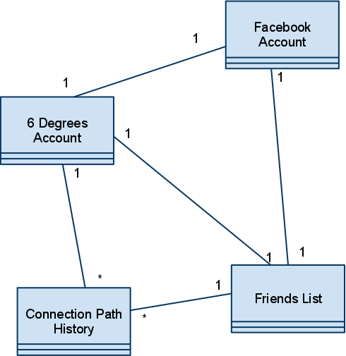

Use Case Diagram

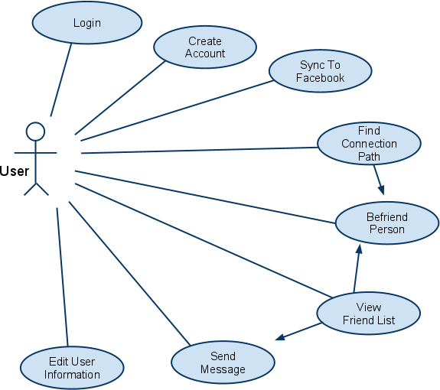

Create New Account
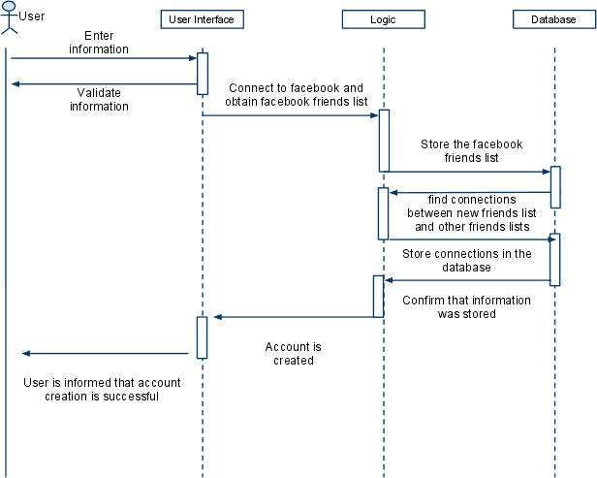

Login to Account
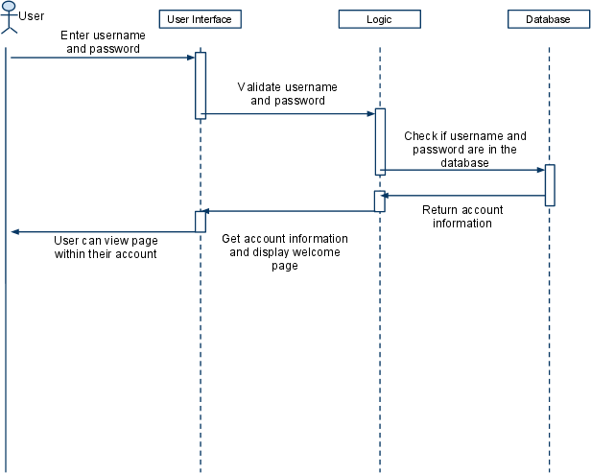

Sync to Facebook Friend List
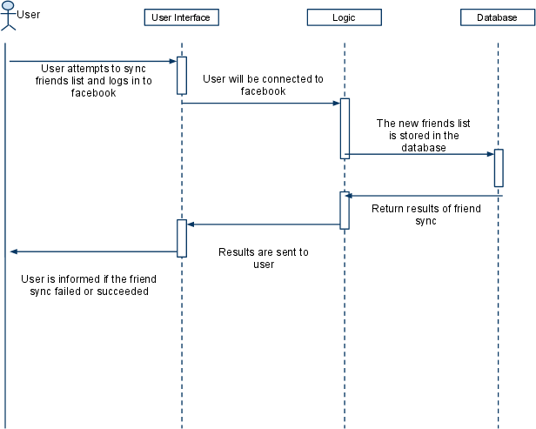

Befriend User on 6 Degrees
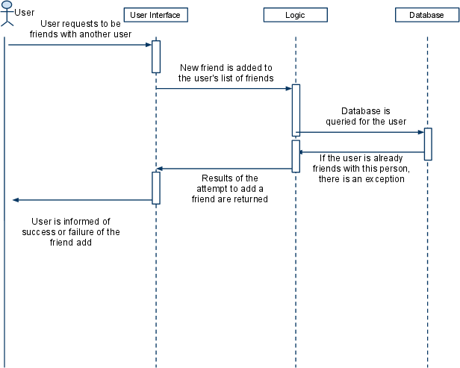

Find Path
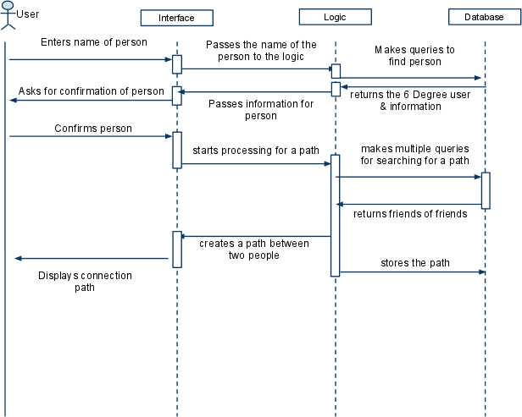

View Friend’s List
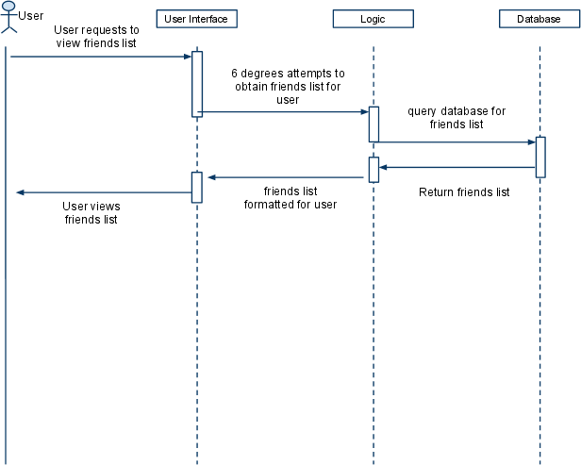

Send Message
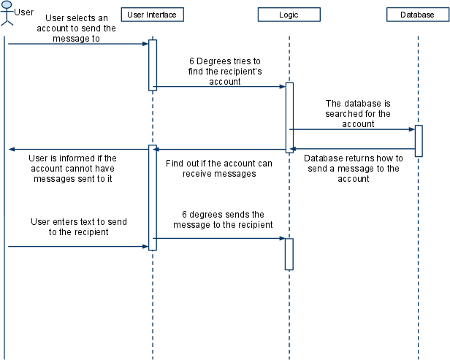

Edit User Information
