AIxRay process workshop guide
Facilitator edition | 15 October 2026
Use this guide to build and review a process with the people who run it. AIxRay is a local-file workbench with one facilitator editing one project file. Agree who owns the working copy, where it will be saved, and who will make edits during the session. Other participants can contribute verbally or keep their own notes; separate project copies do not merge.
The route below follows the implemented controls. A walkthrough is an explicit path through the diagram, and entered scenario timing compares assumptions. Neither executes business rules or simulates live process behavior.
From the start action or More actions, choose Build a process. Enter a process name and initial lane name. The new process begins with a start event, an end event, and a people lane.
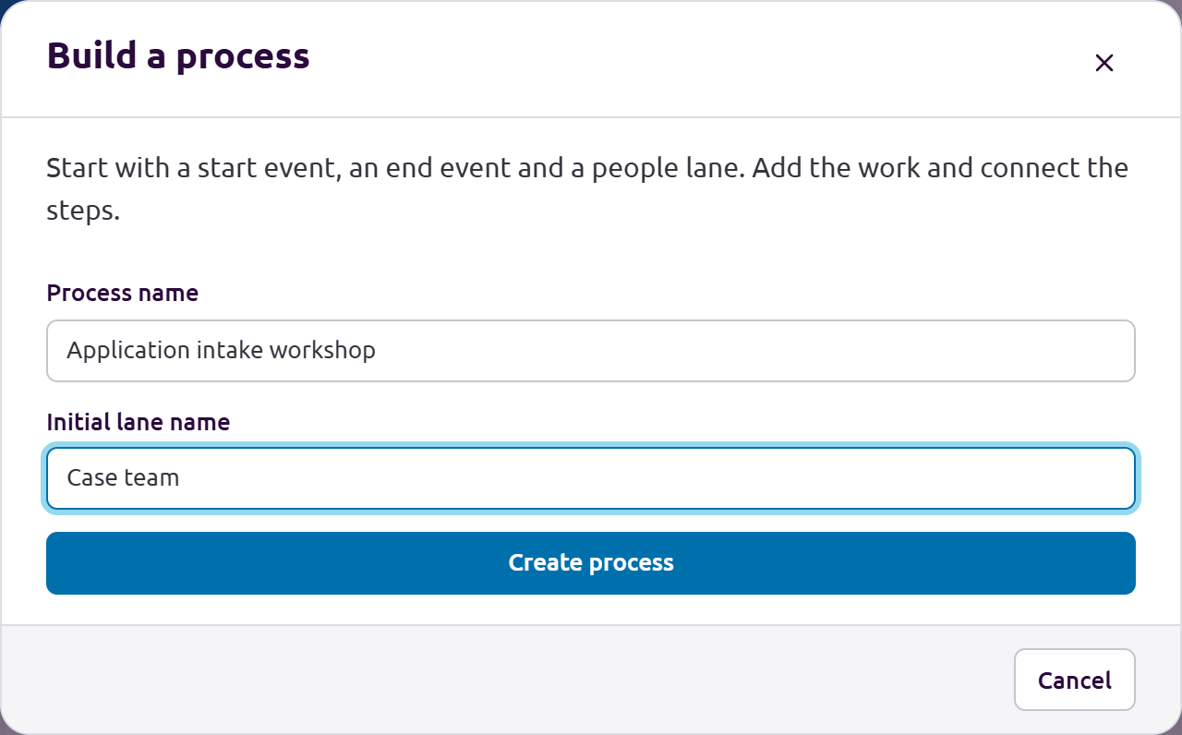
Build a process starts a blank current state with a process name and first lane.
Open webui/index.htm in a current browser. Choose Build a process, enter the name and first lane, then select Create process. The application intake example throughout this guide is synthetic; its figures are illustrative.

1 Name the roles and lanes
In Build a process, expand Lanes. Use clear role names for the teams and external parties who perform the work. Lane type distinguishes People, Automation or AI agent, and External party. Enter a New lane name, choose its type and select Add lane.
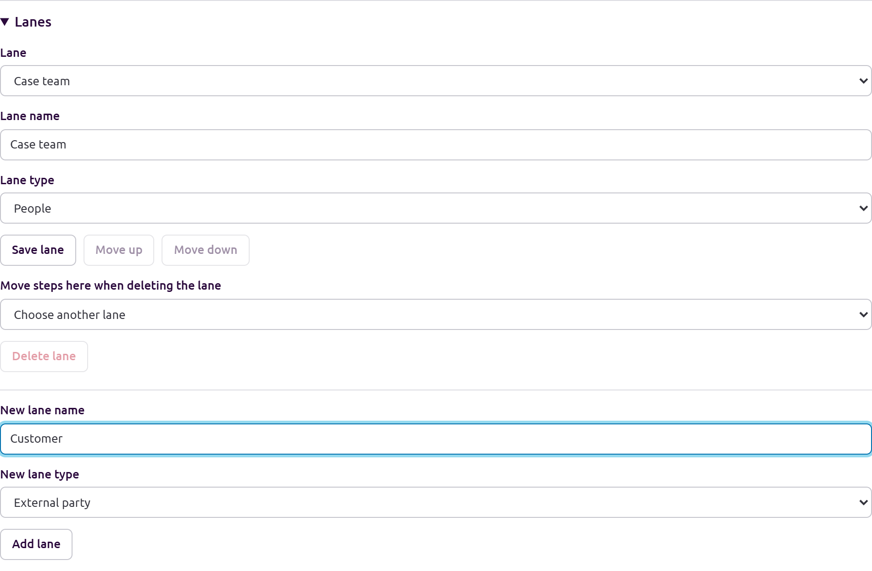
Name the people and external parties who perform the work, then choose Add lane.
The example uses Case team and Approver as people lanes and Customer as an external party. Save lane updates, use Move up or Move down to reorder lanes, and choose a destination for its steps before deleting an occupied lane. Keep at least one lane. The AI assistant lane is added only to the future alternative.

1 Add lanes and steps
In the Build a process editor, add lanes and steps, choose each step's type and lane, and connect steps. Use Exclusive gateway for decisions with conditional branches; label each condition and provide a default branch. Use sequence flows for parallel branches, and a loop flow to return to an earlier step. Use Structure checks to find missing starts or ends, unreachable steps, and incomplete gateway branches. Delete or reconnect carefully: deleting a step disconnects its flows, and Undo last change reverses the last edit. Save a copy preserves the work in a project file.
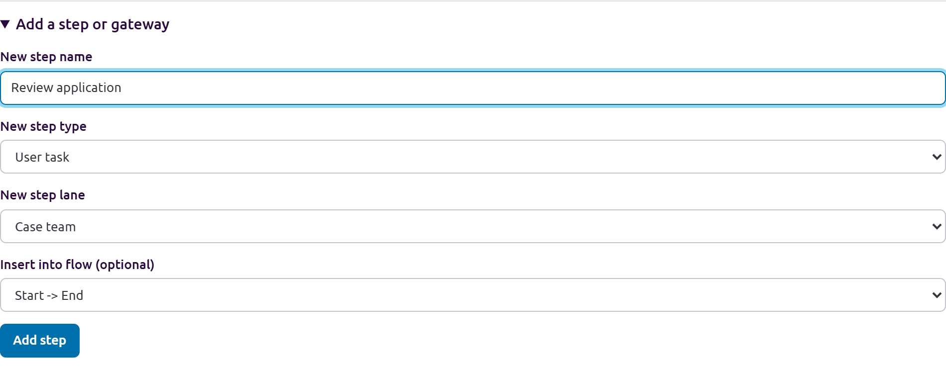
Insert a named step into an existing flow and choose its lane and type.
For the example, add Review application in Case team. Select the existing Start to End flow under Insert into flow, then choose Add step. Add Customer and Approver lanes for the exception and approval work.

1 Connect decisions and loops
Add Documents complete as an Exclusive gateway after the review. Connect a Complete default route to Approve application and then End. Add a Missing documents conditional route to Provide missing documents, followed by a loop back to Review application.
To continue editing an open process, choose Edit process structure from More actions or the Process structure section in the process drawer. This opens the same dedicated editor modal. A current baseline becomes locked after you create a future alternative; select the alternative to edit it. Diagram edits clear saved scenario runs and their derived route effort and cycle figures for that diagram, so rebuild the runs before playback or comparison.
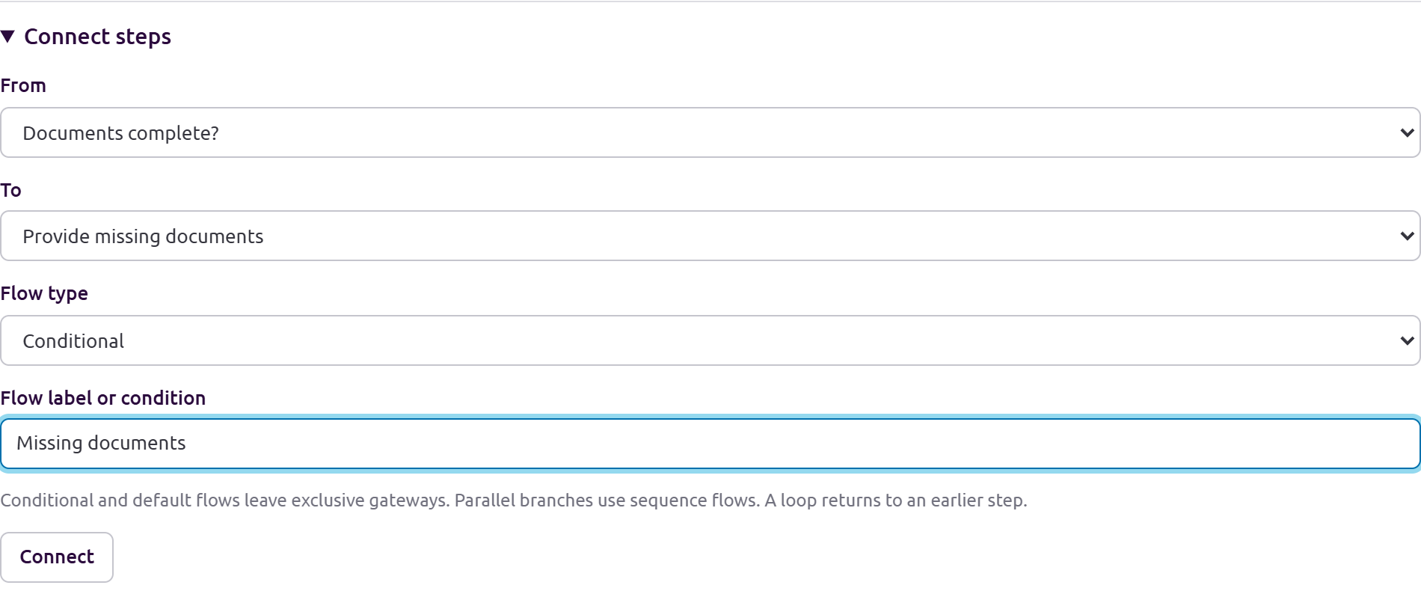
Use a conditional flow for missing documents and a default flow for the complete case.
Use Connect steps to create flows. Reconnect or delete flows changes an existing flow. Check Structure checks after each route change and use Undo last change if the result is wrong.

1 Check the current process
Read the finished map with the people who do the work. Confirm the normal route, each handoff, and the exception route. In this example the customer resubmits missing documents and the case team reviews the application again.
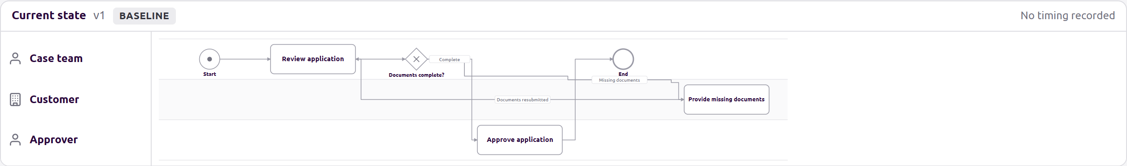
The current state has a normal route and a missing-document loop.
Choose Readable size to discuss labels and Overview to orient the room. Search for a step, role or system when a participant needs to find a particular activity. Capture uncertainty as a question rather than treating a connected diagram as confirmation.

2 Walk normal and exception routes
In Present, choose Walkthrough, or use the walkthrough controls in the process drawer. Choose a process and start step, then select Start walkthrough. At each decision, select Which branch? and choose Next. Use Previous, Start again, and Route history to revisit the path. Capture finding at this step opens a linked finding form. Walk the normal route first, then repeat for each important exception, rework loop, or alternate outcome. Treat unconfirmed branches as questions.
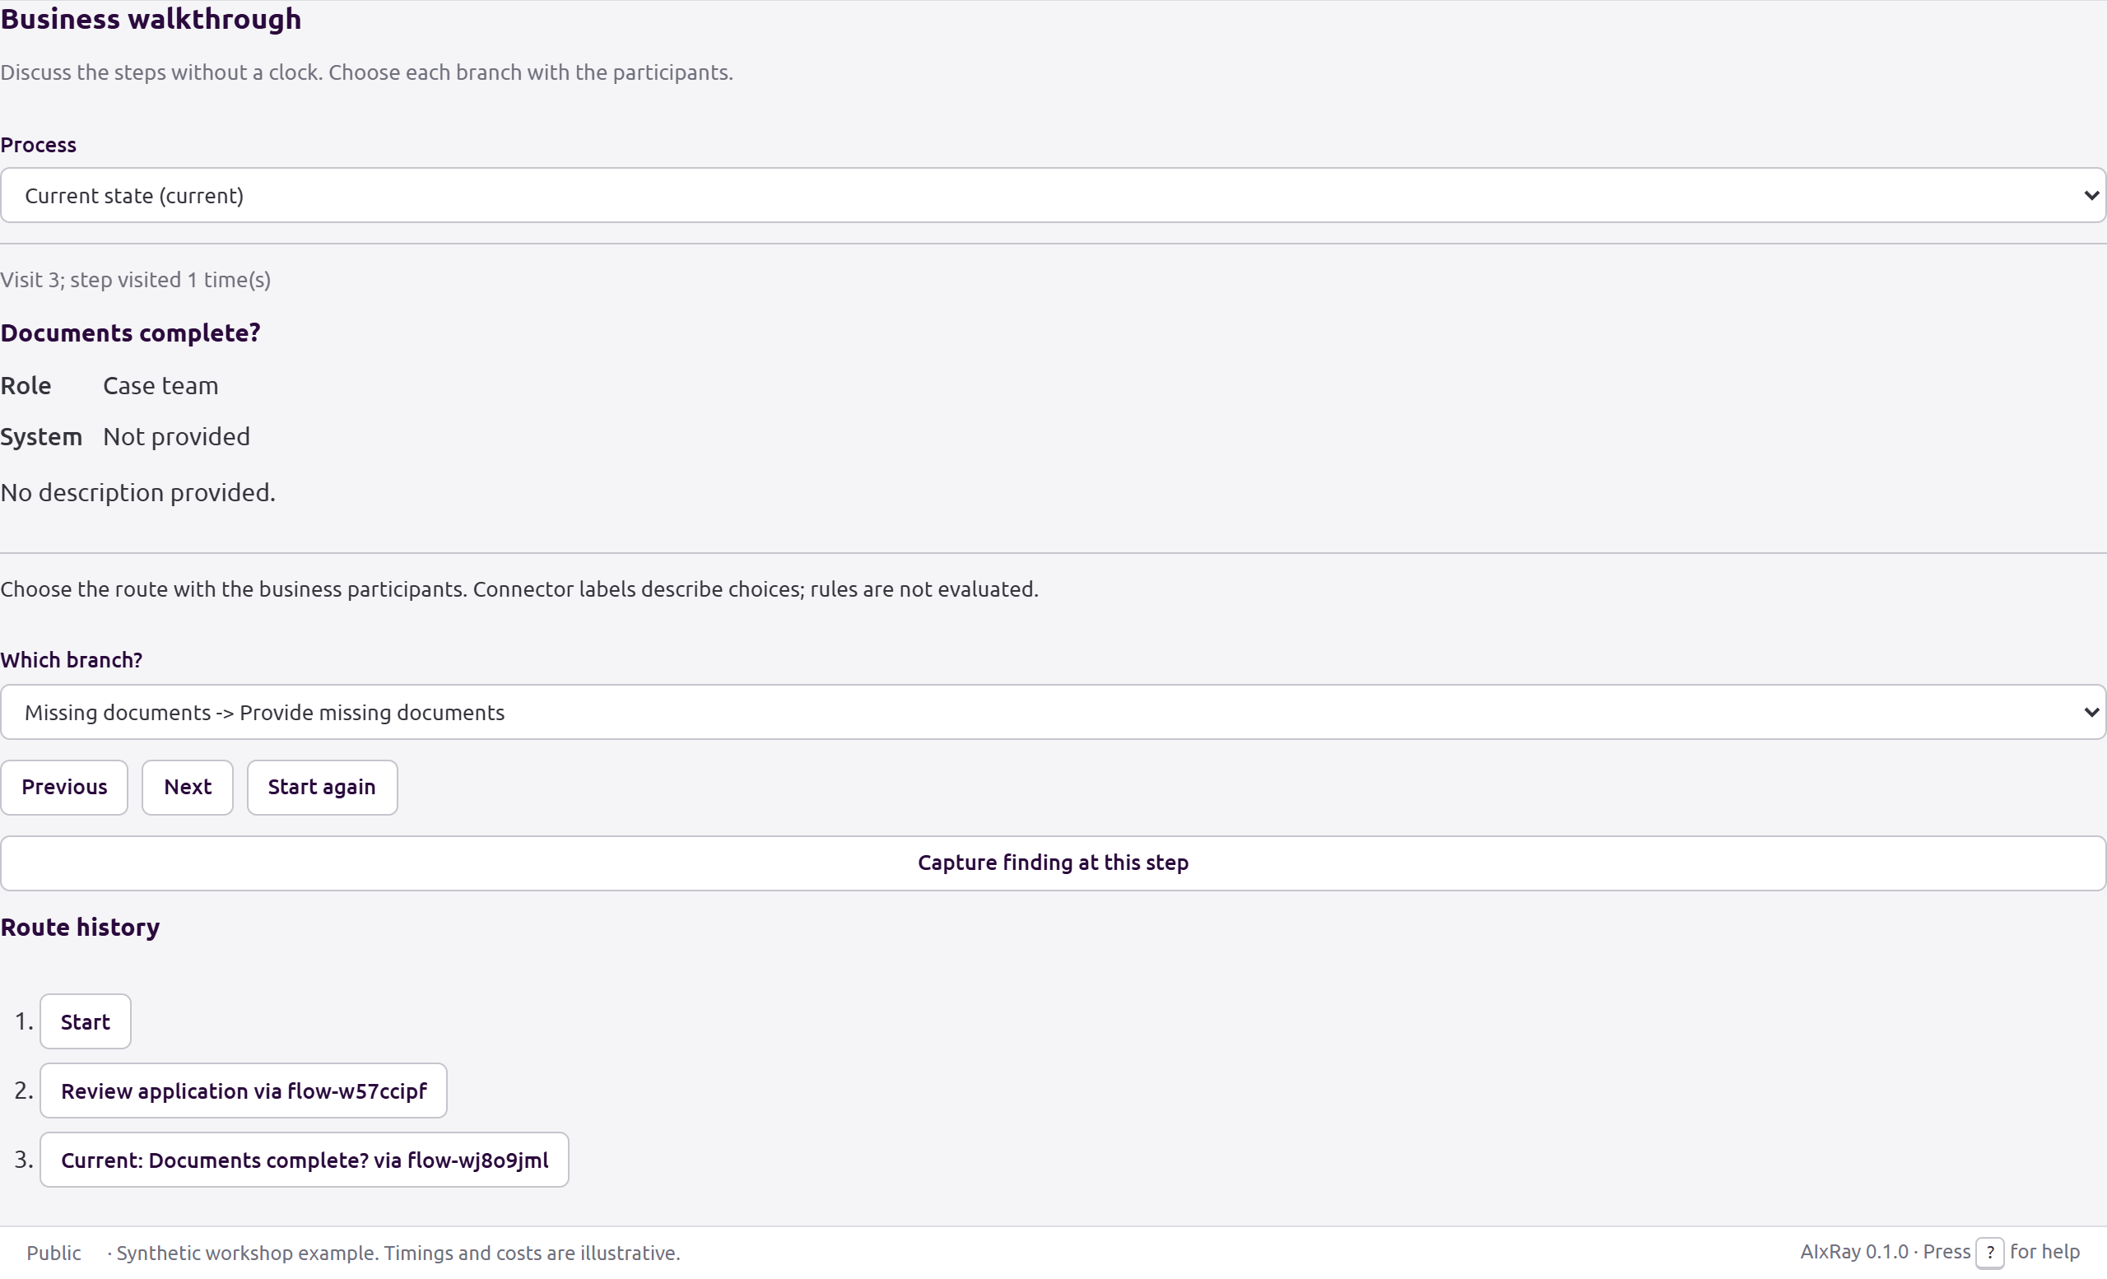
Choose the missing-document branch with the participants before advancing.
At Documents complete, select Missing documents and choose Next. Follow the rework loop back to Review application, then revisit the gateway and take the Complete route. Previous and Route history let you return to an earlier point.

2 Capture a finding at the step
Choose Capture finding at this step while the relevant step is selected. Enter a clear title, choose the appropriate finding type and name an owner. The form keeps the model and step link. Select Add finding to save it.
This walkthrough records one selected route at a time. Parallel or inclusive gateways do not execute all branches or model synchronization; review those branches separately. It does not measure duration. Use it to check the route with participants, not to claim that the process was simulated.
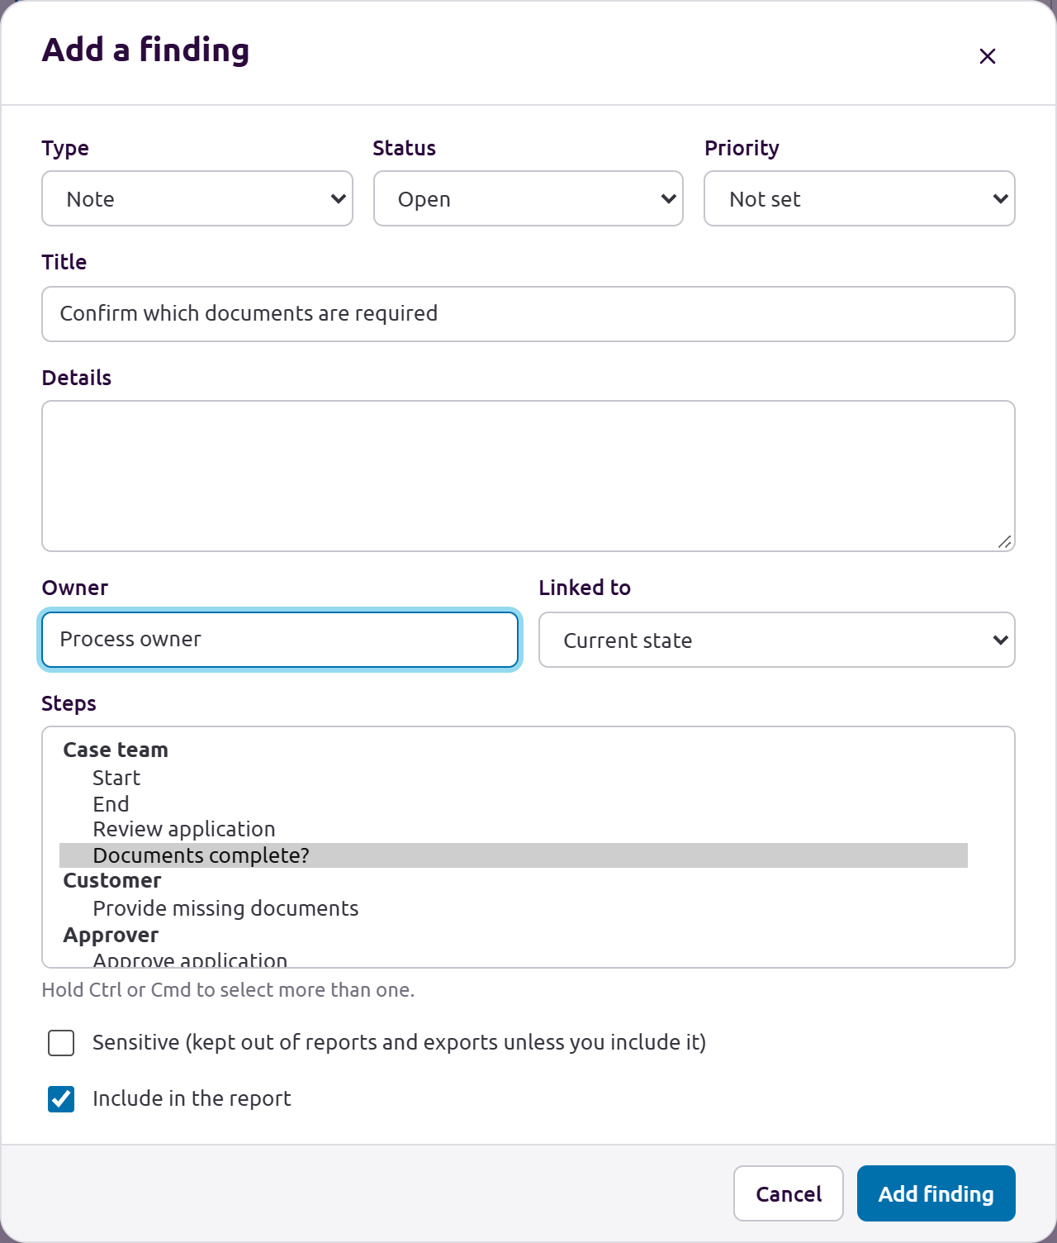
Capture the question against the decision step and name an owner.
In the example, Confirm which documents are required belongs to the completeness decision. Record the process owner as its owner and keep the issue open until the required-document rules are confirmed.

3 Record a timed scenario
Choose Edit scenarios from More actions or the walkthrough panel. Create and name a scenario, select a process under Process for this run, add ordered visits, select incoming branches, and enter wait, duration, human effort, and optional start time. Repeated visits represent rework. Blank human effort remains unknown. Save run saves that route; save before changing assumptions or switching routes. Use Reload saved route to discard unsaved edits.
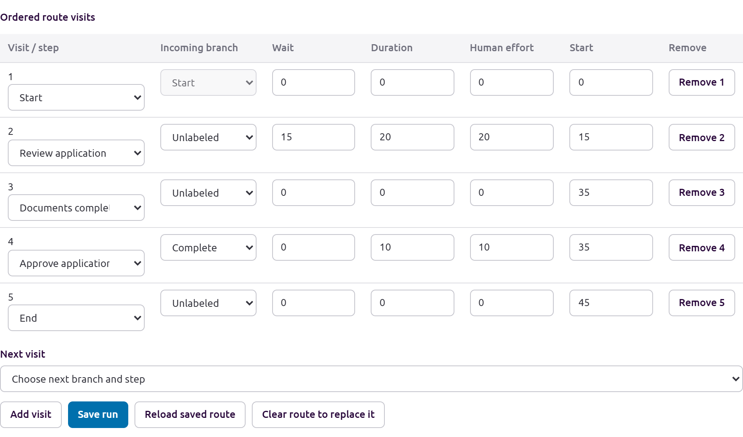
Save the ordered route with explicit wait, duration and human effort for each visit.
For the normal example, enter Start, Review application, Documents complete, Approve application and End. Enter 15 minutes of wait before review, 20 minutes of review effort and duration, and 10 minutes for approval. Enter zero effort for events and decisions when appropriate; leave unknown effort blank. These values are illustrative.

3 Compare explicit assumptions
Under Compare processes and enter assumptions, select the before and future processes and enter any scenario-specific economics overrides. The controls include three explicit variants: Conservative, Expected, and Optimistic. Create three alternatives saves those variants; Save assumptions saves the scenario overrides. The comparison panel reports annual cost difference, time freed up, and missing assumptions from the entered runs and engagement assumptions. These are alternatives, not additive outcomes. Capacity is redeployable time; elapsed duration alone does not establish cost savings. The editor does not schedule parallel branches or execute business rules.
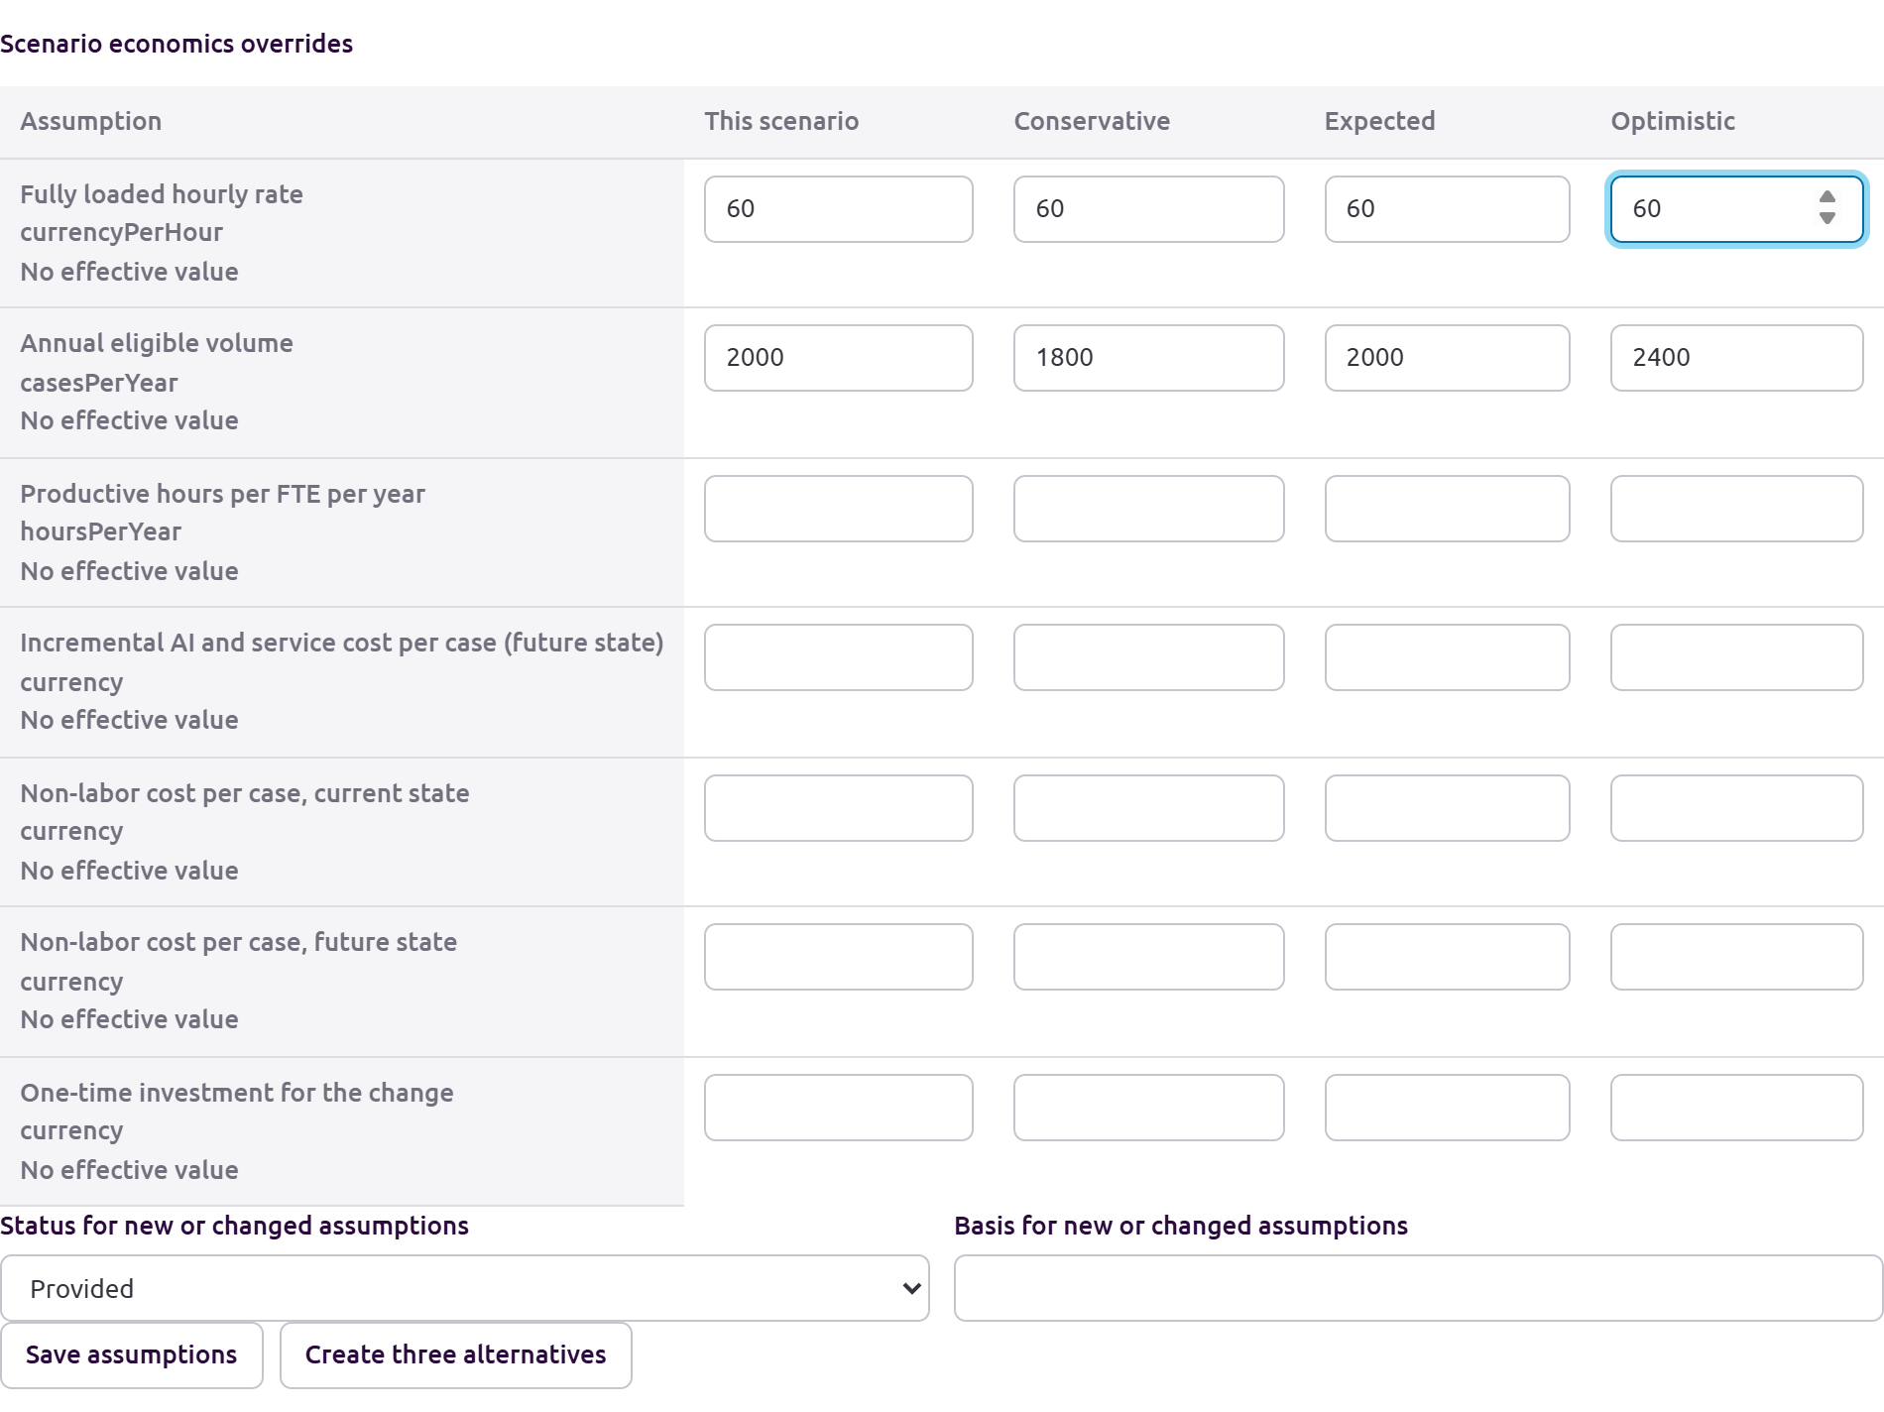
Enter explicit assumptions for conservative, expected and optimistic alternatives.
The example uses annual volumes of 1800, 2000 and 2400 for conservative, expected and optimistic alternatives, with an hourly rate of 60. Replace these inputs with supported project assumptions. A future run still needs its own route and human-effort inputs before the comparison can establish a difference.

4 Create a future alternative
In Build a process, open Future alternatives, name an alternative, and choose Create future alternative. AIxRay copies the current process and locks that baseline. Select the future process in Process diagram and edit its lanes, steps, gateways, and flows. The future-state comparison marks changed, added, and removed items with their lineage. Keep alternatives tied to a clear reason and to findings from the walkthrough. Rebuild scenario runs for a changed diagram before comparing timing again.
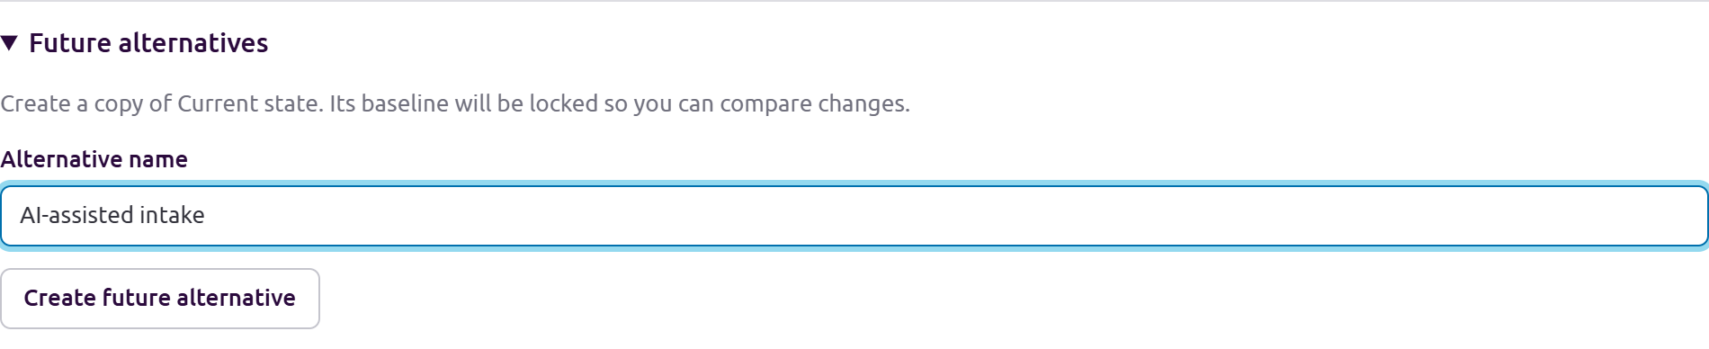
Name a future alternative before creating the copy and locking the baseline.
Name the copy AI-assisted intake. In the future diagram add an AI assistant lane, move the completeness activity there and describe the proposal. Keep the Approver activity with a person. Record the reason for each change and the finding it addresses.

4 Compare the process designs
In Process, select the Side by side view for the future alternative. The current process is the locked baseline; changed, added and removed steps are marked in the future model. Check each handoff and exception with the participants.
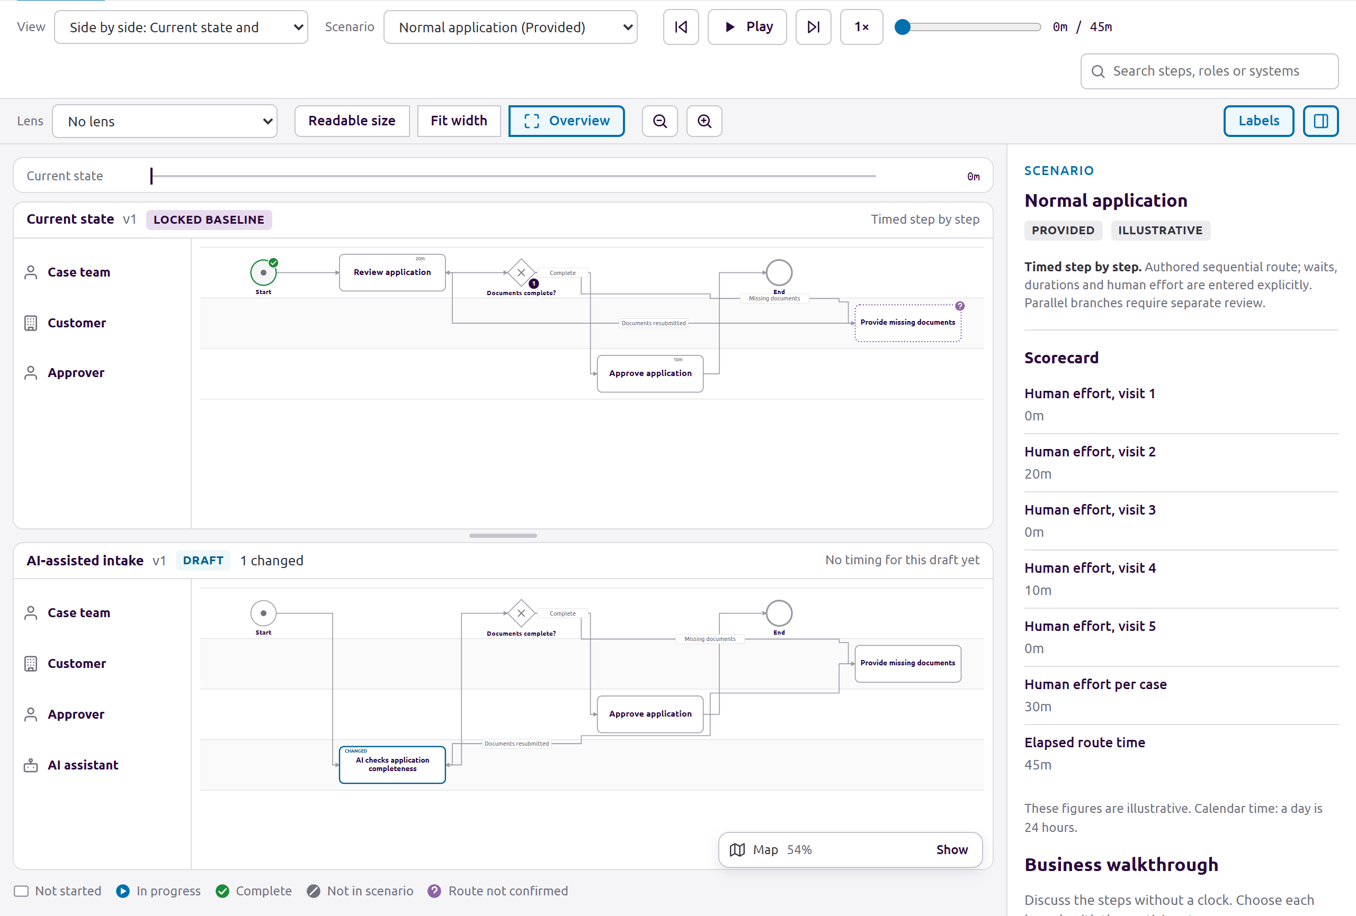
Compare the locked baseline with the AI-assisted future alternative.
This view compares the designs. No timing for this draft yet means the future run has not been authored. Use Edit scenarios to add that run with supported assumptions before discussing a time or cost reduction. The example retains human approval and the missing-document route.

5 Describe the automation work
Open the process drawer for a step and expand Automation design, or go to Findings, Workshop and use Step automation designs to select a process and step. Record a Design owner and Responsibility: Human, Rules, AI assist, or Agent. Fill in Trigger, Inputs, Outputs, Systems, Rules and limits, Approval, Fallback and escalation, and Test criteria.
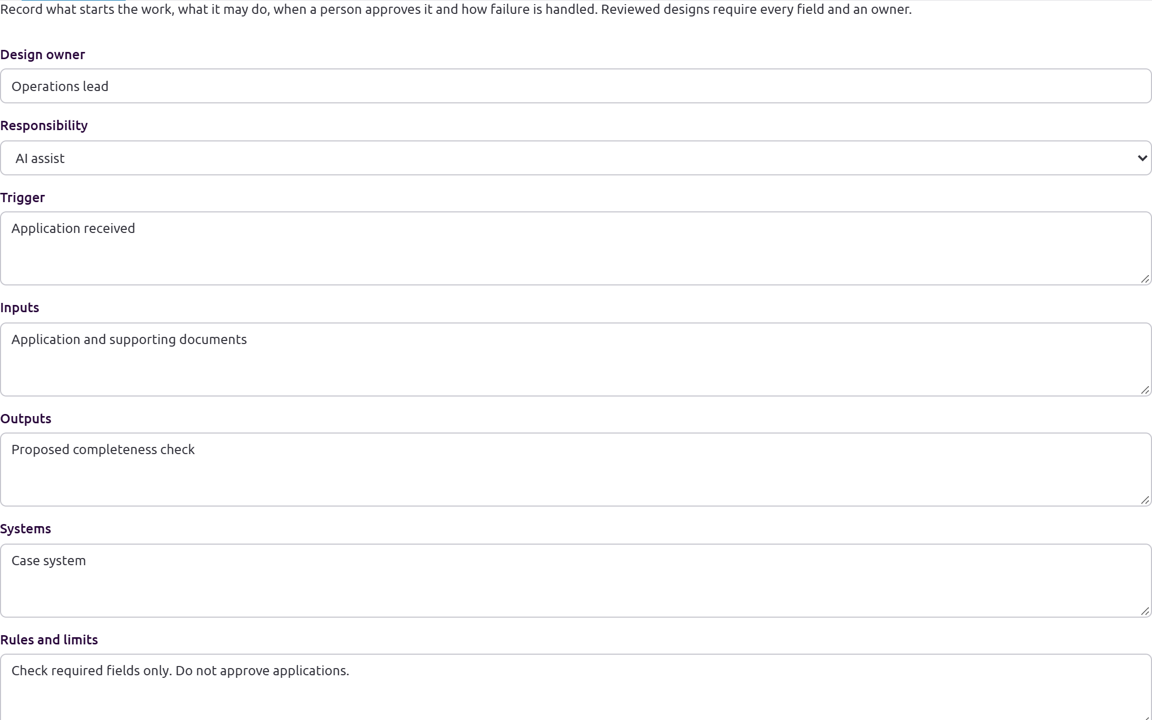
Record the owner, responsibility, inputs and outputs of the proposed AI step.
For AI checks application completeness, choose AI assist and name Operations lead as the design owner. State the documents it receives and the proposed completeness check it produces. Keep the systems and the trigger explicit so the team can judge whether the step is feasible.

5 Define approval fallback and tests
Ask who owns the outcome, which decisions require human approval, what happens when inputs are missing or the automation fails, and how the team will test normal and exception cases. Mark a design Reviewed only after checking its limits and criteria. A reviewed design requires an owner and every design field. Sensitive designs can be excluded from the Pilot brief.
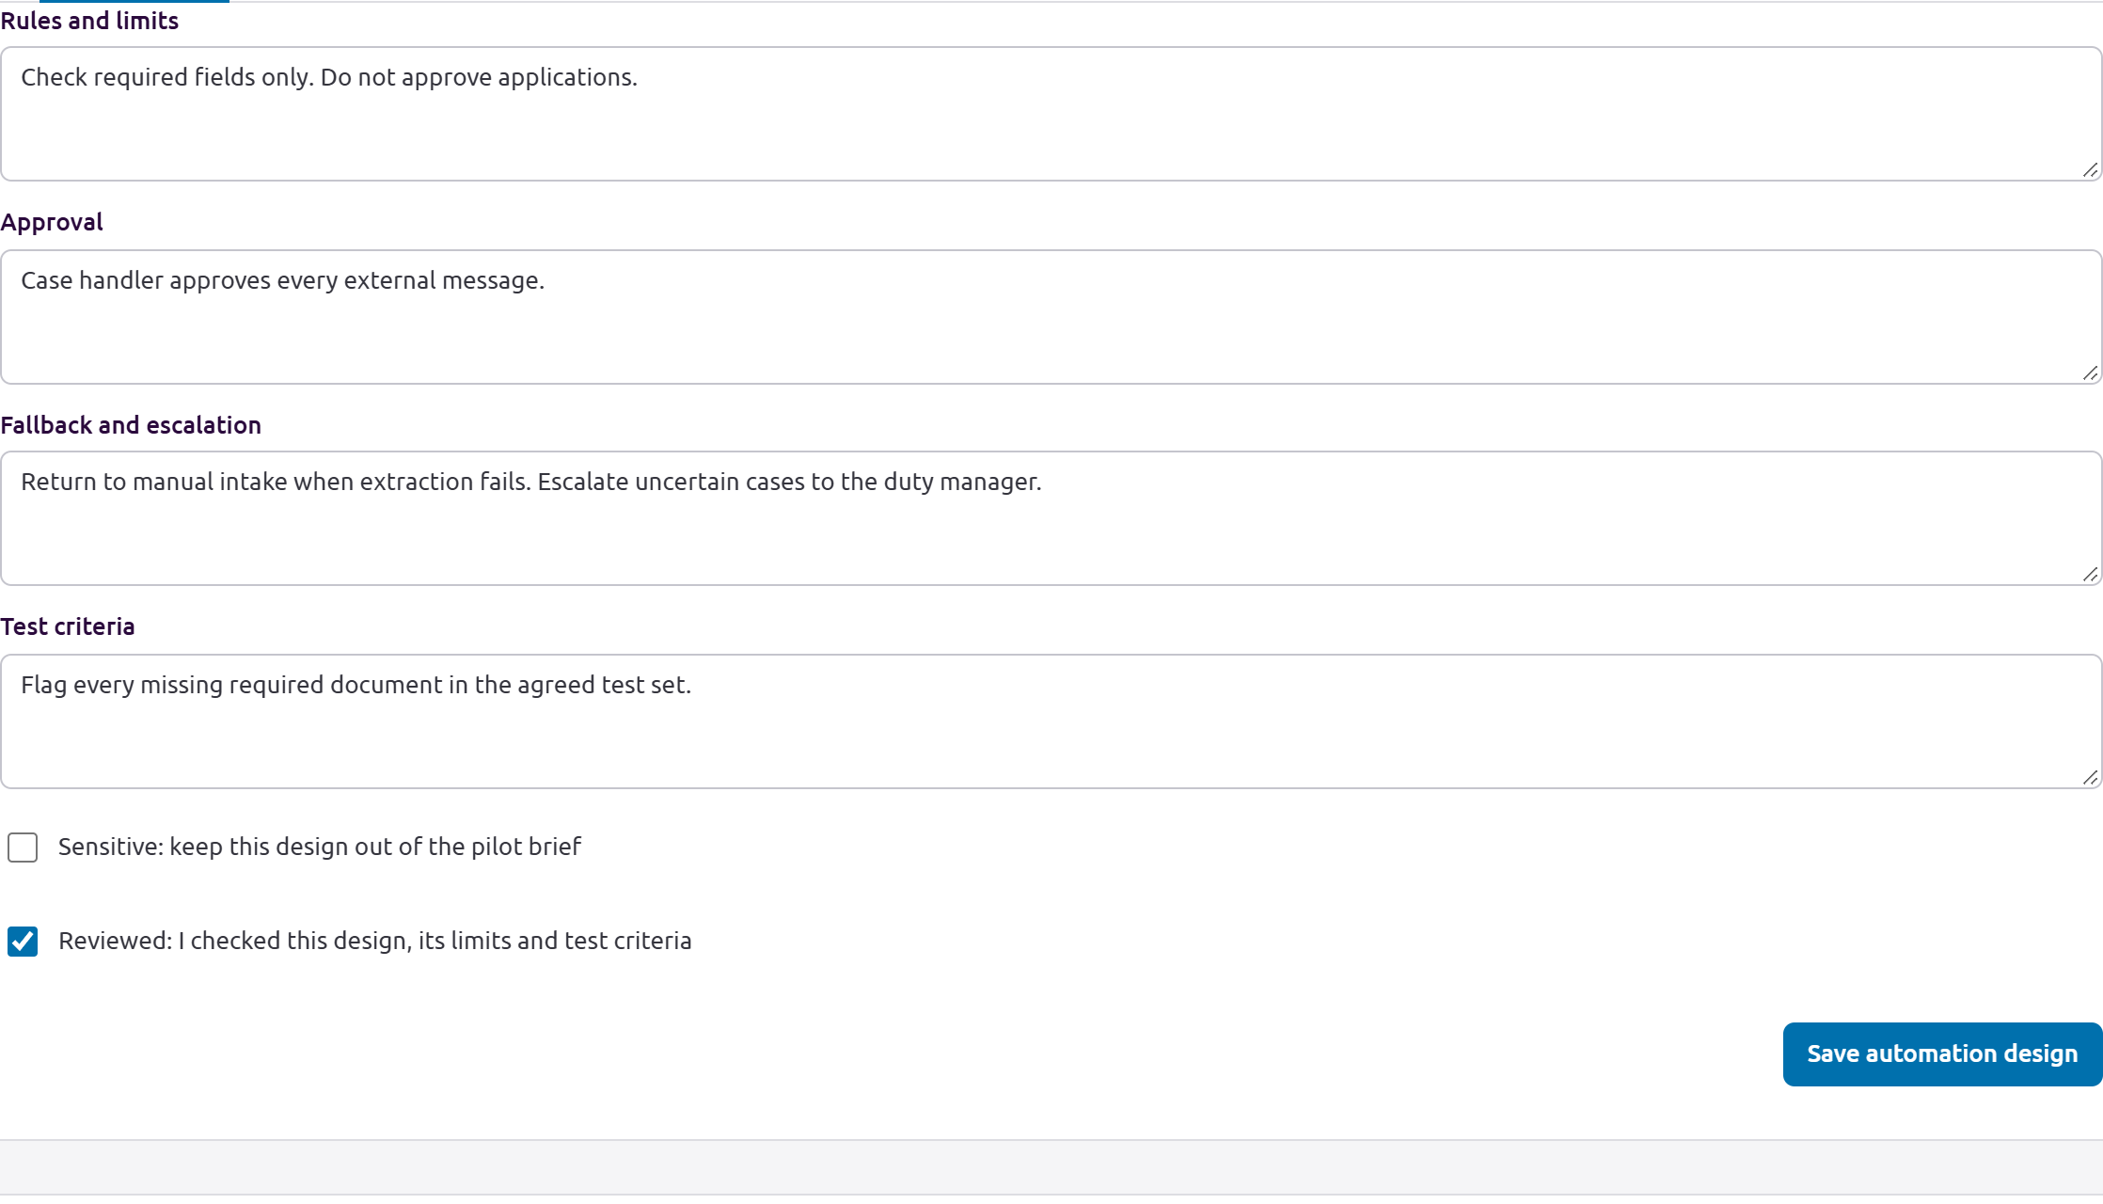
Keep approval, fallback and tests explicit before marking the design reviewed.
The example limits the AI to required-field checks. A case handler approves every external message. Failed extraction returns to manual intake and uncertain cases go to the duty manager. The test set checks that every missing required document is flagged. Select Save automation design after reviewing the fields.

6 Run the agenda and parking lot
In Findings, open the Workshop subtab. Under Agenda, add items with an owner, minutes, and status; use Save agenda to keep changes. Under Parking lot and actions, use Park a question, Add a note, Quick finding, or Add an action. Assign owners and statuses in the finding form.
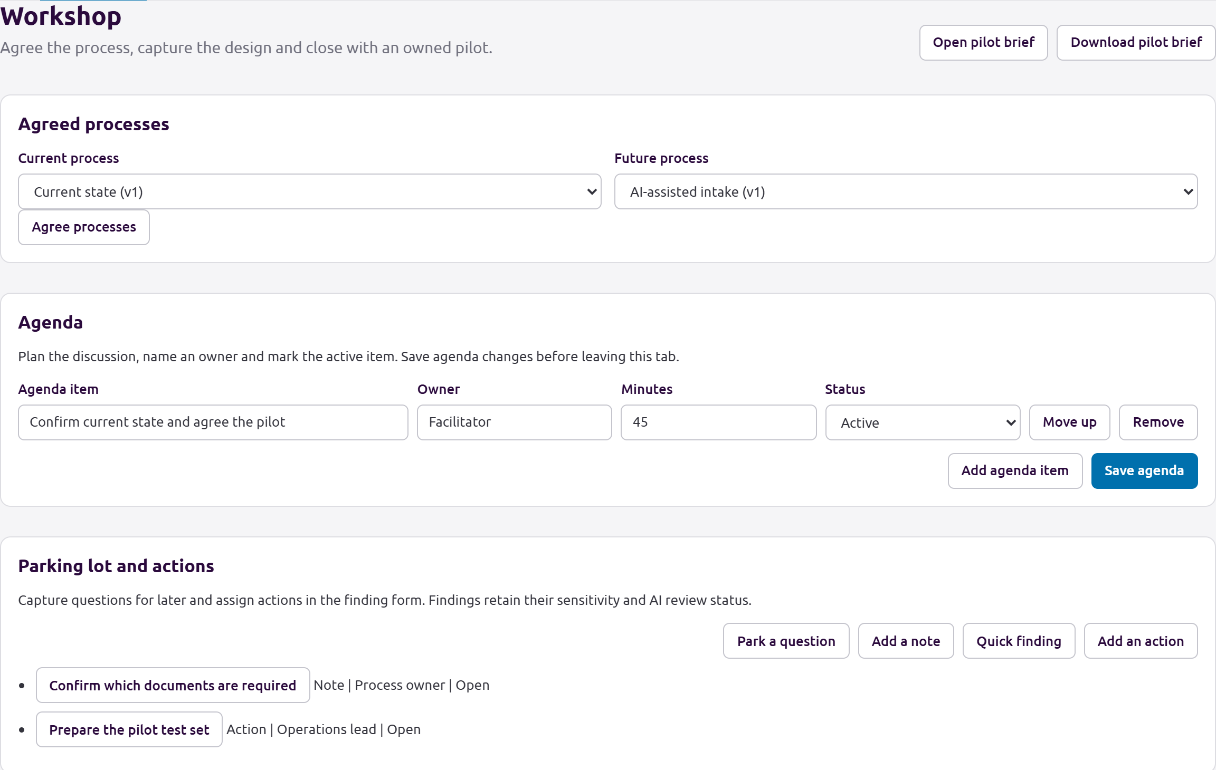
Agree the process versions, save the agenda and assign parked questions and actions.
Keep the process versions under Agreed processes aligned with the discussion. In the example, a 45-minute agenda item covers confirming the current state and agreeing the pilot. Prepare the pilot test set is an action owned by Operations lead. Save the agenda before leaving the tab.

6 Capture a workshop checkpoint
Under Agreed processes, select the current and future processes and choose Agree processes. Under Checkpoint and pilot acceptance, record a reviewer and date, select accepted changes and unresolved issues, and add acceptance criteria with an owner for each. Mark checkpoint details sensitive to exclude them from the Pilot brief. Mark them reviewed only after checking what may be shared. Choose Capture checkpoint when the group has recorded its position.
The checkpoint fingerprint detects changes to the agreed process, findings, or automation designs. A stale checkpoint says to review and capture a new one. It does not constitute formal approval, sign-off, or an organizational authorization.
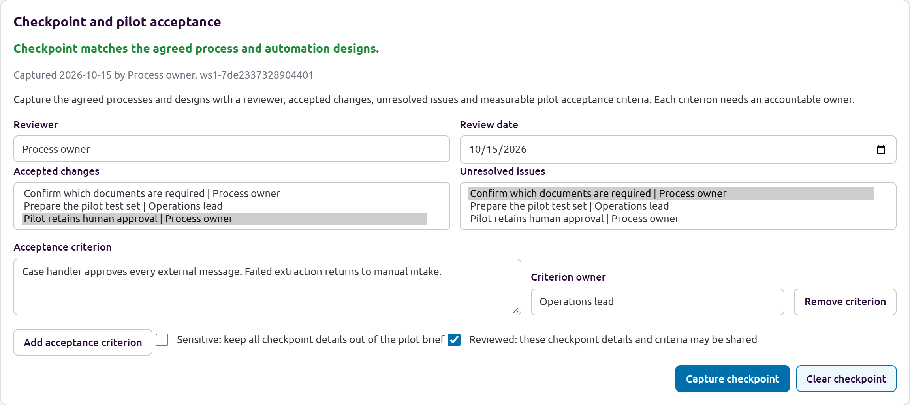
Capture a dated checkpoint with a reviewer and owned acceptance criteria.
The example accepts Pilot retains human approval, leaves the required-document question unresolved, and names an owner for the approval and fallback acceptance criterion. A checkpoint that matches the design can be shared only after its review and sensitivity settings are checked.

7 Review and share the pilot brief
From Workshop, choose Open pilot brief to go to Present and select Pilot brief. Review the agreed processes, checkpoint status, acceptance criteria, accepted changes, unresolved issues, reviewed automation designs, and actions. Sensitive material and unreviewed drafts are excluded. If the checkpoint is stale, review it before sharing. Download pilot brief exports a text file; Pilot brief text is also available in Present. The printable Pilot brief can be printed from Present.
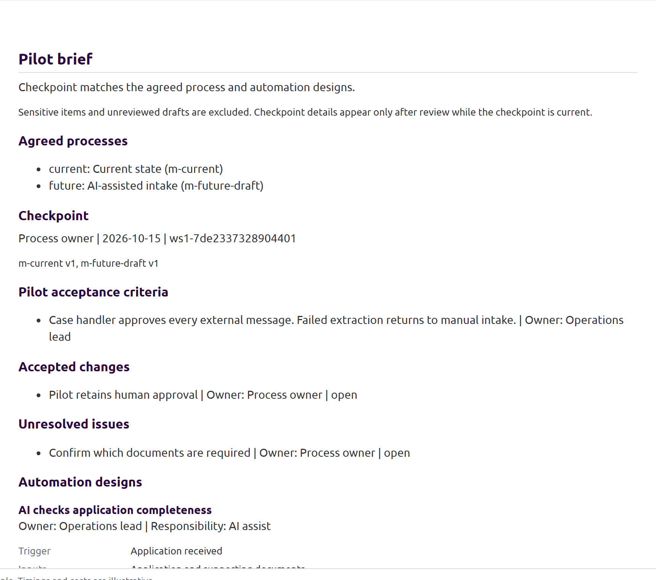
Review the checkpoint, accepted scope and owned criteria in the printable Pilot brief.
Read the agreed current and future process names, accepted decisions, unresolved questions, acceptance criteria and actions aloud. Confirm that each owner accepts the action. If a process, finding or automation design changes, review the stale checkpoint and capture a new one before sharing its details.

7 Save and reopen the project
Return to the project and choose Save a copy. Save the project file in the agreed location. Reopen that saved file with Open and check that the process, routes, findings, Workshop agenda, designs, and checkpoint are present. This confirms the saved file can be continued; it does not replace the participants' decision or approval process.
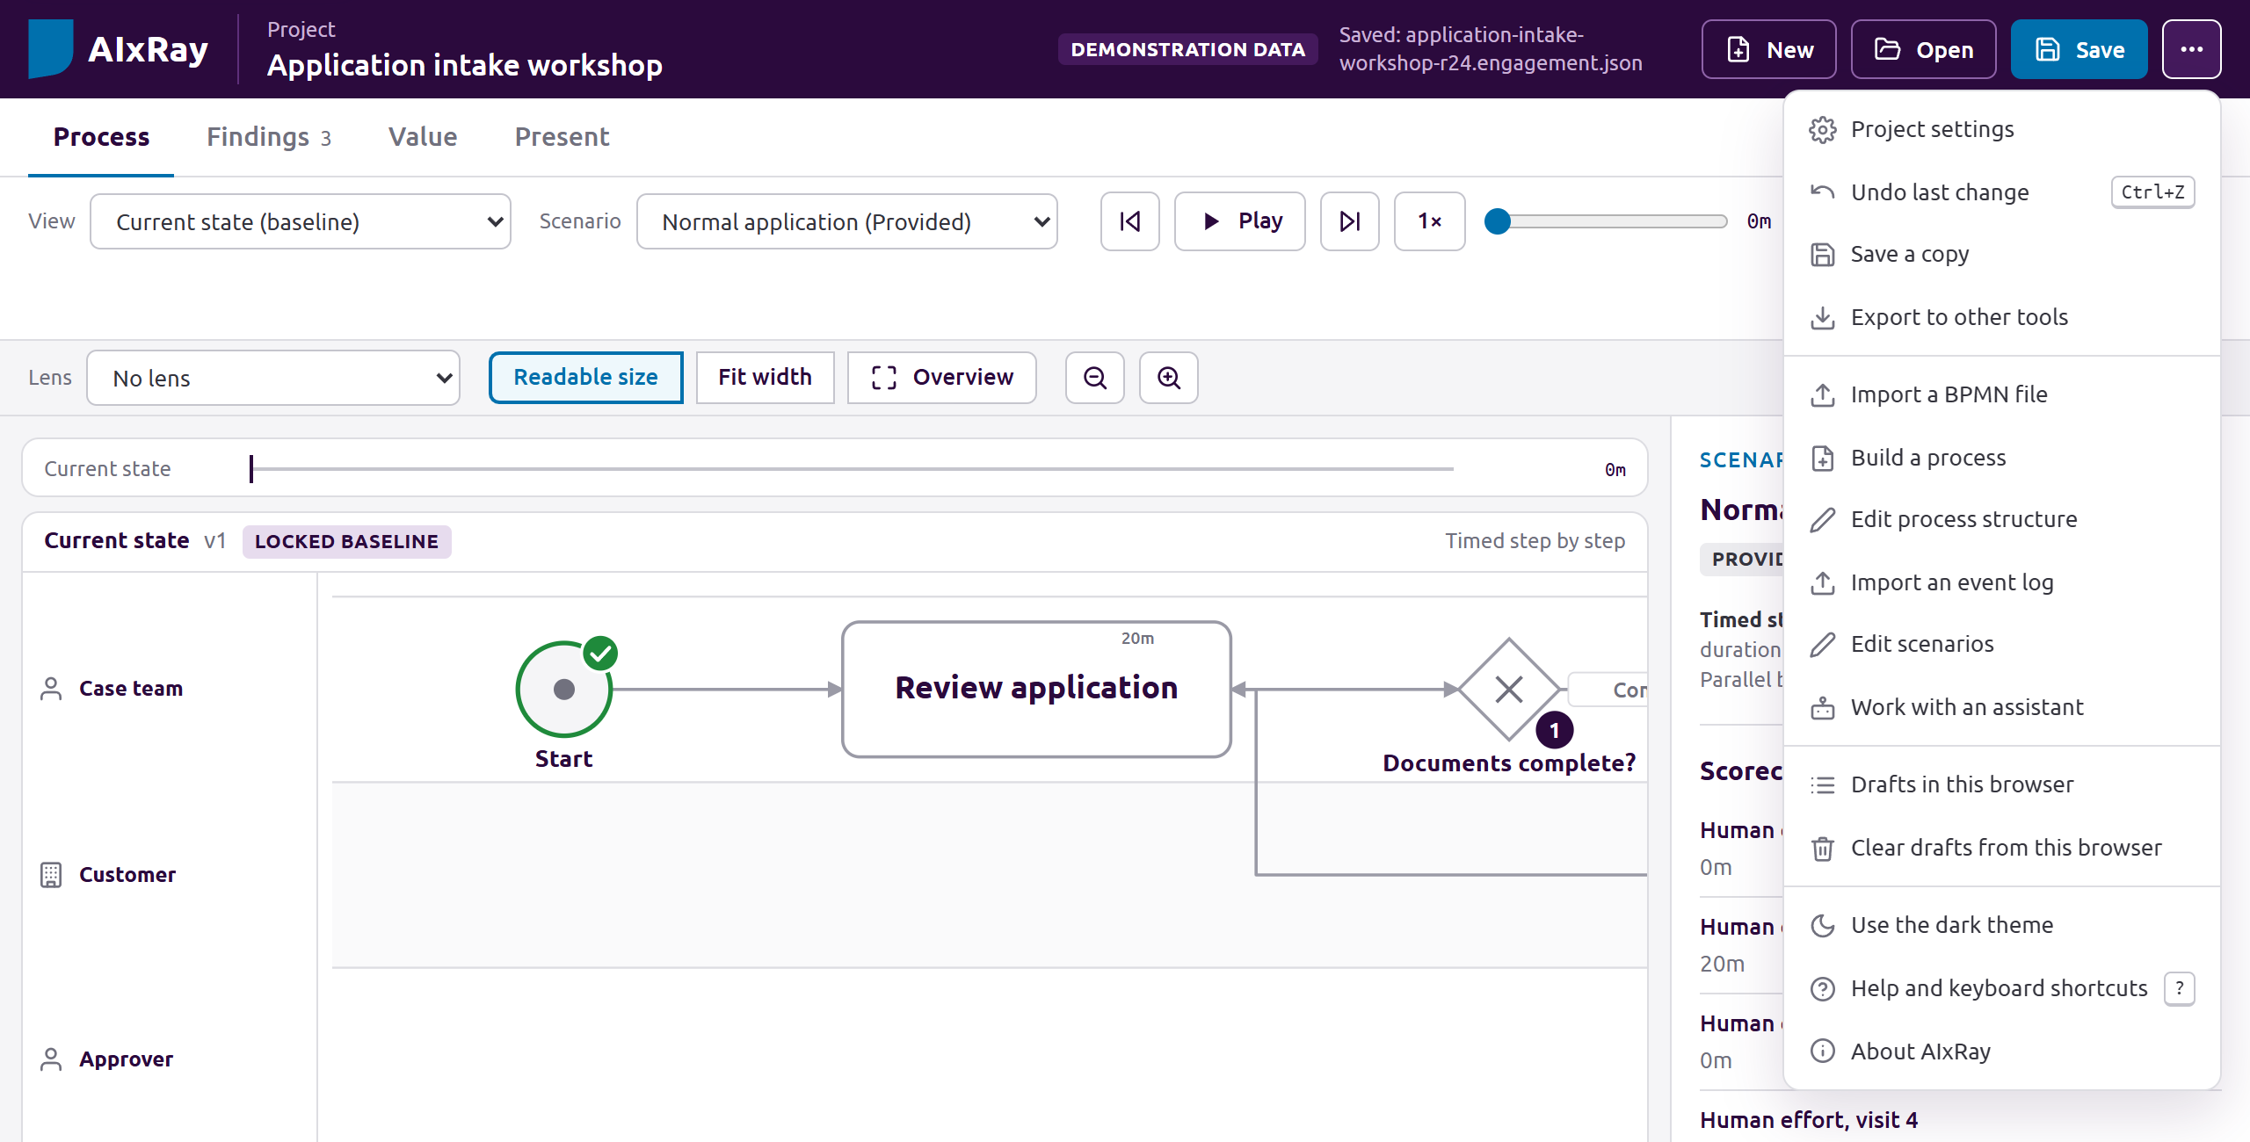
Save the project file and reopen it before handing over the workshop.
Save and Save a copy keep the portable project, while Download pilot brief produces the text handoff. The project file is the durable working copy; the browser recovery draft is a convenience. Store the project in the agreed location and identify its owner.

8 Prepare an assistant packet
Choose Work with an assistant from More actions. Select an assistant label, task, reviewed model baseline, packet format, and account plan. For activity mapping, supply approved activity names. Review the data-handling policy for the destination account and confirm that the material may be sent, then choose Export packet.
The packet is an external handoff for Codex, Claude Code, or GitHub Copilot. AIxRay does not run the assistant from this screen. The assistant name and account plan are user declarations; they do not verify authentication, the model, or the provider's data protections. The packet contains an allowlisted snapshot of reviewed process content and eligible findings, excludes source documents, scenarios, datasets, assumptions, sensitive material, and unreviewed AI drafts, and is checked for possible credentials. Give the packet to the selected assistant using an approved route. Ask it to return a complete .ai-result.json envelope preserving the packet's project, revision, task, and baseline bindings.
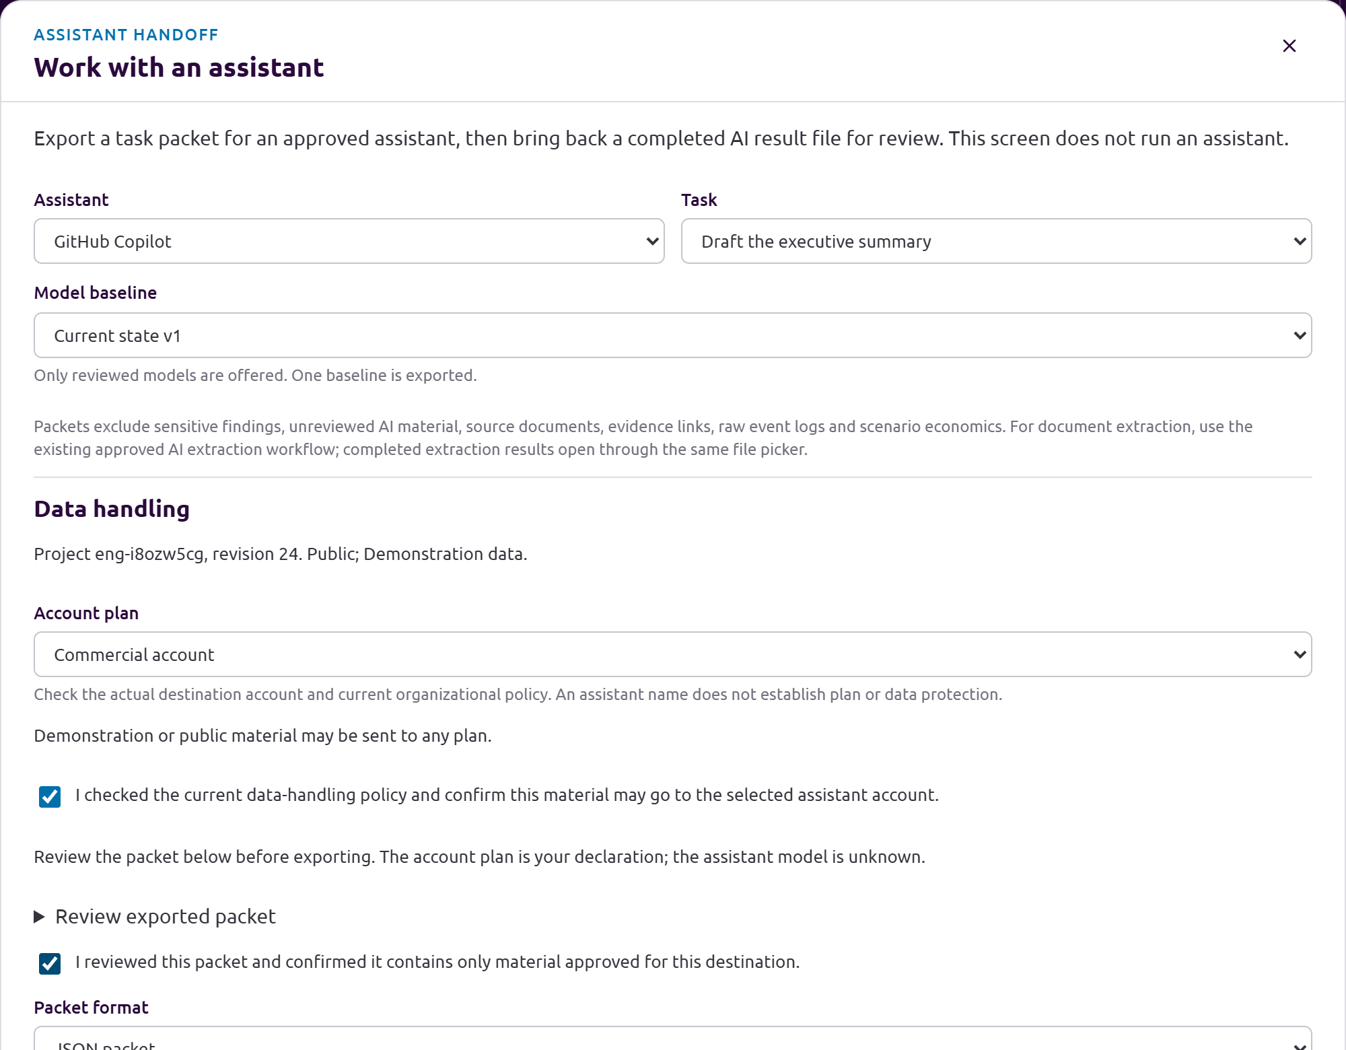
Choose an approved assistant account, review the packet and export the bounded task.

8 Export and return the result
Review exported packet shows exactly what will be handed to the assistant. Confirm the account plan and organizational policy, review the packet, then select Export packet. Give the downloaded packet to Codex, Claude Code or GitHub Copilot through the approved route.
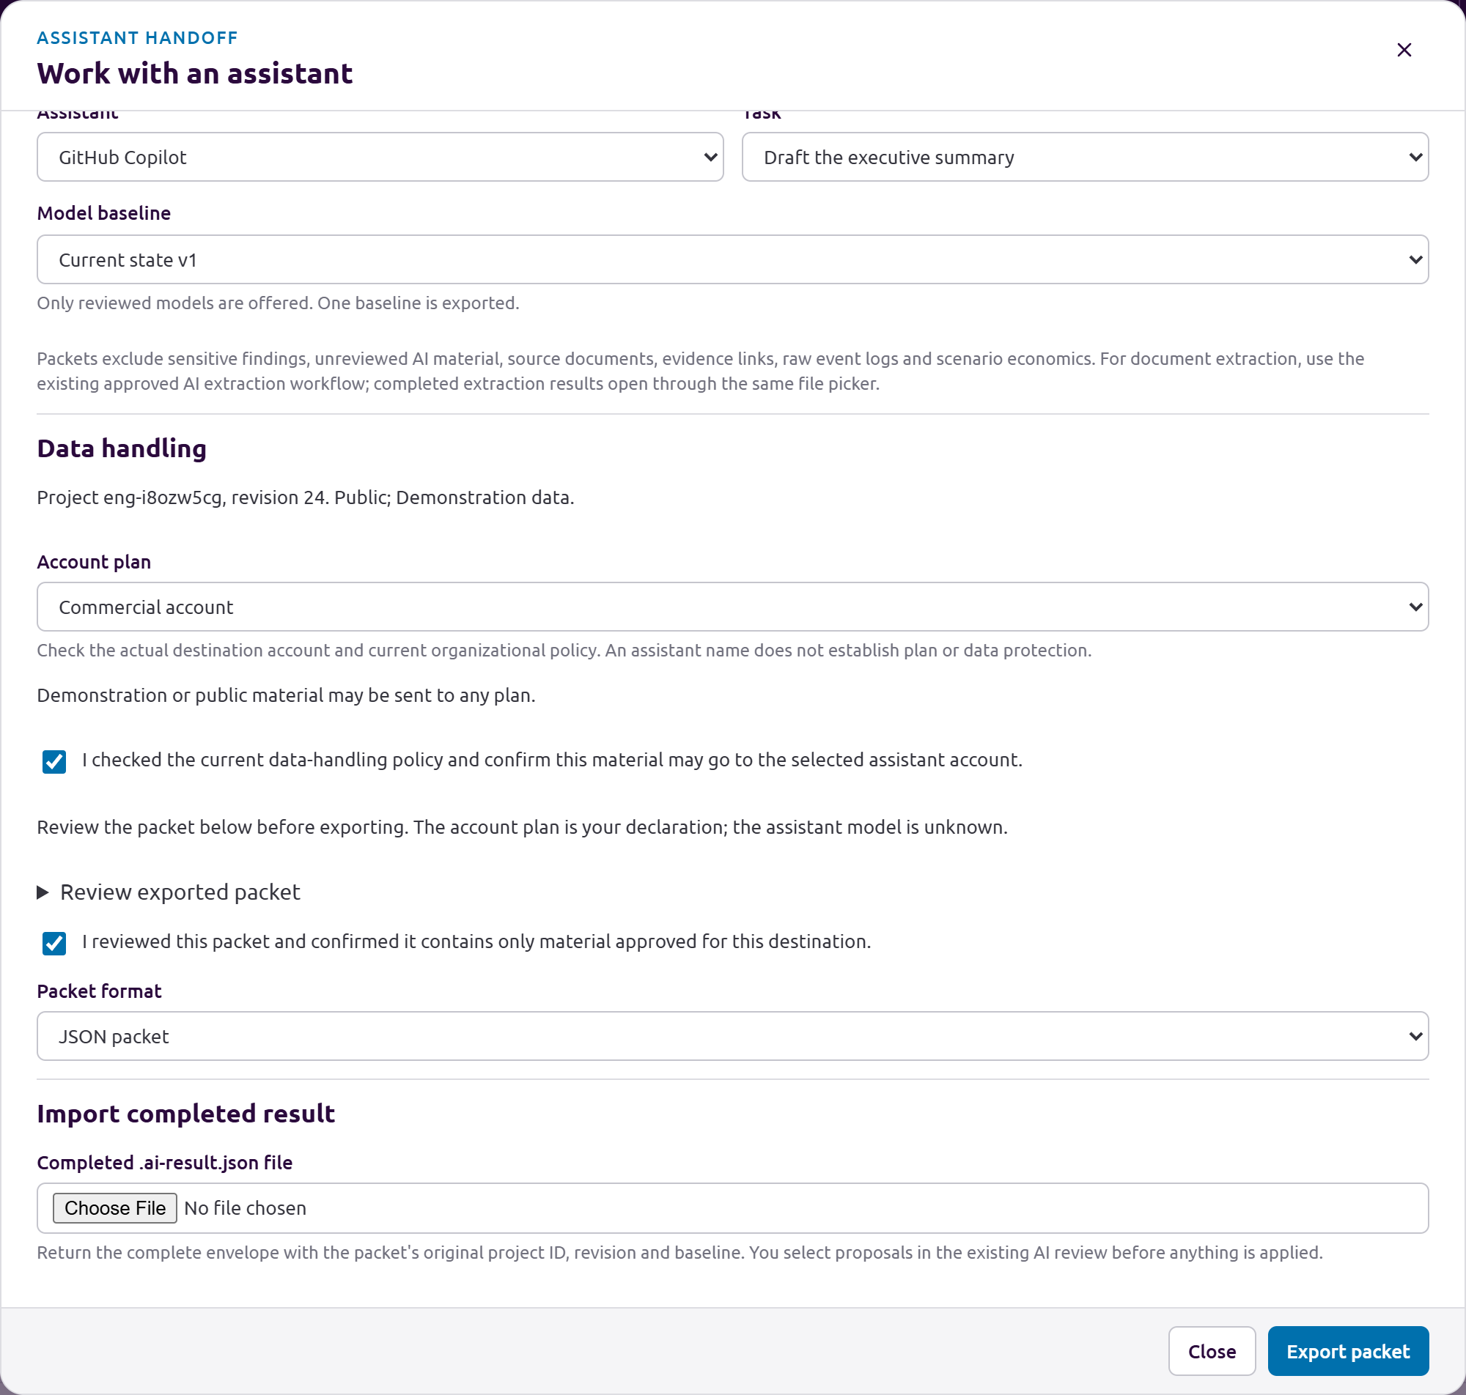
Review the approved packet, export it, then select the completed result file.
Ask for a complete .ai-result.json envelope that preserves the project ID, revision, task and baseline. Back in Work with an assistant, select the file under Import completed result. This handoff is offline file exchange; it does not launch an assistant or verify its account.

8 Review the returned proposal
Back in AIxRay, choose Import completed result in the handoff screen and select the returned file. Review proposals in the existing AI review flow and apply only what a person accepts. A result for a changed project revision needs explicit review against that revision or a new packet. Do not treat assistant output as a decision or approved process change. See AI tasks for the separate Claude Code and Codex task routes and their data-handling rules.
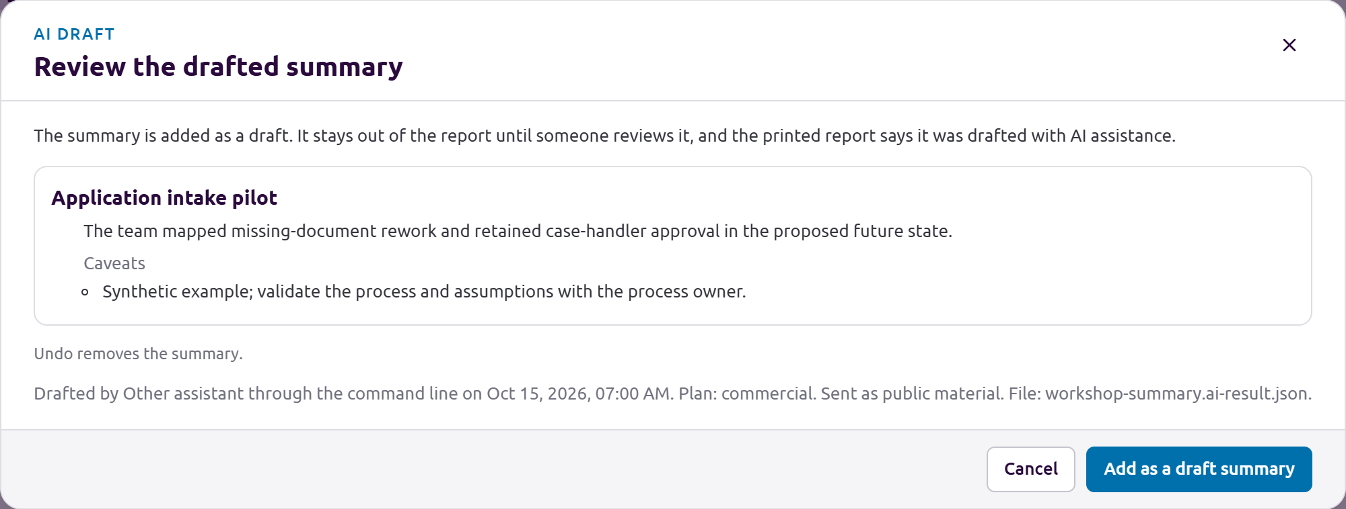
Inspect the returned AI proposal before applying it as an unreviewed draft.
Apply only the proposals you accept. They remain AI drafts until reviewed, and Undo reverses the applied change. A stale draft requires an explicit check against the current project revision; a project change while the review is open blocks application.

Facilitator habits
- Ask for a recent case before generalizing from an unusual one.
- Separate the normal route from exceptions, rework, and skipped work.
- Record observed facts, estimates, and assumptions with their basis.
- Capture disagreements and missing evidence as open questions.
- Confirm decisions, owners, acceptance criteria, and follow-up dates aloud.
- Keep one authoritative project file and tell participants where it is saved.

