Software Installation and Remote User Support Documented Lab
Report Prepared By: | Douglas Babcock
Date: | 11/16/2025
Lab Focus | Software Installation and Supporting Users

Section 1: Executive Summary
This report documents the process of providing software installation support for Evergreen Diagnostics. A centralized Software Repository was created on the server (ED-SRV01) to store approved installation files. The team connected remotely to the Finance Officer’s workstation (ED-CL01) using its IP address, accessed the shared repository by hostname, installed the required applications, and verified successful operation. This documented lab provided hands-on experience in remote support, secure software management, and centralized deployment—skills essential for IT support and help desk technicians.

Section 2: Create the Software Repository Folder
The SoftwareRepository folder was created on ED-SRV01 to store approved installation files. The folder was shared on the network and configured so that authenticated users could read and access installers while administrators retained full control through NTFS permissions.
Evidence / Verification Artifacts:
- Screenshot of C:\SoftwareRepository folder visible in File Explorer.
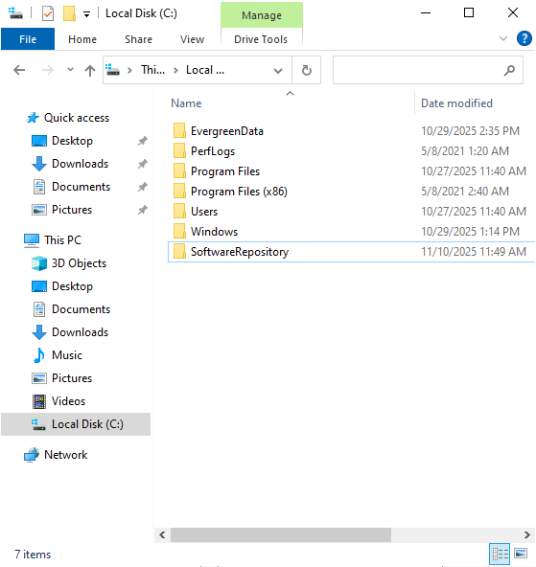

- Screenshot of Advanced Sharing showing Share name = SoftwareRepository and Authenticated Users – Change + Read permissions.
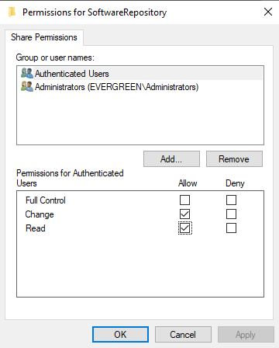
- Screenshot of Security tab showing Authenticated Users – Read & Execute permissions.
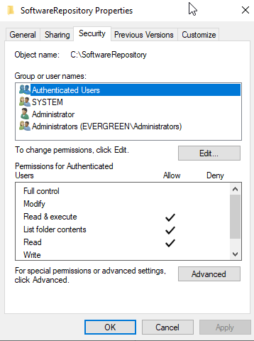

Section 3: Task — Download Approved Software
Approved applications were downloaded from official vendor websites to ensure authenticity and software integrity.
The downloaded files were first saved to the Downloads folder, then copied to the SoftwareRepository for shared access.
Applications Downloaded:
- Google Chrome
- Malware Bytes Anti-Malware
- Adobe Acrobat Reader
- 7-Zip
Evidence / Verification Artifacts:
- Screenshot of the Downloads folder showing the downloaded installer files before copying.
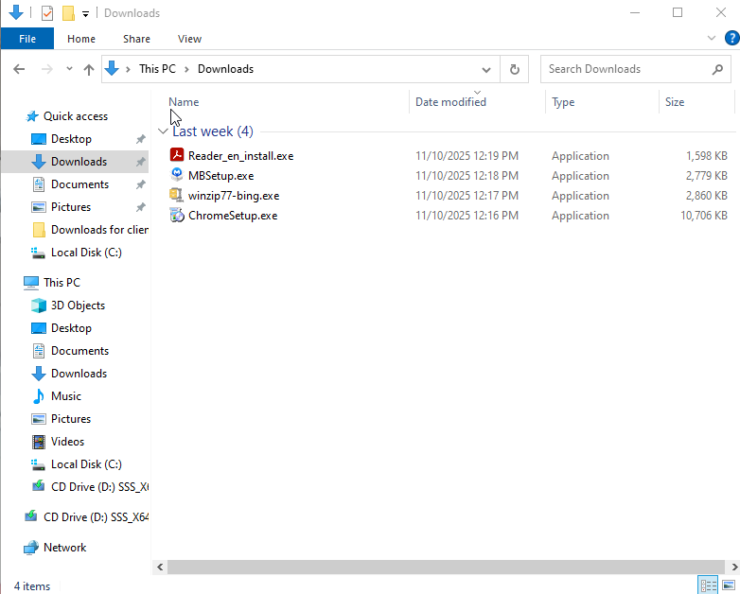

- Screenshot of the SoftwareRepository folder after files were copied, showing all installers with filenames visible.
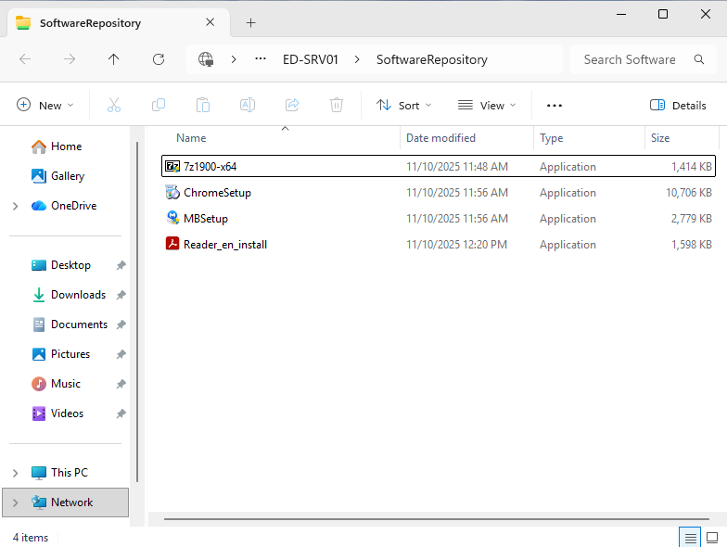

- Screenshot of one vendor’s official download page showing the official URL in the browser’s address bar.
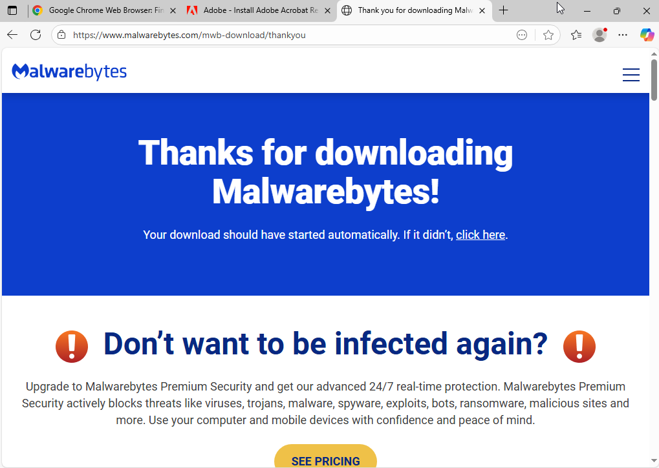

Section 4: Task — Connect to the Client via Remote Desktop
A Remote Desktop connection was established from ED-SRV01 to the Finance Officer’s workstation (ED-CL01) using its IP address. This confirmed that the client could be accessed remotely for administrative purposes.
Evidence / Verification Artifacts:
- Screenshot showing the Remote Desktop Connection window with the IP address of ED-CL01 entered.
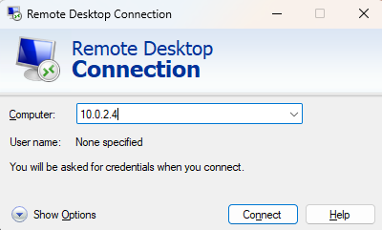
- Screenshot of the active remote desktop session, clearly showing the connection to ED-CL01.
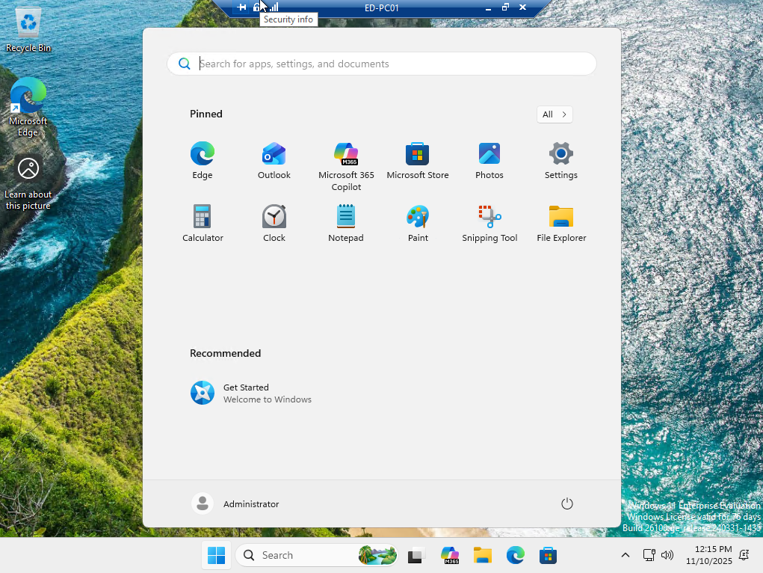

Section 5 :Task - Access the Software Repository from the Client

From the remote session, the SoftwareRepository folder on ED-SRV01 was accessed using the server’s hostname through the Run command. This verified that shared network resources were available over the domain.
Evidence / Verification Artifacts:
- Screenshot of the Run dialog box showing the entered path \\ED-SRV01\SoftwareRepository.
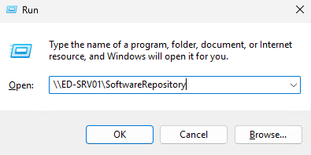
- Screenshot of File Explorer on ED-CL01 showing the opened SoftwareRepository folder with visible installer files.
- 

Section 6 :Task - Verify User Access from the Client
All required applications were installed on ED-CL01 from the SoftwareRepository.
Each installation was verified by launching the application and confirming functionality.
Evidence / Verification Artifacts:
- Screenshot showing installation progress or setup window for one application.
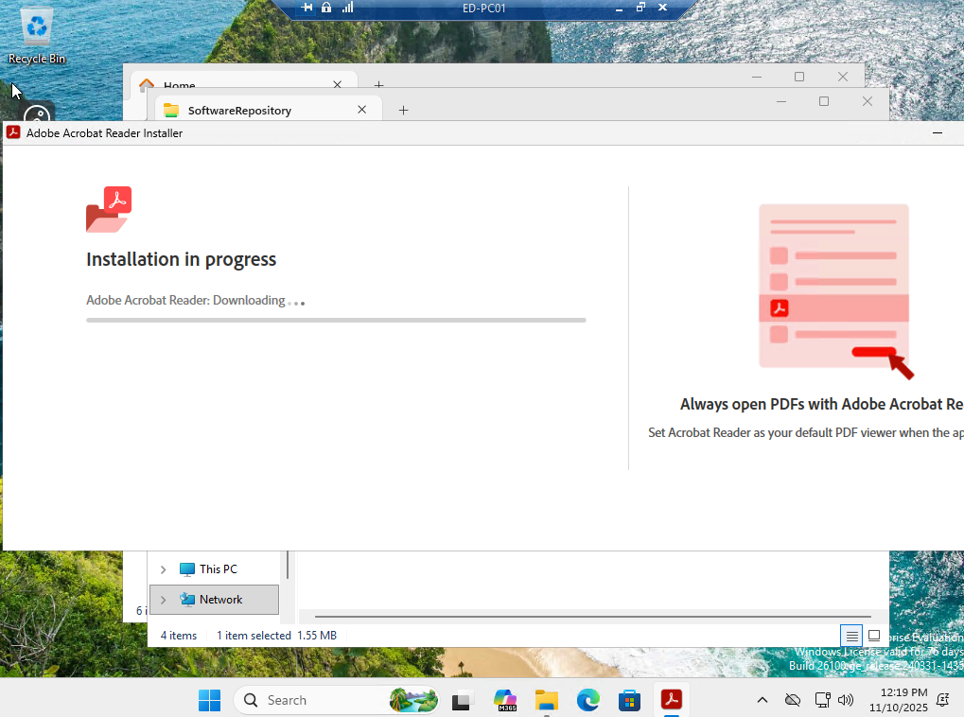

- Screenshot of Settings → Installed Apps or Start → All Apps showing all installed applications.
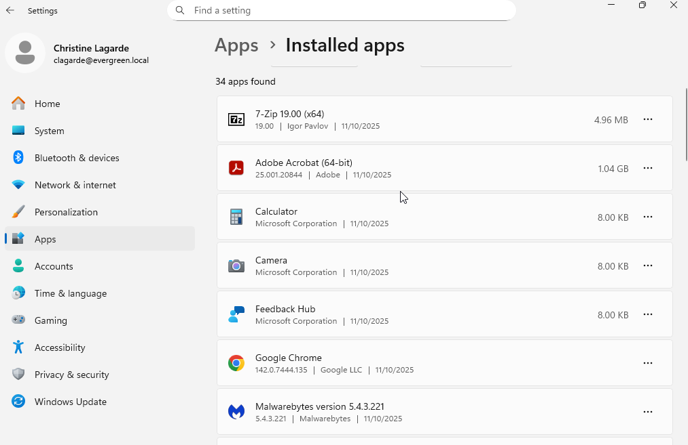
- Screenshot of one installed application open and running (e.g., Chrome, Acrobat Reader, or Malwarebytes).
