Virtualized Windows Environment Documented Lab
Report Prepared By: | Douglas Babcock
Date: | 11/01/2025
Lab Focus | Execution

Section 1: Executive Summary
In this documented lab, I configured a virtual environment for Evergreen Diagnostics, a healthcare startup preparing for its first clinic deployment.
The lab environment used VirtualBox to build a small network consisting of one Windows Server 2022 Standard system and two Windows 11 Enterprise workstations.
The tasks included creating a NAT network, installing and configuring each operating system, cloning the first workstation to create an identical copy, and verifying communication between all systems.
This documented lab provided hands-on experience in virtualization, operating-system installation, IP configuration, and network verification—core skills for IT Support and Help Desk professionals. After setup, network connectivity was tested between all servers and the internet. The results showed that; [insert summary of ping test outcomes below]
All systems were confirmed to have connectivity with all other internal systems as well as the internet.

This proof of concept demonstrates that the proposed design can operate successfully in a virtualized environment and lays the foundation for future Active Directory and file service configuration.
Virtual Machine Summary
The table below summarizes the virtual machines created and verified during the lab.
VM Name | Operating System | RAM | CPU Cores | IP Address
ED-SRV01 | Windows Server 2022 | 4GB | 2 | 10.0.2.3
ED-PC01 | Windows 11 Pro | 4GB | 2 | 10.0.2.4
ED-PC02 | Windows 11 Pro | 4GB | 2 | 10.0.2.5

Section 2: Task 1 – Server Installation and Configuration (ED-SRV01)
I installed Windows Server 2022 Standard (Desktop Experience) on a new virtual machine that will serve as Evergreen’s main administrative computer.
Evidence: Screenshots and verification artifacts are included below each item.
- Name and Operating System screen with ISO attached
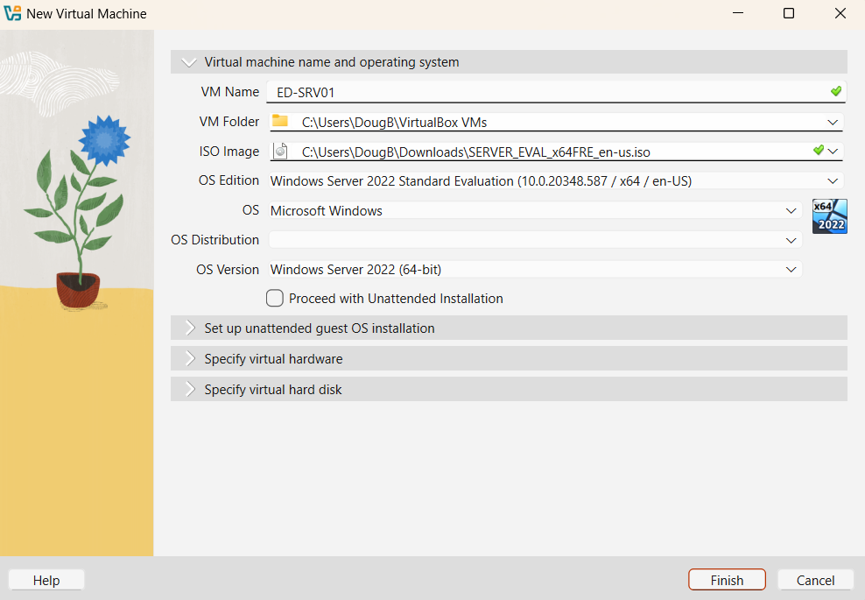

- Hardware settings screen showing RAM and CPU
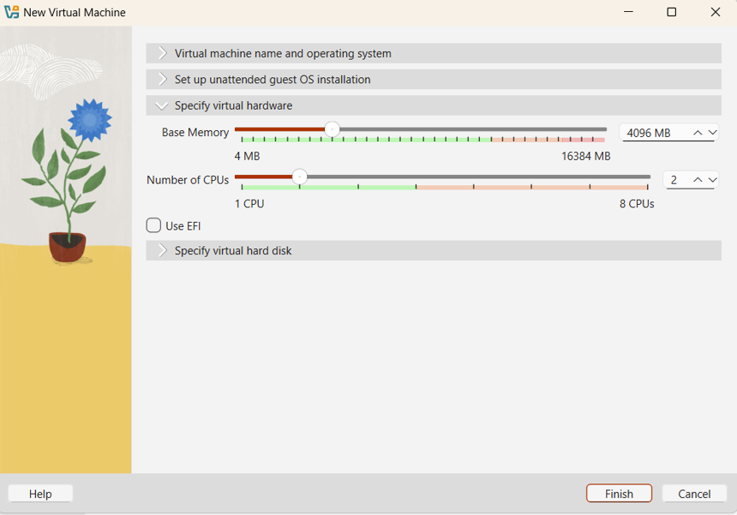
- Virtual Hard Disk setup screen before Finish
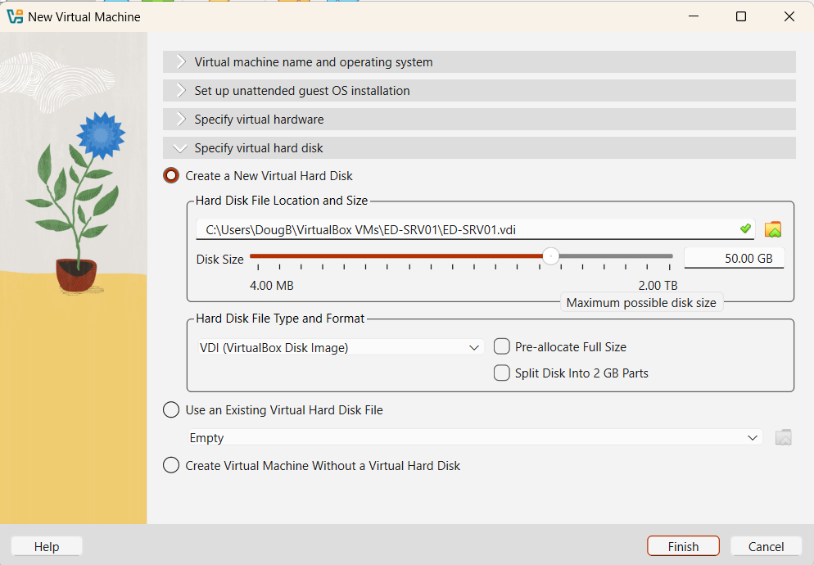
- Edition Selection screen (Windows Server 2022 Standard Desktop Experience)
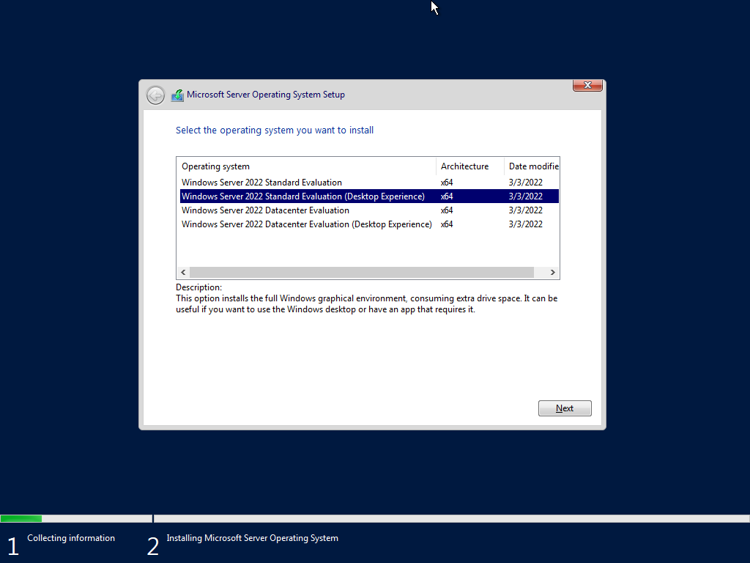

- Disk Selection screen before installation
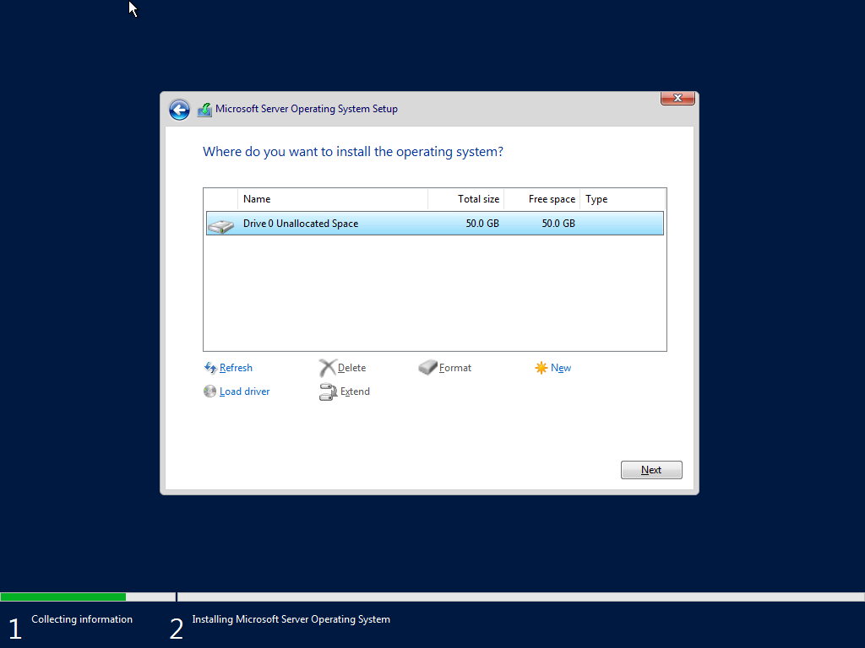
- Administrator logon screen after installation
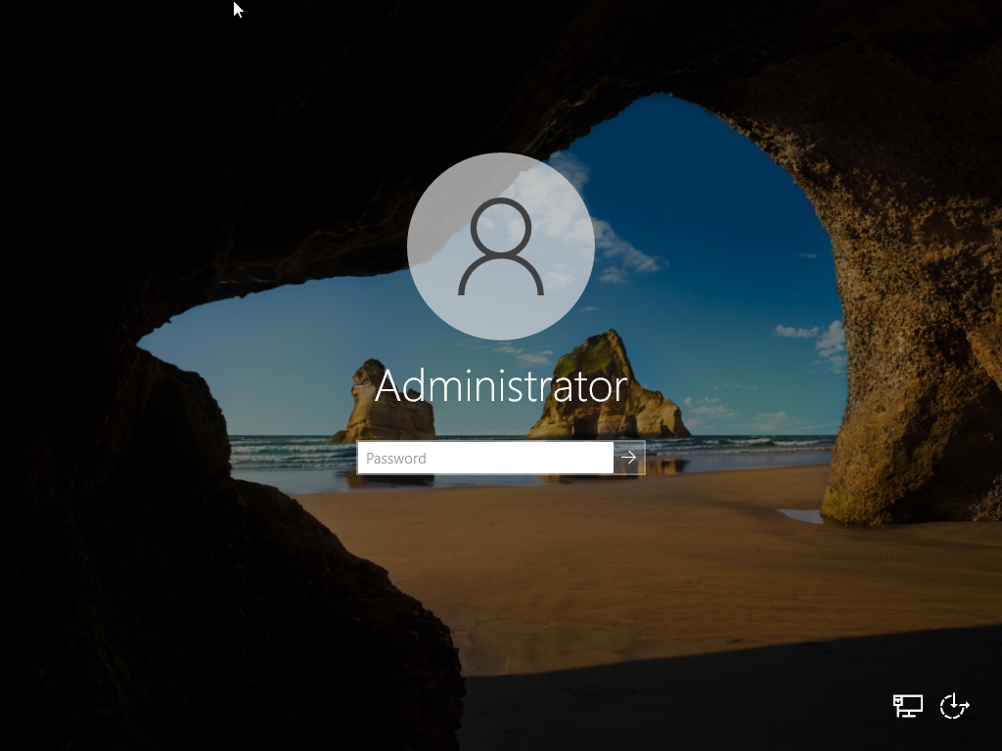

Section 3: Task 2 – Windows 11 Enterprise Workstation Installation (ED-PC01)
This section focused on creating and configuring the first employee workstation using Windows 11 Enterprise. The goal was to perform a clean installation, create a local account, and verify connectivity to the server.
Evidence: Screenshots and verification artifacts are included below each item.

- Name and Operating System screen with ISO attached
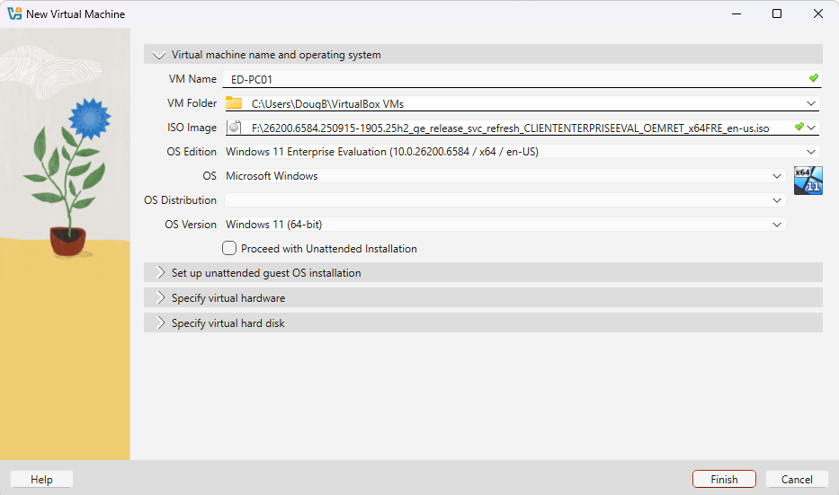
- Hardware settings screen (RAM and CPU)
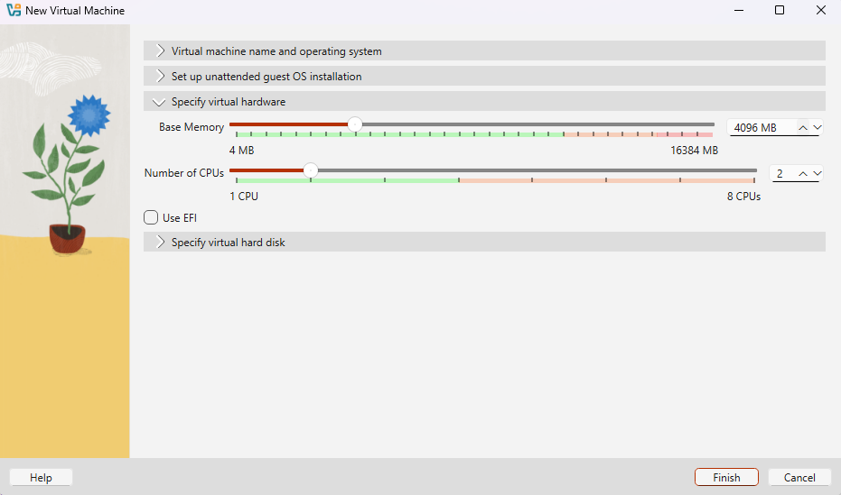

- Virtual Hard Disk setup screen before Finish
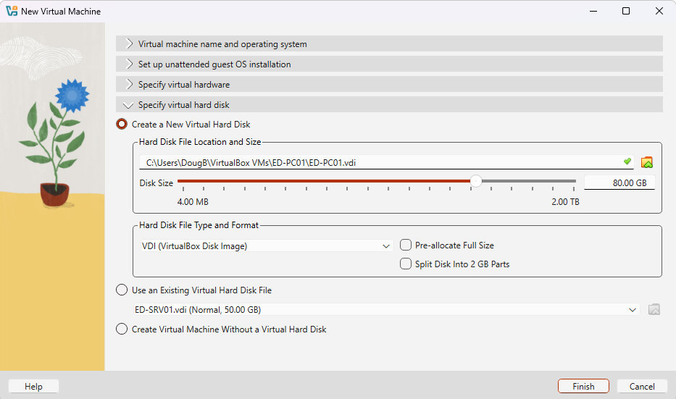

- Edition Selection screen (Windows 11 Enterprise)
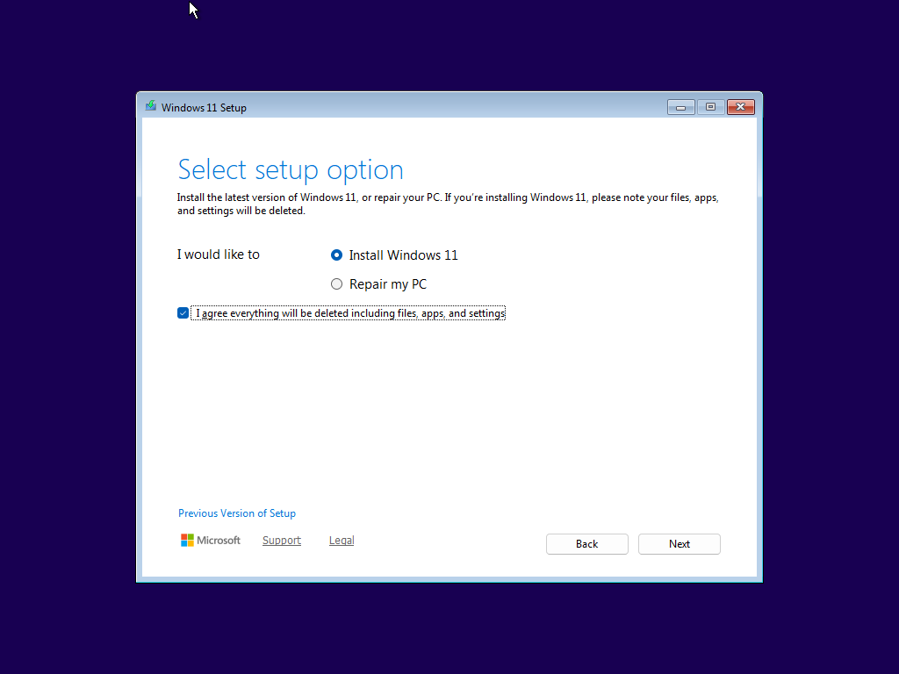
- Disk Selection screen before installation
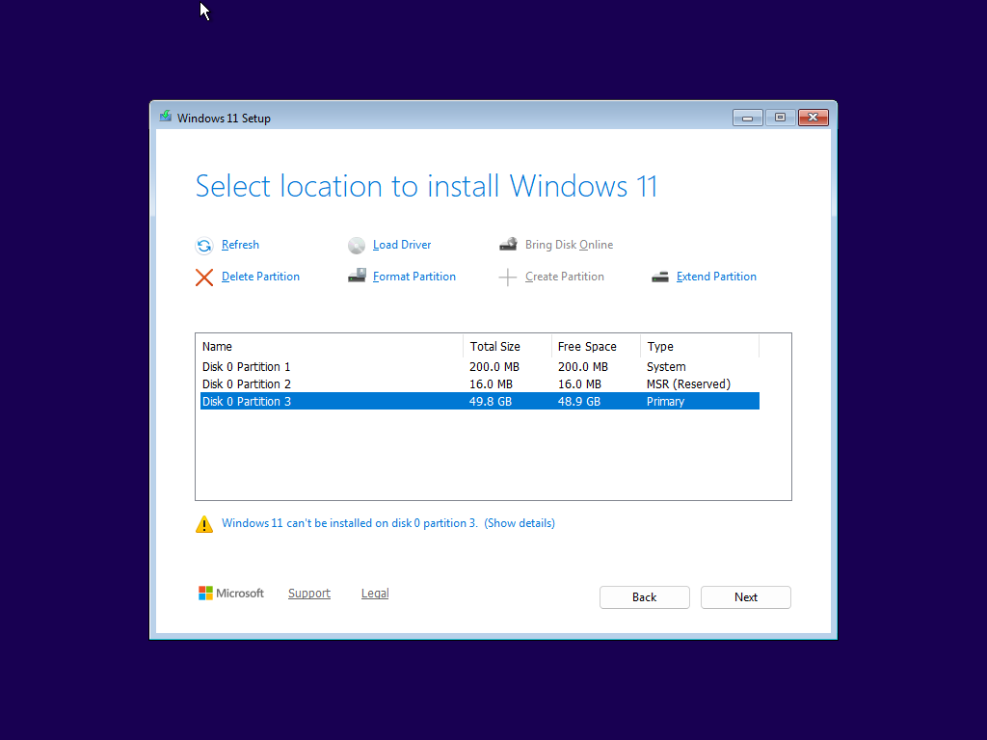
- Region and Keyboard selection screen
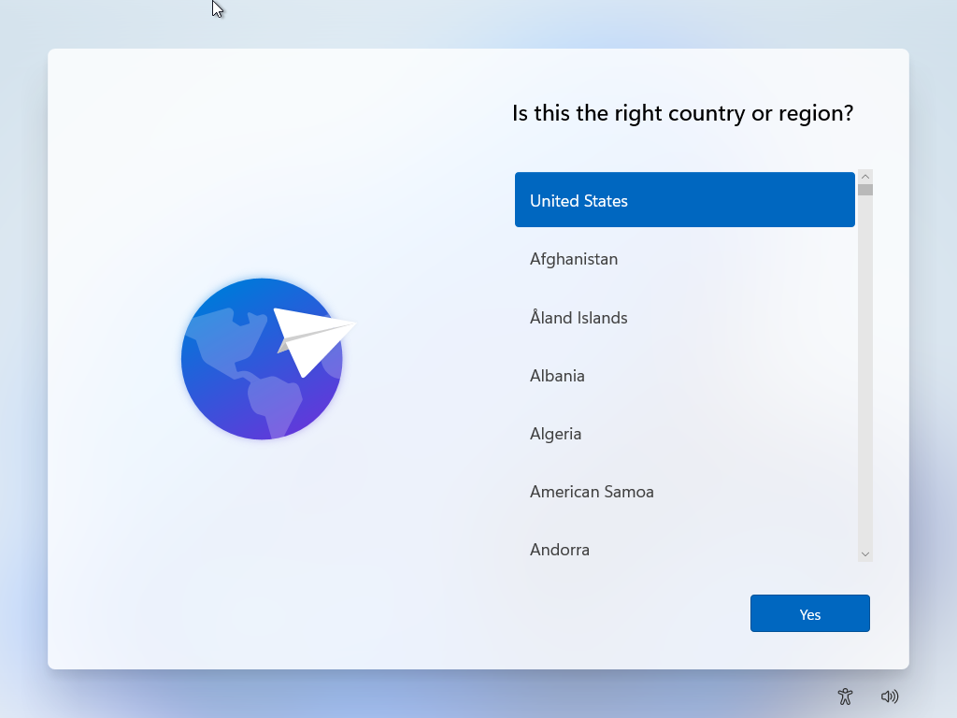
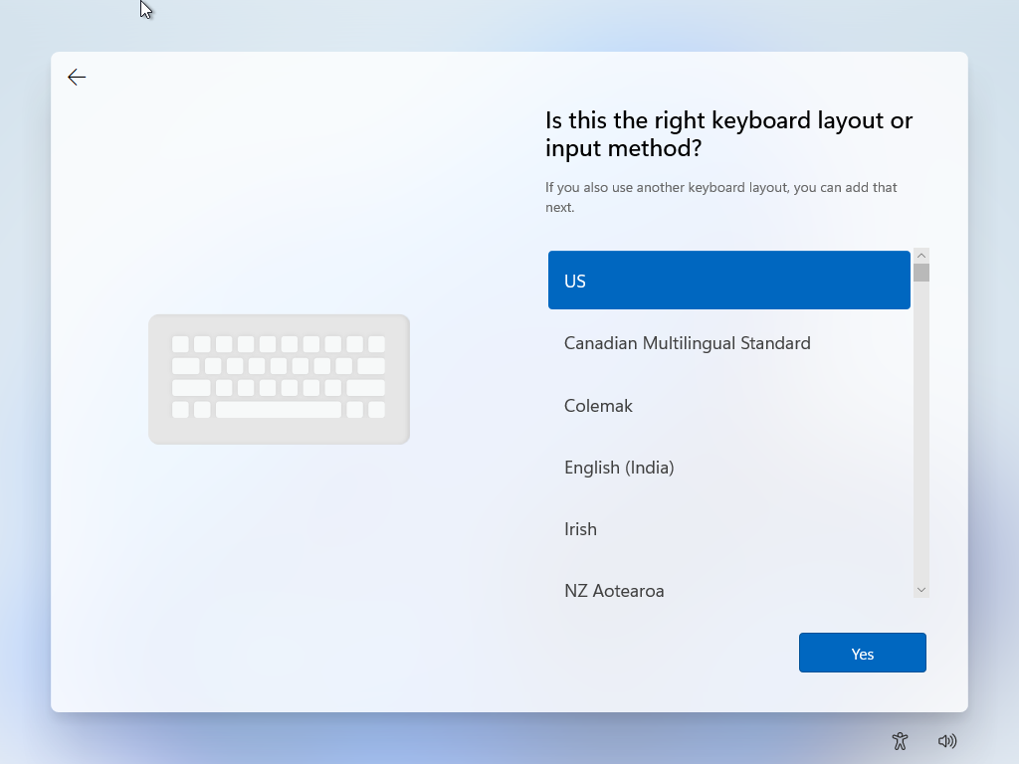
- Limited Setup / No Internet screen
Option not available during installation
- Local Account creation screen (EvergreenUser)
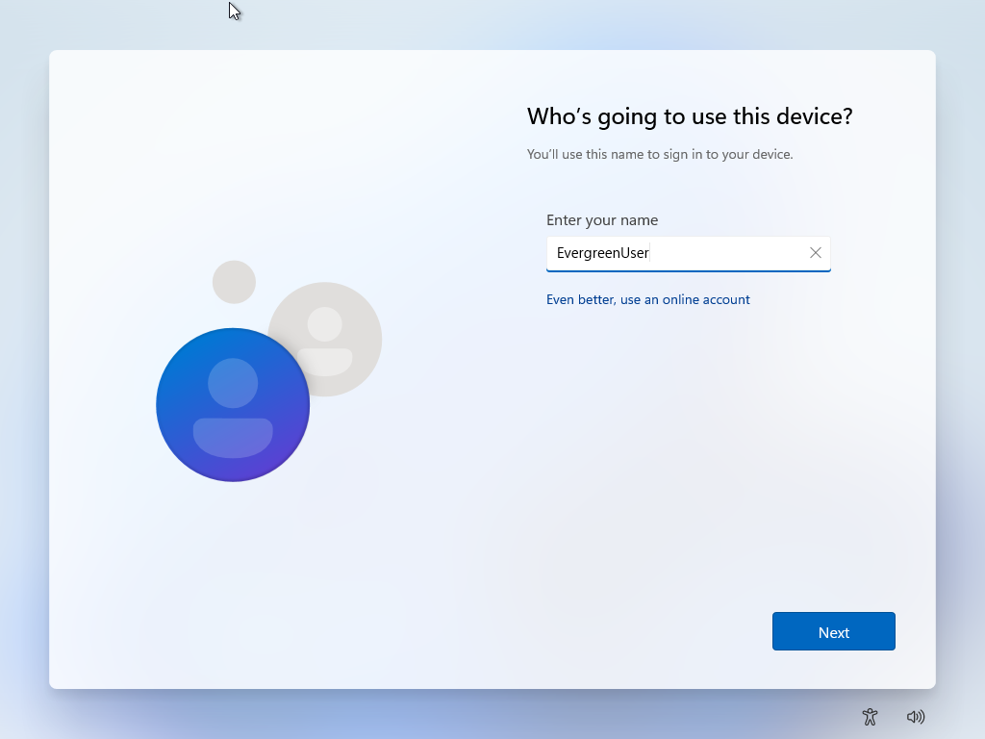
- Windows 11 Enterprise desktop after first logon
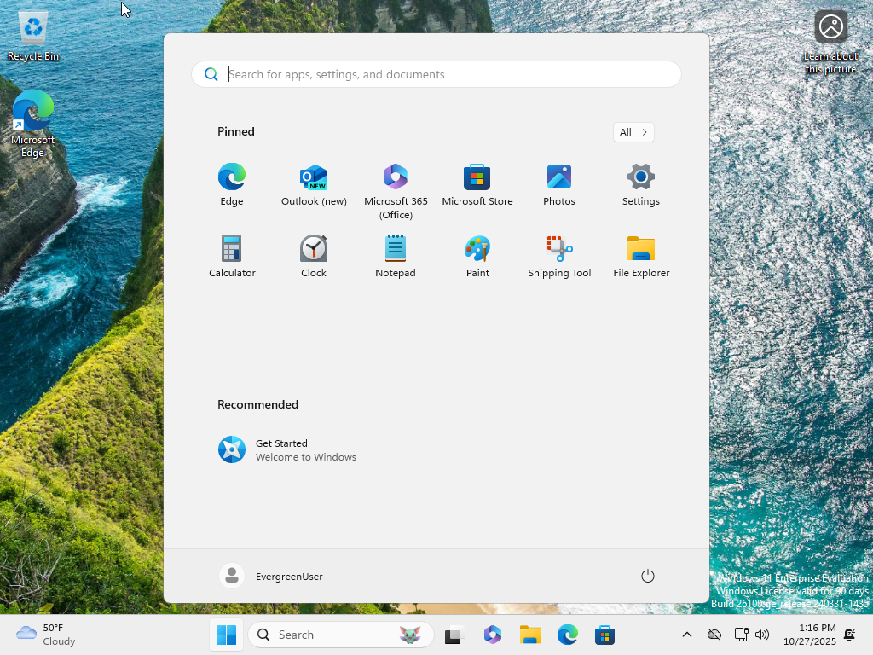
- ipconfig and successful ping to ED-SRV01
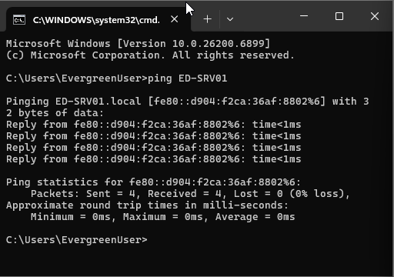

Section 4: Task 3 – Cloning the Workstation (ED-PC02)
To save setup time and maintain consistency, I created a Full Clone of ED-PC01, producing an identical system named ED-PC02.
Evidence: Screenshots and verification artifacts are included below each item.
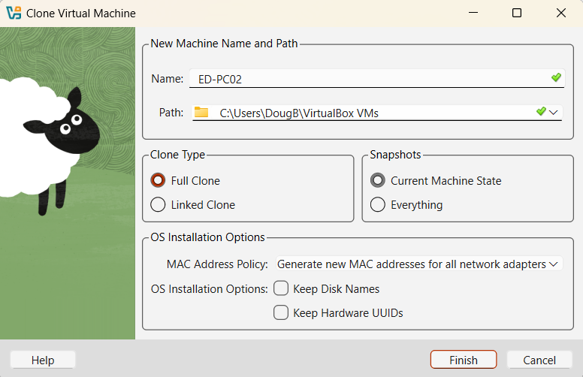

Section 5: Task 4 – Connectivity Verification
Finally, I tested network connectivity across the environment to confirm that all machines could communicate with one another and reach the internet. These tests verified both inter-VM communication and external access through the NAT Network. The table below shows the various ping tests and the outcomes.
The table below summarizes the network verification tests performed during the lab.
Test (From → To) | Outcome (Success/Fail)
ED-SRV01→ ED-PC01 | Success
ED-PC01→ ED-SRV01 | Success
ED-SRV01→ ED-PC02 | Success
ED-SRV01→ Gateway | Success
ED-SRV01→ www.bing.com | Success

Evidence: Screenshots and verification artifacts are included below each item.

Ping from ED-SRV01 to ED-PC01, ED-PC02, Gateway, and bing.com
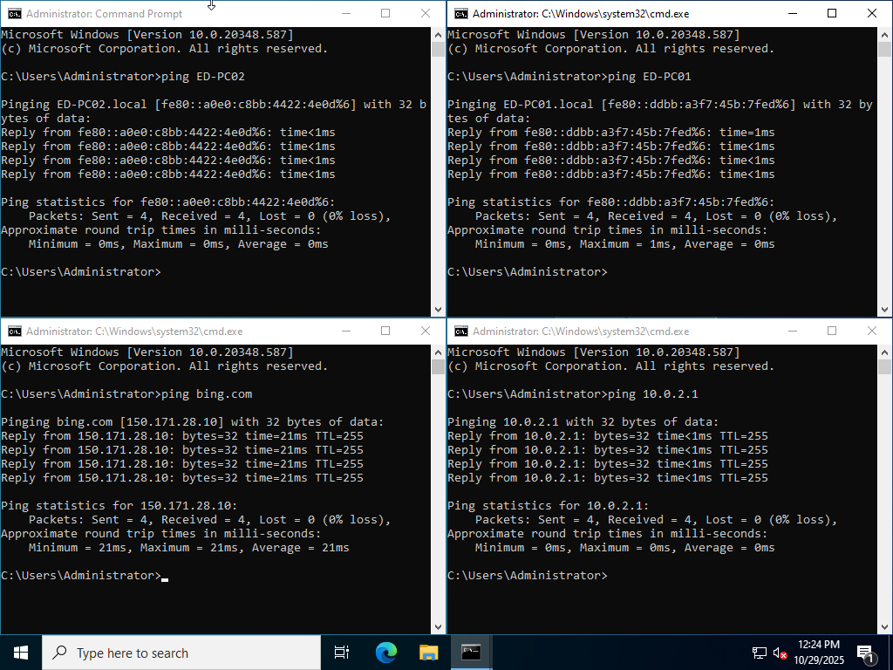

Ping from ED-PC01 to ED-PC02, ED-SRV01, Gateway, and bing.com
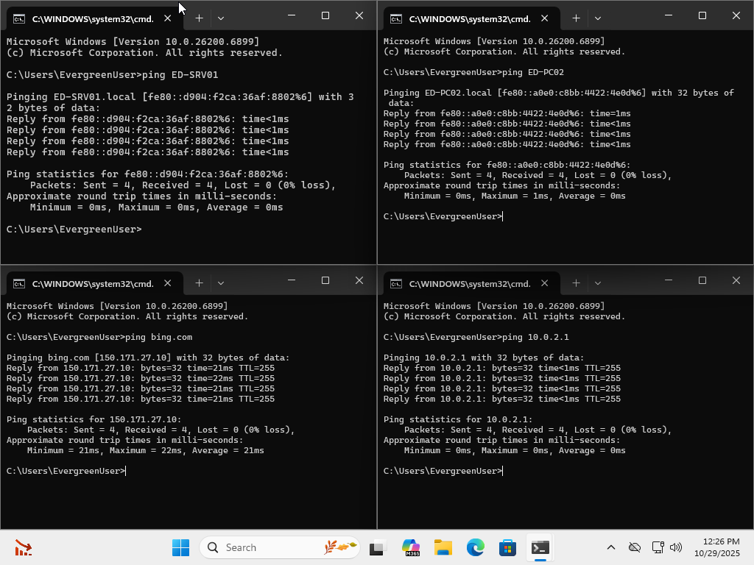

Ping from ED-PC02 to ED-PC01, ED-SRV01, default gateway, and bing.com
