Windows Group Policy Security Lab
Report Prepared By: | Douglas Babcock
Date: | 11/16/2025
Lab Focus | Securing Windows Using Group Policy

Section 1: Executive Summary
This report outlines the implementation of new Group Policy configurations designed to strengthen security and enforce standardization across the Evergreen Diagnostics domain environment. The activity focused on translating Evergreen’s internal compliance requirements into enforceable domain policies managed centrally through Group Policy Management Console (GPMC).As part of this engagement, three major policies were designed and implemented:
- Minimum password length, enforced password complexity, and maximum password age policies apply to all users and increase security by requiring strong, non-repeating passwords.
- Domain Logon Security Message now appears before a user can log on to the domain. This reminder message informs the user that the device is to be used for official business only and that all their actions will be monitored. This increases user accountability.
- Corporate Desktop Branding policy forces a company branded wallpaper to be applied for all users on the domain.
Through these configurations, Evergreen Diagnostics’ domain environment now meets its baseline compliance objectives for authentication security, user accountability, and corporate branding consistency.

Section 2: Task-Password and Account Lockout Policy
The Default Domain Policy was edited to enforce password complexity and account lockout standards for all Evergreen Diagnostics domain accounts.
This configuration strengthens credential security and reduces the likelihood of brute-force attacks.
Evidence / Verification Artifacts
- Screenshot of the Default Domain Policy open in GPMC.
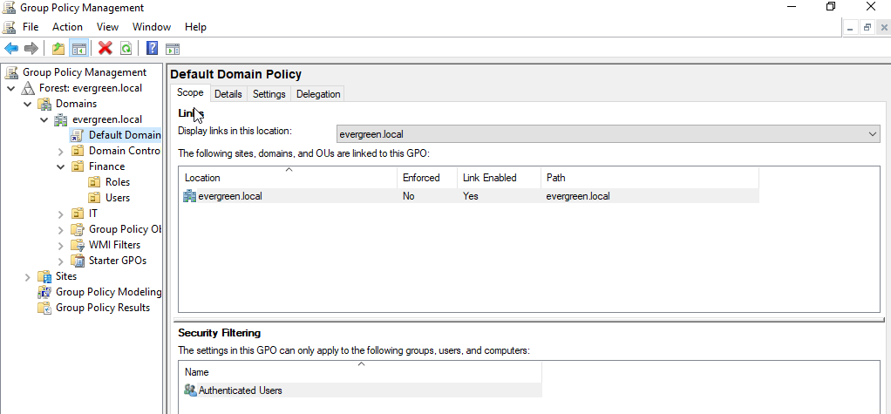

- Screenshot of configured Password Policy settings.
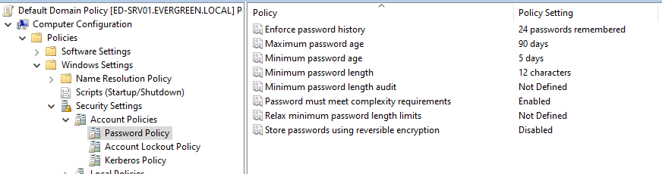

- Screenshot of configured Account Lockout Policy settings.
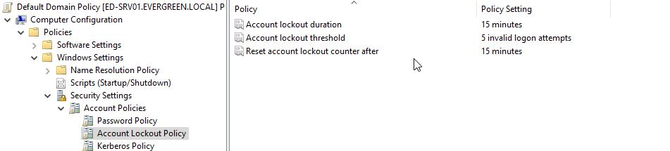
- Screenshot of gpupdate /force confirmation on ED-PC01.
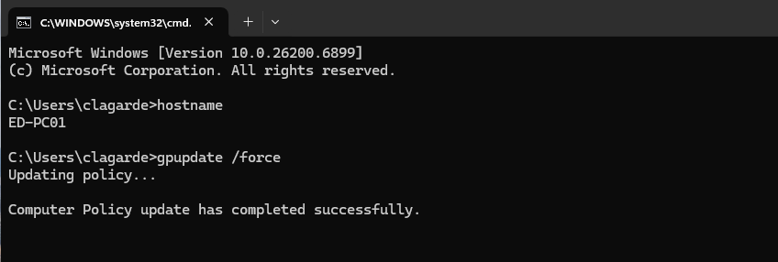

Section 3: Task — Domain Logon Security Message
A new Group Policy Object named Domain Logon Security Message was created and linked to the domain to display a legal banner before authentication. This ensures users are aware that access is restricted to authorized Evergreen Diagnostics personnel and that all activity may be monitored.
Evidence
- Screenshot showing Domain Logon Security Message GPO listed in GPMC.
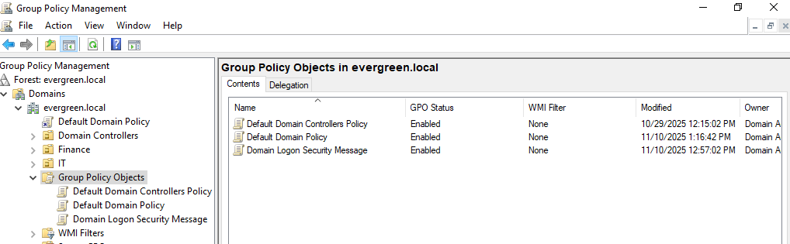
- Screenshot of configured Security Options with title and message text.
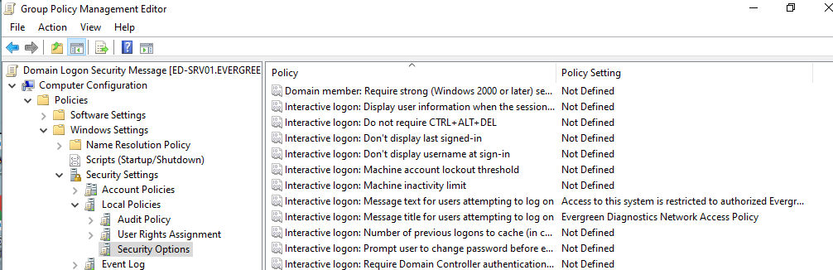

- Screenshot of the logon banner displayed on ED-PC01.
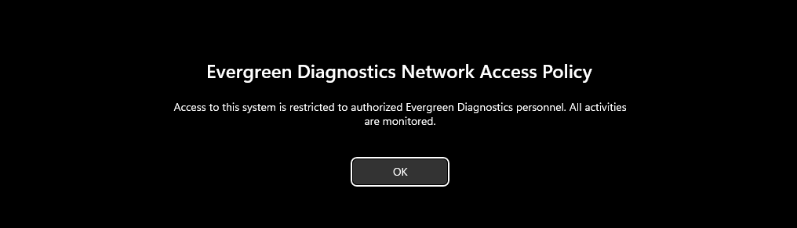
- Screenshot of gpupdate /force confirmation following policy deployment.


Section 4: Task — Corporate Desktop Branding
The Corporate Desktop Branding GPO was created and linked to the domain to establish a uniform desktop experience. A shared network folder was configured on ED-SRV01 containing the approved corporate wallpaper. The policy applies this wallpaper automatically and prevents users from altering desktop backgrounds, reinforcing Evergreen’s professional identity and visual consistency.
Evidence
- Screenshot of the Branding folder and shared wallpaper file on ED-SRV01.
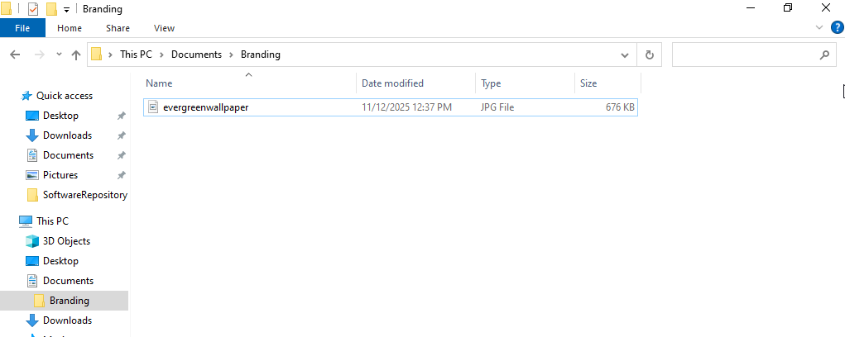
- Screenshot of ED-PC01 accessing \\ED-SRV01\Branding.
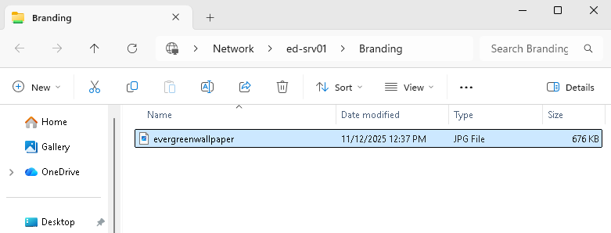

- Screenshot of the Desktop Wallpaper configuration under Desktop → Desktop.
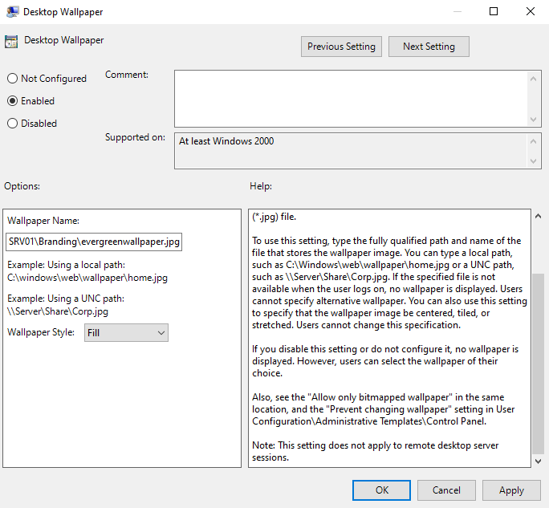

- Screenshot of Prevent changing desktop background under Control Panel → Personalization.
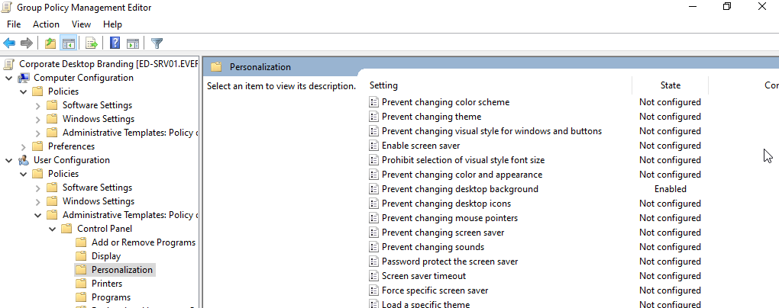

- Screenshot of gpupdate /force confirmation on ED-PC01.


- Screenshot of the ED-PC01 desktop displaying the Evergreen wallpaper.
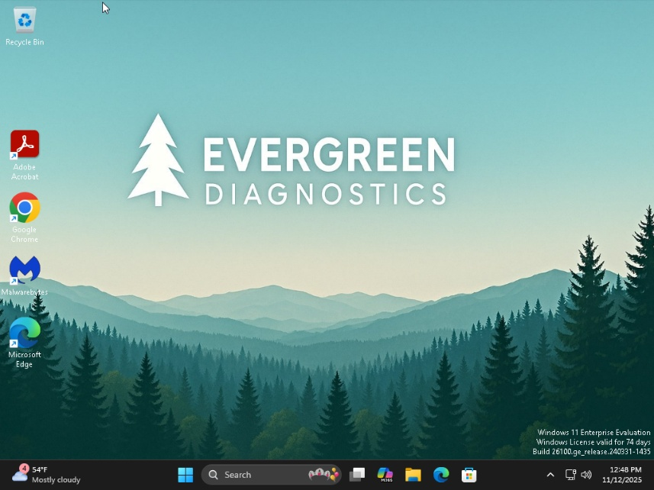
- Screenshot of the Corporate Desktop Branding GPO visible in GPMC.

- Screenshot showing the GPO link under the domain (evergreen.local).
Additional verification artifacts are noted where available. Lab access was limited to the available virtual environment.

Section 5 :Task - Group Policy Verification using gpresult
Verification was completed using the gpresult /r command on ED-PC01 to confirm successful policy deployment. All required GPOs appeared under the applied list, confirming the settings were enforced across the workstation.
Evidence / Verification Artifacts:
- Screenshot of gpresult /r output showing applied GPOs.
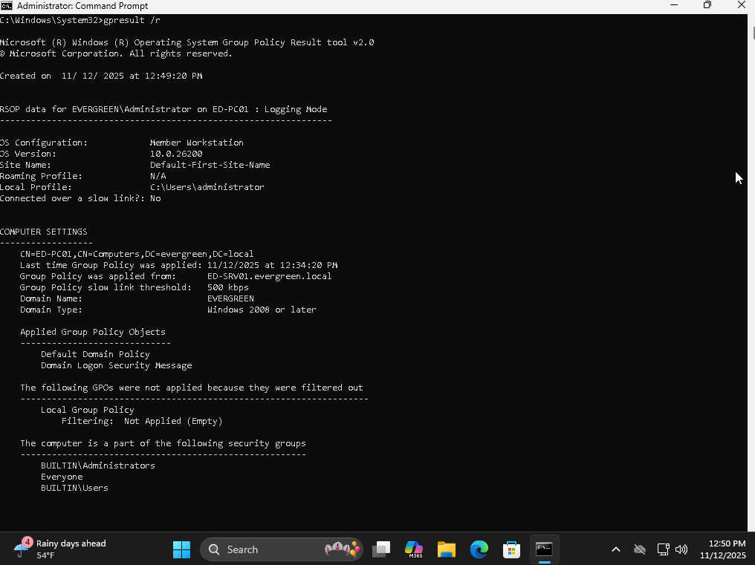
- Screenshot displaying the logged-in user context.
Note: Verification output should be reviewed to confirm the logged-in user context and applied policy list.
- Screenshot highlighting the three applied policies.
The password and lockout policy are included by default and they were only altered. Only two of the policies are new and applied.

