a) Mesh reconstructions for getting the IBS surface
In black, the IBS clustered by a sphere which radio is equal to the box diagonal that involves the object.
The IBS surface calculated by the Poisson method of PCL
Execution time : 9.2 secs
This method add some element on the surface

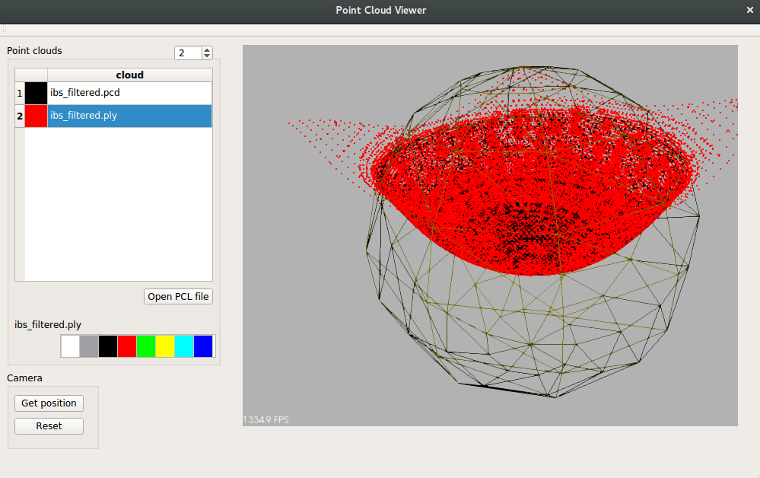
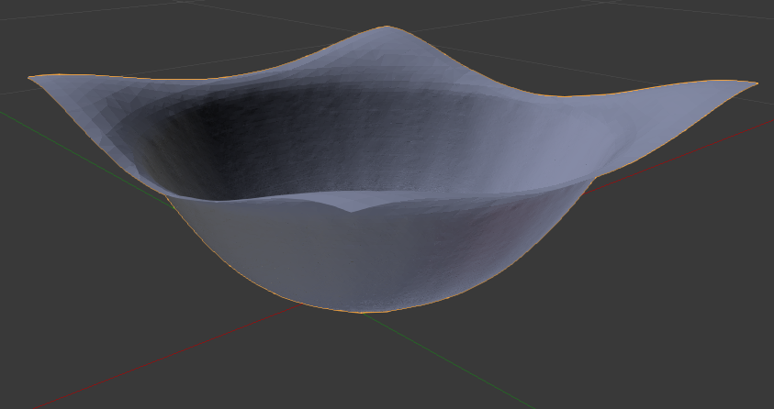

b) Mesh reconstructions for getting the IBS surface
In black, the IBS clustered by a sphere which radio is equal to the box diagonal that involves the object.
The IBS surface calculated by the GreedyProjectionTriangulation method of PCL
Execution time : 2.9 secs
This method don’t add some element on the surface

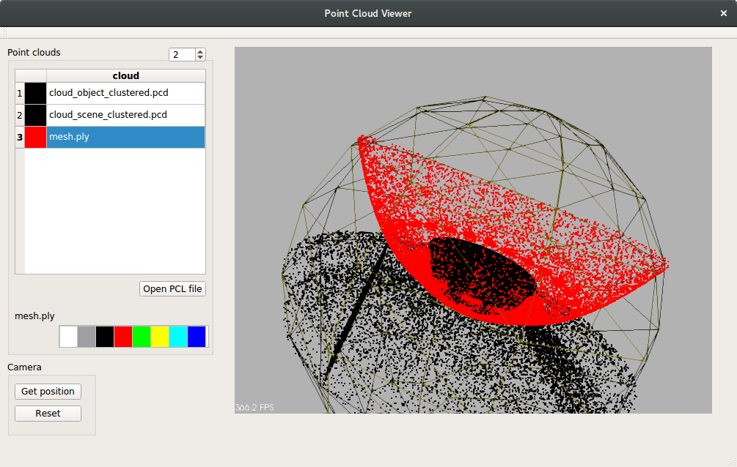
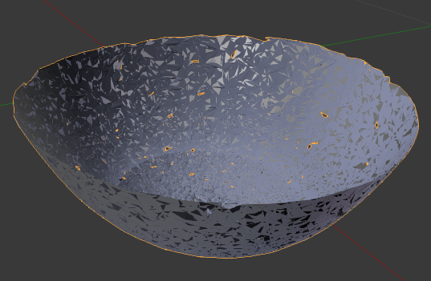
Output example of the original interaction Tensor:
