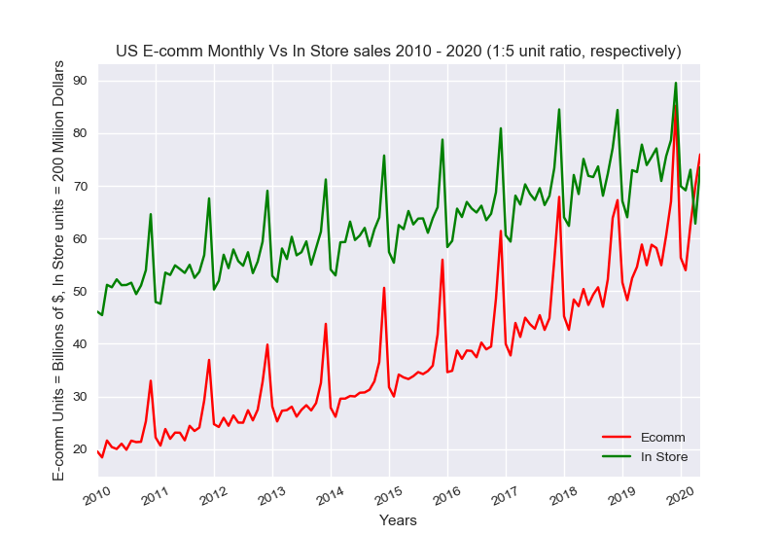**Part 1: General observations and trends**

Retail sales have steadily been on the rise for the past 10 years, both in store purchases and E-commerce. The above chart shows monthly sales over the past 10 years. In store sales have been reduced by 80% for illustration purposes, the actual numbers need to be multiplied by 5 for an equivalent comparison to E-commerce . We can see at the start of 2010 E-commerce sales are about 1/10th that of in store and at the end of 2019, nearly 1/5th, though their January drop off in 2020 was larger for online sales than in store. Not only can we see a steady increase in relative E-comm sales, but also the December peak has shown a larger rate of change than the average throughout each year. This could possibly be due to the ease of purchasing gifts to be sent directly to a recipient or it could suggest an overstressed spending base, increasingly taxed for time at the end of year.

The most notable thing we see about the below graph is not the steady upward trends but the end of year spikes and beginning of year drops in sales. Although a little more difficult to notice is a general trend in monthly sales within each year. The following chart shows monthly change in sales for each month from 2010 to 2020. Retail sales starts off each year with a large deficit from the end of the previous year. We can see January sales are down between 20 and 40 percent from December, with E-comm sales having the largest depreciation, this is due to the fact that they show a larger increase in end of year sales compare to in store purchases. February sales continue to drop, though much less significantly and with a closer gap between in store and E-commerce. March sales show a positive increase from February with the inner-quartile above 10% for both in store and E-commerce. Between April and August monthly sales fluctuate around zero percent change from the previous month with August generally showing an increase from July. September sales have gone down each year for in store and almost always dropped for online purchases. October through December shows constant increase in sales for both types, with November sales leveling out for in store. On line however, has a strong linear increase through December.

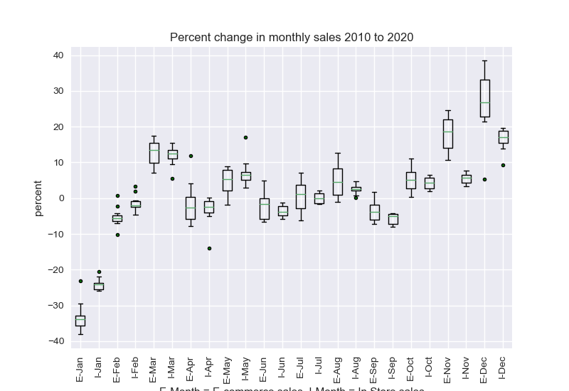

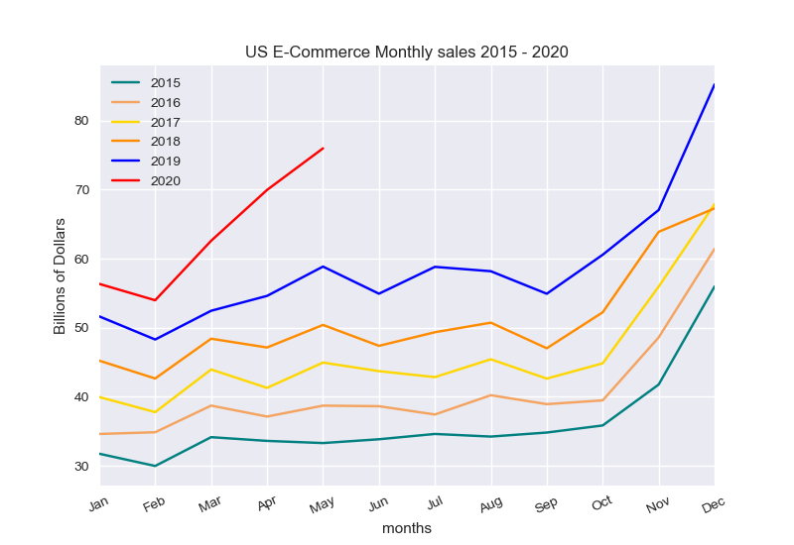

The above chart shows in store sales for five full year from 2015 to 2019 and for 2020, the first five months. As we saw in the previous chart, March is the first month to show an increase in monthly sales each year throughout retail. We see above that April sales for online purchases generally drop off, though in 2019 there was a slight increase, and for May there has been a consistent increase. However, for 2020, due to the COVID situation and lockdown starting mid March, E-commerce shows a considerably steeper increase in March sales than normal, followed by increased April sales, rather than the norm of a drop.

With reported sales through May, we see 2020 start off normally, for both E-comm and In-store, with a large drop in sales from the end of the previous year's holiday sales. However, with the onset of COVID-19 in the United States, In-store sales continued to drop and E-comm sales increased, peaking in April with a record market share of 18.21%.