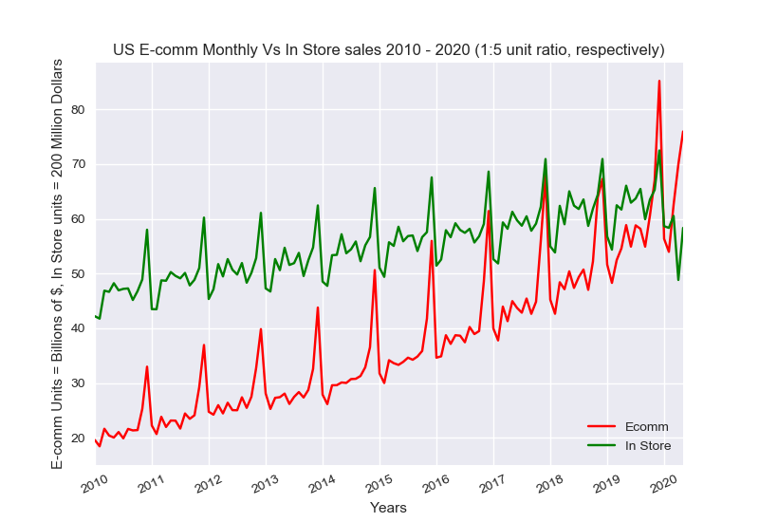

Retail sales have steadily been on the rise for the past 10 years, both in store purchases and E-commerce. The above chart shows monthly sales over the past 10 years. In store sales have been reduced by 80% for illustration purposes. We can see at the start of 2010 E-commerce sales are about 1/10th (9.25% of instore, 8.49% of total) that of in store and at the end of 2019, over 1/5th (23.50% of instore, 19.03% of total). Not only can we see a steady increase in relative E-comm sales, but also the December peak has shown a larger rate of change than the average throughout each year. This could possibly be due to the ease of purchasing gifts to be sent directly to a recipient or it could suggest an overstressed spending base, increasingly taxed for time at the end of year. Also fairly noticeable is a consistent monthly change from year to year.